**5. Beyond the Campus Environmental Promotional Activities**

**Year: 2022 – 2023**

**PROGRAMMES organized by ROSA**

**NAME OF THE DEPARTMENT : HISTORY**

**NAME OF THE VILLAGE : SAMBAKKULAM**

**NAME OF THE ACTIVITY : Video presentation – Sanitation and**

**Safe drinking water**

**NAME OF THE STAFF : Mrs.S.Rajalakshmi**

**NO. OF STUDENTS PATICIPATED : 23**

**NO. OF BENEFICIARIES : 18**

**DATE : 21.9.2022**

**REPORT:**

III year extension students of History Department created awareness on Sanitation and safe drinking water on 21-09-2022. Students gathered the school children and they insisted importance about the Sanitation , open defecation and Safe drinking water. They presented the videos. Villagers watched it.

**Photos with photo caption:**

|  |  |
| --- | --- |
| **C:\Users\HISTORYDEPT\Desktop\Extension 2022\21.09.2022\WhatsApp Image 2022-09-21 at 3.34.16 PM (1).jpeg** | **C:\Users\HISTORYDEPT\Desktop\Extension 2022\21.09.2022\WhatsApp Image 2022-09-21 at 3.34.16 PM (2).jpeg** |
| **Showing Sanitation Videos to the school students** | **Showing open defecation Videos to the school students** |
| **C:\Users\HISTORYDEPT\Desktop\Extension 2022\21.09.2022\WhatsApp Image 2022-09-23 at 10.36.05 AM.jpeg** | **C:\Users\HISTORYDEPT\Desktop\Extension 2022\21.09.2022\WhatsApp Image 2022-09-23 at 10.36.06 AM.jpeg** |
| **Teaching Hand Wash dance to them** | **Importance of Water- Game** |

|  |  |  |
| --- | --- | --- |
| **S.NO** | **REG.NO** | **NAME** |
|  | 2020H02 | ABITHA A |
|  | 2020H06 | ANU S |
|  | 2020H11 | CHITHRA M |
|  | 2020H14 | DEVI LAKSHMI S |
|  | 2020H15 | DEVIBALA M |
|  | 2020H16 | DHEVAYANI G |
|  | 2020H17 | GRECIA SHEKIN J |
|  | 2020H18 | HARINI PA |
|  | 2020H20 | HEMALATHA R |
|  | 2020H21 | JAMUNA D |
|  | 2020H22 | JANANI SRI V |
|  | 2020H32 | MUTHURAKKU M |
|  | 2020H33 | NAGALAKSHMI A |
|  | 2020H35 | NAVEENA P |
|  | 2020H38 | POONGUZHALI P |
|  | 2020H40 | RADHA M |
|  | 2020H41 | RAJAPRIYANGA K |
|  | 2020H42 | RAJESWARI G |
|  | 2020H43 | RAMYA S |
|  | 2020H44 | SANDHIYA DEVI M |
|  | 2020H48 | SIVAKAMI |
|  | 2020H49 | SIVARANJANI P |
|  | 2020H59 | VIJITHA R |

**List of students**

**List of beneficiaries:**

|  |  |
| --- | --- |
| **S.NO** | **NAMES OF BENEFICIARIES** |
|  | Thaniya sri V |
|  | Sudharsan G |
|  | Sarathy S |
|  | Arunachalam A |
|  | Yoga Sri V |
|  | Alagar T |
|  | Sruthika S |
|  | Deepa sri |
|  | Narasingam K |
|  | Sanga mithra P |
|  | Varunika Shri P |
|  | Thanu shri |
|  | Bala saktheeswaran |
|  | Nagalingam M |
|  | Gokul A |
|  | Harish |
|  | Mithun B |
|  | Yashwanth S |

**NAME OF THE DEPARTMENT : ECONOMICS**

**NAME OF THE VILLAG : THEANKARAI**

**NAME OF THE ACTIVITY : Awareness on Environment, Health**

**Hygiene and Sanitation**

**NAME OF THE STAFF : Mrs. A. Gracy Rani**

**Dr.C.Sahaya Mary Sophia**

**NO. OF STUDENTS PATICIPATED : 61**

**NO. OF BENEFICIARIES : 200**

**DATE : 21.10.2022**

**REPORT:**

Students of Economics Dept. Fatima College created awareness on Environment, health hygiene and Sanitation (open defecation) among the students of Vivekanda Matriculation School, Ayyan Thenkarai, Solavandan. Students created awareness through documentary film, charts and slogans. All the school students participated actively and answer all the questions raised by our students. Our students also explained them about having safe drinking water and how to protect the ground water for future generations.

A part of students created awareness on Environment among the villagers by distributing saplings and encouraged them to plant the saplings. They also insisted them the importance of trees to protect the environment and to avoid the pollution. All the students participated actively.

**Geo tag photos with photo caption:**

|  |  |
| --- | --- |
|  |  |
| **Plant Distribution to the Villagers** | **Planting of trees along with the villagers** |
|  |  |
| **Planting of trees along with the villagers** | **Spreading awareness among the villagers** |
|  |  |
| **Spreading awareness among School students** | |

**List of students**

|  |  |  |
| --- | --- | --- |
| **S.NO** | **REG. NO** | **NAME** |
|  | 2020E02 | Akila.B |
|  | 2020E04 | Alageswari.A |
|  | 2020E05 | Angalaeswari.s |
|  | 2020E07 | Arthi.S |
|  | 2020E08 | Asifa.A |
|  | 2020E09 | Babymanimekalai.A |
|  | 2020E10 | Bruthos Begam . T |
|  | 2020E11 | Deepika.C |
|  | 2020E12 | Dharani.F |
|  | 2020E13 | Dharshana.S |
|  | 2020E14 | Gayaythiri.k |
|  | 2020E16 | Gopika.C |
|  | Harini.P | Harini.P |
|  | 2020E18 | Hema Malini.P |
|  | 2020E19 | kalaiselvi.P |
|  | 2020E20 | kamachi.C |
|  | 2020E21 | karthika.A |
|  | 2020E22 | keerthika.M |
|  | 2020E23 | kirubavarshini.R |
|  | 2020E24 | Laveena.S |
|  | 2020E25 | Livitha.B |
|  | 2020E26 | Maniaha.S |
|  | 2020E27 | Meenolotchena.P.P |
|  | 2020E28 | Mohanapriya.k |
|  | 2020E29 | Mutharasi.S |
|  | 2020E30 | Nageshwari.V |
|  | 2020E31 | Nandhini.M |
|  | 2020E32 | Nishapandi.M |
|  | 2020E33 | Nivetha.R |
|  | 2020E35 | Pavithara Devi.R |
|  | 2020E36 | Pooja.K |
|  | 2020E37 | Priya Dharshini.T |
|  | 2020E38 | Rajalakshimi.A |
|  | 2020E40 | Raksha.G |
|  | 2020E41 | Ramya.D |
|  | 2020E42 | Rebecca.A |
|  | 2020E43 | Reethika shree.R |
|  | 2020E44 | Reanuga Devi.B |
|  | 2020E45 | Revathi.R |
|  | 2020E46 | Sangeetha.B |
|  | 2020E47 | Sangeetha.S |
|  | 2020E49 | saranya.M |
|  | 2020E50 | Shanmathi.K |
|  | 2020E51 | Sharulatha.G |
|  | 2020E52 | Sherin safana.S |
|  | 2020E53 | Sivani.B |
|  | 2020E55 | Srinidhi.S |
|  | 2020E56 | Sugashini.T |
|  | 2020E57 | Swathi.T |
|  | 2020E58 | Swetha.M |
|  | 2020E59 | Swethaa.R |
|  | 2020E61 | Varshini.K.R |
|  | 2020E62 | Vidhya.M |
|  | 2020E63 | Vidya.V |
|  | 2020E64 | Vijayalakshimi.M |
|  | 2020E65 | Vinothini.B |
|  | 2020E66 | vinothini.K |
|  | 2020E68 | Yamini.A |
|  | 2020E69 | Bharathi.V |
|  | 2020E70 | Bharkavi.V |
|  | 2020E44 | Tamil kani.R |

**List of beneficiaries:**

Vivekananda Matriculation School Students, Ayyan Thenkarai, Solavandan.

**NAME OF THE DEPARTMENT : Department of Sociology and Social Work**

**NAME OF THE VILLAGE : Thirumalnatham**

**NAME OF THE ACTIVITY : Creating awareness about Sanitation, Open defecation and an effective way of handling water.**

**NAME OF THE STAFF : Dr.T.Geetha**

**NO. OF STUDENTS PARTICIPATED : 14**

**NO. OF BENEFICIARIES : 21**

**DATE : 21-09-2022**

**REPORT:**

The Students and the in charge staff were all gathered together and we left college at 2:00pm. We reached the village at 2:30pm. The concept of the extension is to create awareness about Sanitation, Open defecation and effective way of handling water. After reached the village we collect some photos regarding improper sanitation, using water in ineffective way and open defecation. Then we gathered the school students of the village at one particular place. The audio awareness about Sanitation, Open defecation and effective way of handling water was started to play infront of the village school students.. The audio started with Introduction, importance of proper sanitation, effects of open defecation, importance of water and how to handle the water in effective way and ended with conclusion. While the audio was playing we showed the relevant picture regarding to the audio. In this activity we told the ill effects of improper sanitation and we told how to improve proper sanitation, we told about harmful effects of open defecation and measures to avoid open defecation and finally we told about importance of water and how to handle the water in an effective way through recorded audio. After the audio ended we had an interaction with the school students about the awareness. The students who listened to told about the importance of sanitation, saying stop to open defecation and effective way to using water. They said that they going to maintain proper sanitation, going to use water in effective way and they said that they won’t defecate in open places.

**Geo tag photos with photo caption:**

|  |
| --- |
| C:\Users\User\Desktop\IMG-20220921-WA0023.jpg  Improper sanitation and open defecation near to the residential areas |
| C:\Users\User\Desktop\IMG-20220922-WA0006.jpg  **Students giving awareness through audio and photos** |
| C:\Users\User\Desktop\IMG-20220922-WA0007.jpg  **Student getting signature from beneficiaries** |

**List of students with Reg. No.:**

|  |  |  |
| --- | --- | --- |
| **SI.NO.** | **REGISTER NUMBER** | **STUDENT’S NAME** |
| 1. | 2020S01 | Aafrin M |
| 2. | 2020S02 | Abinaya S |
| 3. | 2020S06 | Angelin B |
| 4. | 2020S07 | Annie Merlin A |
| 5. | 2020S09 | Bavani Priya B |
| 6. | 2020S10 | Bruntha J |
| 7. | 2020S12 | Dhivya Prabha N |
| 8. | 2020S13 | Gobika Laxme S |
| 9. | 2020S16 | Jayashri S |
| 10. | 2020S17 | Joesnisha J |
| 11. | 2020S18 | Kanishka Ragavi MK |
| 12. | 2020S19 | Kavitha S |
| 13. | 2020S26 | Menaka M |
| 14. | 2020S37 | Sobiya P |

**List of beneficiaries:**

1. **Gopika M**
2. **Anushka A**
3. **Akilesh R**
4. **Kaviya K**
5. **Shiva R**
6. **Ashwin Raj S**
7. **Anbu Selvam D**
8. **Manishwaran E**
9. **Arumugam K**
10. **Kavipriyan M**
11. **Velu S**
12. **Saikiran S**
13. **Sabarish B**
14. **Vikash S**
15. **Mithun S**
16. **Dharshan B**
17. **Lokesh A**
18. **Akash A**
19. **Kamalesh K**
20. **Vasikaran R**
21. **Keerthana R**

**NAME OF THE DEPARTMENT : The Research Centre of English**

**NAME OF THE VILLAGE : T.Vadugapatti**

**NAME OF THE ACTIVITY : Swatchtha Pakwoda - Awareness on sanitation, open defecation and effective way of handling of water**

**NAME O F THE STAFF : Ms. J. KAYAL ANTHONY**

**NO. OF STUDENTS PATICIPATED : 31**

**NO. OF BENEFICIARIES : 19**

**DATE : 21/09/2022**

**REPORT:**

In order to bring address the issues of sanitation, open defecation and effective way of handling of water, the students of the Research Centre of English visited their adopted village, T. Vadugapatti to spread awareness. The students played various videos in the regional language (Tamil) to the villagers on the aforementioned issues. The then taught the school students the rhyme “Bits of paper” to motivate them to keep their surrounding tidy. The villagers were greatly benefited by the information shared.

**Geo tag photos with photo caption:**

|  |
| --- |
| **C:\Users\User\Documents\1. fatima college\Extension\2022-2023\Sanitation - Swachatha\videooo.jpeg**  **Videos on sanitation being played for the villagers** |
| **C:\Users\User\Documents\1. fatima college\Extension\2022-2023\Sanitation - Swachatha\hand wash.jpeg**  **School Students being taught how to wash their hands without wasting water** |
| **C:\Users\User\Documents\1. fatima college\Extension\2022-2023\Sanitation - Swachatha\video.jpeg**  **Students watching a video on water management** |

|  |
| --- |
| **C:\Users\User\Documents\1. fatima college\Extension\2022-2023\Sanitation - Swachatha\answer.jpeg**  **Students actively participating in the discussion session** |

**List of students with Reg.No.**

|  |  |  |
| --- | --- | --- |
| **S. No.** | **Reg. No.** | **Name** |
|  | 2020L02 | AASHIHA SHAREEN K |
|  | 2020L03 | ABARNA S |
|  | 2020L04 | ABISHA GANESHEES A |
|  | 2020L08 | ANNRUFINA J |
|  | 2020L09 | ARCHANA A |
|  | 2020L11 | BHAVADHARANI J |
|  | 2020L14 | CHRISTINA SHINY J |
|  | 2020L17 | DHARSHINI S |
|  | 2020L18 | DHARUNASHRI N |
|  | 2020L21 | GEETHA LURTHU MARY J |
|  | 2020L25 | GRIFFITH R |
|  | 2020L27 | JEFRIA SERIN J |
|  | 2020L29 | JOSE AARTHI S |
|  | 2020L30 | KALA MANJARI M |
|  | 2020L31 | KARTHIGAISELVI M |
|  | 2020L33 | LOGA DHARSHANA R |
|  | 2020L35 | MALINI M |
|  | 2020L40 | NAGADEVI K |
|  | 2020L41 | NIHARIKA X A |
|  | 2020L42 | NOORUL SHIFA GHOUSE BASHA |
|  | 2020L48 | PRIYADHARSHINI I |
|  | 2020L49 | PUNITHA S |
|  | 2020L53 | SAHANA BANU J |
|  | 2020L55 | SAISHREE P |
|  | 2020L56 | SAKTHI DHARSHINI M |
|  | 2020L57 | SANDHIYA R A |
|  | 2020L59 | SANJANA G K |
|  | 2020L63 | SHERLINE A |
|  | 2020L66 | SUJITHRA R |
|  | 2020L69 | SWETHA THERES U |
|  | 2020L71 | ABITHA A |

**List of Beneficiaries:**

|  |
| --- |
| 1.Santhosh |
| 2. Mukesh |
| 3. Sanjay |
| 4. Khishor |
| 5. Kanimozhi |
| 6. Santhosh |
| 7. Kiruthika |
| 8. Isai Yazhini |
| 9. Vhishali |
| 10. Naveen Eshwaran |
| 11. Bava Dharani |
| 12. Dharani |
| 13. Kavya |
| 14. G. Anu |
| 15. Gopika |
| 16. Rithik Pandian |
| 17. Inyavan |
| 18. Dharsana Shri |
| 19. Dhansika Shri |

**NAME OF THE DEPARTMENT : RESEARCH CENTRE OF TAMIL**

**NAME OF THE VILLAGE : KONDAYAMPATTI**

**NAME OF THE ACTIVITY : SANITATION AND SAFE DRINKING WATER (VIDEO& AUDIO PLAYING)**

**NAME O F THE STAFF : Dr.S.Arul Micheal Selvi & Dr.J.Sahaya Bowlin**

**NO. OF STUDENTS PATICIPATED: 25**

**NO. OF BENEFICIARIES : 100 STUDENTS**

**DATE : 21.9.2022**

**REPORT:**

**On SEPTEMBER 21, 2022, 25 students along with the staff in charge Dr.S.**Arul Micheal Selvi and Dr.J.Sahaya Bowlin from The Department of Tamil, Fatima College went to Kondayampatti village for Extension Activities.Incharge Teachers of Extension Activities got Permission for Swach Bharath Activity from school.Hundred Students were Benifitted.Our students gave a Skit and Video presentations entitled” SANTITATION AND SAFE DRINKING WATER’’.Teachers and students have appreciated the Program.

**Geo tag photos with photo caption:**

|  |  |
| --- | --- |
| **C:\Users\m1\Downloads\20220921_40430PM_ByGPSMapCamera(2).jpg** | **C:\Users\m1\Downloads\IMG-20220921-WA0059.jpg** |
| **VIDEO PLAYING WITH LAPTOP** | **SKIT PRESENTATION** |
| **C:\Users\m1\Downloads\20220921_35440PM_ByGPSMapCamera.jpg** | **C:\Users\m1\Downloads\20220921_33257PM_ByGPSMapCamera.jpg** |
| **SKIT PRESENTATION** | **SKIT PRESENTATION** |

|  |
| --- |
| **C:\Users\tamildept1\Desktop\20220921_40611PM_ByGPSMapCamera.jpg** |
| **VIDEO PLAYING WITH LAPTOP** |

**List of students with Reg.No.**

|  |  |  |
| --- | --- | --- |
| **S.NO** | **REGISTER NUMBER** | **NAME** |
| 1. | 2020T01 | T.ABARNA |
| 2 | 2020T02 | M.AJITHA |
| 3 | 2020T06 | K.DHANALAKSHMI |
| 4 | 2020T11 | S.GOWSALYA |
| 5 | 2020T13 | S.JAITHUN FATIMA |
| 6 | 2020T14 | L.JAMUNA |
| 7 | 2020T15 | M.JEYANTHI |
| 8 | 2020T23 | C.KALEESWARI |
| 9 | 2020T25 | S.G.KANNIKA PARAMESWARI |
| 10 | 2020T27 | G.R.KARTHIKA |
| 11 | 2020T65 | M.NASRIN BEGAM |
| 12 | 2020T29 | R.KARTHIKA |
| 13 | 2020T32 | G.LAVANYA |
| 14 | 2020T33 | G.LAVANYA |
| 15 | 2020T37 | S.MEENA JASMIN |
| 16 | 2020T39 | A.PRIYADHARSHINI |
| 17 | 2020T42 | K.RAJALAKSHMI |
| 18 | 2020T47 | M.SHIVANIYA |
| 19 | 2020T49 | M.SIVA DHARSHINI |
| 20 | 2020T52 | B.SUREKA |
| 21 | 2020T53 | S.SWATHI |
| 22 | 2020T57 | A.VIJAYALAKSHMI |
| 23 | 2020T58 | A.VIJAYALAKSHMI |
| 24 | 2020T22 | M.KALAIMANI |
| 25 | 2020T64 | T.JEYA PRIYA |

**List of beneficiaries:**

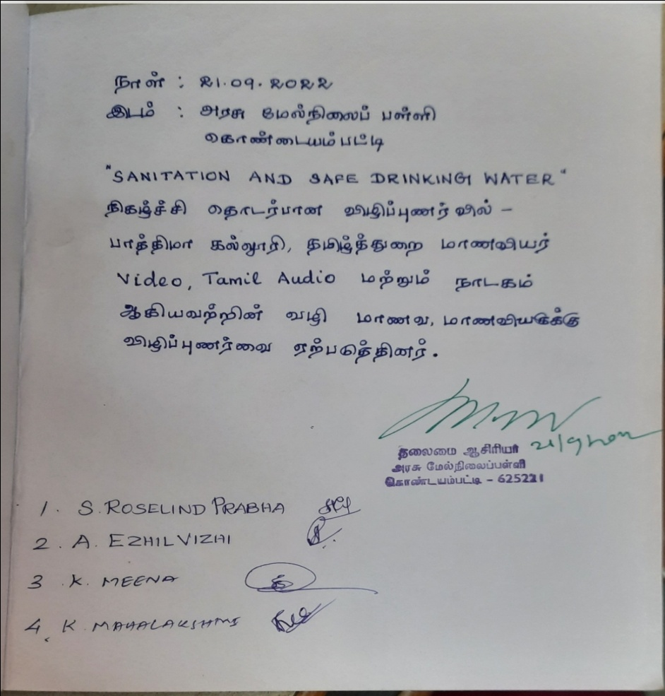

**NAME OF THE DEPARTMENT : MATHEMATICS.**

**NAME OF THE VILLAGE : NEDUNGULAM.**

**NAME OF THE ACTIVITY : EXTENSION.**

**NAME OF THE STAFF : DR. JOSE LITTLE FLOWER**

**NO. OF STUDENTS PARTICIPATED: 25**

**NO. OF BENEFICIARIES : 27**

**DATE : 21/09/2022**

**REPORT**

**INTRODUCTION:**

Extension is an important activity which contributes to the enhancement of the status and public recognition of a profession and welfare of the society at large. Keeping this view in mind the 3rd year Mathematics students of Fatima College carried out an activity on September 21st at Nedungulam Village, Madurai.

**OBJECTIVE:**

* To create awareness about sanitization and save water among the school students.
* To create awareness to avoid plastic items and plastic bags.
* To create awareness to avoid defection in open areas.

**PROGRAMME HIGHLIGHTS:**

The program started with the awareness speech by GC. Dharanisri, S. Gowri, J. Nancy Jerlin from III year Mathematics. The speech was about sanitization and to avoid defecation in open areas. Relevant videos about Sanitization, Saving water were played. Beneficiaries observed the video with full concentration and intaked all the points. Students interacted with the beneficiaries at school in nedungulam about how to keep an environment clean and tidy. Students also justified the health problems, diseases and pollution to the environment caused by open defecation. Most pandemics of recent decades are caused by viruses and lack of sanitization. As a good habit to be practiced, students distributed mask to the beneficiaries. The students carried out rally in the streets of nedungulam. An initiative to avoid plastic bags, students distributed cloth bags to the beneficiaries in the streets and explained them about the emerging risk of plastic bags and the importance of cloth bags. Students pasted sticker posters on the walls of the streets to remind them about sanitization every day.

**AWARENESS SPEECH:**

1. Dharanisri GC - 2020M13
2. Gowri S - 2020M19
3. Nancy Jerlin J - 2020M35

**PHOTOGRAPHY:**

1. Lavanya R - 2020M26
2. Shweatha G - 2020M49

**Geo tag photos with photo caption:**

|  |  |
| --- | --- |
|  |  |
| **Glimpse of School students as audience** | **Awareness speech on Sanitation** |
|  |  |
| **Awareness speech on avoiding plastics** | **Awareness videos on avoiding plastics** |

|  |  |
| --- | --- |
|  |  |
| **Mask distribution to school students** | **Cloth bag distribution to school students** |
|  |  |
| **Cloth bag distribution to the villagers** | |

|  |  |
| --- | --- |
|  |  |
| **Awareness Rally on Plastics** | |
|  | |
| **Sticking Posters on Sanitation** | |

**Student’s List:**

|  |  |  |
| --- | --- | --- |
| S.No | Reg. No | Name |
| 1 | 2020M02 | Aishwarya R |
| 2 | 2020M03 | AmeerNisa G |
| 3 | 2020M05 | Aparna R |
| 4 | 2020M08 | Asmath S |
| 5 | 2020M10 | Catherin Harini A |
| 6 | 2020M13 | Dharanisri GC |
| 7 | 2020M15 | Diffani J |
| 8 | 2020M19 | Gowri S |
| 9 | 2020M25 | KavyaDharshni R |
| 10 | 2020M26 | Lavanya R |
| 11 | 2020M27 | Lavanya S |
| 12 | 2020M35 | Nancy Jerlin J |
| 13 | 2020M40 | Priyadharsini S |
| 14 | 2020M41 | Rajarajeswari B |
| 15 | 2020M42 | Reethi Sharon J |
| 16 | 2020M44 | Sarika N |
| 17 | 2020M47 | Shanmugapriya R |
| 18 | 2020M49 | Shweatha G |
| 19 | 2020M50 | Sowmiya K |
| 20 | 2020M52 | Swathini MR |
| 21 | 2020M56 | Tamilsudar D |
| 22 | 2020M57 | Thirza G |
| 23 | 2020M58 | VilshaJerchini AS |
| 24 | 2020M64 | Sunantha DM |
| 25 | 2020M65 | Varsha J |

**LIST OF BENEFICIARIES:**

**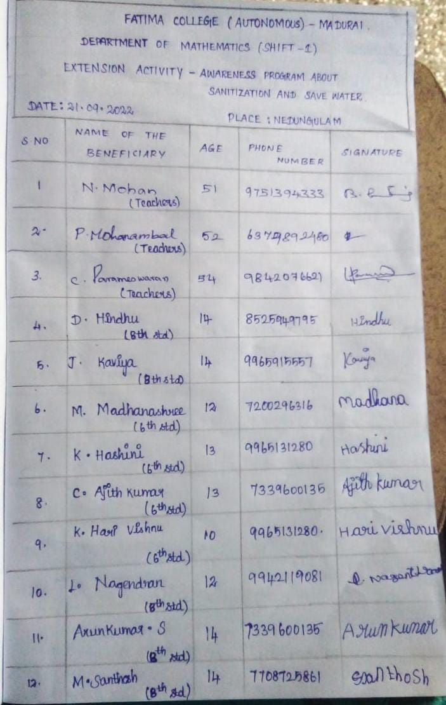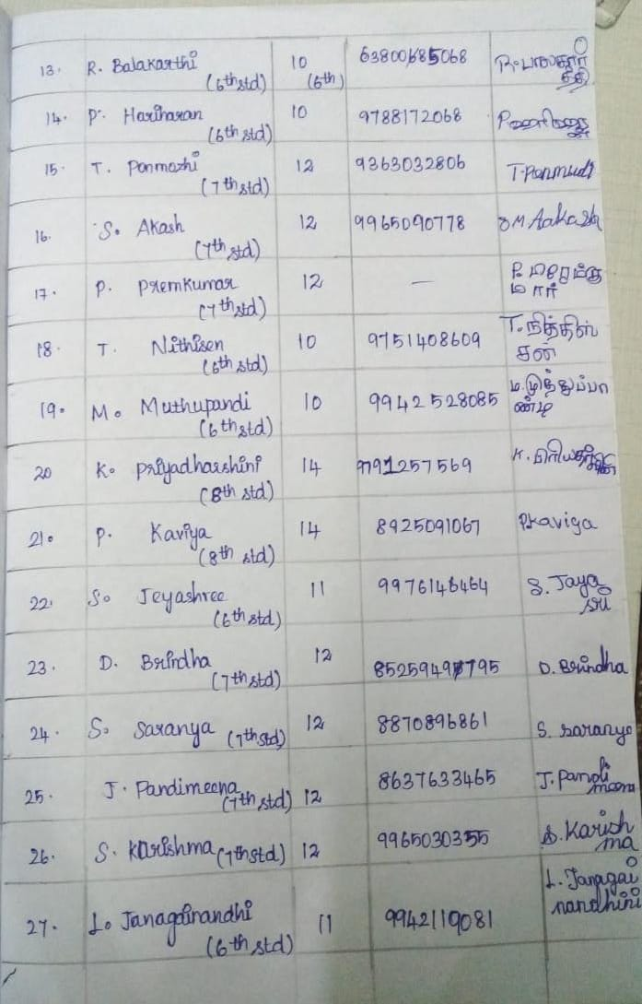**

**NAME OF THE DEPARTMENT : RESEARCH CENTRE OF PHYSICS**

**NAME OF THE VILLAGE : MANIYANCHI**

**NAME OF THE ACTIVITY : VIDEO DISPLAY, SONG AND SPEECH ON “SANITATION, OPEN DEFECATION AND EFFECTIVE WAY OF HANDLING WATER”**

**NAME O F THE STAFF : Dr.J. Selvi & Ms. I. Janet Sherly**

**NO. OF STUDENTS PATICIPATED: 16**

**NO. OF BENEFICIARIES : 40**

**DATE : 21.9.2022**

**REPORT:**

* Students displayed the video on the theme of “sanitation, open defecation and effective way of handling water.
* Students conducted various competitions on the above said theme.
* The song and the speech regarding water conservation create impact among the school students.
* They encourage the school students to actively participate in the competition.

**Geo tag photos with photo caption:**

|  |  |
| --- | --- |
| Description: C:\Users\windows\Downloads\1663939074495.jpg | Description: C:\Users\windows\Downloads\1663939567444.jpg |
| **Song by the students** | **Speech by the students** |
| Description: C:\Users\windows\Downloads\1663939567466.jpg | Description: C:\Users\windows\Downloads\1663939074432.jpg |
| **Speech by the students** | |
| Description: C:\Users\windows\Downloads\1663939567418.jpg | Description: C:\Users\windows\Downloads\1663939074523.jpg |
| **Video display and explanation by the students** | |
| Description: C:\Users\windows\Downloads\1663939074577.jpg  **Participation of school students in the competition** | |

**List of students with Reg.No.**

|  |  |  |
| --- | --- | --- |
| **Sl. No** | **Reg. no** | **Names** |
|  | 2020P02 | Abinaya C |
|  | 2020P08 | Bhuvaneshwari V |
|  | 2020P10 | Devadharshini T |
|  | 2020P17 | Jeyashree B |
|  | 2020P18 | Kavitha P |
|  | 2020P19 | Keerthana C |
|  | 2020P20 | Kiruthika R |
|  | 2020P22 | Lavanya P |
|  | 2020P23 | Nandhini Devi V |
|  | 2020P25 | Nithya Shree G |
|  | 2020P28 | Roshini T |
|  | 2020P31 | Shalinipriya J |
|  | 2020P35 | Vishnu Vardhini J |
|  | 2020P37 | Harish Ifrin SN |
|  | 2020P38 | Mathumitha R |
|  | 2020P41 | Santhiya S |

**List of beneficiaries: 41 (School Students)**

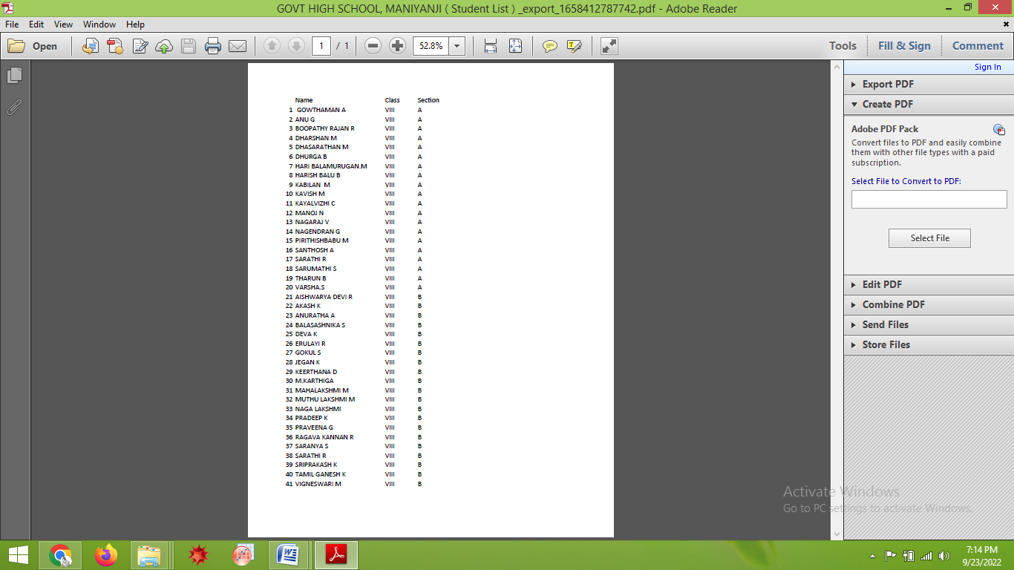

**NAME OF THE DEPARTMENT : CHEMISTRY**

**NAME OF THE VILLAGE : ACHAMPATTI**

**NAME OF THE ACTIVITY : ROSA**

**NAME OF THE STAFF : 1. Mrs. J. BELINDA ASHA**

**NUMBER OF STUDENTS PARTICIPATED: 20**

**NO. OF BENEFICIARIES : 56**

**DATE : 21-09-2022**

**REPORT:**

On 21-09-2022 at 2.00 PM, extension students of chemistry department visited Achampatti Village (along with staff incharge Mrs. J. BELINDA ASHA) and provoke the awareness to adhi-dhravidar elementary school of Achampatti village. The head master and the teaching staff were there along with them 56 students of the school participated in the aware ness on open defecation. The students were eagerly involved in the program and saw the video clippings.

* Awareness regarding open defecation given as a speech
* The video clippings related to the open defecation and its impact shown to the students
* Another video with the stories of cleanliness and hand washing been shown to them
* Students demonstrated how to wash the hands
* Two students from the school also washed their hands

**Geo tag photos with photo caption:**

|  |  |
| --- | --- |
| Description: E:\BA\Extension\21.9.22 Extension activity-open defecation\1663837110940.jpg | Description: E:\BA\Extension\21.9.22 Extension activity-open defecation\1663836186884.jpg |
| **Students give awareness on open defecation** | |
| Description: E:\BA\Extension\21.9.22 Extension activity-open defecation\1663836186829.jpg | Description: E:\BA\Extension\21.9.22 Extension activity-open defecation\1663837362036.jpg |
| **Students show awareness videos to students on open defecation** | |

|  |  |
| --- | --- |
| Description: E:\BA\Extension\21.9.22 Extension activity-open defecation\1663836186843.jpg | Description: E:\BA\Extension\21.9.22 Extension activity-open defecation\1663836186855.jpg |
| **Students of Fatima College demonstrated the hand washing to students** | |
| Description: E:\BA\Extension\21.9.22 Extension activity-open defecation\1663836186869.jpg  **Students giving feedback about the session** | |

**Minutes of students:**

**The students write the minutes of the awareness program**

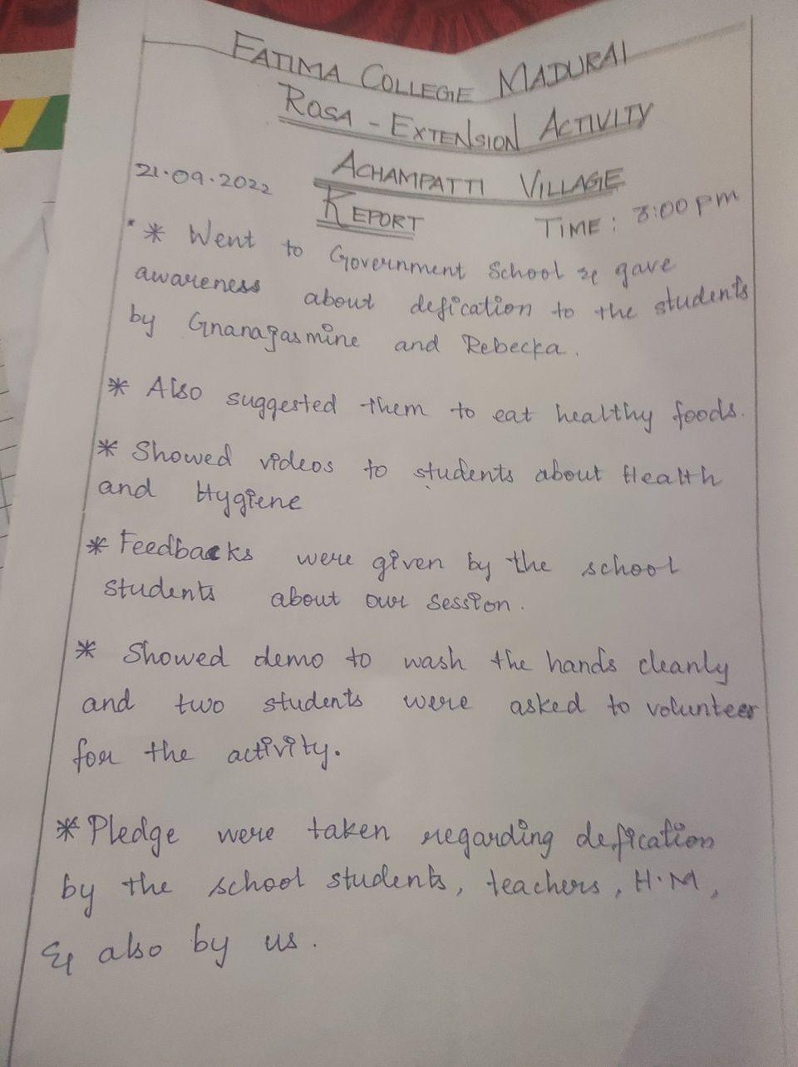

**List of students with Reg.No:**

|  |  |  |
| --- | --- | --- |
| **S.NO** | **REG.NO** | **NAME OF THE STUDENT** |
| 1 | 2020C04 | AlliwinaJency .S |
| 2 | 2020C06 | ArockiyaAmalaSoniya .A |
| 3 | 2020C08 | BowyaDurga .G |
| 4 | 2020C09 | Christy .D |
| 5 | 2020C10 | Devaki .M |
| 6 | 2020C12 | Ezhil .M |
| 7 | 2020C13 | Fermi .E |
| 8 | 2020C15 | Gnanajasmine .J |
| 9 | 2020C17 | Hema Jasmine .A |
| 10 | 2020C19 | InfantaSagayaShalini .J |
| 11 | 2020C07 | Balasre. B |
| 12 | 2020C23 | Jenichristy .AA |
| 13 | 2020C25 | Joe Amirtha .A |
| 14 | 2020C30 | MactalinAjitha .C |
| 15 | 2020C35 | Rebeka .J |
| 16 | 2020C38 | Sherinsamantha .V |
| 17 | 2020C40 | Smitha Angel .R |
| 18 | 2020C44 | ThaslimaNasrin |
| 19 | 2020C45 | Trinity Mary Salomy .D |
| 20 | 2020C49 | VishvaPraba .RS |

**List of beneficiaries-Sample**

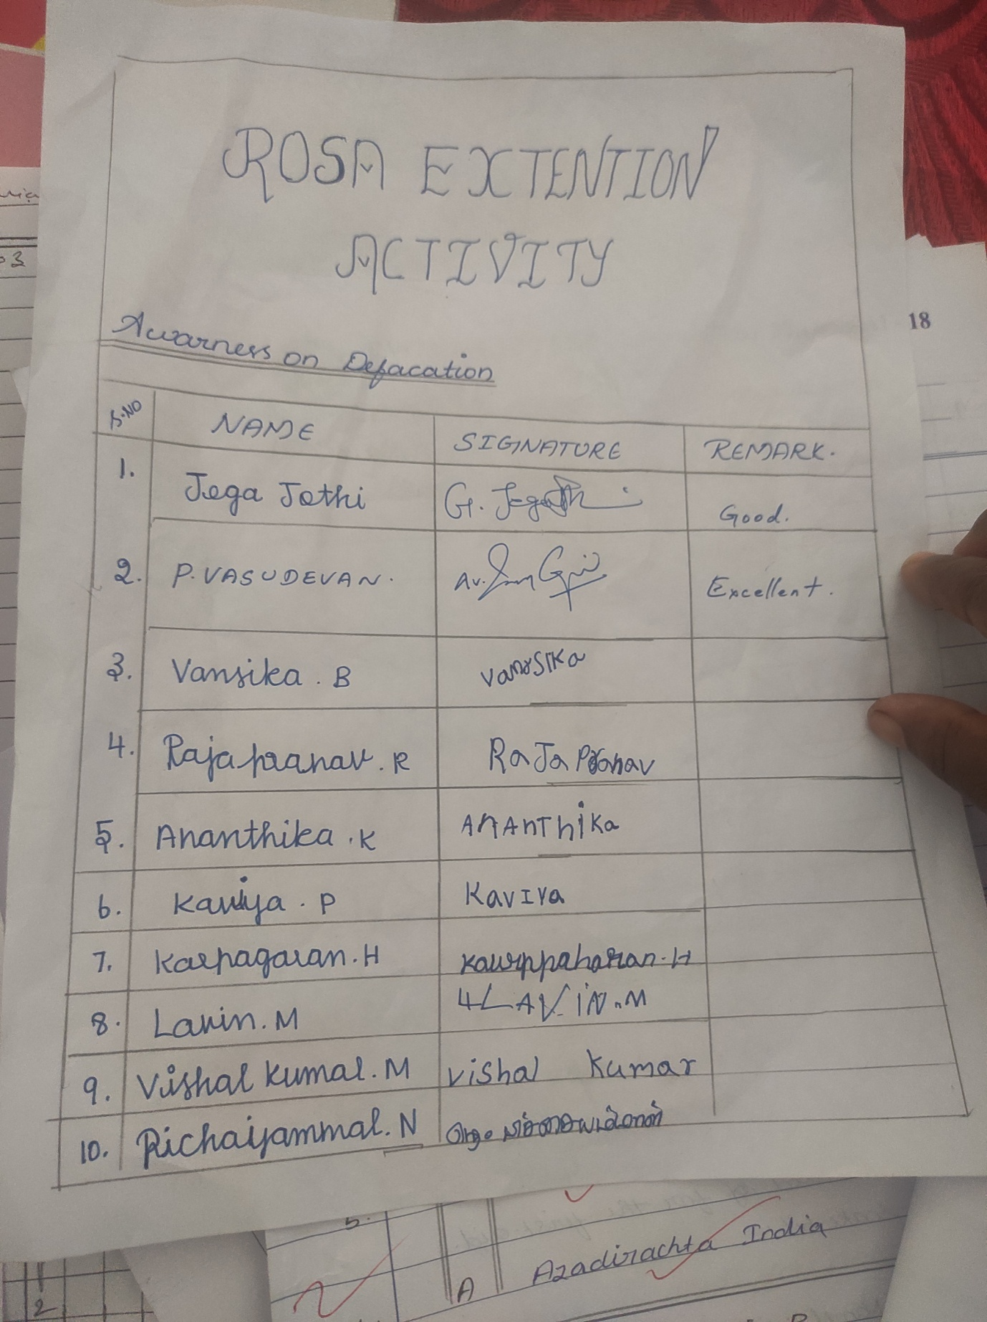

**NAME OF THE DEPARTMENT : Zoology**

**NAME OF THE VILLAGE : Nedungulam**

**NAME OF THE ACTIVITY : Awareness on Sanitation and Safe Drinking Water**

**NAME OF THE STAFF : Dr.AntonyAmalaJayaseeli & Mrs.J.Thelma**

**NO. OF STUDENTS PARTICIPATED : 14**

**NO. OF BENEFICIARIES : 27**

**DATE : 21.09.2022**

**REPORT:**

As a part of ‘Swatchtha Pakwoda’, Awareness on Sanitation and Safe Drinking Water was given to the Govt School Students of Nedungulam village on 21.09.2022. Students of Class VI, VII and VIII participated eagerly in this program.

The activity's main objective was to impart Awareness on Sanitation. The children who learn about Good Hygiene, access to clean water, and sanitation practices in school can encourage healthy lifelong behaviors in their families and communities. Hence, the Students of the Zoology Department planned an interactive activity for the School children by displaying Awareness videos on safe drinking water. They also trained them with the seven steps of Hand Washing. The students also distributed masks and explained the effective and safe usage of masks during the Seasonal Outbreaks of Infectious Diseases. Through these activities, the students also become aware of the challenges faced by the school children. The widespread adoption of safe hygiene practices through a child-centered, interactive, participatory approach helps school children develop life skills and gives them the power to make wise decisions.

**Geotag photos with photo caption:**

|  |
| --- |
|  |
| **Students of Zoology Department, Fatima College at the School in Nedungulam** |

|  |  |
| --- | --- |
|  |  |
| **Students of the Zoology department displaying awareness videos on safe and clean drinking water** | |
|  |  |
| **Students of the Zoology department distributing masks to the school children** | |

**List of students with Reg.No.**

|  |  |  |
| --- | --- | --- |
| **S.No** | **Reg.No** | **Name** |
| 1 | 2020Z01 | ABINAYA.S |
| 2 | 2020Z04 | BHARATHI.S |
| 3 | 2020Z06 | CHITRA SELVI.K |
| 4 | 2020Z07 | DHIVYA BHARATHI.K |
| 5 | 2020Z08 | GAYATHRI.J.C. |
| 6 | 2020Z09 | HARI ABINAYA.M |
| 7 | 2020Z10 | HARSHINI.M |
| 8 | 2020Z11 | KAMALI.S |
| 9 | 2020Z13 | KARTHIKA DEVI.M |
| 10 | 2020Z15 | LALITHAVARSHINI.R |
| 11 | 2020Z16 | MADHUBALA.K |
| 12 | 2020Z18 | MARIA HAILY H |
| 13 | 2020Z20 | NANDHANA.M |
| 14 | 2020Z21 | NARMATHA.N |

**List of beneficiaries:**

**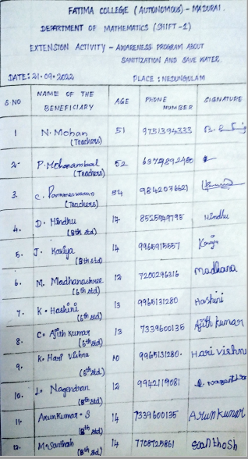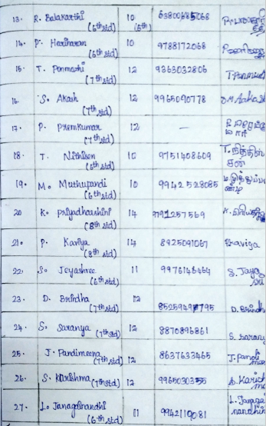**

**NAME OF THE DEPARTMENT : Home Science with Food Biotechnology**

**NAME OF THE VILLAGE : Thandalai**

**NAME OF THE ACTIVITY : Awareness activity on Water conservation, Hygiene and Sanitation and ill effects of open defecation.**

**NAME OF THE STAFF : DR. K. KARTHIGA**

**NO.OF.STUDENTS PARTICIPATED : 17**

**NO. OF.BENEFICIARIES : 26**

**DATE : 21.09.2022**

**REPORT:**

In recent times we could observe the raise of diseases everywhere around us. Flu is common among people and lot of viral infections resulting in closure of school in our neighbouring States. Considering this situation, Home Science with Food Biotechnology ,Fatima college took an initiative to spread awareness among school children regarding Water conservation, Hygiene and Sanitation and ill effects of open defecation.

Third year Undergraduate Home Science students visited the Government school of Thandalai village on 21.09.2022.Grade 6 and Grade 8 School students attended the Awareness session. The awareness activity starts with water conservation videos followed by Hygiene and sanitation and questions were asked to the school students to brain storm them, which made them more curious to listen. Videos were played to give awareness about the ill effects of Open defecation. Finally, the school students raised their doubts regarding conservation of water and ill effects of open defecation. The awareness activity was concluded by motivating the children to follow the self-hygiene and keep their surroundings clean to prevent the spread of various diseases.

**GEOTAG PHOTOS WITH CAPTIONS:**

|  |  |
| --- | --- |
| Description: C:\Users\karth\Desktop\Extension Reports\20220921_25327pmByGPSMapCamera.jpg | Description: C:\Users\karth\Desktop\Extension Reports\20220921_25508pmByGPSMapCamera.jpg |
| **Students gave awareness on Water conservation** | |

|  |  |
| --- | --- |
| Description: C:\Users\karth\Desktop\Extension Reports\IMG-20220922-WA0022.jpg | Description: C:\Users\karth\Desktop\Extension Reports\20220921_30236pmByGPSMapCamera.jpg |
| **Students gave awareness on Hygiene and Sanitation** | |
| Description: C:\Users\karth\Desktop\Extension Reports\IMG-20220922-WA0045.jpg | Description: C:\Users\karth\Desktop\Extension Reports\20220921_31404pmByGPSMapCamera.jpg |
| **Students gave awareness on ill-effects of open defecation** | |

**LIST OF BENEFICIARIES**

1. Keerthana.R
2. Rithish.M
3. Kavitha.A
4. Rubiya.S
5. Sakthi.L
6. Darshan.D
7. Abinaya.A
8. Geetha.R
9. VeeraLakshmi.Y
10. Vijayan.T
11. Shobika.E
12. Kathirvel.R
13. Karthikeyan.K
14. Meenakshi.N
15. Malarvili.P
16. Nithun.S
17. Kayal.C
18. Aashika.V
19. Arun.B
20. Ishwarya.A
21. Nivetha.L
22. Divya.S
23. Vijayan.R
24. Bala.M
25. Pavithra.T
26. Parameshvaran.S

**LIST OF STUDENTS**

**:**

|  |  |  |
| --- | --- | --- |
| **S.No.** | **Reg.No.** | **Name of the Students** |
|  | 2020N22 | PRAVEENA.G |
|  | 2020N23 | RASHIHA.M |
|  | 2020N25 | SALMA ZAHAN.A |
|  | 2020N26 | SAMIHA.S |
|  | 2020N27 | SARANYA.M |
|  | 2020N28 | SARANYA.M |
|  | 2020N30 | SHENBAGA MALLIKA.S |
|  | 2020N31 | SHERLIN SILVIA.A |
|  | 2020N33 | SUBBU LAKSHMI.S |
|  | 2020N34 | SUREKA.P |
|  | 2020N36 | VASUKI.B |
|  | 2020N37 | VENNILA.M |
|  | 2020N38 | VETRI SELVI.S |
|  | 2020N40 | VIJAYASHRIMATHI.A.D |
|  | 2020N41 | YALINI.S |
|  | 2020N43 | SIVASANKARI.S |
|  | 2020N44 | SWETHA RACHAL.S |

**NAME OF THE DEPARTMENT : COMPUTER SCIENCE**

**NAME OF THE VILLAGE : T.ANDIPATTI**

**NAME OF THE ACTIVITY : Creating Awareness and teaching basic knowledge about computer**

**NAME OF THE STAFF : S.ARUL JOTHI**

**NO. OF STUDENTS PATICIPATED : 20**

**NO. OF BENEFICIARIES : 90**

**DATE : 21.09.2022**

On 21.9.2022 the students of III B.Sc Computer Science went for extension to T Andipatti village. The students got surprised when they enter into the school in the village, because the classrooms was filled with students chart work and art craft it was wonderful. They separate them into two groups, one group of students for video presentations and the other group for tutoring the basics of computer. The students show videos to create awareness about sanitizing and the effective ways to handle water usage. From the video the students learn how to save water, the extent of water wastage and how to wash hands with soap and water which causes a lot of infection. The students also made them aware not to defecate in the open and to use the toilet. Finally we instilled in them to conserve water and to wash their hands thoroughly. To their surprise they understood what they were saying and conversed with them in their sweet language.

The second group of students takes over teaching, they thought basic things about the laptop and shortcut keys like cut, copy, paste, undo, redo, refresh, save etc., and thought them how to use notepad and M.S paint. Village school students mesmerized the students by interacting more with them and they raised question, to know about how to change laptop wallpapers. The most interesting thing was they tried to converse with them in English. School teacher's also cooperated well to make the class student's silence. This extension gave them many experience like how to react with students and how to handle them smooth, it was a unique experience.

**TUTORING COMPUTER BASICS TO STUDENTS**

**Group 1 (Teaching)**

Vinmalar .A 2020B42

NahithaParveen. J 2020B29

Anni Judy remina. T 2020B04

Milancy.J. 2020B24

Sathyapriya. 2020B43

Jessipriya. A 2020B15

Anithaamalaurpavam . J 2020B03

AntoAbisha . G 2020B05

bastimonisha. L 2020B07

Vibil.S 2020B41

**Group 2(video making)**

Angeline.D 2020B02

Senehashree.P 2020B37

SibihashreeP 2020B38

Nivetha.A 2020B33

Hepziba.A 2020B12

Princyanto .V2020B34

Stephycindhiya .L 2020B39

Martin vishali.J 2020B23

Aarthi.M 2020B01

Jeya sherlin.J2020B17

**GEOTAG PHOTOS WITH CAPTIONS:**

|  |  |
| --- | --- |
|  |  |
| **VIDEO PRESENTATION BY STUDENTS** | |
|  | |
| **VIDEO PRESENTATION BY STUDENTS** | |

|  |  |
| --- | --- |
|  |  |
|  | |
| **EXPLANATION ABOUT VIDEO PRESENTATIONS BY STUDENTS** | |

**List of Beneficiaries:**

**List of participants in tutorial class**

**VI std:**

N. Santhoshkumar, 6 thstd

S. Sugubarathi,6thstd

C. Madhankumar, 6 thstd

P. Manorithish, 6 thstd

P. Praveenraj, 6 thstd

S. Suryakannan, 6 thstd

P. Sabarivasan, 6 thstd

V. Monika, 6 thstd

P. Janani,6thstd

A. Priyanka, 6 thstd

A. Priyadarshini, 6 thstd

K. Priyadarshini, 6 thstd

R. Sinthu, 6 thstd

P. Abarna, 6 thstd

M. Karthika, 6 thstd

**VII std:**

P.Ruthran, 7 thstd

C. Nirmal, 7th std

E. Devi prasath, 7 thstd

M. Kaviyadarshini, 7 thstd

T. Lavana, 7 thstd

V. Mahalakshmi, 7 thstd

**Vlllstd:**

T. Vanniyaperumal, 8 thstd

P. Rajesh, 8th std

A. Vishvarihith, 8th std

P. Parathmurugan, 8 thstd

P. Kabilesh, 8 thstd

A. Adhavan, 8 thstd

A. Thenmolzi, 8 thstd

C. Durgadevi, 8 std

S. Sudharshanapriya, 8 thstd

C. Priyadarshini, 8 std

**List of participants in awareness: video presentation**

**lllstd:**

C. Kalidas, 3rd std

C. Sasikamatchi, 3rd

A. Karthickjeevan, 3rd std

K. S. Suyambu nathan,3rdstd

C. Vishan th,3rdstd

P. Thusyanth, 3rd std

R. Mukesh, 3rd std

P. Subhakarthikeyan,3rdstd

A. Preethek dev,3rdstd

P. Meenakshi,3rdstd

M jananishree,3rdstd

P. Swasthika,3rdstd

**lVstd:**

Pa. Kathirvel, 4 thstd

K. Pandipradha, 4 thstd

N. Vishnu , 4 thstd

M. Kosik, 4 thstd

P. Vijaymurugan, 4 thstd

L. Niranjan, 4 thstd

N.Sanduru,4thstd

M .Munishka, 4 thstd

C. Subari, 4 thstd

A. Thiaga ,4thstd

P. Kavishree, 4 thstd

C- Monisha, 4 thstd

V. Kavishree, 4 thstd

**V std:**

P. Akhilesh, 5 thstd

A. Madhesh, 5 thstd

C. Shreedarshan, 5 thstd

M. Jenagaimery, 5 thstd

V. Kashni, 5 thstd

M. Dharani, 5 thstd

P. Logavarshini, 5 thstd

P. Maduloar, 5 thstd

M. Mahisha, 5 thstd

**NAME OF THE DEPARTMENT : MATHEMATICS (SF)**

**NAME OF THE VILLAGE : THANICHIYAM**

**NAME OF THE ACTIVITY : SWATCHTHA PAKWODA – Sanitation and Safe drinking water**

**NAME O F THE STAFF : 1. Ms. Dr. M. Subha (Assistant Professor) – Mathematics**

**2. Ms. M. Vimala Suganthi (Assistant Professor) - Mathematics**

**NO. OF STUDENTS PATICIPATED : 46**

**NO. OF BENEFICIARIES : 33**

**DATE: 21.09.2022**

**REPORT:**

On 21.09.2022 as per the communication from UGC via IQAC regarding “SWATCHTHA PAKWODA” students of department of Mathematics (SF), Fatima college, made an awareness to the students of primary school, Thanichiyam, Alankanallur Union School, through Tamil video regarding sanitation, open defecation and effective way of handling water.

**Geo tag photos with photo caption:**

|  |  |
| --- | --- |
| **IMG_20220922_143703 (1).jpg** | **IMG_20220922_143956.jpg** |
| **IMG_20220922_144147.jpg** | |
| **Awareness videos on sanitation, open defecation and effective way of handling water** | |

**List of students with Reg.No.**

|  |  |  |
| --- | --- | --- |
| **S.No** | **Reg.No** | **Name** |
|  | 2020MB01 | AKSHAYA.G |
|  | 2020MB04 | BAVITHA SREE.V |
|  | 2020MB05 | BHUVANESHWARI.R. |
|  | 2020MB06 | BIRUNDHA.PKS |
|  | 2020MB07 | DEVADHARSHINI.S |
|  | 2020MB08 | DEVI BALA.S |
|  | 2020MB09 | DHARSHINI.C |
|  | 2020MB10 | DHIVYA.G |
|  | 2020MB11 | DURGA PARVATHI.R.T |
|  | 2020MB12 | HEMA.M |
|  | 2020MB13 | JEYAPOORNIMA.J |
|  | 2020MB14 | JOSIKA.M |
|  | 2020MB16 | KARTHIKA.S.A. |
|  | 2020MB17 | KARUNYAA.M |
|  | 2020MB18 | KAVI PRIYA.K |
|  | 2020MB19 | KEERTHEKA RANI.V R |
|  | 2020MB21 | SOWMIYA K |
|  | 2020MB23 | MAHESWARI.M |
|  | 2020MB24 | MARAGATHA LAKSHMI.S |
|  | 2020MB25 | MATHANA.R |
|  | 2020MB26 | MEGALA DEVI.M |
|  | 2020MB27 | NILOFAR NISHA.S |
|  | 2020MB28 | POORNIMA.R |
|  | 2020MB31 | SAKTHI G |
|  | 2020MB51 | AISHWARYAA SHRI. M |
|  | 2020MB52 | ALAGURANJANA. A |
|  | 2020MB53 | AMIRDHA VARSHINI. S |
|  | 2020MB54 | ANGALA PARAMESHWARI.M |
|  | 2020MB55 | ANUSHIYA. M |
|  | 2020MB56 | ASMA BEGUM. K |
|  | 2020MB57 | BALA AMBIKA.A |
|  | 2020MB59 | DHARANI. P |
|  | 2020MB62 | JEYA LAKSHMI. B |
|  | 2020MB63 | KARTHIYAYINI. P |
|  | 2020MB64 | KEERTHANA. S |
|  | 2020MB65 | KEERTHANA. R |
|  | 2020MB66 | KEERTHIGA. R |
|  | 2020MB67 | KRISHNAVENI. K |
|  | 2020MB68 | MAHALAKSHMI. S |
|  | 2020MB70 | MITRA. G |
|  | 2020MB71 | NANDHINI.B |
|  | 2020MB72 | NARMADHA. S |
|  | 2020MB73 | NAVOT NAVO. C |
|  | 2020MB74 | PADMAPRIYA. M |
|  | 2020MB75 | PETCHIAMMAL SIVALAKSHMI. A |
|  | 2020MB76 | [POOJA @ AKSHAYA. G](mailto:POOJA@AKSHAYA.%20G) |

**List of beneficiaries:**

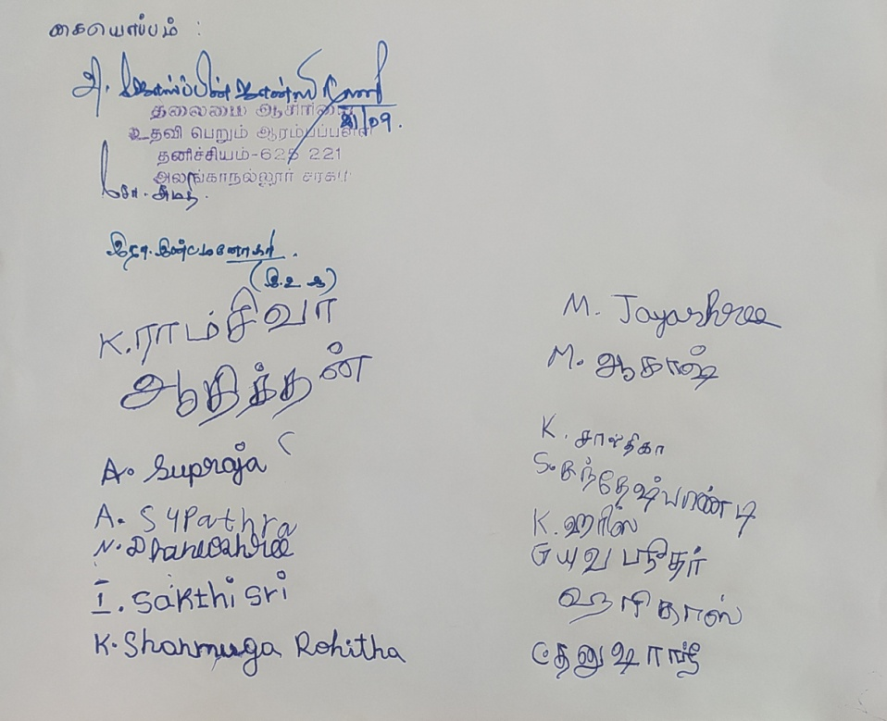

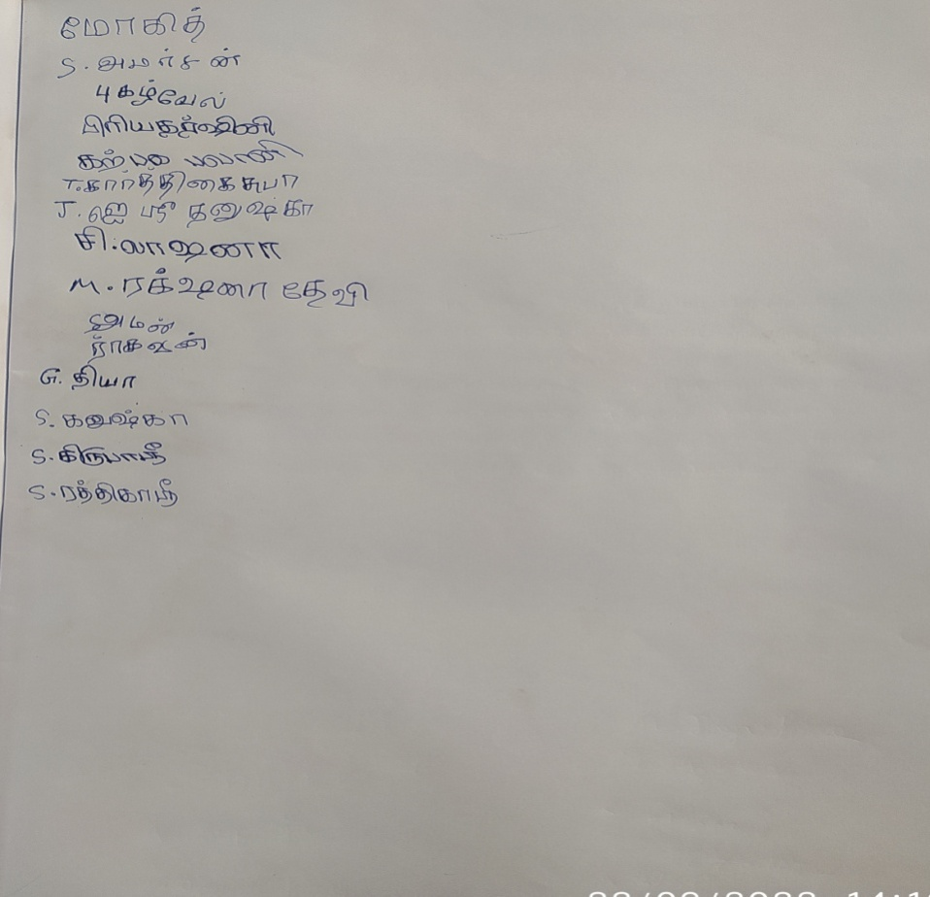

**NAME OF THE DEPARTMENT : COMPUTER APPLICATIONS (BCA)**

**NAME OF THE VILLAGE : Thiruvedagam**

**NAME OF THE ACTIVITY : Sanitation and Safe Drinking Water**

**NAME OF THE STAFF : Mrs.Ramya R**

**NO. OF STUDENTS PARTICIPATED : 40**

**NO. OF BENEFICIARIES : 15**

**DATE : 21-09-2022**

**REPORT :**

We the department of Computer Applications has gone to visit the village Thiruvedagam, which is about 20 kilometre away from our Fatima college for the extension activity with a group of 40 members out of 44 III year BCA students on 21th September, 2022 under the Supervision of Mrs.R.Ramya , Assistant Professor, Department of Computer Applications, Fatima College.

The activity related to **“Sanitation and Safe drinking water**” was organized on September 21, 2022. Students went to the municipality school and showed videos of Hygiene and Sanitation to the students and interacted and taught the kids about the hygiene and sanitation of their daily life.

**Geo tag photos with photo caption:**

|  |
| --- |
|  |
| **Students watching the videos of Hygiene and Sanitation** |
|  |
| **Interacting and Teaching the Students about Hygiene** |

**LIST OF STUDENTS WITH REGISTER NUMBER:**

| **SNO** | **REGISTER NO.** | **NAME** |
| --- | --- | --- |
| 1 | 2020BC01 | J.ABITHA |
| 2 | 2020BC02 | R.AMBIGAI |
| 3 | 2020BC03 | R.ANUSUYA |
| 4 | 2020BC04 | S.ATCHAYA |
| 5 | 2020BC05 | D.DHANASUBRAJA |
| 6 | 2020BC06 | N.DHANUSHYA |
| 7 | 2020BC07 | N.DHARSHINI |
| 8 | 2020BC09 | J.FATIMA SOWMIYA |
| 9 | 2020BC11 | N.GOWRI KARTHIKA |
| 10 | 2020BC12 | V.HANCY SHAMINI |
| 11 | 2020BC13 | M.HARITHA |
| 12 | 2020BC14 | G .HASINI |
| 13 | 2020BC15 | H.HEMA |
| 14 | 2020BC16 | V.JANANI |
| 15 | 2020BC17 | A.JASMINE SUSMITHA |
| 16 | 2020BC18 | R.K JAYA JASHWANTHINI |
| 17 | 2020BC19 | M.JOTHI KEERTHANA SRI |
| 18 | 2020BC20 | J.KEERTHANA |
| 19 | 2020BC21 | K.V.P MAHALAKSHMI |
| 20 | 2020BC23 | S.NANTHINI |
| 21 | 2020BC24 | M.NIVETHA |
| 22 | 2020BC25 | J.PRATHICKSHA |
| 23 | 2020BC26 | B.PRIYADHARSHINI |
| 24 | 2020BC27 | V.PRIYADHARSHINI |
| 25 | 2020BC28 | R.ROCH ABISHA |
| 26 | 2020BC29 | S.SAMRITHA |
| 27 | 2020BC31 | S.SRIMATHI AISHWARYA |
| 28 | 2020BC32 | G.SIVASORNA |
| 29 | 2020BC33 | S.SIVA VARSHINI |
| 30 | 2020BC34 | R.SNEHA |
| 31 | 2020BC35 | G.SWATHI |
| 32 | 2020BC36 | M.SWATHI |
| 33 | 2020BC37 | J.SWEETY |
| 34 | 2020BC38 | J.SWETHA |
| 35 | 2020BC39 | R.THARSHINI |
| 36 | 2020BC40 | S.TRISHALI |
| 37 | 2020BC41 | P.VAISHNAVI |
| 38 | 2020BC42 | T.VAISHNU |
| 39 | 2020BC43 | K.K VIGASHINI |
| 40 | 2020BC44 | A.R.YUVANIKA |

**LIST OF BENEFICIARIES:**

| **SNO** | **NAME** | **GRADE** |
| --- | --- | --- |
| 1 | ABINAV | LKG |
| 2 | LAKSHMI | II std |
| 3 | MUTHU | II std |
| 4 | PREETHI | UKG |
| 5 | KATHICK | IV std |
| 6 | ARUN | I std |
| 7 | AFRUN | II std |
| 8 | ABINAYA | II std |
| 9 | ASHOK | I std |
| 10 | JESLINE | II std |
| 11 | MANJU | III std |
| 12 | VALLI | IV std |
| 13 | CHANDRA | III std |
| 14 | KARTHI | I std |
| 15 | MOHITH | II std |

**NAME OF THE DEPARTMENT : BBA**

**NAME OF THE VILLAGE : KATTAKULAM**

**NAME OF THE ACTIVITY : TUITION & ROLE-PLAY**

**NAME OF THE STAFF : A.ROSARY INFANTA**

**NO. OF STUDENTS PATICIPATED : 34**

**NO. OF BENEFICIARIES : 20**

**DATE : 21-09-2022**

**REPORT:**

III BBA students have visited the Government School at Kattakulam. Totally 47 children are studying at different classes. The school students are divided into various classes. In order to motivate the school students, we have distributed pencils & Erasers. We taught Tamil & English poems. Drawing Training also given to children. We have played the video regarding sanitation & Role Play also done regarding awareness on sanitation.

**Geo tag photos with photo caption:**

|  |  |
| --- | --- |
| C:\Users\BBAdept\Desktop\Downloads\1663736853759.jpg | C:\Users\BBAdept\Desktop\Downloads\1663736853834.jpg |
| C:\Users\BBAdept\Desktop\Downloads\1663736853798.jpg | C:\Users\BBAdept\Desktop\Downloads\1663736853743.jpg |
| **Handling tuition for the students of Government School** | |

|  |  |
| --- | --- |
| C:\Users\BBAdept\Desktop\Downloads\1663736853842.jpg | C:\Users\BBAdept\Desktop\Downloads\1663736853819.jpg |
| **Role Play on sanitation** | |

**List of students with Reg.No.**

|  |  |  |
| --- | --- | --- |
| S.NO | REG.NO | NAME |
|  | 2020BB04 | Akshaya.R |
|  | 2020BB05 | Antho Monica Meenu.A |
|  | 2020BB07 | Divya.N |
|  | 2020BB09 | Hemavarshini.V |
|  | 2020BB10 | Iyashika.P |
|  | 2020BB11 | Jaishali.S |
|  | 2020BB12 | Janagamaari.R |
|  | 2020BB13 | Jaya Meena.K |
|  | 2020BB16 | Jothi Lega.K |
|  | 2020BB17 | Juhitha.M |
|  | 2020BB18 | Kabila.G |
|  | 2020BB20 | Karthiga.R |
|  | 2020BB24 | Lakshmi Priya |
|  | 2020BB25 | Lavanya.K |
|  | 2020BB26 | Lavanya.P |
|  | 2020BB27 | Madhumitha.B |
|  | 2020BB28 | Monal.K |
|  | 2020BB29 | Nazila.M |
|  | 2020BB30 | Niranjana.V |
|  | 2020BB32 | Pasuvathi.B |
|  | 2020BB39 | Ramya.B |
|  | 2020BB40 | Ramya.M |
|  | 2020BB41 | Ramya.R |
|  | 2020BB48 | Santosini.T.H |
|  | 2020BB49 | Saranya.M |
|  | 2020BB50 | Savari Nitheesha.A |
|  | 2020BB51 | Shanmuga Priya.P |
|  | 2020BB54 | Sivaraksha.R |
|  | 2020BB61 | Swetha.G |
|  | 2020BB62 | Swetha.G |
|  | 2020BB64 | Thava Priya.S |
|  | 2020BB66 | Thilippa.T |
|  | 2020BB67 | Vaishnave.R |
|  | 2020BB68 | Vaishnavi.T |

**NAME OF THE DEPARTMENT : COMMERCE WITH COMPUTER APPLICATIONS**

**DATE : 21.09.2022**

**NAME OF THE VILLAGE : AYYANKOTTAI, VADIPATTI**

**NAME OF THE ACTIVITY : CREATING AWARENESS ABOUT SANITATION AND SAVE DIRINKING WATER.**

**NO.OF.STUDENTS PARTICIPATED : 21(TWENTY ONE)**

**NO.OF.BENIFICIARIES : 200**

**REPORT:**

From the department of Commerce with computer application planned to went for an extension on Ayyankottai village on 21st September 2022.

In that village we have planned create awareness about H1N1 virus which was spreading like a fire in recent days in order to protect them from dangerous virus and also awareness about how to manage water.

As per our plan, we reached Ayyankottai village at 10.00 AM. After reaching the village, we splited into two groups .One group of students went to village and other group of students went to Ayyankottai Government school.

In Ayyankottai Government school, Our department students advice them to wash their hands frequently with soap and water or sanitizer and to cover their mouth when they cough or sneeze and to clean their hands after they wash to protect themselves from virus and also demonstrated how to avoid plastic to build plastic free environmentAtlast, on behalf of our department our students presented sapling to the school as a memento.

In that village, our students showed the videos they prepared and explained the villagers about the H1N1 Virus and explained how to protect them from the virus.

Another group of students explained the importance of sanitizer and how to use the sanitizer and also explained the Reuse or conservation of water which helps to recycle ground water by reducing the consumption and using alternative water sources.

**Geo tagged photos with captions:**

|  |  |
| --- | --- |
| **C:\Users\ADMIN\Downloads\IMG-20220922-WA0001 (2).jpg** |  |
| **Students assembled at the village** | **Awareness song on Sanitation** |
|  |  |
| **Presenting Saplings to the villagers** | **Spreading Awareness on H1N1 virus** |
|  | C:\Users\ADMIN\Downloads\20220921_102546AMByGPSMapCamera.jpg |
|  |  |
| **Spreading Awareness on H1N1 virus through videos** | |
|  | |
| **Spreading awareness on reducing the consumption of water** | |

**Students List with Reg. No.**

|  |  |  |
| --- | --- | --- |
| **S. No.** | **Reg. No.** | **Name** |
|  | 2020AB01 | Abiksha .M |
|  | 2020AB02 | Abinaya .S |
|  | 2020AB03 | Anandhi .R |
|  | 2020AB05 | Arunothaya.C |
|  | 2020AB09 | Fany Saran.T |
|  | 2020AB11 | Ilakkiya.K |
|  | 2020AB12 | Jasmine Saritha.R |
|  | 2020AB14 | Josephine Jemima.G |
|  | 2020AB15 | Jothi Lakshmi.T |
|  | 2020AB17 | Kaviya.M |
|  | 2020AB20 | Maria Pio dharshini.L |
|  | 2020AB21 | Maria Glady.J |
|  | 2020AB24 | Mithra.K.M |
|  | 2020AB25 | Mohana Priya.V |
|  | 2020AB27 | Nasrin Fatima.H |
|  | 2020AB28 | Nimesious Borgia.G |
|  | 2020AB29 | Niyomi Santhiya.A |
|  | 2020AB32 | Sahaya Rebecca .J |
|  | 2020AB33 | Sherin Ismath.A |
|  | 2020AB39 | Swetha.L |
|  | 2020AB46 | Vincy Priya.E |

**SIGNATURE OF BENEFICIARIES:**

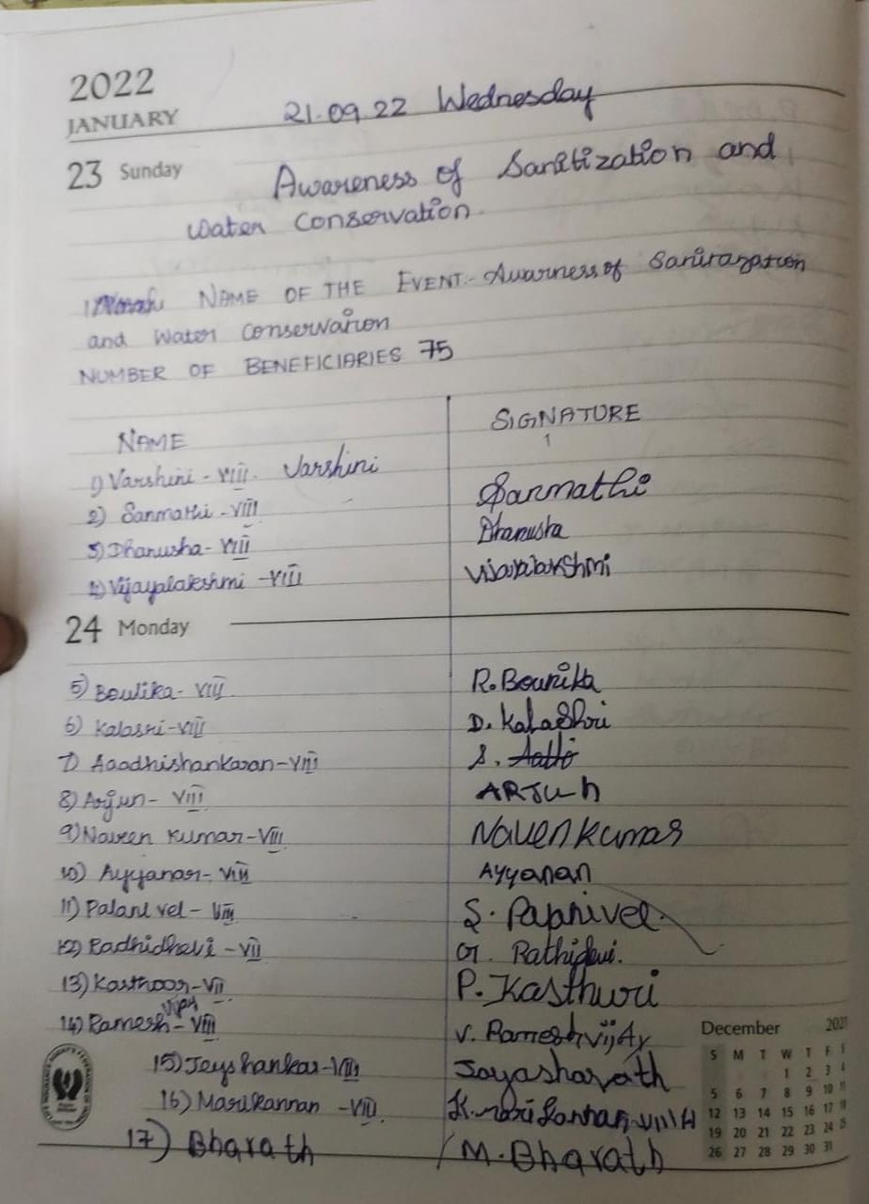

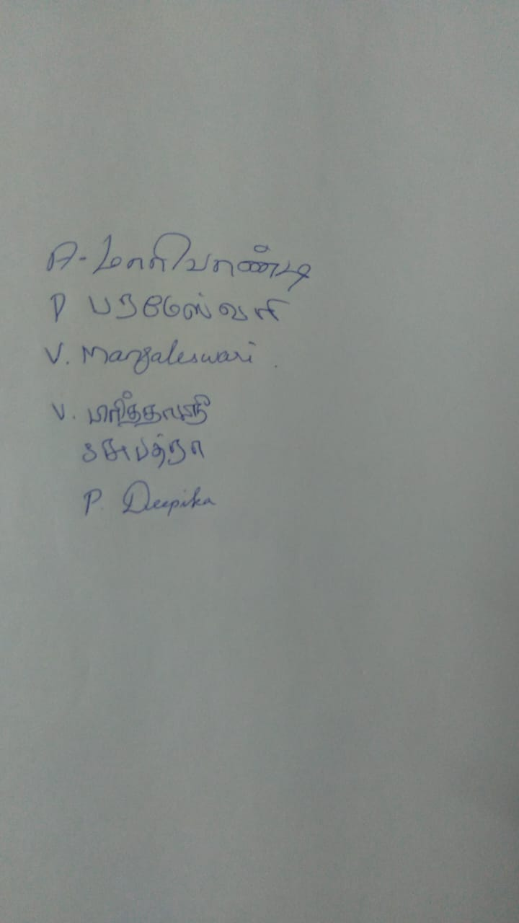

**List of beneficiaries:**

* S.Sangeetha –IV Std
* G.Selvan – IV Std
* H.Boomavathy– IV Std
* U.Raja– IV Std
* I.Asnath Banu– IV Std
* R.Rajalakshmi–VIII Std
* J.Poornima– VIII Std
* G.Ramarajan– VIII Std
* S.Pandiswaran– VIII Std
* S.Shanmugan– VIII Std
* A.Parameshwaran– VIII Std
* V.Murugan – VIII Std
* S.Kala– VIII Std
* E.Easwari– VIII Std
* T.Murugan– VIII Std
* I.Karrupaiyan–VIII Std
* E.Shanmugavel– VIII Std
* T.Haritha –VIII Std
* S.Jamal Mohammed–VIII Std
* D.Gomathi–VIII Std

**NAME OF THE DEPARTMENT : B.A. Journalism and Mass Communication(SF)**

**NAME OF THE VILLAGE : C.PUDUR**

**NAME OF THE ACTIVITY : EXTENSION ACTIVITY**

**NAME OF THE STAFF : Ms. S. Archana**

**NO. OF STUDENTSPARTICIPATED : 29**

**NO. OF BENIFICIARIES : 180**

**DATE : 21.09.2022**

**REPORT:**

III BA students from the department of Journalism and Mass communication (SF) on 21.09.2022 (Wednesday) visited the village C.Pudur as part of their Extension Service Activity. On this day students divided into six groups and visited the government school of that village and gave awareness about water conservation, Health and Hygienic sanitation and open defecation through display some videos to the children’s. Apart from the videos, students gave some instruction about how to handle the usage of water, how to use sanitation, how to be healthy to the children’s. In the end students were interacted with children’s to know how the children’s are understand about the topics.

**Geo tagged photos with captions**

|  |  |
| --- | --- |
|  |  |
| **Awareness speech on Sanitation and Hygiene** | **Display of awareness videos on Sanitation & Open defecation** |

**Students’ Name List with Reg. No.:**

|  |  |  |
| --- | --- | --- |
| **S.No** | **Reg.No** | **Students Name** |
| 1 | 2020JM01 | A.ABIRAMI |
| 2 | 2020JM02 | B. ABIRAMI |
| 3 | 2020JM03 | M. ANITHA |
| 4 | 2020JM04 | R. ANUSHIYA SHERLY TERES |
| 5 | 2020JM05 | K. DEEPIKA |
| 6 | 2020JM06 | M. GAYATHRI |
| 7 | 2020JM07 | M. HALIMA HATHOON |
| 8 | 2020JM09 | M. HARINI |
| 9 | 2020JM010 | R.HARITHA |
| 10 | 2020JM011 | K.S. JANANI |
| 11 | 2020JM012 | P. JANANI |
| 12 | 2020JM014 | T. KANMANI |
| 13 | 2020JM016 | D. LEENA |
| 14 | 2020JM017 | B. MAHALAKSHMI |
| 15 | 2020JM018 | M. MAHARANI |
| 16 | 2020JM020 | D. MOSHINA |
| 17 | 2020JM021 | K. PARVATHA VARTHINI |
| 18 | 2020JM023 | J. RABIA HASINA |
| 19 | 2020JM024 | K. RAJALAKSHMI |
| 20 | 2020JM025 | S. RIZWANA SULTHANA |
| 21 | 2020JM026 | M. SALMA |
| 22 | 2020JM027 | S. SHIYAMALA DEVI |
| 23 | 2020JM029 | P. SUBHIKSHA |
| 24 | 2020JM030 | K. SUJITHATHRISA |
| 25 | 2020JM031 | M. SURUTHI |
| 26 | 2020JM032 | N. SWETHA |
| 27 | 2020JM033 | M. TAMIL KANI |
| 28 | 2020JM034 | V. THAMARAI SELVI |
| 29 | 2020JM035 | J. VAISHALINI |

**NAME OF THE DEPARTMENT : HISTORY**

**NAME OF THE VILLAGE : SAMBAKKULAM**

**NAME OF THE ACTIVITY : Skit and Street Play**

**NAME OF THE STAFF : Dr.M.Vijaya Shanthi**

**NO. OF STUDENTS PATICIPATED : 23**

**NO. OF BENEFICIARIES : 37**

**DATE : 15.10.2022**

**REPORT:**

We started from College at 2 pm. III year extension students of History Department created **Awareness program on crackers** on 15.10.2022. Students gathered small children in that neighbourhood and they insisted about the harmful effects of crackers and ways to burst crackers safely. They projected the concept with street plays. Villagers watched it. We returned to college at 5.00 PM.

**Photos with photo caption:**

|  |  |
| --- | --- |
| C:\Users\HISTORYDEPT\Downloads\IMG-20221015-WA0011.jpg | C:\Users\HISTORYDEPT\Downloads\IMG-20221015-WA0007.jpg |
| **Showing harmful effects of crackers through street play** | **Awareness to children about safe handling of crackers** |
| C:\Users\HISTORYDEPT\Downloads\IMG-20221015-WA0006.jpg | C:\Users\HISTORYDEPT\Downloads\IMG-20221015-WA0009.jpg |
| **Interaction with the village children** | **Creating awareness among the adults in the village** |

**List of students with Reg.No.**

|  |  |  |
| --- | --- | --- |
| **S.No.** | **Reg.No** | **Name** |
|  | 2020H01 | ABIRAMI M |
|  | 2020H03 | AKSHA N |
|  | 2020H05 | ANGELO LANCIA J |
|  | 2020H07 | ARUNYA J |
|  | 2020H12 | DEEPIKA N |
|  | 2020H19 | HEIDY HARRISH MARIYAA A |
|  | 2020H24 | JOSHILA C |
|  | 2020H27 | KAMATCHI K |
|  | 2020H29 | MEENA S |
|  | 2020H31 | MUNEESWARI M |
|  | 2020H36 | NIRANCHANA A G |
|  | 2020H37 | PETCHIAMMAL S |
|  | 2020H45 | SATHIYA PRIYA T |
|  | 2020H46 | SATHYA E |
|  | 2020H50 | SNEHA A |
|  | 2020H54 | UBAYA BHARATHI S |
|  | 2020H56 | VEERAMMAL R |
|  | 2020H57 | VEERASATHYA B |
|  | 2020H60 | YOGASRI R |
|  | 2020H61 | BAMINI R |
|  | 2020H62 | BANUMATHI M |
|  | 2020H63 | JASMIN G |
|  | 2020H65 | THEJAVARJITHA V |

**List of beneficiaries:**

|  |  |
| --- | --- |
| **S.NO** | **NAMES OF BENEFICIARIES** |
|  | Keerthika |
|  | Kalanjiyam |
|  | Bhuvana |
|  | Anandhi |
|  | Palaniyammal |
|  | Viajaya |
|  | Thanyasri |
|  | Mahalakshmi |
|  | Dharani |
|  | Kavin |
|  | Sathya |
|  | Pappu |
|  | Karanthmalai |
|  | Jashwanth |
|  | Seenu |
|  | Kishore |
|  | Mukesh |
|  | Ajay |
|  | Haasan |
|  | Durkesh Pandi |
|  | Nagalingame |
|  | Subathra |
|  | Bhavani Sri |
|  | Ashwin |
|  | Arun |
|  | Vishal |
|  | Kanaka |
|  | Aravindh |
|  | Deepa Sri |
|  | Kalpana |
|  | Arjun |
|  | Sruthika |
|  | Gokul |
|  | Varnika |
|  | Magathi Shri |
|  | Sarathi |
|  | Oomai |

**NAME OF THE DEPARTMENT : Department of Sociology and Social work**

**NAME OF THE VILLAGE : Thirumalnatham**

**NAME OF THE ACTIVITY : Create Awareness through Rally on Safe Diwali**

**NAME OF THE STAFF : Dr.M.Shapna Yasmin**

**NO. OF STUDENTS PARTICIPATED : 16**

**DATE : 15/10/2022**

**REPORT:**

Department of Sociology and Social Work visited Thirumalnatham village for creating awareness to the village people to celebrate Safe Diwali. Students have prepared drawings and quotes related to Safe Diwali and they rallied over the village by raising voice to the quotes written in charts and papers. The children of the village also raised their voices related to Safe Diwali.

Students created awareness not to harm earth by using crackers and also not to burst crackers which harms environment and also insisted to celebrate diwali eco-friendly without using harmful substances. Finally after completing our rally we departed from there and returned back to our college.

**Geo tag photos with photo caption:**

|  |
| --- |
|  |
| **Students of our college went on rally with the quote related to harmful usage of crackers for animals and birds** |

|  |
| --- |
|  |
| **Students of our college went on rally around Thirumaalnatham village** |
|  |
| **Students of our college created awareness on the safe use of crackers.** |

**List of students with Reg. No.:**

|  |  |  |
| --- | --- | --- |
| **SI.NO.** | **REGISTER NUMBER** | **STUDENT’S NAME** |
| 1. | 2020S11 | Dhanushri H |
| 2. | 2020S14 | Harini K |
| 3. | 2020S15 | Ameer Fathima I |
| 4. | 2020S20 | Keerthana S |
| 5. | 2020S22 | Kiruthika J |
| 6. | 2020S24 | Mahalakshmi K |
| 7. | 2020S25 | Megala S |
| 8. | 2020S28 | Pavithra G |
| 9. | 2020S30 | Sahana S |
| 10. | 2020S31 | Santhakumari S |
| 11. | 2020S34` | Shanmuga dharshini S |
| 12. | 2020S35 | Shivitha K |
| 13. | 2020S39 | Subarna C |
| 14. | 2020S40 | Subetha shree R |
| 15. | 2020S41 | Sujitha I |
| 16. | 2020S42 | Thasleem S |

**NAME OF THE DEPARTMENT : MATHEMATICS**

**NAME OF THE VILLAGE : NEDUNGULAM**

**NAME OF THE ACTIVITY : RALLY, OATH TAKING**

**NAME OF THE STAFF : DR. M.V. SETHU MEENAKSHI**

**NUMBER OF STUDENTS PARTICIPATED : 25**

**NO. OF BENEFICIARIES : 27**

**DATE : 15/10/2022**

**Report**

**INTRODUCTION:**

Extension is an important activity which contributes to the enhancement of the status and public recognition of a profession and welfare of the society at large. Keeping this view in mind the 3rd year Mathematics students of Fatima College carried out an activity on October 15th at Nedungulam village, Madurai.

**OBJECTIVE:**

* + - To create awareness about air pollution and noise pollution due to burning crackers.
    - To create awareness to avoid burning crackers during festivals.

**PROGRAMME HIGHLIGHTS:**

The programme started with the rally based on the theme of avoiding crackers. For creating awareness among the people the students had a board in their hand with slogans which are about the impacts of burning crackers. The rally starts from Samudhayakoodam to Ooratchimandram of Nedungulam village. At the end of the programme the students and the children from the village take an Oath of avoid burning crackers.

**PHOTOGRAPHY:**

* Sharmiladevi. G – 2020M63
* Sandhya. A – 2020M61

**Geo-tagged photos with captions**

|  |  |
| --- | --- |
|  |  |
|  |  |
| **Awareness Rally on Harmful effects of Burning crackers** | |
|  |  |
| **Villagers taking oath to avoid crackers** | |

**Student’s Name list with Reg. No.:**

|  |  |  |
| --- | --- | --- |
| **S. No.** | **Register number** | **Name** |
| 1 | 2020M06 | Arockia jenifer. A |
| 2 | 2020M07 | Arul reeta. A |
| 3 | 2020M16 | Divya. B |
| 4 | 2020M17 | Fermi leon. S |
| 5 | 2020M18 | Gokila. J |
| 6 | 2020M20 | Harini. P |
| 7 | 2020M21 | Jenophiya. J |
| 8 | 2020M22 | Jeyalakshmi. N |
| 9 | 2020M23 | Kabitha. G |
| 10 | 2020M24 | Kavinaya. M |
| 11 | 2020M30 | Lokha varshini. S |
| 12 | 2020M31 | Manisha. A |
| 13 | 2020M32 | Maria blessia. A |
| 14 | 2020M34 | Muthulakshmi. N |
| 15 | 2020M37 | Pionish. J |
| 16 | 2020M38 | Praveena. V |
| 17 | 2020M43 | Rosy. S |
| 18 | 2020M45 | Shalini. G |
| 19 | 2020M48 | Sharmila. S |
| 20 | 2020M51 | Swathi. R |
| 21 | 2020M53 | Swetha. S |
| 22 | 2020M55 | Tamilselvi. J.K.J. |
| 23 | 2020M60 | Fathima. M |
| 24 | 2020M61 | Sandhya. A |
| 25 | 2020M63 | Sharmila devi. G |

**List of Beneficiaries:**

****

**NAME OF THE DEPARTMENT : Research Centre of Physics**

**NAME OF THE VILLAGE : Maniyanchi**

**NAME OF THE ACTIVITY : Skit and Poem - Create Awareness on Safe Diwali**

**NAME OF THE STAFF : Dr. J. Selvi and Ms. I. Janet Sherly**

**NO. OF STUDENTS PARTICIPATED : 17**

**NO. OF BENEFICIARIES : 12+25**

**DATE : 15/10/2022**

**REPORT:**

* Students interacted with the villagers on the theme of safe Diwali.
* Students involved in various activities like skit, speech and poetry recitation on important fire safety precautions for Diwali.
* Students make the villagers to actively participate in the events.

**Geo tag photos with photo caption:**

|  |  |
| --- | --- |
| Description: E:\JANET FILES\FATIMA COLLEGE\ROSA\PHOTOS\15 10 2022\20221015_25306PM_ByGPSMapCamera.jpg | Description: E:\JANET FILES\FATIMA COLLEGE\ROSA\PHOTOS\15 10 2022\20221015_24933pm_ByGPSMapCamera.jpg |
| **Students interacting with the villagers** | |
| Description: E:\JANET FILES\FATIMA COLLEGE\ROSA\PHOTOS\15 10 2022\20221015_24518PM_ByGPSMapCamera.jpg | Description: E:\JANET FILES\FATIMA COLLEGE\ROSA\PHOTOS\15 10 2022\20221015_25057pm_ByGPSMapCamera.jpg |
| **Students creating awareness about safe diwali** | |

|  |  |
| --- | --- |
| Description: E:\JANET FILES\FATIMA COLLEGE\ROSA\PHOTOS\15 10 2022\20221015_33521PM_ByGPSMapCamera.jpg | Description: E:\JANET FILES\FATIMA COLLEGE\ROSA\PHOTOS\15 10 2022\20221015_33234PM_ByGPSMapCamera.jpg |
| **Poem on Do’s and Dont’s of Diwali** | |
| Description: E:\JANET FILES\FATIMA COLLEGE\ROSA\PHOTOS\15 10 2022\20221015_32151PM_ByGPSMapCamera.jpg | Description: E:\JANET FILES\FATIMA COLLEGE\ROSA\PHOTOS\15 10 2022\20221015_32120PM_ByGPSMapCamera.jpg |
| **Awareness on important fire safety precautions for Diwali through skit** | |

**List of students with Reg.No.**

|  |  |  |
| --- | --- | --- |
| **Sl. No** | **Names** | **Reg. No** |
|  | Abarna J | 2020P01 |
|  | Abisha S | 2020P03 |
|  | Ancitta D | 2020P05 |
|  | Anushya Mary R | 2020P06 |
|  | Bershina P | 2020P07 |
|  | Divain Penni J | 2020P11 |
|  | Doncy Punitha J | 2020P12 |
|  | Jasmin Fatima G | 2020P15 |
|  | Jeffrina J | 2020P16 |
|  | Nandhini K | 2020P24 |
|  | Rithika M | 2020P26 |
|  | Roshal R | 2020P27 |
|  | Salima Sulthana M | 2020P30 |
|  | Sweetlin Sherly C | 2020P32 |
|  | Sylvia Joan J | 2020P33 |
|  | Thiyathra Risen R | 2020P34 |
|  | Nancy Beaulah R | 2020P39 |

**Sample signatures of beneficiaries:**

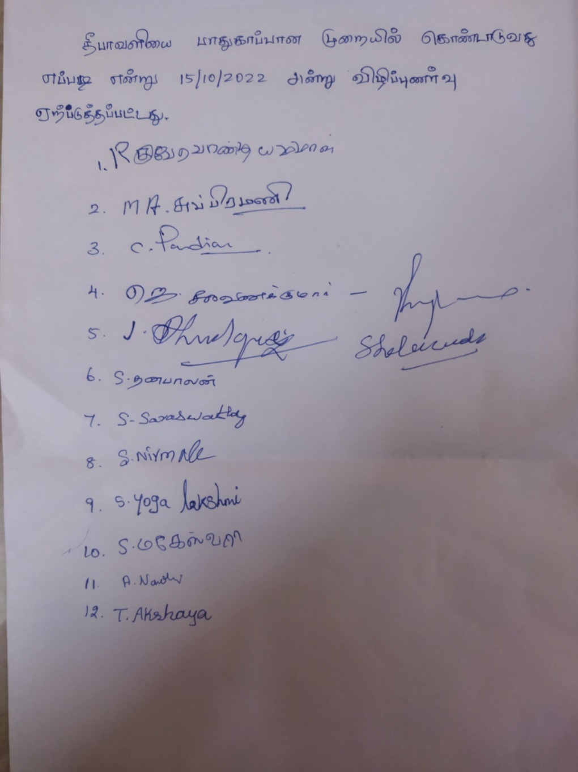

**NAME OF THE DEPARTMENT : CHEMISTRY**

**NAME OF THE VILLAGE : ACHAMPATTI**

**NAME OF THE ACTIVITY : ROSA**

**NAME OF THE STAFF : Dr. K. R. SUBIMOL**

**NUMBER OF STUDENTS PARTICIPATED : 19**

**NO. OF BENEFICIARIES : 50**

**DATE : 15-10-2022**

**REPORT:**

On 15-10-2022 at 2.00 PM, extension students of chemistry department visited Achampatti Village (along with staff incharge Dr.K.R.SUBIMOL) and conducted an awareness program on the environmental impact of crackers and the safety measures to be taken to celebrate a safe Diwali. Students of Fatima College organised a Rally and carried placards containing messages related to the concept and visited the village people door by door. Students tried to educate the people about harmful effects of crackers and the importance of eco-friendly environment. Students insisted the village people to celebrate Diwali with candles, sweets and non-polluting green crackers available in the markets and insisted them the safety measures to be taken for celebrating a safe Diwali.

**Geo tag photos with photo caption:**

|  |  |
| --- | --- |
| E:\SM\EXTENSION-2022-23\october 15th 22\20221015_30039PMByGPSMapCamera.jpg | E:\SM\EXTENSION-2022-23\october 15th 22\20221015_31703PMByGPSMapCamera.jpg |
| **Students of Fatima College give awareness on the environmental impact of crackers and the safety measures to be taken to celebrate a safe Diwali.** | |

|  |  |
| --- | --- |
| E:\SM\EXTENSION-2022-23\october 15th 22\20221015_31346PMByGPSMapCamera.jpg | E:\SM\EXTENSION-2022-23\october 15th 22\20221015_31940PMByGPSMapCamera.jpg |
| E:\SM\EXTENSION-2022-23\october 15th 22\20221015_31857PMByGPSMapCamera.jpg | E:\SM\EXTENSION-2022-23\october 15th 22\20221015_32422PMByGPSMapCamera.jpg |
| **Students of Fatima College organise rally to give awareness on the environmental impact of crackers and the safety measures to be taken to celebrate a safe Diwali.** | |

**List of students with Reg.No:**

|  |  |  |
| --- | --- | --- |
| **S.No** | **Reg.No** | **Name Of The Student** |
| 1 | 2020C01 | Abinaya Prabha .B |
| 2 | 2020C02 | Akshara .M |
| 3 | 2020C03 | Akshaya Varshini .B |
| 4 | 2020C14 | Gayathri .S |
| 5 | 2020C16 | Hamsavardhini .S |
| 6 | 2020C20 | Janani .S |
| 7 | 2020C21 | Janani .VR |
| 8 | 2020C29 | Loshana .E |
| 9 | 2020C32 | Priya .M |
| 10 | 2020C33 | Priyanka .K |
| 11 | 2020C34 | Rajsri .M |
| 12 | 2020C36 | Shanthini .K |
| 13 | 2020C37 | Sharmila .P |
| 14 | 2020C39 | Sivaranjani .J |
| 15 | 2020C43 | Swetha .S |
| 16 | 2020C46 | Udhayakumari .P |
| 17 | 2020C47 | Varshini .T |
| 18 | 2020C48 | Vishalini .R |
| 19 | 2020C50 | Yashini .R |

**List of beneficiaries-**

**Sample signatures of beneficiaries**

**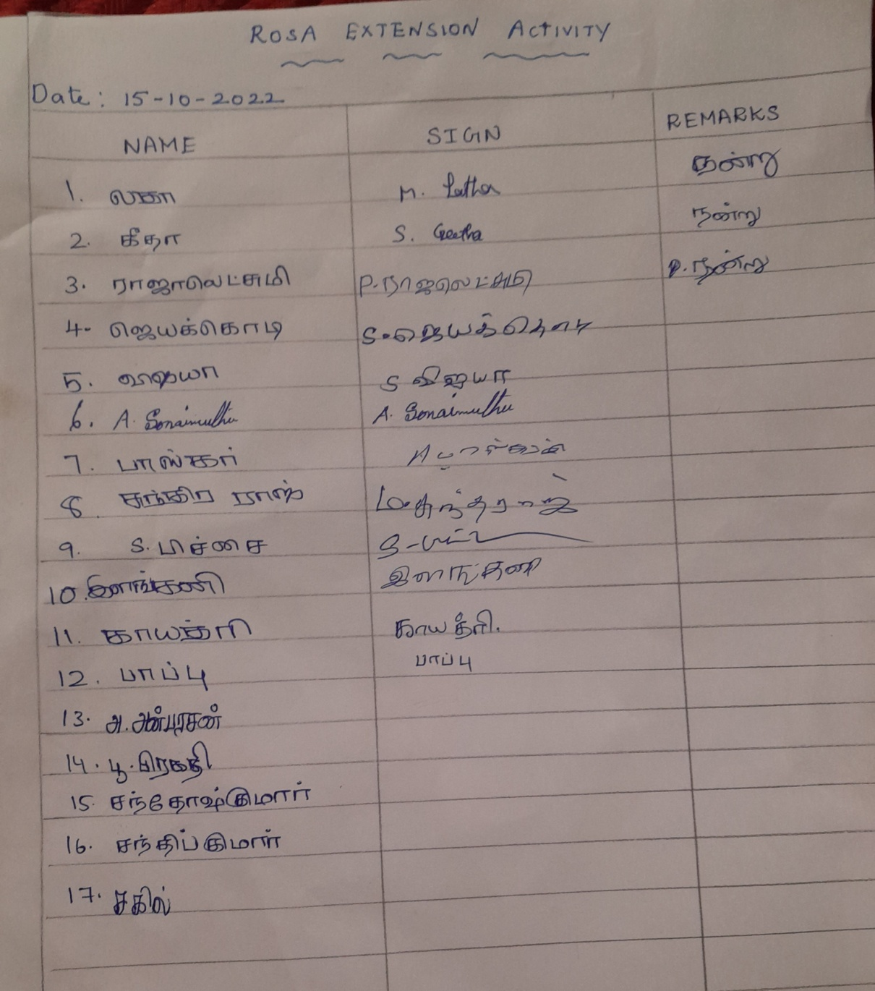**

**NAME OF THE DEPARTMENT : Zoology**

**NAME OF THE VILLAGE : Kondayampatti**

**NAME OF THE ACTIVITY : Awareness on the adverse effects and safe usage of crackers**

**NAME OF THE STAFF : Dr.Antony Amala Jayaseeli and Mrs.J.Thelma**

**NO. OF STUDENTS PARTICIPATED : 34**

**NO. OF BENEFICIARIES : Approximately 60**

**DATE : 15.10.2022**

**REPORT:**

The students of the zoology department, Fatima College took part in a programme to raise knowledge of safe usage of crackers. The event took place at Kondayampatti Village on October 15, 2022. The students started with a rally. Placards with slogans on the safe usage of crackers were written. As they moved through the streets, they engaged in conversation with both young and old people, explaining the different safety precautions that should be observed when handling crackers. They also insisted on using crackers properly, such as not to store them in the kitchen, not to burst crackers while holding them in hand and wearing footwear. The students also asked the villagers to minimize the usage of crackers as it causes air and noise pollution. Finally, the awareness program sensitized the villagers towards issues related to improper usage of crackers.

**Geo tag photos with photo caption:**

|  |  |
| --- | --- |
|  |  |
|  | |
| **Students giving awareness to the villagers and School Children** | |
|  | |
| **Students of Zoology department on an awareness Rally** | |

**List of students with Reg.No.**

|  |  |  |
| --- | --- | --- |
| **S.No** | **Name** | **Reg.No** |
| **1** | 2020Z23 | PREETHI.M |
| **2** | 2020Z24 | PRINCI LISA.S. |
| **3** | 2020Z27 | RASHEENA ROSHMI.B S |
| **4** | 2020Z28 | SANGEETHA.T |
| **5** | 2020Z29 | SARANYA.A |
| **6** | 2020Z30 | SHAMMIMA BANU.H |
| **7** | 2020Z31 | SHANMUGA PRIYA.A |
| **8** | 2020Z34 | SRIMATHI.C |
| **9** | 2020Z36 | SWETHA SIBYL JENIFFER.S |
| **10** | 2020Z37 | TAMILSELVI.A |
| **11** | 2020Z38 | TEJASWINI.P. J |
| **12** | 2020Z39 | VARSHA.M |
| **13** | 2020Z41 | NAVEENA.A |

**Sample Signatures of beneficiaries:**

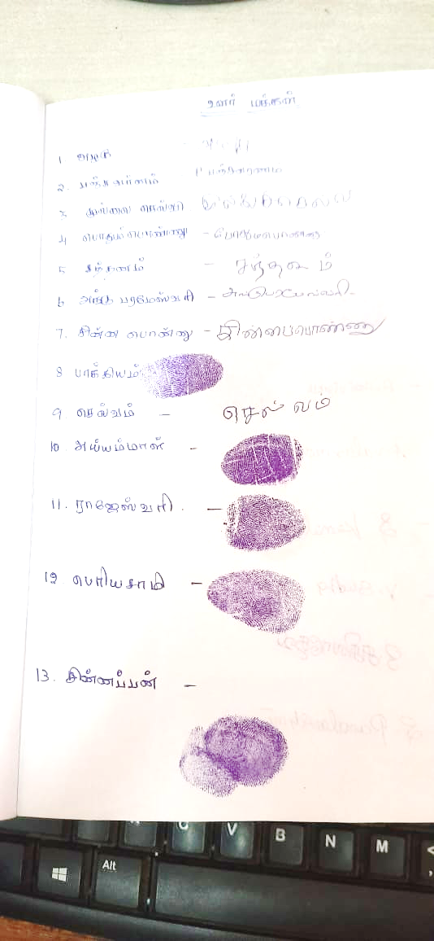

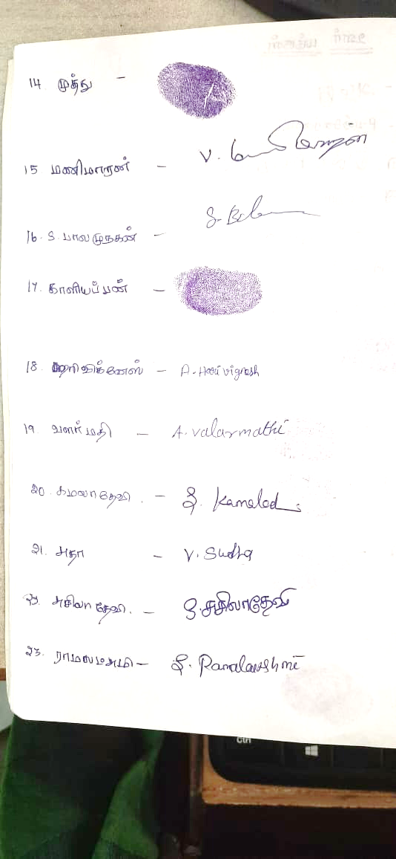

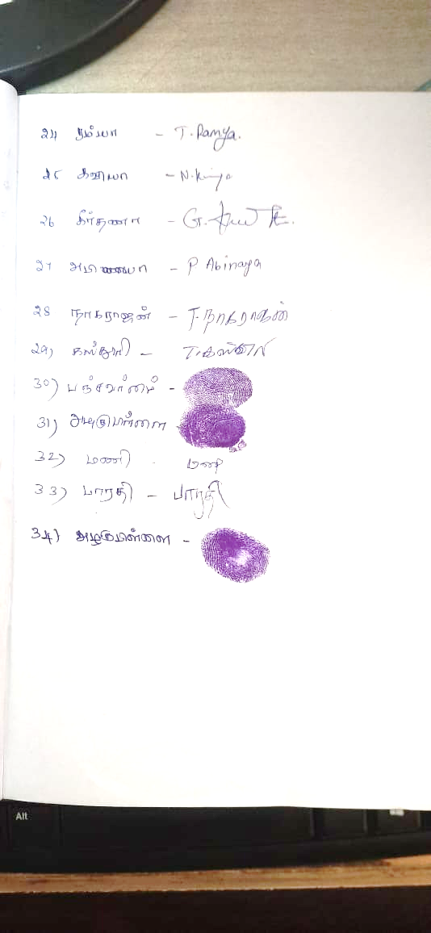

**NAME OF THE DEPARTMENT : COMPUTER SCIENCE**

**NAME OF THE VILLAGE : T.ANDIPATTI**

**NAME OF THE ACTIVITY : Awareness Program on Bursting Firecrackers**

**NAME OF THE STAFF : Dr. G. Rajathilagam**

**NO. OF STUDENTS PATICIPATED : 20**

**NO. OF BENEFICIARIES : 30**

**DATE : 15.10.2022**

**REPORT:**

In an attempt to ensure a pollution free and safe Diwali, on 15.10.2022, The Department of Computer Science(III B.Sc) students went to Andipatti village to create awareness on bursting crackers .We arrived the village at 2:00 pm from our college campus. When we entered the village, many villagers invited us traditionally and gladly.

Bursting of fireworks causes severe air and noise pollution which poses serious health hazards. The noise triggers annoyance, aggression, hypertension, high stress levels, hearing loss and sleep disturbance. Fireworks are mainly composed of toxic chemicals like lead, In olden days Diwali signified bringing of light and happiness around but presently burning of firecrackers is the highlight of Diwali and for most of the people, Diwali is just a synonym to a night full of crackers barium, chromium etc., and these chemicals and gases like carbon monoxide, nitrogen and Sulphur oxides are released during bursting of fireworks, which are harmful to humans, animals, plants and overall environment.

Our students gave a glimpse and explained the impact of bursting crackers through speech and skit and also distributed chocolates. The program was ended by 3:00 pm and we left with a unique experience and a good knowledge.

This experience was enthralling for us . This was totally a new way for us to create awareness to the villages around us ,and it was possible only through this extension trip. We created a lot of memories that will stay in our heart forever.

**Geo tagged photos with captions**

|  |  |
| --- | --- |
|  |  |
| **Our students performing skit about awareness on bursting crackers** | **Our students performing skit about awareness on bursting crackers** |
|  |  |
| **Our students performing skit about awareness on bursting crackers** | **Our students Awareness speech about adverse effects of bursting crackers** |
|  |  |
| **Our students Interaction with the villagers about adverse effects of bursting crackers** | **Our students speech about awareness on bursting crackers** |

**Students List with Reg. No.:**

|  |  |  |
| --- | --- | --- |
| **S.No.** | **Reg. No.** | **Name** |
| 1. | 2020B04 | Anni Judy Remina T |
| 2. | 2020B05 | Anto Abisha G |
| 3. | 2020B07 | Basti Monisha l |
| 4. | 2020B10 | Dharani.M |
| 5. | 2020B11 | Dharani Priya.S |
| 6. | 2020B13 | Janani Joel R |
| 7. | 2020B16 | Jeya Priya.T |
| 8. | 2020B17 | Jeya Sherlin A |
| 9. | 2020B18 | Kaleeswari.S. |
| 10. | 2020B19 | Khushi Chanda.M |
| 11. | 2020B20 | Logabarani.M |
| 12. | 2020B21 | Lyncia Rebek.P |
| 13. | 2020B22 | Madhumithaa.N |
| 14. | 2020B24 | Milancy J |
| 15. | 2020B26 | Muthusnekha.V |
| 16. | 2020B30 | Nandhini S |
| 17. | 2020B32 | Nethra Nandhi.NV |
| 18. | 2020B35 | Rishika Sree.RK |
| 19. | 2020B40 | Thasleema Parveen.S |
| 20. | 2020B41 | Vibil S |

**Sample Signatures of Beneficiaries:**

**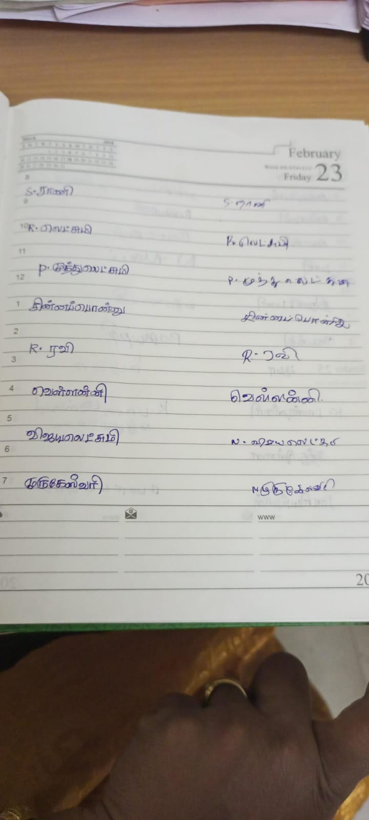**

**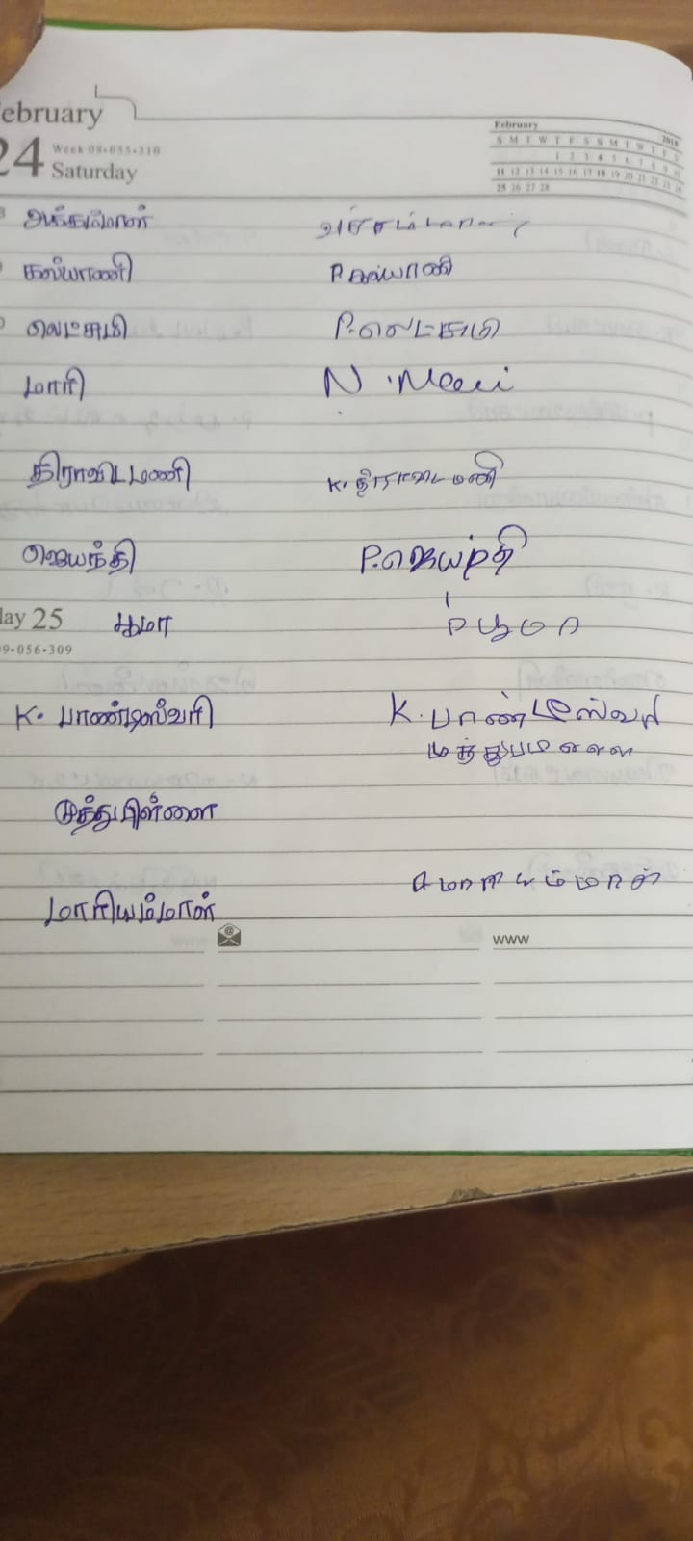**

**NAME OF THE DEPARTMENT : Home Science with Food Biotechnology**

**NAME OF THE VILLAGE : Thandalai**

**NAME OF THE ACTIVITY : Awareness activity-Say No to firecrackers and safety precautions to be followed while bursting crackers.**

**NAME OF THE STAFF :** [**DR. K. KARTHIGA**](https://fatimacollegemdu.org/ufiles/Profile/HomeScience/Dr.K.Karthiga.pdf)

**NO.OF.STUDENTS PARTICIPATED : 16**

**NO. OF.BENEFICIARIES : 55**

**DATE : 15.10.2022**

**REPORT:**

Fire crackers are usually burnt on occasions like festivals, marriages, birthday parties, and sports competitions to celebrate our happiness as part of our tradition. But the fact is that the burning of [firecrackers](https://letmebreathe.in/blog/2019/10/24/the-science-behind-air-pollution-and-bursting-of-fire-crackers/) comes at a steep cost to us that leads to environmental damage, health hazards to humans and animals through various forms of pollution. Fireworks create highly toxic gases and pollutants that poison the air, the water, and the soil, making them harmful to birds, wildlife, pets, livestock, and people. Keeping all these points in to consideration, III Undergraduate Home Science with Food Biotechnology students of Fatima college took out an anti-cracker rally in Thandalai village on 15.10.2022 to spread awareness among the village people to avoid bursting fire crackers and safety precautions to be followed while bursting crackers. Students spread out the message of minimising the use of crackers to celebrate the festival. They carried colourful placards and raised slogans like ‘Say no to crackers, yes to life’ and safety precautions to be followed while bursting crackers to cultivate a sense of responsibility towards society.

**GEOTAG PHOTOS WITH CAPTIONS:**

|  |  |
| --- | --- |
| IMG-20221015-WA0042.jpg | IMG-20221015-WA0029.jpg |
| **Students conducted Rally on the Theme ‘Say No to Firecrackers’** | |
| IMG-20221015-WA0036.jpg | IMG-20221015-WA0019.jpg |
| **Students spreading Awareness on Ill-effects of fire crackers** | |

**LIST OF STUDENTS:**

|  |  |  |
| --- | --- | --- |
| **S.No.** | **Reg.No.** | **Name of the Student** |
| 1. | 2020N05 | Brindha.R |
| 2. | 2020N06 | Divya Pooja.K |
| 3. | 2020N07 | Gowsalya.M |
| 4. | 2020N08 | Harini.R |
| 5. | 2020N09 | Hema Malini.M |
| 6. | 2020N11 | Jana priya.B |
| 7. | 2020N13 | Kavya.A |
| 8. | 2020N14 | Latha.M |
| 9. | 2020N19 | Nisha.S |
| 10. | 2020N23 | Rashiha.M |
| 11 | 2020N25 | Salma Zahan.A |
| 12. | 2020N26 | Samiha.S |
| 13. | 2020N27 | Saranya.M |
| 14. | 2020N28 | Saranya.M |
| 15. | 2020N30 | Shenbaga Malika.S |
| 16. | 2020N31 | Sherlin shilviya.A |

**SAMPLE SIGNATURES OF BENEFICIARIES**

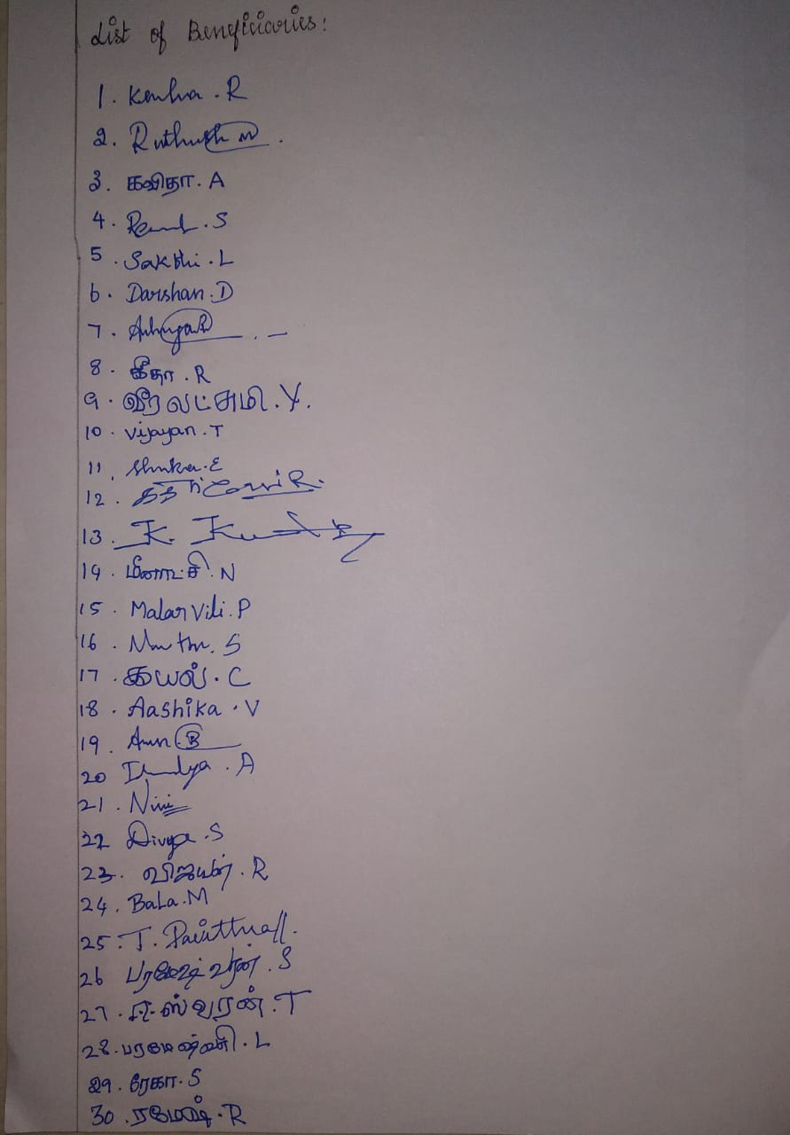

**NAME OF THE DEPARTMENT : BA ENGISH (SF)**

**NAME OF THE VILLAGE : C.PUDUR**

**NAME OF THE ACTIVITY : EXTENSION ACTIVITY**

**NAME OF THE STAFF : MRS.J.ANITHA**

**NO.OF STUDENTS PARTICIPATED : 33**

**NO.OF BENEFICIARIES : 15**

**DATE : 15.10.2022**

**REPORT**

III BA ENGLISH (SF) Department on 15.10.2022 (Saturday ) visited the village C.Pudur as part of Extension Service Programme .We started from college at 9.30 am and reached the village by 10.15 am.We,the students went on a rally, dictating the slogans that we prepared, regarding the awareness on how crackers pollute the air.Also through our slogans we made the people understand how crackers could harm the environment. Our college students have prepared charts based on that and taught them by actions.Our students participated actively.The villagechildreneagerly participated and enjoyed the session thoroughly. It was finally made as a good awareness session.

**GEO TAGGED PHOTOS WITH CAPTIONS**

|  |  |
| --- | --- |
|  |  |
| **Students’ rally to spread awareness on Fire crackers** | |

**List of Students with Reg no:**

|  |  |  |
| --- | --- | --- |
| **S.NO** | **REGISTER NO** | **NAME OF THE STUDENTS** |
| 1 | 2020LB02 | AKSHAYA.N |
| 2 | 2020LB03 | AMRITHA.D |
| 3 | 2020LB04 | ANGEL DEBORAH.V |
| 4 | 2020LB05 | ANGEL FATHIMA.S |
| 5 | 2020LB08 | BRINDHA.I |
| 6 | 2020LB11 | DHARSHINA SRI.R.D |
| 7 | 2020LB12 | DIVYADHARSHINI.M |
| 8 | 2020LB13 | DIVYADHARSHINI.M |
| 9 | 2020LB16 | GAYATHREE.S |
| 10 | 2020LB17 | HARINI.J |
| 11 | 2020LB18 | HARINI.K |
| 12 | 2020LB21 | JAYASRI.J |
| 13 | 2020LB23 | JEYA DURGESH.M |
| 14 | 2020LB25 | LAKSHMI PRIYA.V |
| 15 | 2020LB27 | MARAGATHAVALLI.R |
| 16 | 2020LB28 | MARIYAM BANU.I |
| 17 | 2020LB36 | NITHYASHREE.S |
| 18 | 2020LB37 | PRIYADHARASHINI.R |
| 19 | 2020LB38 | RAHAMATH MUBEENA.A |
| 20 | 2020LB39 | ROMILA BINU. S |
| 21 | 2020LB40 | RONI BEULAH.J |
| 22 | 2020LB41 | SIVASHATHI.G |
| 23 | 2020LB42 | SNEHA.M |
| 24 | 2020LB43 | SONIA MAHALAKSHMI.K |
| 25 | 2020LB45 | SRI HARINI.P.K |
| 26 | 2020LB46 | SRUTHIKA.K.J |
| 27 | 2020LB50 | SWATHY.N |
| 28 | 2020LB51 | SWETHA DEVI.J |
| 29 | 2020LB52 | SWETHA.S |
| 30 | 2020LB53 | THANGA KIRUTHIKA.M |
| 31 | 2020LB57 | UDHAYA SRI.S |
| 32 | 2020LB60 | VISHNU VARTHINI |
| 33 | 2020LB62 | JAYASHREE.R |

**NAME OF THE DEPARTMENT : B.A. Journalism and Mass Communication**

**NAME OF THE VILLAGE : C.PUDUR**

**NAME OF THE ACTIVITY : EXTENSION ACTIVITY**

**NAME OF THE STAFF : Ms. S. Archana**

**NO.OF STUDENTS PARTICIPATED : 28**

**NO.OF BENIFICIARIES : 30**

**DATE : 15.09.2022**

**REPORT:**

III BA students from the department of Journalism and Mass communication (SF) on 15.09.2022 (Saturday) visited the village C.Pudur as part of their Extension Service Activity. On this day students gave awareness about crackers, avoid pollutions through rally throughout the village. Apart from the rally, students gave some instruction about how to handle the crackers, how to avoid pollutions, and some useful tips to the children’. In the end students were interacted with children’s to know how the children’s are understand about the topics.

**Geo tagged photos with captions**

|  |
| --- |
|  |
| **Display of charts to spread awareness on Fire Crackers** |

|  |  |
| --- | --- |
|  |  |
| **Students going on Rally to spread awareness on Air Pollution due to Fire crackers** | |

**Students’ Name List:**

|  |  |  |
| --- | --- | --- |
| **S.No** | **Reg.No** | **Students Name** |
| 1 | 2020JM02 | B. ABIRAMI |
| 2 | 2020JM03 | M. ANITHA |
| 3 | 2020JM04 | R. ANUSHIYA SHERLY TERES |
| 4 | 2020JM05 | K. DEEPIKA |
| 5 | 2020JM06 | M. GAYATHRI |
| 6 | 2020JM07 | M. HALIMA HATHOON |
| 7 | 2020JM09 | M. HARINI |
| 8 | 2020JM010 | R.HARITHA |
| 9 | 2020JM011 | K.S. JANANI |
| 10 | 2020JM012 | P. JANANI |
| 11 | 2020JM013 | P. KALEESWARI |
| 12 | 2020JM014 | T. KANMANI |
| 13 | 2020JM016 | D. LEENA |
| 14 | 2020JM017 | B. MAHALAKSHMI |
| 15 | 2020JM018 | M. MAHARANI |
| 16 | 2020JM020 | D. MOSHINA |
| 17 | 2020JM016 | D. LEENA |
| 18 | 2020JM017 | B. MAHALAKSHMI |
| 19 | 2020JM018 | M. MAHARANI |
| 20 | 2020JM020 | D. MOSHINA |
| 21 | 2020JM016 | D. LEENA |
| 22 | 2020JM017 | B. MAHALAKSHMI |
| 23 | 2020JM018 | M. MAHARANI |
| 24 | 2020JM020 | D. MOSHINA |
| 25 | 2020JM031 | M. SURUTHI |
| 26 | 2020JM033 | M. TAMIL KANI |
| 27 | 2020JM034 | V. THAMARAI SELVI |
| 28 | 2020JM035 | J. VAISHALINI |

**NAME OF THE DEPARTMENT : BACHELOR OF COMMERCE (SF)**

**NAME OF THE VILLAGE : AYYANKOTTAI**

**NAME OF THE ACTIVITY : AWARNESS RALLY**

**NAME O F THE STAFF : 1) Mrs.M.FANNY**

**2)Mrs.C.JOSELYN NITHYA**

**NO. OF STUDENTS PARTICIPATED : 28**

**NO. OF BENEFICIARIES : 30**

**DATE : 15/10/2022**

**REPORT :**

**1. Students form a group to spread awareness about ways to celebrate Diwali in an eco friendly manner.**

**2. Awareness about firing the crackers were created among the children.**

**3. Feedback collected from villagers**

**Geo tag photos with photo caption:**

|  |  |
| --- | --- |
|  |  |
| **Awareness rally was created at village about firing crackers** | |
|  | |
| **Instructions given to children's about firing the crackers safely** | |

|  |  |
| --- | --- |
|  |  |
|  | |
| **Getting Feedback from the public** | |

**List of students with Reg.No :**

|  |  |  |
| --- | --- | --- |
| S.NO | REGISTER NUMBER | NAMES |
| 1 | 2020AC01 | |  | | --- | | Ajeetha . A | |
| 2 | 2020AC04 | |  | | --- | | Amala Reeta . K | |
| 3 | 2020AC05 | |  | | --- | | Amsa . R | |
| 4 | 2020AC07 | |  | | --- | | Ananthi . V | |
| 5 | 2020AC08 | |  | | --- | | Anjali . M | |
| 6 | 2020AC09 | |  | | --- | | Antony Princy. A | |
| 7 | 2020AC10 | |  | | --- | | Bharathipriya. S | |
| 8 | 2020AC11 | |  | | --- | | Cathrin Mary . S | |
| 9 | 2020AC12 | |  | | --- | | Dhurgaselvi . S | |
| 10 | 2020AC15 | |  | | --- | | Harini . S | |
| 11 | 2020AC17 | |  | | --- | | Jaba Nibisha. P | |
| 12 | 2020AC20 | |  | | --- | | Keerthana . R | |
| 13 | 2020AC24 | |  | | --- | | Mahasivasakthi . L | |
| 14 | 2020AC25 | |  | | --- | | Manisha . R | |
| 15 | 2020AC27 | |  | | --- | | Maris Swetha . G | |
| 16 | 2020AC22 | Lakshmi Narasu.R |
| 17 | 2020AC32 | |  | | --- | | Pavithra .I | |
| 18 | 2020AC33 | |  | | --- | | Poorani.R | |
| 19 | 2020AC34 | |  | | --- | | Priyadharshini.S | |
| 20 | 2020AC35 | |  | | --- | | Puvanamahadevi .R | |
| 21 | 2020AC39 | |  | | --- | | Roshini .M .B | |
| 22 | 2020AC45 | |  | | --- | | Siberla . C | |
| 23 | 2020AC46 | |  | | --- | | Sowmiya .M | |
| 24 | 2020AC52 | |  | | --- | | Swetha .R | |
| 25 | 2020AC55 | |  | | --- | | Thavasakthi . P | |
| 26 | 2020AC58 | |  | | --- | | Vasima Banu .S | |
| 27 | 2020AC62 | |  | | --- | | Vaishnavi . V | |
| 28 | 2020AC63 | Saruprabha. R |

**List of Beneficiaries:**

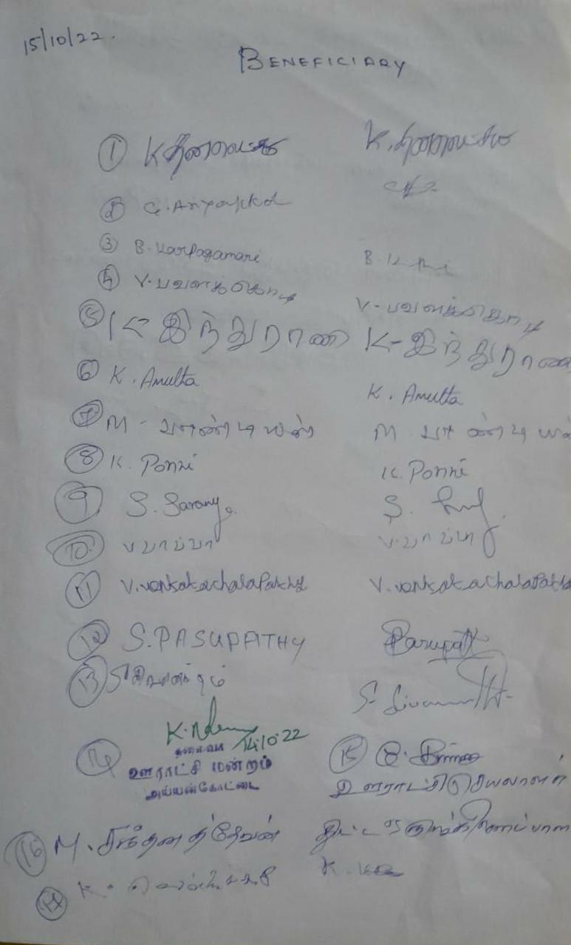

**NAME OF THE DEPARTMENT : Information Technology**

**NAME OF THE VILLAGE : MANIYANJI**

**NAME OF THE ACTIVITY : Software and Mobile App training**

**NAME O F THE STAFF : Mrs. T. Charanya Nagammal**

**NO. OF STUDENTS PATICIPATED : 43**

**NO. OF BENEFICIARIES : 20**

**DATE : 15.10.2022**

**REPORT**

On 15th October 2022, 43 students of 3rd B.Sc. INFORMATION TECHNOLOGY of FATIMA COLLEGE visited the village MANIYANJI, which is nearly about 18kms away from our college. The students of IT started their journey with proper plans and assignment of different tasks to each of 5 groups.

After reaching the village, the groups separated into different regions of the village. They taught applications like Speed Dial, Online Ration stock details, Language Translation and Google Voice Search for elders and word, paint and mind game apps for children in the village. Students gave a demonstration of mail id creation to the villagers. They train them with the basics of the android applications and the online websites such as shopping, gas booking, and Aadhaar correction and so on. Students gave an introduction about social media platforms like YouTube and applications that are helpful for their studies. They gave awareness about the boon of gadgets to the villagers. Villagers from Maniyanji welcomed the students in a wise manner and interacted with them.

**OUTCOME**

The villagers showed much eager in learning new things from our students. They gave a nice send off to the students with a satisfied feel of learning new technologies in day-to-day life. Our students also came out with a satisfaction of sharing their knowledge with the innocent people.

**GEO TAG Photos With Caption**

|  |  |
| --- | --- |
|  |  |
| **Students are educating the villagers about the true caller application in their mobile phone.** | **Students are educating Villagers about Mail Id creations for official use.** |
|  |  |
| **Students are educating about MS Word and Brain Games For Young Children to Develop Themselves** | **Students are educating the villagers about Language Translation and Google Voice search** |

|  |
| --- |
|  |
| **Students are educating the villagers about Kavalan App and MS paint** |
|  |
| **Our Students At Maniyanji Village For Extension** |

|  |  |
| --- | --- |
|  |  |
|  | |
| **Beneficiaries in Maniyanji with their Signature** | |
|  | |
| **Feedback from Villagers** | |

**List of students with Reg.No.**

|  |  |  |
| --- | --- | --- |
| **S. NO.** | **Reg. No.** | **Student Name** |
|  | 2020IT01 | AARTHI M |
|  | 2020IT02 | AKANTHIYA E |
|  | 2020IT03 | ASHA R |
|  | 2020IT04 | EBINESA R |
|  | 2020IT05 | FATHIMA NOOR NISHA G |
|  | 2020IT06 | GOKILA R |
|  | 2020IT07 | HARSHA B |
|  | 2020IT08 | HARSSHINE B |
|  | 2020IT09 | JANANI MAHALAKSHMI A |
|  | 2020IT10 | JANNATHUL FIRTHOUS G |
|  | 2020IT11 | KALARANJANI K |
|  | 2020IT12 | KAVI PRIYA M |
|  | 2020IT13 | KAVIYA G |
|  | 2020IT14 | KEERTHANA K |
|  | 2020IT15 | LEENASHREE B |
|  | 2020IT16 | LOGAVARSHA N |
|  | 2020IT17 | MEKALA S |
|  | 2020IT18 | MOHANA PRIYA K |
|  | 2020IT19 | NANDHINI T |
|  | 2020IT20 | NIDARSHINI P V |
|  | 2020IT21 | NIRANJANA DEVI K S |
|  | 2020IT22 | NISHANTHINI S |
|  | 2020IT24 | NITHYAA SREE KV |
|  | 2020IT25 | NIVETHA C S P |
|  | 2020IT26 | NIVETHA R |
|  | 2020IT27 | PREETHI S |
|  | 2020IT28 | RATHIKA S |
|  | 2020IT29 | RITHIGA DEVI S |
|  | 2020IT30 | SAMEEM BANU A |
|  | 2020IT31 | SANMATHI T |
|  | 2020IT32 | SHALINI NITHARSANA D |
|  | 2020IT33 | SOWMIYA S |
|  | 2020IT34 | SRIVARSHINI J |
|  | 2020IT36 | SWATHI ALIAS RAJALAKSHMI G |
|  | 2020IT37 | SWATHI P |
|  | 2020IT38 | KOUSALYA T B |
|  | 2020IT39 | THILAGAVATHI T |
|  | 2020IT40 | VISWA LAKSHMI JEEVA G |
|  | 2020IT41 | YAALHARINI M U |
|  | 2020IT43 | JENIFER S |
|  | 2020IT44 | SWEATHA R |
|  | 2020IT45 | VEDHIKA S |
|  | 2020IT46 | LAKSHMISHREE S |

**List of beneficiaries:**

|  |  |
| --- | --- |
| **S. NO.** | **Villagers Name** |
|  | D. MANJULA |
|  | T. BHAKYASRI |
|  | R. DHARSHINI |
|  | K. IYAMMAL |
|  | K. THIRUVAN |
|  | M. MEENAMBAL |
|  | R. SHANMUGAVALLI |
|  | B. MANJU |
|  | S. NIRMALA |
|  | R. RAVI |
|  | SURIAGANDHI |
|  | VALLI |
|  | S. SARASWATHY |
|  | S. YOGA LAKSHMI |
|  | N. NAFARANI |
|  | R. MONISHA |
|  | A. HARISHINBA |
|  | A. KAVYA ARCHANA |
|  | B. VANMATHI |
|  | RAKAYE |

**NAME OF THE DEPARTMENT : MATHEMATICS (SF)**

**NAME OF THE VILLAGE : THANICHIYAM**

**NAME OF THE ACTIVITY : RALLY - SAFETY MEASURES WHILE FIRING CRAKERS**

**NAME OF THE STAFF : 1. Ms.P.Dhanapriya(Assistant Professor) –Statistics**

**2. Ms. Dr. M. Subha (Assistant Professor) – Mathematics**

**3. Ms. M. Vimala Suganthi (Assistant Professor) - Mathematics**

**NO. OF STUDENTS PATICIPATED : 54**

**NO. OF BENEFICIARIES : 19**

**DATE : 15.10.2022**

**REPORT:**

On 15.10.2022 the students of Mathematics and Statistics went a rally for creating an awareness on “ safety measures while bursting crackers” students were chanting suitable slogans during the rally and created awareness on this.

**Geo tag photos with photo caption:**

**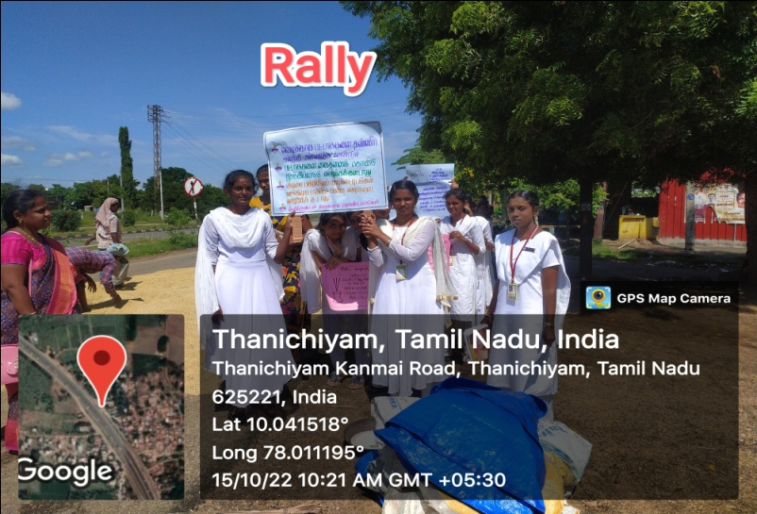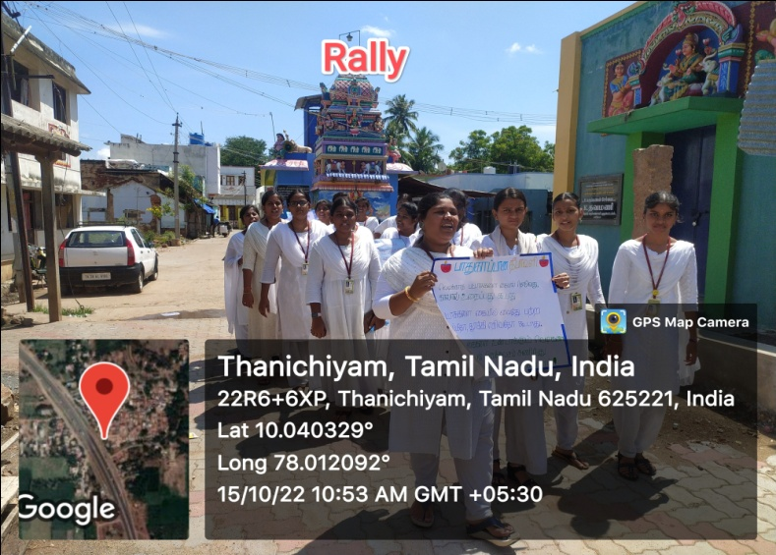**

**List of students with Reg.No.**

|  |  |  |
| --- | --- | --- |
| **S.No** | **Reg.No** | **Name** |
|  | 2020MB02 | ANANTHIKA.A |
|  | 2020MB03 | AZHAGURANI.P |
|  | 2020MB20 | KIRIJHA.P.S |
|  | 2020MB29 | PRITHIGA.M |
|  | 2020MB30 | SAJITHA.A |
|  | 2020MB33 | SATHYA.S |
|  | 2020MB34 | SATHYASHEELA T. |
|  | 2020MB35 | SHOBANA.S |
|  | 2020MB37 | SWATHI.R |
|  | 2020MB39 | VISHVAJANANI.G |
|  | 2020MB40 | YOGASREE.K |
|  | 2020MB41 | YONISHA.J |
|  | 2020MB42 | SANGEETHA.A |
|  | 2020MB43 | JEYASHRI.R |
|  | 2020MB44 | VEERACHINNAMMAL.V |
|  | 2020MB45 | JANANI SOWMIYA.R |
|  | 2020MB46 | RAMYA.G V |
|  | 2020MB49 | NAGALAKSHMI.S |
|  | 2020MB77 | POORANI.R |
|  | 2020MB78 | PRAVAHENI.M |
|  | 2020MB79 | RAAGASHWATHI.S |
|  | 2020MB80 | RAGHAVI.R |
|  | 2020MB81 | RAJA RAJESHWARI.B |
|  | 2020MB82 | SANDHIYA.P |
|  | 2020MB83 | SHALINI.B.V |
|  | 2020MB84 | SHANMUGAPRIYA.M |
|  | 2020MB85 | SIVANANTHINI.V |
|  | 2020MB86 | SIVARANJANI.R |
|  | 2020MB87 | SONIGA.R |
|  | 2020MB88 | SREE LAKSHMI.R |
|  | 2020MB89 | SUBUHANIYA.M |
|  | 2020MB90 | SUVEETHA.R |
|  | 2020MB91 | SWETHA.M |
|  | 2020MB93 | VAIRAMEENA.V |
|  | 2020MB95 | VINUPRIYA.A |
|  | 2020MB96 | YAMINI KARTHISWARI.K |
|  | 2020MB97 | YOGALAKSHMI.A |
|  | 2020MB98 | SWETHA.K |
|  | 2020MB99 | SUSHMA.M |
|  | 2020ST01 | K.S AKSHAYA |
|  | 2020ST02 | AROCKIA SWETHA.T |
|  | 2020ST03 | AROKIA MERVIN JOY.M |
|  | 2020ST05 | V.DEEPTI |
|  | 2020ST06 | B.GOKILAVANI |
|  | 2020ST08 | KEERTHANA.L |
|  | 2020ST10 | MARIA BENISTA.G |
|  | 2020ST12 | SANGEETHAPRIYA.L |
|  | 2020ST13 | SHAMITHA.P |
|  | 2020ST14 | SWETHA.K |
|  | 2020ST15 | SWETHA.M |
|  | 2020ST16 | UDHAYASRI.M |
|  | 2020ST18 | VEGITHA SAI.T |
|  | 2020ST19 | ISHWARYA.P |
|  | 2017ST21 | LATHA.K |

**List of beneficiaries:**

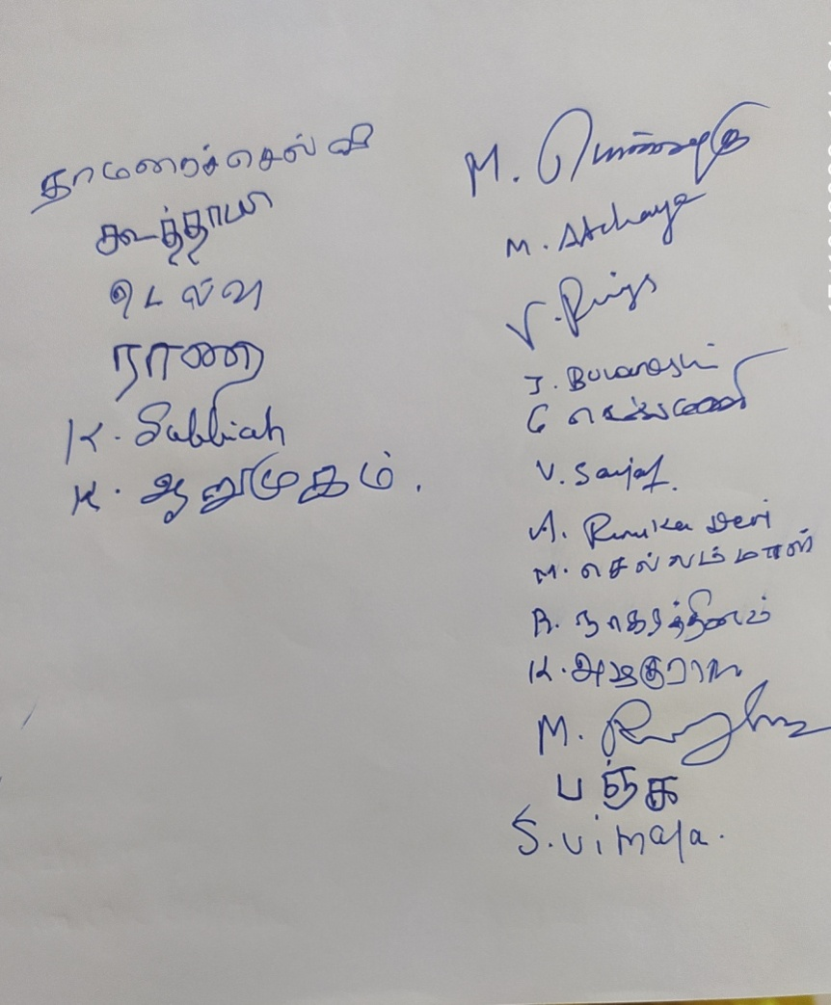

**NAME OF THE DEPARTMENT : BACHELOR OF BUSINESS**

**ADMINISTRATION**

**NAME OF THE VILLAGE : KATTAKULAM**

**NAME OF THE ACTIVITY : DIWALI AWARNESS CAMPAIGN**

**NAME OF THE STAFF : Mrs. SUKASINI**

**NO. OF STUDENTS PARTICIPATED : 31**

**NO. OF BENEFICIARIES : 30**

**DATE : 15-10- 2022**

**REPORT:**

**Campaign at Village**

1. An speech about why Diwali is celebrated was addressed to children
2. Awareness Campaign Created to Students on various topic :
   1. Firecrackers
   2. Noise and smoke pollution
   3. Clothing ( avoid synthetic clothing)
3. Drama session was organised to children
4. Pamphlet were distributed among the children

**Geo tag photos with photo caption :**

|  |
| --- |
|  |
| **Introduction Speech was given to children about why Diwali is celebrated** |

|  |
| --- |
|  |
| **Distribution of Pamphlets on Awareness on Fire crackers** |
|  |
| **Drama performed to spread awareness about Air Pollution** |
|  |
| **Instruction about safety precaution to be taken while bursting crackers** |

**List of students with Reg.No:**

|  |  |  |
| --- | --- | --- |
| **S.NO** | **REGISTER NO** | **NAME** |
| 1. | 2020BB01 | Arthi.C |
| 2. | 2020BB02 | Abinayashree.S |
| 3. | 2020BB03 | Afrose banu.S |
| 4. | 2020BB14 | Jeba josphine anitha |
| 5. | 2020BB15 | Joseda.V |
| 6. | 2020BB21 | Kaviya.K |
| 7. | 2020BB22 | Kavya.K |
| 8. | 2020BB33 | Pavithra.R |
| 9. | 2020BB34 | Pooja.B |
| 10. | 2020BB36 | Rabiya bashree |
| 11. | 2020BB37 | Radhiga.C |
| 12. | 2020BB38 | Rakku.N |
| 13. | 2020BB42 | Rooba sri.N |
| 14. | 2020BB43 | Roshini shaikh |
| 15. | 2020BB44 | Rubasri.N |
| 16. | 2020BB46 | Samina begam |
| 17. | 2020BB47 | Sankavi.M |
| 18. | 2020BB52 | Shiva dharshini.M |
| 19. | 2020BB53 | Shree shobini.B |
| 20. | 2020BB55 | Sivaranjani.M |
| 21. | 2020BB57 | Sree ranjani.R |
| 22. | 2020BB58 | Sri priya.S |
| 23. | 2020BB59 | Subha shree.B |
| 24. | 2020BB60 | Suruthi.S |
| 25. | 2020BB63 | Tanushrii raj |
| 26. | 2020BB67 | Vaishnave.R |
| 27. | 2020BB69 | Vanitha.K |
| 28. | 2020BB70 | Yaveneka shree.B |
| 29. | 2020BB71 | Jessica.A |
| 30. | 2019BB24 | Jeevitha Lakshmi.G |
| 31. | 2020BB23 | Kavya sri.K |

**NAME OF THE DEPARTMENT : COMMERCE WITH COMPUTER APPLICATIONS**

**DATE : 15.10.2022**

**NAME OF THE VILLAGE : AYYANKOTTAI, VADIPATTI**

**NAME OF THE ACTIVITY : CREATING AWARENESS ABOUT SAFE DIWALI**

**NO. OF STUDENTS PARTICIPATED : 22(TWENTY TWO)**

**NO. OF BENEFICIARIES : 87**

**REPORT:**

From the department of Commerce with computer applications and bachelor of commerce (SF) planned to go for an extension to Ayyankottai village on 15th October 2022.

In that village we have planned to create awareness about “Safe Diwali” by doing rally. Because many people don’t aware of the safety measures about crackers and about pollution especially in rural areas.

As per our plan, we reached Ayyankottai village at 10:00 AM. After reachingthe village, both B.COM (CA) and B.COM (SF) were separated and we do rally on the one side of the village mainly in high way side and they did rally on the other side of the village. And the Ayyankottai village president directs us to do rally on the village.

We explain briefly about the safety measures while blasting the crackers to the village people. Another group of students explained the importance of blasting crackers and how to burst the crackers safely and securely.

**Geo tagged photos with captions**

|  |  |
| --- | --- |
| IMG-20221015-WA0017.jpg | IMG-20221015-WA0032.jpg |
| **Rally on Importance of Avoiding crackers** | |
| IMG-20221015-WA0025.jpg | IMG-20221015-WA0019.jpg |
| **Rally on Air Pollution due to firing crackers** | |

|  |  |
| --- | --- |
| IMG-20221015-WA0035.jpg | IMG-20221015-WA0068.jpg |
| **Spreading awareness about Avoiding Fire crackers** | |
| IMG-20221015-WA0054.jpg | 20221015_100446AMByGPSMapCamera.jpg |
| **Students with the villagers** | **Getting Feedback from the villagers** |

**SIGNATURE OF BENEFICIARIES:**

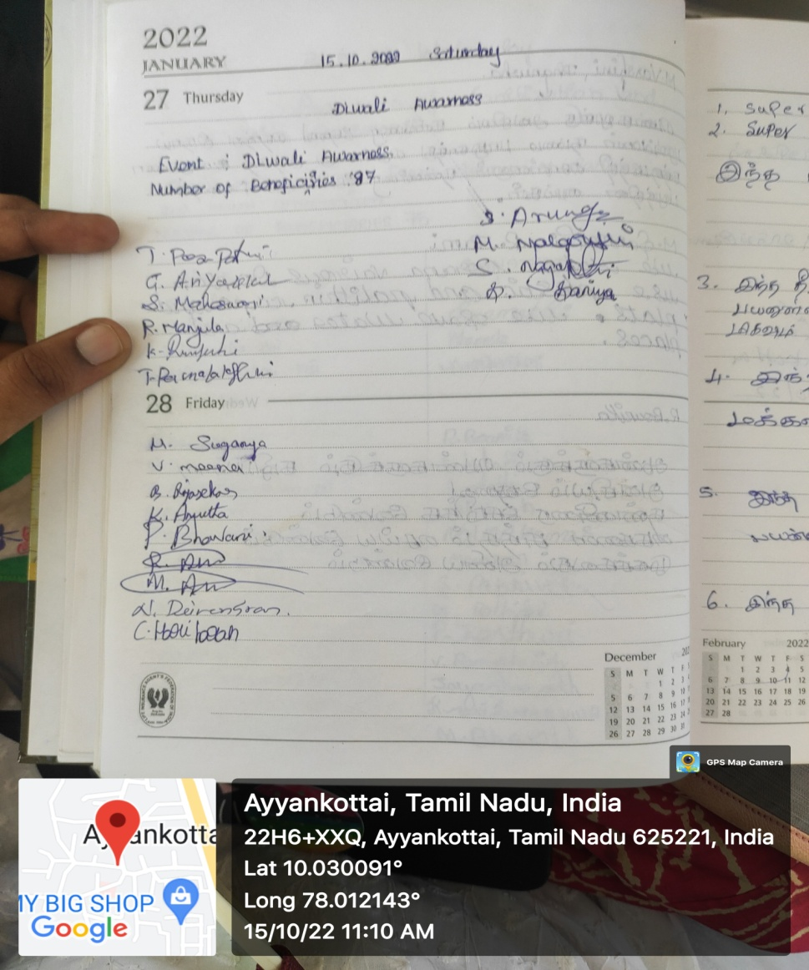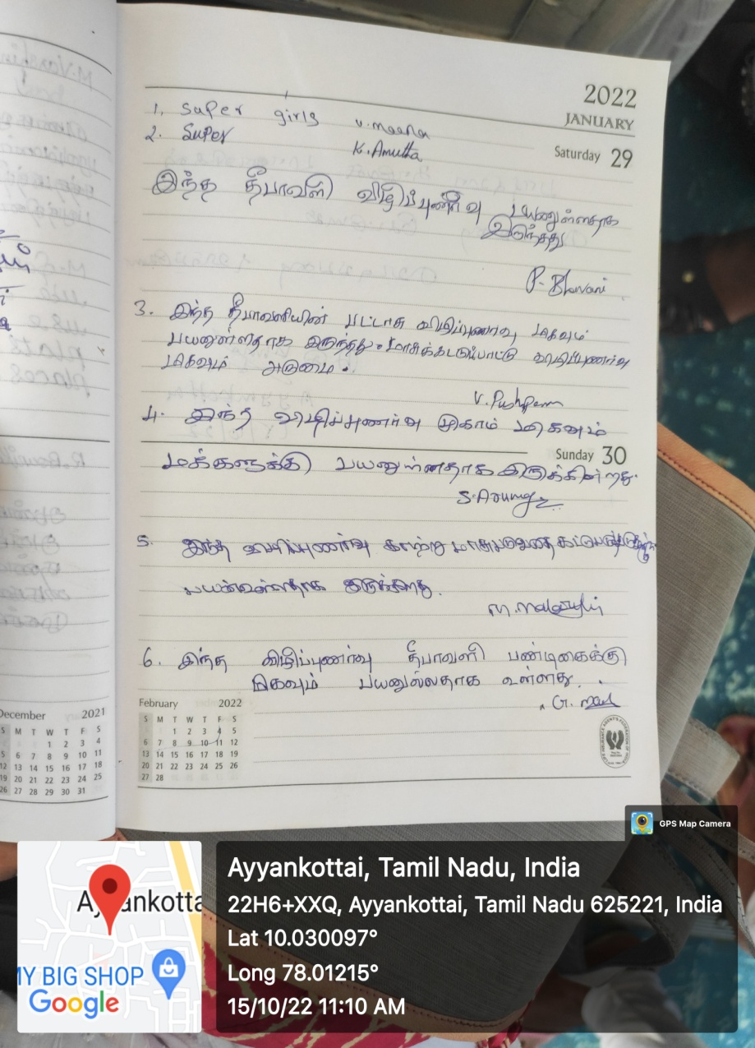

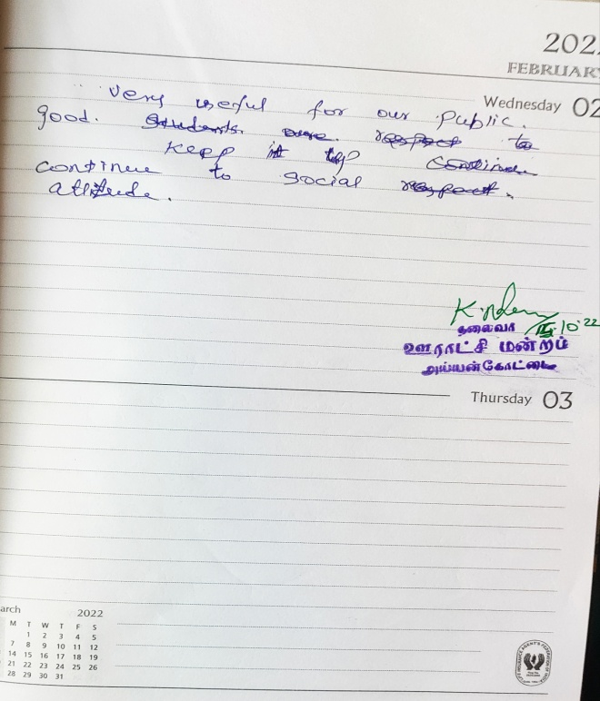

**Students Name List with Reg. No.:**

|  |  |  |
| --- | --- | --- |
| **S. No.** | **REGISTER NO** | **NAME** |
|  | 2020AB04 | ANUVARHTINI.M |
|  | 2020AB06 | DEEPIKA.S |
|  | 2020AB07 | DHANUSSRI.B |
|  | 2020AB08 | EMIMA.S |
|  | 2020AB10 | HARSHINI.F.K. |
|  | 2020AB13 | JEYALAKSHMI.C |
|  | 2020AB18 | KIRUTHIHA.R |
|  | 2020AB19 | JEYA KARPAGA SUNDARI.K.V. |
|  | 2020AB22 | MEGA.M |
|  | 2020AB23 | MEYYAMMAI.M |
|  | 2020AB26 | NANSIROOPINA.S |
|  | 2020AB30 | PANDIAMMAL.V |
|  | 2020AB31 | RAHMATH FEMINA.B |
|  | 2020AB34 | SOBIYA.M |
|  | 2020AB35 | SOORIYA JENIFER.K |
|  | 2020AB36 | SATNIS SHERIN.D |
|  | 2020AB37 | SUBA LAKSHMI.M |
|  | 2020AB38 | SUMATHI.M |
|  | 2020AB40 | TERRANCE DEEPKA.A |
|  | 2020AB42 | THENDRAL.S |
|  | 2020AB43 | THENMOZHI.N |
|  | 2020AB44 | VIDHYA SHREE.M |

**NAME OF THE DEPARTMENT : COMPUTER APPLICATIONS (BCA)**

**NAME OF THE VILLAGE : Thiruvedagam**

**NAME OF THE ACTIVITY : Awareness to avoid crackers on Diwali and World**

**Students Day Celebration**

**NAME OF THE STAFF : Mrs.Ramya R**

**NO. OF STUDENTS PARTICIPATED: 39**

**NO. OF BENEFICIARIES : 16**

**DATE : 15-10-2022**

**REPORT :**

We the department of Computer Applications has gone to visit the village Thiruvedagam, which is about 20 kilometre away from our Fatima college for the extension activity with a group of 39 members out of 44 III year BCA students on 15th October, 2022 under the Supervision of Mrs.R.Ramya , Assistant Professor, Department of Computer Applications, Fatima College.

The activity related to **“Awareness to avoid crackers on Diwali”** was organized on September 21, 2022. Students all divided themselves into groups .One group of Students went for the rally with the boards saying to avoid burst crackers to protect the nature and gave awareness to the people to avoid crackers for the and how to take safety measures while using crackers for the people who wanted to burst crackers and they advised the people out there to follow the timing that the government mentioned for bursting crackers and the other group went and gathered the childrens and conducted games as 15/10/2022 is a **“World Students day”** and gave prize to the winners.

**GEO TAGGED PHOTOS WITH CAPTIONS:**

|  |  |
| --- | --- |
| **C:\Users\Gokul\Downloads\WhatsApp Image 2022-10-16 at 10.16.55 AM.jpeg** | **C:\Users\Gokul\Downloads\WhatsApp Image 2022-10-16 at 10.16.53 AM.jpeg** |
| **Rally on Avoiding crackers on Diwali** | |
| **C:\Users\Gokul\Downloads\WhatsApp Image 2022-10-16 at 10.35.10 AM.jpeg** | **C:\Users\Gokul\Downloads\WhatsApp Image 2022-10-16 at 10.35.09 AM.jpeg** |
| **Conducting games regarding “World Childrens Day”** | |

**LIST OF STUDENTS WITH REGISTER NUMBER:**

| **SNO** | **REGISTER NO.** | **NAME** |
| --- | --- | --- |
| 1 | 2020BC01 | J.ABITHA |
| 2 | 2020BC02 | R.AMBIGAI |
| 3 | 2020BC03 | R.ANUSUYA |
| 4 | 2020BC04 | S.ATCHAYA |
| 5 | 2020BC05 | D.DHANASUBRAJA |
| 6 | 2020BC06 | N.DHANUSHYA |

| 7 | 2020BC07 | N.DHARSHINI |
| --- | --- | --- |
| 8 | 2020BC09 | J.FATIMA SOWMIYA |
| 9 | 2020BC11 | N.GOWRI KARTHIKA |
| 10 | 2020BC12 | V.HANCY SHAMINI |

| 11 | 2020BC13 | M.HARITHA |
| --- | --- | --- |
| 12 | 2020BC14 | G .HASINI |
| 13 | 2020BC15 | H.HEMA |
| 14 | 2020BC16 | V.JANANI |
| 15 | 2020BC17 | A.JASMINE SUSMITHA |
| 16 | 2020BC18 | R.K JAYA JASHWANTHINI |
| 17 | 2020BC19 | M.JOTHI KEERTHANA SRI |
| 18 | 2020BC20 | J.KEERTHANA |
| 19 | 2020BC21 | K.V.P MAHALAKSHMI |
| 20 | 2020BC23 | S.NANTHINI |
| 21 | 2020BC24 | M.NIVETHA |

| 22 | 2020BC25 | J.PRATHICKSHA |
| --- | --- | --- |
| 23 | 2020BC26 | B.PRIYADHARSHINI |
| 24 | 2020BC27 | V.PRIYADHARSHINI |
| 25 | 2020BC28 | R.ROCH ABISHA |
| 26 | 2020BC31 | S.SRIMATHI AISHWARYA |
| 27 | 2020BC32 | G.SIVASORNA |
| 28 | 2020BC33 | S.SIVA VARSHINI |
| 29 | 2020BC34 | R.SNEHA |
| 30 | 2020BC35 | G.SWATHI |
| 32 | 2020BC36 | M.SWATHI |
| 33 | 2020BC37 | J.SWEETY |
| 34 | 2020BC39 | R.THARSHINI |
| 35 | 2020BC40 | S.TRISHALI |
| 36 | 2020BC41 | P.VAISHNAVI |
| 37 | 2020BC42 | T.VAISHNU |
| 38 | 2020BC43 | K.K VIGASHINI |

| 39 | 2020BC44 | A.R.YUVANIKA |
| --- | --- | --- |

**BENEFICIARIES LIST:**

|  |  |
| --- | --- |
| **S. No.** | **Name** |
|  | AKSHITHA |
|  | GOPAL |
|  | KATHIR |
|  | JAYA |
|  | MAHALAKSHMI |
|  | ANBU |
|  | ARASAMMAL |
|  | POOJITHA |
|  | KARUNAGARAN |
|  | KUMARAVEL |
|  | MUTHULAKSHMI |
|  | MONIKA |
|  | THARANI |
|  | KANIMOZHI |
|  | PRABHAKARAN |
|  | SAICHARAN |