**5. Beyond the Campus Environmental Promotional Activities**

**Year: 2022 – 2023**

**PROGRAMME 1 organized by NSS**

Name of the Programme : Swachhta Pakhwada– Video Making

Date of the Programme : 28.08.2022

Beneficiaries : 31 (Students of Fatima College)

Highlights of the Programme:

* The NSS volunteers presented videos on clean environment.
* The impact of global warming and pollution were emphasized.
* The videos were posted in WhatsApp status and Instagram
* The benefits of having a clean environment without plastics were highlighted.

Outcome of the Programme:

* To spread awareness on the importance of cleanliness in reducing the risk of diseases in the community.

**PHOTOS - depicting the WHATSAPP status of students featuring the videos made by them**

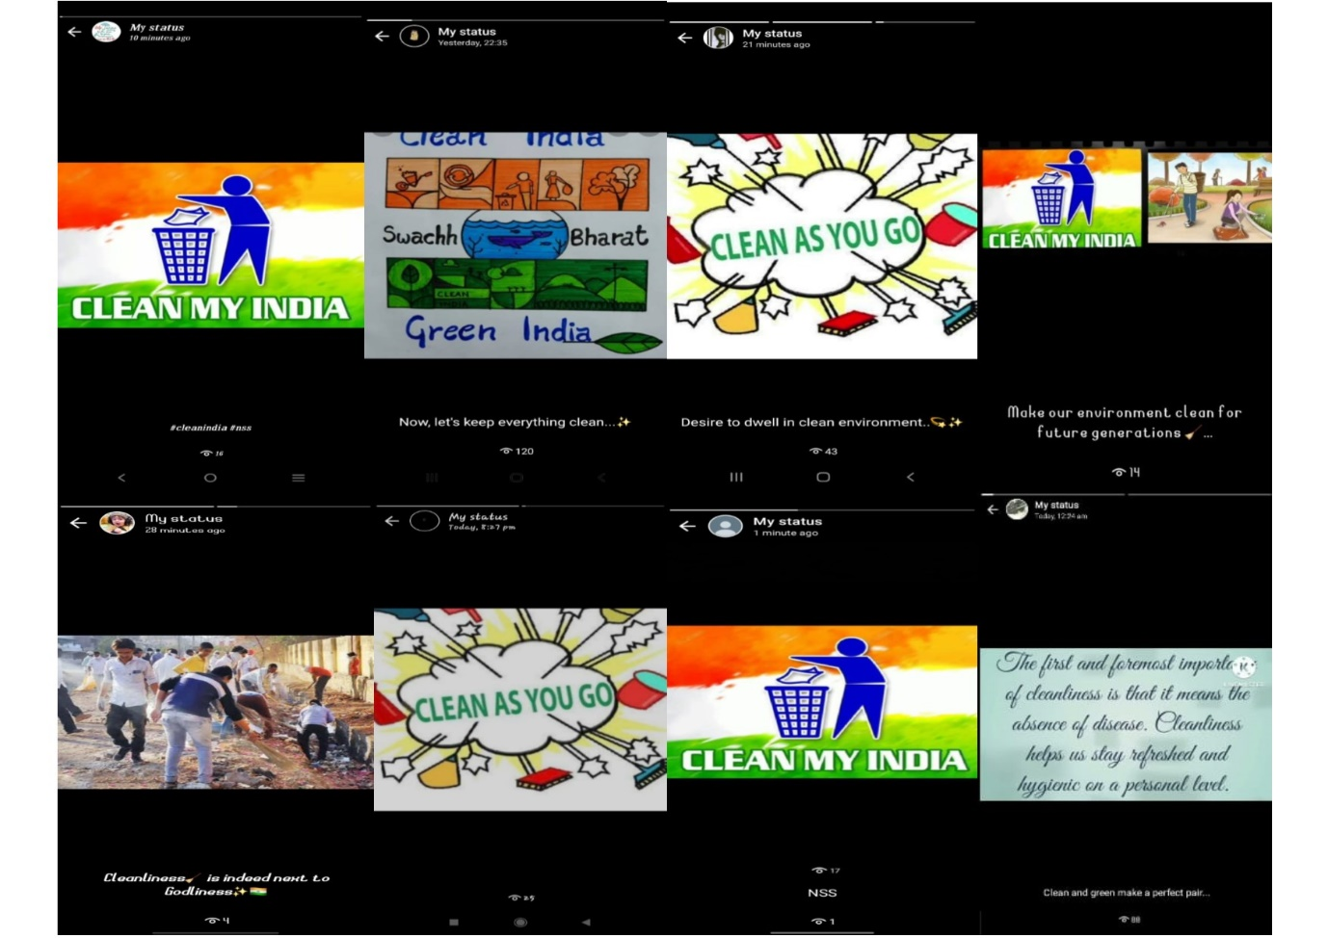

**Link for the Videos:**

1. <https://www.instagram.com/reel/Ch97SUiDyQO/?igshid=YmMyMTA2M2Y>=
2. <https://www.instagram.com/reel/Ch97yOwjhI4/?igshid=YmMyMTA2M2Y>=
3. <https://www.instagram.com/reel/Ch9782hDP2F/?igshid=YmMyMTA2M2Y>=
4. <https://www.instagram.com/reel/Ch98Ig5DuS-/?igshid=YmMyMTA2M2Y>=

**PARTICIPANTS**

|  |  |  |
| --- | --- | --- |
| **S.NO.** | **REG. NO.** | **NAME** |
| 1 | 2021L02 | ABHIRAMI.S |
| 2 | 2021L03 | K.AKFEYA JEBIN |
| 3 | 2021L07 | S.AYESHA |
| 4 | 2021L08 | M. M. BARGAVI |
| 5 | 2021L16 | HELIN MALAR.A |
| 6 | 2021L17 | HEMA PRIYA S |
| 7 | 2021L19 | A.JANE ROSE PAULINE |
| 8 | 2021L20 | JAYA DHARSHENI. T |
| 9 | 2021L21 | V.JEEVITHA |
| 10 | 2021L22 | A.JEFFRIN JUSTICE MARIYA |
| 11 | 2021L23 | A. JENCY ALEXIA |
| 12 | 2021L25 | A. MARIYA VARSHNI |
| 13 | 2021L26 | G.R.MEGALA |
| 14 | 2021L31 | RACHEL. S |
| 15 | 2021L34 | SAHAYA BABILA ROSE.R |
| 16 | 2021L35 | SAHAYA RANI.A |
| 17 | 2021L36 | SAHAYA ROMILDA. C |
| 18 | 2021L38 | T.SELVA INISHA |
| 19 | 2021L42 | SOWMIYA LAKSHMI.P |
| 20 | 2021L43 | S.SRILATHA |
| 21 | 2021L45 | G.VAISHNAVI |
| 22 | 2021L46 | P. M. VAISHNAVI |
| 23 | 2021L49 | S. YAZHINI TERASA |
| 24 | 2021L50 | CHITRA DEVI @ JANANI.J |
| 25 | 2021L51 | S.DEEPA LAKSHMI |
| 26 | 2021L54 | A. PETHA PRAMILA |
| 27 | 2021L55 | SILAMBU SELVI K |
| 28 | 2021L57 | R.BOOMIKA |
| 29 | 2021L58 | S.KARTHIGAYINI |
| 30 | 2021L60 | J.ANANTHI |
| 31 | 2021L62 | ABIRAMI.T.S |

**PROGRAMME 2 organized by NSS**

Name of the Programme : Awareness on Plastic free & Green environment

Date of the Programme : 01.09.2022

Beneficiaries : 30 (UG Students of Fatima College)

Highlights of the Programme:

* As part of **Swachhata Pakhwada** activity, an initiative was taken by NSS volunteers to spread awareness about BAN ON PLASTICS.
* Students imparted the ideas as 3R - REFUSE, REDUCE AND REUSE to ban plastic pollution.

Outcome of the Programme:

* Provoked a motivational spirit to create an eco-friendly environment

**PHOTOS**

NSS volunteers of unit no.43 creating awareness on **BAN PLASTICS** through an **Environmental Awareness song**

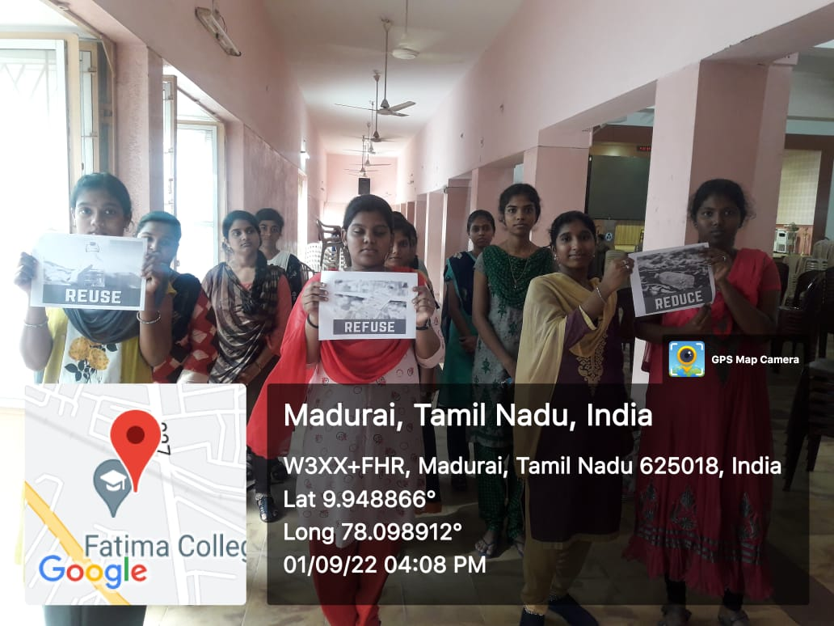

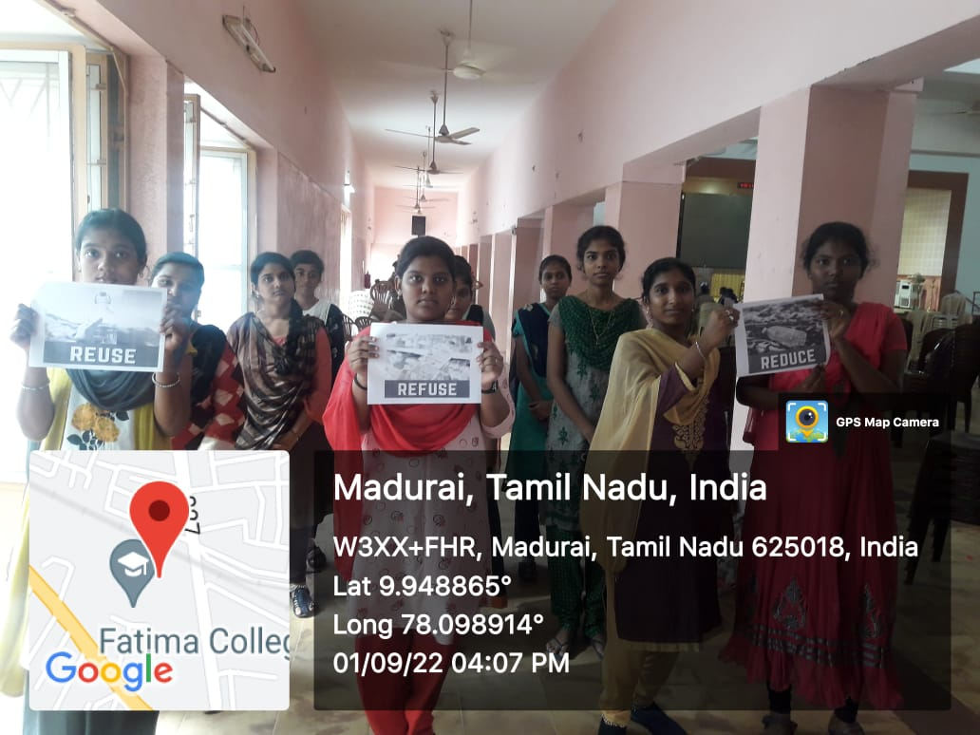

**PARTICIPANTS**

|  |  |  |
| --- | --- | --- |
| **S. No.** | **REGISTER NO.** | **NAME** |
| 1 | 2021C01 | AGNES MARY A |
| 2 | 2021C02 | AMUDHA A |
| 3 | 2021C04 | BHAVADHARANI M |
| 4 | 2021C05 | CAROLINE FABINAA N |
| 5 | 2021C07 | CRISPIN VIRGILA A |
| 6 | 2021C08 | DHARANI S |
| 7 | 2021C09 | DHARSHINI M |
| 8 | 2021C11 | DIVYA PRIYA R |
| 9 | 2021C13 | DURGALAKSHMI C |
| 10 | 2021C15 | HARINI M |
| 11 | 2021C16 | HARISHMA T |
| 12 | 2021C17 | HENCY LISHA M |
| 13 | 2021C18 | INFANT HEVEENA C |
| 14 | 2021C19 | JAFRINA BARVIN Z |
| 15 | 2021C20 | JANIKA M |
| 16 | 2021C22 | MAHESWARI S |
| 17 | 2021C24 | NIVETHA P |
| 18 | 2021C25 | PAVITHRA R |
| 19 | 2021C26 | PAVITHRA V |
| 20 | 2021C27 | PRIYANKA P |
| 21 | 2021C28 | RAJASRIARASI G |
| 22 | 2021C31 | RONICA ALICE J |
| 23 | 2021C33 | SHINISHA BRIJET D |
| 24 | 2021C35 | SUBHANIYA PARVEEN S |
| 25 | 2021C37 | UDAYA TERESA F |
| 26 | 2021C38 | VAISHNAVI R |
| 27 | 2021C40 | VINOTHINI R |
| 28 | 2021C41 | VISHALINI A |
| 29 | 2021C43 | SAHAYA SHERLY JOICE J |
| 30 | 2021C44 | DHAROSHINI M |
| 31 | 2021C45 | RENUKA DEVI R |
| 32 | 2021C46 | SHIVARANJANI P |
| 33 | 2021C47 | SWETHA B |
| 34 | 2021C48 | CATHERIN SIBA J |

**PROGRAMME 3 organized by NSS**

Name of the Programme : Cleaning Activity at the Adopted Village

Date of the Programme : 10.11.2022

Beneficiaries : 47 (UG NSS volunteers of Fatima College)

Place : Thenkarai, Madurai

Highlights of the Programme:

* 45 NSS students participated in the cleaning activity at the adopted village- Thenkarai.
* NSS students cleaned the places near temples and schools.
* The NSS volunteers worked with the motto of having civic responsibility of maintaining our environment clean.
* Plastic covers and other plastic wastes were collected in a large bag and disposed properly

Outcome of the Programme:

* Motivation to keep the environment clean.
* Bringing community together and enhancing the community spirit to keep the environment clean and tidy

**PHOTOS**

Cleaning Activity

Before During

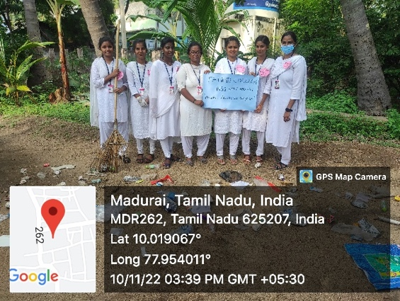 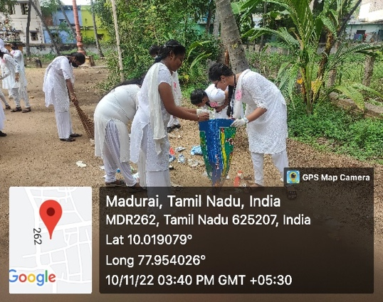

NSS Volunteers Involved in Cleaning

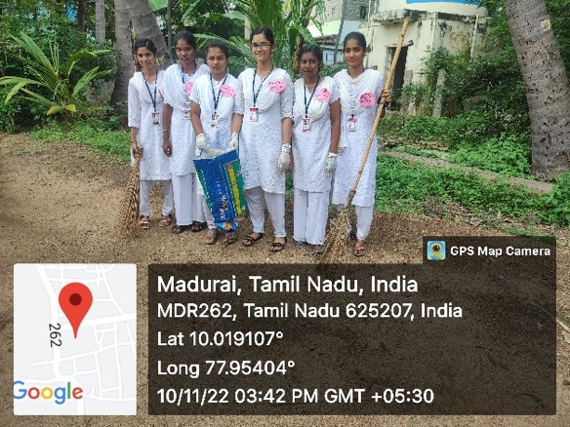 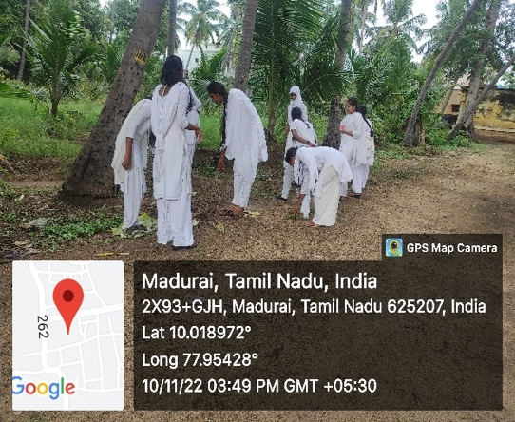

After Cleaning Activity

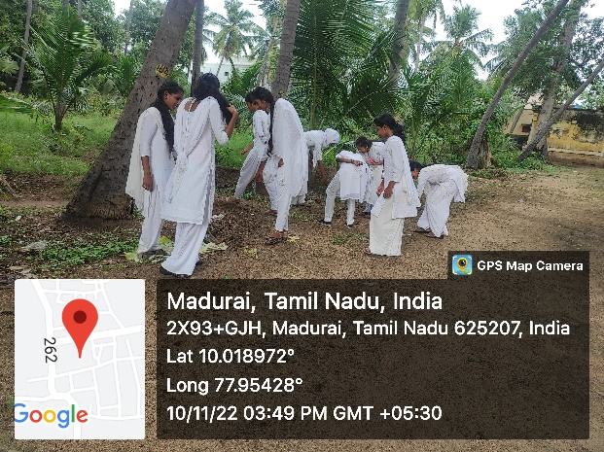

**PARTICIPANTS**

|  |  |  |
| --- | --- | --- |
| **S.NO** | **REG. NO** | **NAMES** |
|  | 2022E01 | M. ABINAYA |
|  | 2022E03 | D.AROCKIYA SALOMIYA |
|  | 2022E04 | K.ARULNATHI |
|  | 2022E05 | M.BHARATHI |
|  | 2022E06 | A.BHAVA SHREE |
|  | 2022E07 | V.BRINDHA |
|  | 2022E08 | K.K.DEVAKI |
|  | 2022E09 | M.DHANIYA SHREE |
|  | 2022E10 | S.DHARANI |
|  | 2022E11 | S.DHIVYA BHARATHI |
|  | 2022E13 | K.DIVYA |
|  | 2022E14 | P.GAYATHRI |
|  | 2022E15 | A.HAJIRA BANU |
|  | 2022E16 | P.HARINI |
|  | 2022E17 | G.ISWARYA |
|  | 2022E18 | P.ISWARYA SAROJINI |
|  | 2022E19 | B.JANANI |
|  | 2022E21 | P.JAYALALITHA |
|  | 2022E22 | V.JEYA PRIYA |
|  | 2022E24 | D.KARISHMA |
|  | 2022E25 | V.KARPAGA VARTHINI |
|  | 2022E26 | M.KARTHIGA |
|  | 2022E27 | V.KARTHIKA |
|  | 2022E28 | A.KAVITHA |
|  | 2022E30 | R.KAVIYA DHARSHINI |
|  | 2022E32 | P.LAKSHMI PRIYA |
|  | 2022E33 | S.MADHUMITHA |
|  | 2022E34 | M.MALA |
|  | 2022E37 | M.MUTHEESHWARI |
|  | 2022E38 | P.MUTHU MANI MOZHI |
|  | 2022E39 | K.MUTHU MEENAKSHI |
|  | 2022E40 | S.MUTHU SANGARI |
|  | 2022E41 | J.NANDHINI DEVI |
|  | 2022E42 | T.NIVETHA |
|  | 2022E43 | K.POOMIKA |
|  | 2022E45 | A.PREETHI |
|  | 2022E46 | S.PRITHIGA |
|  | 2022E48 | V.RASHMITHA |
|  | 2022E50 | J.REENGA |
|  | 2022E51 | U.ROSECARLEENA |
|  | 2022E52 | G.SANDHIYA |
|  | 2022E54 | T.SANTHIYA |
|  | 2022E55 | R.SARASWATHI |
|  | 2022E56 | K.SARUMATHY |
|  | 2022E58 | T.SEYATHALI FATHIMA |
|  | 2022E59 | P.SHARINI |
|  | 2022E60 | G.SIVAPACKIA |

SIGNATURE

(NSS COORDINATOR)

**PROGRAMME 4 organized by Green Club**

Name of the Programme : VERMICOMPOST

Date of the Programme : 19.08.2022

Beneficiaries : 10

Place : Fatima College, Madurai

Highlights of the Programme:

On 19.08.2022 the green club volunteers along with the green club in charge staff cleaned the pit and filled the pit with decomposable organic wastes such as animal excreta, kitchen waste, farm residues and leaf litter as composting materials. The volunteers filled the pit with cow dung and chopped dried leafy materials which are mixed in the proportion of 3: 1 and are kept for partial decomposition for 15 – 20 days. A layer of 15-20cm of chopped dried leaves was kept as bedding material at the bottom of the bed. And then red earthworm were released on the upper layer of bed. The student volunteers visited the pit regularly and sprinkled water in order to keep the beds moist. Vermi-Compost gets ready in 45-50 days. The finished product is 3/4th of the raw materials used. It is one of the easiest methods to recycle agricultural wastes and to produce quality .

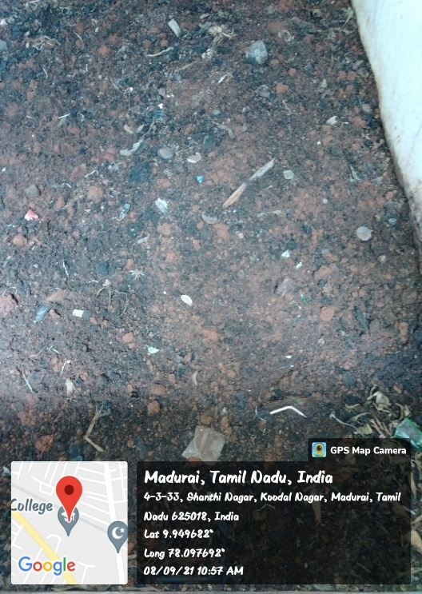**PHOTOS**

**PARTICIPANTS**

|  |  |  |
| --- | --- | --- |
| S.NO | REG.NO | NAME |
|  | 2020N02 | AFRIN.J |
|  | 2020N04 | ASMAA SABREEN.B |
|  | 2020N06 | DIVYA POOJA.K |
|  | 2020N08 | HARINI.R |
|  | 2020N10 | ISWARYA.V |
|  | 2020IT33 | SOWMIYA.S |
|  | 2020IT29 | RITHIGA DEVI.S |
|  | 2020IT20 | NITHARSHINI. PV |
|  | 2020IT08 | HARSHINE .B |
|  | 2020IT17 | MEKALA.S |

**PROGRAMME 5 organized by Green Club**

Name of the Programme : Harvesting the VERMICOMPOST

Date of the Programme : 19.11.2022

Beneficiaries : 10

Place : Fatima College, Madurai

Highlights of the Programme:

On 19.11.2022 the green club volunteers checked the completion of decomposing process. When the raw material is completely decomposed it appears black and granular. Next watering was stopped as compost gets ready. The compost was kept over a heap of partially decomposed cow dung so that earthworms could migrate to cow dung from compost. After two days compost can was separated and sieved for use. After sieving the green club volunteers packed the composed in rice bags for selling it.

**PHOTOS**

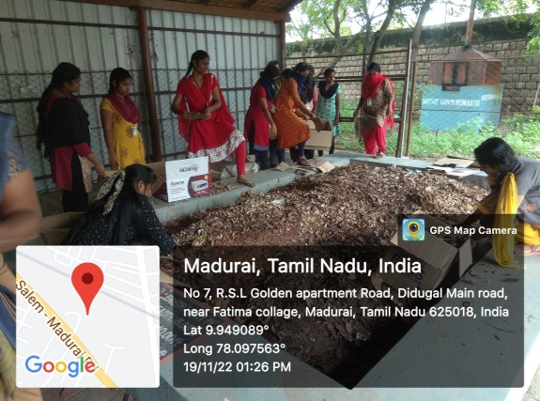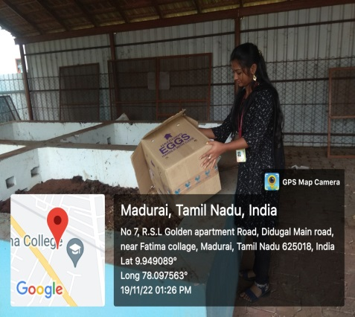

.

**PARTICIPANTS**

|  |  |  |
| --- | --- | --- |
| S.NO | REG.NO | NAME |
|  | 2020N02 | AFRIN.J |
|  | 2020N04 | ASMAA SABREEN.B |
|  | 2020N06 | DIVYA POOJA.K |
|  | 2020N08 | HARINI.R |
|  | 2020N10 | ISWARYA.V |
|  | 2020IT33 | SOWMIYA.S |
|  | 2020IT29 | RITHIGA DEVI.S |
|  | 2020IT20 | NITHARSHINI. PV |
|  | 2020IT08 | HARSHINE .B |
|  | 2020IT17 | MEKALA.S |

**PROGRAMME 6 organized by Green Club**

Name of the Programme : Selling the VERMICOMPOST

Date of the Programme : 18.04.2023

Beneficiaries : 10

Place : Fatima College, Madurai

Highlights of the Programme:

On 18.04.2023 the green club volunteers along with the green club staff incharge brought the Compost from the pit and arranged a stall in order to sell the fertilizer to the students and staffs in the college. Announcement regarding the sale was given during the prayer. Many students and staff from Shift I and Shift II brought the vermi-compost enthusiastically. They were happy to buy the fertilizer that was prepared in the college campus. It cost Rs.35 per kg

**PHOTOS**

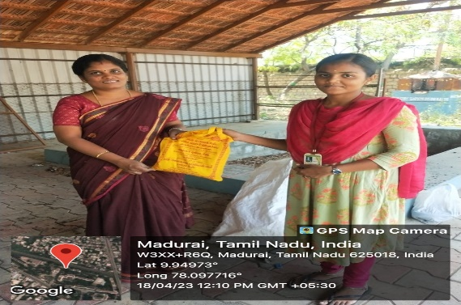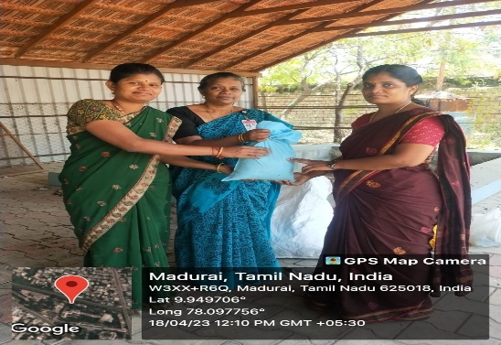

**PARTICIPANTS**

|  |  |  |
| --- | --- | --- |
| S.NO | REG.NO | NAME |
|  | 2020N02 | AFRIN.J |
|  | 2020N04 | ASMAA SABREEN.B |
|  | 2020N06 | DIVYA POOJA.K |
|  | 2020N08 | HARINI.R |
|  | 2020N10 | ISWARYA.V |
|  | 2020IT33 | SOWMIYA.S |
|  | 2020IT29 | RITHIGA DEVI.S |
|  | 2020IT20 | NITHARSHINI. PV |
|  | 2020IT08 | HARSHINE .B |
|  | 2020IT17 | MEKALA.S |

**PROGRAMME 7 organized by Green Club**

Name of the Programme : One Day Camp( on Saplings Distribution

Date of the Programme : 19.12.2022

Beneficiaries : 26

Resource Person : Mr.Ponkumar,

Secretary, Pasumai Nanbargal, Madurai.

Place : Fatima College, Madurai

Highlights of the Programme:

Green Club along with Pasumai Nanbargal organized one day camp on distribution of saplings to the faculties of Fatima College on 19.12.2022. Mr.Ponkumar secretary of the organization distributed first saplings to Dr. Fatima Michael, Vice principal and to all the members of Green Club. Nearly 350 saplings were distributed to the staff members as Christmas gift.

He also suggested that every student should at least plant one tree per year as it will help the world to fight against global warming. All the staffs were given a sapling each to plant at home

**PHOTOS**

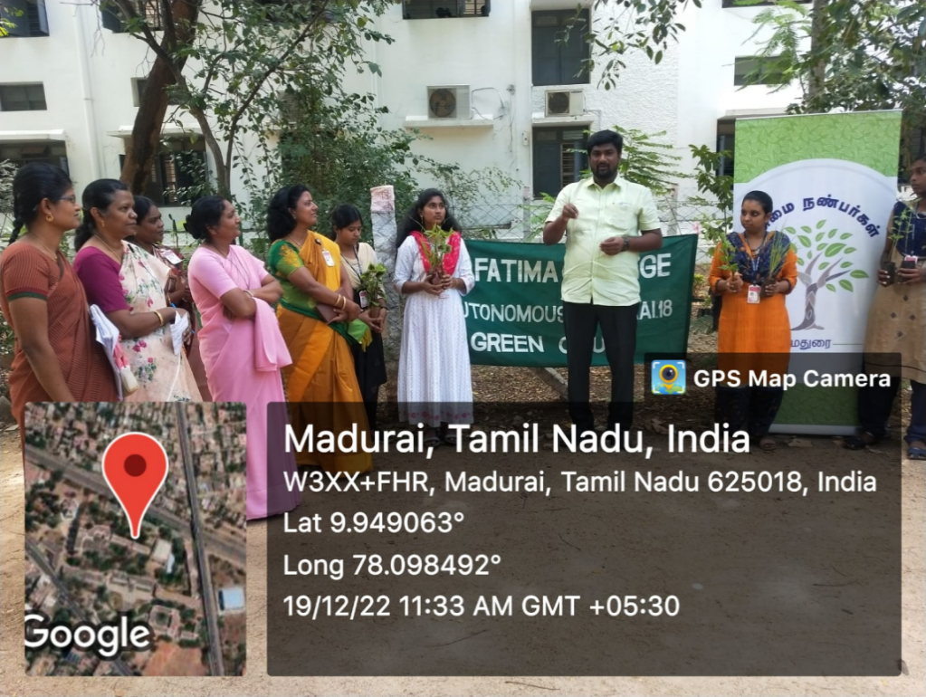

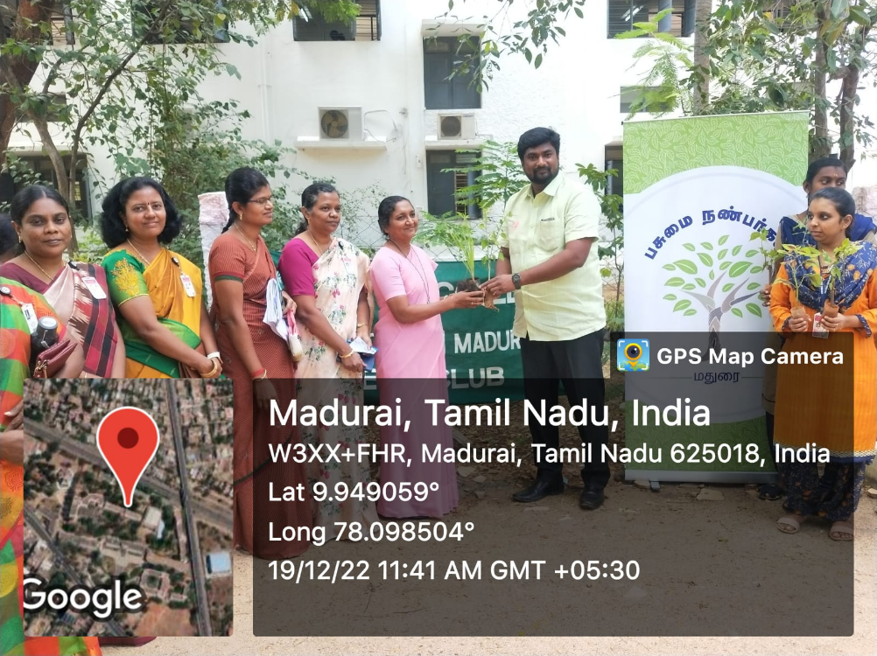

**PARTICIPANTS**

|  |  |  |
| --- | --- | --- |
| S.NO | REG.NO | NAME |
|  | 2020N01 | ARTHY.K |
|  | 2020N02 | AFRIN.J |
|  | 2020N03 | ANUSUYA.N |
|  | 2020N04 | ASMAA SABREEN.B |
|  | 2020N05 | BRINDHA.R |
|  | 2020N06 | DIVYA POOJA.K |
|  | 2020N07 | GOWSALYA.M |
|  | 2020N08 | HARINI.R |
|  | 2020N09 | HEMA MALINI.M |
|  | 2020N10 | ISWARYA.V |
|  | 2020N11 | JANAPRIYA.B |
|  | 2020N13 | KAVYA.A |
|  | 2020N14 | LATHA.M |
|  | 2020N17 | MIRUDHULLA.S |
|  | 2020N19 | NISHA.S |
|  | 2020N20 | NITHYASHRIHARITA.R |
|  | 2020IT01 | AARTHI.M |
|  | 2020IT06 | GOKILA.R |
|  | 2020IT08 | HARSHINE .B |
|  | 2020IT17 | MEKALA.S |
|  | 2020IT20 | NITHARSHINI. PV |
|  | 2020IT24 | NITHYA SREE.KV |
|  | 2020IT25 | NIVETHA. CSP |
|  | 2020IT29 | RITHIGA DEVI.S |
|  | 2020IT30 | SAMEEM BANU.A |
|  | 2020IT33 | SOWMIYA.S |

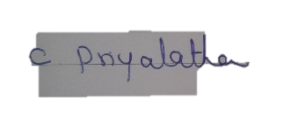

**Signature of Coordinator**