**BAN ON USE OF PLASTIC – INITIAIVES / PROGRAMMES ORGANIZED**

|  |  |  |  |
| --- | --- | --- | --- |
| **S.NO** | **DATE** | **THEME** | **VENUE** |
| 1 | 28.08.2022 | To spread awareness on the importance of cleanliness in reducing the risk of diseases in the community. | Fatima College, Madurai |
| 2 | 01.09.2022 | Awareness on plastics free and green environment | Fatima College, Madurai |
| 3 | 10.11.2022 | Cleaning Activity at the Adopted Village | Thenkarai, Madurai |

**PROGRAMME - 1**

Name of the Programme : Swachhta Pakhwada– Video Making

Date of the Programme : 28.08.2022

Beneficiaries : 31 (Students of Fatima College)

Highlights of the Programme:

* The NSS volunteers presented videos on clean environment.
* The impact of global warming and pollution were emphasized.
* The videos were posted in WhatsApp status and Instagram
* The benefits of having a clean environment without plastics were highlighted.

Outcome of the Programme:

* To spread awareness on the importance of cleanliness in reducing the risk of diseases in the community.

**PHOTOS - depicting the WHATSAPP status of students featuring the videos made by them**

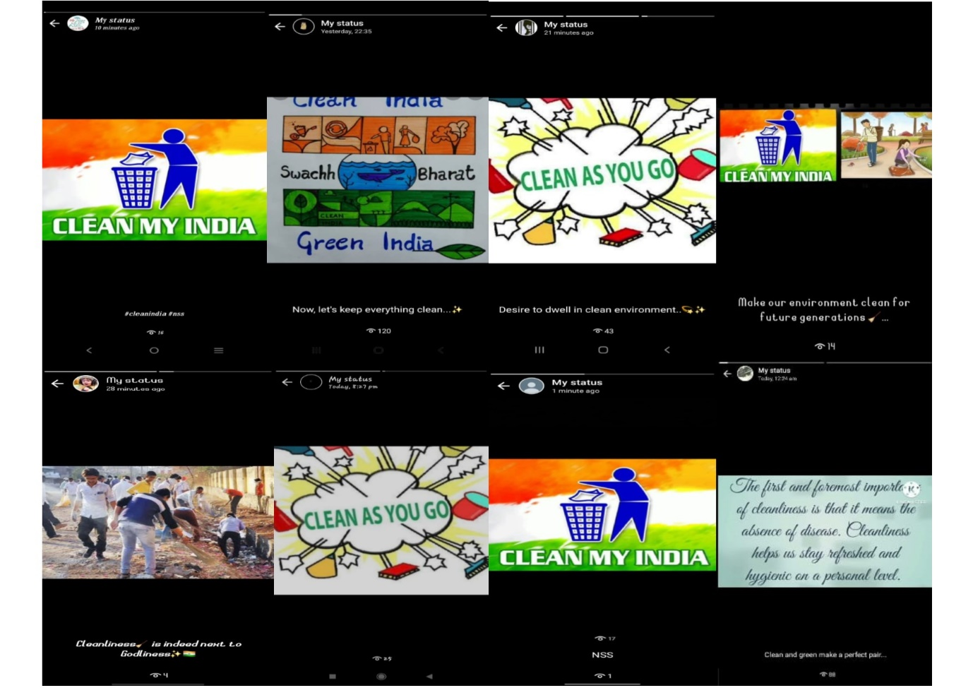

**Link for the Videos:**

1. <https://www.instagram.com/reel/Ch97SUiDyQO/?igshid=YmMyMTA2M2Y>=
2. <https://www.instagram.com/reel/Ch97yOwjhI4/?igshid=YmMyMTA2M2Y>=
3. <https://www.instagram.com/reel/Ch9782hDP2F/?igshid=YmMyMTA2M2Y>=
4. <https://www.instagram.com/reel/Ch98Ig5DuS-/?igshid=YmMyMTA2M2Y>=

**PARTICIPANTS**

|  |  |  |
| --- | --- | --- |
| **S.NO.** | **REG. NO.** | **NAME** |
| 1 | 2021L02 | ABHIRAMI.S |
| 2 | 2021L03 | K.AKFEYA JEBIN |
| 3 | 2021L07 | S.AYESHA |
| 4 | 2021L08 | M. M. BARGAVI |
| 5 | 2021L16 | HELIN MALAR.A |
| 6 | 2021L17 | HEMA PRIYA S |
| 7 | 2021L19 | A.JANE ROSE PAULINE |
| 8 | 2021L20 | JAYA DHARSHENI. T |
| 9 | 2021L21 | V.JEEVITHA |
| 10 | 2021L22 | A.JEFFRIN JUSTICE MARIYA |
| 11 | 2021L23 | A. JENCY ALEXIA |
| 12 | 2021L25 | A. MARIYA VARSHNI |
| 13 | 2021L26 | G.R.MEGALA |
| 14 | 2021L31 | RACHEL. S |
| 15 | 2021L34 | SAHAYA BABILA ROSE.R |
| 16 | 2021L35 | SAHAYA RANI.A |
| 17 | 2021L36 | SAHAYA ROMILDA. C |
| 18 | 2021L38 | T.SELVA INISHA |
| 19 | 2021L42 | SOWMIYA LAKSHMI.P |
| 20 | 2021L43 | S.SRILATHA |
| 21 | 2021L45 | G.VAISHNAVI |
| 22 | 2021L46 | P. M. VAISHNAVI |
| 23 | 2021L49 | S. YAZHINI TERASA |
| 24 | 2021L50 | CHITRA DEVI @ JANANI.J |
| 25 | 2021L51 | S.DEEPA LAKSHMI |
| 26 | 2021L54 | A. PETHA PRAMILA |
| 27 | 2021L55 | SILAMBU SELVI K |
| 28 | 2021L57 | R.BOOMIKA |
| 29 | 2021L58 | S.KARTHIGAYINI |
| 30 | 2021L60 | J.ANANTHI |
| 31 | 2021L62 | ABIRAMI.T.S |

**PROGRAMME - 2**

Name of the Programme : Awareness on Plastic free & Green environment

Date of the Programme : 01.09.2022

Beneficiaries : 30 (UG Students of Fatima College)

Highlights of the Programme:

* As part of **Swachhata Pakhwada** activity, an initiative was taken by NSS volunteers to spread awareness about BAN ON PLASTICS.
* Students imparted the ideas as 3R - REFUSE, REDUCE AND REUSE to ban plastic pollution.

Outcome of the Programme:

* Provoked a motivational spirit to create an eco-friendly environment

**PHOTOS**

NSS volunteers of unit no.43 creating awareness on **BAN PLASTICS** through an **Environmental Awareness song**

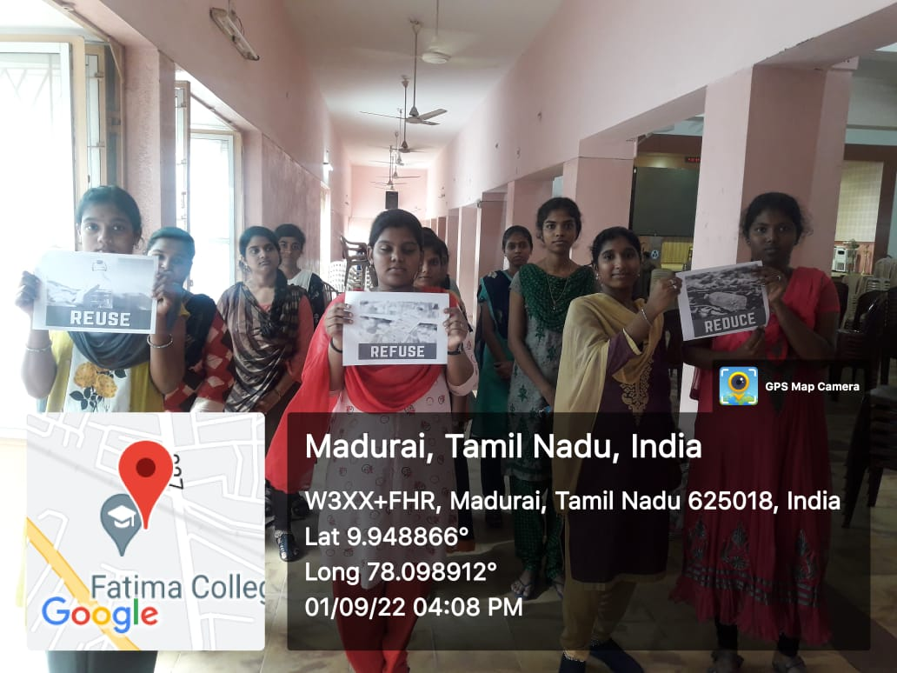

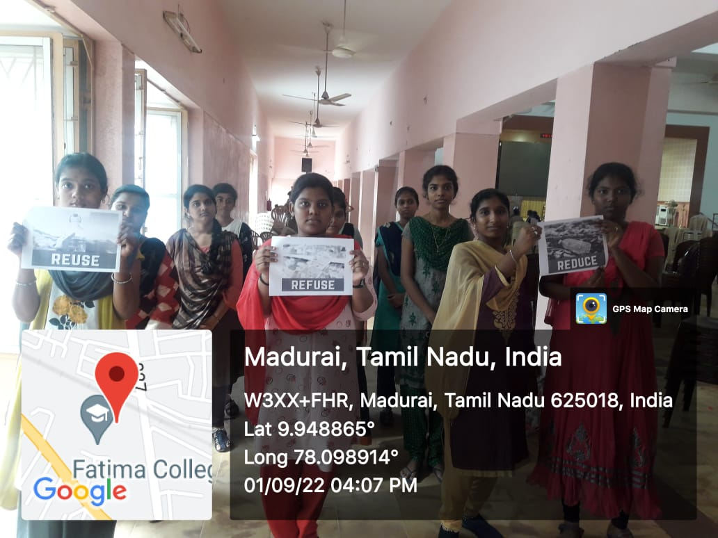

**PARTICIPANTS**

|  |  |  |
| --- | --- | --- |
| **S. No.** | **REGISTER NO.** | **NAME** |
| 1 | 2021C01 | AGNES MARY A |
| 2 | 2021C02 | AMUDHA A |
| 3 | 2021C04 | BHAVADHARANI M |
| 4 | 2021C05 | CAROLINE FABINAA N |
| 5 | 2021C07 | CRISPIN VIRGILA A |
| 6 | 2021C08 | DHARANI S |
| 7 | 2021C09 | DHARSHINI M |
| 8 | 2021C11 | DIVYA PRIYA R |
| 9 | 2021C13 | DURGALAKSHMI C |
| 10 | 2021C15 | HARINI M |
| 11 | 2021C16 | HARISHMA T |
| 12 | 2021C17 | HENCY LISHA M |
| 13 | 2021C18 | INFANT HEVEENA C |
| 14 | 2021C19 | JAFRINA BARVIN Z |
| 15 | 2021C20 | JANIKA M |
| 16 | 2021C22 | MAHESWARI S |
| 17 | 2021C24 | NIVETHA P |
| 18 | 2021C25 | PAVITHRA R |
| 19 | 2021C26 | PAVITHRA V |
| 20 | 2021C27 | PRIYANKA P |
| 21 | 2021C28 | RAJASRIARASI G |
| 22 | 2021C31 | RONICA ALICE J |
| 23 | 2021C33 | SHINISHA BRIJET D |
| 24 | 2021C35 | SUBHANIYA PARVEEN S |
| 25 | 2021C37 | UDAYA TERESA F |
| 26 | 2021C38 | VAISHNAVI R |
| 27 | 2021C40 | VINOTHINI R |
| 28 | 2021C41 | VISHALINI A |
| 29 | 2021C43 | SAHAYA SHERLY JOICE J |
| 30 | 2021C44 | DHAROSHINI M |
| 31 | 2021C45 | RENUKA DEVI R |
| 32 | 2021C46 | SHIVARANJANI P |
| 33 | 2021C47 | SWETHA B |
| 34 | 2021C48 | CATHERIN SIBA J |

**PROGRAMME – 3**

Name of the Programme : Cleaning Activity at the Adopted Village

Date of the Programme : 10.11.2022

Beneficiaries : 47 (UG NSS volunteers of Fatima College)

Place : Thenkarai, Madurai

Highlights of the Programme:

* 45 NSS students participated in the cleaning activity at the adopted village- Thenkarai.
* NSS students cleaned the places near temples and schools.
* The NSS volunteers worked with the motto of having civic responsibility of maintaining our environment clean.
* Plastic covers and other plastic wastes were collected in a large bag and disposed properly

Outcome of the Programme:

* Motivation to keep the environment clean.
* Bringing community together and enhancing the community spirit to keep the environment clean and tidy

**PHOTOS**

Cleaning Activity

Before During

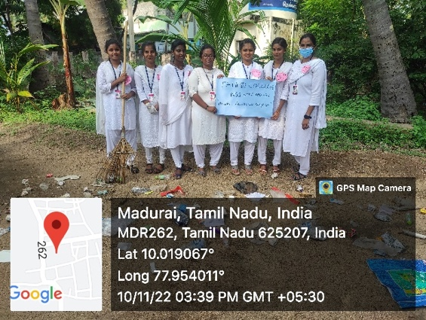 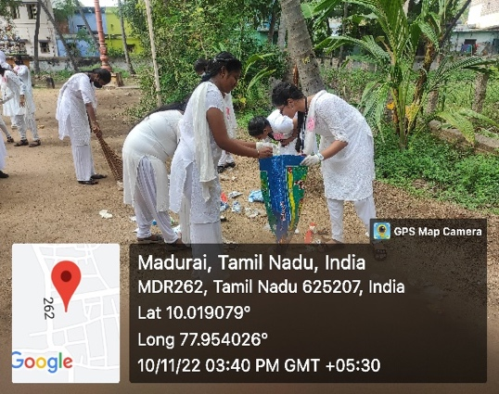

NSS Volunteers Involved in Cleaning

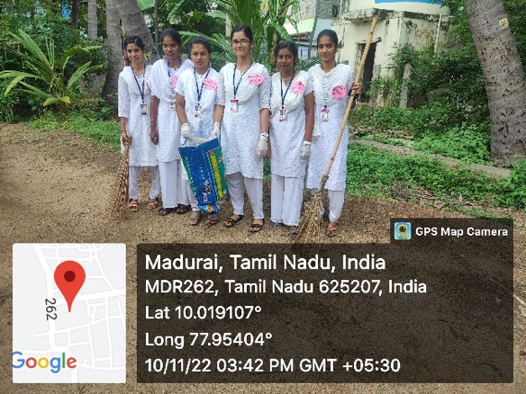 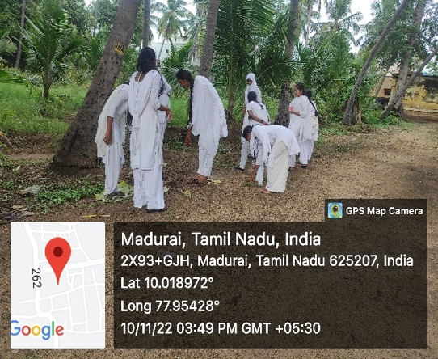

After Cleaning Activity

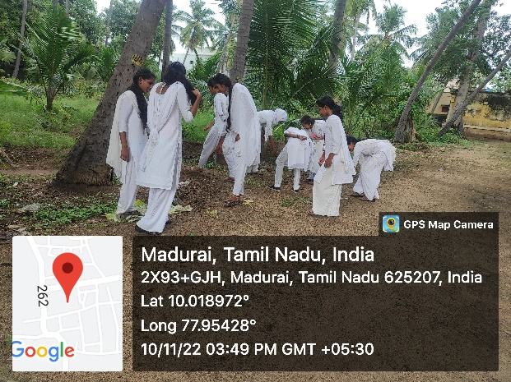

**PARTICIPANTS**

|  |  |  |
| --- | --- | --- |
| **S.NO** | **REG. NO** | **NAMES** |
|  | 2022E01 | M. ABINAYA |
|  | 2022E03 | D.AROCKIYA SALOMIYA |
|  | 2022E04 | K.ARULNATHI |
|  | 2022E05 | M.BHARATHI |
|  | 2022E06 | A.BHAVA SHREE |
|  | 2022E07 | V.BRINDHA |
|  | 2022E08 | K.K.DEVAKI |
|  | 2022E09 | M.DHANIYA SHREE |
|  | 2022E10 | S.DHARANI |
|  | 2022E11 | S.DHIVYA BHARATHI |
|  | 2022E13 | K.DIVYA |
|  | 2022E14 | P.GAYATHRI |
|  | 2022E15 | A.HAJIRA BANU |
|  | 2022E16 | P.HARINI |
|  | 2022E17 | G.ISWARYA |
|  | 2022E18 | P.ISWARYA SAROJINI |
|  | 2022E19 | B.JANANI |
|  | 2022E21 | P.JAYALALITHA |
|  | 2022E22 | V.JEYA PRIYA |
|  | 2022E24 | D.KARISHMA |
|  | 2022E25 | V.KARPAGA VARTHINI |
|  | 2022E26 | M.KARTHIGA |
|  | 2022E27 | V.KARTHIKA |
|  | 2022E28 | A.KAVITHA |
|  | 2022E30 | R.KAVIYA DHARSHINI |
|  | 2022E32 | P.LAKSHMI PRIYA |
|  | 2022E33 | S.MADHUMITHA |
|  | 2022E34 | M.MALA |
|  | 2022E37 | M.MUTHEESHWARI |
|  | 2022E38 | P.MUTHU MANI MOZHI |
|  | 2022E39 | K.MUTHU MEENAKSHI |
|  | 2022E40 | S.MUTHU SANGARI |
|  | 2022E41 | J.NANDHINI DEVI |
|  | 2022E42 | T.NIVETHA |
|  | 2022E43 | K.POOMIKA |
|  | 2022E45 | A.PREETHI |
|  | 2022E46 | S.PRITHIGA |
|  | 2022E48 | V.RASHMITHA |
|  | 2022E50 | J.REENGA |
|  | 2022E51 | U.ROSECARLEENA |
|  | 2022E52 | G.SANDHIYA |
|  | 2022E54 | T.SANTHIYA |
|  | 2022E55 | R.SARASWATHI |
|  | 2022E56 | K.SARUMATHY |
|  | 2022E58 | T.SEYATHALI FATHIMA |
|  | 2022E59 | P.SHARINI |
|  | 2022E60 | G.SIVAPACKIA |

SIGNATURE

(NSS COORDINATOR)