|  |  |  |
| --- | --- | --- |
| **7.1.4** |  |  |
| **QnM** | ***Water conservation facilities available in the Institution: (4)*** |  |
|  |  |  |
|  | 1. [Rain water harvesting](#Rain) | Yes |
|  | 2. [Borewell /Open well recharge](#Borewell) | Yes |
|  | 3. [Construction of tanks and bunds](#Water) | Yes |
|  | 4. [Waste water recycling](#wastewater) | Yes |
|  | 5. [Maintenance of water bodies and distribution](#distribution)  [system in the campus](#distribution) | Yes |

**RAIN WATER HARVESTING**

|  |  |  |
| --- | --- | --- |
| **S.No** | **Block** | **Capacity** |
| 1 | Behind JubileeHall | 1,60,000Ltr |
| 2 | Near Canteen | 60,000Ltr |
| 3 | Near Chemistry Block | 6,000Ltr |
| 4 | Near Convent | 30,000Ltr |
| 5 | Hostel | 80,000Ltr |
| 6 | Hostel | 80,000Ltr |

**(Behind Jubilee Hall) –1,60,000Ltr.**

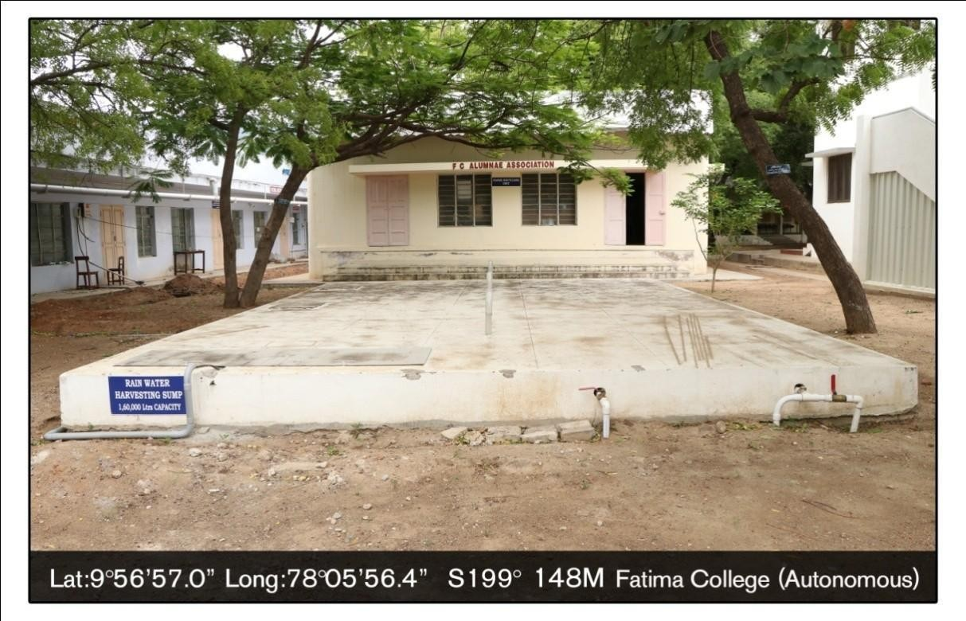

**Rain Water Harvesting (Near Canteen)–60,000Ltr.**

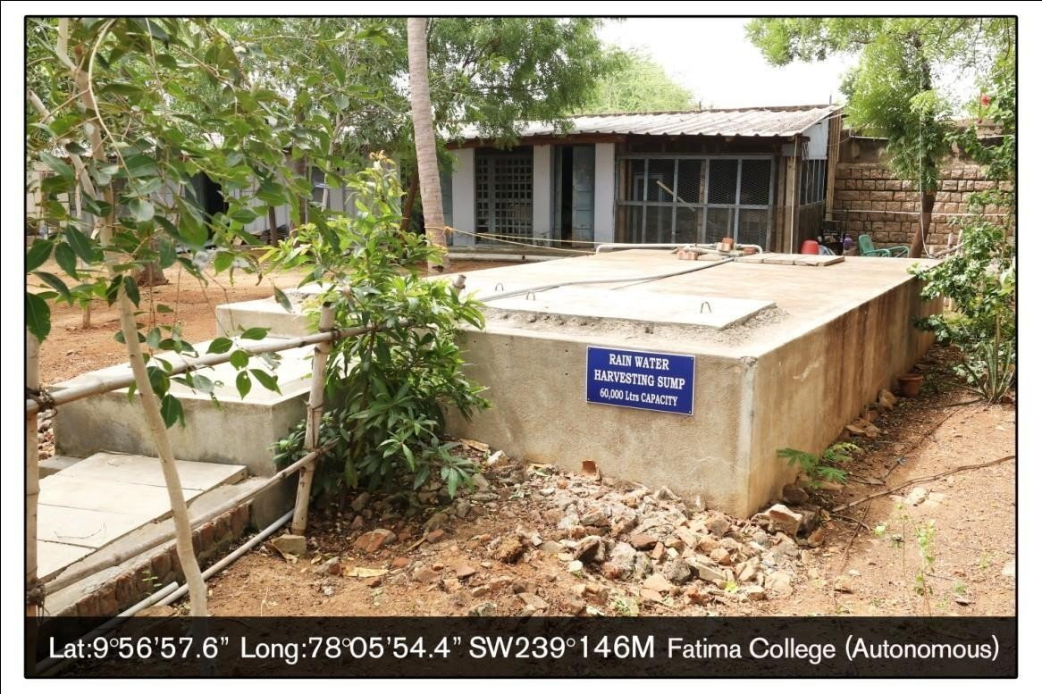

**Rain Water Harvesting 6,000 Ltr (Chemistry Block)**

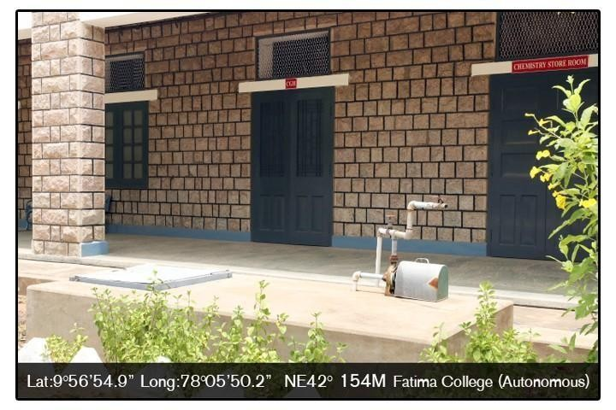

**Rain Water Harvesting (Near Convent)-30,000Ltr.**

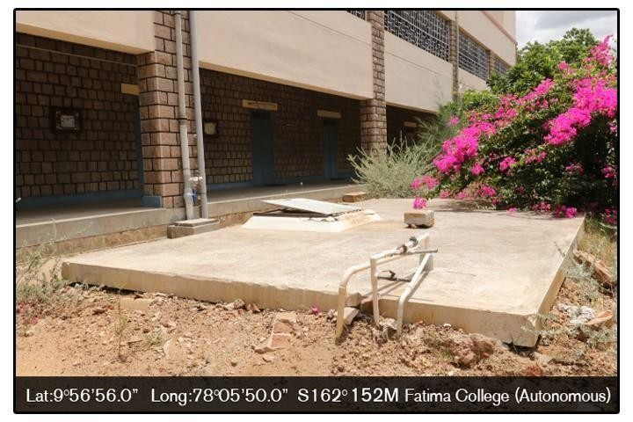

**Rain Water Harvesting (Hostel) -80,000Ltr**

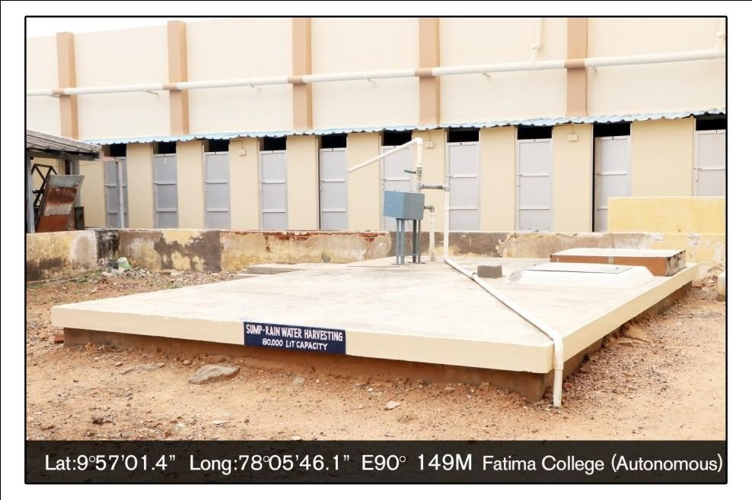

.

**Rainwater Harvesting 80,000 Ltr (Hostel)**

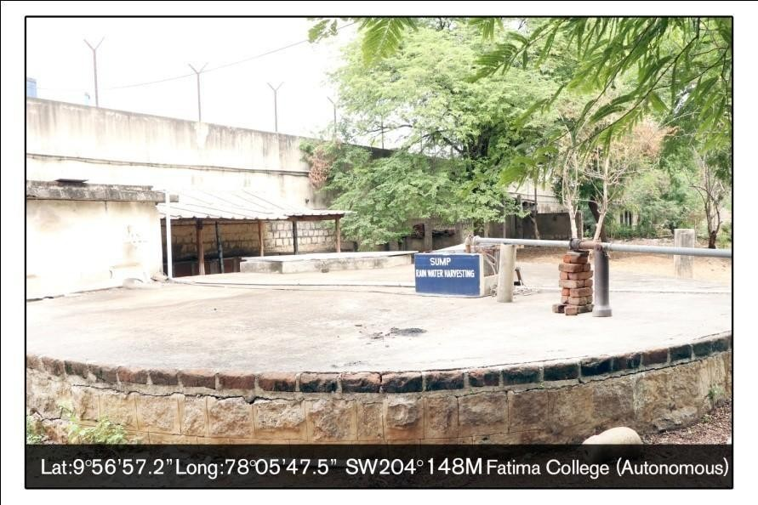

**Rain Water Harvesting (Administrative Block)**

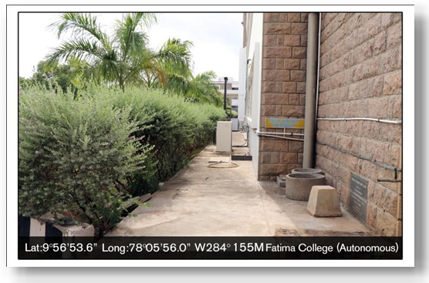

**Rain Water Harvesting (Home Science Block)-2022**

# F:\sangeetha\AQAR 22-23\Sump\_MG_4642.JPG

# F:\sangeetha\17.4.2021\AQAR\Rain water\IMG-20220106-WA0004.jpgF:\sangeetha\17.4.2021\AQAR\Rain water\IMG-20220106-WA0003.jpg

# Water Aquifer

**Near WEAT BLOCK Near Library**

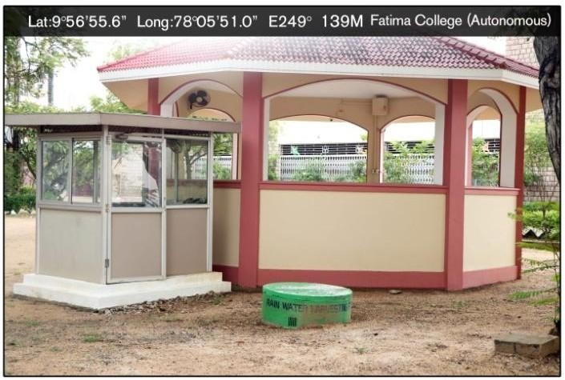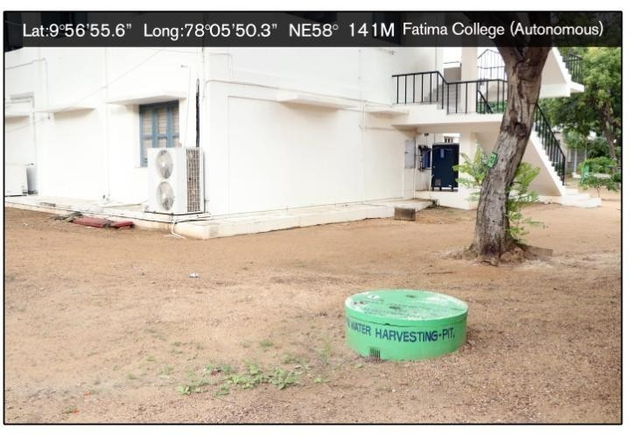

**Near Visitor’s Lounge**

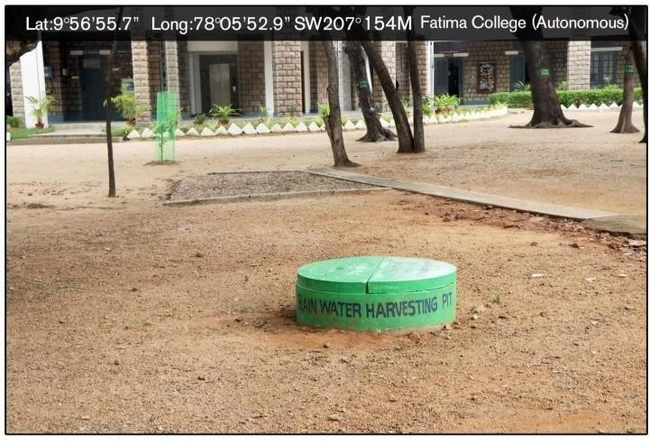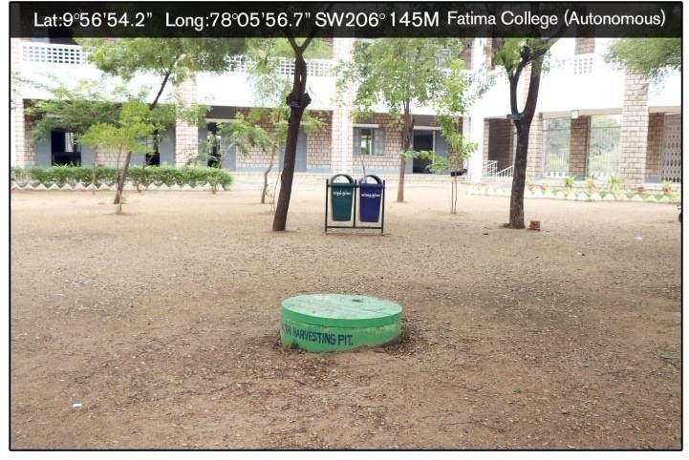

**In front of Administrative Block Near R4**

**2.****BoreWell**

**San Jose Block-5HP**

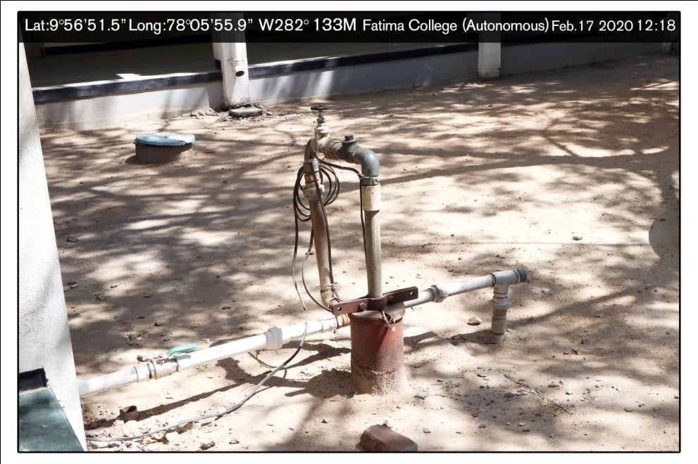

**Bore well (Sports Ground)-7HP**

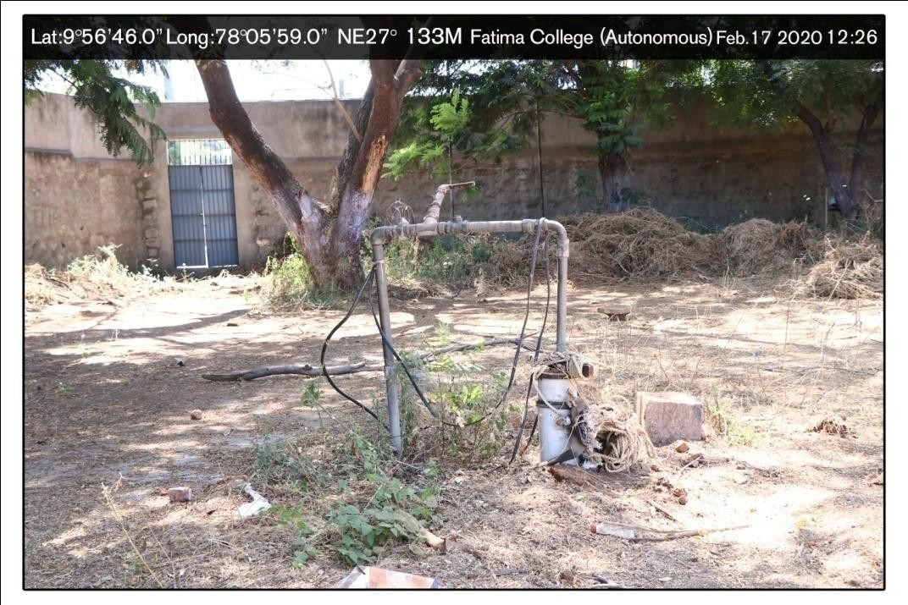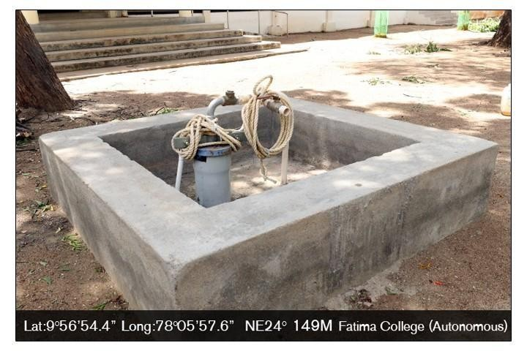

**Bore well (Office Front Side)-7HP**

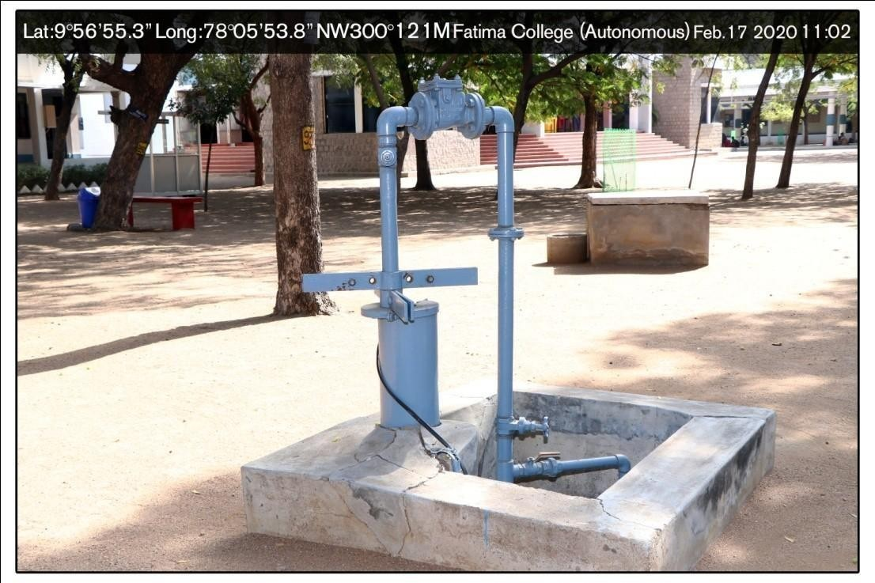

**Bore well (WEAT Block)-7 HP**

**Bore well (Lunch Shed) - 5HP**

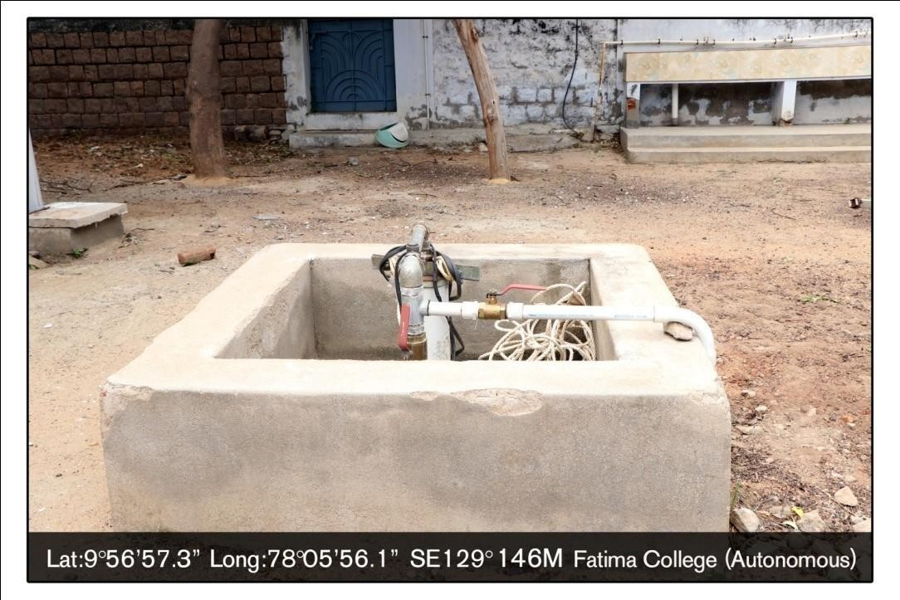

**3.** **WaterTank**

**Drinking WaterTank-20,000Ltr Capacity**

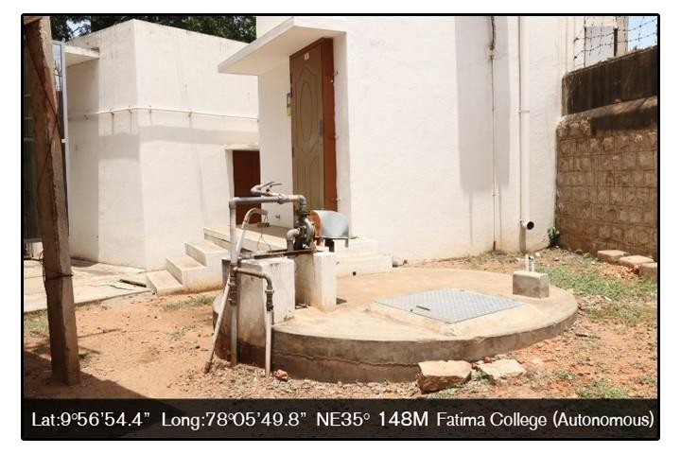

**(Near Hostel Gate Entrance)**

**Water Tank (Near College Compound) 50,000 Ltr Capacity**

### 8

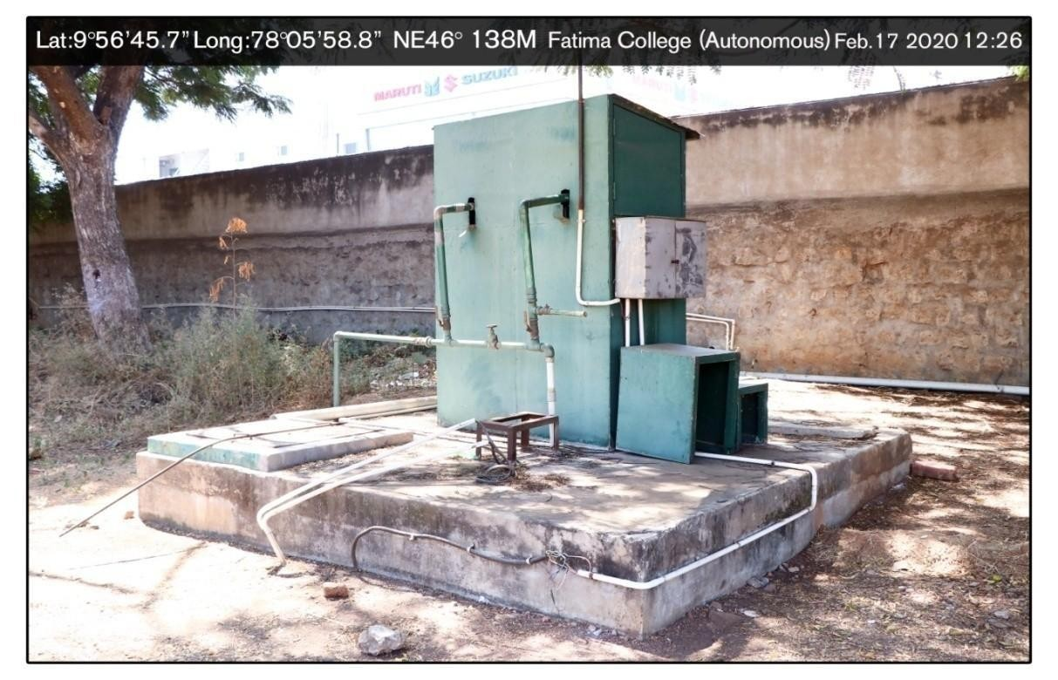

**Water Storage Tank 34,000 Ltr (Hostel)**

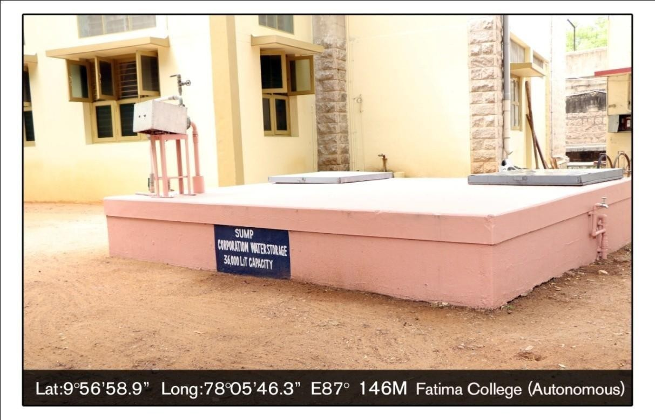

**Water Tank in San Jose Block**

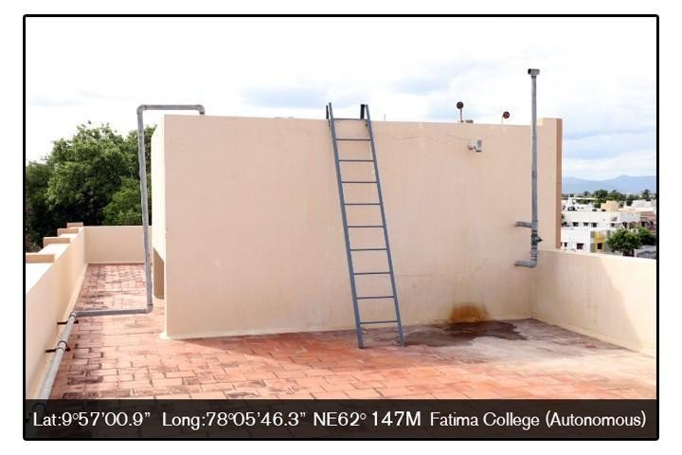

**New Water Tank 1,5,000Ltr (Near MCA Department)**

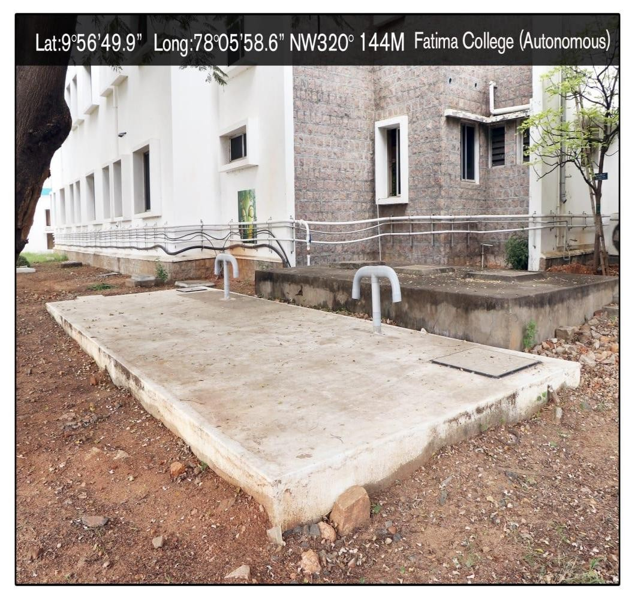

**Water Tank in San Jose Block**

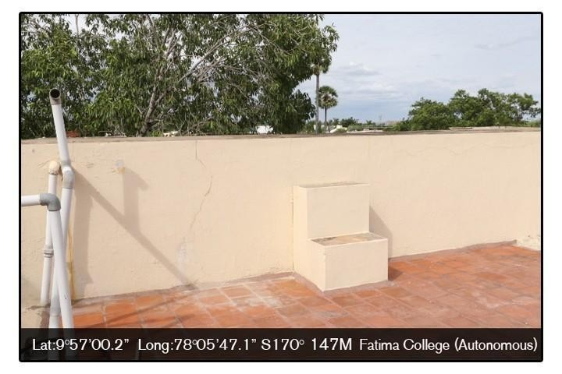

10

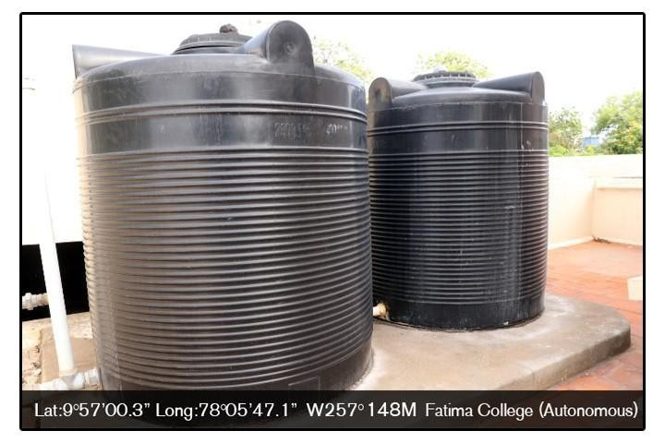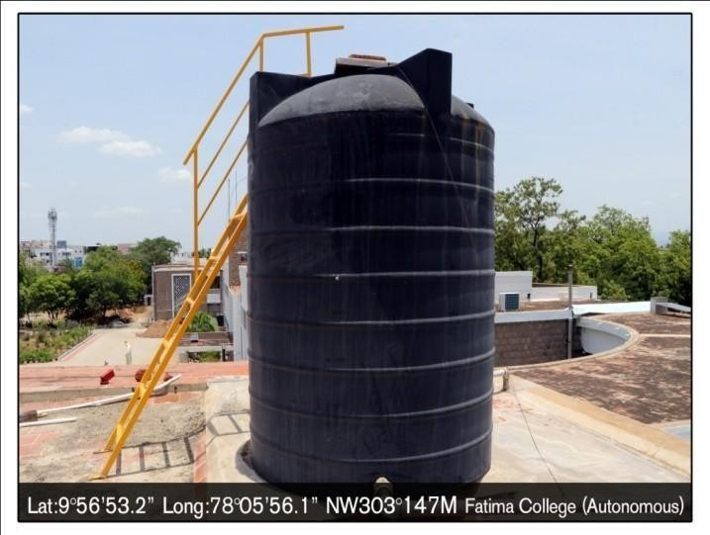

**Water Tank in Maureen Block**

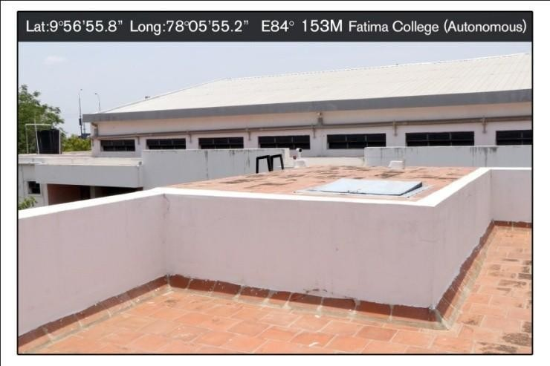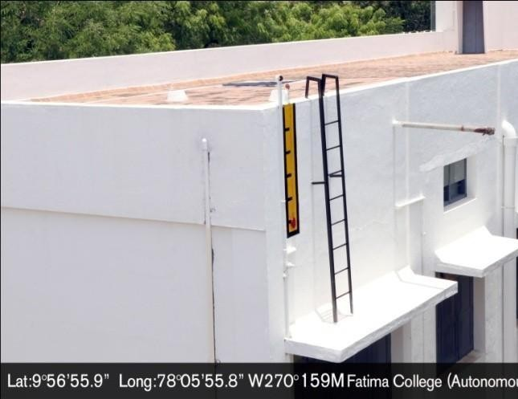

**Water Tank in “R” Block**

**Water Tank in Admin Block**

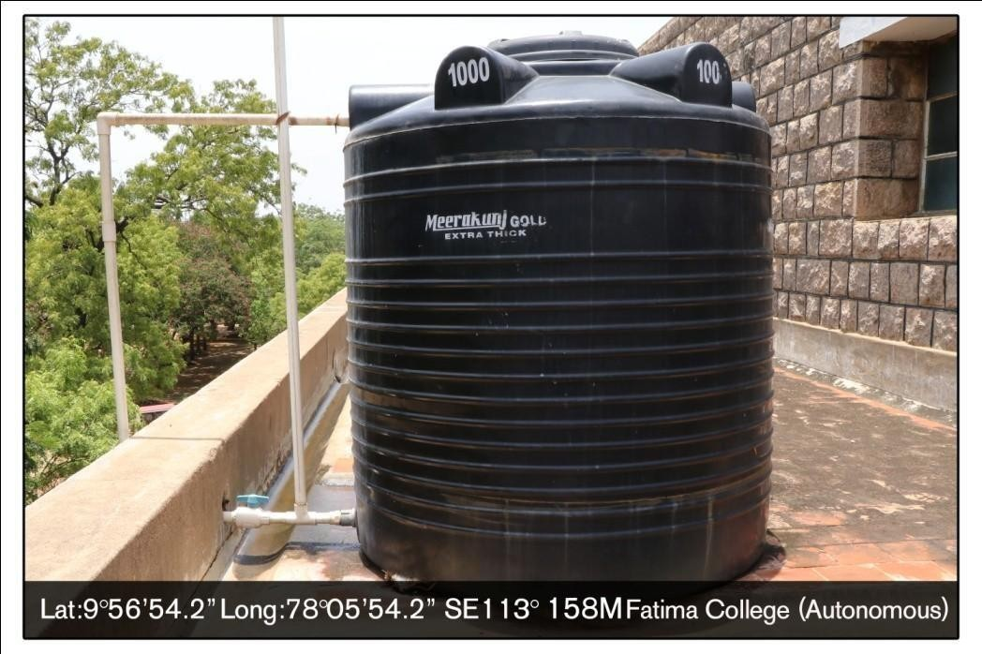

**Water Tank in Jubilee Hall**

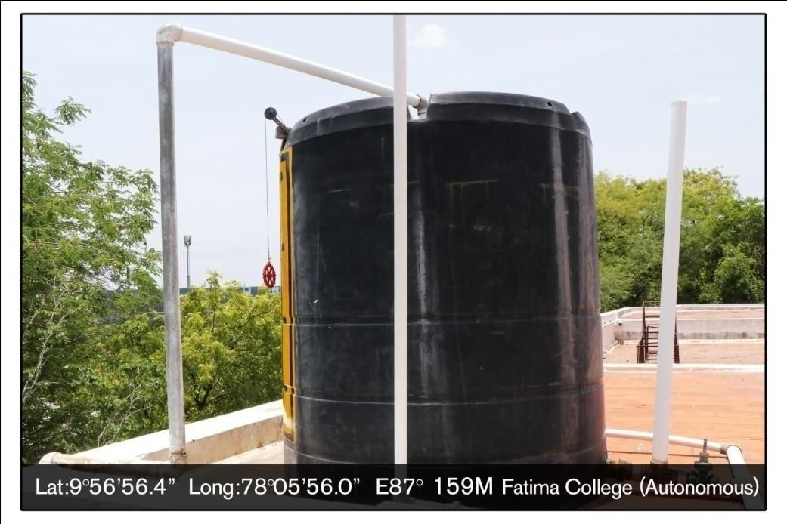

**Water Tank Near “N” Block**

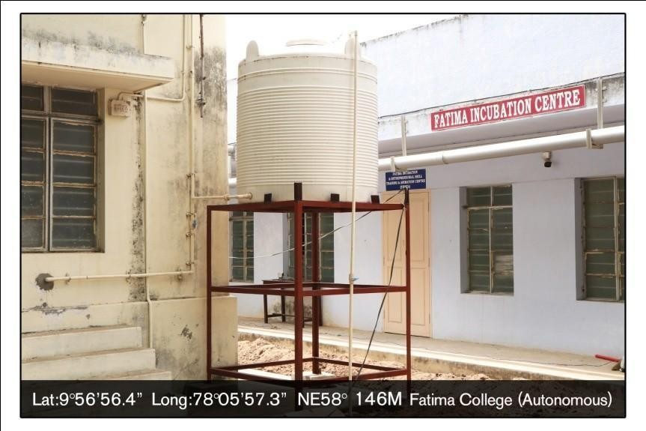

**Water Tank in Sancta Maria Block**

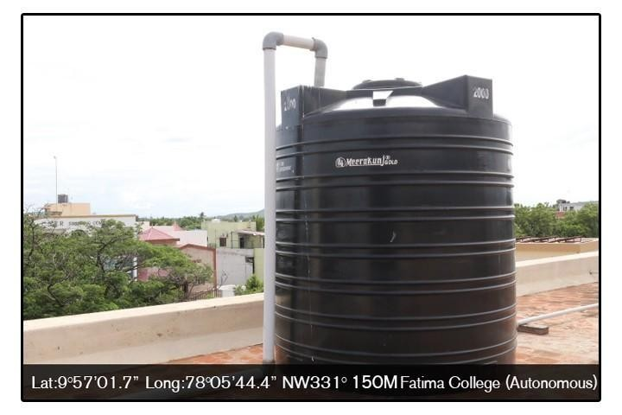

**Water Tanks in Hostel**

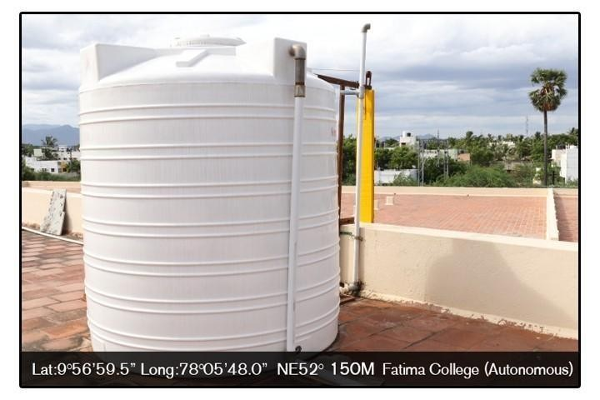

**Water Tanks in Hostel**

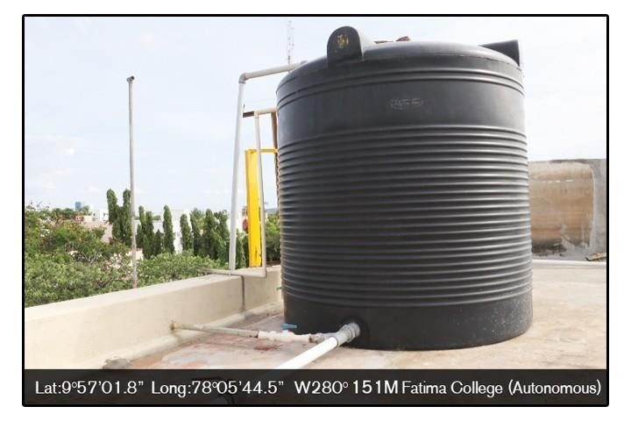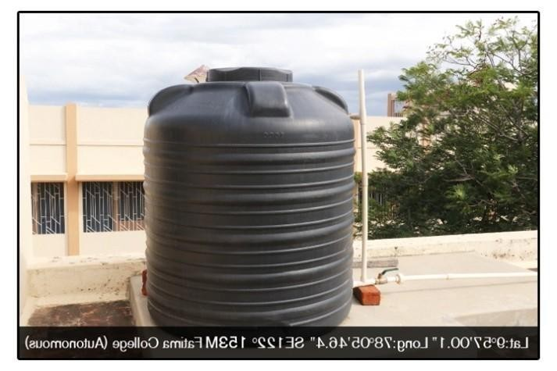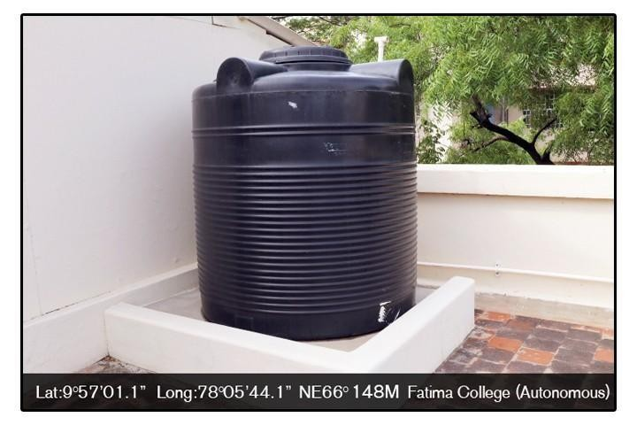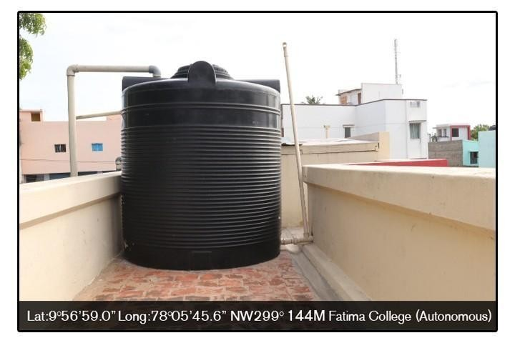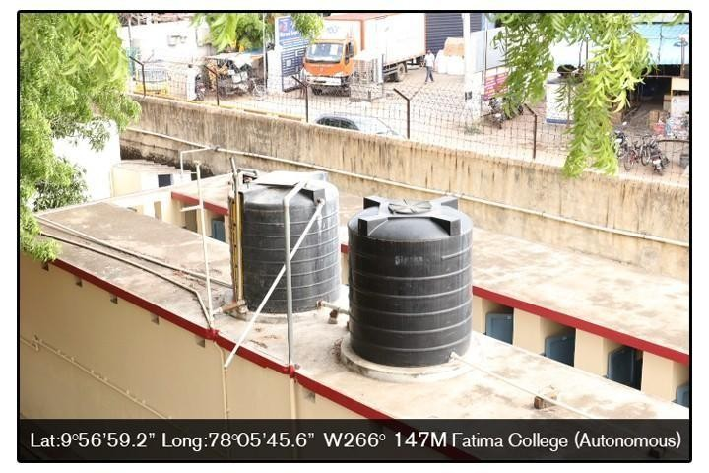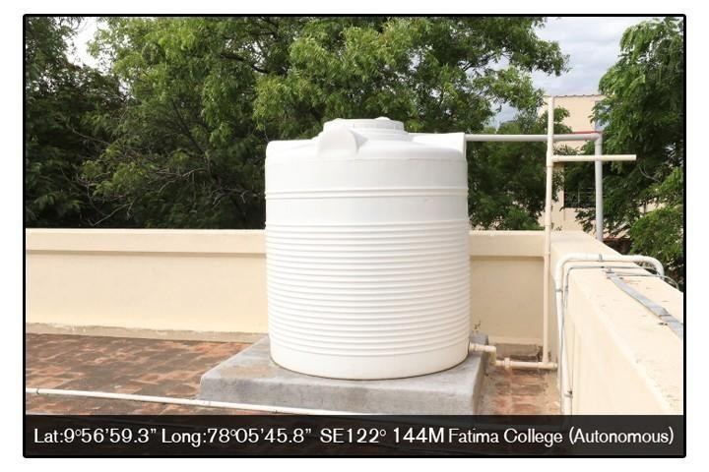

## 4. Waste Water Recycling

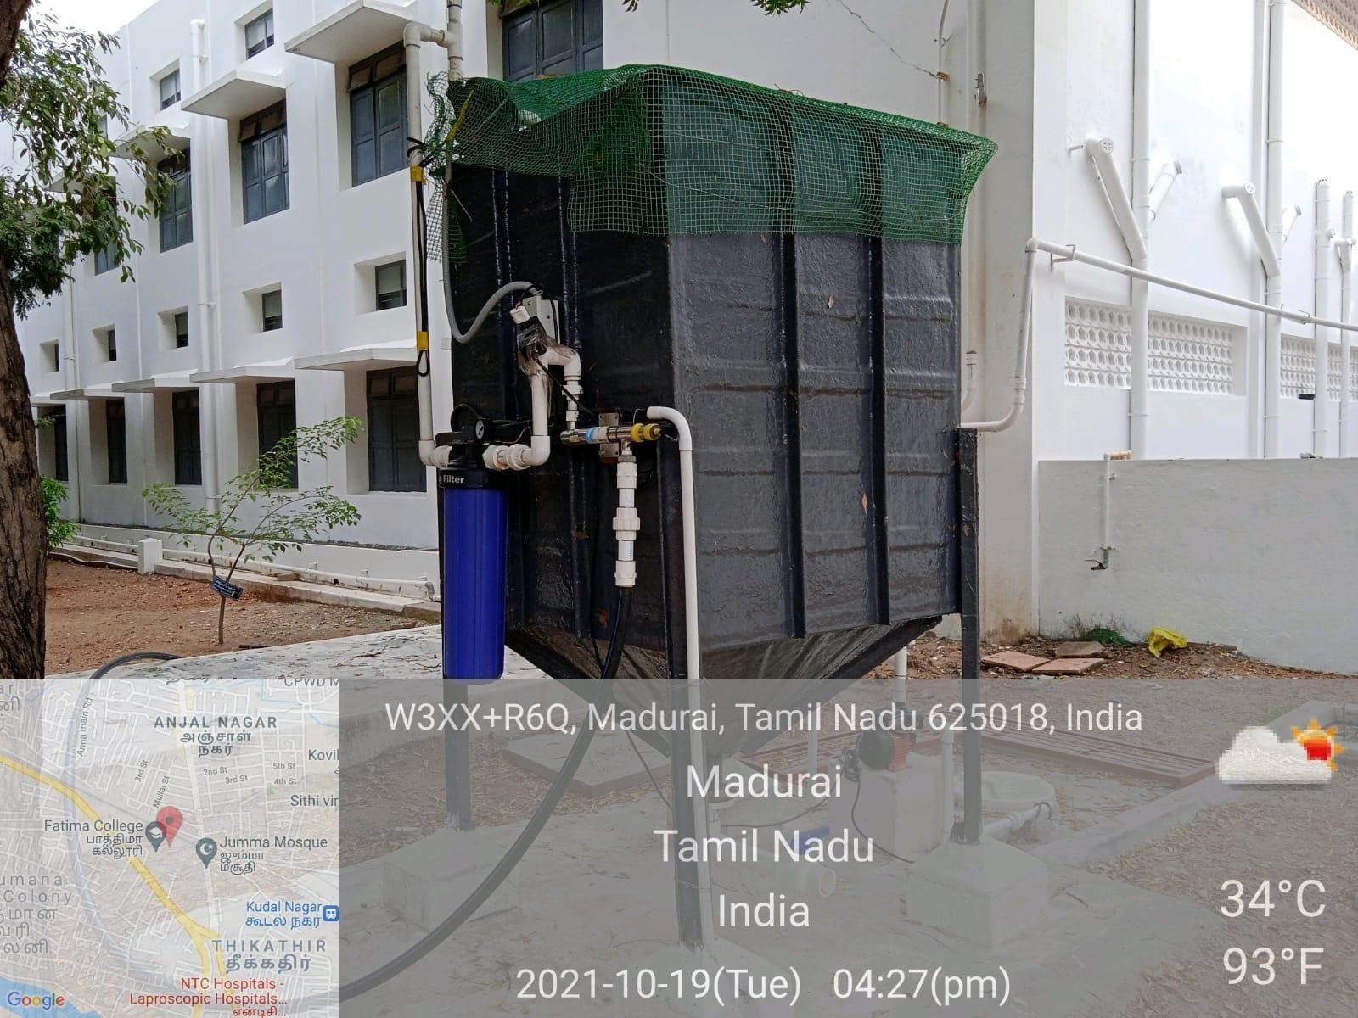

Waste Water Recycling

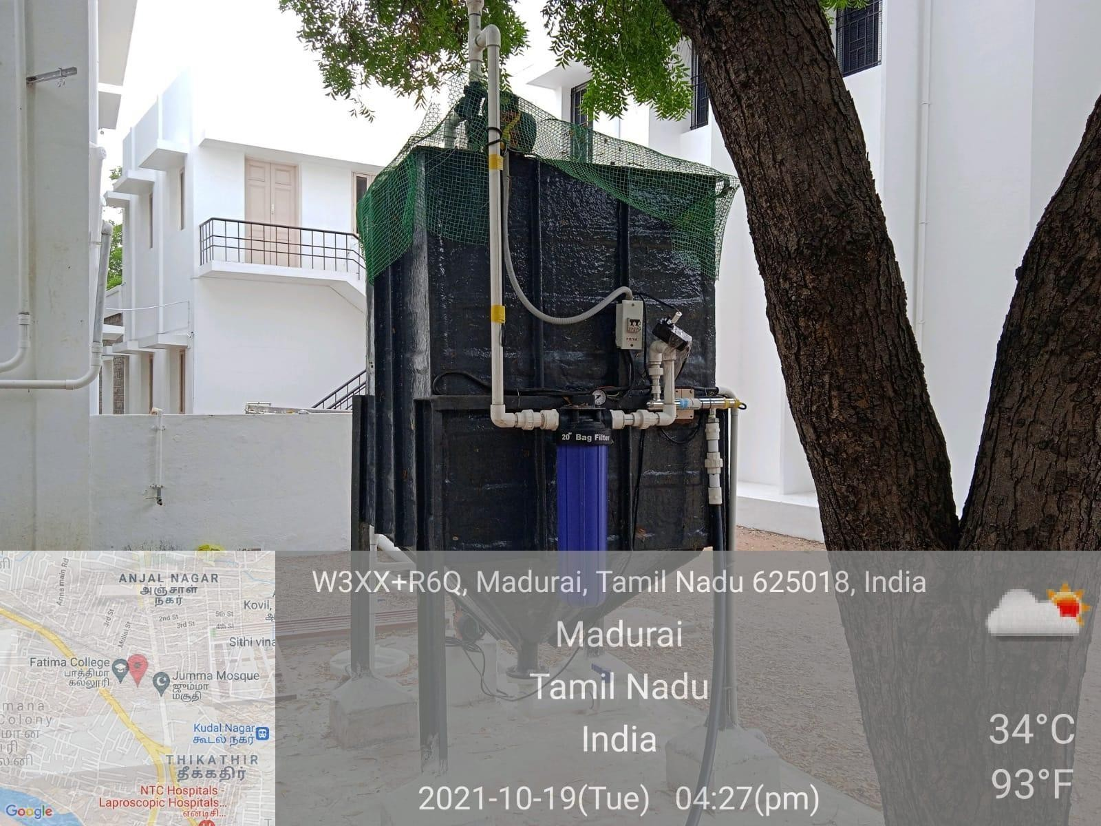

**5.** **Water Distribution system**

**Water Taps (Near Maureen Block)**

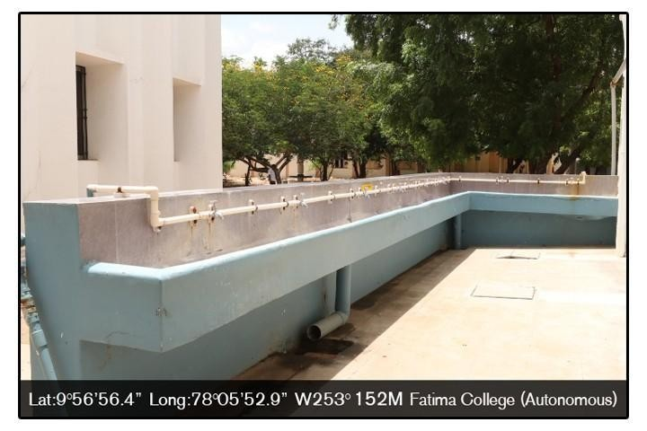

**Water Taps (Near Carmel Hall)**

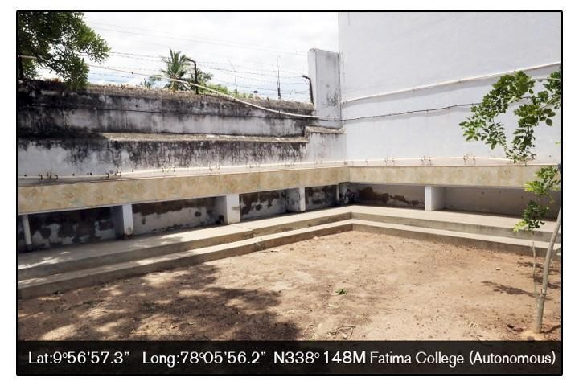

18

**Water taps (Benedicta Block)**

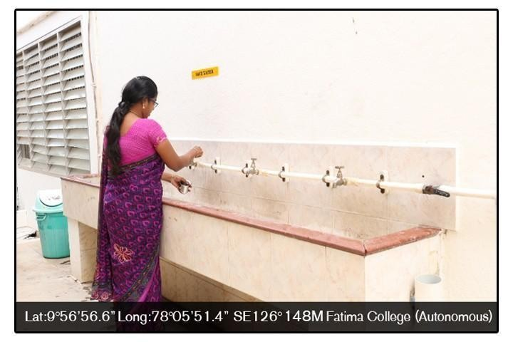

**Water Taps (San Jose Block)**

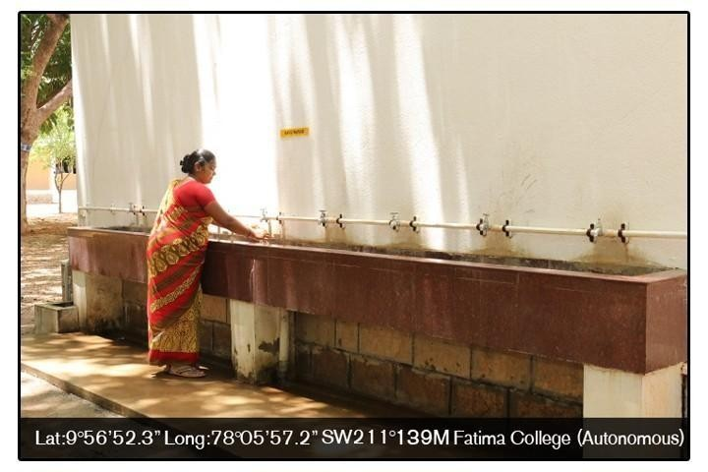

**Water Taps (Near Bank)**

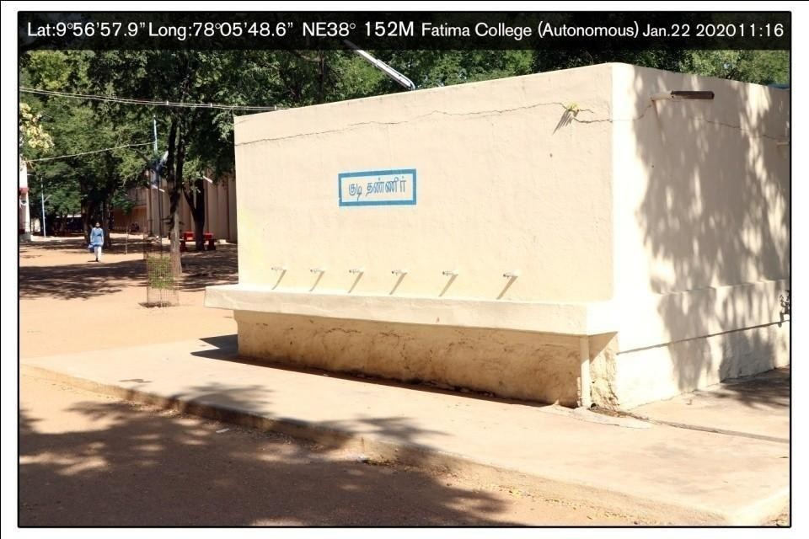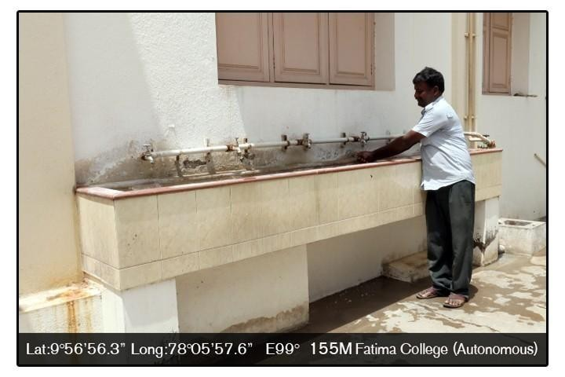

**Water Taps (Hostel)**

**Water Taps (Hostel Dining Hall)**

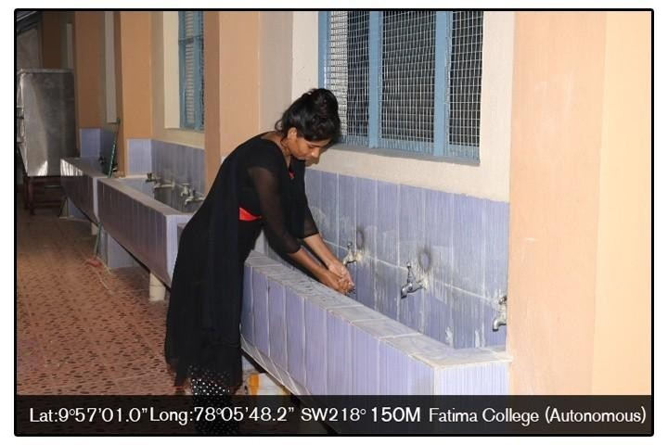

**Water Distribution System**

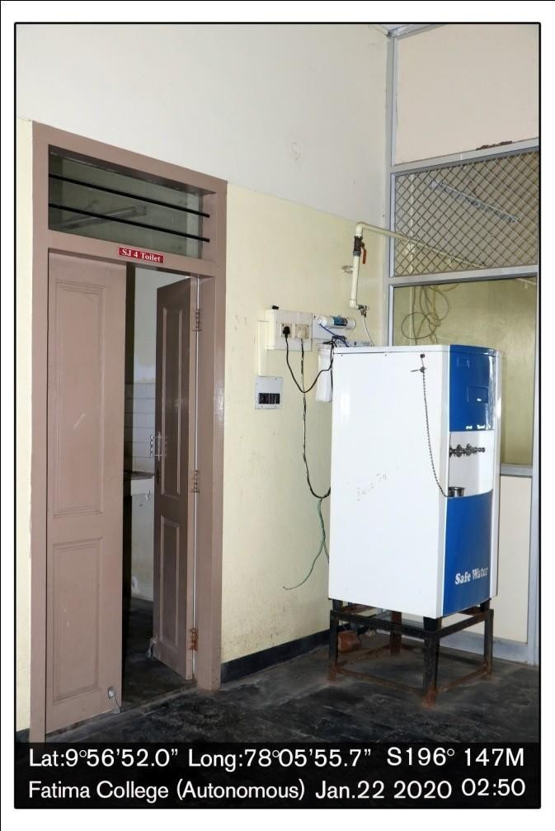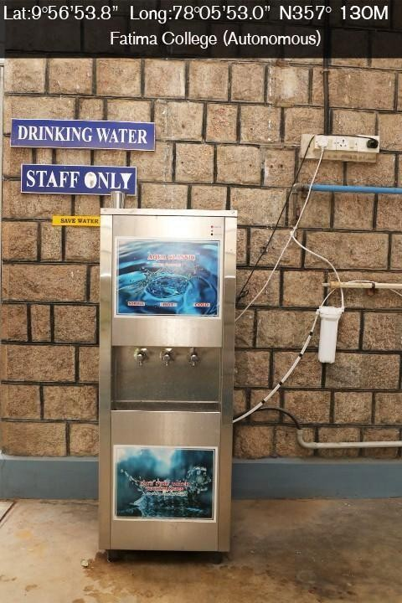

**RO in SanJose Block RO Near Bethany**

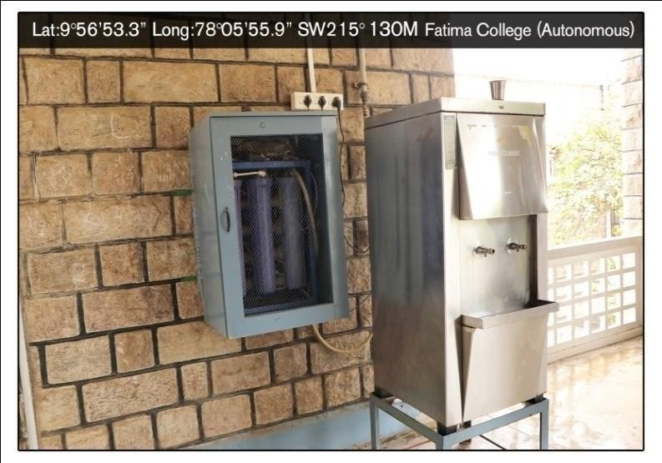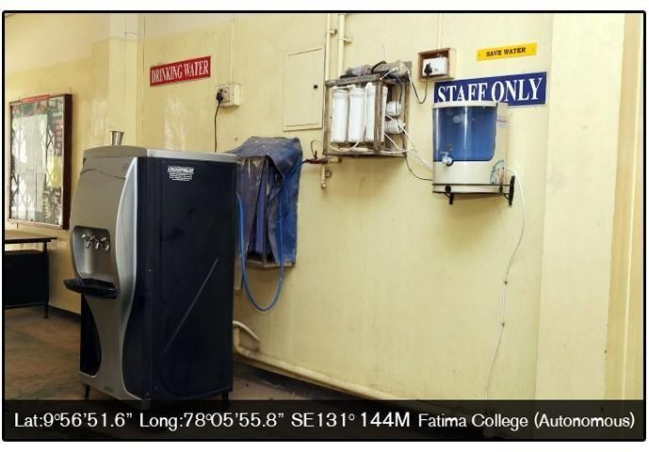

**RO (Near BLH1Room) RO ( Near SanJose Lobby)**

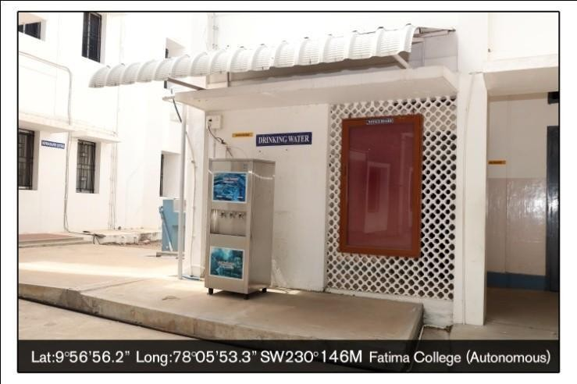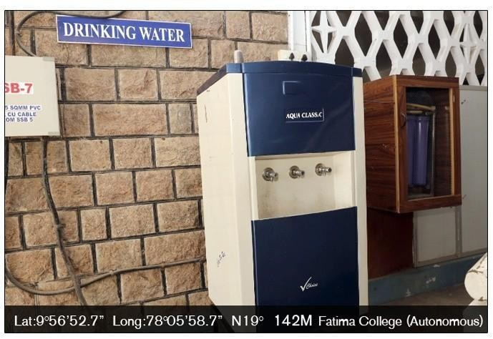

**RO (Near M Block) RO (Near Home Science Department)**

**RO in Hostel**

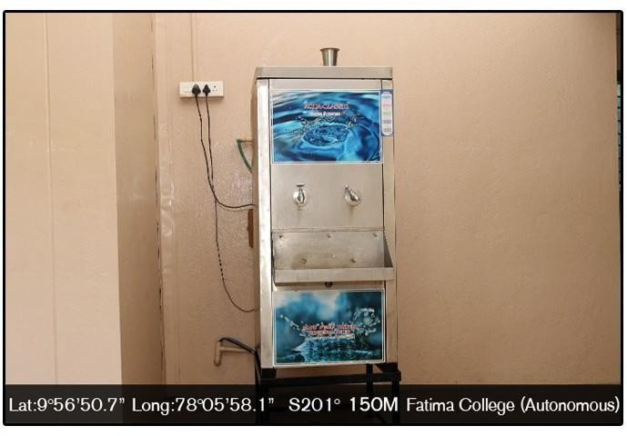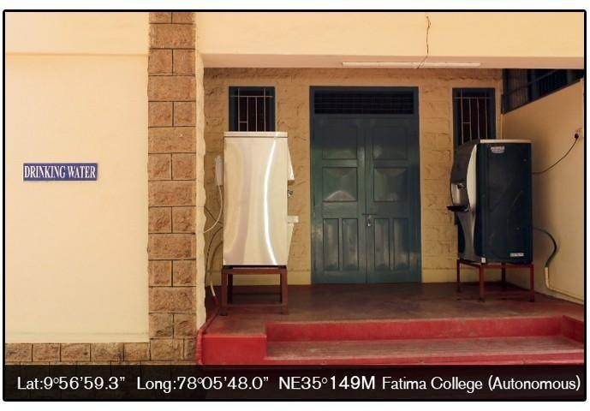

**RO in Hostel**

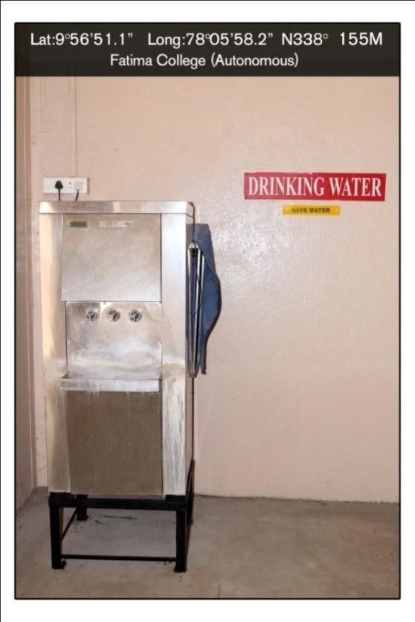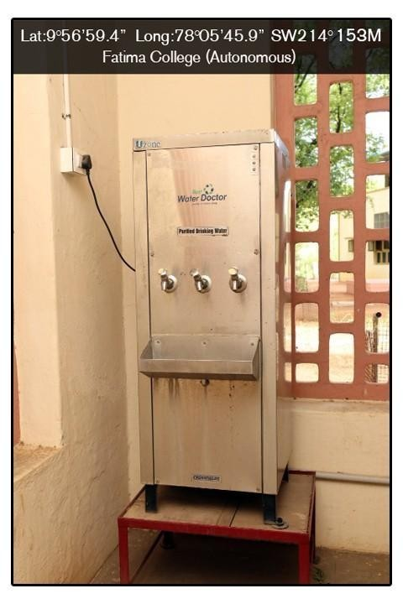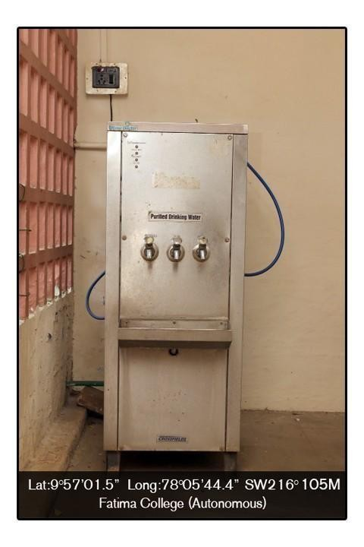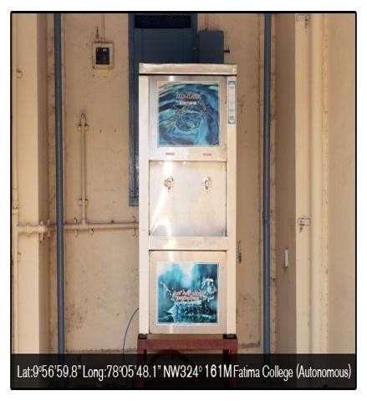

**RO reject water used for Garden**

