7.1.2
QnM | The Institution has facilities for alternate sources of energy and energy conservation measures  (5)
 | 1.Solar Energy | Yes
 | 2.Biogas plant | Yes
 | 3.Wheeling to the Grid | Yes
 | 4. Sensor based energy conservation | Yes
 | 5.Use of LED bulbs/ power efficient equipment | Yes

Solar Energy

Solar Power Panel

S.No | SolarPanel | Block
1. | On Grid9.9KW | Administrative Block
2. | On Grid10.24KW | Madona(Hostel)
3. | On Grid8KW | Amalita(Hostel)
4. | Off Grid1.93KW | Mareitta(Hostel)

Solar Pane l9.9 KW in AdministrativeBlock
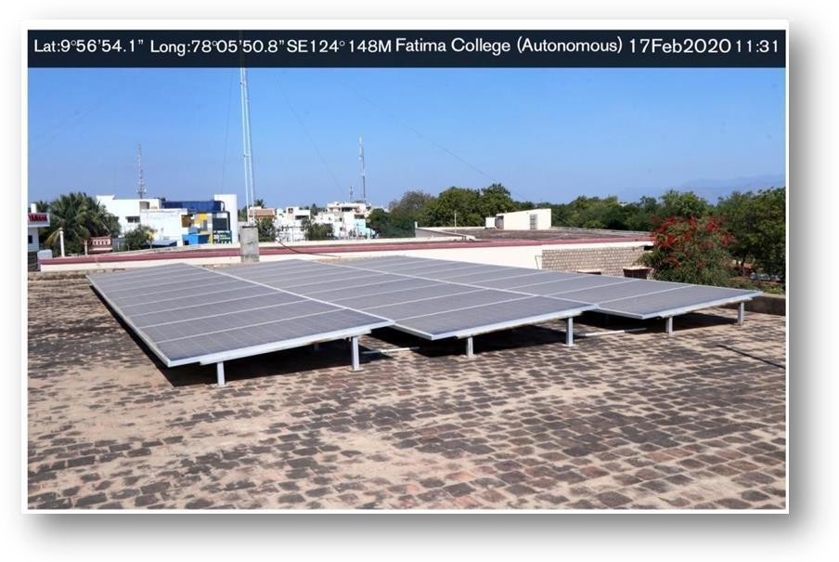

Solar Panel 10.24 KW in Madona Block-Hostel
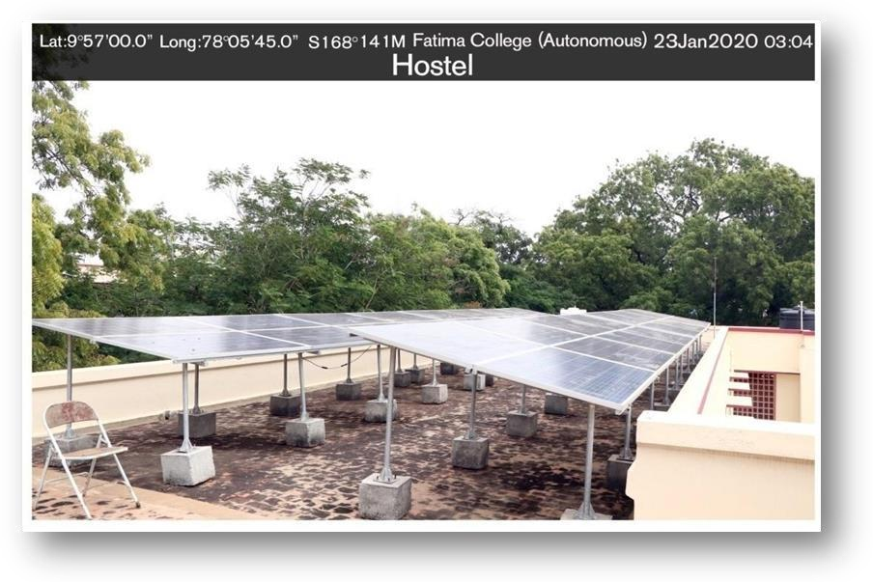
2
Solar Pane l8 KW in Amalita Block-Hostel
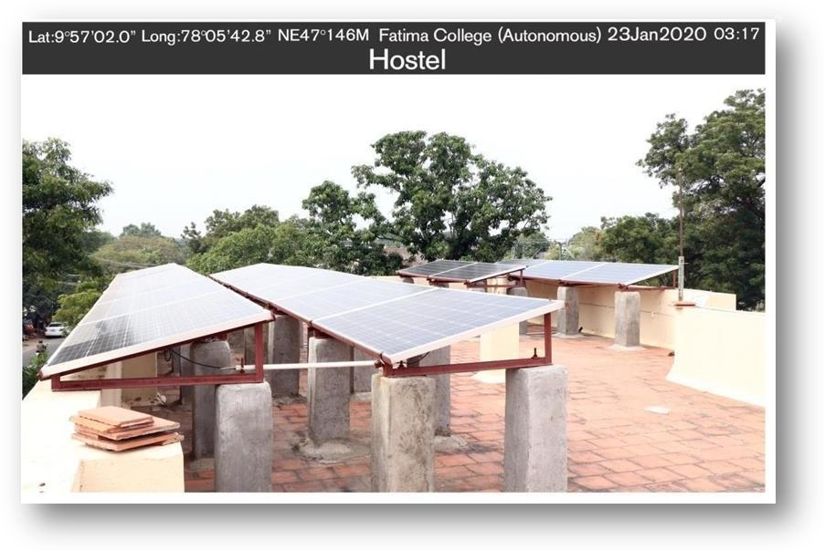

Solar Panel 1.92 KW in Marietta Block-Hostel
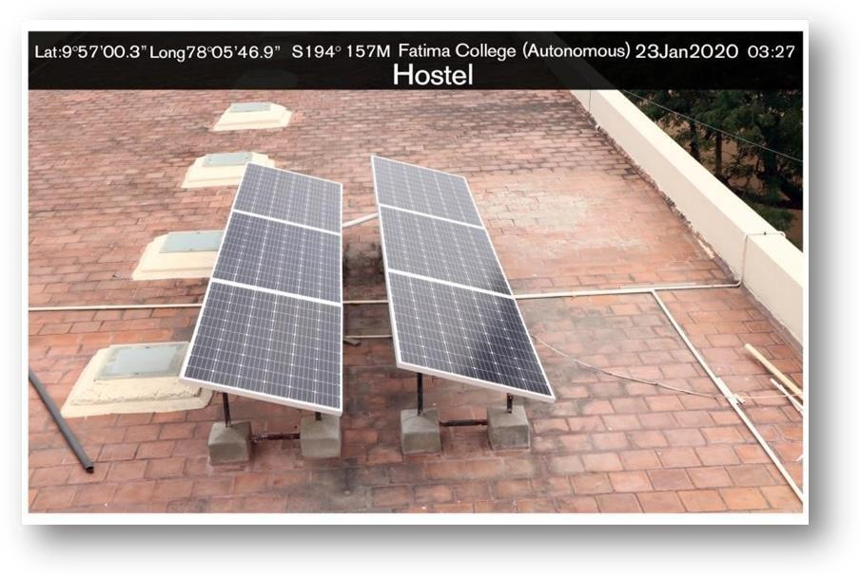
Solar panels Satellite Picture

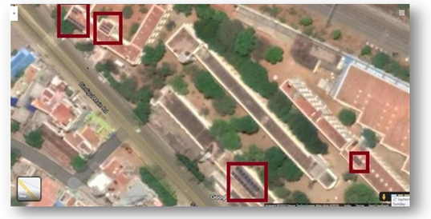

Total Number of Solar Street Lights=14

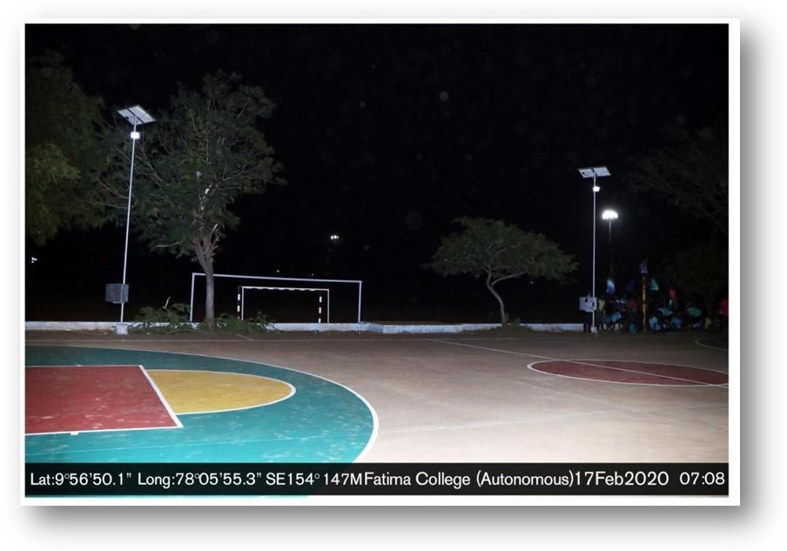
Solar Lights in Basket Ball Ground
Solar Light in Playground
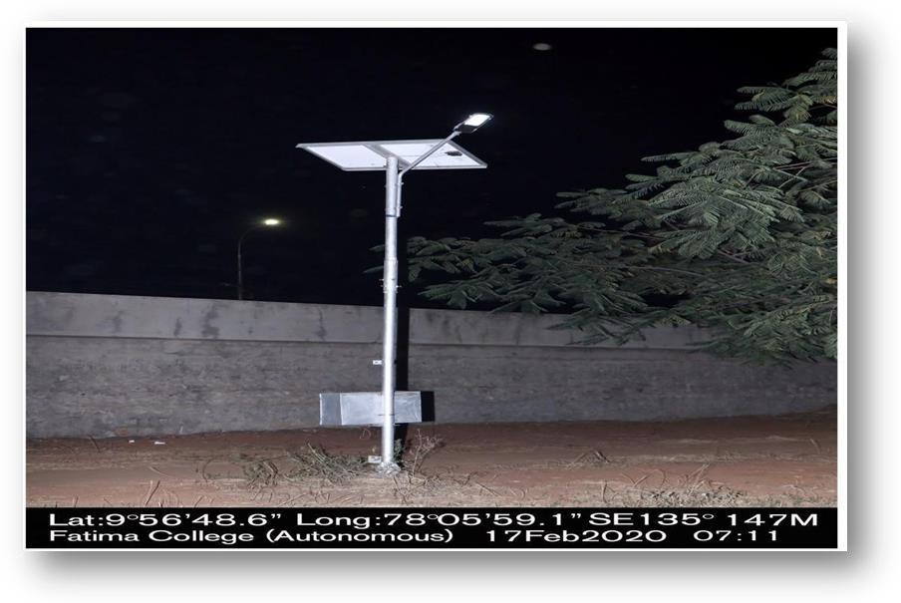

Solar Lights near Mother Rose Statue
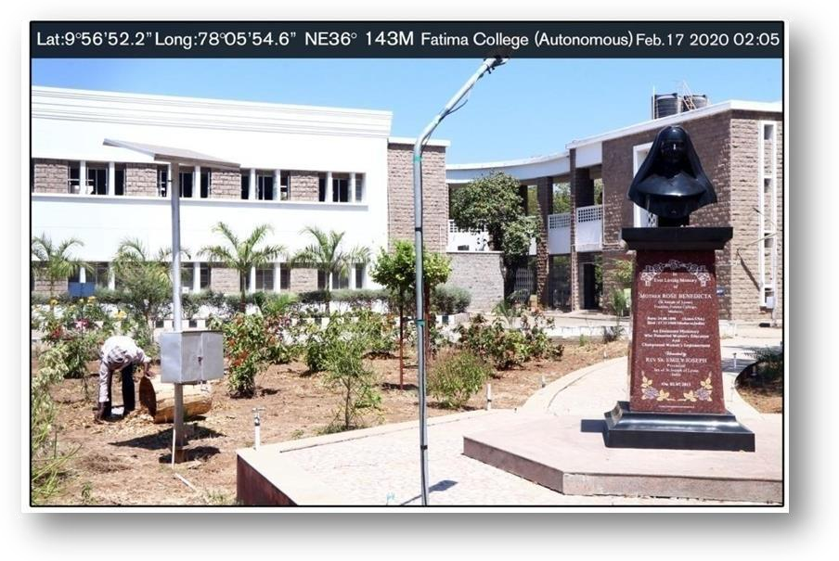

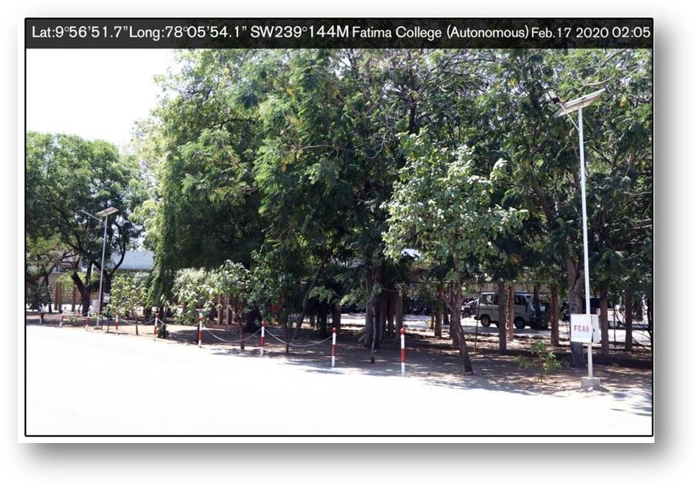
Solar Lights on the left side of college Entrance

Solar Lights on the right side of College Entrance
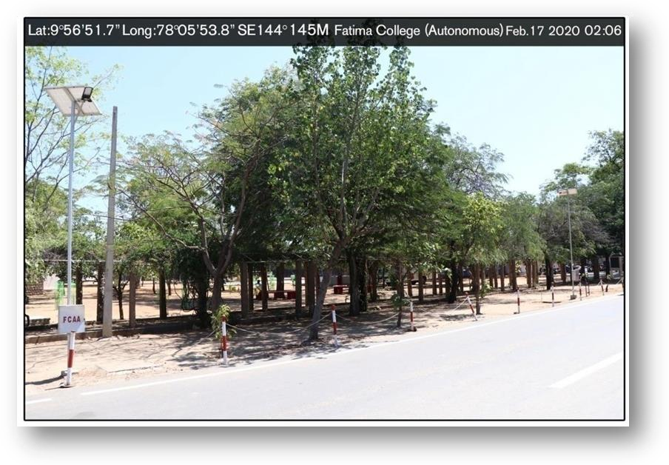

Solar Light near Basket Ball ground
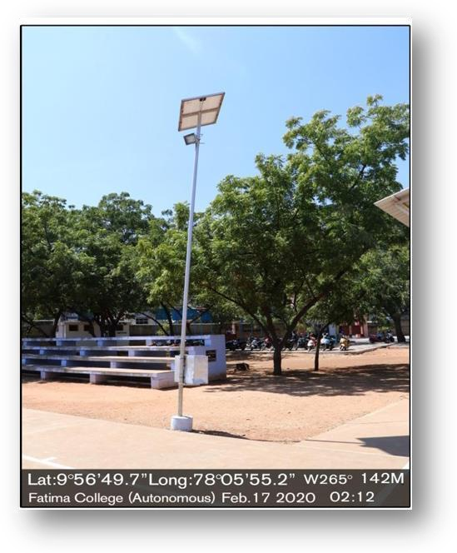
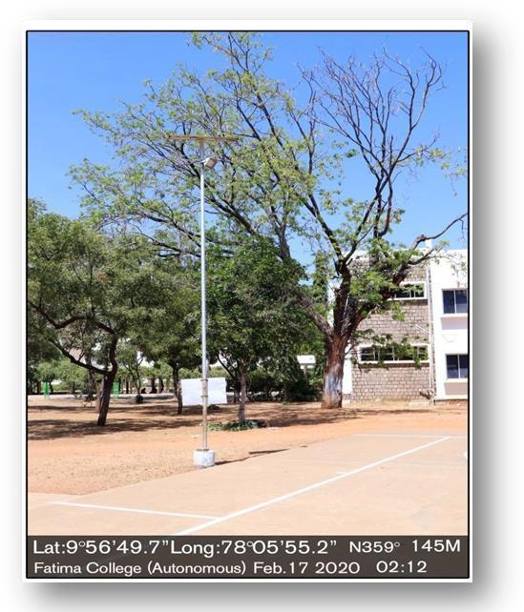
Solar light on the right side of Basket Ball Ground

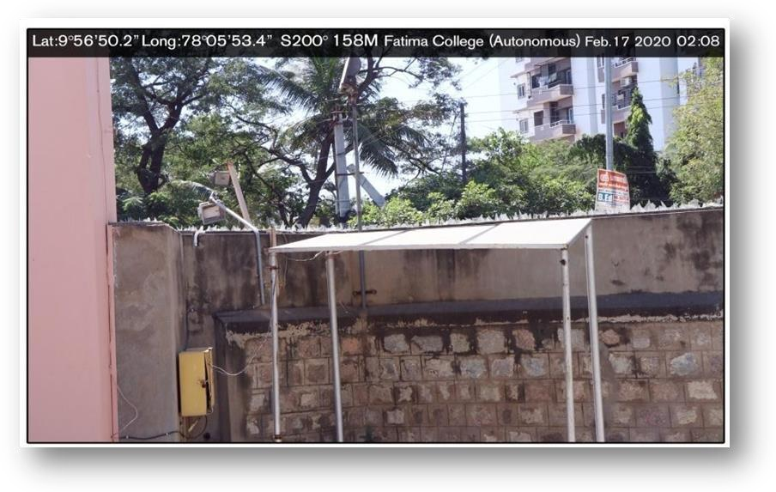
Solar Lights on the left side of Basket Ball ground

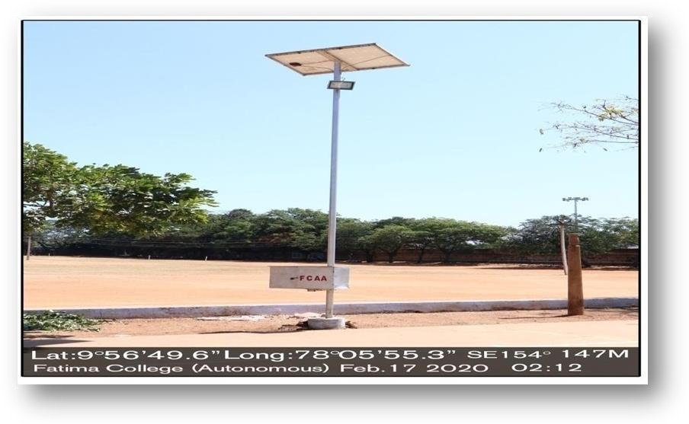
Solar Panel near college compound wall

Solar water Heater-150 Ltr Per day(Hostel)
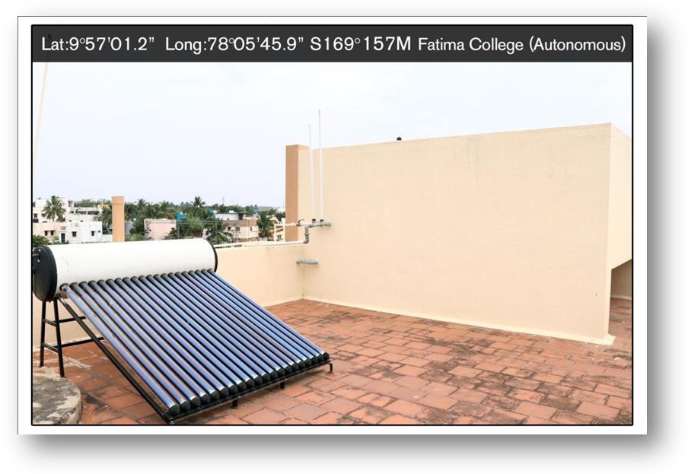

2. Biogas Plant–Output Capacity-20M3/day

Bio Gas Plant-Hostel
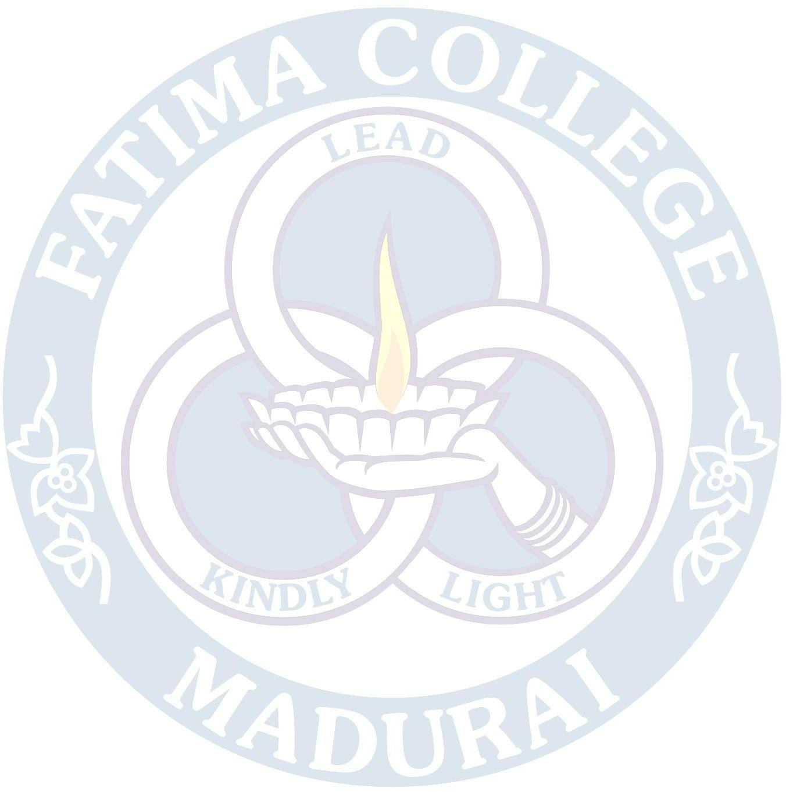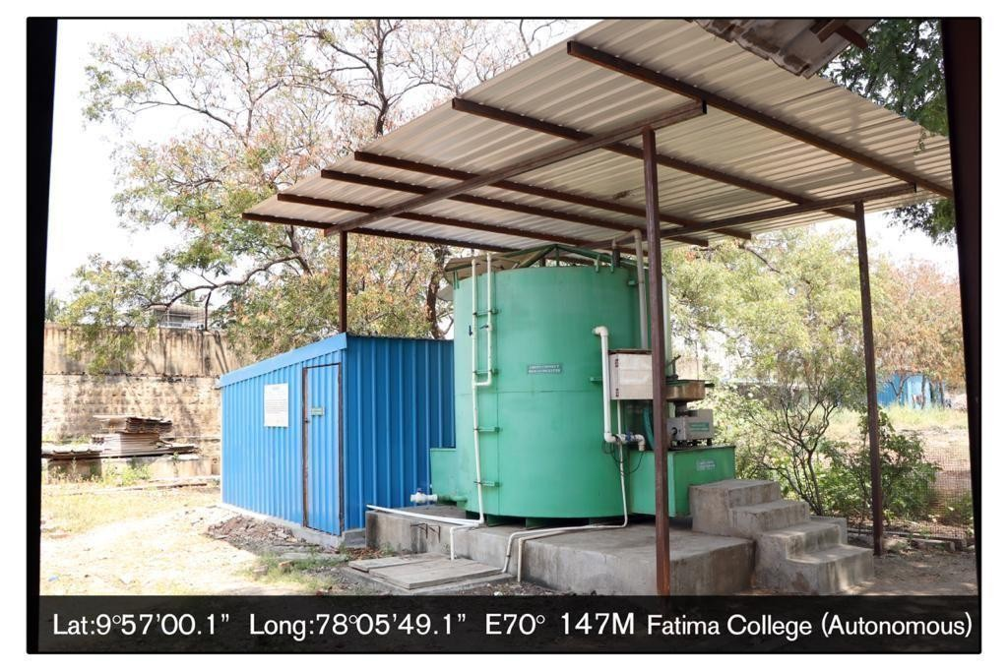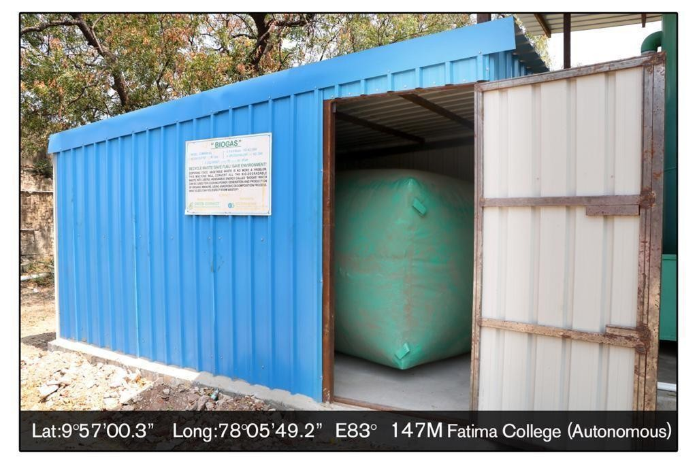
Bio Gas Balloon

Bio Gas Meter (Hostel Kitchen)
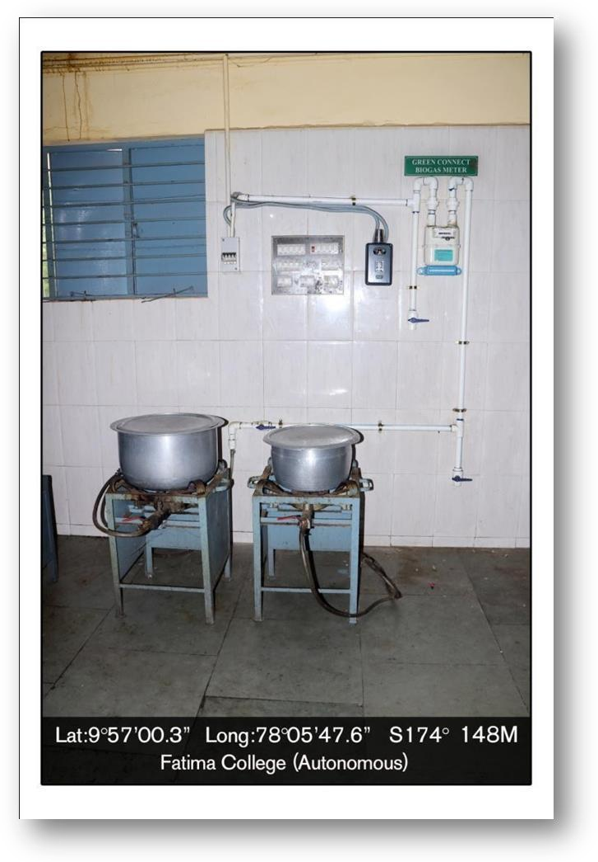

Wheeling to the grid

“Bi Directional Meter” for On grid solar roof top power plant-
Amalitta Block

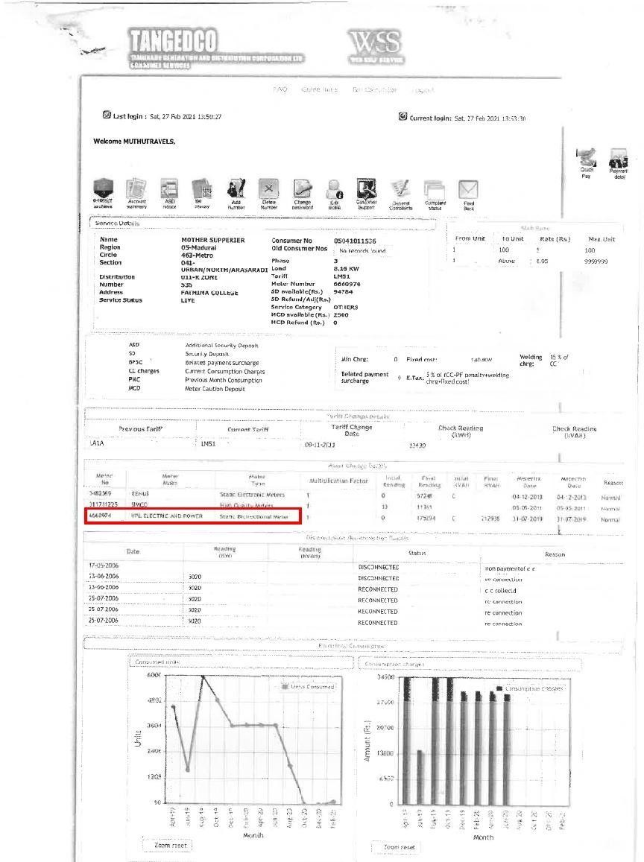

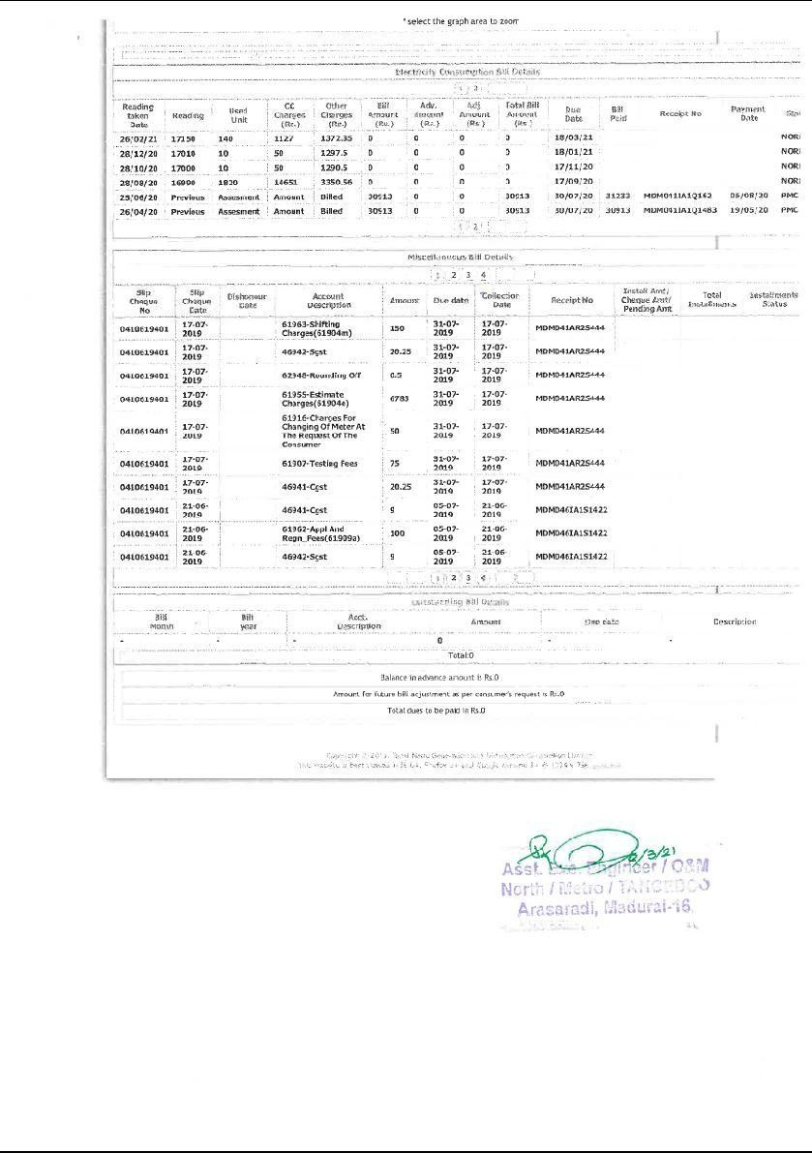

Summary stating “Bi Directional Meter” for On grid solar roof top
Power plant –Madona Block

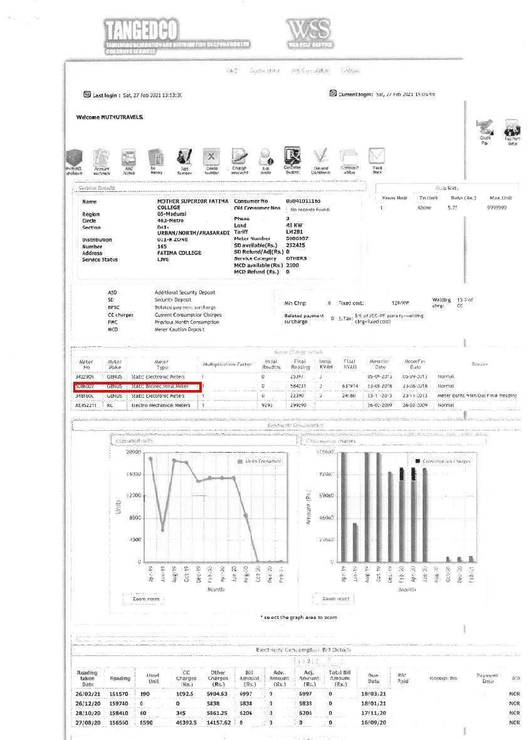

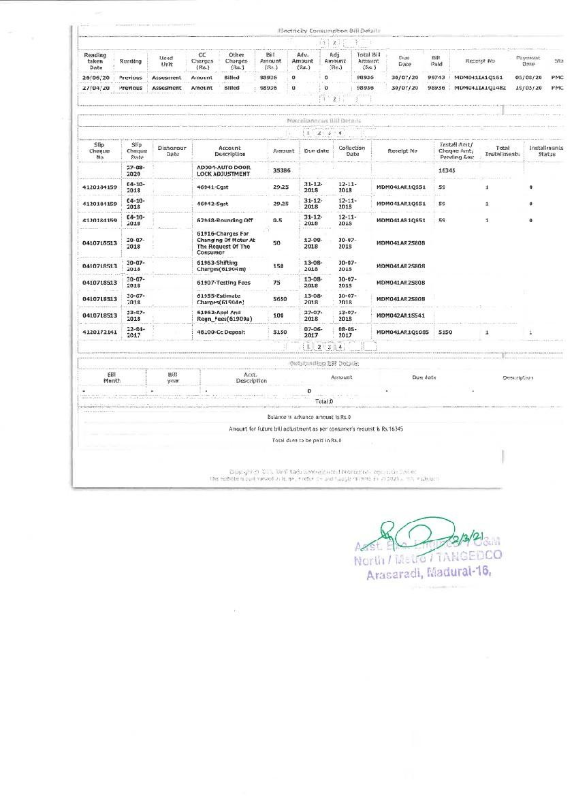

Wheeling to the grid (Export from the grid)
(Amalita Block) EB ServiceNumber:041-011-165

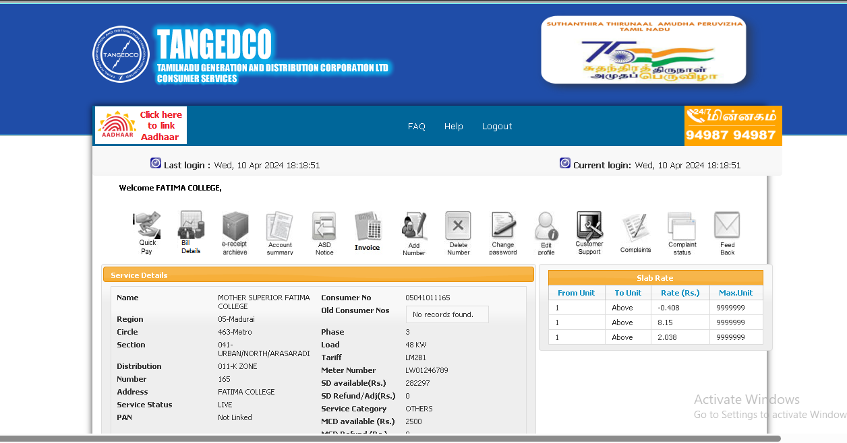

EB Service No:041-011-165 Export from the GRID (2022- 2023)
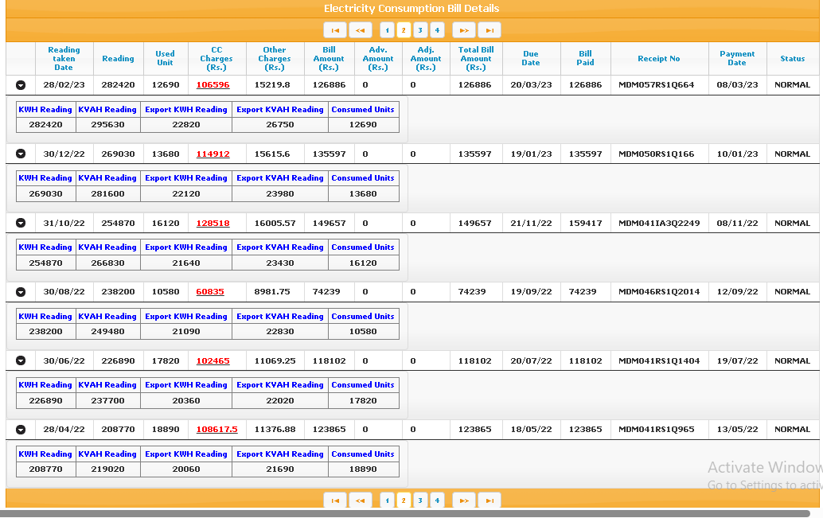

Wheeling to the grid (Export from the grid)
(Hostel Solar Room ) EB Service Number: 041-011-536
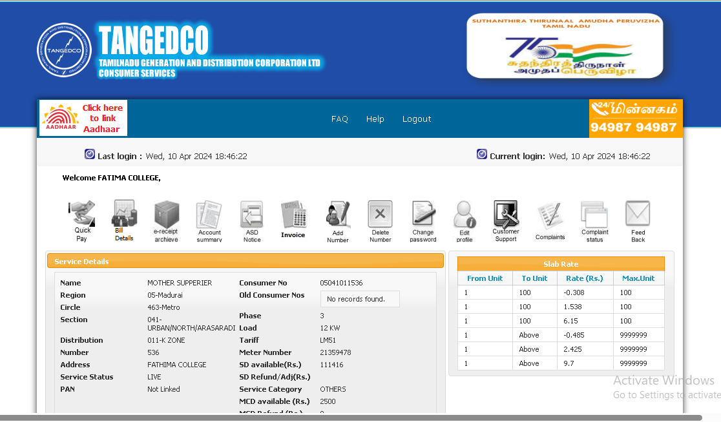

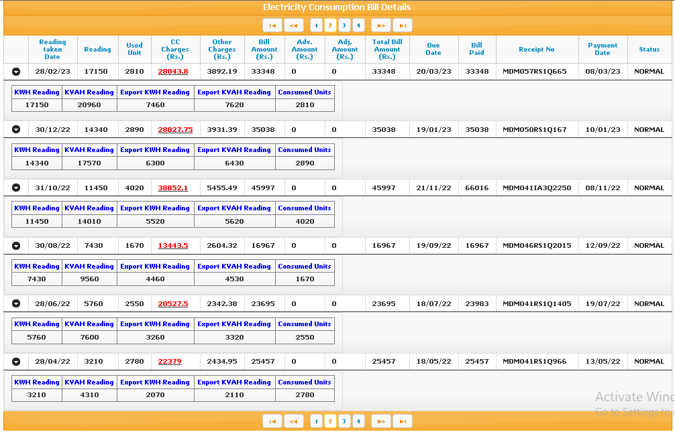
EB Service No: 041-011- 536 Export from the GRID (2021-2022)

Net meter (Near Physics Lab)
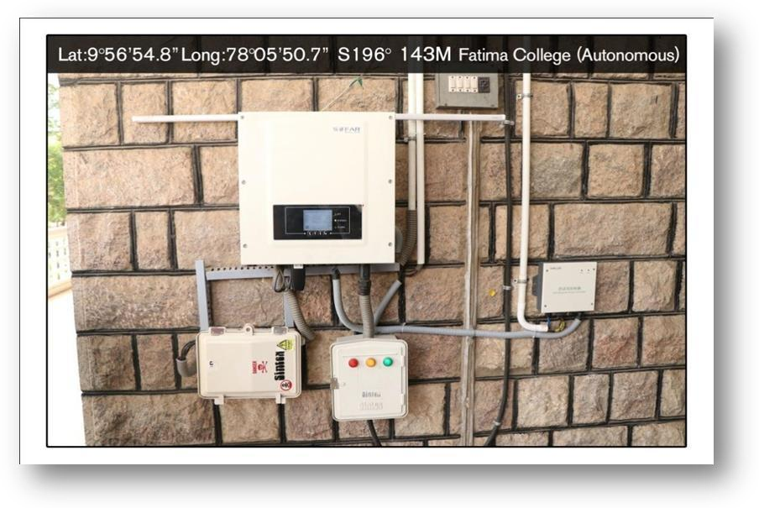

Net Meter Readings for July -2022

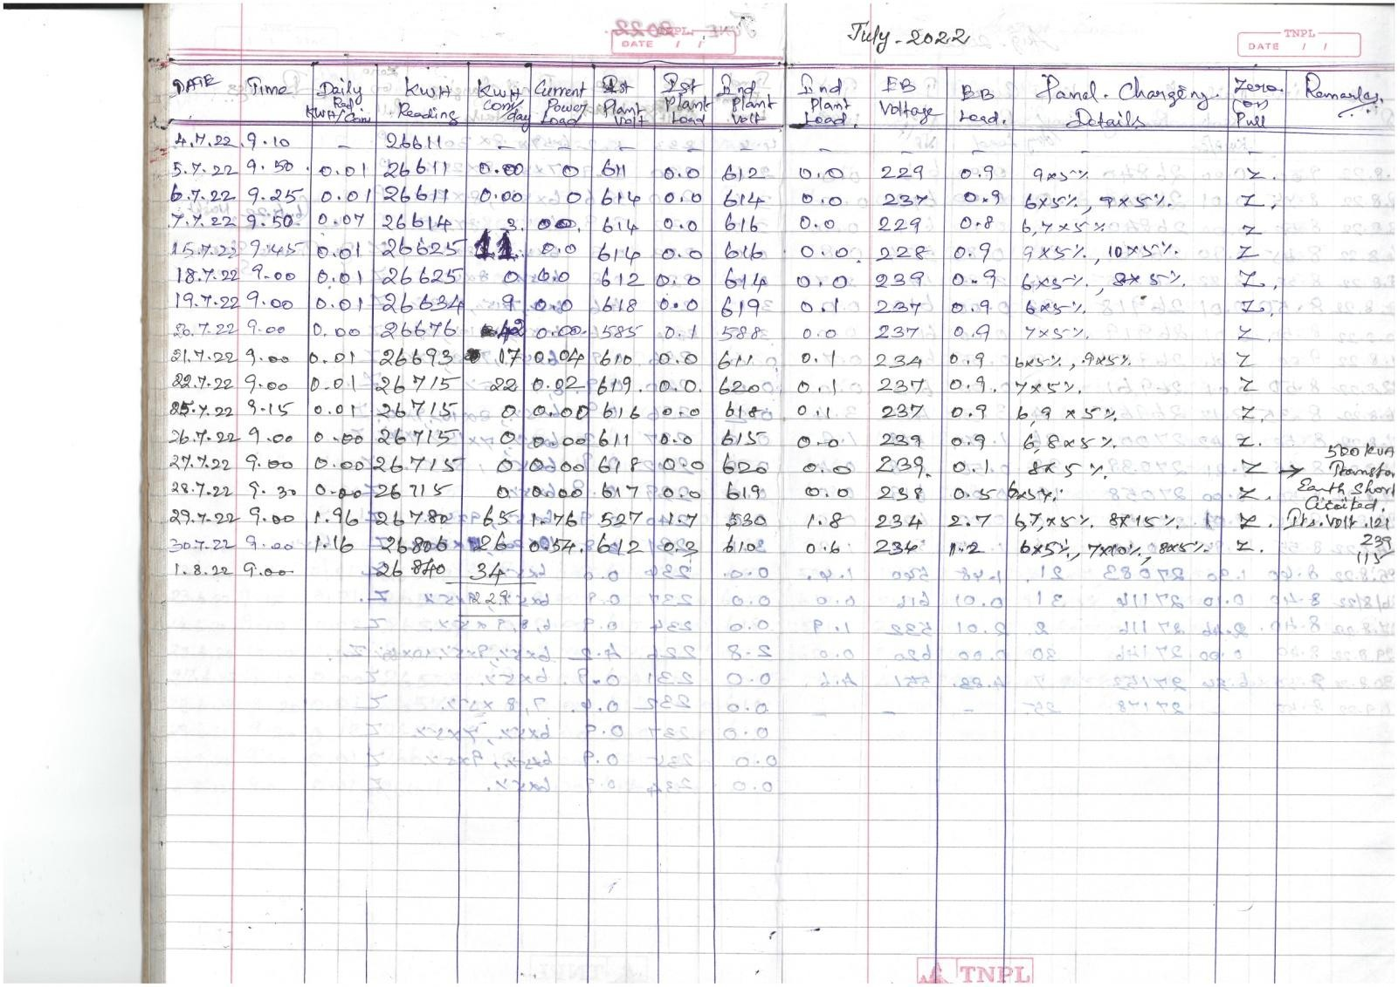

Net Meter Readings for August -2022
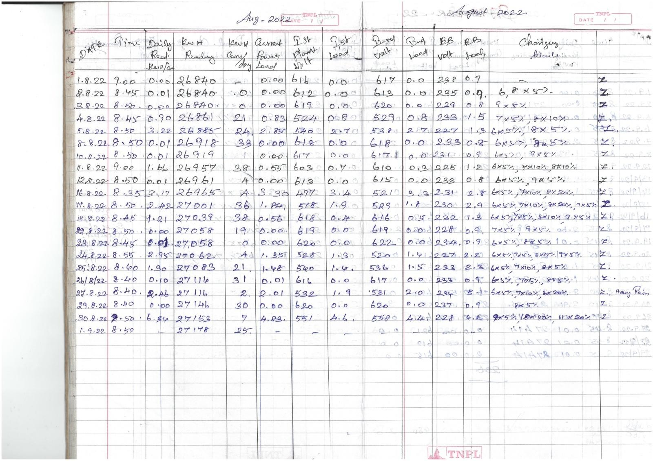

Net Meter Readings for September- 2022

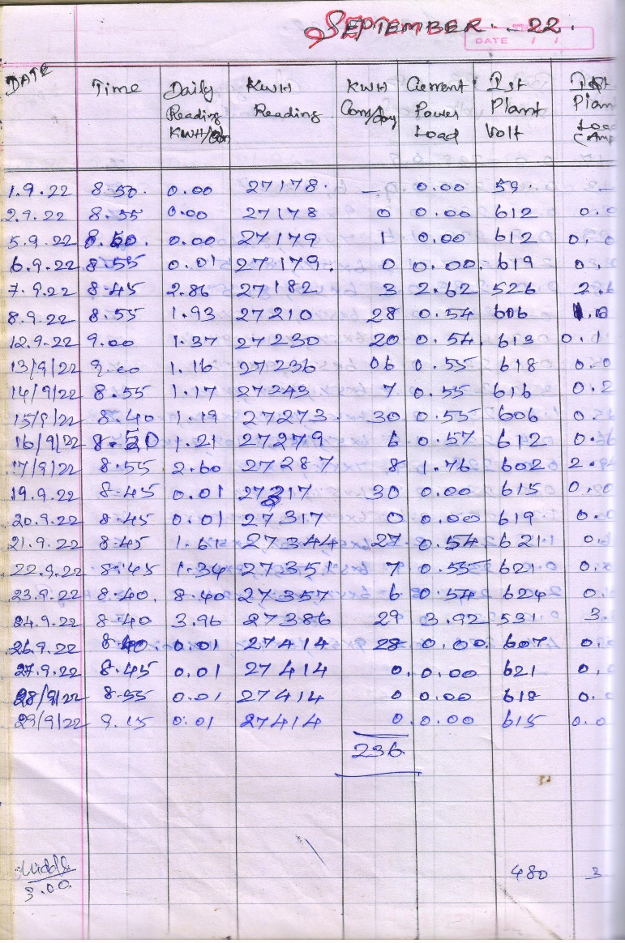
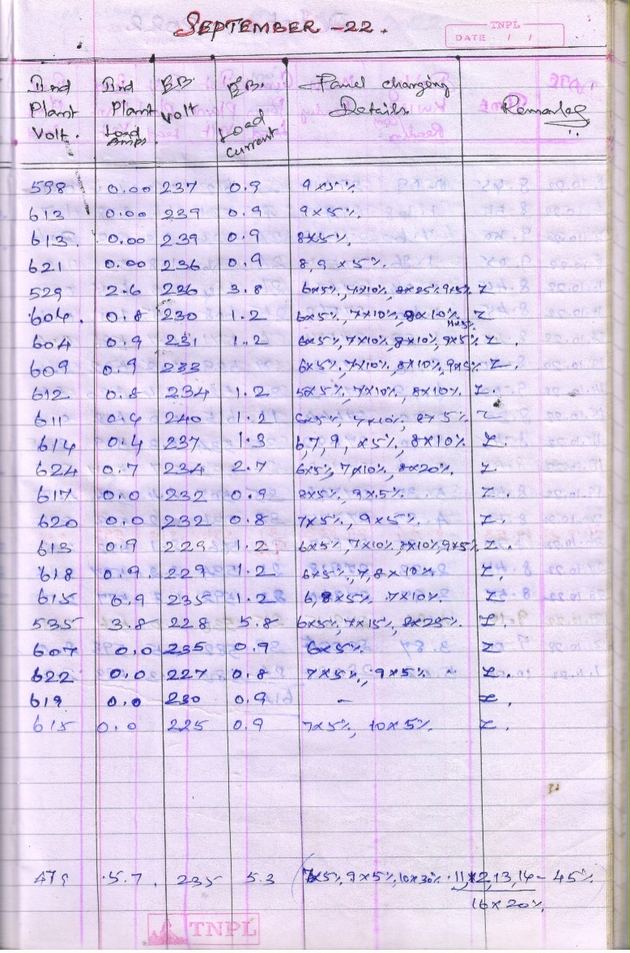

Net Meter Readings for October -2022

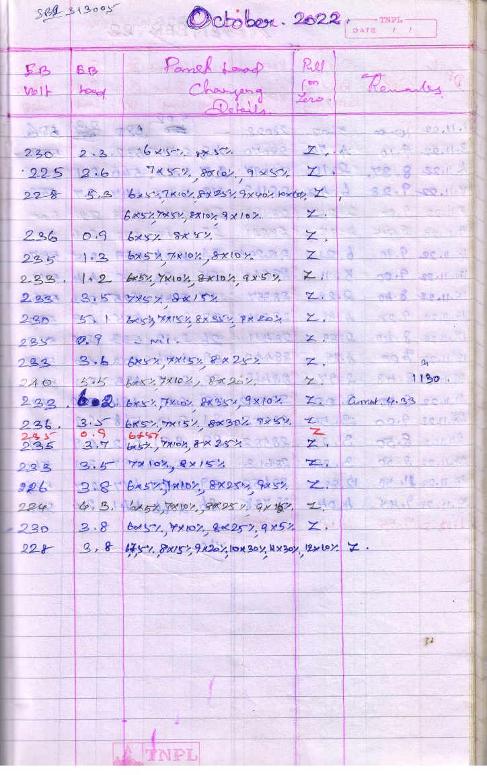
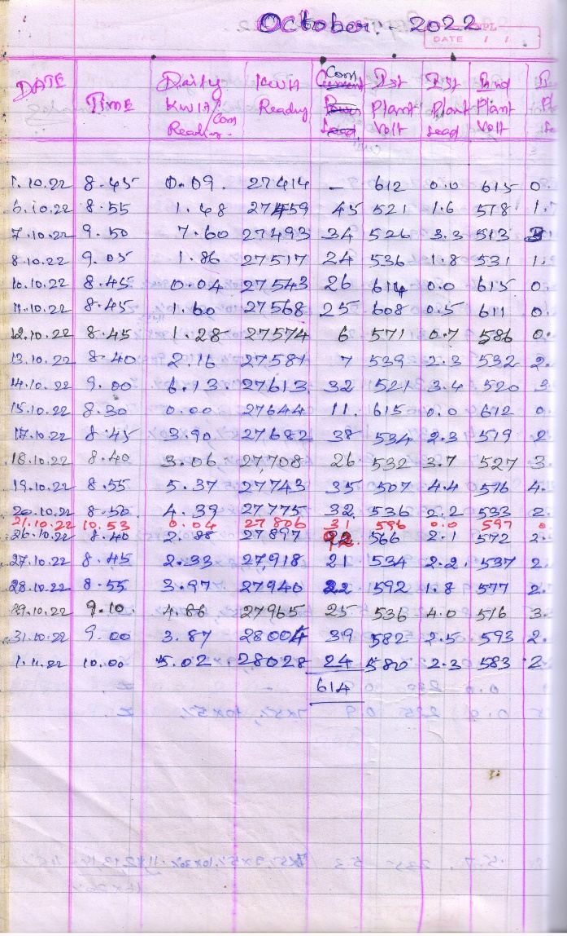

Net Meter Readings for November -2022

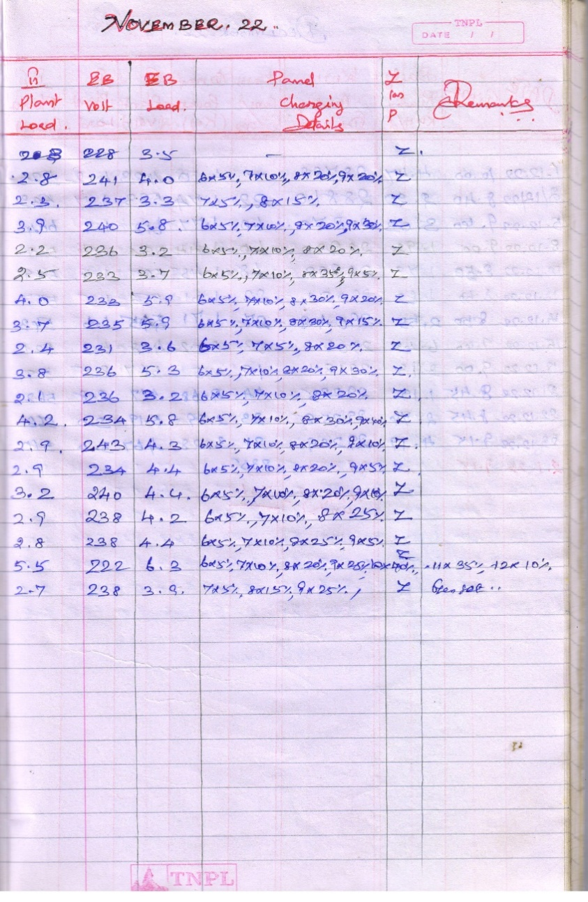
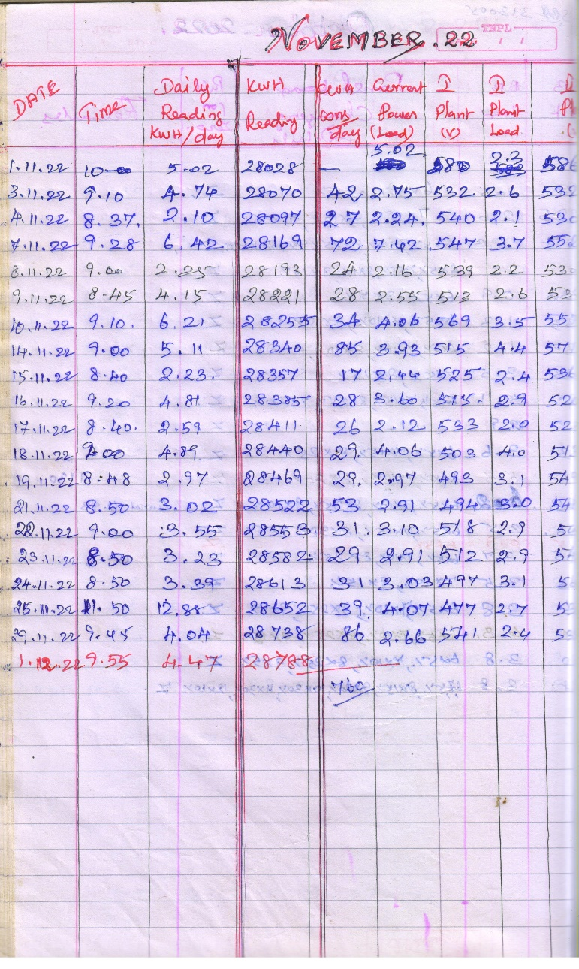

Net Meter Readings for December - 2022

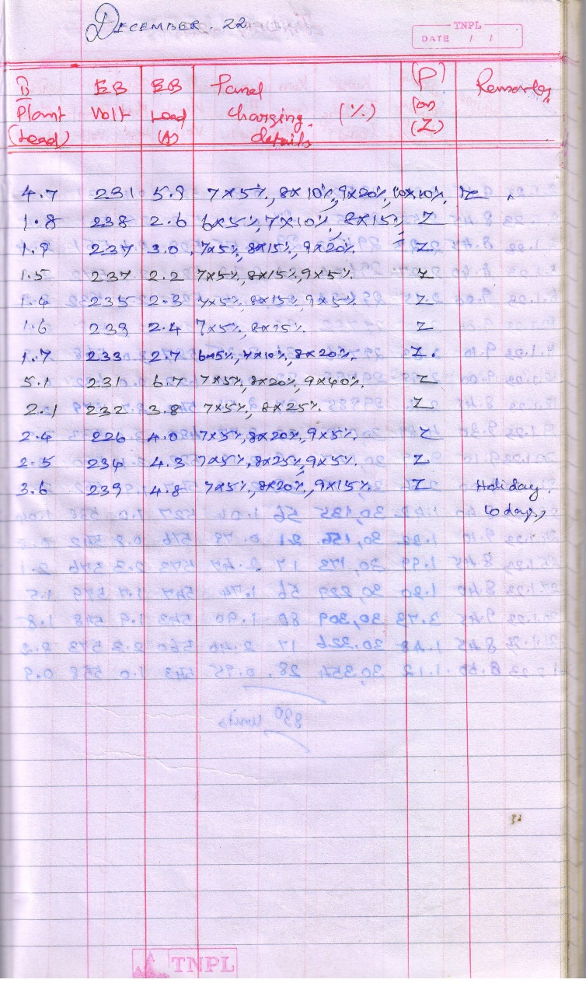
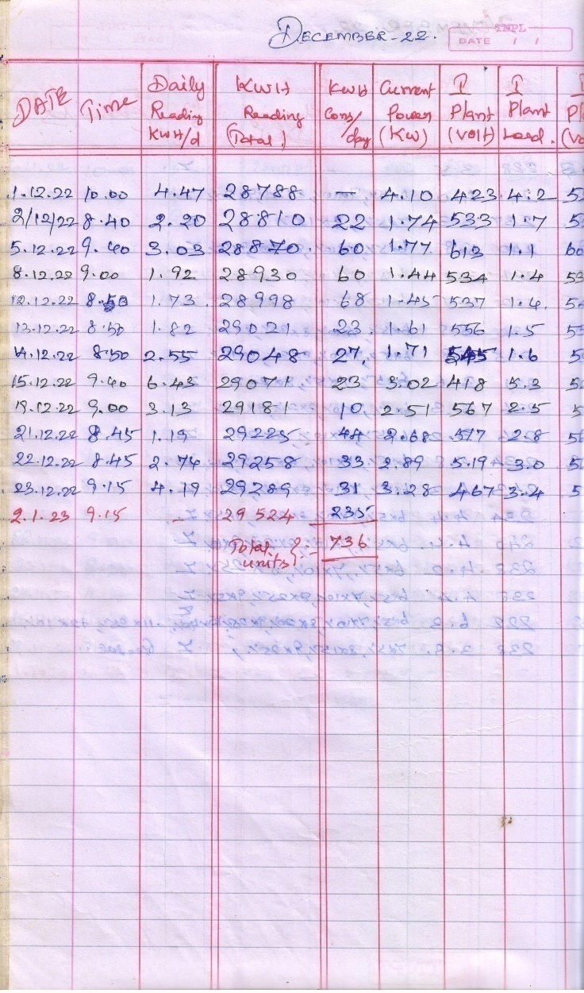

Net Meter Readings for January -2023

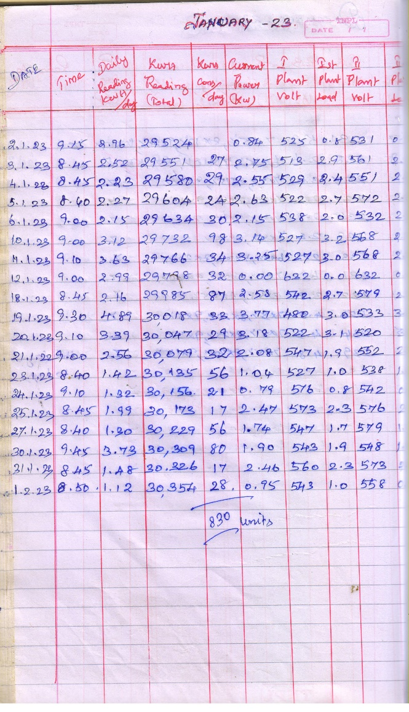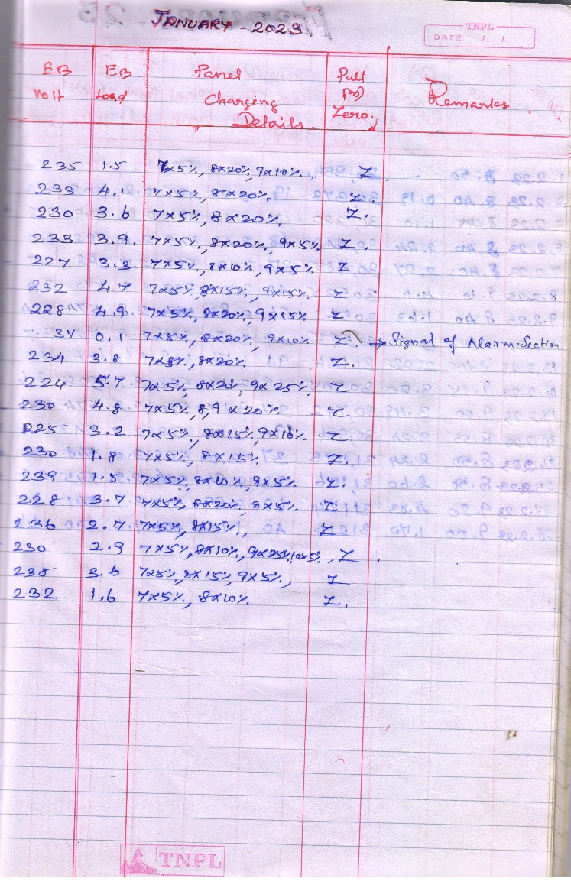

Net Meter Readings for February 2023

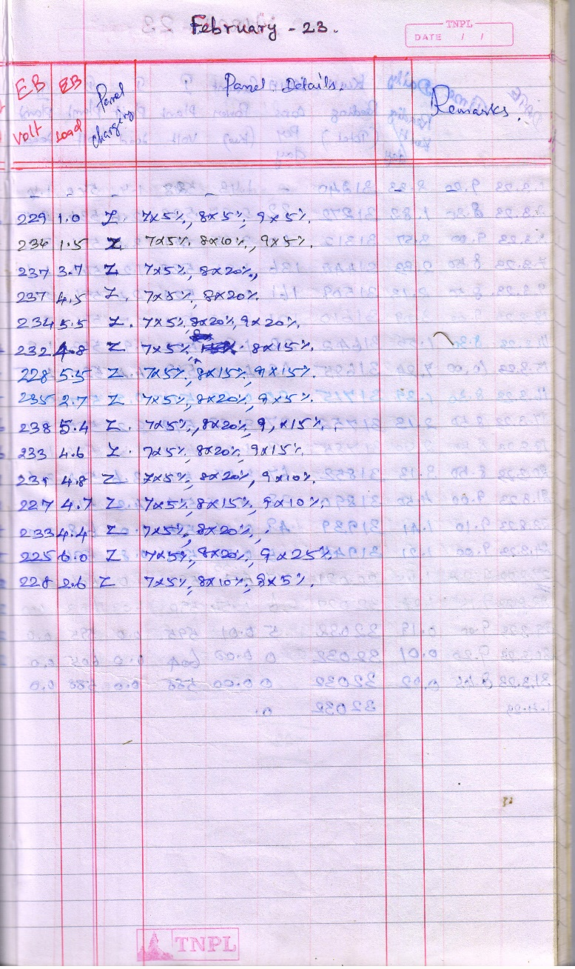
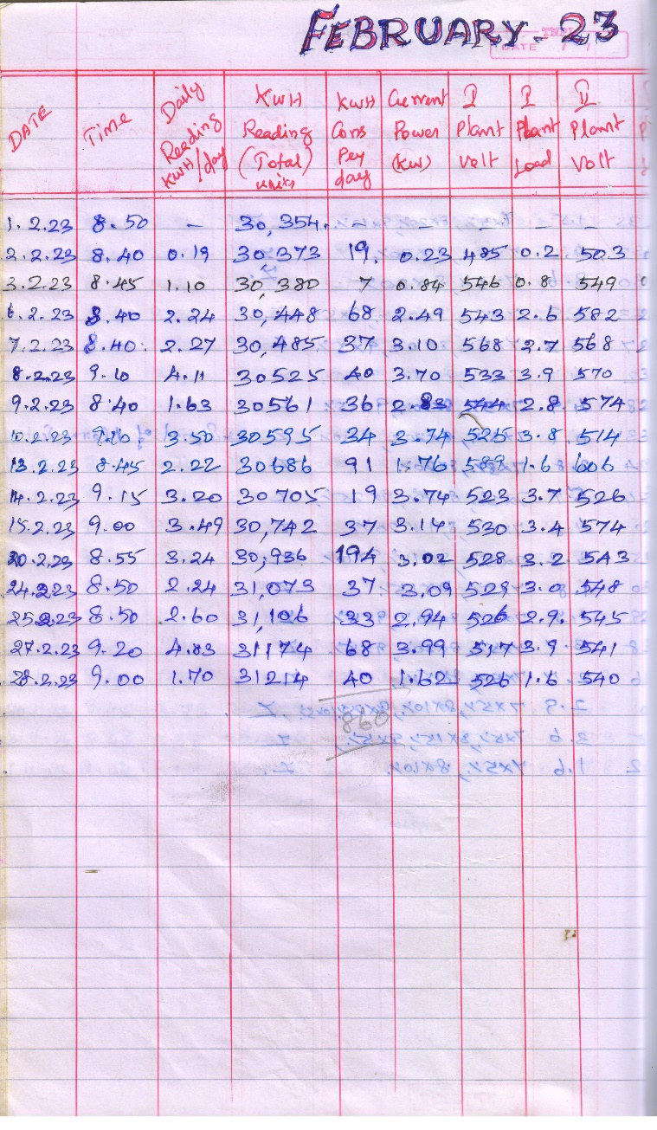

Net Meter Readings for March -2023

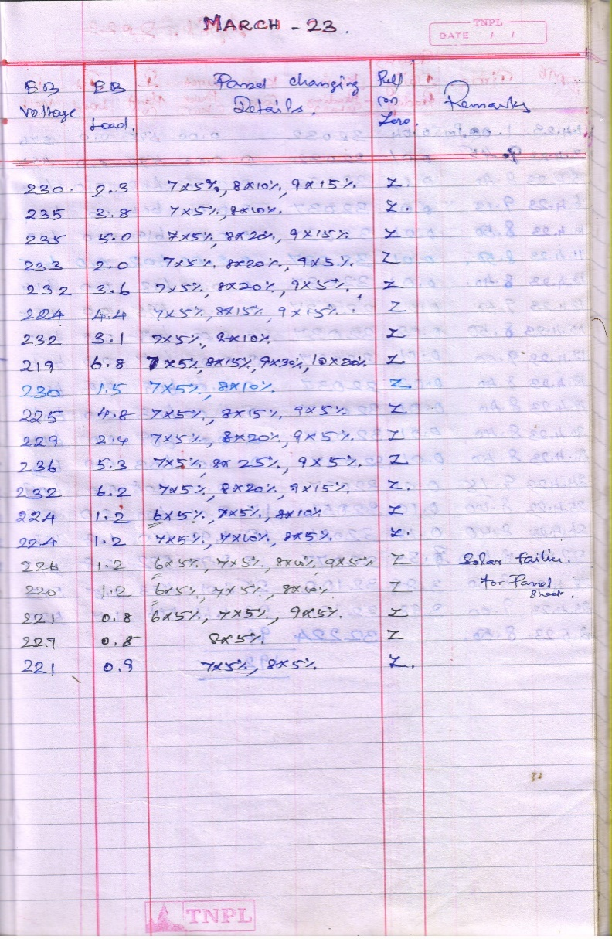
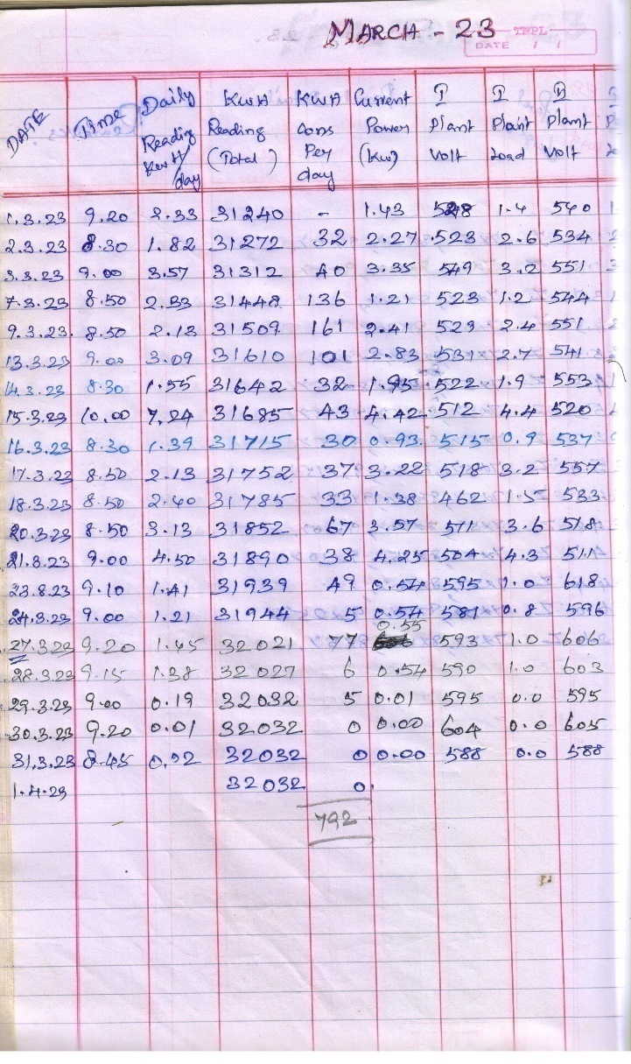

Net Meter Readings for April - 2023

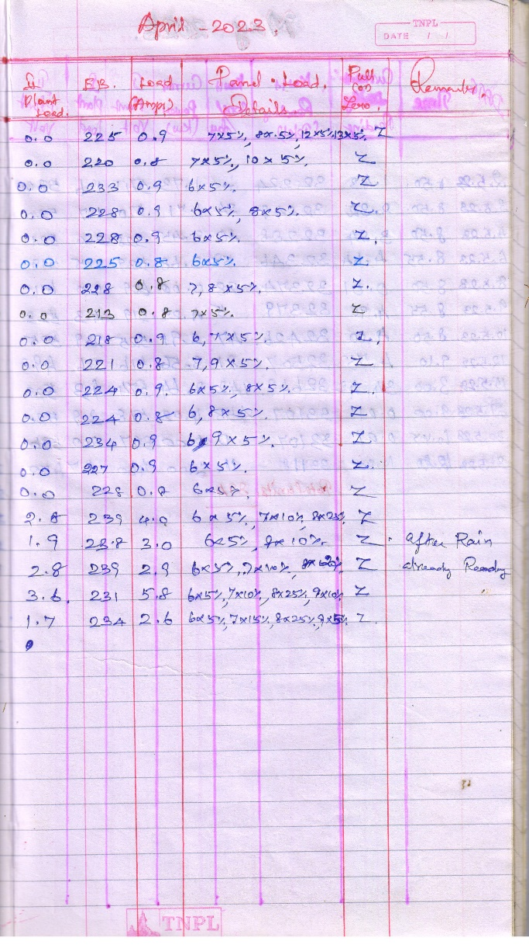
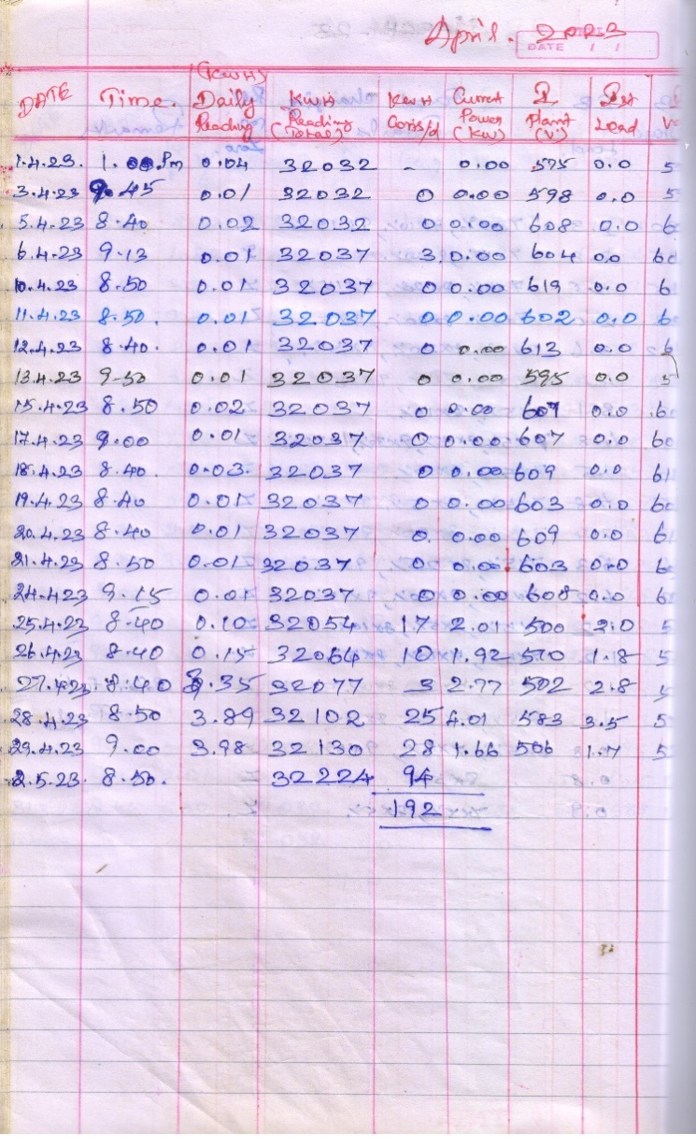

Net Meter Readings for May - 2023

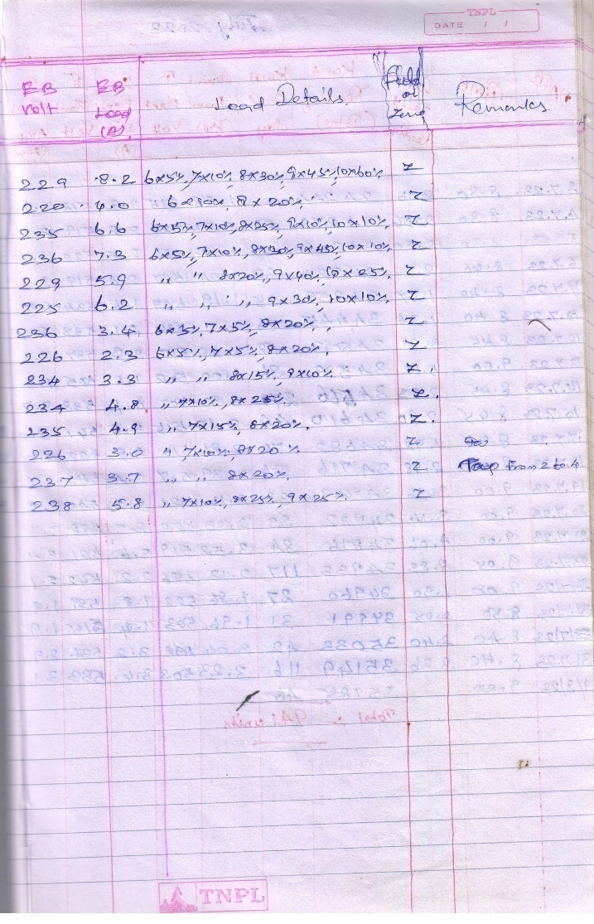
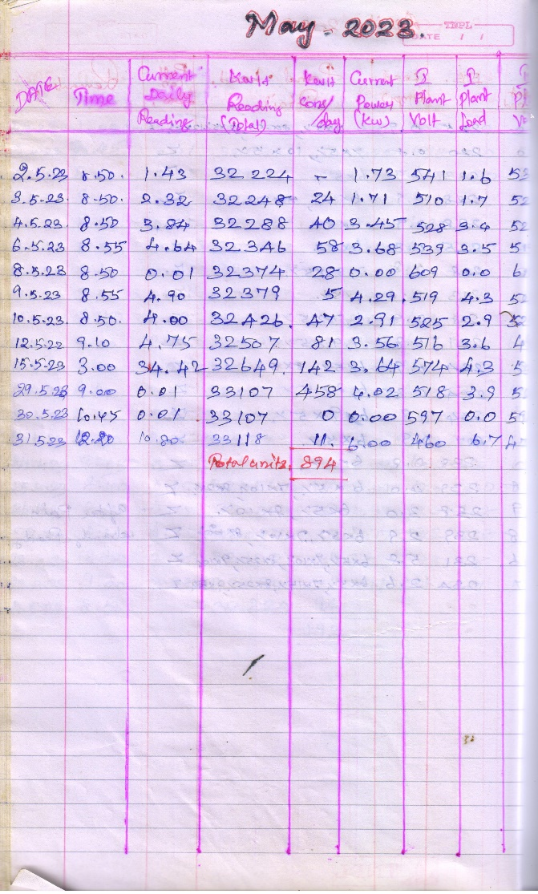

Net Meter (Hostel)
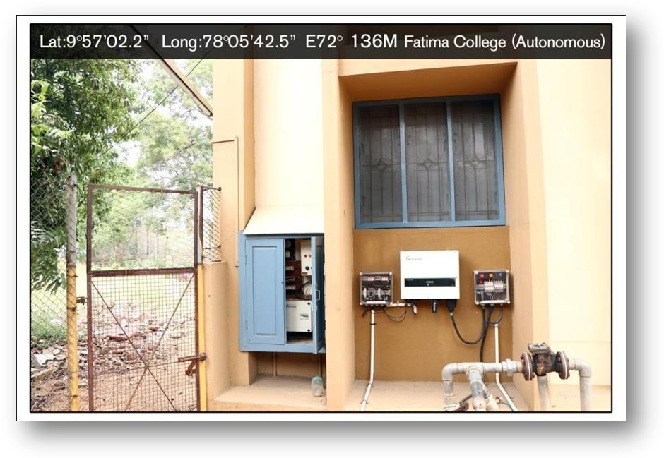

- Sensor Based Energy Conservation

S.No | Items Designed by UG Physics Students
1 | Automatic light for rest room
2 | Water tank over flow alarm
3 | Fire alarm

- Use of LED bulbs / Power efficient equipment

S.No | Block | Energy Saving Super fans | LED  Lights
1 | Admin Block Office | 48 | 57
2 | Admin Block Left Wing | 65 | 107
3 | Admin Block Right Wing | 33 | 96
 | Total | 146 | 260

List of LED Bulbs and Energy saving super fans in college Campus

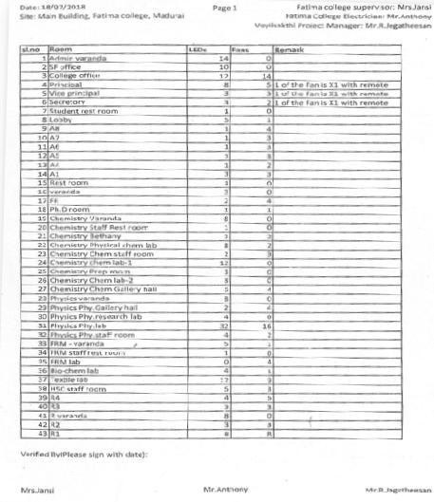

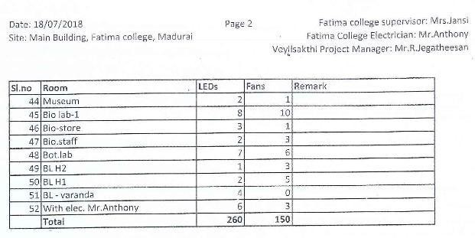
List of LED Bulbs and Energy saving Super fans in Hostel

Block | LED  lights | Fans
Amalita | 55 | 45
Loretta | 50 | -
Marysown | 22 | -
Madona | 22 | -
Meritta | 10 | -
Pinkroom | 6 | -
Dinninghall | 40 | -
CommonToilets&  Bathrooms | 100 | -
Office | 6 | 2
Annunciata | 15 | -
Total | 326 | 47

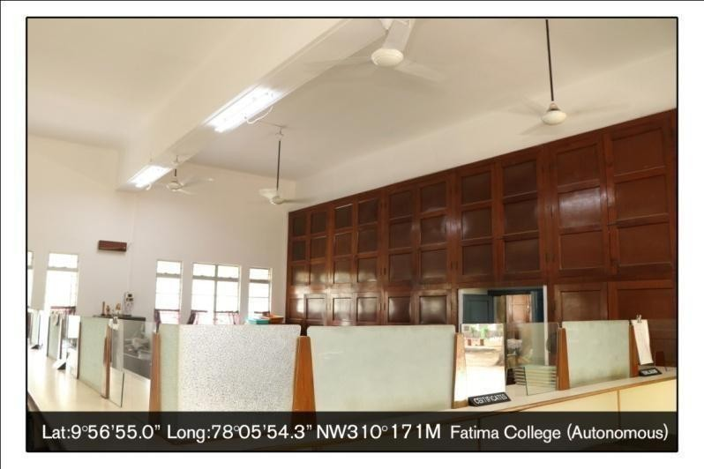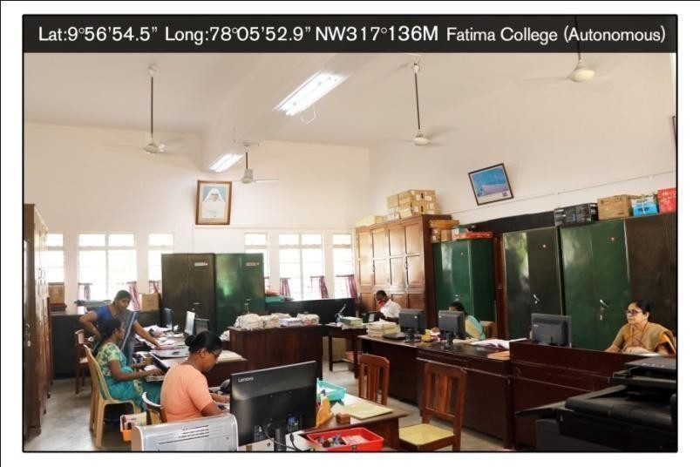

LED lights and Energy Saving super fans in the Administrative
Block

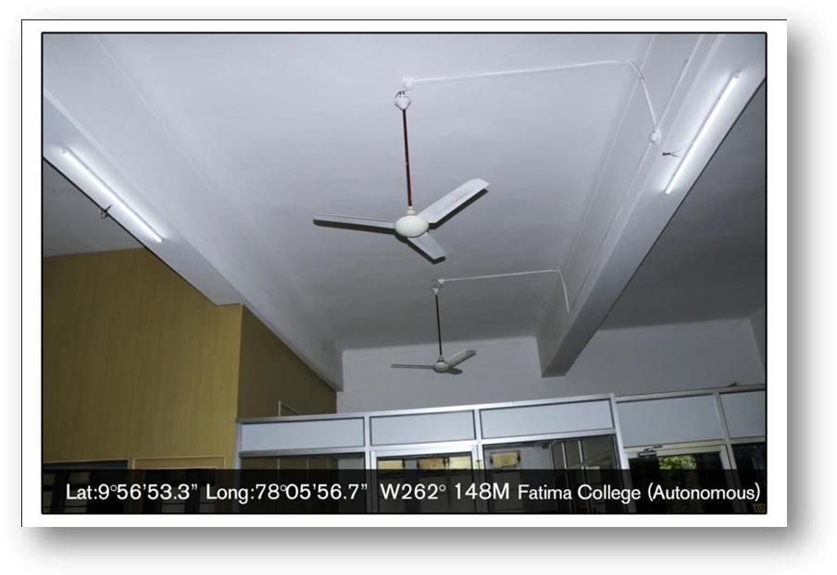

LED Lights in Hostel
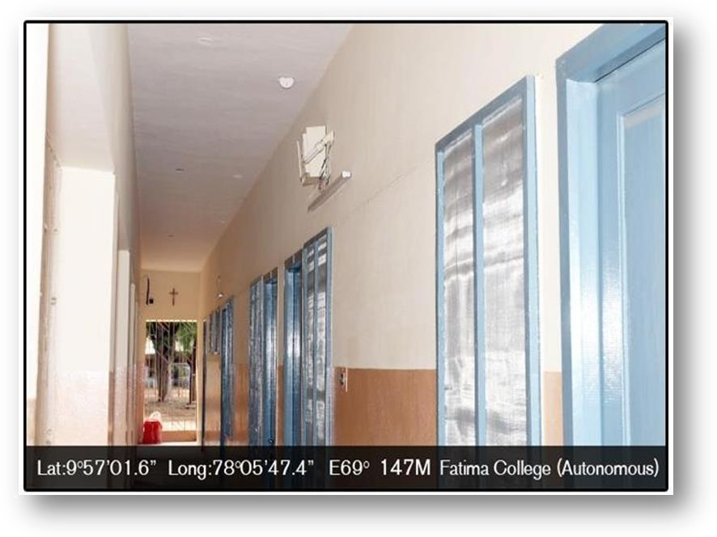
Energy Saving super fans in Hostel
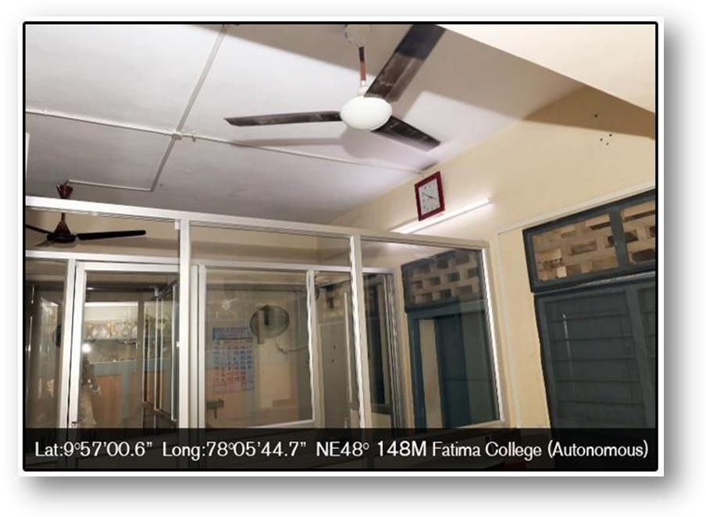

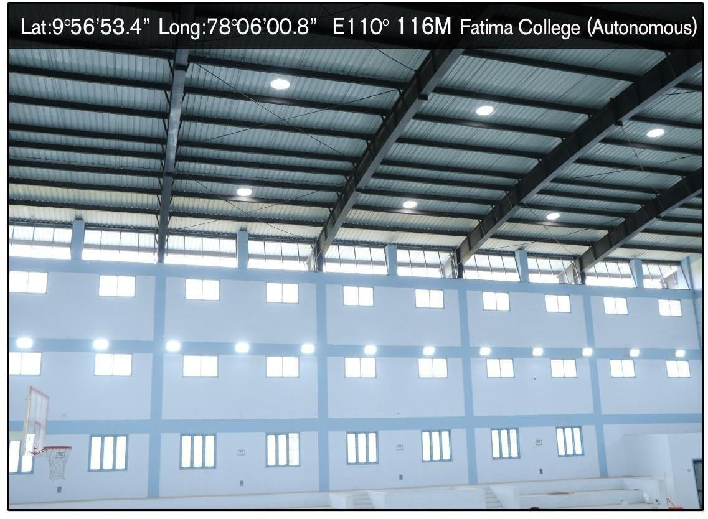
LED Lights in Indoor Stadium

