**Annual Awareness Programme on Code of Conduct for Students**

## (Printed in the College Handbook)

**College Hand book with code of conduct related to Examinations system and general discipline is circulated to all stakeholders. The management calendar committee officials finalise and decide upon the code of conduct enumerated in the handbook.The entire code of conduct is reinforced on the parents teachers meet,I year Orientation and Induction Programme Every year.**

**Type of Annual Awareness Awareness Created on Code of Conduct Programme**

1. Student Induction Programme (July 25,2022-August 1,2022)
2. Parents–Teachers Meeting
3. Exam related code of conduct Awareness given during semester Exam

**I year UG, PG, ProfessionalCourse students are briefed about the culture of Fatima College and the kind of conduct expected of the students as a Fatimite**

**Information on Code of Conduct meant for**

**Students is shared with the parents in the presence of students.**

**Every day during exam, announcement on code**

**of Conduct is given for the students through**

**Intercom.**

**Fatima College (Autonomous), Madurai**

**Schedule from July 25 to August 04, 2022**

**Student Induction Programme (DEEKSHARAMB) - July 25 to August 01, 2022**

**organized by IQAC**

|  |  |  |  |  |  |  |  |  |
| --- | --- | --- | --- | --- | --- | --- | --- | --- |
| **Date / Time** | **08.30 – 9.00 a.m.** | **09.00 – 10.15 a.m.** | **10:15-10:45** | **10:45-11:45 (SIP – Session I)** | | | **11.45 am – 1:00 p.m.** | |
| **25.07.2022**  **(Monday)** | **Attendance**  (Before Administrative Block) | **Orientation Program** | **Break** | **The Journey Begins - Dr. S. Saira Banu**  Associate Professor of English & Head, Dept, of JMC  **Binary University -Dr. Sr. J. Arul Mary**  Assistant Professor of Chemistry and Chief  Warden, Fatima College Hostel  **Being a Fatimite - Ms. Deepthika**  Treasurer, Student council | | | **English Attainment Test (EAT)** | |
| **08.30 - 9.00 a.m.** | | **9.00- 10.30 a.m.** | | | | | **10.30 – 10.45 a.m.** | **10.45 - 01.30 p.m.** |
| **26.07.2022**  **(Tuesday)** | Major wise Attendance (Dept. Should Take care) | **SIP - Session-II– Holistic Formation at Fatima Dr. S. J. Kala**  Associate Professor of English | **SIP- Session-III - Activities**  **Ms. A. Sheela Roselin**  Assistant Professor of Mathematics | | **10:00 – 10:30AM**  **Campus Tour** | | **BREAK** | **Bridge Course – I UG**  **10.45 – 11:40 a.m.**  **11:40 – 12:35 p.m.**  **12:35 - 1:30 p.m.** |
| **27.07.2022**  **(Wednesday)** | **SIP - Session-IV – Quality Standards**  **Dr. S. Vidya**  Associate Professor of Computer Science | **SIP- Session-V - Fitness**  **Dr. G. Velankanni Matharasi** Directress of Physical Education | | | |
| **28.07.2022**  **(Thursday)** | **SIP - Session-VI – Finding Yourself Through Community Service   Dr. M. Ragam Dr. R. Ponni**  Assistant Professor of Physics Assistant Professor of Tamil (SF) | | | **SIP- Session-VII**  **Rosa Mystica Library: An Overview**  **Dr. C. Sujatha,** Librarian | |
| **29.07.2022**  **(Friday)** | **SIP - Session-VIII**  **Making the Best Out of Challenges**  **Dr. Sr. Jenita**  Vice Principal (Shift II) | **SIP - Session-IX**  **Exploring Talents through Cultural Activities**  **Dr. M. Pappa** Assistant Professor of Tamil | | **SIP - Session-X**  **Environment:  Be Aware & Awake**  **Dr. G. Revathy** Assistant Professor of Tamil | |
| **30.07.2022**  **(Saturday)** | **SIP- Session-XI**  **Dimensions for Progressive Life**  **Dr. K. Rosemary Euphrasia**  Associate Professor of Computer Science | **SIP- Session-XII**  **What it means to be a Fatimite**  **Dr. Mary Magdalene Abraham** Associate Professor of English | | **BREAK**  10.30 – 10.45 a.m. | **Bridge Course**  10.45 a.m. – 12.15 p.m. | **Welcome party**  12:30 – 1 p.m. – Jubilee Hall  1 - 1:30 p.m. – Dept. Get-together | |
| **01.08.2022**  **(Monday)** | **SIP-Session-XIII**  **Research – A Formalized Curiosity!**  Mrs. S. Selvarani Assistant Professor & Head, Dept. of BCA | **SIP - Session-XIV  Introduction to Placement**  **Mr. H. Vincent** Coordinator & Institute Industry Liaison Officer | | **SIP - Session-XV**  **Student Talent Finding**  Student Council | | **BREAK** | **Bridge Course – I UG**  **10.45 – 11:40 a.m.**  **11:40 – 12:35 p.m.**  **12:35 - 1:30 p.m.** |
| **02, 03 & 04.08.2022**  **(Tue., Wed.& Thurs.)** | **8.30 – 9.30 a.m.**  Major Class | **9.30 – 10.25 a.m.**  Language Class | **10.25 – 10.45 a.m.**  **Break** | | **10.45 a.m. – 1.30 p.m.**  **Bridge Course – I UG** | | | |

**STUDENT INDUCTION PROGRAMME (SIP) REPORT**

**2022- 2023**

The Student Induction Programme (SIP) was organized by IQAC to the Undergraduate First year students who had stepped into the portals of Fatima. The SIP comprised various sessions, from 9.30 to 11.00 a.m. from 25thJuly to 1st  August 2022.The coordinators Mrs. A. Sheela Roselin, Assistant Professor, Department of Mathematics and Mrs. Sumedha, Assistant Professor, Department of English (SF) lead the programme with a Prayer song followed by College Prayer.The first day SIP session I was handled by Dr.S.Saira Banu, Associate Professor of English and Head, Department of JMC. She gave an outline about “The Journey Begins”.

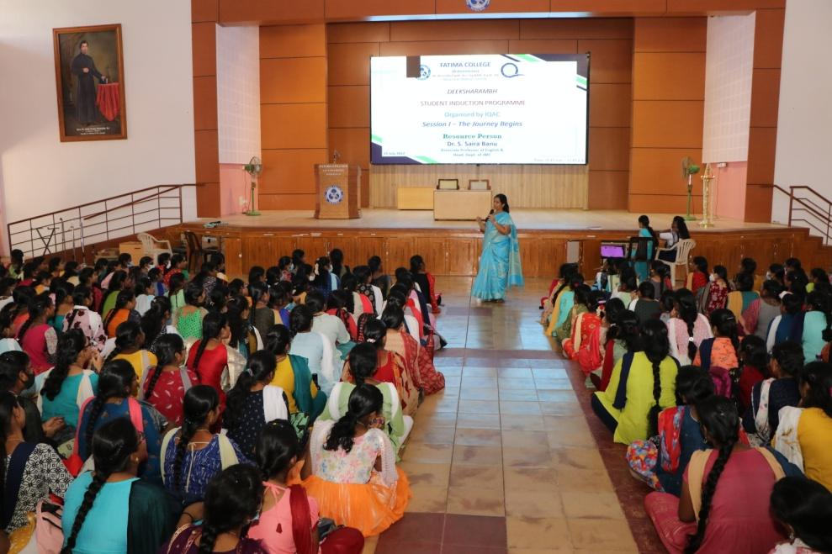

**Dr.S.Saira Banu, Associate Professor of English and Head, Department of JMC addressing the students on the topic “The Journey Begins”.**

The next session SIP was captured by Dr. S. J. Kala, Dean of Academic Affairs (Arts),Associate Professor, The Research Centre of English. She clearly explained onHolistic formation at Fatima. She explored on Keybodies in Higher Education, Quality Based Curriculum Designing, Outcome Based Education, Examination System.

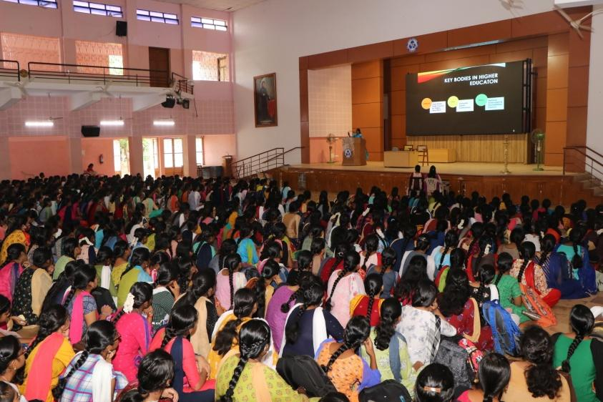

**Dr. S. J. Kala, Dean of Academic Affairs (Arts),Associate Professor, The Research Centre of English explained on Holistic formation at Fatima**

On 27 July 2022, Dr.S.Vidya, Associate Professor, Department of Computer Science and Coordinator of International Collaboration and Foreign Students Welfare Cell handled the session on “Quality Standards” The Resource person gave a wide exposure regarding National Assessment and Accreditation Council (NAAC) and National Institutional Ranking Framework (NIRF).

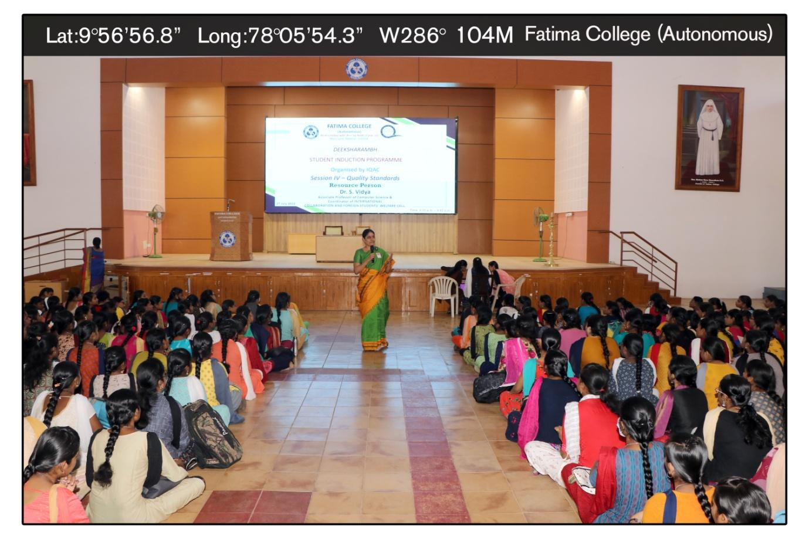

**Dr.S.Vidya, Associate Professor, Department of Computer Science and Coordinator of International Collaboration and Foreign Students Welfare Cell handled the session on “Quality Standards”**

The next session was taken by Dr. Velankanni Matharasi, Directress of Physical Education. She described on Self Confidence and Emotional Control. She clarified the difference between Confidence and Self-Confidence.It included Next Rotation, Finger Shoot, Wrist Rotation, Shoulder Rotation, Arm Rotation, Hip Rotation, Knee Rotation, Ankle Rotation, eOn 28 thJuly 2022, All the Part V Coordinators introduced and gave and brief note on the various Part V activities on the topic “Finding yourself through Community Service” etc…

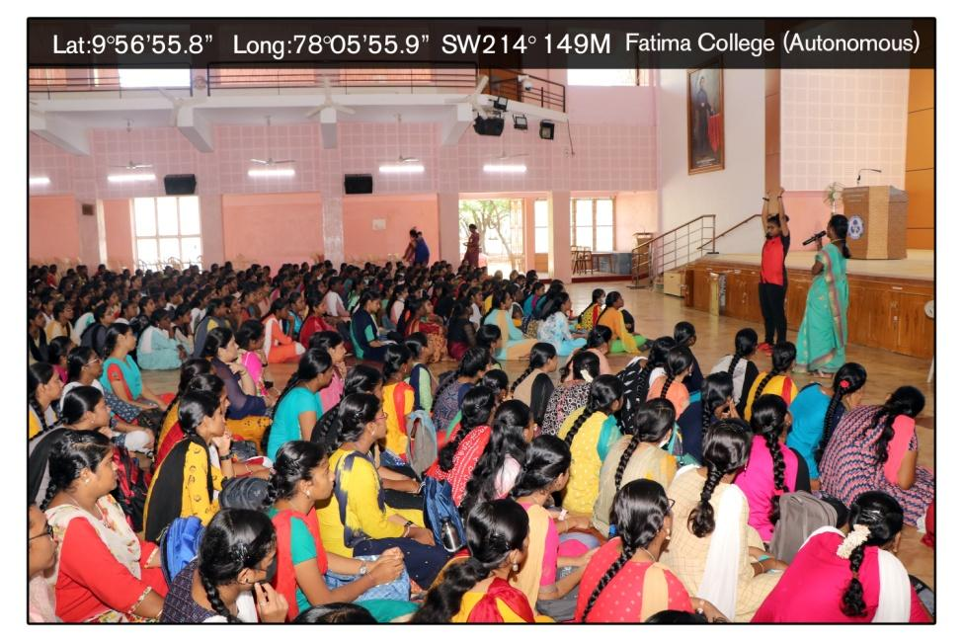

**Dr. Velankanni Matharasi, Directress of Physical Education. She described on Self Confidence and Emotional Control**

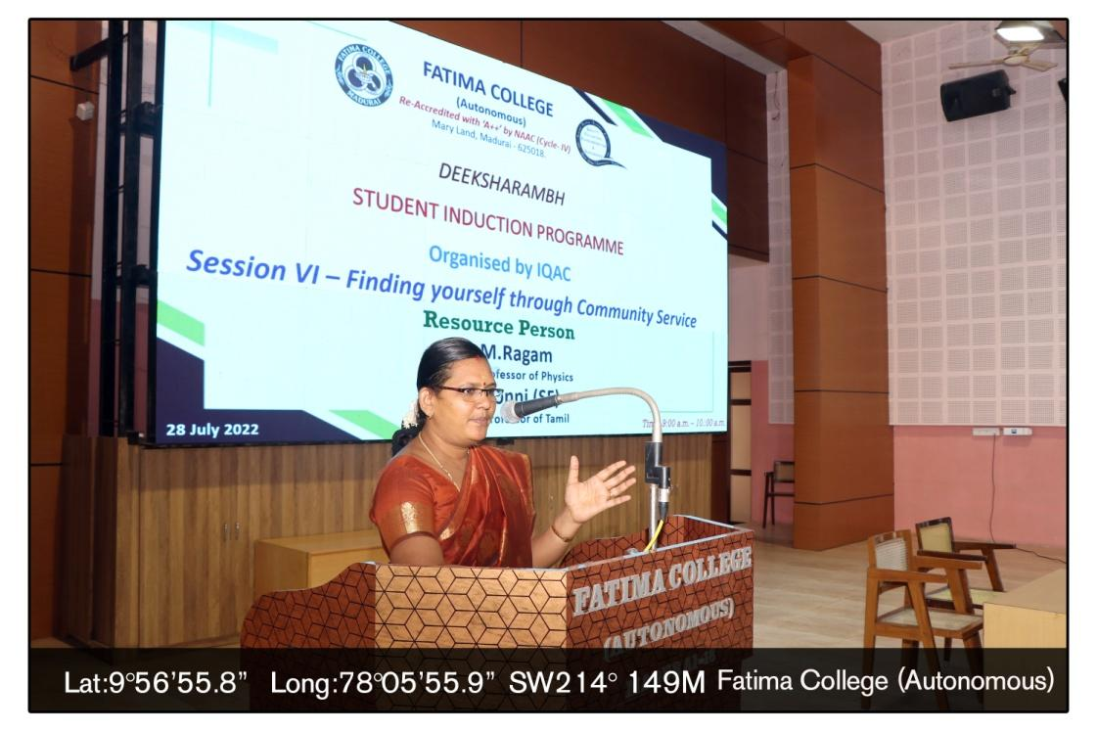

On 28 thJuly 2022, All the Part V Coordinators introduced and gave and brief note on the various Part V activities on the topic “Finding yourself through Community Service”

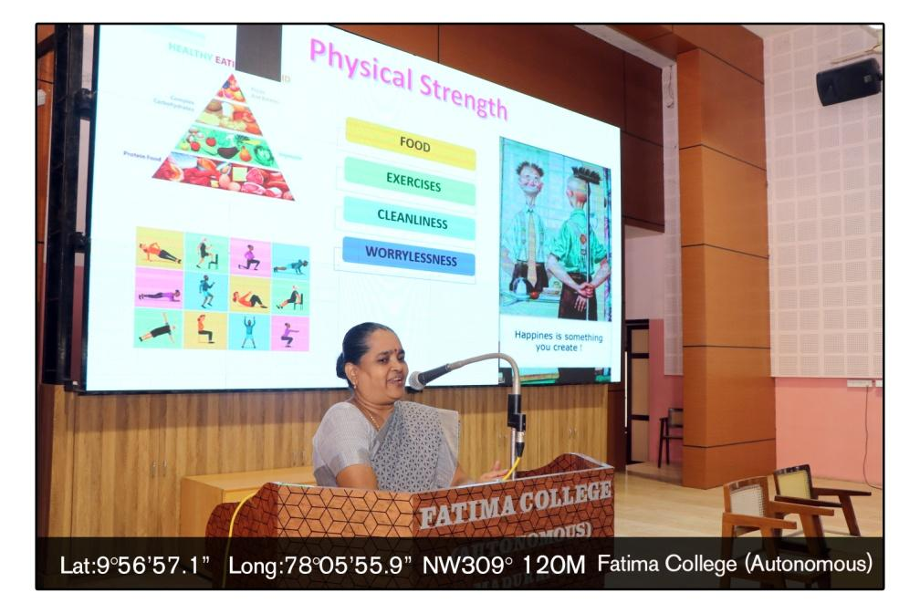

The Session on ‘Dimensions for Progressive Life’ was captured by Dr. K. Rosemary Euphrasia, IQAC Coordinator, Associate Professor of Computer Science. The resource person focussed the students to have different perceptions in life.

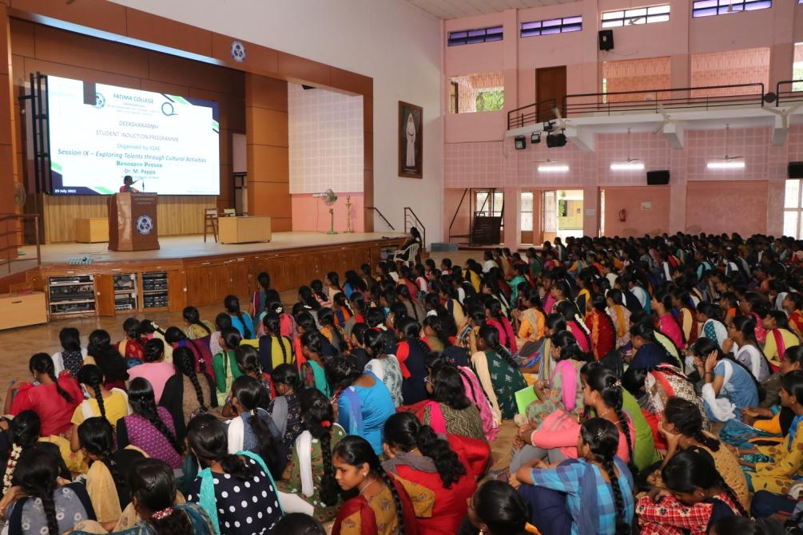

On 29th July SIP was handled by Dr.Pappa, Assistant Professor, The Research Centre of Tamil on “Exploring Talents through Cultural Activities” followed by Dr.G.Revathy on “Be Aware & Awake” .

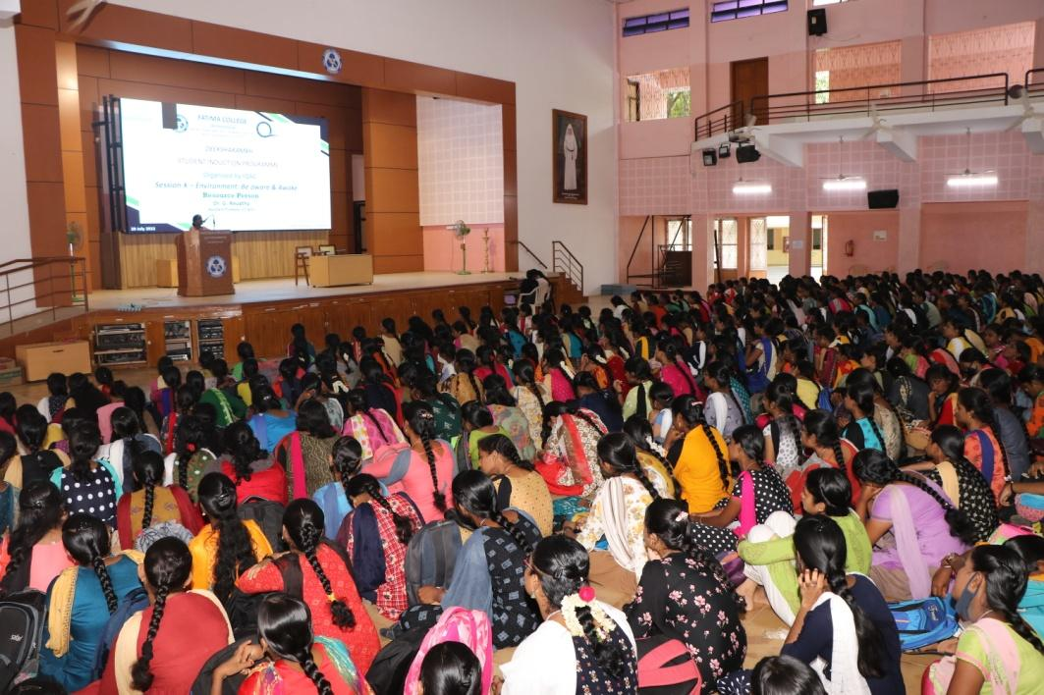

On the same day, Dr. Magdalene Abraham, Assistant Coordinator, IQAC, addressed the students on “What it means to be a Fatimite”. She spoke about the Culture in Fatima.

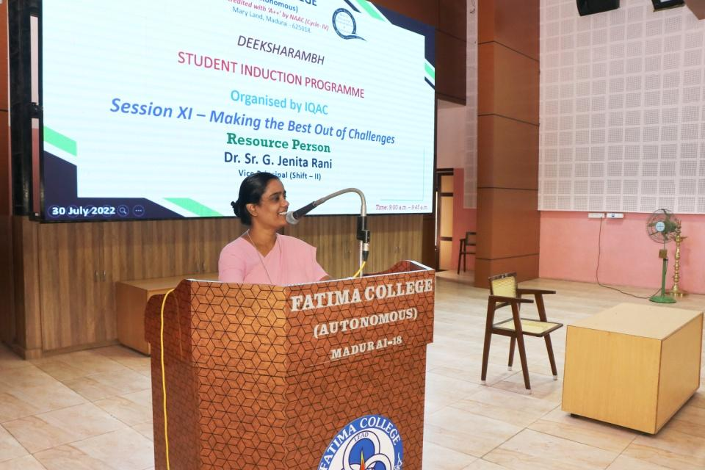

**On 30 July 2022, Dr.Sr.G.Jenita Rani, Vice Principal (Shift II) addressed the students on “Making the Best Out of Challenges”**

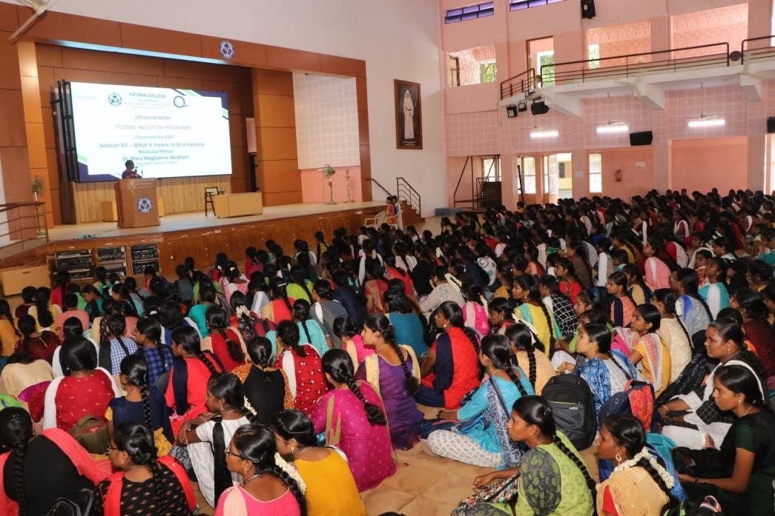

**The Session about Rosa Mystica Library: An Overview handled by Dr.C.Sujatha, Librarian. She gave a wide exposure on Library and other related online portals. She insisted students to inculcate knowledge in their own discipline as well as in other Programmes.**

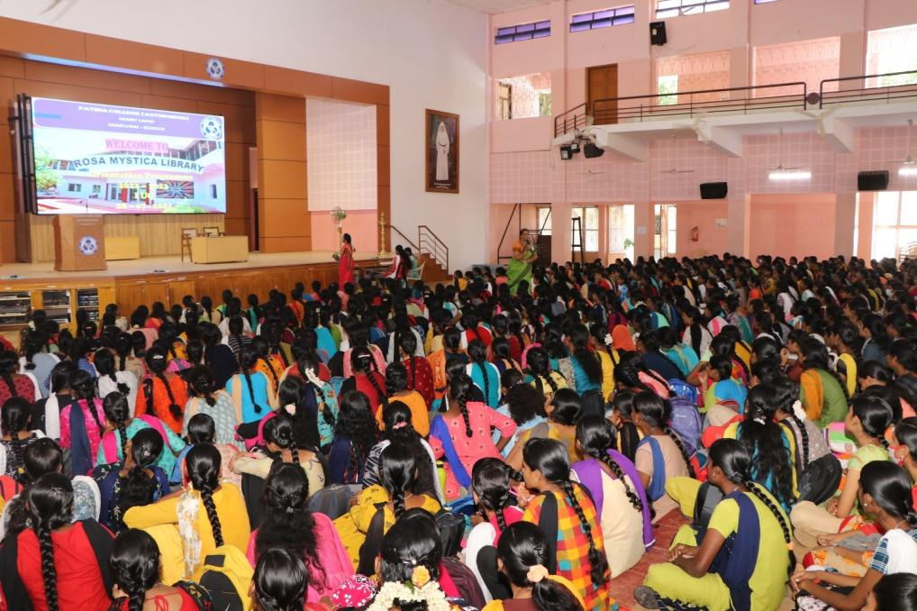

**A video about various functionings of college was shown to the students**

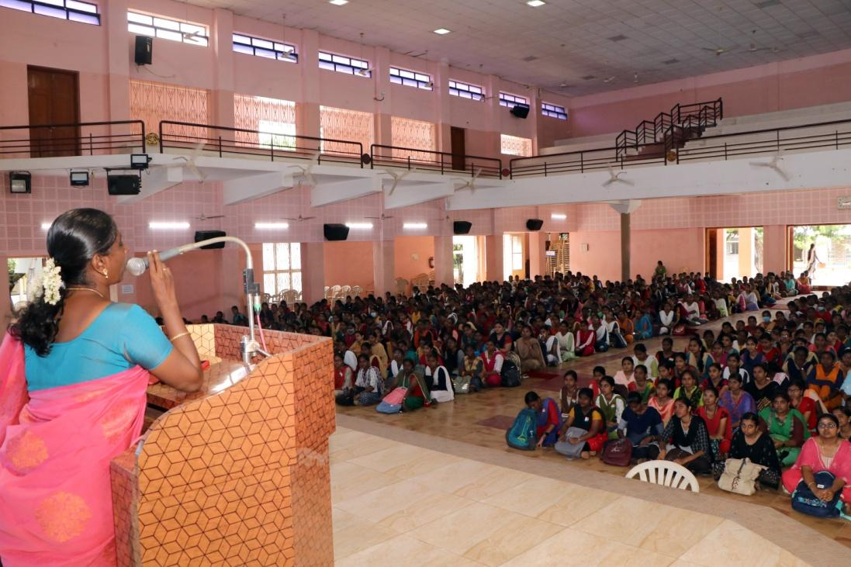

**Mrs. Selvarani, Head & Assistant Professor, Department of BCA, addressed the gathering on Research Activities in Fatima**

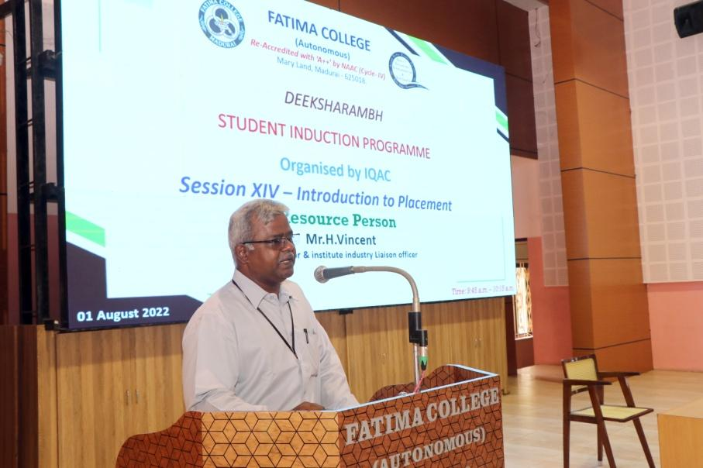

**The last day of SIP was handled by Mr.H.Vincent, Placement Officer. He gave a brief note on “Introduction to Placement”**

SIP feedback were collected online. The students exhibited their talents in “Talent Finding” and all the students enjoyed participating in it.

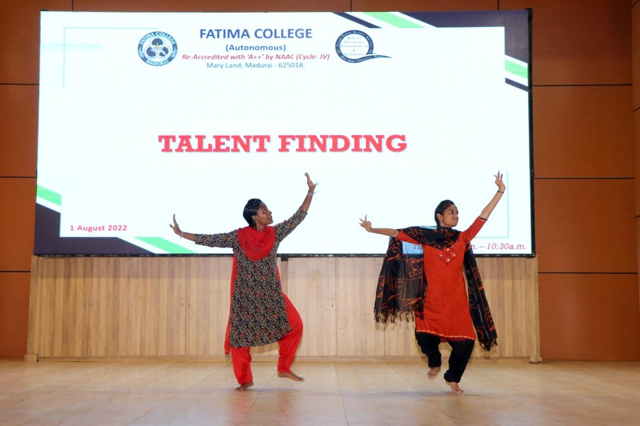

**Students exhibiting their talents through dance Performance during Students Induction Programme**

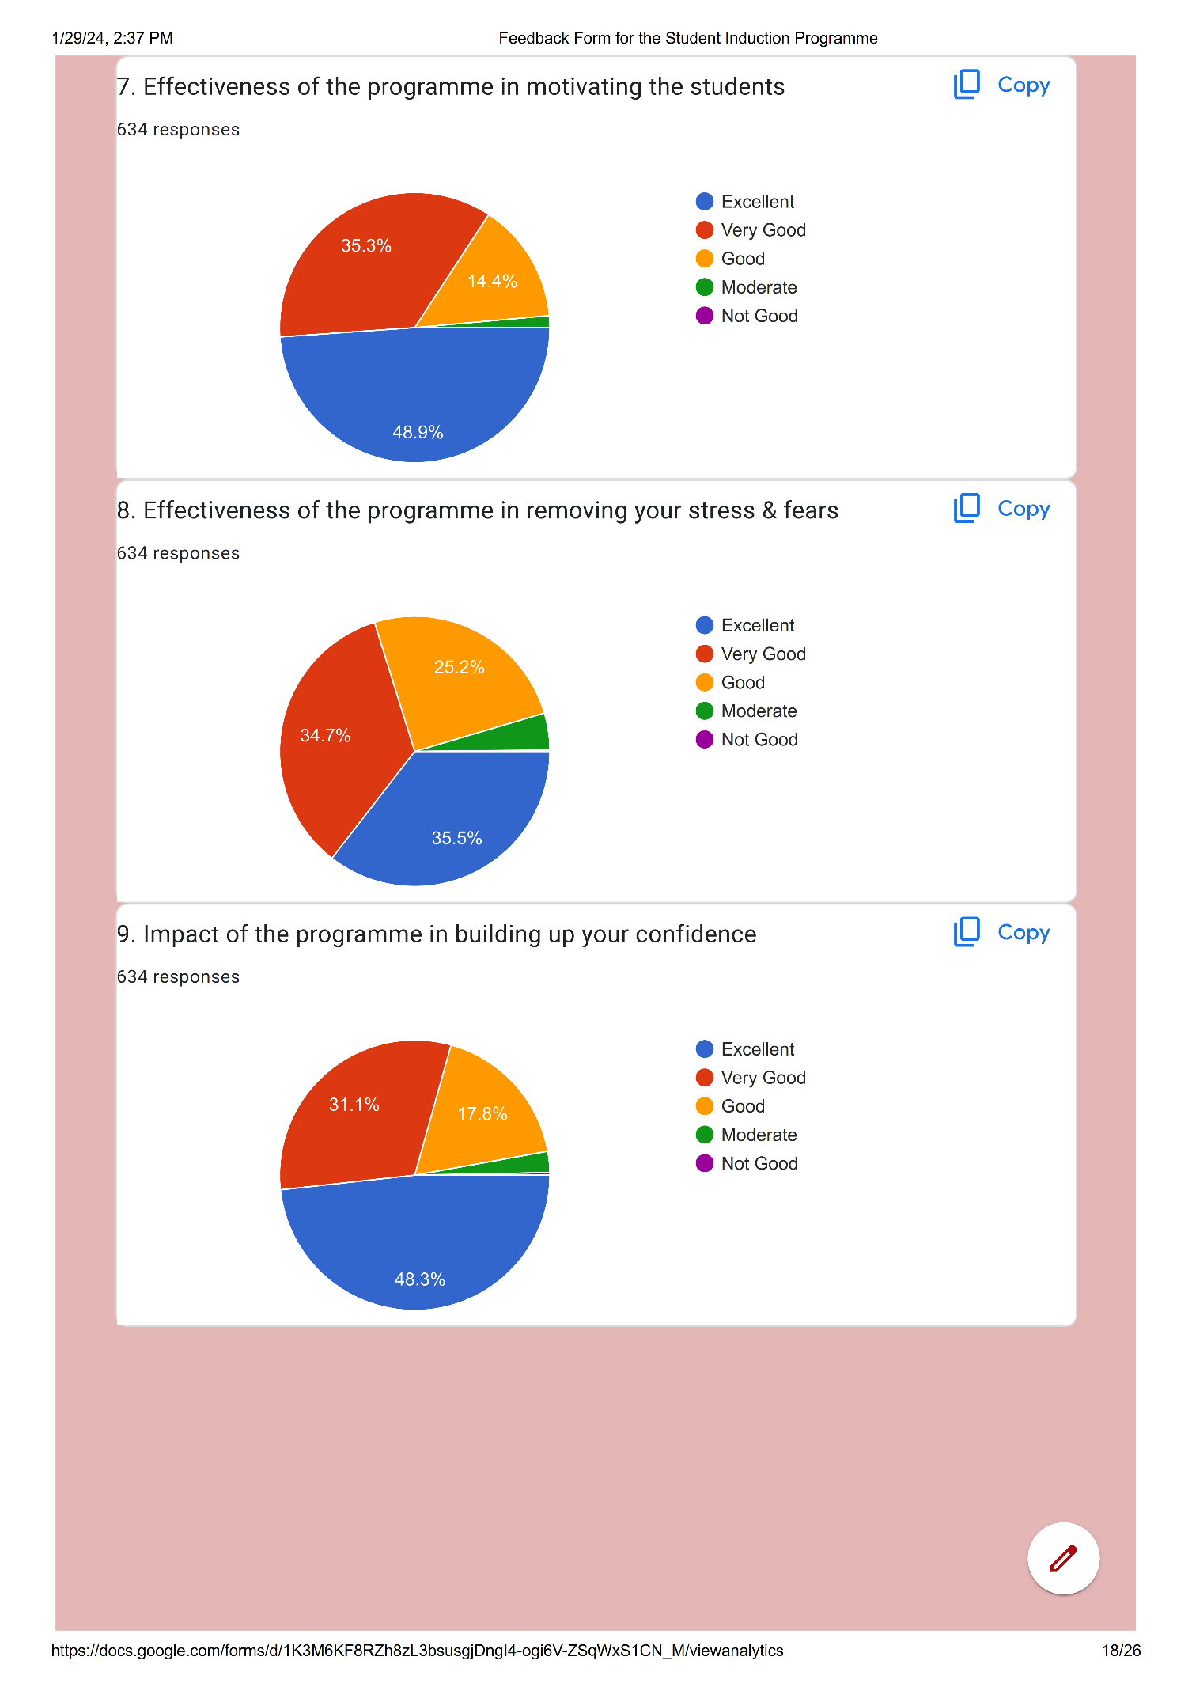Feedback Form:

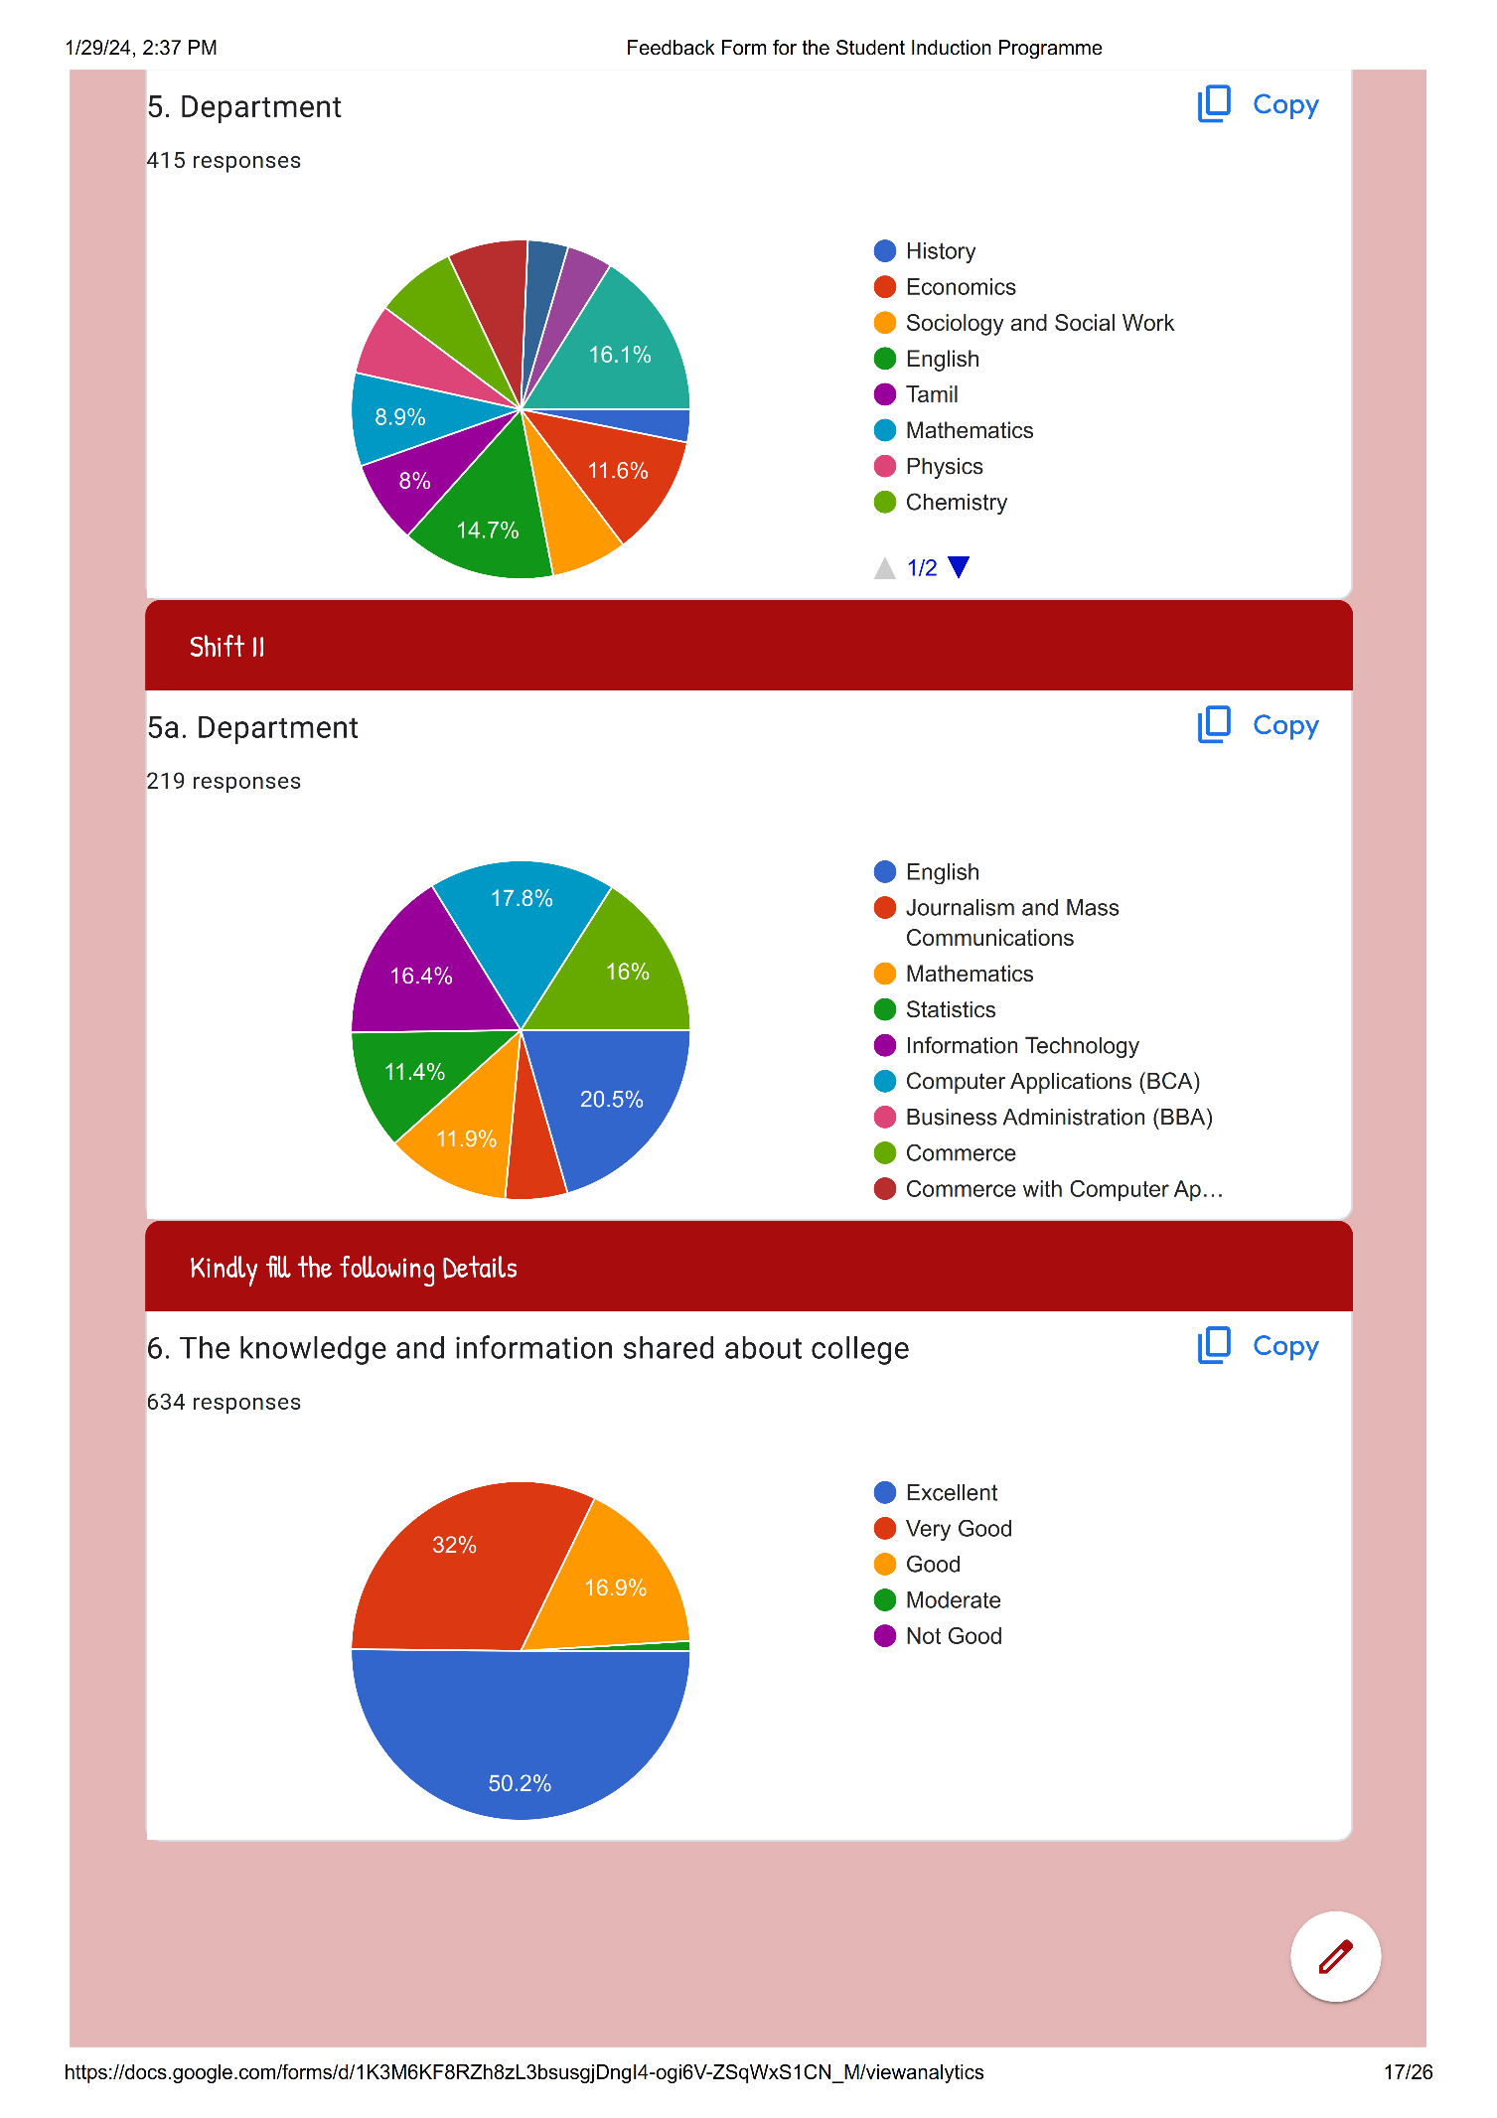

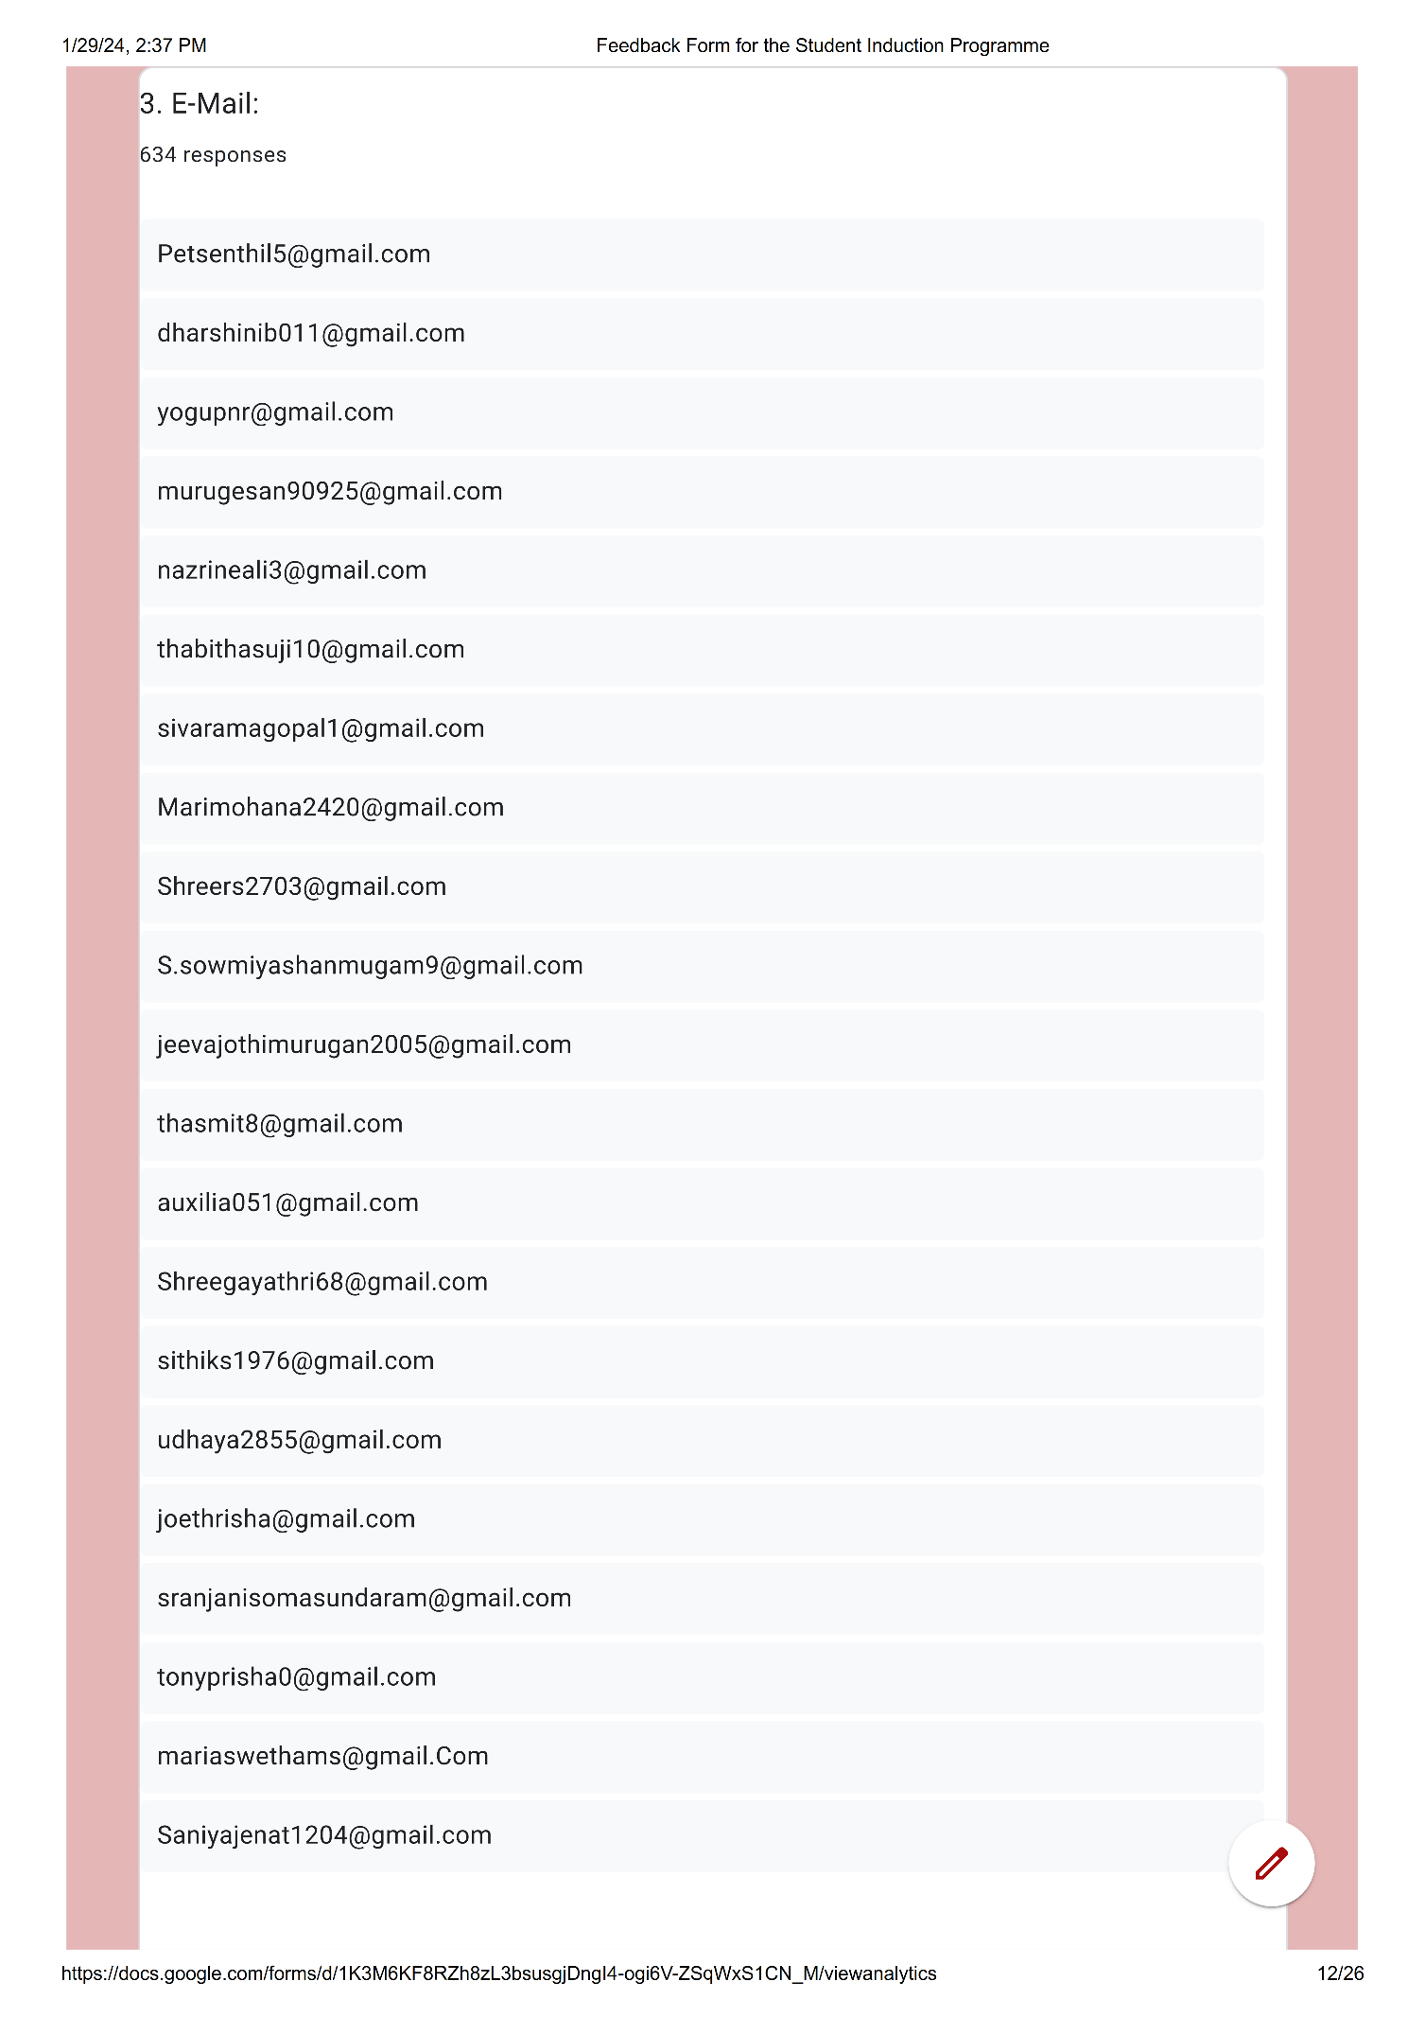

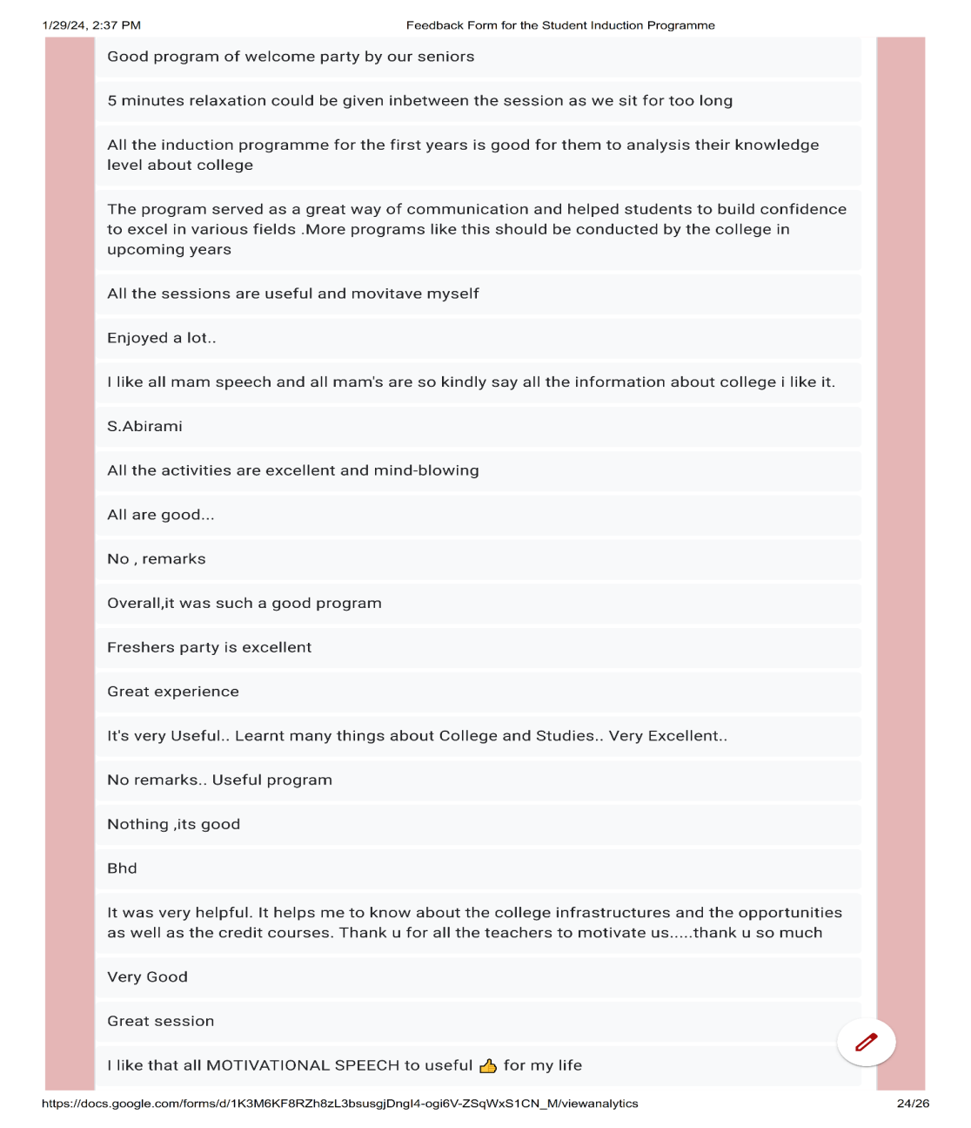

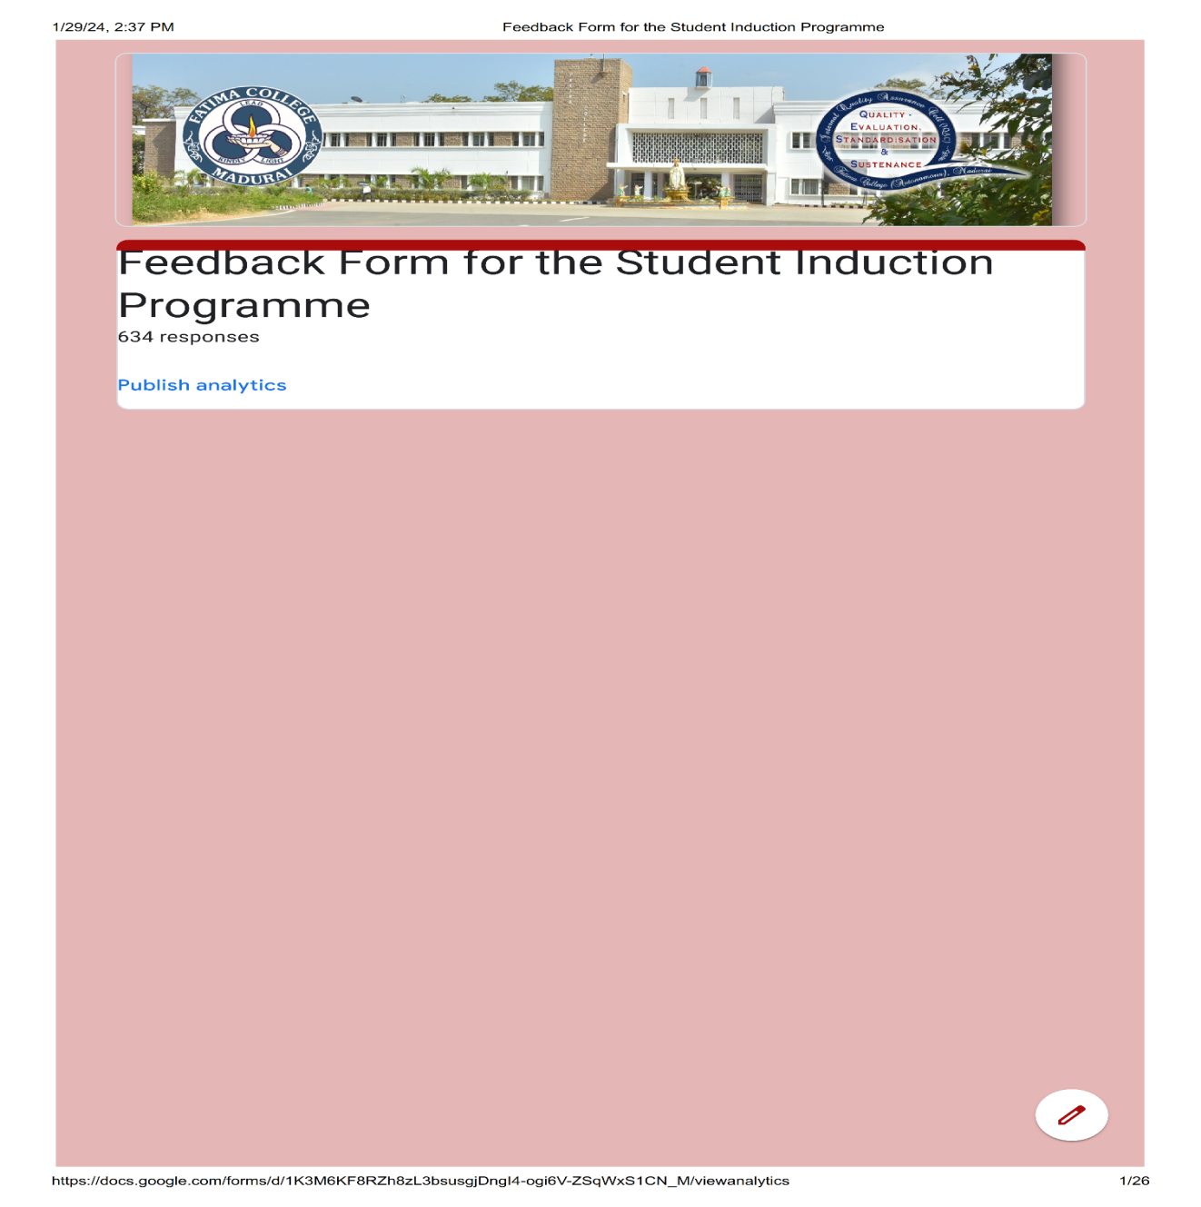

**Student Responses: 634**

| **S. No** | **Participant Name:** | **E-Mail:** | **Department** | **Any other Remarks / Suggestions** |
| --- | --- | --- | --- | --- |
|  | M.Sundareshwari | murugesan90925@gmail.com | Computer Applications (BCA) | Good |
|  | J. Heena Ali | nazrineali3@gmail.com | Computer Applications (BCA) | Good |
|  | J.Thabitha Suji | thabithasuji10@gmail.com | History | Good |
|  | G.Priyaveni | sivaramagopal1@gmail.com | History | Good |
|  | K. Mari Mohana | Marimohana2420@gmail.com | Computer Applications (BCA) | Good |
|  | N.Rajashree | Shreers2703@gmail.com | Computer Applications (BCA) | I want more motivation like this program |
|  | S.Sowmiya | S.sowmiyashanmugam9@gmail.com | Computer Applications (BCA) | Well & good experience |
|  | M.Jeevajothi | jeevajothimurugan2005@gmail.com | Computer Applications (BCA) | I have a lot of experience |
|  | Thasmitha.T | thasmit8@gmail.com | Tamil | Good |
|  | A. Auxilia | auxilia051@gmail.com | Commerce | No |
|  | Shree Gayathri | Shreegayathri68@gmail.com | Commerce | - |
|  | Shifa Fathima .S | sithiks1976@gmail.com | Commerce | No |
|  | S.Udaya | udhaya2855@gmail.com | Commerce | Good |
|  | A.Joe Thrisha | joethrisha@gmail.com | Commerce | Good |
|  | S Ranjani | sranjanisomasundaram@gmail.com | Chemistry | Good |
|  | Tony Prisha | tonyprisha0@gmail.com | Commerce | is a self-motivated to students |
|  | M. Maria Swetha | mariaswethams@gmail.Com | Commerce |  |
|  | A.Saniya Jenat | Saniyajenat1204@gmail.com | Commerce | It is useful to know about the college |
|  | S. Santhia | rameshsudha6774@gmail.com | Commerce | It changed my thoughts ..and the program was very helpful for me to get comfortable with the college. Good step towards student's welfare |
|  | M.Shabeeha Roshan | Shabeeharoshan8@gmail.com | Commerce | It's very useful to me to briefly know about the college |
|  | Sangeetha Jasmine .L | sangeejas01@gmail.com | Commerce | Yeah it's gud no any remarks |
|  | K.Loshini | jiviradhika45@gmail.com | Commerce | No |
|  | K.R.Aashika | aashika2005.18@gmail.com | Commerce | - |
|  | N.Irfana Nisha | nishairf1009@gmail.com | English | no suggestion everything has excellent |
|  | U.Yamini | y14200411@gmail.com | Commerce | I am highly thankful to you for providing me with an opportunity to be a part of your college. |
|  | Suganya V | suganyavinayagamoorthi@gmail.com | Commerce | Everything was good |
|  | F.Hepshiba Santhiya Roshini | arunarani1398@gmail.com | Commerce | All Good |
|  | A.Dilraz | dilraz2427@gmail.com | English | All Good |
|  | Shobana R | shobanaram2003@gmail.com | English | All Good |
|  | R.Sneka | rk2602592@gmail.com | English | All Good |
|  | V Carmel Theresa | Carmelvictor06@gmail.com | Commerce | - |
|  | K. Madhumitha | madhumithak19042005@gmail.com | English | No |
|  | P.Gracy Ruby | princeisac2005@gmail.com | Commerce | Good College |
|  | R.Janani | jananykanmany@gmail.com | English |  |
|  | A. Poorna Sankari | Poorna190804@gamail.Com | Commerce | I am highly thankful to you for providing me with an opportunity to be a part of your college. |
|  | Merlin Vinnarasi | merlinvinnarasi1207@gmail.com | English |  |
|  | C.Karthiga | karthigac2005@gmail.com | Commerce | No |
|  | S.Anu Priya | anupriya88004@gmail.com | Commerce | - |
|  | G.Swetha | Swethagopi539@gmail.com | Computer Applications (BCA) | - |
|  | Febricia Berlyn . D | febriciaberlyn02@gmail.com | English | Noo... |
|  | Harshini B. J. K | Harshini5858@gmail.com | Commerce | Everything is gud and excellent in our campus... One req is to plz allow to bring phone... Coz it's may useful for the student who coming through buses.... Thank you |
|  | Ramya I | Ilangoi724@gmail.com | English | This program was very useful to us  This program help us to better know about the college. |
|  | Hairoon Nisha | hairoonnisha13@gmail.com | English | All Good |
|  | G.Priyadharshini | lakshmi27041986@gmail.com | English | All Good |
|  | Viyashini | Viyashinisubramanian@gmail.com | English | No |
|  | Hajira | hhajira293@gmail.com | English | All Good |
|  | Angalaeswari | msundaram493@gmail.com | Commerce | All Good |
|  | J.Farhaana Jahir Hussain | Jahirhussain13021978@gmail.com | English | No |
|  | S.Varshini | gskumartn@gmail.com | Chemistry | All Good |
|  | C.S.Shalini | Shalinicss2004@gmail.com | English | All Good |
|  | Chethana.M | sasirekharadhakrishnan86@gmail.com | English | Nothing |
|  | Naina Toppo | nainatoppo16@gmail.com | English | All Good |
|  | Thahirun Nisha | thahirunnishat@gmail.com | English | Good |
|  | S. Sulthan Rukshana | Sulruk1234@gmail.com | English | All Good |
|  | B.Poorna | manjunlata@gmail.com | Commerce | All Good |
|  | A.Rizwana | ayishakani02@gmail.com | Chemistry | Nothing |
|  | Nivetha.A | Nivenirmal2010@gmail.com | Commerce | No |
|  | Krishna Ranjini .M | krishnaranjini2005@gmail.com | Commerce | Nothing |
|  | Archana Devi. M | marchanadevi2004@gmail.com | English | Everybody is good in the campus |
|  | M Kaviya | kaviyalogesh17@gmail.com | Commerce | All Good |
|  | Yuvasrigomathi.M | Yuvasrigomathi04@gmail.com | English | All Good |
|  | X.Persiya | persiyajothi@gmail.com | Commerce | No |
|  | M.Angalaeswari | msundram495@gamil.com | Commerce | Not only answer |
|  | Hajira. A | hajtf786@gmail.com | English | Nothing |
|  | Samreen J | samreenjahir15101975@gmail.com | Computer Applications (BCA) | -Nil- |
|  | X.Josephine Teresa | j72636173@gamail.com | Chemistry | Nothing |
|  | Y Jerlin Reega | jinojerlinsisters@gmail.com | Chemistry | Nothing |
|  | Keerthana. A | Keerthanaarivalagan01@gmail.com | English | No |
|  | Kalkitha N | kalkithanimalan@gmail.com | Commerce | Nil |
|  | Muthumari M | kittumari76@gmail.com | Commerce | All Good |
|  | A.S.Mary Jesli | maryjesli62@gmail.com | English | Super👌 |
|  | V. Hema Priya | hemzzz571@gmail.com | Information Technology | All Good |
|  | K.Kalaiarasi | kalaiarasi4316@gmail.com | Chemistry | All Good |
|  | M.Priya Dharshini | pd7380847@gmail.com | English | No |
|  | J.Dayana Therasal | dayanatherasal@gmail.com | English | No |
|  | B.Infant Helina | infanthelina02@gmail.com | English | Nil |
|  | K. S. Tharshini Priya | tharshinikannan19@gmail.com | Computer Applications (BCA) | Nothing |
|  | Yazhini. S | yazhinisubramani004@gmail.com | English | All Good |
|  | D.Krishna Dharshini. | krishnadharshini54@gmail.com | English | All Good |
|  | M.Archana | archanamarimuthu54@gmail.com | English | No |
|  | M. Revathi | mkrishnaraju1970@gmail.com | English | Nothing |
|  | R.Mithuna | rmithuna75@gmail.com | English | All Good |
|  | Divya | divyam.31072003@gmail.com | Chemistry | Very usefull program for me |
|  | Akshaya | akshaya29012005@gmail.com | English | No |
|  | P.Shobika | Shobiprabu15@gmail.com | English | Nothing |
|  | Kavibala K S | kavibalakavibala05@gmail.com | English | All Good |
|  | Thirisana.R | rajajothiraja03@gmail.com | Commerce | All Good |
|  | Muskan Jaiswal. D | mj5160158@gmail.com | English | No suggestion |
|  | J.Vincy Rebeena | Vincyrebeena2005@gmail.com | Commerce | No |
|  | A.Yuga Shree | yugashree2004@gmail.com | Commerce | All Good |
|  | S. Varshini | Varshinisd100@gmail.com | English | No, I think the college rules are enough for us |
|  | S.Alvaseela Banu | Vaseelabanu14@gmail.com | English | All Good |
|  | D.Rajalakshmi | ezhilmemiste@gmail.com | Tamil | Good |
|  | V.Elizabeth | ebeth3268@gmail.com | English | I join the college after 3 days so I don't know about previous section kindly make some arrangements for that late admission students |
|  | S.Pradeepa | nsivamku@gmail.com | English | Nothing |
|  | P.Anamika | abishakepushparaj@gmail.com | Commerce | All Good |
|  | M Atchaya Dharshini | aswinatsaya@gmail.com | Chemistry | EXCELLENT |
|  | Gobika.S | gobisenthil.@g8mal.com | English | All Good |
|  | J.Kanish Rahima | ravinthkanish@gmail.com | Computer Applications (BCA) | Nothing |
|  | Abinaya.R | rajendranv725@gmail.com | English | Nil |
|  | Ninfa Annie J.C | ninfakodai@gmail.com | English | Nothing |
|  | Yaamini R | yaaminilaura58@gmail.com | English | All Good |
|  | F.Antony Maria Robisha | antonymariarobisha@gmail.com | Commerce | Nothing |
|  | S.Prathiba | prissilaprathiba0@gmail.com | English | The sessions were so informative |
|  | Swetha. S | swethasethu03@gmail.com | English | The programme helped us know about the details of the college which we might have not known if it was not conducted😇✨The terms curriculum,programme and course were clearly explained to us which was a new thing to learn😁We got an idea that we have several competitions coming ahead to explore our talents and this woke us up to develop our skills🤩We realized the features that are available in our Rosa mystica library too🤯❤Thank yu for the information that made us well informed before entering our majors😌 |
|  | K.Thangam | guru20572@gmail.com | Physics | All Good |
|  | Bhavani. V | bhavacute2725@gmail.com | English | All Good |
|  | Geetha Varshini | geethavarshinig@gmail.com | Mathematics | Nothing |
|  | G.Geetha Hasini | geethahasinig@gmail.com | Mathematics | Kindly please put sitting tables for students!! |
|  | S.Abirami | abiparu2005@gmail.com | Tamil | No |
|  | Swarna Latha | shankarpoongodi376@gmail.com | Sociology and Social Work | I proud to be fatimites |
|  | Arul Jays.A | arulj2004henry@gmail.com | English | We want chair to set... |
|  | B.Infant Princy | infantprincy2004@gmail.com | Mathematics | I felt so sleepy throughout the programme |
|  | M.Bhavani Manikandan | bb0292446@gmail.com | Information Technology | This student induction programme is very useful to me . And I known about fatima college . |
|  | A. Carolina | Carolinaarasu33vi@gamil.com | Mathematics | No |
|  | U. Abinaya | abichitra2005@gmail.com | Commerce | No |
|  | A.Arulmancy | Arulmancy19742020@gmail.com | Mathematics | No |
|  | A. Jemila Michline | jayaroselin1980.jr@gmail.com | Mathematics | No |
|  | C.Shantha Chelva Gifta | giftagifta21@gmail.com | English | No |
|  | M.Maria Amala | aamalimani@gmail.com | Commerce | No |
|  | K.Yogeshwari | kaviparvathi2002@gmail.com | Commerce | All Good |
|  | Abinaya Raji,Nagaraj | kavinnila7474@gmail.com | Home Science | No |
|  | Gayathri G | ganeshan2017.p@gmail.com | Mathematics | All Good |
|  | A. Sopiya Jeyaseelin | Sopiyasopiya589@gmail.com | Commerce | All Good |
|  | N.Vaishnavi | ushaashamary1983@gmail.com | Mathematics | No Remaks |
|  | S.Sameena Banu | saminabhanu6369@gmail.com | Home Science | It's very useful to us...I. very proud to Study in this college... |
|  | M.Kaviyadevi | kaviyadevi91508@gmail.com | Mathematics | This program is very good for first year students to know about the Fatima college |
|  | A.Martina Celin | celinamalraj022@gmail.com | Mathematics | All Good |
|  | A. Immaculate Ratsinga | ratsingaimmaculate@gmail.com | Mathematics | All the programs are very useful and help me to motivate myself |
|  | M. Mukila | Moorthymukila@gmail.com | Mathematics | All Good |
|  | A. H. Humnna | jeharahumnna@gmail.com | Home Science | All Good |
|  | Arputha.K | kubendrank83@gmail.com | English | All Good |
|  | P. Murugeshwari | pandiyarajandharmaraj@gmail.com | Physics | All Good |
|  | N. Sweety | Jhokulins@gmail.com | English | No |
|  | S.Harini | harinisaravana638@gmail.com | Information Technology | All Good |
|  | S.Subarna | subarnasivaraj13@gmail.com | Physics | Way of explaining is excellent |
|  | R.Selvarani | selvarani.r1234@gmail.com | Mathematics | All Good |
|  | Saranya .A | Saranaya4040@gmail.com | Home Science | All Good |
|  | M.Abinaya | abi945827@gmail.com | Physics | I learned many information tq |
|  | A.Tansila | tansilaagcee@gmail.com | Chemistry | All Good |
|  | Lavanya N | lavanyalavanya1952@gmail.com | Computer Applications (BCA) | All Good |
|  | M.Yuvasri | yuvasrichitra770@gmail.com | Mathematics | All Good |
|  | Renitta | jospinrenitta2005@gmail.com | English | All Good |
|  | P.Deborah | mphilipesther@gmail.com | English | Everything is good |
|  | K R Lavanyadevi | lavanya2022ems@gmail.com | Home Science | - |
|  | B. Gomathi | gomathiboominathan357@gmail.com | Sociology and Social Work | Nothing |
|  | R.Rathi Priya | rbanumathi272@gmail.com | English | All Good |
|  | B.L.Meenalochini | meenulakshmanan2005@gamil.com | Sociology and Social Work | All Good |
|  | Roselin Mary | roselinm399@gmail.com | Commerce | All Good |
|  | V.Priyadharshini | Priyavenkatv0@gmail.com | Mathematics | No |
|  | A. Maryshelma | Shelmamary17@gmail.com | English | Helpful |
|  | Macrina | macrina0731@gmail.com | English | - |
|  | Idhaya Franklina. A | elizaidhaya@gmail.com | Commerce | None |
|  | A.Preethi | preethiannadurai23@gmail.com | Commerce | No suggestion |
|  | M. Vinothini | muthumaniaruthiramanim@gmail.com | Sociology and Social Work | All Good |
|  | B.Aishwarya | aishwaryabalamurali18@gmail.com | English | All Good |
|  | K. Kayal Vizhi | Kannankkannank811@gmail.com | Home Science | All Good |
|  | A.Remi | remiarockiasamy@gmail.com | Commerce | All Good |
|  | S.Shaliha | ibrahimibrahim74856@gmail.com | English | No  . Everything is good |
|  | A. Deepthi Lynette | deepthilynette972@gmail.com | English | All Good |
|  | R.Luckya | luckya0409@gmail.com | Commerce | All Good |
|  | P.Muruges Wari | Ambikap2867@gmail.com | Tamil | All Good |
|  | M.Nasrin Banu | haseenabanu86@gmail.com | Commerce | Program has been very useful to me |
|  | S.Indumathi | srinivasantvs1973@gmail.com | Sociology and Social Work | - |
|  | J. Carolina | carolinajesudasan@gmail.com | Commerce | No |
|  | Oviya . S | oviya3059@gmail.com | Chemistry | - |
|  | Dulaitta Mary . T | dulaittamary@gmail.com | Physics | Very good |
|  | S. Shwetha | vsatheeshkumar81@gmail.com | Information Technology | No |
|  | Muthu Priya | Mmuthupriya16@gmail.com | Tamil | All Good |
|  | K. Divya | divyababu701@gmail.com | Mathematics | All Good |
|  | M. Sahaya Roselin Jenifer | jenijasjenijas891@gmail.com | Commerce | All Good |
|  | S.J Akchaya Dharshini | akchayadharshinijeyabal@gmail.com | Mathematics | All Good |
|  | Manju Sree.E | e.manjusree@gmail.com | Mathematics | All Good |
|  | M Muthu Santhiya | mmsanthi555@gmail.com | Physics | M MUTHU SANTHIYA |
|  | A. Bhavani | abibhavani@gamil.com | Tamil | - |
|  | M.Mareeshwari | karupukarupu693@gmail.com | Tamil | - |
|  | V.Jenifer | jenifertriumph1033@gmail.com | Mathematics | Nothing |
|  | Aiswarya S | jayanthiradjakrishnan@gmail.com | Mathematics | Really It was an wonderful experience. |
|  | Harini.N | Senthoorvanitha@gmail.com | Mathematics | Good program of welcome party by our seniors |
|  | Harsini S B | harsinisb86@gmail.com | English | 5 minutes relaxation could be given inbetween the session as we sit for too long |
|  | A. Joice Rajam | orithamakthalin11@gmail.com | Commerce | - |
|  | K.Swetha | pavithrakarthi186@gmail.com | Mathematics | - |
|  | Ilakkiya Jothi.R | mkail3583@gmail.com | History | No |
|  | Rubhika P | rubhika.p@gmail.com | Mathematics | No |
|  | R Hema Sree | Selvikalaiselvi172@gmail.com | Tamil | All the induction programme for the first years is good for them to analysis their knowledge level about college |
|  | V. Monika Devi | visaganhemanath@gmail.com | Tamil |  |
|  | M.Miraclin Chella Vailankanni | miraclinchellavailankanni@gmail.com | English | The program served as a great way of communication and helped students to build confidence to excel in various fields .More programs like this should be conducted by the college in upcoming years |
|  | A.Amirtha Varshini | amirtha2004@gmail.com | Physics | All the sessions are useful and movitave myself |
|  | J Akshitha | padhu.akshu@gmail.com | English | Nil |
|  | Amirtha.S | jeyapackiamsethu@gail.com | Mathematics | All Good |
|  | M.Bharathi Priya | vennilamuthusamy17@gmail.com | Home Science | All Good |
|  | Malathi.M | Josilin75@gmail.com | History | All Good |
|  | Joshna Berlin Roy J | joshnajerard24@gmail.com | Computer Science | All Good |
|  | C.Sarojini | mudhupandic2006@gmail.com | Tamil | All Good |
|  | C.M.Azhagu Sabari Bala | Azhagusabaribala2675@gmail.com | Sociology and Social Work | Good |
|  | Karolin Mini . R | Karolinmini5@gmail.com | English | No |
|  | P.Kaviya | rajakuttys12345@gmail.com | Tamil | Good |
|  | Rinoviola. X | rinoviola107@gmail.com | Computer Science | Enjoyed a lot.. |
|  | Lalima R | lalimalalima29@gmail.com | Information Technology | I like all mam speech and all mam's are so kindly say all the information about college i like it. |
|  | Dharshini. A | dharshinialagumurugan645@gmail.com | Commerce | - |
|  | S.Mahalakshmi | mahalakshmidhanam2005@gmail.com | Tamil | No |
|  | S.Abirami | alagappanmdu222@gmil.com | Tamil | S.Abirami |
|  | C.Iswarya | Jegansami6@gmail.com | Tamil | Very good |
|  | J. Janet Rodrigo | judysherlinjanet@gmail.com | English | All Good |
|  | R.Priyadharshini | pd838721@gmail.com | Computer Science | All Good |
|  | A.Baveena | arumugambaveena@gmail.com | Mathematics | Nothing |
|  | Varshine R.S | varshinersb@gmail.com | Computer Applications (BCA) | All the activities are excellent and mind-blowing |
|  | P.Akila | v.pandikamala@gmail.com | Chemistry | - |
|  | Kosalai P | kingbell555@gmail.com | Tamil | All are good... |
|  | K.Deepika | deepika200519@gmail.com | Computer Applications (BCA) | No |
|  | S.Selvi | sherinselvi31@gmail.com | English | - |
|  | Mohana | mohana1105t@gmail.com | Commerce | No , remarks |
|  | Varshini | shanthimathav@gmail.com | Physics | Good |
|  | R.Kamatchi | kamatchiramar2004@gmail.com | Computer Applications (BCA) | Overall,it was such a good program |
|  | S.Narkees | Narkeess25@gmail.com | Mathematics | Freshers party is excellent |
|  | M.Gatlin Swetha | Nivethasuvetha2005@gmail.com | History | Great experience |
|  | N. Keerthana | Keerthananagendran@gmail.com | English | It's very Useful.. Learnt many things about College and Studies.. Very Excellent.. |
|  | A.Thasneem Begam | thas5992@gmail.com | English | No |
|  | Anusiya.B | b.anusiyadevi2005@gmail.com | English | No |
|  | L.Kiruba | kirubakiru2004@gmail.com | Computer Science | - |
|  | M.Gayathri | Mahalingampandian1969@gmail.com | Tamil | No |
|  | J. Sherline Nishaa | Sherlinenishaa2004@gmail.com | Commerce | No |
|  | A. Meenalosini | meenalosini233@gmail.Com | Chemistry | No remarks.. Useful program |
|  | A.Arokiya Amala Santhiya | jamesalpin931@gmail.com | Computer Science | - |
|  | Sr. G. Celine Sahaya Mary | Subha2612@gmail.com | Tamil | Good |
|  | S.Lizy | Johnnoel.lvb@gmail.com | English | No |
|  | Pavithra | Sankarpavithra14@gmail.com | Information Technology | - |
|  | B.Dharini | dharini352005@gmail.com | English | No |
|  | V.Arockia Christina | arockiaroobina@gmail.com | Chemistry | - |
|  | A.Hema Kanikkai Tresa | hemakanikkaitresa2004@gmail.com | Computer Science | No |
|  | Fathima Zohara.R | hussainraja445@gmail.com | Chemistry | Nothing ,its good |
|  | Hamza Hassain | rockhamzahassain@gmail.com | Sociology and Social Work | Bhd |
|  | D.Gayathri | gayathritharmendran2003@gmail.com | Mathematics | No |
|  | M. Ramya | muthuramya252@gmail.com | Chemistry | No |
|  | M.Dhanya Shree | Dhanyashree2995@gmail.com | Chemistry | Nothing |
|  | Fathima John | sumaiyafathima9716@gmail.com | English | - |
|  | Yuvarani.S | 2020L17@fcmdu.edu.in | English | No suggestions |
|  | A.Betchi Bavya | rajamedilta@gmail.com | Computer Science | - |
|  | Jemima .A | jemiabraham123@gmail.com | Computer Science | All Good |
|  | Ashifa | saithabanu83@gmail.com | Home Science | - |
|  | Janane S | mailtosasikumar1973@gmail.com | Computer Applications (BCA) | No |
|  | V. R. Swathi Priya | swathiravikumar2404@gmail.com | Economics | - |
|  | S.Dhiviya Darisini | dhiviyadarisini@gmail.com | Mathematics | All Good |
|  | Anushya | Anushyaravisterraj@gmail.com | Tamil | No |
|  | Sophia Shas N | sophiashas1804@gmail.com | Mathematics | - |
|  | B.Janani | jananijanani74350@gmail.com | Economics | - |
|  | S.Siva Roobini | Selvasnkl24@gmail.com | Chemistry | It was very helpful. It helps me to know about the college infrastructures and the opportunities as well as the credit courses. Thank u for all the teachers to motivate us.....thank u so much |
|  | R.Ilakkiya | rilakkiyarilakkiya08@gmail.com | Mathematics | Very Good |
|  | Maria Jeba Thimona | theresalveethustheresal@gmail.com | Home Science | No |
|  | Jeevitha K | jeevikarnan@gmail.com | Chemistry | Great session |
|  | Mini Priya M | priyamini047@gmail.com | Zoology | No remarks |
|  | T. Kunthavai | tmkunthavai@gmail.com | Economics | - |
|  | A. Kavitha | attukarankavitha@gmail.com | Economics | I like that all MOTIVATIONAL SPEECH to useful 👍 for my life |
|  | Dharaniselvam | dharaniselvam2608@gmail.com | Economics | All Good |
|  | V Karthika | karthikavengadesan2k5@gmail.com | Economics | - |
|  | P.Sandhiya | Prabakaransivakami68@gmail.comcom | Chemistry | All Good |
|  | A.Jainual Juhaina | Ahamedfaleela@gmail.com | Home Science | No remarks |
|  | Karpaga Varthini .V | genkatg278@gmail.com | Economics | All Good |
|  | Asma S | asma30102004@gmail.com | Mathematics | All Good |
|  | T.Seyathali Fathima | Seyathaifathima1901@gmail.com | Economics | Nope |
|  | N.S.Mythili | mythilins05@gmail.com | Computer Science | All Good |
|  | Mini Kavitha.P | minikavi11@gmail.com | Home Science | I really enjoyed and gain some knowledge from this programme |
|  | R.Shalini | priyar0809@gmail.com | Zoology | Nothing to say. All programmes is very useful to me. |
|  | S. Licy Winslet | licysujivan@gmail.com | Zoology | All Good |
|  | Aisashithikka. N | naisashithikka764@gmail.com | Zoology | All Good |
|  | M.Archana | archanaarchu36786@gmail.com | English | All Good |
|  | A. Devishri | elakkiyaayyappan016@gmail.com | Mathematics | It is very useful for me for knowing this college |
|  | K.K.Devaki | devakikannan4@gmail.com | Economics | - |
|  | V.Rashmitha | vrasmithar@gmail.com | Economics | Good |
|  | P.Vinotha | Vinoth9842859151@gmail.com | Mathematics | All Good |
|  | R.Jessintha Mary | jessinthamary2@gmail.com | English | No suggestions |
|  | M.Sandhiya | ilamathivanan@gmail.com | Chemistry | Nothing |
|  | A.Pavithra | Anitha21mdu@gmail.com | Sociology and Social Work | All Good |
|  | S.Thirumalar | Thirumalarsuresh2005@gmail.com | Chemistry | No |
|  | I.Jeba Cathrin | jelinjeba7@gmail.com | English | It's nice |
|  | Anusanthalika | Santhalika2005@gmail.com | Chemistry | Nothing |
|  | Varshini | Varshuk311004@gmail.com | Economics | No remarks |
|  | M.Nithya | nithyamalaiyappan@gmail.com | Commerce | No |
|  | Gifta Angelin.D | giftaregina@gmail.com | Home Science | All Good |
|  | K.Shefana Banu | afsiyaafsiya7@gmail.com | Physics | No |
|  | Iswarya.G | iswaryaganesh2124@gmail.com | Economics | All Good |
|  | Denita Vinish Radan Sr | denitaradan.dvr2004@gmail.com | Zoology | All things are good.no other suggestions. |
|  | M. Kanmani | Kanmanim646@gmail.com | Tamil | Student Induction programme is Good |
|  | M. Riya | riyaraju30@gmail.com | English | No |
|  | Dhanusri.S | dhanusrisrithar@gmail.com | Zoology | It is really useful for me to understand more about college |
|  | S .Swathi | Swathisivachandran11@gmail.com | Sociology and Social Work | All Good |
|  | R.Vedha Valli | rajagopalthanasekaran@gmail.com | Economics | No Remarks |
|  | S.Parthasarathi Priyai | arasu.kumar73@gmail.com | Commerce | No remarks |
|  | R.Panimalar | Panim2005@gmail.com | Commerce | No |
|  | P.Priyanka | priyankapalpandi13@gmail.com | English | No |
|  | R.Kaleeswari | kaleeswarir2005@gmail.com | Economics | No |
|  | S.Sivacelcya | Petsenthil5@gmail.com | English | It is very useful for me |
|  | Sandhiya.G | gopalsandhiya923@gmail.com | Economics | 492 |
|  | M Soma Sundari | mrlingam569@gmail.com | Economics | No |
|  | Soorya Preethi C | sooryapreethoi0612@gmail.com | Zoology | On the whole it was good for building up confidence and for socializing with my peer groups |
|  | Preethi A | arumugamramaiah8@gamil.co. | Economics | No |
|  | S.Srinithi | srinithi233@gmail.com | Physics | All Good |
|  | B.Gayathri | Gayathribalachandran11@gmail.com | English | All Good |
|  | K.J.Sakana Sri | Sakanasrijothikavitha@gmail.com | Chemistry | All Good |
|  | Swetha.S | swethaselvam964@gmail.com | Sociology and Social Work | Overall program is very good. |
|  | K.Bhavani | amuthabhavani74@gmail.com | Physics | No |
|  | Madhumitha. D | madhumithadeivendran@gmail.com | English | Very useful&nice experience thanks a lot to all of our mams and seniors |
|  | P. Gayathri | ggayu2381@gmail.com | Economics | No |
|  | Karan Priya G | vasanthiganesan07@gmail.com | English | The program was interesting and motivate the students to achieve their goals |
|  | D.Karishma | mahimajudi@gmail.com | Economics | No |
|  | G.Renukaa | ganeshanmani617.@gmail.com | Zoology | This is excellent college with many good infrastructure and in teaching manners it will help for us and for our good career thank you so much |
|  | V.P.Srinithi | vpsrinithi87@gmail.com | Information Technology | All Good |
|  | S.Madhumitha | atrpathy02@gmail.com | Zoology | Good |
|  | S.Sivacelcya | Petsenthil5@gmail.com | English | It is very useful for me |
|  | T. Lakshmi Priya | Priyatlakshmi1@gmail.com | Zoology | All are good |
|  | P.Harini | ganamharini@gmail.com | Economics | All Good |
|  | Samyuktaa V | samyuktaabarathi@gmail.com | Physics | Can include many other innovative programs in SIP to make the students feel more engaged. |
|  | Jayalalitha. P | jayalalitha573@gmail.com | Economics | No |
|  | Meenamba.A | meenamba.akil@gmail.com | Zoology | All Good |
|  | Yazhini.P | Pandiarajanyazhini@gmail.com | Zoology | All Good |
|  | Gr Ratsaka | grratsakar2004@gmail.com | Economics | No |
|  | P.Sharini | sharinichelvan@gmail.com | Economics | Very good 👍🏻 |
|  | M.Vimala | Michaelrajraj570@gmail.com | Economics | No |
|  | Kanniga R | kannigarathina@gmail.com | Zoology | No |
|  | M.. Arockia Annie Nilofer | nilofarniloson@gmail.com | English | No |
|  | G.Karthiga | rguna8347@gmail.com | Zoology | All Good |
|  | F.Helan | f.helan2005@gmail.com | Commerce | No remarks |
|  | K.Arulnathi | rpkumarrpkumar3@gmail.com | Economics | Good |
|  | Bhava Shree A | abhavashree2004@gmail.com | Economics | All Good |
|  | Shobana | Deepakmanikandan2905@gmail.com | Zoology | All Good |
|  | M.Mahalakshmi | mahalakshmi25062005@gamil.com | Tamil | The programme is very useful. |
|  | B.Sasi Rubiya | Viratjeeva1425@gmail.com | Economics | All Good |
|  | J.Nandhini Devi | nandhinijaisankar@gmail.com | Economics | All Good |
|  | Anu Rahini . D | dee15pak@gmail.com | Tamil | All Good |
|  | S.Nachammai | nachammai.sundaram@yahoo.com | Information Technology | Program is More useful to us,give us Confidence towards the College and the Course |
|  | J.Christina Infenta | Christinainfenta@gmail.com | Computer Science | All Good |
|  | D.Jaclin | Jaclind47@gmail.com | Commerce | All Good |
|  | Aeonachawla.T | manchysuyha@gmail.com | English | Nothing.. |
|  | Hajira Banu | rasik028bazzar@gmail.com | Economics | Induction programme is very useful for me our education system and enjoy very well. I learn knowledge and information about the college. |
|  | A.Jessica Angelin | jessicaannadurai@gmail.com | Home Science | We gain a lot of information about college facilities and it's rules.it helped and also will help me a lot for upcoming days.Thank you for this session and this is really useful for us. |
|  | Angel Hepshepa | jenifer041999@gmail.com | History | All Good |
|  | K.Janani Shree | Kannan101214@gmail.com | Zoology | No |
|  | Bharathi M | bharathi.economics22@gmail.com | Economics | No |
|  | R. Uma | 2019mb10dharani@gmail.com | English | No |
|  | Jayaharitha.J | jayaharithajaiganesh@gmail.com | Economics | Keep it up |
|  | A.Iris Jessica | irisjessica2712@gmail.com | Information Technology | All Good |
|  | S. Santhiya | Jeyasenthil37@gmail.com | English | All Good |
|  | Mahalakshmi K | deepimaha22@gmail.com | Information Technology | All Good |
|  | R. Dhanusha | rk9075540@gmail.com | Zoology | No |
|  | V. Mani Bharathi | Bharathimani344@gmail.com | Economics | No |
|  | J.Heeramathi | vannamathij@gmail.com | Tamil | No |
|  | M.Nithiyasree | hemamurugan1357@gmail.com | English | All Good |
|  | R.Sugirtha | Sugirtha24r@gmail.com | Economics | All Good |
|  | K.Pooja | Kjeevashobha@gmail.com | Commerce | Helped me gain confidence... |
|  | Sanjudha .M | suregasanju@gmail.com | Commerce | Noo |
|  | P.Parkavi | sk8128968@gmail.com | Tamil | No |
|  | K. Sarumathy | nandhinikumar2k2@gmail.com | Economics | Phone allow panunga |
|  | Lara Angel | jpauldoniyal@gmail.com | Computer Science | No |
|  | Kesavika.K | gurukifs@gmail.com | Commerce | no |
|  | K.Samayalakshmi | Samayalakshmi05102004@gmail.com | Commerce | All Good |
|  | Joan Lity Infanta A | joan01278@gmail.com | Chemistry | All Good |
|  | S. Prithiga | chitraprithi8887@gmail.com | Economics | Nothing |
|  | C.M.Rohini | briyani18mku2004@gmail.com | Chemistry | This programme is very useful |
|  | N. Shivani Rajashree | Shivanirajashree@gmail.com | Physics | All Good |
|  | Girija Velpandi | murugeshwari7@gmail.com | Chemistry | No. I don't |
|  | K. Amala Jency | amalajency310@gmail.com | Commerce | I am highly thankful to you for providing me with an opportunity to be a part of your college |
|  | J.Jasmine Packiya | Jasminepackiya088@gmail.com | Computer Science | No |
|  | Sabana Yasmin.S | Yasminsabana304@gmail.com | English | No |
|  | P.Iswarya Sarojini | ISWARYASAROJINI@GMAIL.COM | Economics | Nothing |
|  | Swetha K | m1349487@gmail.com | English | All Good |
|  | Rameena I | rameenai653@gmail.com | Tamil | All Good |
|  | S Dhivyabharathi | sdhivyab@gamil.com | Economics | All Good |
|  | S.N.Shanthini | Shanthinisn2205@gmail.com | English | I like it very much |
|  | Kavya.V | sripriyavijaysundar@gmail.com | Physics | Satisfied with the way of teaching of the assistant professors |
|  | M.Potheswari | smuthupandi610@gmail.com | English | All Good |
|  | S. Priyadharshini | spriyadharshini05122004@gmail.com | Information Technology | All Good |
|  | R.Hema Dharshini | hemadharshini834@gmail.com | Information Technology | All Good |
|  | M. Gayathri | gmgayathri67@gmail.com | Tamil | I love collage |
|  | M . M Utheeshwari | qdazzling43@gmail.com | Economics | Nothing |
|  | S.Rajeshwari | strrajeshwari@gmail.com | Information Technology | All Good |
|  | S.Noaline Flora | fizzyflora1306@gmail.com | English | All Good |
|  | Reenga.J | Reengakeerthi@gmail.co | Economics | No |
|  | K.Sameena Begum | K.sameenabegum241@gmail.com | Computer Applications (BCA) | All Good |
|  | S. Sobhikadevi | solaikumar809@gmail.com | Computer Science | All Good |
|  | S. Bhuvaneshwari | Siva46228@gmail.com | Chemistry | All Good |
|  | S. Sathieswari | Ssuresh78331@gmail.com | Information Technology | All Good |
|  | S.Sahaya Ancy Sugirtha | sahayamejemes@gmail.com | Commerce | No suggestions |
|  | S.Thaarani | Thaaranisukumar@gmail.com | Information Technology | No |
|  | V. Rohini | 0516rohinimurugan@gmail.com | Commerce | All Good |
|  | M.Mala | malamuthuraj64@gmail.com | Economics | No |
|  | R.Abinaya | Abinayaselvimadurai2005@gmail.com | Zoology | Nothing else |
|  | M. Rohini | rohinipapa298@gmail.com | Chemistry | மிகவும்நல்லகல்லூரி |
|  | V.Manimegalai | manimegalaiv18102004@gmail.com | Zoology | No |
|  | Dr.Sr.G.Celine Sahaya Mary | arockiyasalomiyad@gmail.com | Economics | Improve |
|  | P.Nithishree | nithishree2004@gmail.com | Zoology | All Good |
|  | Lakshmi Priya | priyaishu164@gmail.com | Economics | Noo |
|  | J.Imakulin Sweetika | sweetistella@gmail.com | Computer Science | Good |
|  | A.Abitha | abishekashok16@gmail.com | Chemistry | Good |
|  | R.Kaviya | Kaviyavisalachi@gmail.com | Computer Applications (BCA) | All Good |
|  | C.Kiruba Jasper | jaspercibi@gmail.com | Commerce | All Good |
|  | S.Shanthini | Sonavikraman20@gmail.com | Sociology and Social Work | Nothing |
|  | M.Karthiga Prrasanna | karthigaprrasannamurugan@gmail.com | Home Science | All Good |
|  | S.Mariyammal | suresh63696@gmail.com | English | No |
|  | Vanitha.J | vini35204@gmail.com | Chemistry | Nothing |
|  | Faisul Rifana.A | allahpitchaiallahpitchai131@gmail.com | Computer Applications (BCA) | No |
|  | Varshini.N | natarajan201069@gmail.com | Information Technology | All Good |
|  | A.Harene | jojerlin04@gmail.com | Zoology | All Good |
|  | Lavanya Shanmugam | 14lavanya2005@gmail.com | Information Technology | I like my college |
|  | Ajitha E | theekar0410@gmail.com | Physics | No |
|  | Rubica.P | Rubica2806@gmail.com | English |  |
|  | Roshika. P | Pandi141179@gmail.com | Zoology | Everything is nice |
|  | Santhiya .C | santhiyadevi1606@gmail.com | Computer Applications (BCA) | Nope |
|  | M. Srimathi | boomikasri06@gmail.com | Information Technology | All Good |
|  | R. Madhumitha | madhu.raj0913@gmail.com | Information Technology | Well & Good |
|  | J.Deepika | deepijeya16@gmail.com | Zoology | It is very useful. |
|  | M.Rajakumari | Kumariraja68960@gmail.com | Information Technology | Very good |
|  | P .Henisha | Pawnraj06@gmail.com | English | All Good |
|  | R.Dhanusri | dhanusrir84@gmail.com | Information Technology | No |
|  | V.Subalakshmi | swethapappa0708@gmail.com | Tamil | Good |
|  | M.Sowmiya | muuganchidambaram@gmail.com | Information Technology | All Good |
|  | M.Booma Devi | boomadevim33@gmail.com | Information Technology | No suggestion |
|  | Subhiksha | sekaranvijaya73@gmail.com | History | I feel to be good in the college campus ,thank you for your infrastructure to all the students.. |
|  | Santhiya | Mathanmathannn@gmail.com | Economics | All Good |
|  | G.Sharmili | gsharmili2010@gmail.com | Information Technology | No |
|  | P.Felixya Merlin | felixyamerlin@gmail.com | Computer Applications (BCA) | All Good |
|  | J.Pagampriyal | jpagampriyal@gmail.com | Physics | All Good |
|  | A.Nandhini | asumathi087@gmail.com | Computer Applications (BCA) | All Good |
|  | M.Krishna Priya | mjayarani0@gmail.com | Computer Applications (BCA) | Bridge course was very usefull to improve our English knowledge |
|  | B. K. Agalya | www.akalyaasmitha123@gmail.com | Computer Applications (BCA) | Yess.. This program is very useful to me.. To face without fear in any things |
|  | V. M.Divya Dharshini | divyadmuruganantham123@gamil.con | Computer Applications (BCA) | All Good |
|  | T. Sivadharshini | selvamthiru955@gmail.com | Computer Applications (BCA) | No |
|  | Priyanka | priyanka197004@gmail.com | Computer Applications (BCA) | No |
|  | Mahalakshmi | mahabalram02@gmail.com | Computer Applications (BCA) | All Good |
|  | K.Viveka Srilakshmi | subhasubha9480@gmail.com | Computer Applications (BCA) | All Good |
|  | Bharathi.R | nagavijay1303@gmail.com | Computer Applications (BCA) | No |
|  | S.Cecilia Mary | Sesuliander@gmail.com | Computer Applications (BCA) | All Good |
|  | J.Nancy | Johnkennedy120705@gmail.com | Information Technology | Excellent |
|  | Sindhuvaliyammai | sknagappan@yahoo.com | Computer Applications (BCA) | Excellent 👍🏽 |
|  | M.Suganthi | Suganthisugan876@gmail.com | Computer Applications (BCA) | All Good |
|  | R. Bhala Shivani | bhalajeya@gmail.com | Computer Applications (BCA) | All Good |
|  | M.Dowlathul Kathira | dowlathulkathira@gmail.com | English | Yes..it's really good |
|  | M. Lavanya | ml0795016@gmail.com | Information Technology | No |
|  | M.Muthu Bhavani | seguprabhav@gmail.com | Information Technology | Very good |
|  | Hershel Rayen.P | hershelrayen2004@gamil.com | Computer Applications (BCA) | No |
|  | M.Priyadharshini Vinnarasi | mariasahayaraja1969@gmail.com | Computer Science | Good |
|  | Jemima Josi.J | josijemima@gmail.com | Information Technology | All are super excellent |
|  | M.Udhaya Sri | udhaya221204@gmail.com | Computer Applications (BCA) | Good |
|  | Soundarya | nithisponraj2007@gmail.com | Physics | Good |
|  | Belinda B | belindabenjamin04@gmail.com | Computer Applications (BCA) | Excellent 👍🏽 |
|  | Pramika | Pramikarani24@gmail.com | Computer Applications (BCA) | Good |
|  | Santhiya. T | Lovelysiva0204@gmail.com | Zoology | No |
|  | N.Krithika | nkrithika1706@gmail.com | History | Smooth going bridge course, thank u for the initiation |
|  | R V Deepthi Thangam | rvdeepthi1609@gmail.com | English | Good |
|  | Merlin.S | merlinsedm27@gmail.com | Physics | Good |
|  | S.Suchithra Benaticta | suchithrabenaticta@gmail.com | Chemistry | Excellent |
|  | V Sujitha | vsujitha649@gmail.com | History | Good |
|  | A.Jeba | jebabeula13@gmail.com | Home Science | No |
|  | S. B. Anbu Asha | ammukutty@gmail.com | Information Technology | No |
|  | M.Logeshwari | gomathimurukeshan@mail.com | Tamil | I feel lonely in my class |
|  | Devadharshini | Kdevadharshinik705@gmail.com | Sociology and Social Work | Good |
|  | R.Balasubetha | subethavenirajendran888@email.com | Zoology | The program was very good but the day of the session was more, So I feel little bored. The opportunity was given in the college was excellent. |
|  | M. Vishnupriya | moorthi1978s@gmail.com | Physics | No |
|  | B.Maria Christina Jefrin | mariajefrin13@gmail.com | Computer Applications (BCA) | Good |
|  | V.Kaviya | Kaviyavijayan243@gmail.com | History | Nill |
|  | R. Priyanka | priyaramesh767@gmail.com | English | No |
|  | J Arockiya Mesiya | mesiyaarockiya@gmail.com | English | Good |
|  | J Annie Joselin | jrboso1976@gmail.com | Physics | Good |
|  | S.Arockia Silviya | arockiasilviyasilviya@gmail.com | English | No |
|  | B. Elakkiya Arasi | elakkiyaarasi74@gmail.com | Sociology and Social Work | Everything was good |
|  | S.Sangeetha | Senthil.jaihind@gmail.com | Mathematics | No. The programme is perfect |
|  | Almas Banu.Y | 20052007almu@gmail.com | Information Technology | Good |
|  | S. Infant Jesly | josuva4549@gmail.com | Chemistry | Good |
|  | T. Deva Dharani | devadharani6090@gmail.com | Sociology and Social Work | Good |
|  | Mareeswari M | mareeswari5795@gmail.com | Tamil | All the arrangements are very good |
|  | Praveena | nmnv3656@gmail.com | Sociology and Social Work | Suggest |
|  | Tamilselvi | T.tamilselvi2435@gmail.com | Sociology and Social Work | Good |
|  | M.Priya | mpriya31122004@gmail.com | Sociology and Social Work | No |
|  | Dharshini.B | dharshinib011@gmail.com | Sociology and Social Work | No |
|  | K.Kaviya | k.kaviyakanagavel0@gmail.com | Mathematics | Good experience |
|  | K . Bhuvaneshwari | pooranam4050@gmail.com | History | Good |
|  | S.Indhuja | indhujasaravanan776@gmail.com | Computer Applications (BCA) | Well and good |
|  | S.Abitha Devi | abithadevi2004@gmail.com | Sociology and Social Work | No |
|  | P.Abinaya | vapdeva12@gmail.com | Information Technology | This program will very useful to me |
|  | B. Priyadharshini | barathi93451@gmail.com | Information Technology | Good |
|  | A.Bhuvanalakshmi | Panju8903633256@gmail.com | Mathematics | Nothing |
|  | Muthu Mathi.A | mathiarun2004@gmail.com | Computer Science | Thnks for the useful and excellent program |
|  | U. Ajitha | Indraajitha@gmail.com | History | Good |
|  | W. Sherlyn Lourdu Mary | wsherlynlourdumary@gmail.com | Home Science | Good |
|  | Maria Antonio Noyella A | Noyella2002@gmail.com | Information Technology | I really like the students induction programme, the time i have spent on the programme was very useful for me. I would like to say thank you to the teachers for such an amazing time. |
|  | M.Dhaniya Shree | dhaniyaindia@gmail.com | Economics | No |
|  | B.Janani | Karnanbhawani23@gmail.com | Sociology and Social Work | No |
|  | B. Nageshwari | Balamuruganb393@gmail.com | Tamil | The program very use ful my life and college study's ✨😻 |
|  | A.Shreenithi | Shreenithi1105@gmail.com | English | Good |
|  | M. Ebro Nimisha | nimisham061@gmail.com | English | Good |
|  | Flaciya | flaciya17@gmail.com | English | Good |
|  | V.Kaviyadharshini | Kaviyadharshini.200544@gmail.com | Physics | Good |
|  | B.Jenita | antojeni004@gmail.com | Information Technology | Good |
|  | M. Sahaya Shalini | Sahayashalini75@gmail.com | English | Good |
|  | T.Kiruthiga | tamilarasan1974@gmail.com | Physics | No |
|  | Dharshini | dharshinib011@gmail.com | Sociology and Social Work | No,I like the programme |
|  | P.Vindhiya | Vindhiyapuruchothaman@gmail.com | Sociology and Social Work | No |
|  | A. Kani Priya | Kp6702728@gmail.com | Tamil | Good |
|  | Sameera S | sameeras0309@gmail.com | Sociology and Social Work | Good |
|  | A.Sakthi | a.saky1712@gmail.com | Sociology and Social Work | Good experience❤️ |
|  | Narmadha | porselvi150@gmail.com | English | Very good. |
|  | Dhanalakshmi V | dl20002003@gmail.com | Sociology and Social Work | Good |
|  | Deni Flencia | dflencia@gmail.com | Computer Science | Good |
|  | K.R.Harshini | harshinikalidasss@gmail.com | Commerce | Good |
|  | Dhanalakshmi.M | Sumanraj10907@gmail.com | Physics | Good |
|  | G. Sivapackia | sivapackia2@gmail.com | Economics | Nothing |
|  | R.P.Leelavinodha | leelavinodha5@gmail.com | Information Technology | No |
|  | K.Gowri | gowri84388@gmail.com | Sociology and Social Work | Good |
|  | Brindha | brinthavivetha@gmail.com | Economics | All are good😍❤️ |
|  | T.M.Kaleeshwari | Kaleeshwari23042004@gmail.com | English | Nil |
|  | Saraswathi.R | swethalakshmanan2002@gmail.com | Economics | Nothing |
|  | A.J.R. Princy | princyajr@gmail.com | Computer Science | It's very useful to us |
|  | Suvathi.M | Muthu123p45@gmail.com | Sociology and Social Work | Nil |
|  | M.Menaga | Murugesanm456@gmail.com | Tamil | Student Induction programme is good |
|  | Ramya | vasanthakumar2306@gmail.com | History | It's very useful to us |
|  | M.Nithiya Jenifer | nithiyajenifer13@gmail.com | Sociology and Social Work | Amazing college ,amazing infrastructure |
|  | Kannan.R | Kannanpriya3070@gmail.com | Physics | Good |
|  | J.Roseline Jebiya | jaganatharajaa@gmail.com | Physics | Good |
|  | R. Bhavani | mahibhuvana07@gmail.com | Tamil | Good |
|  | Mahimaprasleen.V | venish1971@gmail.com | Physics | Good |
|  | V.Jeyapriya | vppriya0123@gmail.com | Economics | Good |
|  | Karishma Devi .P | Sound921991@gmail.com | Physics | Good |
|  | Varshini.J | maalaa.sis2@gmail.com | Sociology and Social Work | Everything was good |
|  | V.Amirthavarshini | Shanmuammu@gmail.com | Sociology and Social Work | Nothing |
|  | K.Harivathana | harivathana20@gmail.com | Mathematics | Good |
|  | J.Gopika | jayagopikagopika@gmail.com | Tamil | Very good |
|  | T. Jeevana | jeevanat45@gmail.com | Zoology | No comments everything was good.. |
|  | Sarunikaa.B | sarunikab@gmail.com | Zoology | Very useful programmes |
|  | J. Selastin Beaula | ajustinmanohar@gmail.com | Zoology | No |
|  | Sowjanya.M | manisowsi32@gmail.com | Zoology | Noo |
|  | Sangeerthana. M | nareshkannan518@gmail.com | Physics | Good |
|  | Prekshitha Gayathri.P | pgps3320@gmail.com | Zoology | Good |
|  | Kayalvizhi | Kayalvizhikayalvizhi2922@gmail.com | Zoology | Good |
|  | Divya. B | baladeepak14@gmail.com | Statistics | Good |
|  | K. Harishma | Kumarharishma72@gmail.com | Statistics | Good |
|  | Shreen Jawahar Bee | sshreen228@gmail.com | Mathematics | Good |
|  | Shobana.S | shobanasomasundharam99@gmail.com | Mathematics | Good |
|  | S. Akshaya | Akshaya12240761@gmail.com | Statistics | Good |
|  | Ashima.M. Marlin | ashimasutha3@gmail.com | Statistics | Its very useful for me |
|  | S.Thendral | aruniniyavan9585@gmail.com | Statistics | Nil |
|  | M. Rubba Sri | jeyaanandhi057@gmail.com | Mathematics | Collage facilities is good. |
|  | J.Pavithra | pavij1702@gmail.com | Statistics | Good |
|  | S.Nadanapriyadharshini | nadana3124@gmail.com | Mathematics | Good |
|  | M. Rathi Sri | rathisri12a3@gmail.com | Mathematics | Infrastructure is nice |
|  | Harini | Harinibalu1405@gamil.com | Statistics | No |
|  | Thanisha Sivasri.S | sivakumarpss491@gmail.com | Statistics | Good |
|  | G.Subhalakshmi | subhagopal420@gmail.com | Statistics | No words to say.because this college is very excellent |
|  | V.Harshini | vharshini015@gmail.com | Statistics | Good |
|  | S.Abinayashree | abinayashree192@gmail.com | Statistics | Good |
|  | R.Keerthana | Keerthanaramjothi@gmail.com | Mathematics | I like this college very much for its sincerity to create students in a good manner and their way of teaching all are very good . |
|  | M.Rathika | Rathikamoorthi22@gmail.com | Statistics | Good |
|  | Santhiya.S | santhiyasenthil03@gmail.com | Statistics | Good |
|  | K.P.Janani | sweetjanu1504@gmail.com | Mathematics | Good |
|  | Deebadharani | deebadharani1@gmail.com | Mathematics | Good |
|  | K.Jeevitha | jeevithakrishnamoorthy73@gmail.com | Mathematics | Good |
|  | S Pooja | poojsowmi@gmail.com | Mathematics | Nothing |
|  | G.Lakshmi Prabha | gowthamnarayanan2001@gmail.com | Statistics | That's Nice |
|  | V.P.Nandhitha | Umaperiyasamy46@gmail.com | Mathematics | Good |
|  | Jaharna Shree | jaharnasriayyappan@gmail.com | Statistics | Good |
|  | D.Dhalanya | Dhalanya2324@gamil.com | Mathematics | Good |
|  | T. Tharshini | starcastedreamworld@gmail.com | Statistics | Nil |
|  | A.Rabiya | rabiyaabdulrajak@g.mail.com | Mathematics | Good |
|  | M S Prethipa | Prethipa20517358@gmail.com | Mathematics | I’m Happy |
|  | R Prathija | prathija2110@gmail.com | Information Technology | Good |
|  | N.Yogalakshmi | yogupnr@gmail.com | Statistics | Good |
|  | M.Durga Devi | durgadevi071727@gmail.com | Mathematics | Good |
|  | N.Yogalakshmi | yogupnr@gmail.com | Statistics | No remarks |
|  | A.Aafia Zunairah | aafiazunairah12a1@gmail.com | Mathematics |  |
|  | S.Keerthika | keerthisrinivasan2020@gmail.com | Mathematics | Good |
|  | S. Devashree | Srideva338@gmail.com | Statistics | No |
|  | S.Sangeswari | ssangari419@gmail.com | Statistics |  |
|  | Vaishnavi . K | Kannankrishnan8778@gmail.com | Mathematics | Actually it was awesome but try to make it more intresting |
|  | Subashini Iswarya | Subashiniiswarya3@email.com | Journalism and Mass Communications | |
|  | M.Abinaya | m.abinaya.chhssmadurai@gmail.com | Mathematics | Good |
|  | J.Shrilakshmi | www.svijayalakshmi1904@gmail.com | Mathematics | No remarks |
|  | S.Athilakshmi | ponlakshmisundatrajan@gmail.com | Mathematics | Good |
|  | R.Dhivya | rdhivya9345@gamil.com | Mathematics | Nil |
|  | K Yuva Shree | Priyayoga.k@gmail.com | Journalism and Mass Communications | |
|  | M.Mugil | rathimuthu1677@gmail.com | Journalism and Mass Communications | Nil |
|  | Hema Suja.N | hemasuja123@gmail.com | Journalism and Mass Communications | I am happy |
|  | Kamali Muthu .V | krishnavenivengadesang3011@gmail.com | Journalism and Mass Communications | It was an awesome experience . Thank you for making us this wonderful opportunity |
|  | C.Shuruthi | Chinn0612@gmail.com | Journalism and Mass Communications | No remarks are there |
|  | G. Swathi | Swathi1422005@gmail.com | Mathematics |  |
|  | Kathija Reeshman. E | Ethullasait@gamil.com | Journalism and Mass Communications | |
|  | N.Karpparatchambigai | karpparatchambigainatarajan@gmail.com | Statistics | I expect more motivative speech and I think students should talk in english that thing is little bit problematic but please should take some effort like Bridge course and kindly do something to overcome their hesitation to come forward and make all of them to attend the jubilee Hall upcoming speech programmes |
|  | Lakshitha | lakshithajeyakumar916@gmail.com | Journalism and Mass Communications | Good |
|  | C.Preethiga | preethisaro32@gmail.com | Journalism and Mass Communications | All about good ..keep it up |
|  | Lathika.P | Lathikaprithivirajan@gmail.com | Journalism and Mass Communications | |
|  | T.Boomika | boomikathirumalait@gmail.com | Journalism and Mass Communications | No |
|  | M Manjula | mmanjumadasamy@gmail.com | Journalism and Mass Communications | Very usefully of bridge course |
|  | S Siva Priya | Sivapriyasubbiah2005@gmail.com | Journalism and Mass Communications | Use full and worth for bridge course |
|  | K.Abinaya | 2021M02@fcmdu.edu.in | Statistics | Good |
|  | Deeshika.B | Deeshika0303@gmail.com | Statistics | Everything was good |
|  | S. Sumaiya Banu | sumaiyabanu.ug@gmail.com | Statistics | Good |
|  | Nandhika K | kumaresank53@gmail.com | Mathematics | Good |
|  | K.Ukthigasri | ssdevi056@gmail.com | Mathematics | Good |
|  | S.Sugirtha | sugirtharaj@gmail.com | Commerce | Nil |
|  | S.Yuvalakshmi | sankarrajabcd2020@gmail.com | Commerce | Good |
|  | S.Harshini | harshusaran03@gmail.com | Commerce | Good |
|  | Ishwariya Radha | radhaishwariya@gmail.com | Commerce | Good |
|  | M.Dhivya Dharshini | dhivyadharshini2403@gmail.com | Commerce | Nope |
|  | G.Hari Chitra | Harichitra2004@gmail.com | Commerce | Good |
|  | K.Kamali | kamalik1607@gmail.com | Commerce | Good |
|  | Rithi. R | ritheefire@gmail.com | Commerce | Good |
|  | Swetha Umayal.Ct | swethaumayal@gmail.com | Commerce | You can extend the Bridgecourse classes for us one week. All the session were good. Thank You |
|  | B.Tharshika | kishoreff123123@gmail.com | Commerce | Good |
|  | Sn. Maheshwari | Snmaheshwari4@gmail.com | Commerce | Good |
|  | Sandhiya R | saisandhiya2005@gmail.com | Commerce | I was useful for us to know everything about the college for induction program |
|  | G.Boomijasri | boomijasrig@gmail.com | Commerce | Good |
|  | T. Harshitha Lakshmi | harshithathinakaran2005@gmail.com | Commerce | Good |
|  | V.G Harini | harinivg02@gmail.com | Commerce | Studies, extra curricular activities and discipline are good |
|  | M. Yamuna | yamunarevathi26@gmail.com | Commerce | No |
|  | Janani.H | selvajanani1101@gmail.com | Commerce | -NIL- |

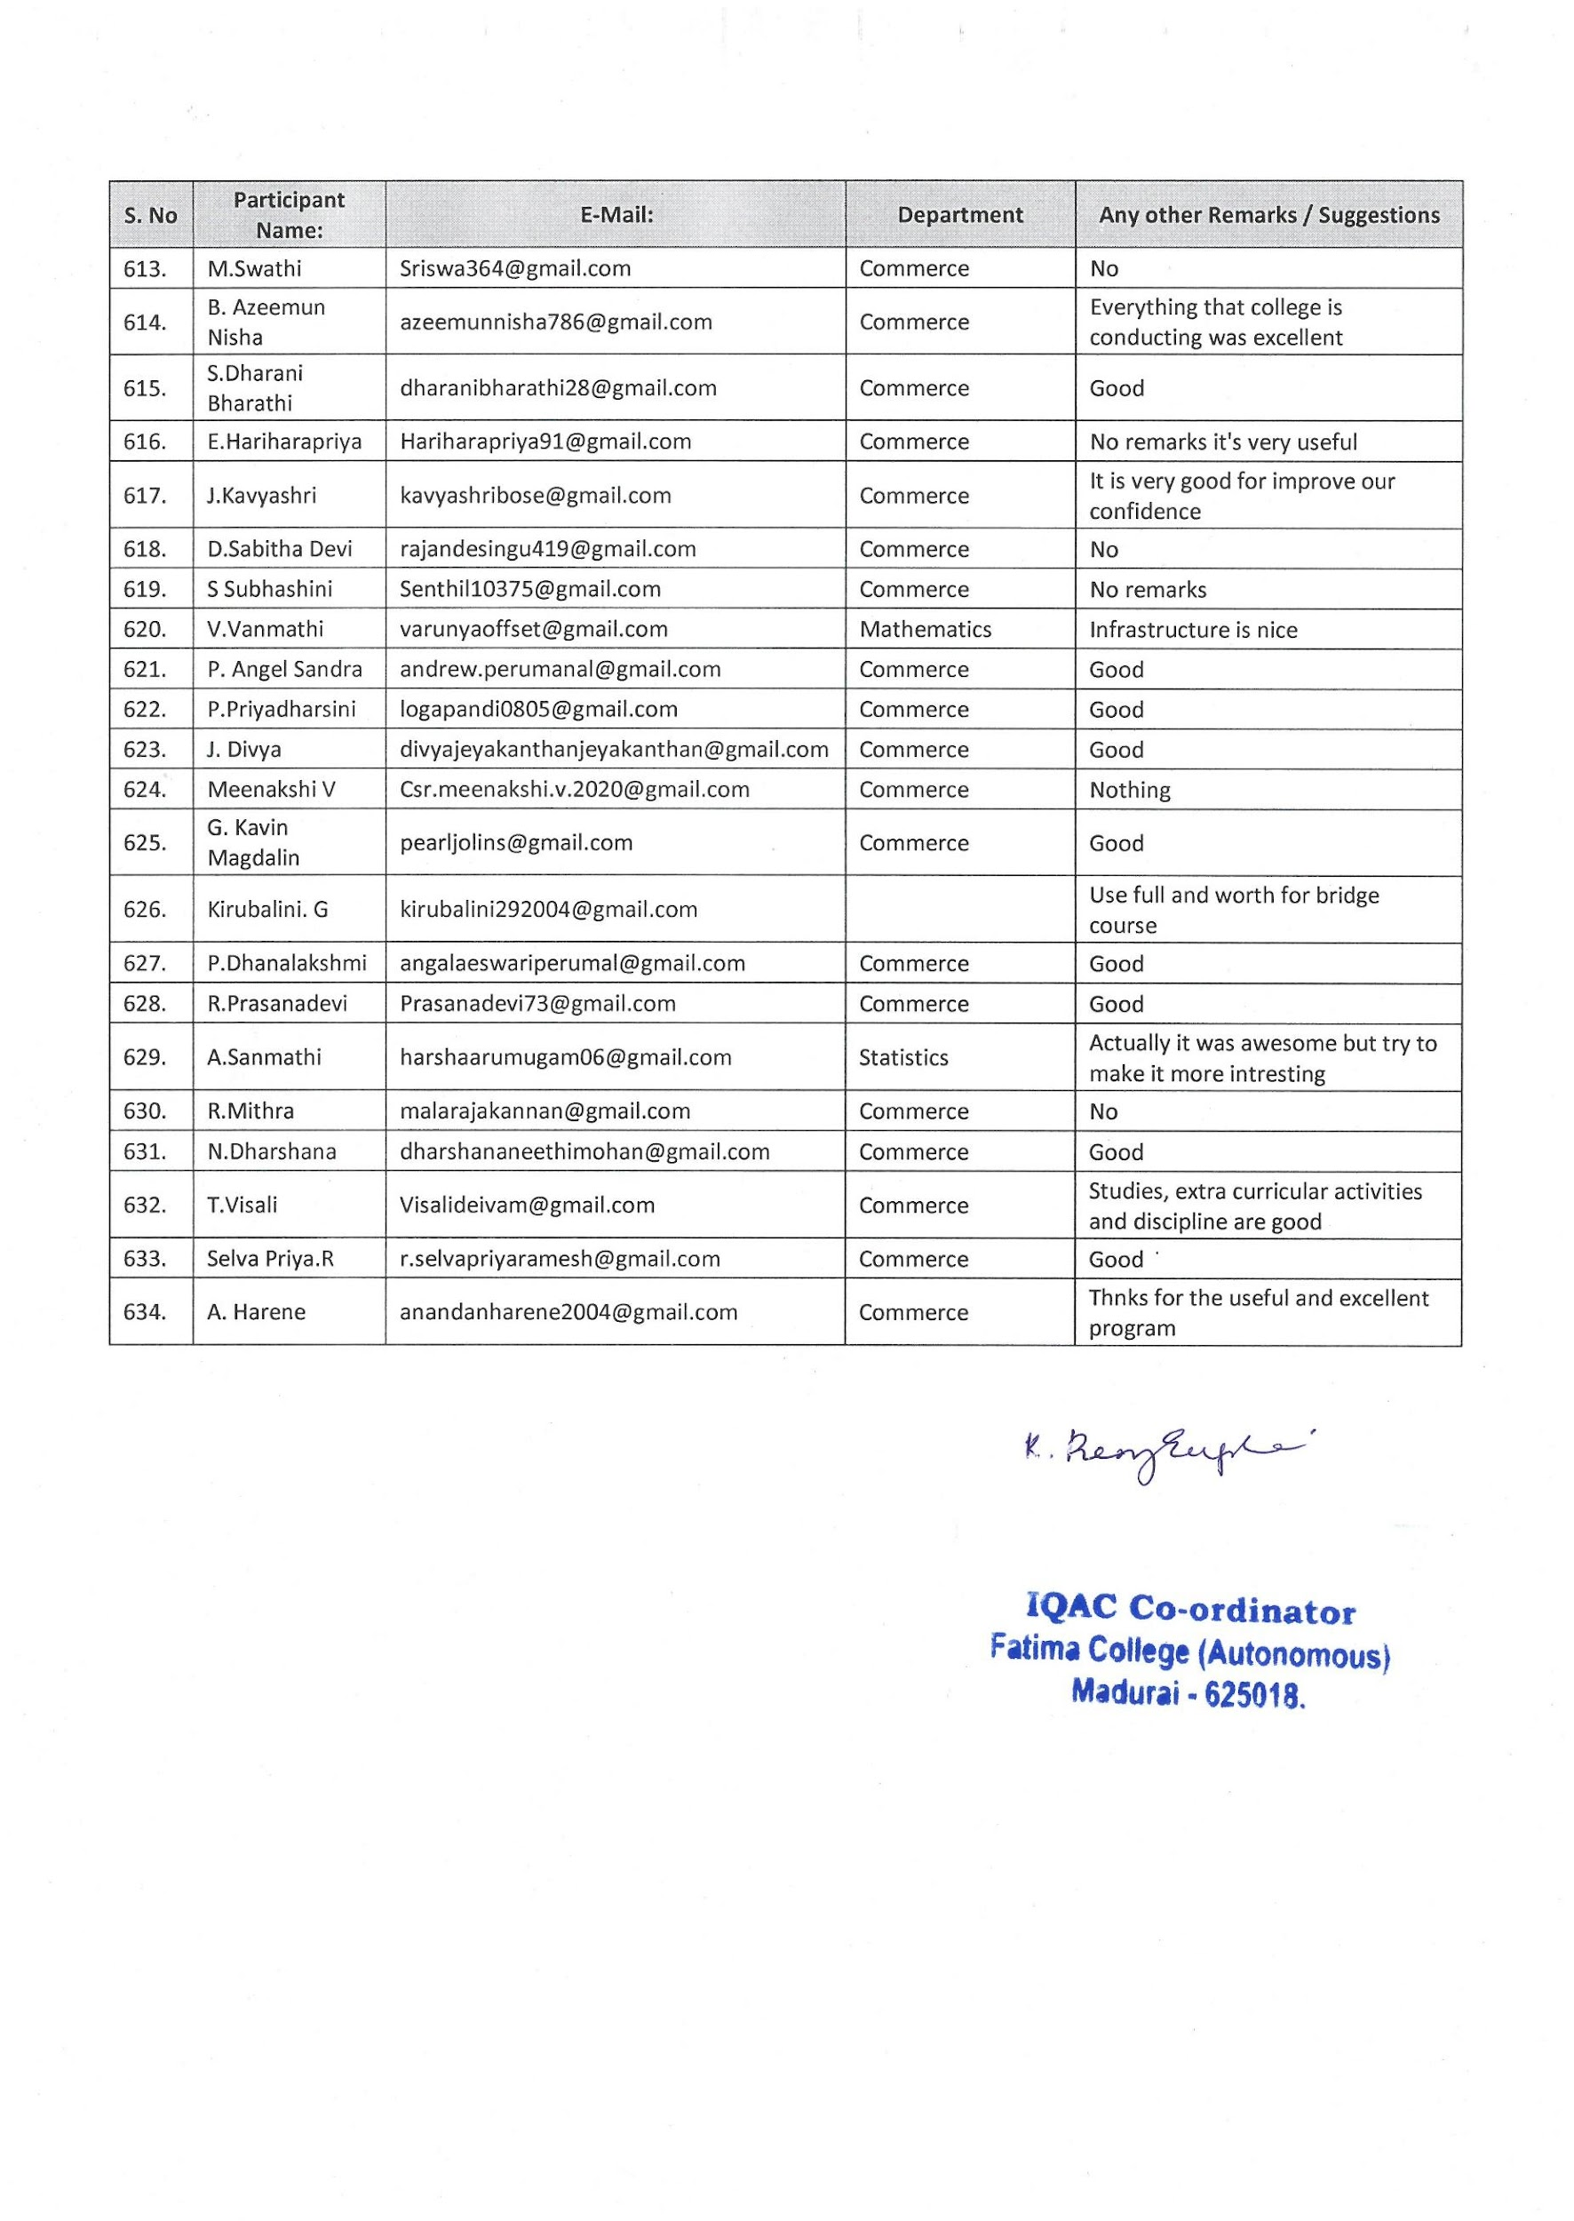

**Parents Teachers Meet I UG & I PG-2022**

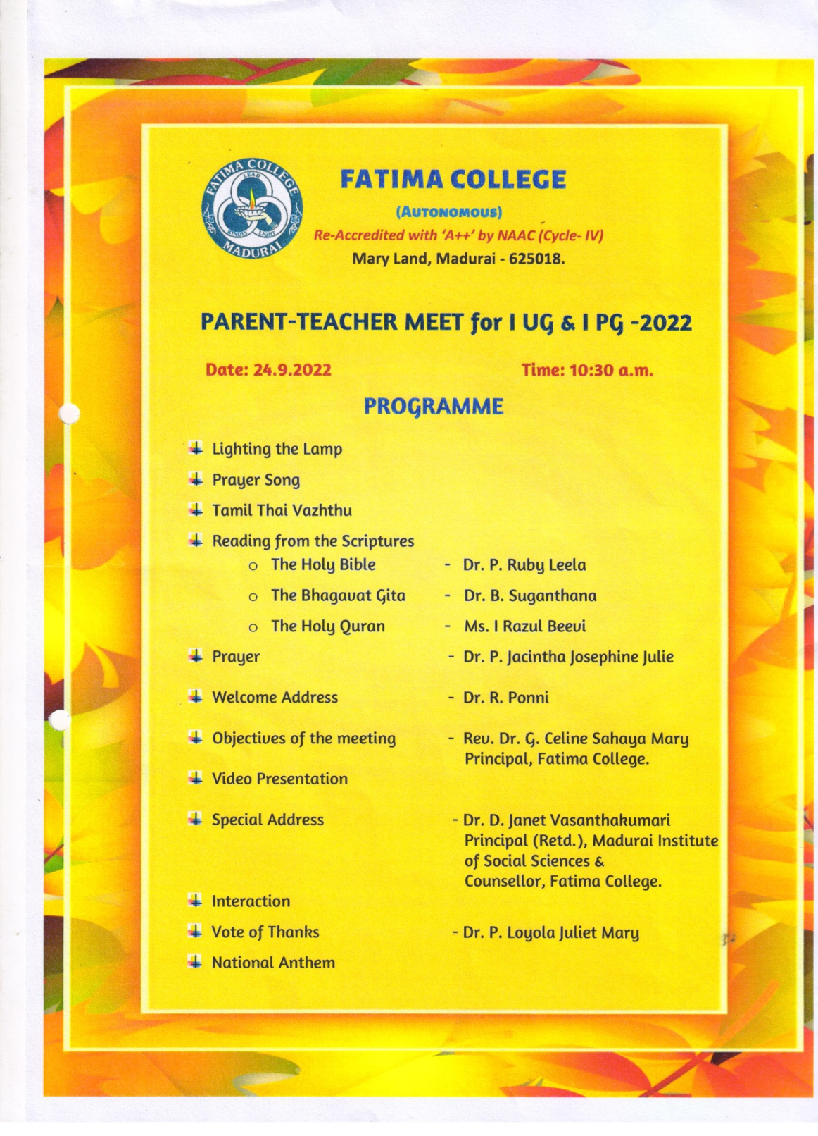

**Parent Teachers Meet– I UG & I PG**

**Date :24.09.2022**

**midtUf;Fk; md;ghd fhiy tzf;fk;/**

Respected ***Dr. Sr. M. Francisca Flora***, Secretary of the College, Vice-Principals ***Dr. Sr. M. Fatima Mary, Dr. Sr. G. Jenita Rani, Dr. G. Germine Mary***and ***Dr. M. Arasammal***, IQAC Co-ordinator, Head of the Departments , Other Faculties, Parents and my dear Students, I extend a warm welcome to all.

Rev Dr,Sr,G.Celine Sahaya Mary , Principal addressed the gathering by giving a brief Introduction about the history of the institution and the founder of the congregation Father Medaille. Sister Given an over view of college status from its establishment till now also instructions regarding college timings,attendance, dresscode and usage of mobile phones were given.

Elaborately explained about the exam patterns and formalities, oriented about the activites though various cells, committees and clubs.

Dr.D.Janet Vasanthakumari, Counsellor, Fatima College addressed the parents community stressing on the importance of parenting a teenagers etc.

flt[spd; gpurd;dj;jpy; epuk;gp. flt[s; Kd;Fwpj;j ,e;j ehspny FGkpapUf;Fk; bgw;nwhh;fshfpa c';fs; midtUf;Fk; vd; thH;j;Jf;fSk;. tzf;f';fSk;/

c';fs; gps;isfs; gw;wpa vjph;ghh;g;g[. mth;fspd; tsh;r;rp. thH;f;ifapd; cah;t[ vd;w gy fw;gidfnshL இருக்கும் bgw;nwhnu. ,d;W eh';fs; c';fSf;Ff; bfhLj;jpUf;Fk; miHg;g[. bgw;nwhh;fshfpa eP';fs; fy;Yhhpia elj;Jfpd;w v';fnshL. midj;J epiyfspYk;; ,ize;J bray;gl;lhy; kl;Lnk c';fs; gps;isfspd; tsh;r;rpapy; KGikahd btw;wp fhz Koa[k; vd;gij czh;j;Jtjw;fhf kl;Lnk/

**v';fisg;gw;wp xU rpwpa mwpKfk; :**

ghj;jpkh fy;Y}hp. yad;rpd; g[dpj tsd; rigiar; rhh;e;j mUs; rnfhjhpfshy; elj;jg;gLfpwJ/ yad;rpd; g[dpj tsd; rig 1650 Mk; Mz;L gpuhd;!; njrj;jpy;; **je;ij/ $hd; gPl;lh; bklha;(சேசுசபை)**அவர்களால்; bjhl';fg;gl;lJ. md;g[. xw;Wik. kd;dpg;g[ Mfpa tpGkpa';fis மையமாகவும் kdpjid kdpjndhLk;. kdpjid ,iwtndhLk; இணைப்பதைகோட்பாடாகbfhz;L vk; rig bray;gLfpwJ/

,e;j vk; rig ,e;jpa kz;zpny 1905 Mk; Mz;L rK:fg;gzp. kUj;Jtg;gzp vd;W bjhl';fpf; fy;tpg;gzpapny ikak; bfhz;lJ/ தென்தமிழகத்தில்குறிப்பாகமதுரையில்bgz;fspd; cah;fy;tpf;fhf Kjy; moj;jsj;ij ,l;lth;fs; vk; tsd; rigf; fd;dpah;fs;/

ghj;jpkh fy;Y}hp **1953** Mk; Mz;L mbkhpf;f ehl;ilr; rhh;e;j **mUs;rnfhjhp nuh!; bgdof**;l; mth;fshy; bjhl';fg;gl;lJ/ bgz;fspd; xU';fpize;j MSik tsh;r;rpf;fhf Kj;jpiu gjpj;j vk; fy;Y}hpiaj; bjhl';fpa rnfhjhp nuh!; bgdof;l;; mth;fs;. kf;fshy; **‘kJiu kPdhl;rp. Man of Madurai**vd;W md;ghf miHf;fg;gl;lhh;fs;/ ,th;fs; cah; fy;tpf;F Mw;wpa nritiag; ghuhl;o kJiu fhkuhrh; gy;fiyf; fHfk; ,th;fspd; cUtr;rpiyiag; gy;fiyf;fHf tshfj;jpy; mikj;Js;sJ/

ghj;jpkh fy;Y}hpஆரம்பகாலத்தில்g[dpj tsdhh; gs;sptshfj;jpy; 63 khztpah;fisf; கொண்டுsecond grade college ?Mfj; துவங்கபட்டது/ mjd;gpd; KJepiy fy;Yhhpahf 1964Yk;. jd;dhl;rpf; fy;Y}hpahf 1990-Yk; cah;e;jJ/ jw;bghGJ 21 ,sepiy ghl';fisa[k; 16 KJepiyg; ghl';fisa[k;. 6 Jiwfspy; Muha;r;rp ika';fisa[k; bfhz;Ls;sJ/200 Mrphpah;fSk;; 100 Mrphpah; my;yhj mYtyh;fSk; இக்கல்லூரியில்gzpbra;fpd;wdh;/4000? f;Fk; nkw;gl;l khztpaUld; bray;gLk;இக்கலூரியில்முதலாமாண்டுஇளங்கலைமற்றும்முதுகலைbgw;nwhh; Mrphpah; Tl;lj;jpw;F எங்கள்அழைப்பைஏற்றுபங்கேற்றுள்ளbgw;nwhh;fs; midtUf;Fk; ed;wp TWfpd;nwd;/

**பெண்கல்லூரியில்புரட்சிபடைக்கும்பெருமைமிகுஎம்கல்லூரிக்கு**1999 Mk; Mz;L NAAC Committeeahy; Kjy; Kiwahf 5 Star Status tH';fg;gl;lJ/ 2004?k; Mz;L ghj;jpkhf; fy;Yhhp **College with Potential for Excellence** epiyf;F cah;e;jJ/ 2006kw;Wk; 2013 Mk; Mz;L NAAC Committee ?My; Ma;t[ bra;ag;gl;L **‘A’ Grade** jFjpia; bgw;wJ/ 2021 Mk; Mz;oy; NAAC Committee ?My; மறுMa;t[ bra;ag;gl;L **‘A++’ Grade எனும்உயரிய**jFjpia bgw;Ws;sJ vd;gijg; bgUika[ld; c';fsplk; Twpf;bfhs;fpnwd;/

c';fs; kfis ,sepiy 3 Mz;LfSk;; KJepiy 2 Mz;LfSk; v';fs; ifapy; xg;gilj;J mtSila KGikahd tsh;r;rpia vjph;ghh;j;jpUf;Fk; c';fSila ek;gpf;ifiaf; fy;Yhhpa[k;. epUthfKk; ed;whfnt czh;e;jpUf;fpwJ/ mtSila KGikahd cly;. cs;s. Md;kPf kw;Wk; czh;t[epiyapyhd tsh;r;rpf;Ff; fy;Yhhp gy tHpfspYk; cjtp bra;fpwJ/

fhyj;jpd; njitf; கேற்பபுதுமையும், ntiy tha;g;g[f;fis பெற்றுதரும்யுக்திகளையும்கற்றலில்புகுத்திமாணவியரைஉயர்கல்வியில்வெற்றிபெறவைப்பதுrthyhf **அமைகிறது**

Mfnt c';fs; gps;isfs; fy;Yhhpapy; tH';fg;gLk; xt;bthU tha;g;iga[k; mth;fs; rhpahfg; gad;gLj;jp mth;fspd; MSikiaa[k; fy;tpj;juj;ija[k; cah;j;jpf; bfhs;tJ mtrpak;/

* flt[s; ek;gpf;ifa[k;. ,aw;if vHpYk;. kdpj nea czh;t[k;. bgz;fs; Kd;ndw;wj;jpy;. <LghLk; epiwe;j v';fs; fy;Y}hpapy; gapy tUk; xt;bthU khztpa[k; ghpt[. fdpt[. ek;gpf;iff;F chpa jd;ik. neh;ik. ciHg;gpd; nkd;ik nghd;w kjpg;gPLfis cs;th';fp. சமுகத்தில்ஒருபொறுப்பானகுடிமகளாகஉருவாகcjt[fpd;nwhk;/
* muR cjtp bgWk; ghlg;gphpt[ (Aided Courses – Shift I) fhiy 8/30 kzp Kjy; kjpak; 1/30 kzp tiuapYk; Raepjpg; ghlg;gphpt[ (Self Fianacing Courses – Shift II)kjpak; 12/30 kzp Kjy; 5/30 kzp tiu eilbgWfpwJ/ ,uz;L gphpt[fSk; khztpahpd; vz;zpf;if. tFg;giw kw;Wk; ,l trjpfSf;fhf. kl;Lnk Vw;gLj;jg;gl;Ls;sjhy; khztpahplj;jpy; ve;j ntWghLk; ,y;iy vd;gijg; bgw;nwhUf;Fj; bjhptpj;Jf; bfhs;fpnwd;/ mts; v';F brd;whYk; ghj;jpkhf; fy;Y}hp khztp vd;W jhd; gjpthFk;/
* bgw;nwhh;fns! Shift I khztpaUf;Ff; fy;Y}hp bjhl';Fk; neuk; fhiy 8/30 kzp vd;gjhy; khztpah; 08/25kzpf;Fs;Sk; Shift II khztpaUf;Ff; fy;Y}hp bjhl';Fk; neuk; kjpak; 12/30 kzp vd;gjhy; 12/25 kzpf;Fs;Sk; b$gj;jpw;fhf tFg;g[f;fspy; ,Uf;f ntz;Lk;/ c';fs; gps;isfs; fy;Y}hpf;Fj; jhkjkhf tUtij Koe;j mst[ jtph;g;gjw;F cjtpahf ,U';fs;/ bjhlh;e;J jhkjkhf te;jhy; bgw;nwhh;fshfpa c';fSf;Fj; jfty; bjhptpf;fg;gLk;/ mjw;fhd eltof;ifa[k; vLf;fg;gLk;/ fy;Y}hpf;F xG';fhd tUif mtrpak;/ VjhtJ jtph;f;f Koahj fhuz';fshy; fy;Y}hpf;F tu ,aytpy;iy vd;why; tFg;g[ Mrphpahplk; Kd; mDkjp bgw;W tpLg;g[ vLf;fyhk;/ vjph;ghuhj tpLg;g[ vd;why; tFg;g[ MrphpaUf;Fj; bjhiyngrpapy; bjhptpf;fyhk;/ tpLKiw njitg;gLk;nghJ tpLg;g[f;fojk; vGjpg; bgw;nwhh; my;yJ fz;fhzpg;ghsh; ifbahg;gkpl;L tFg;g[ Mrphpahplk; bfhLf;fntz;Lk;/ tpLg;g[f; fojk; bfhLf;f Koatpy;iybad;why; fy;Yhhpf;F tUk;nghJ fl;lhak; bfhz;L tu ntz;Lk;/ அவள்கல்லூரியில்இருக்கும்போதுcly; eyk; ,y;yhknyh. VjhtJ fhuz';fSf;fhf tPl;;ow;nfh my;yJ tpLjpf;nfh bry;y ntz;Lbkd;why; khztpah; fl;lhak; Jiz Kjy;thpd; mDkjp bgw ntz;Lk;/10 ehl;fSf;F nky; kUj;Jt tpLg;g[ vLj;jhy; fy;Y}hp Kjy;thpd; Kd; mDkjp bgw;W. kUj;Jtr; rhd;wpjiHf; bfhz;L tu ntz;Lk;/
* muR cjtpj;bjhif (Scholarship) bgWk; trjpfs; khztpah;fSf;F cz;L/ me;j mwptpg;g[ tUk;nghJ njitahd Mtz';fis mYtyfj;jpy; bfhLj;J mijg; bgWtjw;F cjtp bra;a ntz;Lk;/
* v';fs; fy;Y}hp xU jd;dhl;rpf; fy;Y}hp/ fy;Y}hp g[jpa ghl';fis. ghlj;jpl;lj;jpy; nrh;j;J khztpaiuf; fhyj;jpw;Fj; jFe;j திறமையானமற்றும்சிறந்தFokfshf cUthf;Ftjw;fhd KG Rje;jpuk; vk; fy;Y}hpf;F cs;sJ/ ,e;jg; ghlj;jpl;lj;jpy; bjhlh; kjpg;gPl;ow;F tHptif cs;sJ/

**njh;t[ Kiw :**

Kjyhk; Mz;oy; ,sepiyapy; nrh;e;Js;s c';fs; kfs; xt;nthh; Mz;ow;Fk; ,uz;L Semester tPjk; K:d;W Mz;Lfspy; MW Semester?y; njh;t[vGJths;/ KJepiy khztpahf ,Ue;jhy; xt;nthh; Mz;ow;Fk; ,uz;L Semester tPjk; ,uz;L Mz;Lfspy; ehd;F Semester?y; njh;t[vGJths;/

khztpahpd; bjhlh; fw;wy; jpwd; mjpfhpf;Fk; tifapy; ghl';fis MHkhft[k; EQqf;fkhft[k; fw;gjw;F. cjtf;Toa CIA vdg;gLk; Continuous Internal Assessment 40 kjpg;bgz;zpw;Fk; External Exam vdg;gLk; End Semester Examination 60 kjpg;bgz;zpw;Fk; eilbgWk;/ Internal Exam kjpg;bgz;zpy; khztpahpd; tUifg; gjptpw;Fk; tFg;gpy; ftdpf;Fk; jpwDf;Fk; kjpg;bgz; xJf;fPL bra;ag;gl;L cs;sjhy;. khztpahpd; jpdrhp tUif kpf kpf Kf;fpak;/

உங்கள்மகள்Fwpg;gpl;l kzpj;Jspfs; jpdKk; tPl;Lg; ghlj;jpw;fhfr; bryt[ bra;a வேண்டும்bjhiyf;fhl;rpapy; neuj;ij tPzhf;FtJ. bjhiyngrpapy; jfty; mDg;g[tJ nghd;w bray;fspy; <Lglhky; பயனுள்ளவிதத்தில்நேரத்தைசெலவிடவும்M';fpyj;jpy; ngRk; jpwid tsh;f;f. M';fpy ehspjH;fs; thrpf;Fk; gHf;fj;ij உருவாக்கிகொள்ளவும்ஊக்கg;படுj;துங்கள்

[

* Koe;jtiuapy; c';fs; Rw;Wyhg; gaz';fis tpLKiw ehl;fspy; itj;Jf; bfhs;S';fs;/ ntiyehl;fspy; ePz;l ehl;fs; gazk; vd;gJ khztpah;fSila gog;igj; jilbra;a[k; vd;gJ c';fSf;Fj; bjhpa ntz;Lk;/ khztpahpd; tUifg;gjpT 80 tpOf;fhL ,Ue;jhy; kl;LNk Nju;T vOjj; jFjp ngWfpwhu;fs;. 80 tpOf;fhl;bw;Ff; Fiwthf tUifg; gjpT ,Uf;Fk; khztpah;> jq;fspd; tUifg;gjpT FiwTf;fhd> jFe;j fhuzk; ,Ue;jhy; kl;Lk; Kjy;thpd; mDkjp ngw;W> fhy ePl;bg;Gf; fl;lzk; nrYj;jpj; Nju;T vOj ,aYk;.65?tpGf;fhl;ow;Fk; Fiwthf ,Ue;jhy; njh;t[ vGjnt ,ayhJ/
* brk!;lh; njh;t[fis khztpah; vGjpa gpwF. ,sepiy Kjy;. ,uz;lhk; Mz;L khztpah;fsplk; jpUj;jpa tpilj;jhs;fisf; bfhLj;Jr; rhpghh;j;j gpd;dnu njh;t[ Kot[fis btspapLfpnwhk;/ mt;thW jpUj;jpa tpilj;jhs;fisg; bgw;Wf;bfhs;Sk; nghJ mtw;iwj; jpwk;glr; rhpghh;j;J kjpg;bgz;fs; tpLgl;L ,Ue;jhnyh. tpilfs; jpUj;jg;glhky; ,Ue;jhnyh Mrphpahplk; brhy;ypr; rhp bra;a ntz;oaJ khztpah; flikahFk;/ tpilj;jhs;fis khztpahplk; bfhLj;J th';Ffpd;w நாள்(Transparency day)md;W khztpah; fl;lhak; tUif juntz;Lk;/ khztpah; xU gUtj;jpy; njh;r;rp bgwhj ghl';fis mLj;j gUtj;jpnyna vGjyhk;. cjhuzkhf Kjy; gUtj;jpy;; Arrear ,Ue;jhy; mj;njh;t[fis ,uz;lhk; gUtj;jpYk; ,uz;lhk; gUtj;jpy; Arrear ,Ue;jhy; mj;njh;t[fis K:d;whk; gUtj;jpYk; vGjpf; bfhs;syhk;. ,t;thnw MW gUtg; ghl';fspYk; njh;t[ vGj mDkjpf;fg;gLth;. mth;fs; rhpahf ,e;jj; njh;t[fSf;Fg; gof;f ntz;oaJ kpfkpf mtrpak;/ ,ijf; fz;fhzpg;gJ bgw;nwhuhfpa c';fs; flik MFk;/ mth;fs; kjpg;bgz; rhd;wpjH;fisg; bgWk;nghJ kjpg;bgz;fs;. mjpy; bfhLf;fg;gl;oUf;Fk;/ ,ju tptu';fisr; rhpghh;g;gJ mtrpak;/ c';fs; kfs;.Semester njh;tpw;fhd ghl';fspd; njh;r;rp Fwpj;j tptu';fs; kjpg;bgz;fnshL c';fSf;Fj; bjhiyngrpapd; K:yk; FWe;jfty;fs; (SMS) mDg;gg;gLk;/
* khztpah;fspd; kjpg;bgz;fspd; tptuk;. tUifg; gjpt[. kw;Wk; Kf;fpaj; jfty;fs; c';fs; Mobile Phone - f;Fj; bjhptpf;fg;gLtjhy; eP';fs; ,e;j mkh;t[ Koe;J Mrphpah;fisr; re;jpf;Fk; nghJ c';fs; Kfthp. kw;Wk; bjhiyngrp vz;izr; rhp ghh;f;FkhW nfl;Lf;bfhs;fpnwd;/ xU ntis c';fs; Kfthp. kw;Wk; bjhiyngrp vz;iz khw;wpapUe;jhy; tFg;g[ Mrphpahplk; bjhptpf;f ntz;Lk;/
* fzpdpf; fy;tp vy;nyhUf;Fk; fl;lhakhf;fg;gl;Ls;sJ/ me;j tFg;g[fspy; fl;lhak; khztpah; g';nfw;f ntz;Lk;/ TLjyhff; fzpdp fw;f tpUk;g[k; khztpah; mjw;Fhpa fl;lzk; brYj;jp tFg;gpw;Fg; gpwF cs;s neu';fspy; gof;fyhk;/ ehd;F kw;Wk; ,uz;L rf;fu thfd Xl;Leh; gapw;rp. kw;Wk; jl;lr;R tFg;g[fSf;Fk; Vw;ghL bra;ag;gl;Ls;sJ/ khztpaUf;F kof;fzpzp cgnahfpf;f WI-FI trjpa[k; fy;Yhhpapy; cs;sJ/
* fpwp!;jt khztpaUf;F. xt;bthU khjKk; fy;Yhhpf; ifnal;oy; Fwpg;gpl;Ls;sgo. Kjy; rdpf;fpHikfspy; elf;Fk; kiwf;fy;tp tFg;g[fSf;F KG tUif ,Ug;gJ mtrpak;/ khztpah; fpwp!;jt kjpg;gPLfspy; tsu cjt[tJ fy;Y}hpapd; flik.
* ,s';fiy gapYk; khztpah; Part V vd;w gphptpy; rKjhaf; fy;tpiaa[k; gapy ntz;Lk; vd;gJ UGC-apd; xG';F Kiwfspy; xd;W/ vdnt NCC, NSS, Women’sCell, Red Cross, Rotract , AICUF, Physical Educationvd;w gphpt[fspy; mts; VjhtJ xd;wpy; nrh;e;J mjw;Fhpa tFg;g[ neuj;ija[k; KGikahf epiwt[ bra;a ntz;Lk;/ ,jw;F mtsJ tUif Fiwthf ,Ue;jhy; mts; ,s';fiy Koj;j rhd;wpjiHg; bgWk; jFjpia ,He;J tpLths; vd;gijj; bjhptpj;Jf; bfhs;fpnwd;/thuj;jpy; xt;bthU ehSk; khztpah;f;Fr; rpwg;g[ tFg;g[fs; cz;L/ mjd; tptuk; fhyz;lhpy; bfhLf;fg;gl;Ls;sJ/ Part V vd;w gphptpd; fPH; tpahHd; njhWk;Shift If;F kjpa tFg;g[fSk;Shift II f;F fhiy tFg;g[fSk; eilbgWk; . NSS Mf ,Ue;jhy;; tpLKiw Kfhk;fSk; Vw;ghL bra;ag;gLk;/ mjpy; g';bfLj;jhy; kl;Lnk mts; 3 tUlg; gog;ig epiwt[ bra;a ,aYk;/

[[[[

* khztpah; K:d;W tUlk; Koj;Jr; bry;Yk; nghJ mth;fSila Fwpg;gpl;l ,sepiy gl;lr; rhd;wpjGld; TLjyhf ntiytha;g;g[j; njitf;nfw;g xU (Diploma) gl;lag; gog;g[ my;yJ rhd;wpjH; gog;g[ (Certificate)gof;f tha;g;g[fs;; cs;sd/ TLjyhff;$g;ghdpa. gpbu";r;;. b$h;khdpa. ,j;jhyp bkhHp. இசை.நடனம். நாட்டுபுறகலைகள். fuhj;njkw;Wk; UPSC, Group II & Bank exam fw;f tpUk;g[k; khztpah; mjw;Fhpa fl;lzk; brYj;jp tFg;gpw;Fg; gpwF cs;s neu';fspy; gof;fyhk;/ ,e;jf; TLjy; rhd;wpjH; mtSf;F mjpfkhd ntiy tha;g;g[fisf; bfhLf;Fk; vd;gjhy; khztpah;fSf;F ,j;jifa; ghl';fs; Vw;ghL bra;ag;gl;Ls;sd/
* fy;Yhhp Placement Oficer cld;,ize;J. xt;bthU Jiw rhh;gpYk; me;je;jg; ghlg;gphpitr; rhh;e;j Mrphpah; xUth;. ey;y ntiy tha;g;g[fs; fpilf;f khztpaiuj; jahhpf;fpwhh;fs;/ ,e;j ntiy tha;g;g[fs; fpilf;f khztpah;fSf;F M';fpy bkhHpg;ngr;Rj; jpwd; mtrpakhfpd;wJ/ vdnt khztpah;; M';fpyj;jpy; jhd; ngr ntz;Lk; vd;W Cf;fg;gLj;Jfpd;nwhk;/ xt;bthU JiwapYk; cs;s bghWg;g[ ntiytha;g;g[ MrphpaUk;. Placement Officer-k; Cf;fK:l;o khztpaUf;F ey;y ce;Jjy; mspj;J mth;fs; 3 tUl';fs; Koj;J rpwe;j MSikj;jpwd; bfhz;l khztpauhf btspapy; bry;y cjt[fpnwhk;/ khztpaUf;F Campus interview மூலம்வாய்ப்புகளைபெற்றுதரசிறப்பானமுயற்சிகளைகல்லூரிநிர்வாகம்மேற்கொள்கிறது
* nkYk; khztpah; jk; thH;f;ifia vjph;bfhs;s ntz;oa kjpg;gPl;Lf;fy;tp. kdpj chpikf; fy;tp. Rw;Wg;g[wr; N:H;epiyf;fy;tp Kjypatw;nwhL cly;ey mtrpak; fUjp clw;gapw;rp tFg;g[fs;. nahfh tFg;g[fs;. kdeyk; ngQqk; tFg;g[fs; kw;Wk; cly; cWg;g[fs; jhdk;. ,uj;j jhdk; Fwpj;j tpHpg;g[zh;t[. rKjha eyf; fy;tp. rKjha nrit nghd;wtw;wpYk; gapw;rp mspf;fpnwhk;/ khztpah; fy;tp gapYk; K:d;W Mz;Lfspy; vy;yhtw;wpYk; gapw;rp bgw;W. KGikaile;J ey;y xU bgz;kzpahf. jd;dk;gpf;ifnahL thH;it vjph;bfhs;s ntz;Lk; vd;gnj bgw;nwhuhfpa c';fSila tpUg;gKk; Mrphpah;fshfpa v';fSila tpUg;gKk; MFk;/
* midj;J tptu';fisa[k; mwpaf; fy;Y}hpf; ifnal;il th';fpg; goj;Jj; bjhpe;J bfhs;S';fs;/ c';fSf;Fj; njitahd tptu';fs; midj;Jk; fy;Y}hpf; ifnal;oy; cs;sd/ nkYk; tptu';fs; njitg;gl;lhy;. fy;Y}hpj; bjhiyngrpapy; bjhlh;g[ bfhz;L c';fSf;Fj; njitahd tptu';fisg; bgw;Wf; bfhs;S';fs;/ Mrphpah;fisr; re;jpf;f ntz;oa njit Vw;god; Kd; mDkjp bgw;W te;jhy; fy;Y}hp ntiy neu';fspy;; mth;fisf; re;jpf;f Vw;ghL bra;ag;gLk;/
* tpLKiw ehs;fspy; khztpah;fy;Yhhpf;F tuntz;oapUe;jhy; tptuk; c';fSf;Fj; bjhptpf;fg;gLk;/ TLjy; tptuk; njitg;gl;lhy; fy;Y}hpj; bjhiyngrp vz;zpy; bjhlh;g[ bfhs;S';fs;/ bjhiyngrp mYtyh; fhiy8.30 kzp Kjy; khiy5.30 kzp tiu mYtypy; ,Ug;ghh;/
* rKjhak; thpg;gzk; brYj;jp c';fs; kfSila cah;fy;tpf;F cjt[fpwJ/ cah;fy;tp bgw;w khztpah;. rKjha Kd;ndw;wj;jpw;fhfg; ghLgl flikg;gl;oUf;fpwhh;fs; vd;gij eP';fs; kwf;ff; TlhJ/
* cah;fy;tp bgWk; khztpah;. rKjhaj;jpw;F ed;wpf;flid VjhtJ xU tHpapy; brYj;JtJ mtrpak;/ mijf; fy;Y}hp ‘Out reach’ ghlj;jpl;lj;jpd; கீழ்கிராமப்புறத்திற்குசென்றுசெய்யும்சேவைtHpahf Cf;Ftpf;ft[k;. cWjpg; gLj;jt[k; bra;fpwJ/ ஏதேனும்fhuz';fs; brhy;yp khztpaiu ,e;jf; flikapypUe;J tpLtpf;f Kaw;rp bra;a ntz;lhk; vd;Wk; bgw;nwhiuf; nfl;Lf; bfhs;fpnwd;/ khztpah; ‘Out reach’பாடத்தை epiwt[ bra;ahtpl;lhy; gog;ig epiwt[bra;a ,ayhJ. vd;gija[k; bjhptpj;Jf; bfhs;fpnwd;/
* khztpaUila jdpj;jd;ikia[k;. jpwikiaa[k; tsh;j;Jf; bfhs;s fy;Yhhpapd; cs;Sk;. kw;wfy;Yhhpapy; elf;Fk; nghl;ofspYk; g';bfLf;fkhztpaiur; rpwe;j Kiwapy; jahh; bra;fpnwhk;/
* vk; fy;Y}hp tshfj;jpy; Ragging Kw;wpYkhfj; jil bra;ag;gl;Ls;sJ/ khztpah; Raggingvd;w thh;j;ijf;Fg; gae;Jtplhky; ,Uf;f ey;y Kd;dwptpg;g[fs; mth;fSf;Ff; bfhLf;fg;gl;Ls;sd/ c';fs; gps;isfSf;F VjhtJ rpuk';fs; ,Ug;gJ nghy; eP';fs; czh;e;jhy; mjw;fhf xJf;fg;gl;oUf;Fk; Mrphpah; my;yJ Jiz Kjy;th;fis clnd bjhlh;g[ bfhs;syhk;/ ,th;fspd; ifngrp vz;fs; fy;Y}hp ,izajsj;jpy; nghlg;gl;Ls;sd/
* ,e;jf; fy;Yhhpapd; khztpahfpa c';fs; kfs; ve;jtpjj; jfhj bray;fspYk; <Lglf;TlhJ/ uhfp';. jtwhd eltof;if. Vkhw;Wjy;. திருடுதல்Kd;dwptpg;g[ ,y;yhky; mof;fo tpLg;g[ vLg;gJ nghd;w jtWfs; c';fs; kfisf; fy;Yhhpia tpl;L mDg;g tHp tFf;Fk;/
* vk; fy;Y}hpiag; bghWj;jtiu khztpah; ifngrp bfhz;Ltu mDkjp fpilahJ mth;fs; அனுமதியின்றிifngrpiaf; bfhz;LtUtJ fy;Y}hp eph;thfj;jpdUf;Fj; bjhpa te;jhy; eltof;iff;F Mshf nehpLk; vd;gijj; bjhptpj;Jf; bfhs;fpnwd;/tshfj;jpy; khztpau; ve;jf; fhuzj;ij Kd;dpl;Lk; bry;nghd; gad;gLj;j mDkjpapy;iy vdj; bjupe;Jk; gy khztpau; mj;jtiwr; bra;fpwhu;fs;/ mtu;fs; Kjy;tu;. Mrpupah;fSf;Fj; bjupahky; ifngrpia kiwj;J itj;J ahUk; ghu;f;fhj tifapy; rhu;$; bra;at[k; ngrt[k; Kw;gLfpwhu;fs;. eP';fs; bfhLf;ftpy;iy vd;whYk; mth;fSf;Fj; bjupe;j egu;fsplk; bfhLf;fy; th';fy; bra;fpwhu;fs;/ jw;nghJ fy;Y}upapy; khztpah; mjpfkhff; ifngrp itj;jpUg;gJk; ez;gu;fSld; btspapl';fSf;Fr; bry;tJk; mjpfupj;J tUfpwJ/ ,jdhy; gps;isfs; gy jtwhd tHpfSf;Fk; cwt[fSf;Fk; ghykpLfpwhu;fs; vd;gijg; bgw;nwhu; kwf;f ntz;lhk;/ mtu;fs; அனுமதியின்றி ifngrpiaf; bfhz;L tUtJ fy;Y}up epu;thfj;jpw;Fj; bjupa te;jhy; xG';F eltof;iff;F Mshf neupLk; vd;gijj; bjuptpj;Jf; bfhs;fpnwd;/ jtph;f;f Koahj fhuzj;jpw;fha; c';fs; kfs; miyngrp itf;f ntz;Lbkd;W eP';fs; epidj;jhy; me;j khztpapd; bgw;nwhh; fy;Y}hp Jiz Kjy;tiur; re;jpj;J mDkjp bgw ntz;Lk;/
* khztpaUf;F ntW VjhtJ gpur;rpidfs; vd;whYk; fy;Y}hpf;F eP';fs; te;J Kjy;tiu my;yJ Jiz Kjy;th;fisj; bjhlh;g[ bfhs;syhk;/ c';fs; kfs; c';fisf; fy;Y}hpf;F tuf;TlhJ vd;W brhd;dhy;. mJ jhd; gpur;rpidapd; bjhlf;fk; vd;gijg; g[hpe;J bfhs;S';fs;/
* bgz;fspd; Rakhpahijiaa[k;. Ra kjpg;iga[k; ghJfhj;Jf; bfhs;Sk; tifapy;. ele;J bfhs;tJk;. Mil mzpe;J bfhs;tJk; mtrpak;/ etPdj;jpw;F Kd;Dhpik mspg;gijtpl. gz;ghl;ow;F cfe;j Milfis mzpa cjt[';fs;/rpwpa Milfshfnth. ,Wf;fkhfnth. mzpa mDkjp ,y;iy/ RojhUf;Fj; Jg;gl;lh (Shawl) fl;lhak; mzpa ntz;Lk;/ mij Pin bra;J ,Uf;f ntz;Lk;/
* c';fs; mDkjp ,y;yhky; gpw ,l';fSf;nfh. tPLfSf;nfh bry;yf;TlhJ vd mwpt[Wj;J';fs;/ ,e;j 3 Mz;Lfs; kw;Wk; 2 Mz;Lfs; fy;tp gapYk; fhyj;jpy; mtSila jdpg;gl;l MirfSf;F ,lk; bfhLj;Jj; jtW bra;jhy;. jpUk;g mts; fy;Yhhpg; gog;igj; bjhlu tpLjpa[k; / fy;Y}hpa[k; mDkjpf;fhJ/
* jfty; bjhHpy; El;g tsh;r;rpahy; cyfj;ijna cs;s';iff;Fs; itj;Js;s ,d;iwa NHypy;. ,iza tHpf; fy;tpa[k; mtrpakhd xd;whf cs;sJ/ cah; fy;tp epWtd';fspy; c';fs; gps;isfs; fy;tp fw;f ntz;Lk; vd;w fdt[k; Vf;fKk; c';fSf;F ,Uf;fyhk;/ mf;fdit edthf;Fk; tifapy;. eLtz; murhy; tH';fg;gLfpd;w ,iza tHpf; fy;tpiaa[k; bgw fy;Y}hp Vw;ghL bra;fpd;wJ/ ,sepiy khztpauhf ,Ue;jhy; **“!;tak;”** tHpahft[k; KJepiy khztpauhf ,Ue;jhy; **“PG?ghlrhyh”** tHpahft[k; mf;fy;tpiag; bgw;Wg; bghpa bghpa epWtd';fspy; c';fs; gps;isfs; ntiytha;g;gpidg; bgw;Wf;bfhs;s tHptif bra;fpnwhk;/ ,it Fwpj;j tptu';fs; c';fs; gps;isfsplk; bjhptpf;fg;gLk;/ ntiytha;g;gpidg; bgWtjw;F cjtpahf ,Uf;fpd;w ,f;fy;tpiaa[k; c';fs; gps;isfs; bgWtjw;F mth;fis Cf;fg;gLj;J';fs;/

**E}yfk; :**

fy;Y}hp E}yfk; thu ehl;fspy; fhiy 8/30 kzp Kjy; khiy 5/30 kzp tiua[k;. rdpf;fpHikfspy; fhiy 9/00 kzp Kjy; ez;gfy; 1/00 kzp tiua[k; bray;gLfpwJ/ **1.45.596** g[j;jf';fisf; bfhz;l v';fs; E}yfk; fpilg;gjw;fhpa Xh; mhpa tha;g;g[/ khztpah; ,e;j tha;g;ig KGikahfg; gad;gLj;jpf; fy;tpj;juj;ij nkk;gLj;jpf; bfhs;s miHf;fg;gLfpwhh;fs;/

* “ifj;njhopy; xd;iwf; fw;Wf;nfhs;. ftiy cdf;fpy;iy xj;Jf;nfhs;” vd;gjw;Nfw;gf; ifj;njhopiyf; fw;Wf;bfhs;st[k; RabjhHpy; Kidnthuha; cUthft[k; tha;g;g[f;fs; Vw;gLj;jpf; bfhLf;fg;gLfpd;wd/ Mil totikg;g[ kw;Wk; ijay;. Nutrition Cafe, mHF kw;Wk; Mnuhf;fpak;. ,aw;if vz;bza; jahhpg;g[. fhfpj kW RHw;;rp. fhshd; cw;gj;jp. kz;g[G kw;Wk; ,aw;if cu';fs; cw;gj;jp Mfpatw;wpw;;fhd gapw;rpfs; bfhLg;gJld; mit bjhlh;ghd ika';fSk; bray;gLfpd;wd/ ,';F bjhHpy; fw;Wj; bjhHpy; bjhl';fpath; btspapy; epWtdk; bjhl';Fk; mstpw;F Kd;ndwp cs;shh; vd;W $Wtjpy; kfpH;r;rp milfpnwd;/

**tpLjpapy; j';fpg; gapYk; khztpahpd; bgw;nwhnu!**

* c';fs; gps;isfSf;F Kf;fpaf; fhuz';fSf;fhf mtru tpLKiw njitg;gl;lhy; tpLjp mYtyfj;jpy; cs;s bjiyngrpapy; bjhlh;g[ bfhz;L. Kd; mDkjp bgw;w gpd;dnu eP';fs; Tl;or; bry;y Koa[k;/
* மாதம்தோறும்மாணவியர்tPl;ow;F mDg;gg;gLtjhy; jtph;f;f Koahj fhuz';fisj;jtpu ghh;itahsh;fs; (Visitors) tpLjp khztpaiug; ghh;f;f tUtij jtph;g;gJ ey;yJ/
* tpLKiw Koe;j Fwpg;gpl;l ehspy;. Fwpg;gpl;l neuj;jpy; tpLjpf;F tu ,aytpy;iy vd;why; bgw;nwhh;. tpLjpf; fhg;ghsUf;Fj; jfty; bjhptpg;gJ mtrpak;/
* njh;t[r; rkaj;jpy; gy;ntW fhuz';fSf;fhf tPl;ow;Ff; Tl;or; bry;y mDkjp ,y;iy/
* Kd; mDkjp ,y;yhky; tpLjpia tpl;L. bry;Yk; khztpah; tpLjpapypUe;Jk; btspnaw;wg;gLth;/
* tpLjp khztpah; xU Semsester-y;2 ghl';fSf;F nky; njh;r;rp bgwhky; ,Ue;jhy; mLj;j tUlk; tpLjpapy;; mth;fSf;F ,lk; mspf;fg;glkhl;lhJ/
* tpLjp kw;Wk; fy;Yhhpapd; Rw;Wg;g[wj;ijj; Jha;ikahf itf;f khztpah; cWJiz bra;a ntz;Lk;/
* tpLjp khztpah; ifg;ngrp. kof;fzpdp itj;Jf;bfhs;syhk;/ tpLjp khztpah; ,ut[ 9/00 kzp tiu kl;Lk; jhd; ifg;ngrp cgnahfg;gLj;j mDkjp cs;sJ/ Iron Box, Water Heater nghd;w kpd;rhu rhjd';fis tpLjpapy; gad;gLj;jf; TlhJ/
* fy;Y}hp tshfj;jpy; ,e;jpad; t';fpapd; fpis bray;gLfpwJ/ khztpaUf;Fg; gzk; vLf;Fk; trjpa[k;. ATM trjpa[k; cs;sd/ nkw;fz;l tptu';fSf;F tpLjpf;fhg;ghsiu mQqF';fs;/ khztpah; tpiy cah;e;j bghUs;fs; kw;Wk; gzk; itj;jpUe;jhy; mjw;F khztpanu bghWg;g[/ midj;J ,l';fspYk; CCTV nfkuh bghUj;jg;gl;L cs;sJ vd;gij khztpah; bjhpe;J bfhs;S';fs;/ beU';fpa el;g[ vd;W. gpwkhztpahplk; c';fs; Purse/ATM/Bank Account Number ,tw;iw btspg;gLj;jhky; ,Ug;gJ njitaw;w jtWfisj; jtph;f;Fk; vd;gij czh;e;J bfhs;S';fs;/
* mtruj; njit vd;why; bgw;nwhh; my;yJ ghJfhtyh; (Local Guardian)nehpy; te;Jjhd; c';fs; gps;isfis miHj;Jr; bry;y ntz;Lk;. jdpahf mDg;g mDkjp ,y;iy/

khztpah;. bgw;nwhUf;F vd;Wk; FHe;ijfs;jhd;/ Mdhy;. c';fs; kfs; Kjph;r;rp mila[k; nghJ gy tpc&a';fisj; jhnd Kd;bdLj;Jr; bra;a Muk;gpf;fpwhs; vd;gij eP';fs; xg;g[f;bfhz;L. jFe;j tpjj;jpy; mtis tHpelj;j Kaw;rp bra;a[';fs;/

bgw;nwhuhfpa eP';fs; c';fs; fc&;l. ec&;l';fis mth;fnshL gfph;e;J. cz;ikahff;fye;J ngrp. thH;f;ifapd; vjhh;j;j';fis mth;fs; czUk; tz;zk; ele;J bfhz;lhy;. mth;fs; tHp jtwpr; bry;Yk; tha;g;g[fisf; Fiwf;fyhk;/

* bgw;nwhh;fns c';fs; kfs; vg;bghGJk; vija[k; kiwf;fhky; c';fsplk; kdk; tpl;Lg; ngRk; mstpw;F mth;fsplk; beUf;fkhf ,U';fs;/
* c';fs; kfSld; jpdKk; rpy kzpj;JspfisahtJ brytHpa[';fs;/
* FLk;gkha; ,ize;J 10 epkplkhtJ ,iw ntz;ly; bra;a[';fs;/
* cilapYk; eilapYk; khw;wk; Vw;gLfpwJ vd;why; mjidf; ftdpj;J mjw;fhd fhuz';fisf; fz;lwpe;J bfhs;s KaY';fs;/ rhpahd tHpelj;Jjiy nkw;bfhs;S';fs;/ c';fs; thH;f;if mth;fSf;F Kd; khjphpaha; mika ntz;Lk;/
* c';fs; kfs; ve;j yl;rpaj;ij - ,yf;if -Fwpf;nfhis mila ,f;fy;Y}hpapy; nrh;f;fg;gl;lhnsh mjpy; btw;wp bgwr; RK:fkhd R{Hiy Vw;gLj;jpj;jhU';fs;/ bgw;nwhhpd; gpur;rpidfs; khztpaUf;Fj; jilaha; ,y;yhjgof; ftdKld; bray;gLtnjhL mts; ,yl;rpaj;ij mof;fo epidt[gLj;J';fs;/
* re;njfg;gLtijf; Fiwj;J **“cd;id ek;g[fpnwd;”**vd;w thh;j;ijia mof;fo cgnahfg;gLj;J';fs;/
* Fiw TWtJ. rhgkpLtJ nghd;w khztpahpd; Ra kjpg;igf; Fiwf;Fk; brhw;fisf; Fiwj;J. c';fs; gps;isfSf;F MrPh;thjj;ijf; bfhL';fs;/ ey;y tpc&a';fis mjpfk; ghuhl;L';fs;/

**bgw;nwhh;fns c';fsplk; xU md;ghd ntz;Lnfhs;:**

* Covid fhy fl;lj;jpw;F gpwF. khztpaUf;F j';fs; gog;gpd; kPJ ,Ue;j Mh;tk; Fiwe;J tpl;lJ/ mij bgw;nwhh;fshfpa eP';fs; j';fs; ftdj;jpy; bfhz;L gps;isfis fy;tpapy; Cf;Ftpf;FkhW nfl;Lf; bfhs;fpnwd;/
* jpUkzj;jpw;F chpa gUtj;ij miltjw;F Kd; c';fs; bgz; gps;isfSf;Fj; jpUkzk; bra;a ntz;lhk; vd;W md;g[ld; nfl;Lf;bfhs;fpnwd;/
* Vbddpy; bgz; FHe;ijahd c';fs; kfs; cly;. cs;sk;. mwpt[. Md;kpfk; Mfpatw;wpy; Kiwahd Kjph;r;rpa[k; gf;FtKk; bgWk; taJ 21 Mjyhy; Kjy; Mz;nlh. ,uz;lhk; Mz;nlh. K:d;whk; Mz;nlh goj;Jf;bfhz;oUf;Fk; nghnj jpUkzk; bra;J itj;jhy; gog;g[. FLk;gk; Mfpa ,uz;oYk; ftdk; brYj;j ,ayhky; kdjstpYk; cly; mstpYk; ghjpg;gila nehpLk;/
* ey;y tud; tUk; gl;rj;jpy; Kot[ bra;J itj;Jtpl;L K:d;whk; Mz;L Koj;j gpd; jpUkzk; bra;J itf;FkhW md;g[ld; nfl;Lf; bfhs;fpd;nwd;/ fy;Y}hpapy; nrh;e;jt[ld; jpUkzk; vd;gJ ,d;iwa fyhr;rhuk; vd;gij vd; mDgtj;jpy; czUfpd;nwd;/ jpUkzk; Koj;J. gog;igj; bjhlUk; khztpah; fy;Y}hpapy; gpw khztpah;fsplk; xU khWgl;l fyhr;rhuj;ij cUthf;Ftija[k; czUfpd;nwd;/ vdnt ,ijj; jtpu;f;f bra;a c';fSila xj;JiHg;ig ey;fpf; fy;Y}hpapd; fyhr;rhuj;ij tsh;f;f cjt[khW bgw;nwhh;fshfpa c';fis md;g[ld; nfl;Lf;bfhs;fpnwd;/

**Kf;fpaj; jfty; :**

* vk; fy;Y}hpapy; khztpah;; gog;ig Kog;gjw;F Kd; mth;fspd; rhd;wpjH;fisj; jpUk;gg;bgw ntz;o ,Ue;jhy; khztpapd; bgw;nwhhpd; ifbahg;gk; ,Ue;jhy; kl;Lnk rhd;wpjH; bfhLg;gijf; fy;Y}hp eph;thfk; tHf;fkha;f; bfhz;Ls;sJ/ Mdhy; khztpah; 18 taijg; g{h;j;jp mile;j gpd;g[ bgw;nwhh; xg;g[jy; ,d;wp j';fspd; thH;f;ifj; Jiziaj; njh;e;bjLf;Fk; gl;rj;jpy; rhd;wpjH;fisj; jpUk;gg;bgw khztp fy;Y}hp eph;thfj;ij mQqFk; ntisapy; fy;Y}hp. bgw;nwhh; ifbahg;gk; bgw;why; kl;Lnk rhd;wpjH;fisg; bgw ,aYk; vd;W mWjpapl;Lf; TWtjpy; rl;lr; rpf;fy;fs; ,Uf;fpd;wd vd;gijg; bgw;nwhh;fshfpa c';fs; ftdj;jpw;Ff; bfhz;L tUfpnwd;/
* fhyk; khwp tUfpwJ/ fhyj;jpd; khw;wj;jpy; ek; gps;isfs; jlk; g[uz;L tplhky; bewpg;gLj;Jtjpy; bgw;nwhh;fshfpa c';fSf;F mjpfg; g';F cz;L vd;gij czh;e;J bray;gl ntz;Lfpnwd;/

**md;g[g; bgw;nwhnu!**

,Jtiu v';fs; fy;Y}hp vd;W mwpKfg;gLj;jpndd;. ,dp ek; fy;Y}hp vd;W Fwpg;gpl tpUk;g[fpnwd; Vbdd;why; vg;nghJ c';fs; gps;isfs; ,f;fy;Yhhpapy; mDkjpf;fg;gl;lhh;fnsh me;j behoapypUe;J ,J ek; fy;Y}hp vd;w ge;jj;ij Vw;gLj;jpf;bfhz;L c';fs; gps;isfspd;KGikahd tsh;r;rpapy;; v';fnshL ,ize;J bray;gl;lhy; c';fs; ek;gpf;if epiwtila[k;/ eP';fs; vjph;ghh;f;Fk; btw;wpia epr;rak; fhz;gPh;fs;/ ,iwtd; c';fisa[k; c';fs; FLk;g';fisa[k; epiwtha; MrPh;tjpg;ghu;/

**ed;wp/**

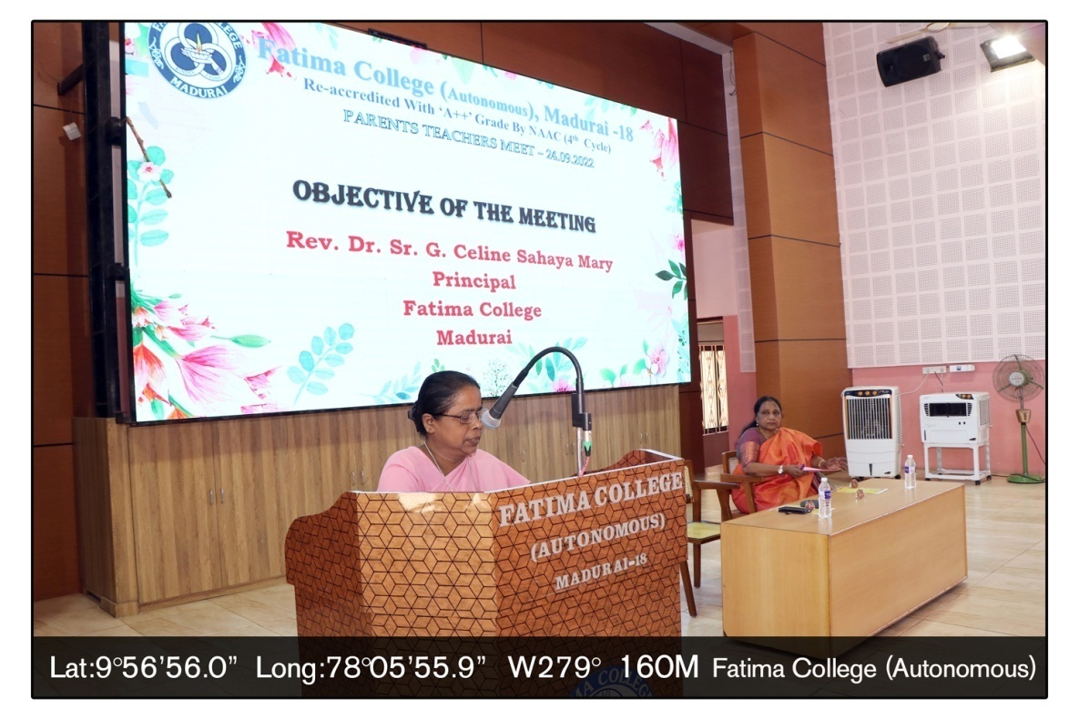

**Rev Dr.Sr.G.Celine Sahaya Mary , Principal addressing the parents on Parents Teachers**

**Meeting.**

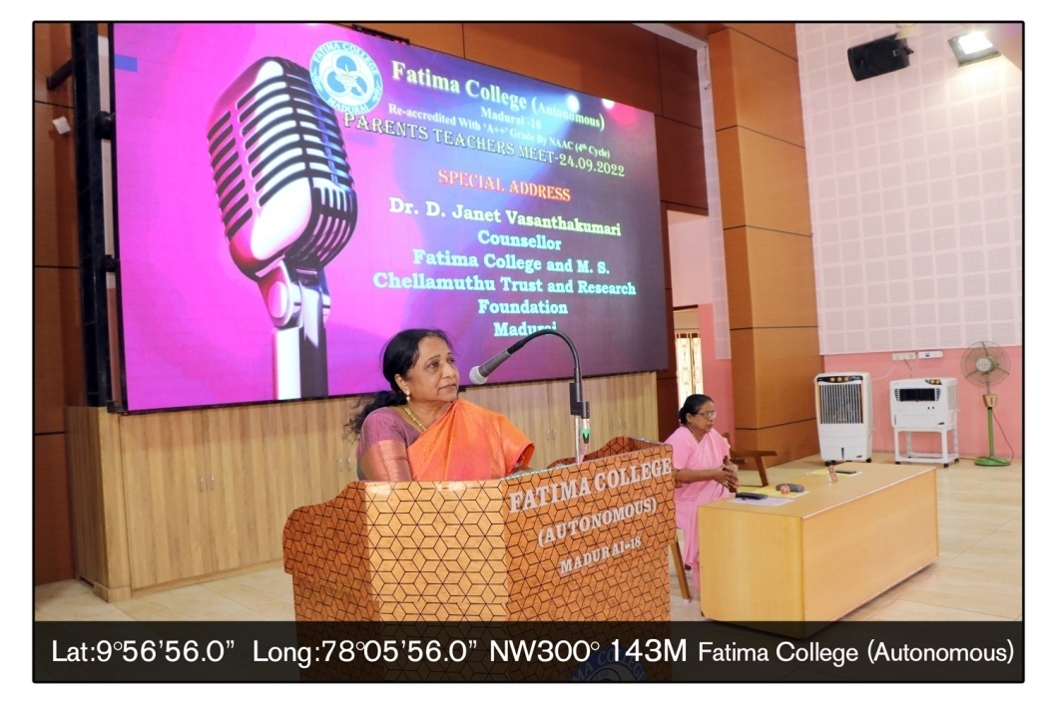

**Dr.D.Janet Vasanthakumari, Counsellor, Fatima College addressing the parents**

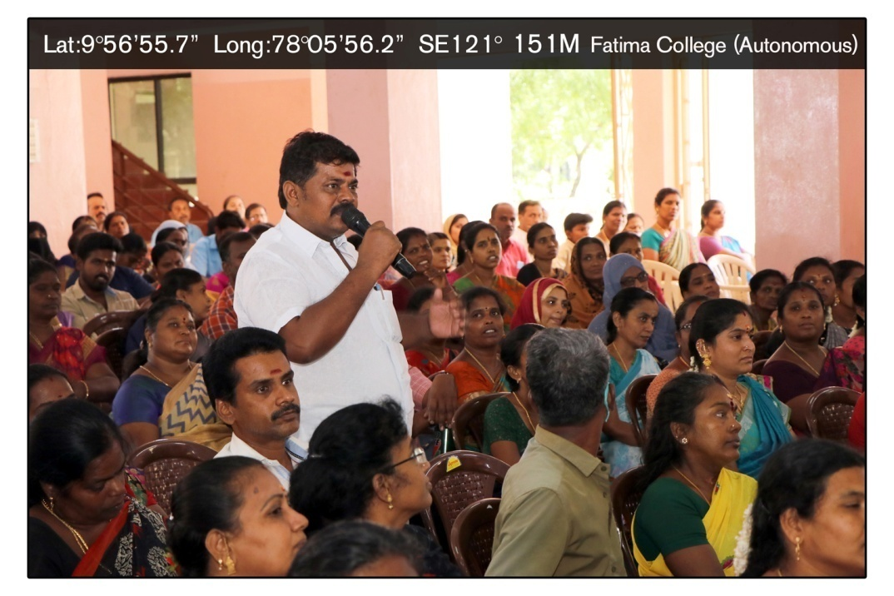

**One of the parents interacting with the Principal during Parents Teachers Meet**

**Code of Conduct for students during Exam**

**Announcement**

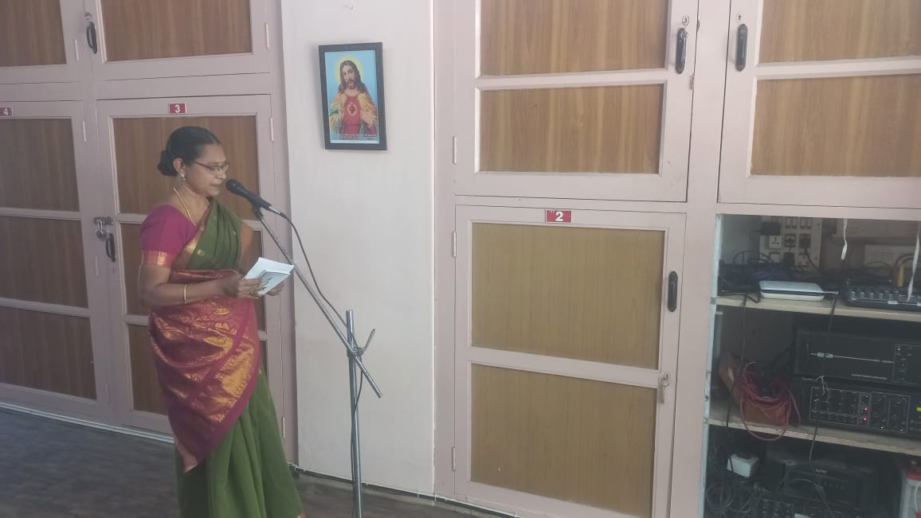

**Dr.G.Germine Mary , Exam Superintendent giving announcement about exam related code of conduct expected from the students.**

**Daily Announcement before the Semester Exam**

Dear Students,

Kindly listen to the announcement. As you are writing your examination, we advise you not to indulge in any of the malpractices such as possession of papers or any other material with hints/coping/insertion of prewritten answer paper, giving and receiving help etc., in case if you have any such material, either leave it outside or hand over to the hall invigilator before the exam starts. Also if you find any incriminating material (bits of papers with hints) near your seat, you have to report it to the invigilator immediately.

Believe in yourself and put your trust in the lord. God will certainly bless your hard work. All the best for your exam.

**FATIMA COLLEGE (Autonomous), MADURAI -18**

**INFORMATION TO THE OUTGOING STUDENTS**

**During Semester Exam**

**Passed through Department**

**I GENERAL INFORMATION**

1. Examination results are scheduled to be published on 21.05.2024 **( Tuesday )** on the college web site. It is your responsibility to access the results (supplementary also).Your results will also be forwarded to the mobile number you have given to the college.

2. Dates for receiving your Mark sheets will be informed through whats app.

3. Provisional certificates will be issued after we receive them from Madurai Kamaraj

University. Contact the college administrative office for any further information.

**Keep your Identity card safe as it will be required for any future reference.**

4. Fatima College will hold the Convocation after the Convocation has been conducted in Madurai Kamaraj University. The date of Convocation will be intimated to you.

5. Change of address must be communicated to the office so that the Convocation invitation can be sent to your correct address.

6. Office transaction during summer holidays:

* + - Give 2 days for the office to prepare the certificates that you have requested for.
    - Working hours will be from 9.00 a.m to 4 p.m. Saturdays may be holidays. Hence avoid Saturdays.

Out-Station students who foresee their inability to come in person to collect their certificates should contact the administrative office in person before they leave the college and give in person the following:-

* By post

A written request to send her certificates by post and accepting liabilities of the same being lost in transit. A self addressed and stamped envelope/ cover (for registered post with acknowledgement due) big enough to hold the certificates.

* Through authorized person.

A written request along with a ID of the student to hand over her certificates to a person she authorizes with full details of the person and a passport size photograph of the person. She must provide her contact number through which she will be informed of the issue of the certificates.

**II. SUPPLEMENTARY EXAMINATION**

Once the student has left the college and has arrear papers to clear, she will be considered a **PRIVATE CANDIDATE.**

**SPECIAL SUPPLEMENTARY EXAMINATION (for Outgoing)**

**Special supplementary examination (for Outgoing)**

**will be allowed only for April 2024 end semester arrears of the present III U.G, II P.G & Diploma** **students.**

They can appear for the arrears in the end semester examination of April 2024 only i.e **IVth semester papers for P.G, VIth semester papers for U.G and IInd semester papers for PGDCA .**

**The candidates must register for arrear papers within 7days after the publication of results, with the Xerox copy of the last received mark sheet. Special Supplementary Examination will be conducted in the 4th Week of June 2024. The results of the Special supplementary (for Outgoing) examination will be published on the web site in the second week of July 2024. Mark sheets will be issued a week after publication of results.**

**FEES & SCHEDULE**

|  |  |  |  |
| --- | --- | --- | --- |
| **Month & Year** | **Fees-Rs/ paper** | **Registration** | **Papers** |
| **Special supplementary**  **(for Outgoing)**  **2024)** | UG – 600 + 120 + 60  P.G – 600 + 120 + 60  MBA, MCA -  600 + 120 +60 | Within 7working days after publication of results | April 2024 END SEMESTER PAPERS ONLY  Open only for the present III U.G, II P.G & Diploma students. |

**Private candidates can appear with the regular students for any paper in any end semester examination of April / November .They cannot appear for the July supplementary examination.**

**Contact the college administrative office regarding registration for April / November examinations. Check the college website for the time table of these examinations.**

1. Application forms for writing supplementary examination should be signed by the Head of the Department. **Xerox copy of the Last Received Mark Sheet of semester VI (U.G) and IV (P.G) should be attached to the application form.**
2. Identity Card should be presented at the time of supplementary examination.
3. **Time table will be published on the college web site and a copy will be displayed on the notice board. It is the responsibility of the candidate to note down the examination dates.**
4. Late submission of application forms for registration will not be permitted
5. Even if you are sick, contact the office to get permission for registration.

**III. Number of attempts allowed for Passing in the same syllabus.**

**1+4** chances are allowed for any paper in the same syllabus. After that, the candidates can write the examination only in current syllabus. Students, who have exhausted the allowed chances, must contact the H.O.D and register for the current equivalent paper only.

**IV. Revaluation of answer paper**

Students who have **FAILED** and wish to apply for revaluation, should contact the college administrative office within 7 working days after the publication of results, to get the application form and details of fee for revaluation. Revaluation results will be forwarded to their home address within ten days after the last day allowed for applying for revaluation.

**V. C.I.A REPEATS (for improving INTERNAL marks only).**

A student who has **passed in the external examination but has failed because of getting less than the aggregate minimum 40/100 (U.G) or 50/100(P**.**G),** can apply for this provision at the **BEGINNING** of any semester.

CIA improvement can be **attempted in any semester for any paper**. The students must contact the administrative office at the **beginning** of each semester to register for CIA improvement for odd /even semester papers.

**REGISTRATION FOR CIA IMPROVEMENT WILL NOT BE ALLOWED AFTER THE CONDUCTION OF FIRST INTERNAL TEST FOR THAT SEMESTER.**

After registering and duly paying the fees, she should keep in contact with the Department and get to know the dates of the Tests, Quiz and Assignment.

**PRINCIPAL**