 Fatima College (Autonomous)

Students Attributes Facilitated by the Institution

- College Graduate Attributes

- The Sisters of St.Joseph of Lyon Educational Apostolate Policy (Hand Book)

COLLEGE GRADUATE ATTRIBUTES (GA)

Fatima College empowers her women graduates holistically. A Fatimite achieves all-round empowerment by acquiring Social, Professional and Ethical competencies. A graduate would sustain and nurture the following attributes:


I. SOCIAL COMPETENCE

GA 1 | Deep disciplinary expertise with a wide range of
 | academic and digital literacy
GA 2 | Hone creativity, passion for innovation and aspire
 | excellence
GA 3 | Enthusiasm towards emancipation and empowerment
 | of humanity
GA 4 | Potentials of being independent
GA 5 | Intellectual competence and inquisitiveness with
 | problem solving abilities befitting the field of research
GA 6 | Effectiveness in different forms of communications to
 | be employed in personal and professional
 | environments through varied platforms

GA 7 | Communicative competence with civic, professional
 | and cyber dignity and decorum
GA 8 | Integrity respecting the diversity and pluralism in
 | societies, cultures and religions
GA 9 | All – inclusive skill sets to interpret, analyse and solve
 | social and environmental issues in diverse
 | environments
GA 10 | Self awareness that would enable them to recognise
 | their uniqueness through continuous self-assessment
 | in order to face and make changes building on their
 | strengths and improving their weaknesses
GA 11 | Finesse to co-operate exhibiting team-spirit while
 | working in groups to achieve goals
GA 12 | Dexterity in self-management to control themselves in
 | attaining the kind of life that they dream for
GA 13 | Resilience to rise up instantly from their intimidating
 | setbacks
GA 14 | Virtuosity to use their personal and intellectual
 | autonomy in being life-long learners
GA 15 | Digital learning and research attributes


GA 16 Cyber security competence reflecting compassion, care and concern towards the marginalised

GA 17 Rectitude to use digital technology reflecting civic and social responsibilities in local, national and global scenario

II. PROFESSIONAL COMPETENCE

GA 18 Optimism, flexibility and diligence that would make them professionally competent

GA 19 Prowess to be successful entrepreneurs and become employees of trans-national societies

GA 20 Excellence in Local and Global Job Markets GA 21 Effectiveness in Time Management GA 22 Efficiency in taking up Initiatives GA 23 Eagerness to deliver excellent service

GA 24 Managerial Skills to Identify, Commend and tap Potentials

III. ETHICAL COMPETENCE
GA 25 | Integrity and be disciplined in bringing stability
 | leading a systematic life promoting good human
 | behaviour to build better society
GA 26 | Honesty in words and deeds
GA 27 | Transparency revealing one‟s own character as well as
 | self-esteem to lead a genuine and authentic life
GA 28 | Social and Environmental Stewardship
GA 29 | Readiness to make ethical decisions consistently from
 | the galore of conflicting choices paying heed to their
 | conscience
GA 30 | Right life skills at the right moment

Fatima College (Autonomous)

COLLEGE GRADUATE ATTRIBUTES
(Attributes facilitated by the Institution)
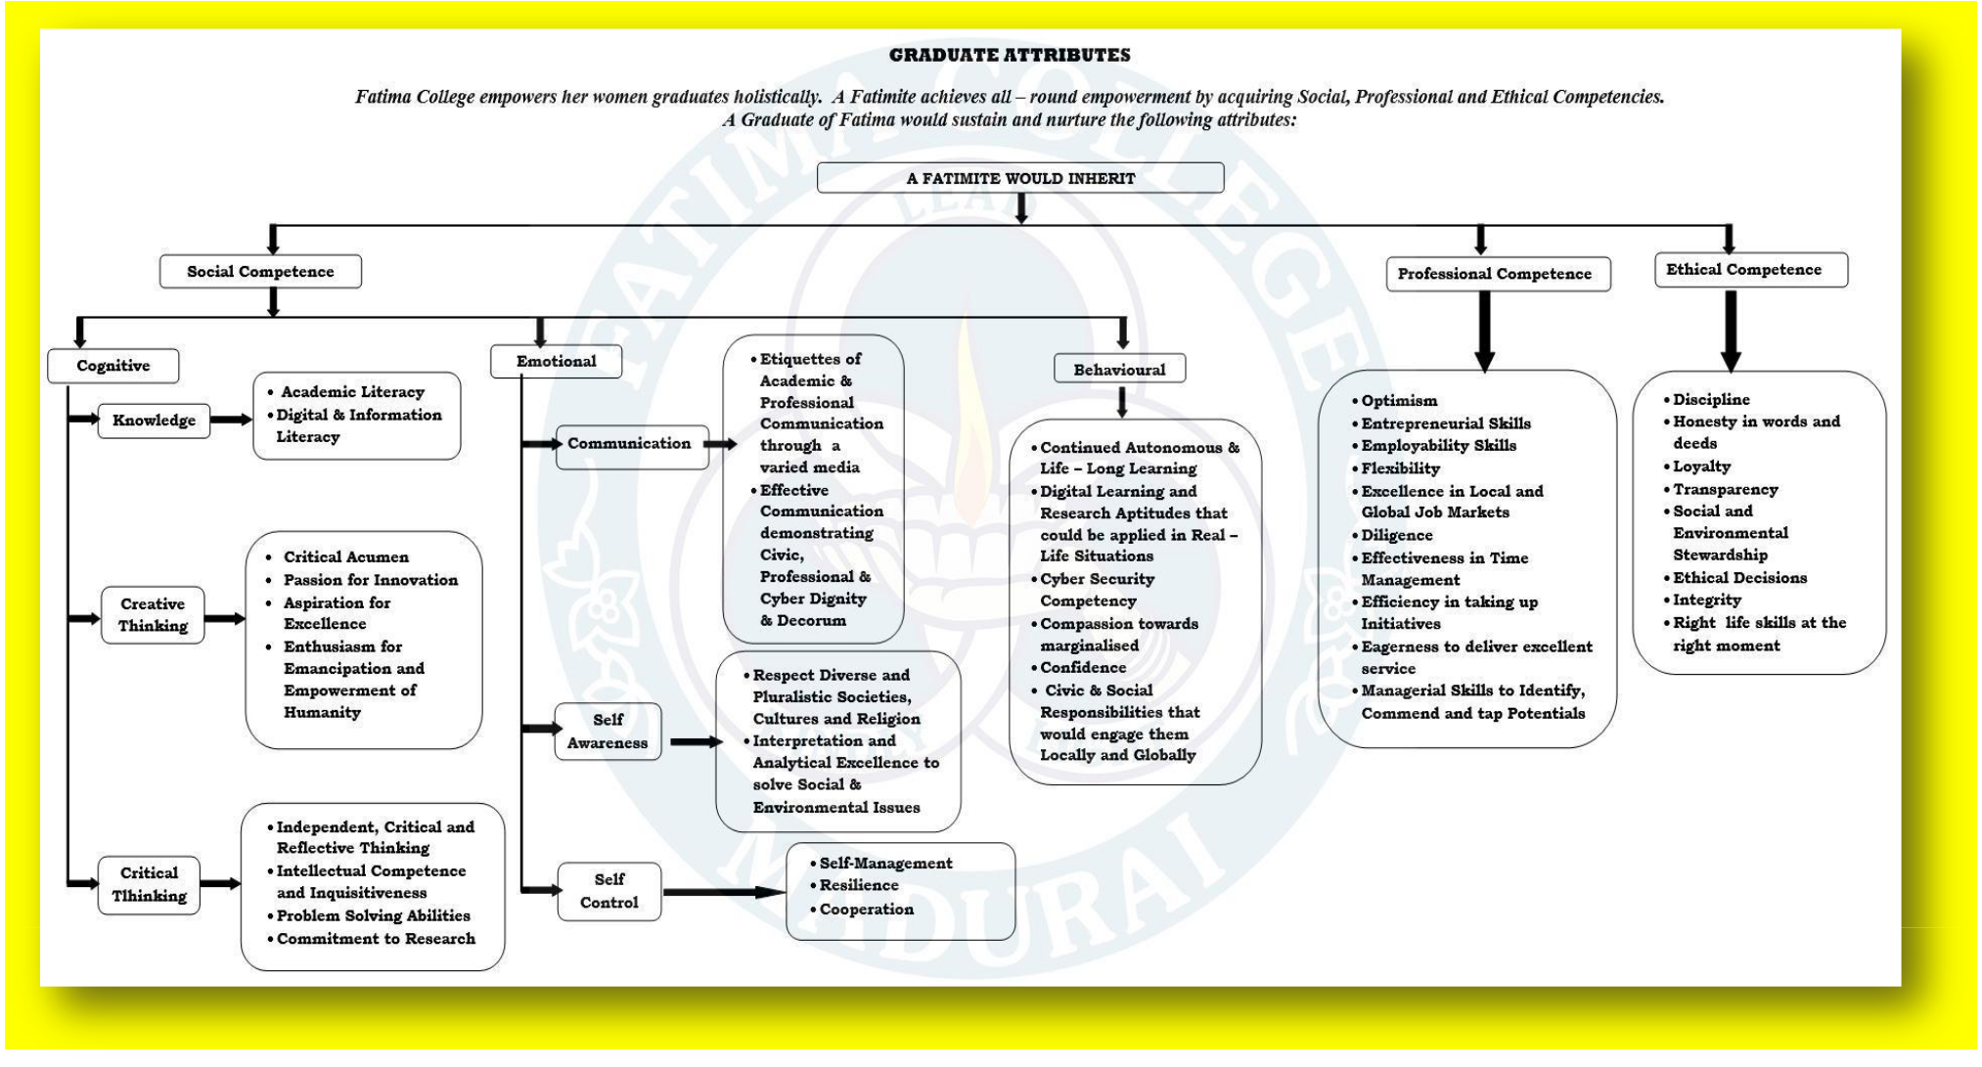

Students Attributes facilitated by the Institutions
Hand book of The Sisters of St.Joseph of Lyon


Hand book of The Sisters of St.Joseph of Lyon’s
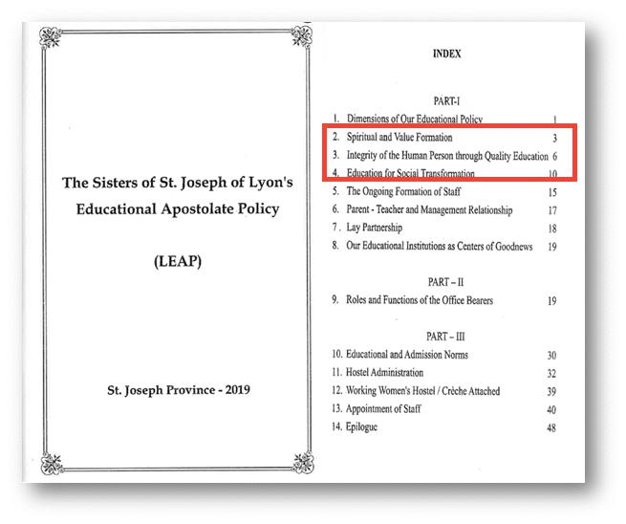

I.SPIRITUAL AND VALUE FORMATION

Every human person is created in the image of God, in His likeness; the life of Christ propels sacrificial love, which implores us towards an educational involvement to enable human persons to a life of personal integrity, development, social commitment nourished by an encounter with God through our religious life.

In the business world, the customer gets the top priority. We all the more in our institutions will put people above everything and value them most of all. Disrespectful and arrogant behaviour and insensitivity to the feelings and needs of the students and parents must give way to a friendly attitude and approach.

SPIRITUAL / FAITH AND VALUE FORMATION

❖ We creatively Open up opportunities for interfaith relations, inter –religious exposures, interfaith scriptural understanding by ways of conducting liturgical and para – liturgical services, religious instructions and regular scriptural in our campus.

- The Catholic / Christian student community must be accompanied to deepen their faith in the Eucharistic Presence and devotion to Mother Mary. “ One of the important aims of catholic education is Faith Formation, deepening the Christian commitment to Jesus in his Church”

- Persons from other religions traditions must be helped to deepen their faith in God and understand the deeper meaning of life and the need to lead a life of values rooted in their faith tradition.

We should hold Religious /Ethics classes in the campus apart from regular classes. Since Education is a transformation process, we try to bring about changes in the mindset and attitude of the students, which in turn will help transform society.

Following are some of the key factors, which help to bring about a transformative process.

- Creating mutual trust and solidarity among us and others.

- Solving conflicts through transparent dialogue.

- Inculcating spirit of freedom and service and concern for each other especially the needy.

- Enforcing discipline with love and compassion.

- Creating opportunities to all the students.

- Encouraging and respecting cultural diversity and differences.

- Promoting counselling and guidance for a life of authenticity.

II.INTEGRITY OF THE HUMAN PERSON THROUGH QUALITY EDUCATION

Quality education in the true sense produces persons with thought and feeling, with eagerness to share, persons who are capable of looking to nobler things in life. It has reference to things like the all – round development of the person, humanism, authentic values, intellectual curiosity and acuteness, aesthetic sensitivity, character formation, social awareness, healthy relationships, refined manners, dignified self presentation, intelligent and clear self- expression, good diction and thoroughness about everything. One does.

We enable each student to see her life as a gift of God, as a call to serve. We help them realize that it is the right attitudes and principles that give power and dignity to one‟s life. We nurture the vocational dimension of life in each student and help each to

interpret one‟s life in the light of God‟s plan for her and contribute to life.

a. Intellectual Formation

Special efforts should be made to enable students to think for themselves independently and critically and critically – to seek, extend and apply Knowledge to the solution of human problems: to continually strive for excellence in every field. This is actualized by the following ways;

- We promote Interdisciplinary options in the college involving a free choice of job and life oriented and skill based courses to be provided.

- Our involvement in higher education should provide people with an opportunity to reflect on the critical, social, economic, cultural, moral and spiritual issues facing humanity, with the view of contributing to social / national development through dissemination of specialized knowledge and skills. (National Policy on Education, 1986, 5.24)
b. Ethical Formation

- Regular course on sex education should be given each year to the outgoing students as part of the „Education of Love‟. This should be formative in nature and not mere information alone.

- We inculcate values through organizing sports and games, youth- groups and associations that foster discipline, loyalty and dignified behaviour.

- Ethics and Moral Education are an integral part of our college and school Education.

- Programmes related to professional ethics such as Medicine, Business, Information Technology and Communication.

- Special Program on Family, Morality, Sexuality, Marital Fidelity, pre/Extra Marital Relationship, Birth control, Sex- determination, Female infanticide, Abortion, Alcoholism, Drugs, etc. ought to be conducted for the student community.

c. Cultural Education

- We need to equip young people to be rooted in their own culture and at the same time open to other cultures, and interpret the social processes as to take responsibility to bring about social transformation. Our Education “must enable students to raise questions concerning the meaning of life and the significance of reality and to develop a responsible

- commitment to transform it in the light of the evangelical values and modern culture,” (All India Catholic Education Policy 2007, p.26)

- We need to nurture/respect the sense of relatedness and identity in the context of multiplicity of cultures, which implying an awareness of the negative aspects of each other and transcend them.

- We promote positive attitudes, right perspectives and life- skills, in order to deepen the richness of our cultural and religious traditions and to interpret them according to the signs of times.

- We develop self – confidence and aesthetic tastes by appreciation of literature, music, nature, sports and fine arts etc. and encourage students to participate in intra and inter school /college competitions on the above-cited themes.

- We provide training programmes in Media Education, Film Analysis and Folk Arts expressions and employ them as tools for social transformation.

- Through extracurricular activities, we in still in the minds of students a sense of history, culture and tradition, to foster national solidarity.
III. Education for social Transformation

Running schools and the college like any other agency should not be our purpose. We need to take the maximum effort to be different. Our institutions should be training centres where we develop visionary leaders with character and mental stamina to face any crisis and also intelligence to make their own opinions freely and capable of bringing about social transformation and thus contributing towards nation building process. Our Educational Apostolate is socially relevant in the sense that it promotes
awareness and action to reclaim Social Justice, Gender justice, Eco – justice, Human Rights and stand for the cause of the periphery.

- Education for justice

  - As a major contribution to build a new India and a new ethos, we plan and execute an awareness and action program to make the students understand and become sensitive to the major social issues and inherited inequalities.

  - We” identify talented children from the marginalized communities with a view to prepare them for higher and professional education. Among them, we hope to train a select group for social and political leadership”.

  - We keep in contact with our former students to keep alive their commitment and to evolve relevant agenda to transform that part of the society of which they are a part, while pursuing various professions. (All India Catholic Education Policy 2007,p.41)

  - Helping students to become aware of their status in the society, to stand for justice and human rights by linking with other organizations/ movements.

  - Action –Reflection- Action is the mode of our educational communication for societal awareness and action. Exposure program to rural areas, refugee camps, places of natural and unnatural calamities and other vulnerable regions of social restlessness and conflict are some ways of achieving this process of education.

  - Making available our school and college campus facilities for community program and developmental projects.

    - Human Rights Education

  - Human rights education is an integral part of our education in our schools and college. Knowledge about human rights and justice needs to be provided to all the inmates of our institutions.

  - Conducting, legal, para-legal and literacy program about stress on women and children‟s rights in collaboration with justice and peace team.

The YCS/YSM, AICUF has a powerful vision and spirituality. The concentration in the youth ministry should reach out to both Catholics and

- Youth of other faiths with equal importance. It is advisable to have a director for the animation of non-Christian youth and another one for the Catholic youth. The priorities and policies should be district. The work with the non- Christian youth in our schools, colleges and hostels should be a top priority in the present anti- Christian atmosphere.

- Creating Women‟s Cell, Legal Club, and Consumer club in the College / Schools. c. Care for the common home

- Apart from awareness of environmental devastation, we will promote a right understanding of creation and appreciation of the dignity of the whole of creation by emphasizing affirmative action towards the restoration of life.

- We make our student community involved in environmental concerns in the neighbourhood, which would create eco-consciousness among them, promoting pro-life actions.

- We strongly resist the use of plastic products in our campus and also collaborate with the government.

- Schools /Colleges shall participate in protest against any anti- ecological and socio- political actions.

