**Fatima College (Autonomous)**

**Code of Conduct For Teaching and Non Teaching Staff**

|  |  |
| --- | --- |
| **1.Employment Terms** | **Both Teaching and Non Teaching Staff** |
| **2. Exams Related Instruction** | **Teaching Staff** |

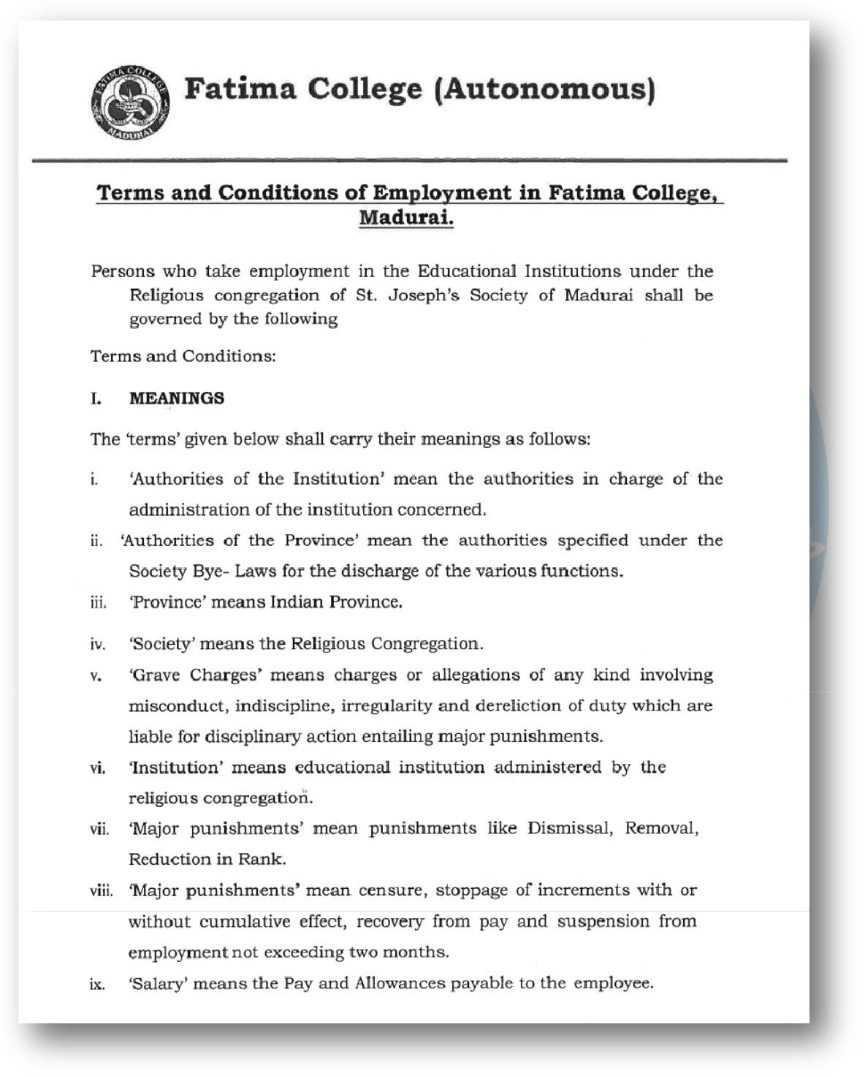

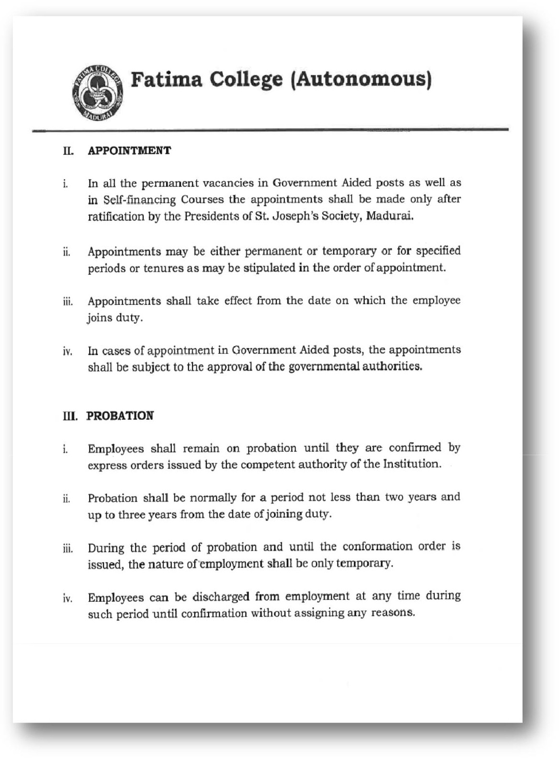

2

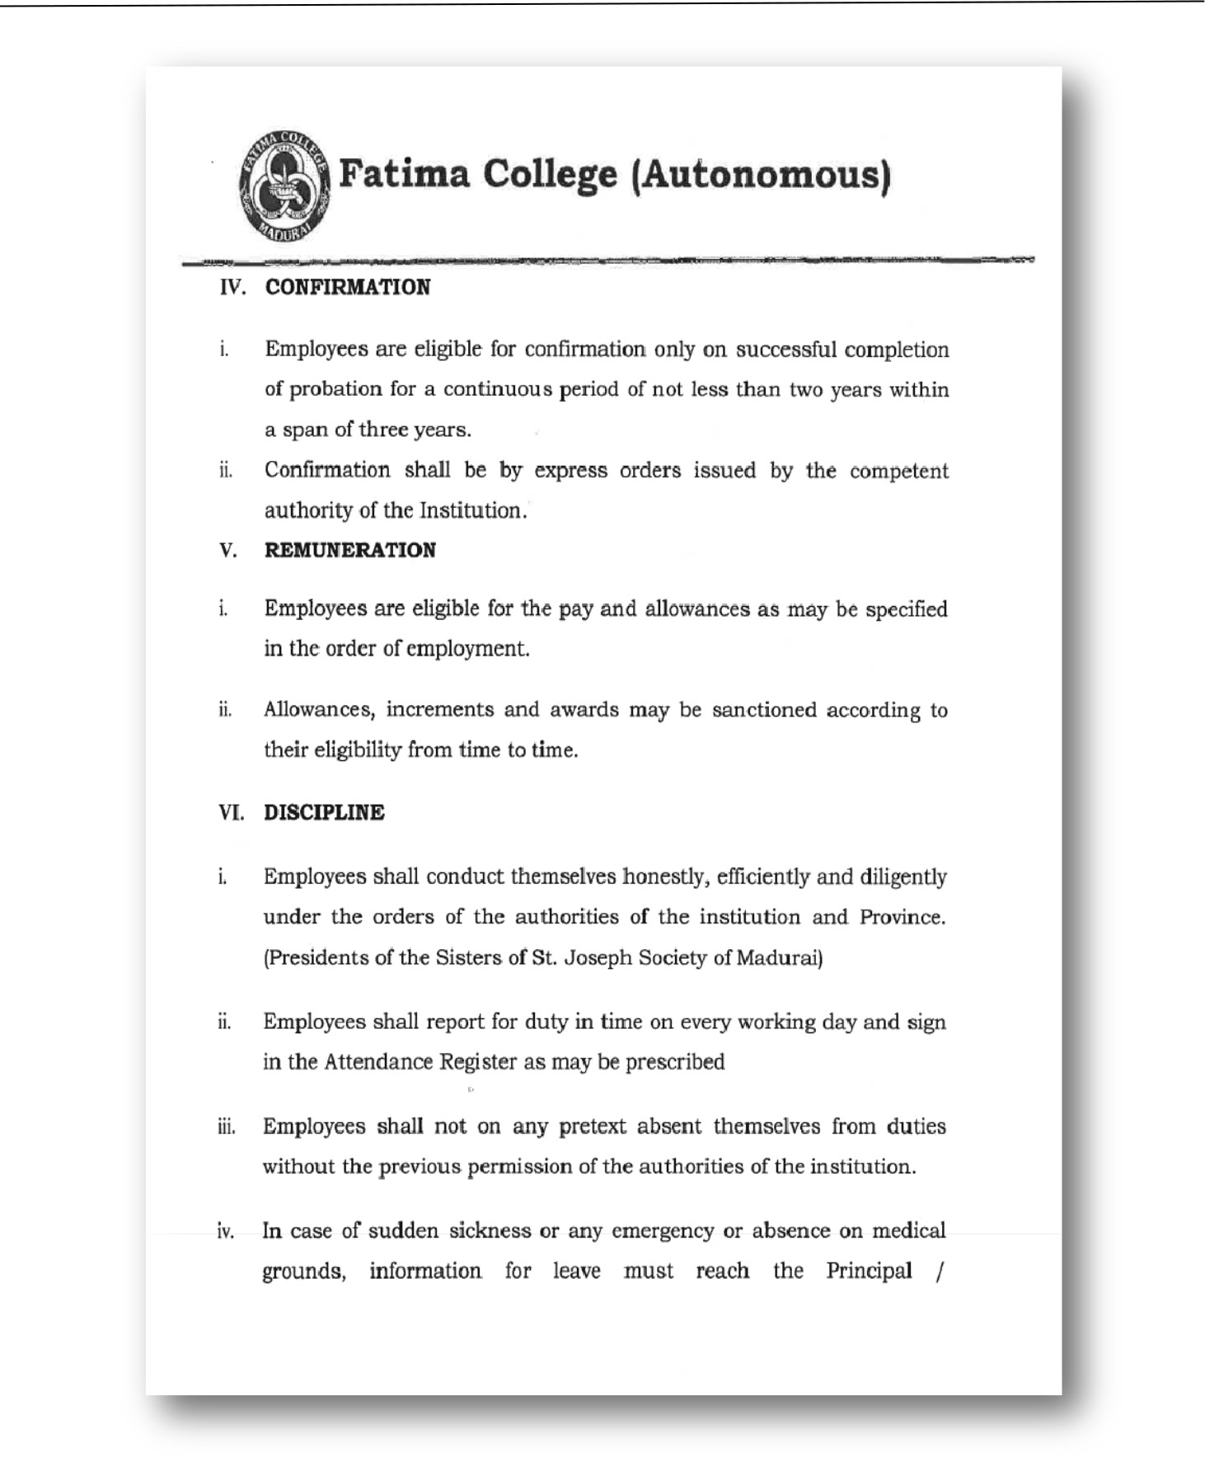

3

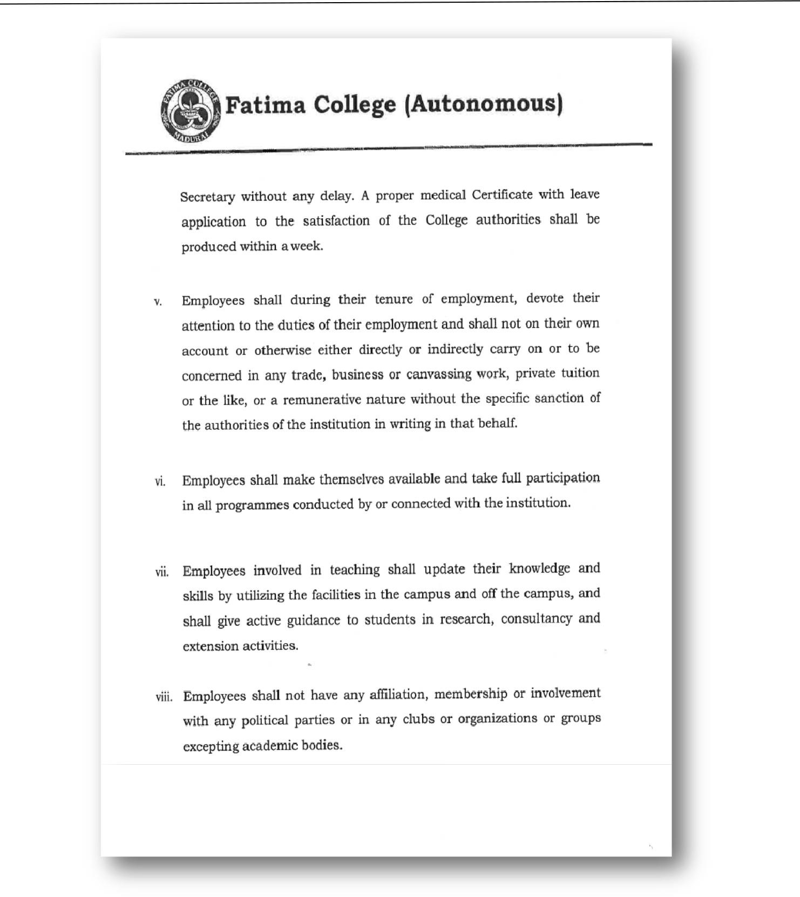

4

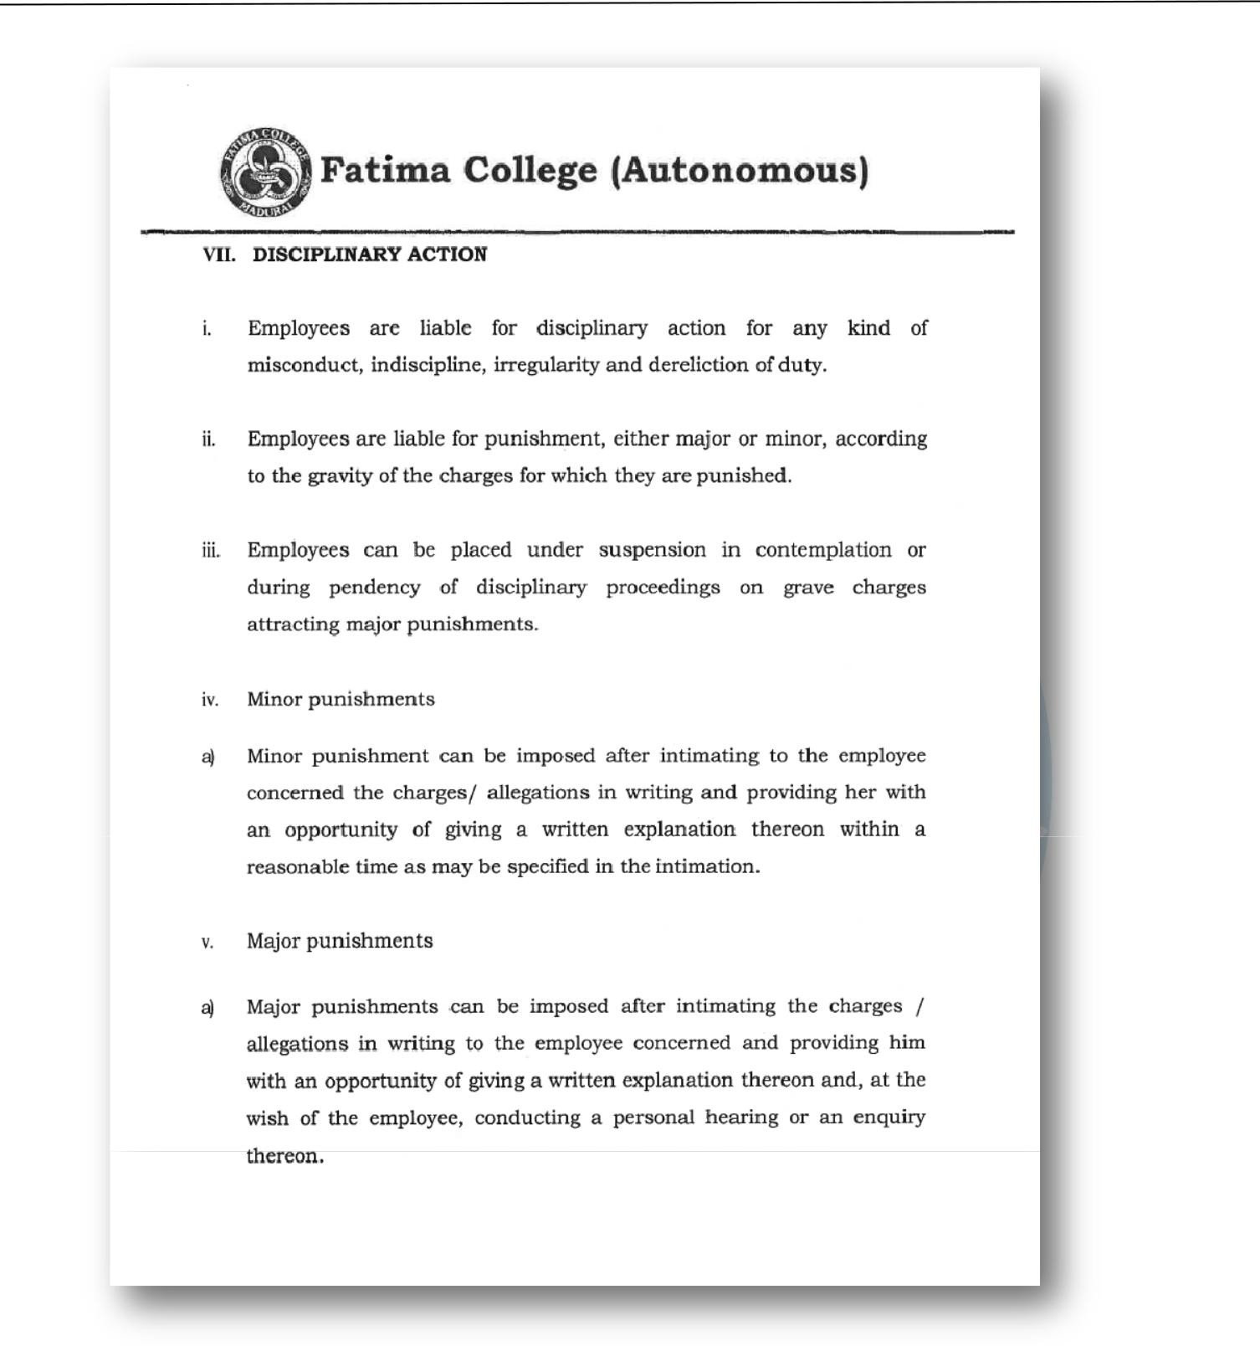

5

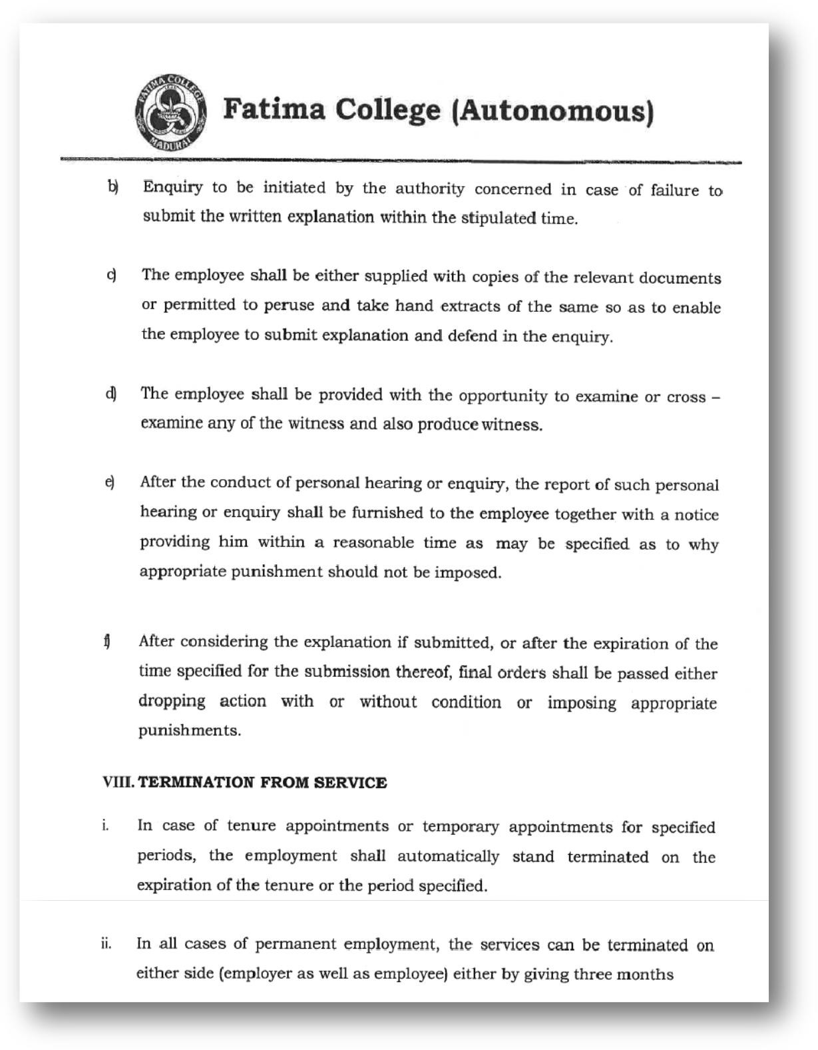

6

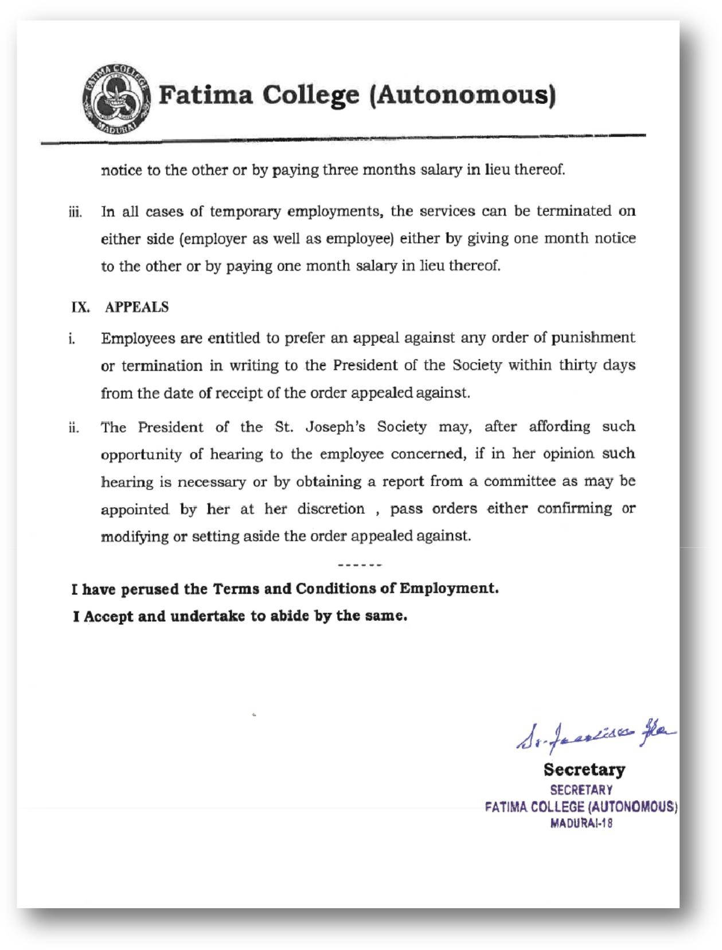

7

**Teachers Code of Conduct during Exams.**

Fatima College (Autonomous), Madurai – 18.

End Semester Examinations – APRIL 2023

**GUIDELINES TO THE EXAM SUPERINTENDENTS FOR APRIL - 2023 END SEMESTER EXAMINATIONS**

**GENERAL INSTRUCTIONS:**

1. The Examinations for the APRIL 2023 will be held from April 12, 2023 onwards through offline mode.
2. The time duration of the Examinations will be
   1. PG – 3 hours, EDC - 2 hours
   2. UG - 2 1/2 hours, NME and Skill Based - 2 hours

**Exam Superintendents**

1. The Exam Superintendents will look into the overall conduct of the Offline Examinations April 2023.
2. The Exam Superintendents will check the question papers the previous day and sign on the sealed cover to say the packing is correct.
3. The Exam Superintendents will receive the question paper in Room No.8 from the Controller’s office at 8am for FN session and 12 pm for AN session on the day of exam.
4. The Exam Superintendents will distribute the hard copies of the Question Papers to the concerned course teachers at 9.00 a.m. and 1.00 p.m for the FN and the AN sessions respectively.
5. The Exam Superintendents will collect the list of absentees from the Exam Halls at 9.30 a.m for the FN session and at 1.30 p.m for the AN session.
6. The Exam Superintendents have to bring to the notice of the Controller of Examinations any issues related to the conduct of exams reported to them by the Course Teachers.
7. After the completion of the exams the superintendent have to receive the answer sheets from the Invigilators and check with the foil card to make sure the answer sheets , collected from the students tally with the foil card and hand over the answer sheets to the controller of exam for correction/valuation by the course teacher and external in case of outgoing students answer sheets .

** Fatima College (Autonomous), Madurai - 18**

***Instructions to Invigilators***

* **Please note the dates on which you have been assigned invigilation duty and be in**

**R 1 on or before 8.15 am /12.15 pm without fail.**

* **If for any unavoidable reason you are unable to report for invigilation duty, you should inform the Superintendent the previous day, so that alternate arrangement can be made.**
* **You must be in the examination hall allotted to you by 8.45 am /12.45 pm.**
* **Allow the students to enter the hall only after checking the identity card.**
* **Direct the students who do not have the ID card to contact the Chief Superintendent to get the permission slip. The permission slip is valid for one day of the examination only. Hence check the date for which the Chief Superintendent has granted permission.**
* **Do not allow the students to carry purse/ bag inside the hall.**
* **Do not issue Answer Sheets to students at the entrance as they enter the hall. Answer sheet should be given only when the students are seated. Distribute the question paper only after the prayer is over.**
* **30 minutes after the commencement of the examination, no student should be allowed into the hall. Please be strict about this rule.**
* **Instruct the students to check the question paper and verify if all the questions are printed, especially if the question paper has more than two pages.**
* **Contact the Chief Superintendent through your cell phone if the students need any clarification. The invigilator should not leave the hall on any account.**
* **Check that the student is in her allotted place by verifying the number written on her desk and the number on her ID card correspond. Verify if she has written her register number, subject code and title correctly in the front page of the main sheet, before signing in the answer script.**
* **Provide additional sheets one at a time, so that no student will have unused additional sheet at the end of the examination. Instruct the students to use all the lines provided in a page.**
* **Malpractice**

**The incriminating material and the answer sheet should be collected and retained by the invigilator. The Chief Superintendent should be informed immediately through the cell phone. The invigilator should give a written report of the incident to the Chief Superintendent, in the format provided along with the incriminating material.**

* **No student should be allowed to leave the hall before the final bell. The students should be asked to stand up and hand over the answer sheets which should be collected according to the order of register numbers. All students should remain in the hall till all the answer sheets are collected. Before leaving the hall check that no answer sheet or question paper is left behind in the hall.**
* **Keep your cell phone in the ‘switched – off’ mode during invigilation; Use it only to contact the Chief Superintendent, whose cell number will be given to you.**

**^^^^^^^^^^^^**

**The Head of the department is requested to read out the “*Instructions for Invigilators”* to the staff during the departmental meeting and clarify doubts of Junior staff members.**

**Kindly instruct the teachers to award marks that indicate**

**a clear failure i.e less than 18 for U.G and 24 for PG**

**or**

**a clear pass minimum 21 for UG and 27 for PG**

**( Not in between these two marks to avoid grievances.)**

**IMPORTANT DATES**

**COMPLETION OF CORRECTION FOR I AND II YEAR - 4.5.2023**

**COMPLETION OF VALUATION by STAFF - 4.05.2023**

**MARKS VERIFICATION BY I & II U.G STUDENTS - 7.05.2023 (9 am onwards)**

**EXTERNAL MARKS CHECKING BY STAFF on 16.05.2023 at 9.30am**

**Instruction for Course Teachers During Transparency**

**Fatima College (Autonomous) - Madurai -18**

**Mark Verification By I &II D.C Students**

**The course teachers are requested to read the following instructions before distributing the answer papers:**

* **Distribute the answer sheets to the students who are present**
* **Ask the students to check the total and verify if all answers are corrected**
* ***Give time to the students to check the total and then read out the marks entered in foil card* to check if there are discrepancies.**
* **DO NOT OVERWRITE / ERASE / USE CORRECTION INK OVER THE ORIGINAL ENTRY.**
* **Make corrections in the foil card in Red ink only**
* **Write the marks to be added or deducted placing + or – next to the original entry +3 . Initial every changed entry .**

**3555 6**

* **The teacher herself must check the marks of absentees.**
* ***The students must sign in the space provided in the foil card.* Ask the class representative to sign for absentees after verifying the marks.**
* ***Advise the students to record their marks so that they can counter check the marks forwarded to their mobile after publication of results***
* **Return the answer scripts and the foil card to the examination section. The difference in marks should be reported to the controller in writing a letter to the principal through controller.**
* **IF 5 MARKS AND ABOVE ARE ADDED OR DEDUCTED, THE FOIL CARD SHOULD BE COUNTERSIGNED BY THE PRINCIPAL.**

**Instruction for Course Teachers for Course Teacher work and Paper Valuation**

** FATIMA COLLEGE (AUTONOMOUS)**

**END SEMESTER EXAMINATION**

**Instructions to Course Teachers:-**

* Please be present at 9.00 am/1.00 pm on the day of examination, to go through the question paper. Only corrections of spelling errors can be clarified to the students. **No change must be made in the question paper** without the permission of the Principal and the Controller.
* Any problem concerning change in pattern or out of syllabus questions **should be discussed with the Principal** and modifications made with the Principal’s permission must be informed to the Controllers.
* **Detailed scheme for questions taken from question bank should be prepared by the course teacher and presented to the COE for claiming remuneration. Only after getting the COE’s signature on the scheme prepared, answer papers can be taken for correction.**
* **Count and receive the answer scripts.**
* **Check whether the register numbers on the foil cards tally with the answer scripts received.**
* Complete correction/ valuation within 3 days after the conduct of the examination.
* Use blue or black ink only for mark entry.
* Strictly follow the scheme of valuation provided by the External Examiner, for III U.G and P.G.
* **Leave on your table in the valuation hall, all materials pertaining to valuation (answer scripts, scheme of valuation, mark sheets and foil cards) until valuation / correction is completed**.
* **After completion of correction –**

1. Verify that you have valued all the answers.
2. Check that the marks for excess answers have been entered and the least mark in that section has been struck off.
3. Take time to check the total. Marks awarded for all answers should be totalled page wise and entered on the first page of the answer script.
4. Only after these verifications, marks should be entered in the foil card. Fraction is not allowed. Total marks should be rounded off to the next higher integer.

5 Foil card entry must be one digit in each column -

**92**

**33333**

**7**

**0**

and single digit must be preceded by zero.

6. Do not overwrite on the foil card or use correction ink to change entries. Strike off the wrong entry and enter the correct marks parallel to the original entry and countersign the change made.

1. If many corrections are to be made or if the foil card is damaged, contact the Examination section for new foil cards.

* On returning valued / corrected answer scripts, **hand over question paper with changes made (if any) and scheme of valuation.**
* **Junior staffs are requested to get instructions from the seniors or contact the Controllers to clear doubts if any.**

**Specific instructions for valuation of Sem. VI( U.G )and Sem. (II &IV) P.G papers.**

1. While preparing the valuation sheets for VI & VII enter –

* 1. Subject code and title
  2. Sections, Question numbers and maximum marks allotted

**c.** “AA" against absentees

2. **Do not write anything on the answer sheets (no underlining, no comments & scoring off), as these papers go for valuation II.**

3**. Different coloured inks must be used for valuing shared papers. Use the same coloured ink for signing.**

**VENUE FOR VALUATION: B5, B6, B14 & CGH**

T**IMINGS: FROM 8.30 AM TO 5.30 PM including Sunday (except 18&19th April 2024)**

**Kindly maintain silence in the valuation hall and avoid taking coffee/ snacks and meals inside the hall. Children and persons not concerned with valuation work are not allowed inside. The last person to leave the hall must close all doors and inform the examination section.**

correction MUST BE COMPLETED ON OR BEFORE : 4.05.2023

valuation must be completed on or before - 4.05**.2023**

**marks verification by i & ii u.g students - 7.05.2023 (9 am onwards)**

**END SEMESTER EXAMINATION – APRIL 2023**

**Heads of departments are requested to read out the instructions enclosed and give explanations if any regarding marks entry and valuation. They are also requested to display on the notice board, the important dates on which staff availability will be required.**

**Controller of examinations**