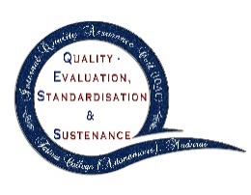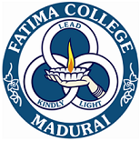

**FATIMA COLLEGE   
(Autonomous)**

**Re-Accredited with ‘A++’ by NAAC (Cycle – IV)**

**Mary Land, Madurai – 625 018.**

**Internal Quality Assurance Cell (IQAC)**Organizes a

**CAPACITY BUILDING PROGRAMME   
on**

**HEALTHY MILLET RECIPES  
for the Sub-Staff**

**Venue: Food Science Lab Date: Feb. 03, 2023**

**Programme Schedule**

**Prayer**

**Welcome Address : Dr. Vasantha Esther Rani** Associate Professor of Home Science  
 Fatima College (Autonomous), Madurai.

**Resource Person : Mr. Mariappan**

Senior Food processing Consultant   
 Retired Officer from Food Dept.   
 Govt. of India.

**Vote of Thanks :** Mrs. Annamayil  
 Fatima College (Autonomous), Madurai.

**\*\*\***

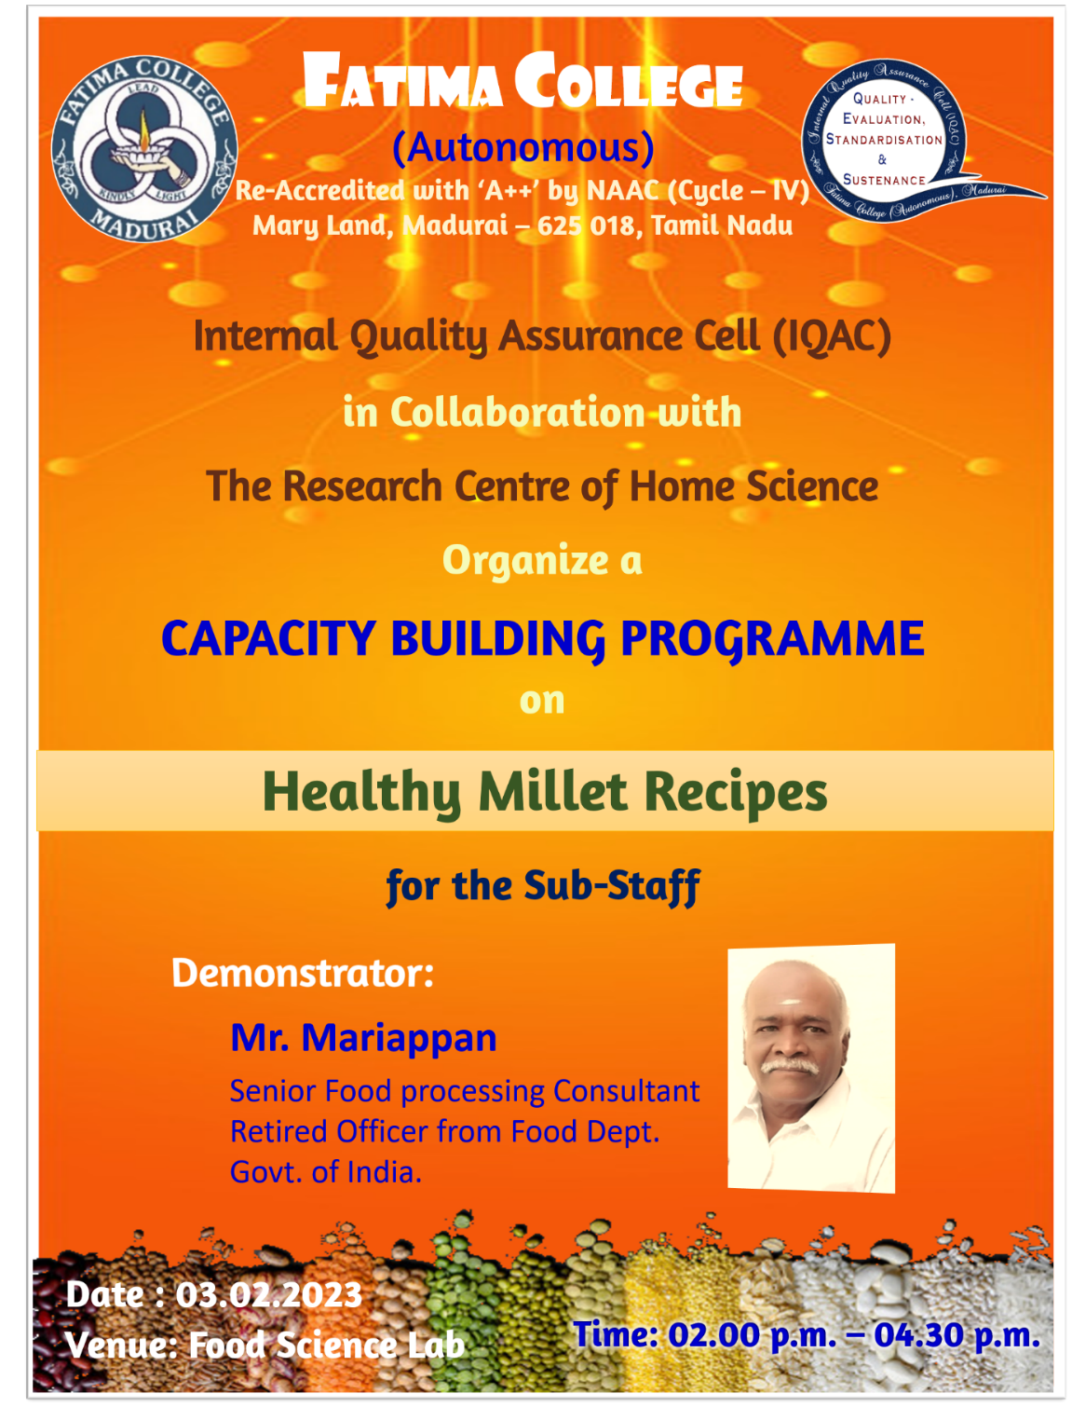

**Resource Person:**

Mr. Mariappan

Rtd. Senior Food Processing Consultant,

Food Science Department, Government of India

**Report:**

**Day 2:** The Fatima College sub-staff members were the target audience for the programme. They enthusiastically engaged in the programme and displayed their abilities in a competitive manner. The main guest acknowledged their curiosity and gave them advice on how to promote the cuisine locally.

**Outcome:** This event was being recreated by non-teaching and support staff members. They got the notion to start their own business.

**PHOTOS**

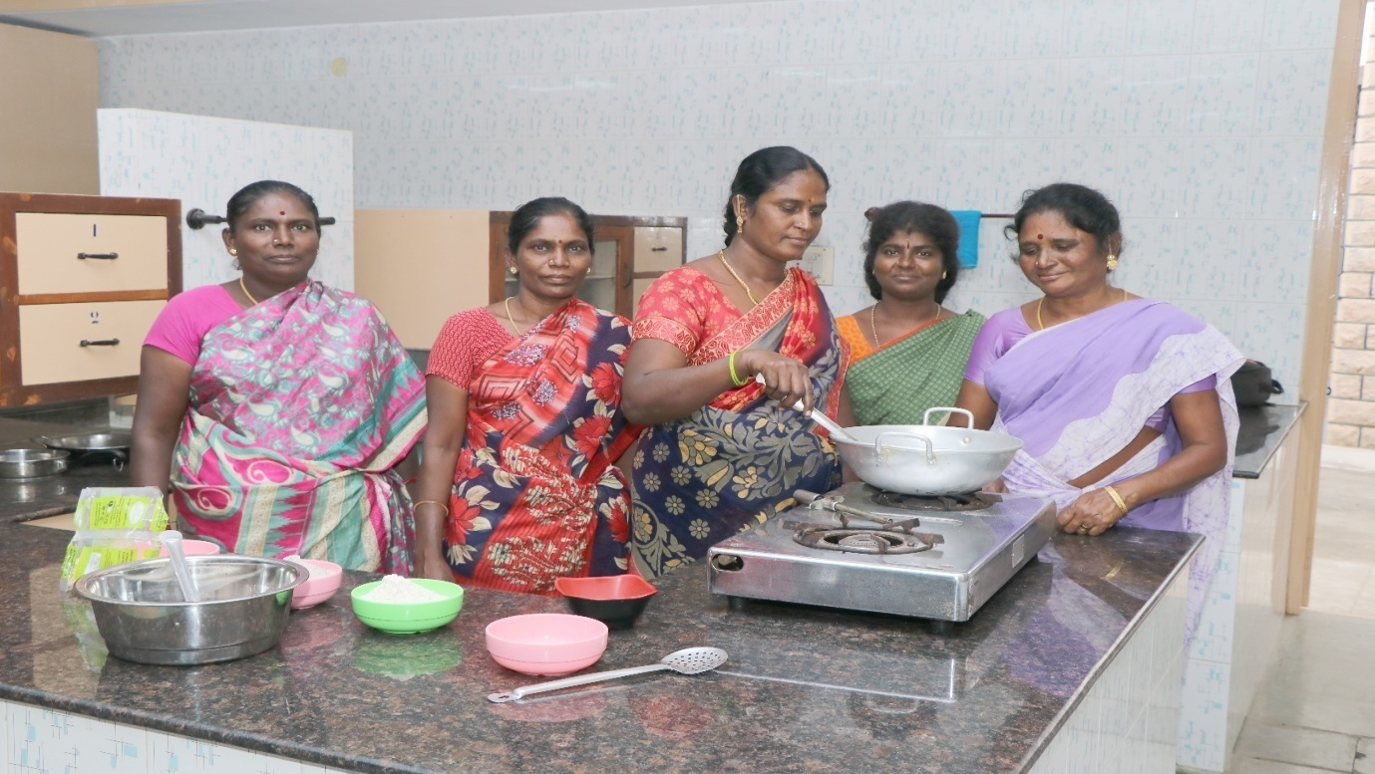

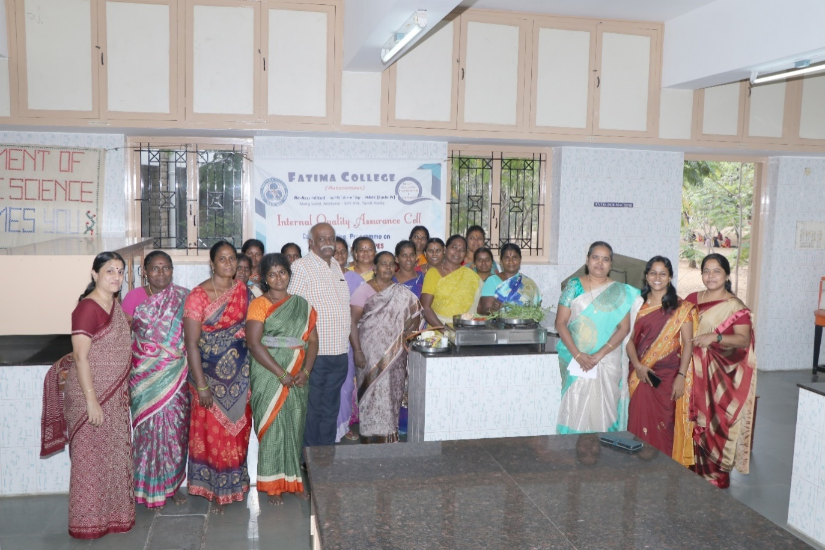

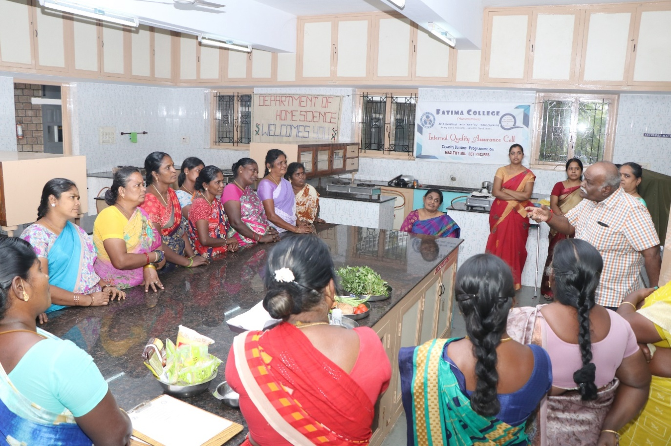

**Attendance:**

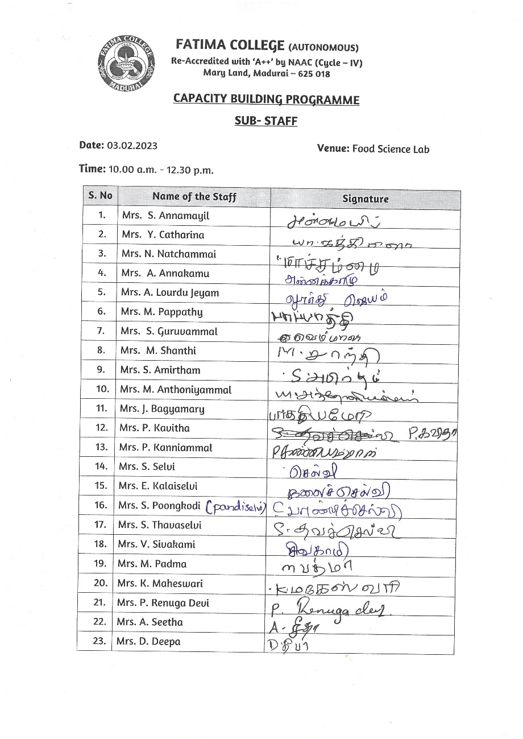

**Feedback Form:**

