Professional Ethics Programme for
Teachers

S.No | Programme | Date
1. | Faculty Induction Programme | 16.09.2022-20.9.2022
2. | Three Days Faculty Development Programme | 22.09.2022
3. | Faculty Enrichment Programme | 29.10.2022
4. | National Level One Week Faculty Development Programme | 10.04.2023 - 15.04.2023

Faculty Induction Programme

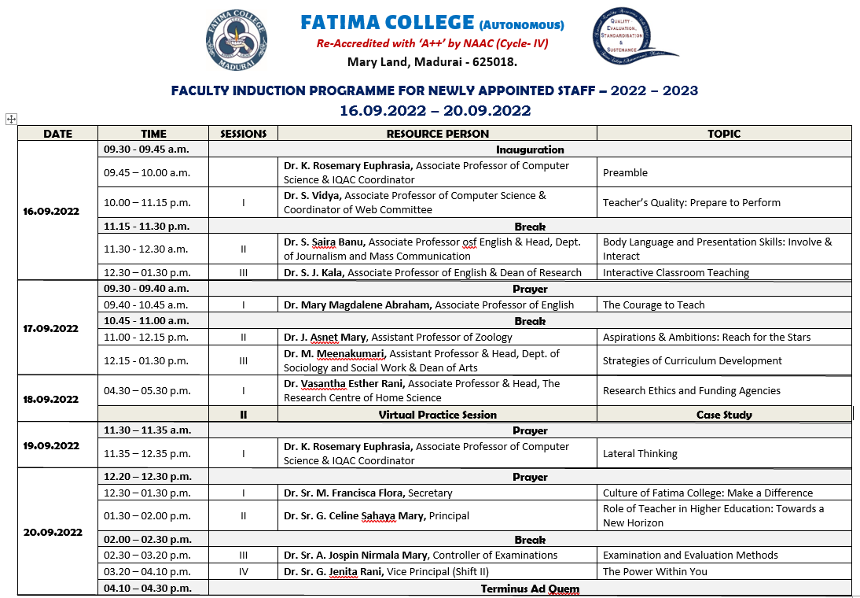

INVITATION
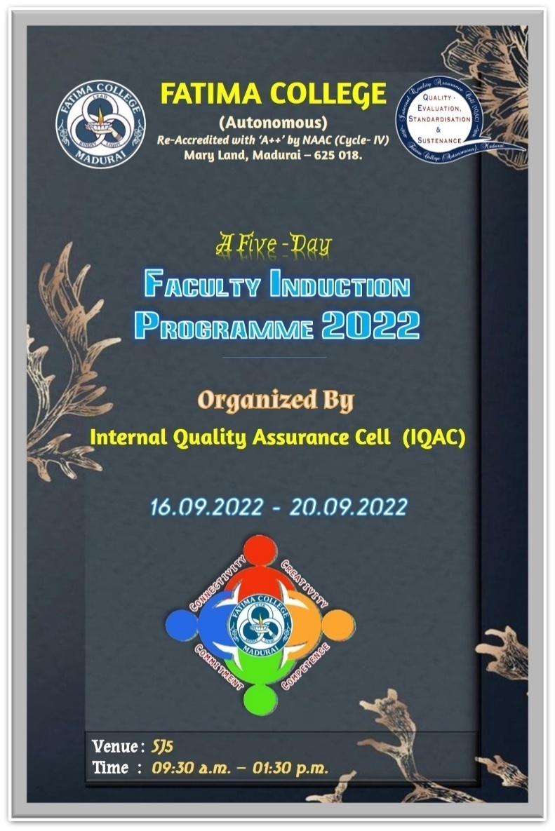

Report of Faculty Induction Programme

Date: 16.09.2022
Teaching is an ethically and intellectually demanding profession. New teachers need rigorous preparation and opportunities for continuous professional development along with academic and professional support.
The Faculty Induction Programme can help new teachers to improve their teaching and management skills, adjust to the culture of the institution, and better understand their professional responsibilities.
The Faculty Induction Programme begins with the prayer and Dr. R. Saktheswari, Assistant IQAC Coordinator and Assistant Professor in English welcomed the gathering.
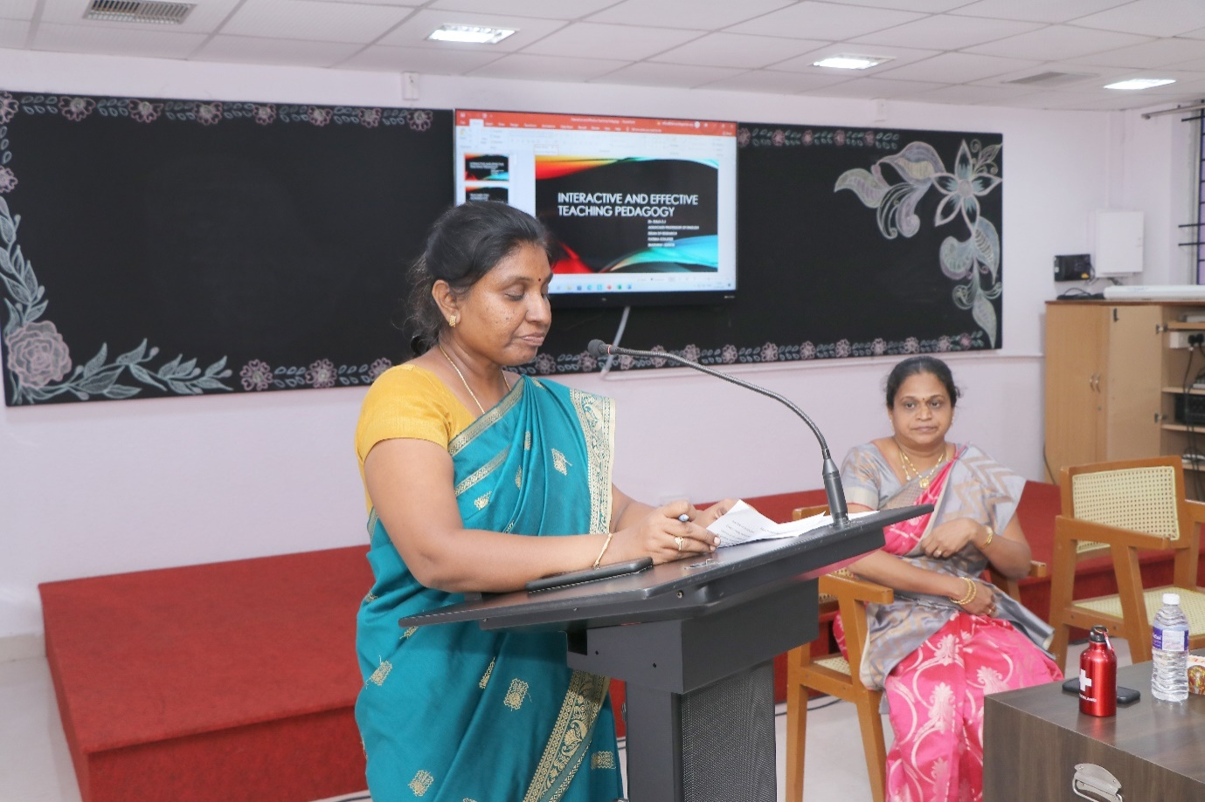
The IQAC Coordinator, Dr. K. Rosemary Euphrasia, Associate Professor of Computer Science explained the objective of the programme
The Faculty Induction Programme aims to help new teachers:
a. Understand their roles and responsibilities as faculty members
b. Familiarize themselves with the structure, functioning, governance, rules, regulations and professional expectations in the institution
c. Explore pedagogical processes - aims of higher education, curriculum, instructional planning, classroom management and transaction, use of resources and assessment
d. Recognise the importance of self-development, socio-emotional development of students and the importance of nurturing ethics and values in higher education
Dr. S. SairaBanu, Associate Professor of English & Head, Dept. of Journalism and Mass Communication handled the first session on Body Language and Presentation Skills: Involve & interact.
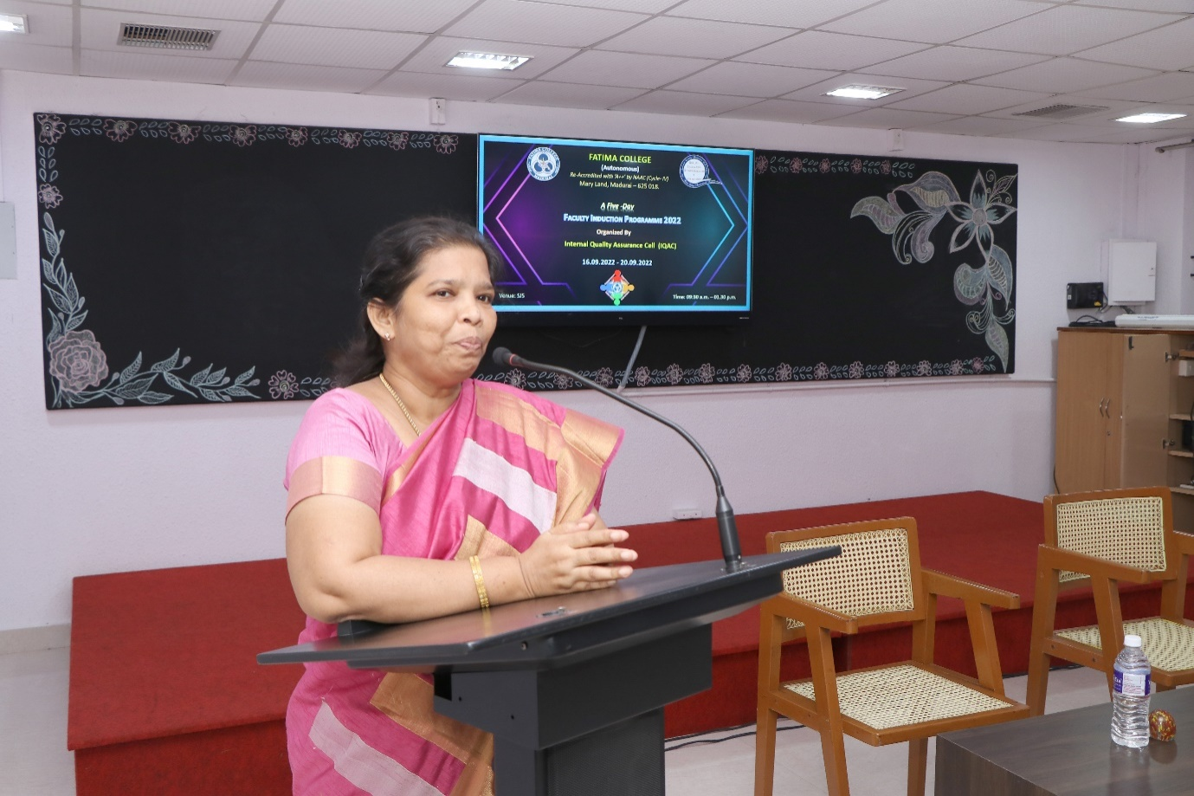
Dr. S. SairaBanu, Associate Professor of English & Head, Dept. of Journalism and Mass Communication handled the first session on Body Language and Presentation Skills: Involve & interact.

The second session was handled by Dr. S. J. Kala, Associate Professor of English & Dean of Research who described the Interactive Classroom Teaching.

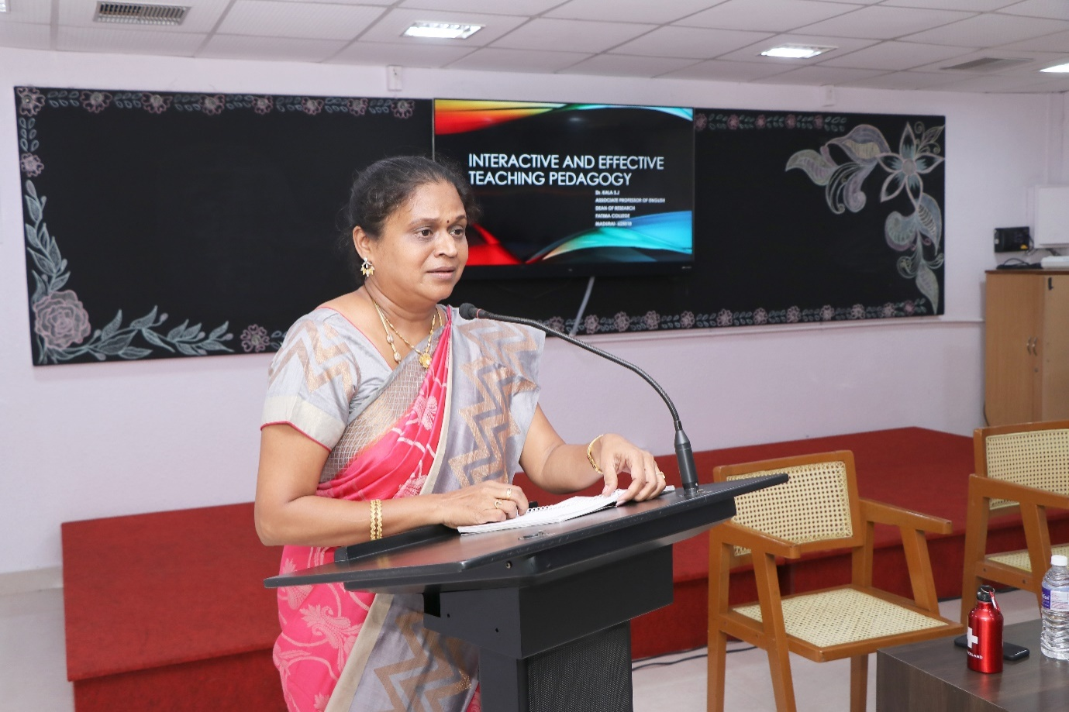

Dr. S. J. Kala, Associate Professor of English & Dean of Research who described the Interactive Classroom Teaching.

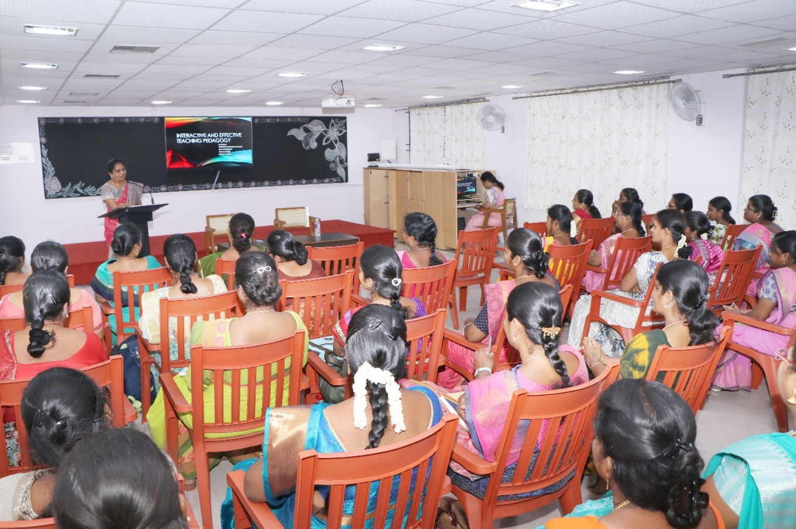

Date: 17.09.2022
Session1:The Courage to Teach
The day started with a prayer song. Dr.Magdalene Abraham, Associate Professor, PG & Research Centre of English, Fatima College, was the resource person for the firstsession.
Dr. L. Meena, Assistant Professor of Management Studies, introduced and welcomed the chief guest, IQAC members and the participants. Dr.Magdalene started the session by recollecting her good-old memories of being a significant member in all IQAC initiatives. She kick started her speech by insisting on the importance of learning. ShequotedSocrates’slines“Anunexaminedlivingisnotworthliving”andsheemphasizedon her philosophical call to examine into the inner landscape as a teacher. She appreciated and recognized the college as a secular institution. Further, Dr.Magdalene gave her deliberations on the necessary etiquettes that a teacher of Fatima College should practice by touching upon the topics like proper teacher-student language of communication, saying ‘no’ at the right time and how to respond elegantly. Later, she posed the question “Why do you want to teach?” to the participants and made them to think deeply about their purpose of choosing this noble profession. Few teachers shared their own stories of inspiration. After this sharing session, Dr.Magdalene shared her personal anecdote of how she became the professor of English after going through so much difficulties and challenges in her life and it was truly inspiring. She highlighted the courage and joy that a professor needs to become an empathetic teacher.
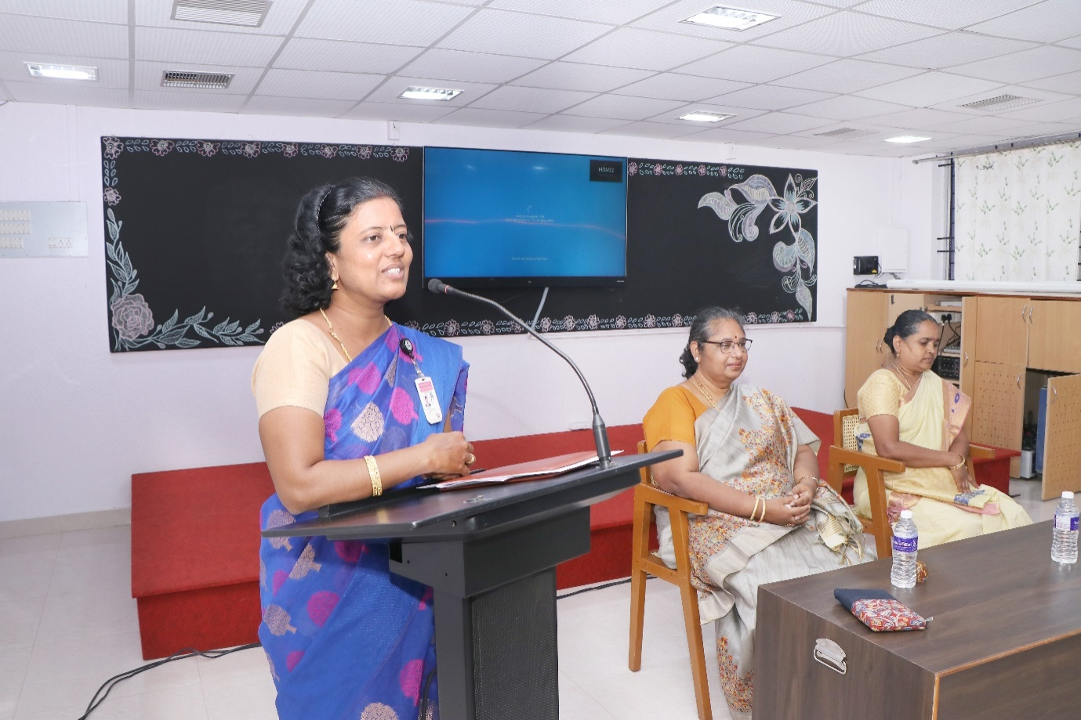

Furthermore, she encouraged the teachers to have courage not only to question something or someone, but also to have courage to give some concrete solution to the problems stated by the students.

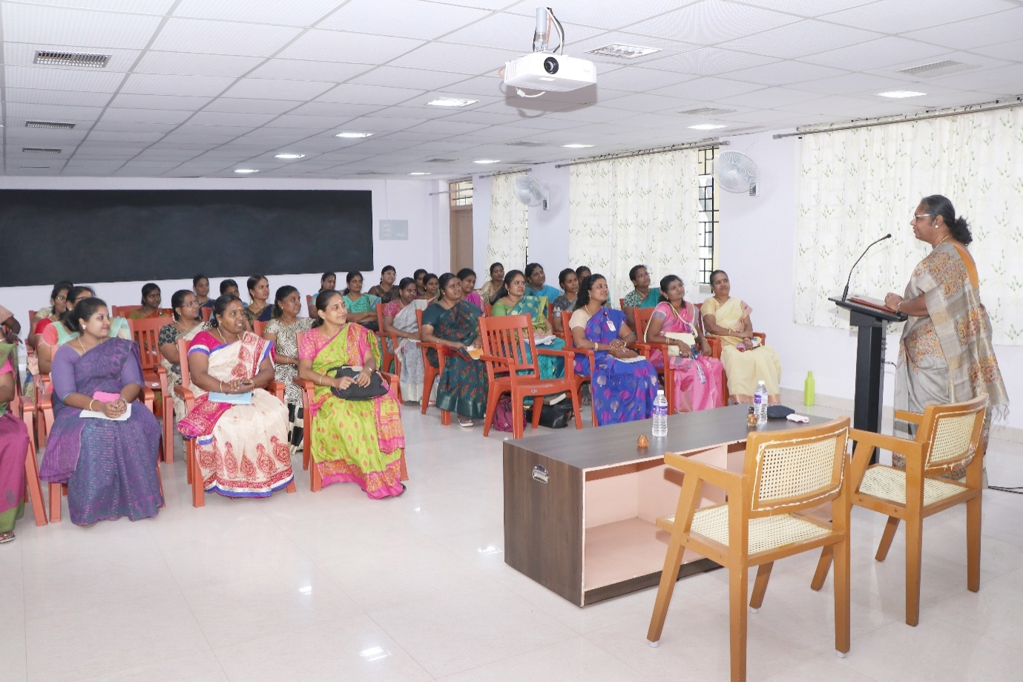
Dr.Magdalene Abraham, Associate Professor, PG & Research Centre of English addressing the young Teachers on the Topic “The Courage to Teach”

Session2:“Ambitions and Aspirant on-Reach to Stars”
Dr. J. Asnet Mary, Assistant Professor of Zoology, Fatima College, was the resource person for the session. Mrs. P. Sumedha, Head& Assistant Professor of English introduced the chief guest. She started her session deliberating on the effectiveness of the teacher in terms of personal, professional and interpersonal qualities. Dr. J. Asnet Mary encouraged the fellow teachers to transform from ordinary to extraordinary teachers. She beautifully connected the effectiveness of teaching to two important concepts such as Pendulum principle and Effectiveness Equation. She further highlighted on Aristotle’s statement “Excellence is not an act, but a habit” to bring out the constructive changes in the methods and strategies of teaching. Her metaphor of comparing this change with the right amount of different qualitative ingredients to yield a quality product was so thought provoking. Her in-depth deliberations on the difference between proactive and reactive persons were really useful and teachers were asked to self-examine themselves on these terms. Her most engaging session was on the topic “Begin with the End in Mind”. After which, teachers were asked to write their own mission statements as an individual and as a teacher. Her interesting motivational songs were the highlights of the session. The session ended with her personal miraculous story of the completion of Ph.D, followed by an activity named “Human Knot” insisting on the team spirit needed to achieve common goals of the institution.

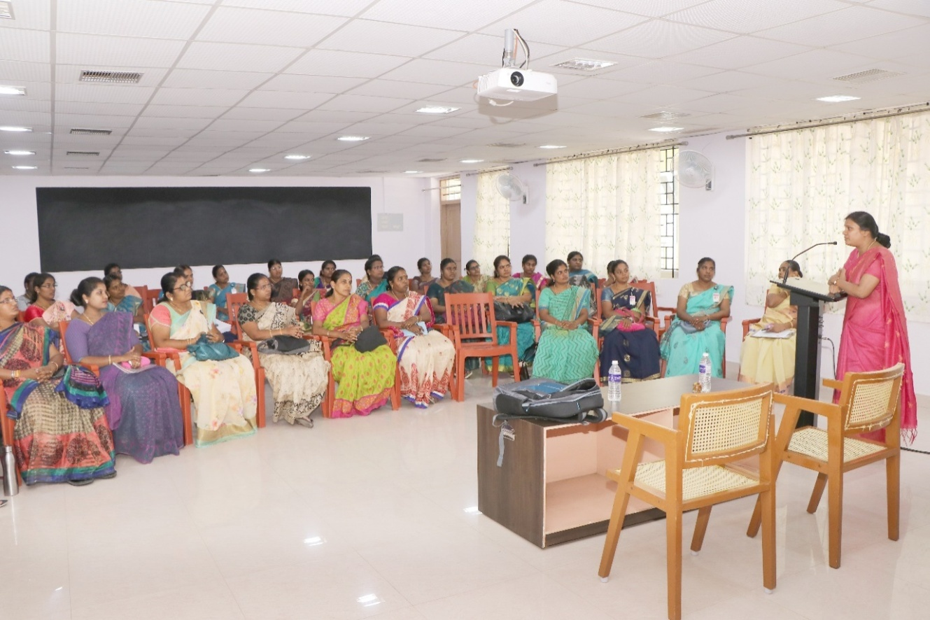

Dr. J. Asnet Mary, Assistant Professor of Zoology, Fatima College, addressing the gatherings on the topic “Ambitions and Aspirant on-Reach to Stars”

Session3:“Strategies of Curriculum Development”
Dr. M. Meenakumari, Head& Assistant Professor of Sociology and Social Work, Dean of Academic Affairs(Arts) was the resource person for the session. Mrs.P.Sumedha, HOD& Assistant Professor of English (SF) introduced the chief guest. She started her session by quoting a line from Kothari Commission that destiny of India is shaped in the classroom insisting on the significance of curriculum development inHigherEducation.HerdetaileddeliberationsonthecurrentOBEpatternandmappingofvisionandmissionofthecollegewithProgramEducationalObjectives(PEOs),ProgramOutcomes (POs) and Course Outcomes (Cos) were really productive and gave a clear-cut idea of how a higher education would design its curriculum. She also briefly explained about the Board of Studies and its role in designing and revision of curriculum in Fatima College. She laid emphasis on how curriculum designed in the college matches with graduate attributes. Further, she vividly explicated the concept of bloom’s taxonomy and its role in the curriculum development and also discussed its role in course design and in setting K levels (specific to Fatima College). Moreover, she elucidated the difference between the old OBE and new OBE pattern and explained in detail about the credit distribution for both UG and PG. Especially, this session was really useful to the new recruits as they were enriched with the holistic knowledge of curriculum development in Fatima College. The session ended with her appeal to the new staff to adapt different strategies to address the different category of students(free will, adopted, rebellious) and their needs through the concept of transaction analysis.

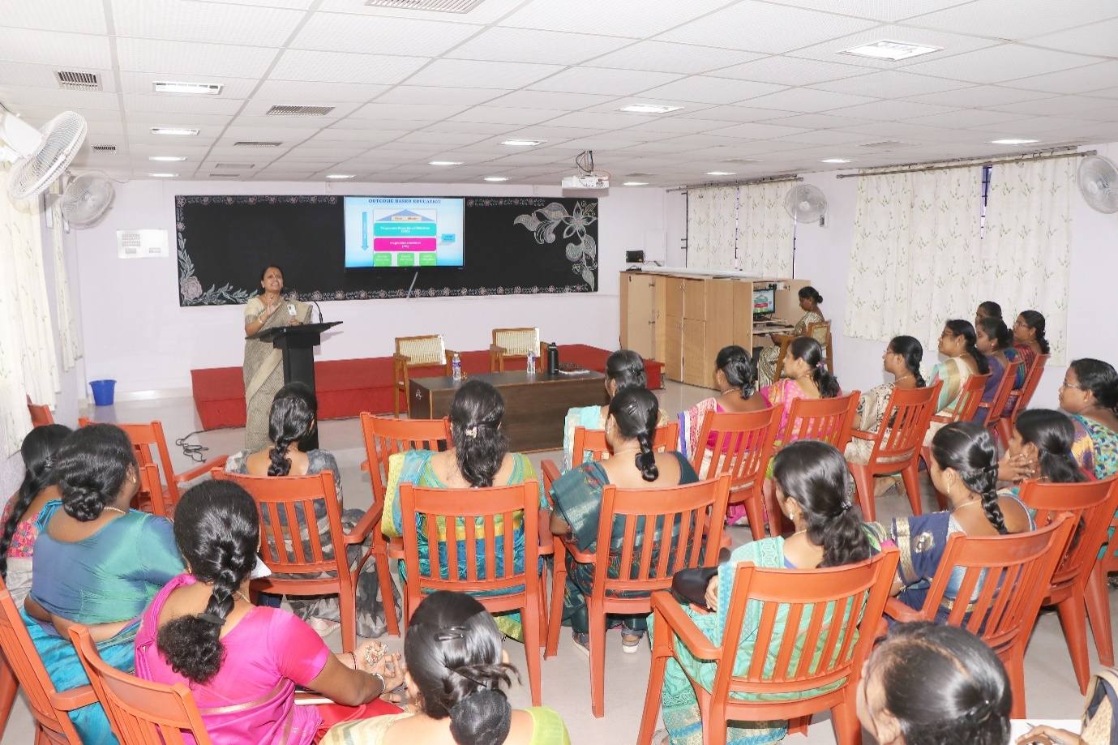

Dr.M.Meenakumari, Head& Assistant Professor of Sociology and Social Work, Dean of Academic Affairs(Arts) addressing the gatherings on the topic “Strategies of Curriculum Development”
Date: 18.9.2022.
Session: 1 Research Ethics and Funding Agencies.
The resource person for this session was Dr. Vasantha Esther Rani, Associated Professor and Head, The Research center of Home Science, Fatima College, Madurai. Mrs. B. Usha, Assistant Professor of MCA introduced the Chief Guest.
The Chief Guest started the session with an introduction to research a formalized curiosity. She explained about pre-research and stage in pre-research. She gave detailed description about the stages of pre-research. Then she shared some tips for selecting a topic. After that, she discussed about Research ethics quoting that Research ethics are the application of fundamental ethical principles to research activities including the design and implementation of research. Research ethics are set of rules of our own and others behavior. She explained about the research ethics committee. Institutional Review Board reviews whether the research is ethical enough or not to protect the rights dignity and welfare of the respondents. Then she discussed about the five broad categories of research ethics namely, minimizing the risk of harm next, minimizing the risk of the research, obtaining informed consent, protecting anonymity and confidentiality and to avoid misleading practices. She also explained about the advantages of research ethics like how research ethics promotes the aim of the research. Also she explained about the limitations of research ethics. She discussed about ensuring ethics at every step of research. Then she gave us the list of various funding agencies. She gave us few tips to reduce stress level during research. She motivated us saying if the research is rejected try again. She concluded the session by sharing her personal experiences in research. Vote of thanks was delivered by Mrs. B. Usha, Assistance Professor of MCA, Fatima College, Madurai.

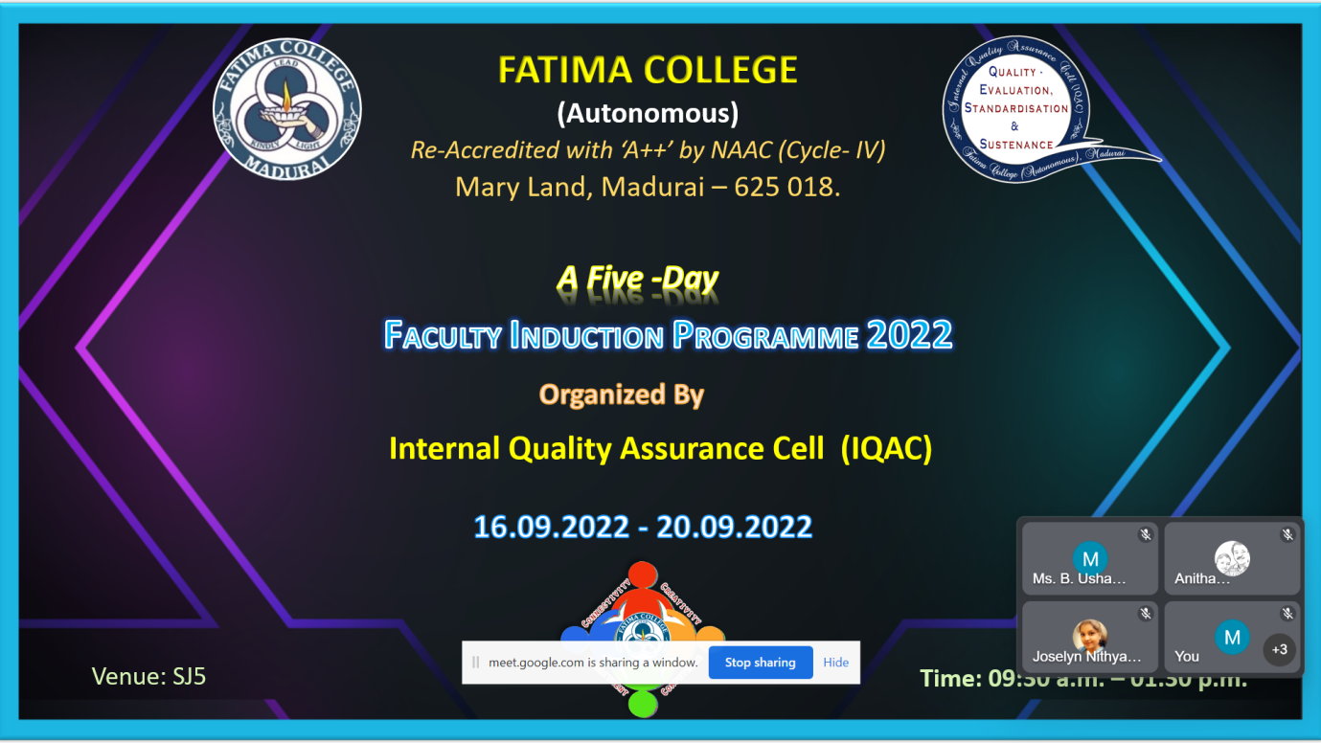

Dr. Vasantha Esther Rani, Associated Professor and Head, The Research center of Home Science, addressed the gatherings on “Research Eths and Funding agency”
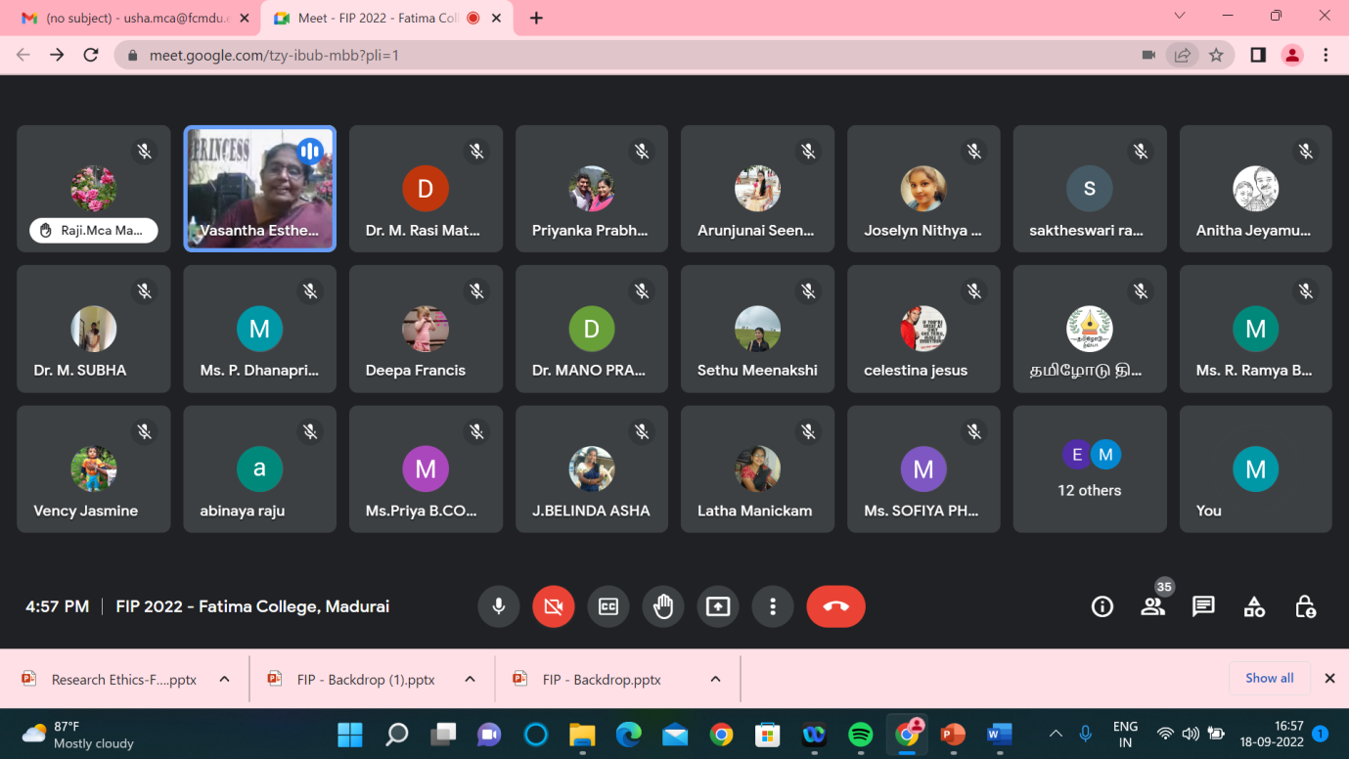

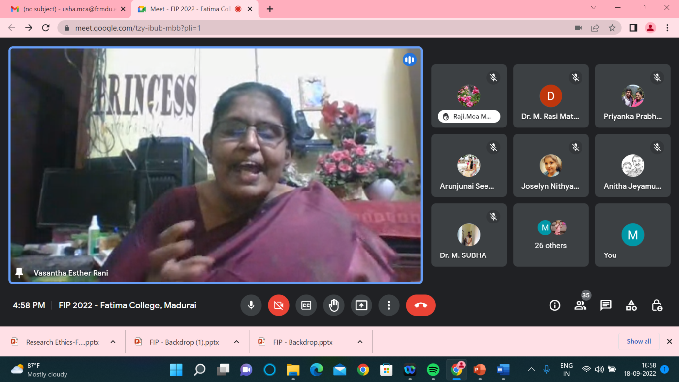

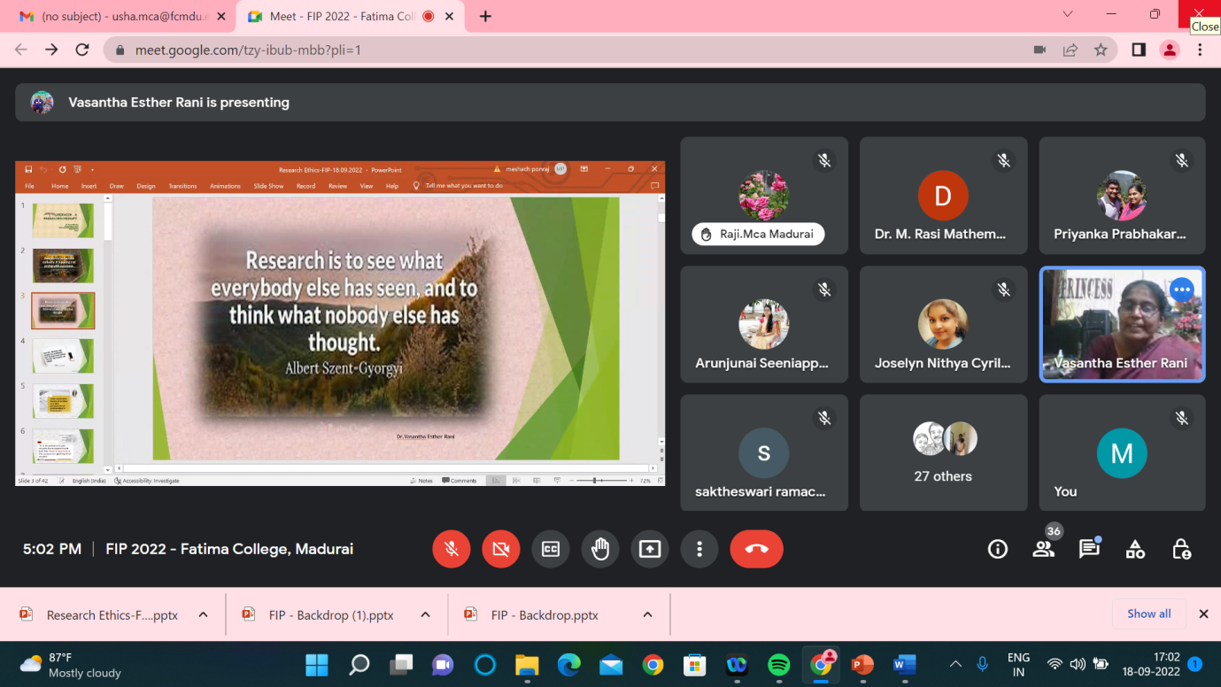

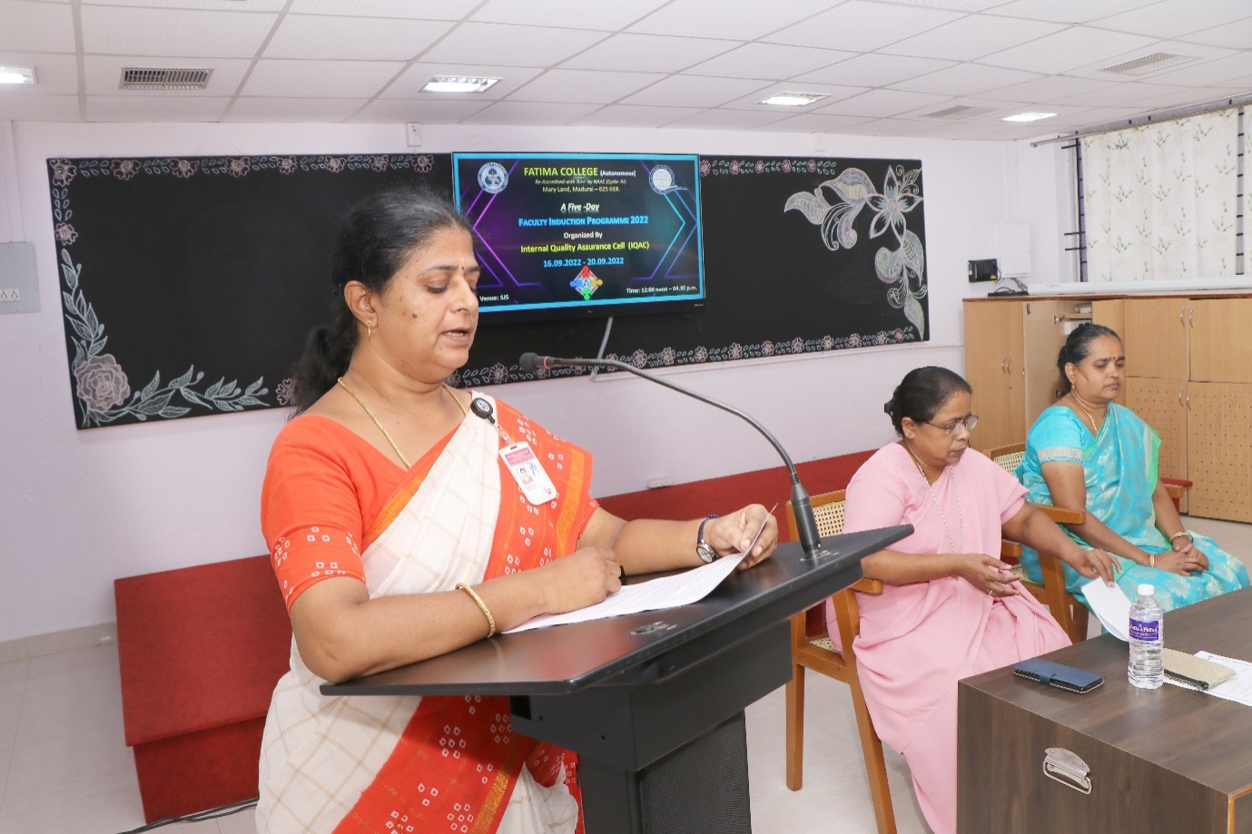

Date:19.09.2022
Session 1: LATERAL THINKING
The session was addressed by Dr. K. Rosemary Euphrasia, Associate Professor of Computer Science &IQAC Coordinator, Fatima College. She enlightened the participants about LATERAL THINKING, required to be a competent teacher. Various innovative methods on problems and solutions were elaborated in detail. She highlighted certain techniques to think from a different perspective – OUT OFBOX THINKING. As an add-on credit to the topic, she gave an insight towards two categories of thinking – convergent and divergent.
She cited the story of Hare and the Tortoise as an example to make the attainment of the session very clear. To conclude, she motivated the faculty regarding the ‘change’ to be instigated in young minds to develop their creativity. She quoted that creativity leads to ultimate happiness for the students. Exercises on out of box, lateral and logical thinking, picture illusion, re buzz puzzles, few other games etc. were conducted which made the session lively. The lecture was very beneficial and provided the perception which a teacher educator has to overcome all challenges.
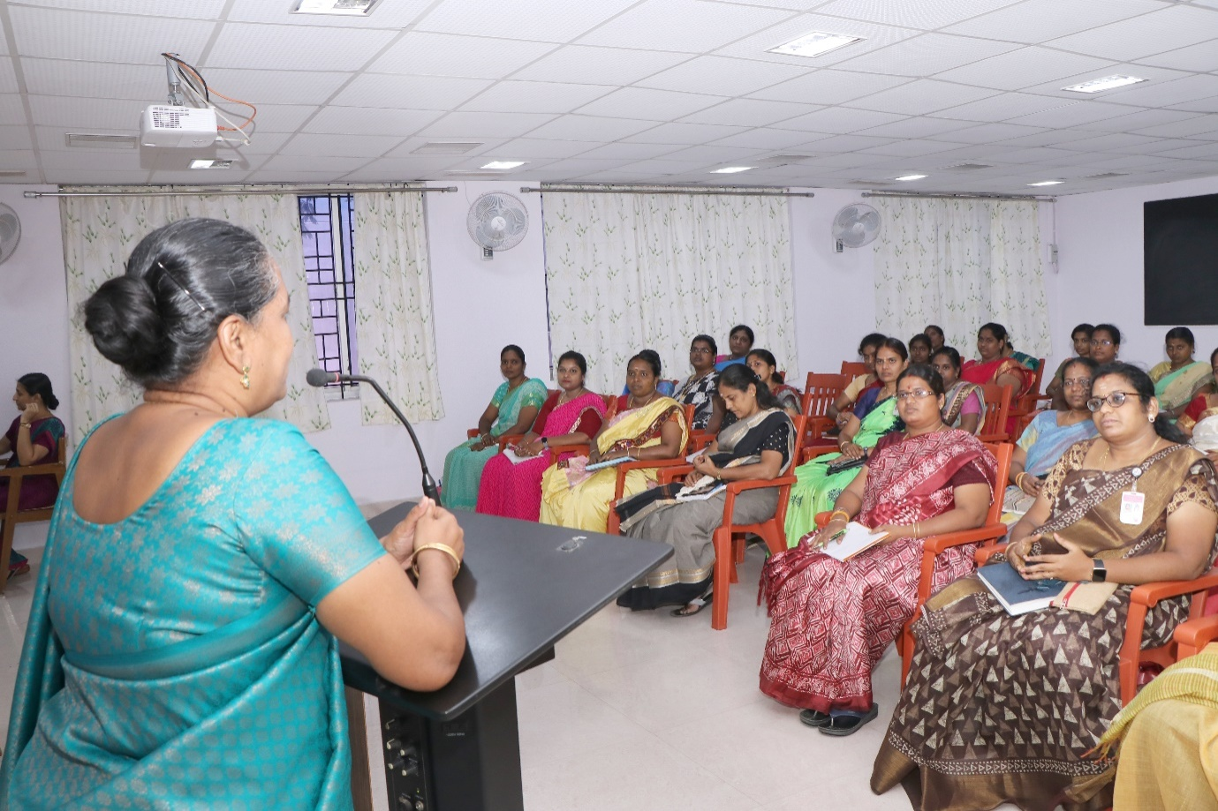

Dr. K. Rosemary Euphrasia, Associate Professor of Computer Science &IQAC Coordinator, addressing the gathering on the topic “LATERAL THINKING”

Date: 20.09.2022
The session was started with prayer followed by welcome address which was delivered by Mrs. P. Sumedha, Head and Assistant Professor of English.

The first session was delivered by the Principal Rev. Dr. G.Celine Sahaya Mary.
The aim of the session was about to highlight the aim of higher education and the role of teachers. ‘Who am I’ is a sensitive question highlighted to the teachers. The sense of unity was sensitized and emphasized by the founder’s vision. The importance of meditation was brought out through which self-mastery could be attained. Besides this she emphasis on contentment in one’s professional life is explained through stories. The importance of counselling to the students was explained. Teachers were told about the professional ethics, class preparation, and active presence during the meetings, taking casual leaves and to keep a pleasant smile amidst the students.

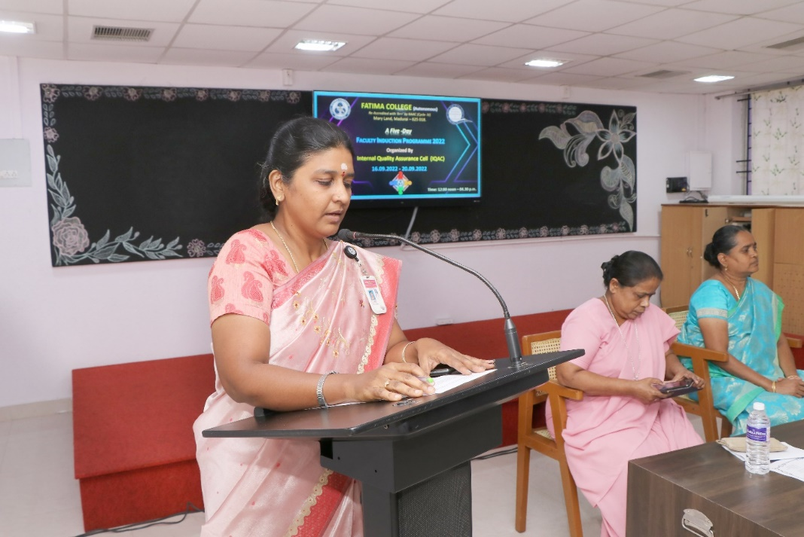

Principal Rev. Dr. G.Celine Sahaya Mary about to address the gathering on the topic “The role of teachers”.

The next session was delivered by Secretary Rev. Dr.M.Fransica Flora who talked about the founder’s vision and the culture of Fatima College. Gender inequality was referred with Tamil poet Bharathiyaar’s Poetic lines. The vision of Mother Rose was insisted that it is communication in which contact becomes connection. Later on the terms and conditions of Fatima College was listed out by sister Secretary. Authoritative powers were explained to the new teacher’s right from President to the Superintendent of the college. The session was concluded with the note of the code of conduct that to be instilled

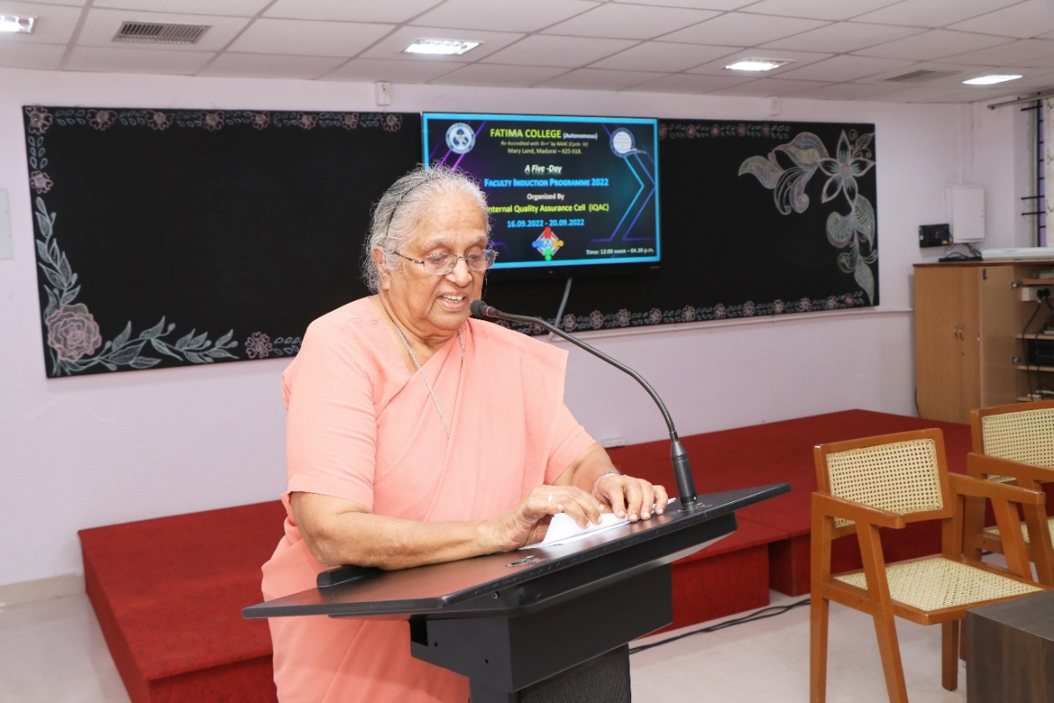

Secretary Rev. Dr.M.Fransica Flora talked about the founder’s vision and the culture of Fatima College.

The third session was delivered by Controller of Examinations, Rev. Dr. A. Jospin Nirmala Mary. The session began with the introduction of examination pattern and the presentation slides were displayed in which key aspects- accuracy, credibility &time, efficiency are shown. Self-learning courses for the students to update and deepenthe subject knowledge was explained. The lecture was concluded with the care and love of the students that to be showered by the teachers.

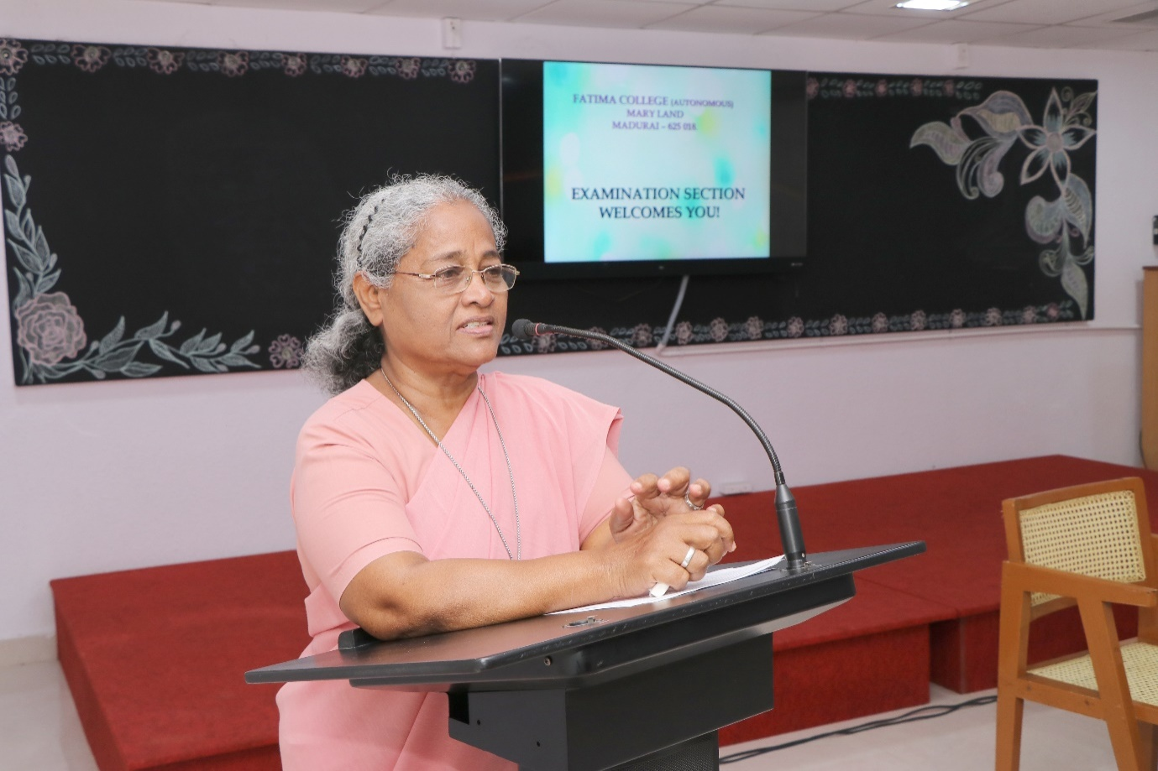

Rev. Dr. A. Jospin Nirmala Mary, Controller of Examinations
Introduced examination pattern

The final session was delivered by Vice Principal Rev. Dr. G. Jenita Rani.
The lecture was started with a note of the quality of a best teacher. The teachers were insisted to adopt various teaching methods based on the understanding level of the students. The session was really engaged with Shankar D. Sharma’s stories – how the teacher influenced the students and created a spark in all of us through various incidents. Finally the session was oriented with the story video played to bring in the idea of essence of teaching.

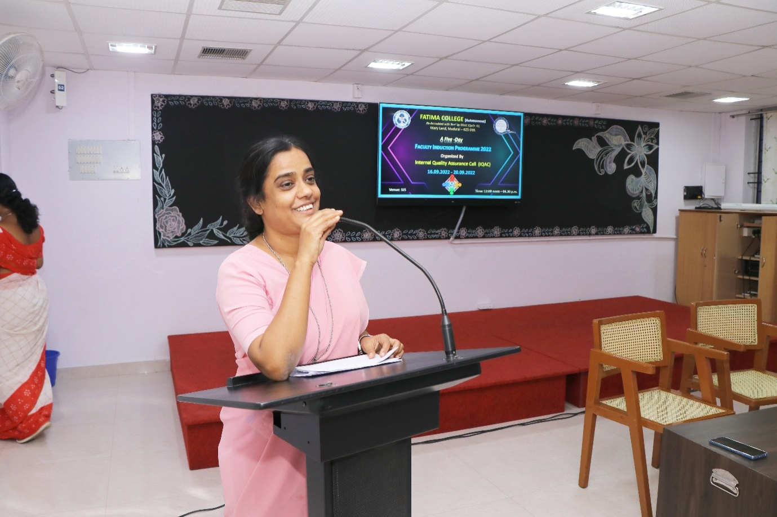
Vice Principal Rev. Dr. G. Jenita Rani addressed the gatherings in the concept qualities of a best teacher

Attendance:
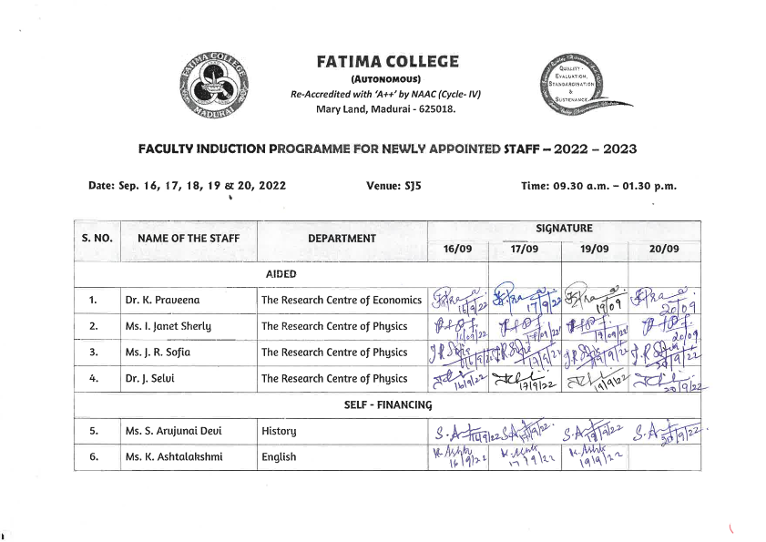

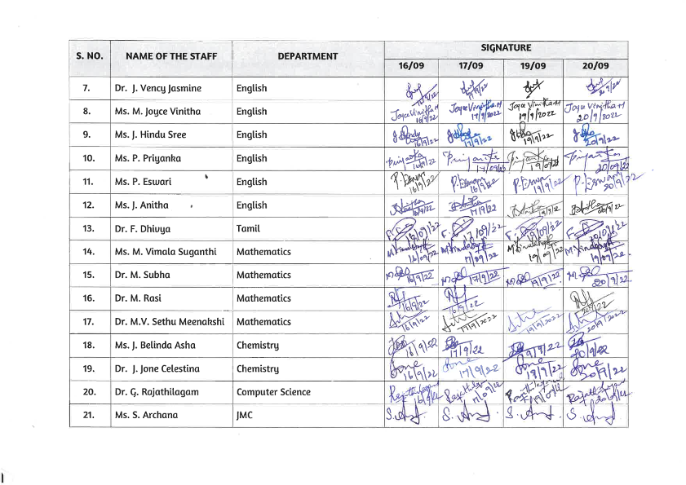

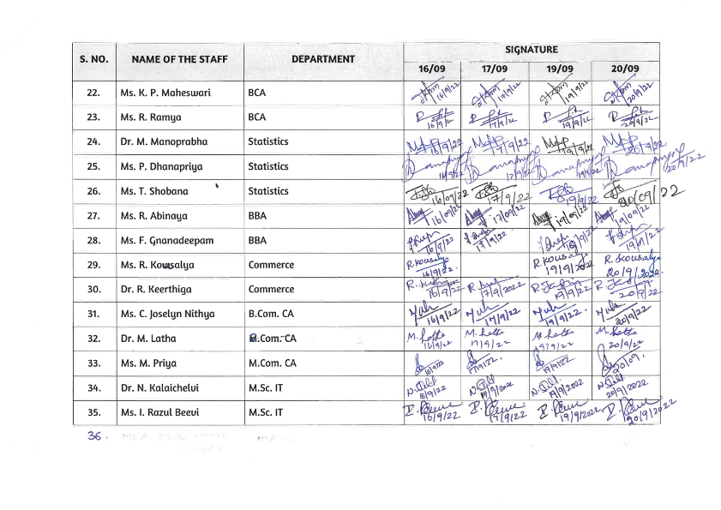

Certificates:
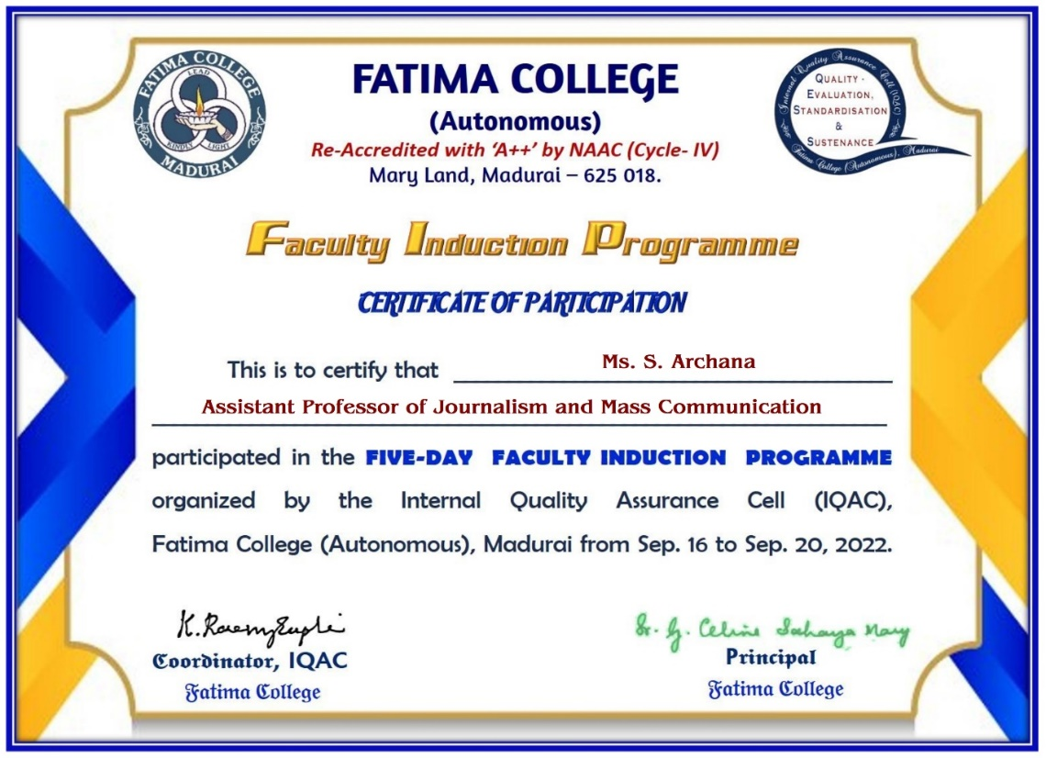

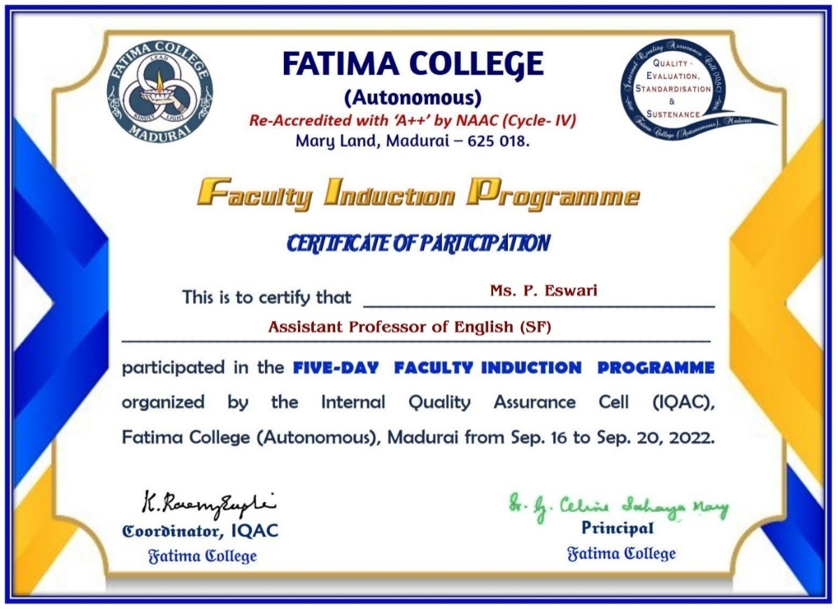

Feed Back

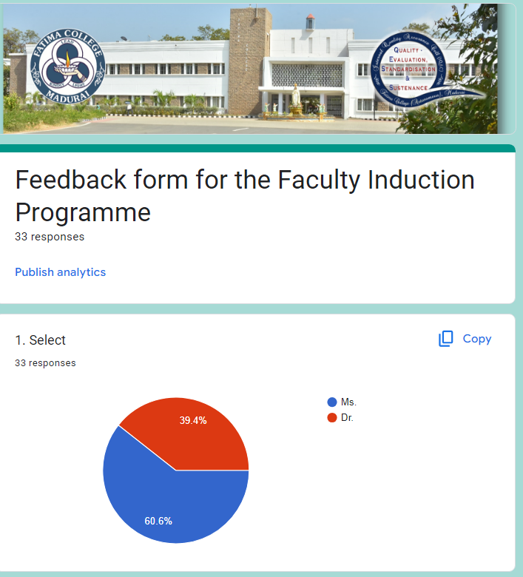

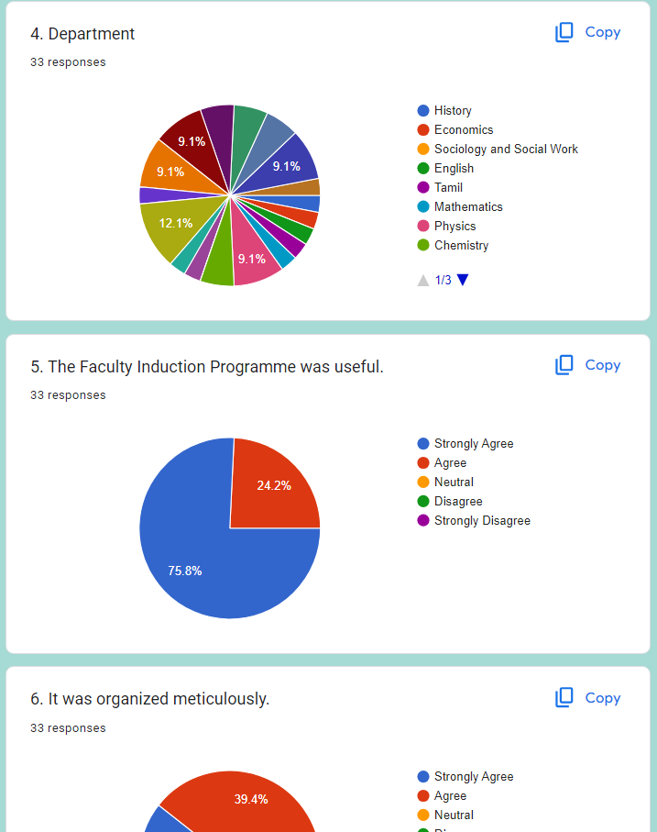

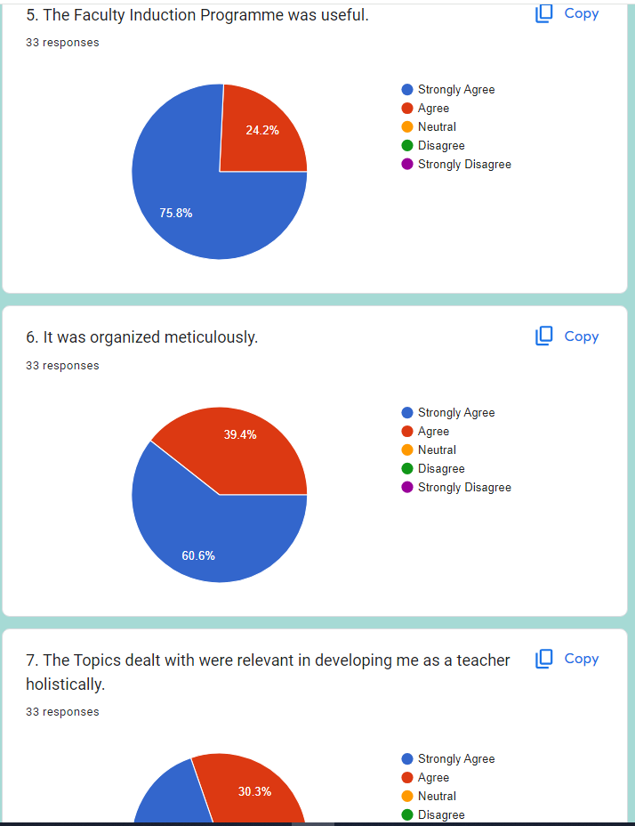

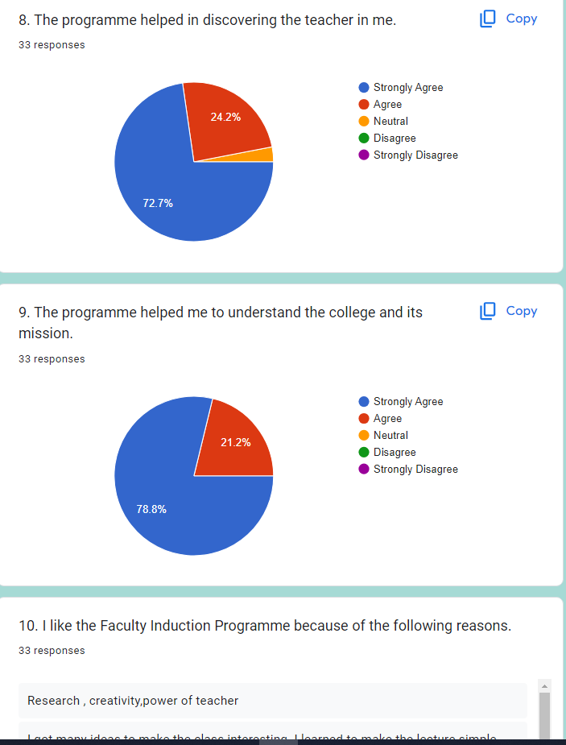

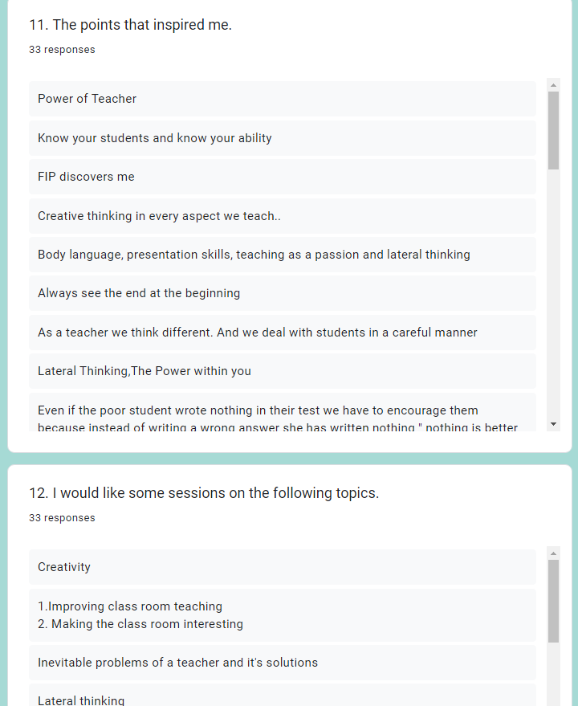
REPORT ON A THREE-DAY FACULTY DEVELOPMENT PROGRAM ON
‘EMOTIONAL INTELLIGENCE’ on 22.09.2022
Invitation:
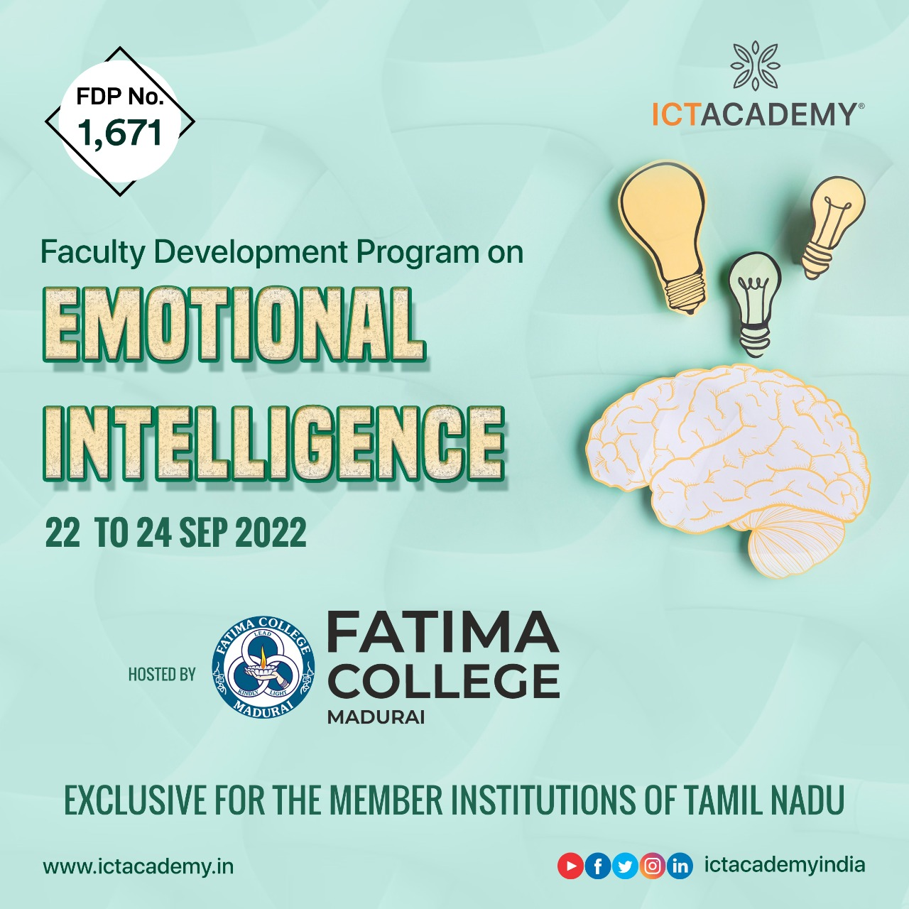

Date-22-09-2022
Agenda:
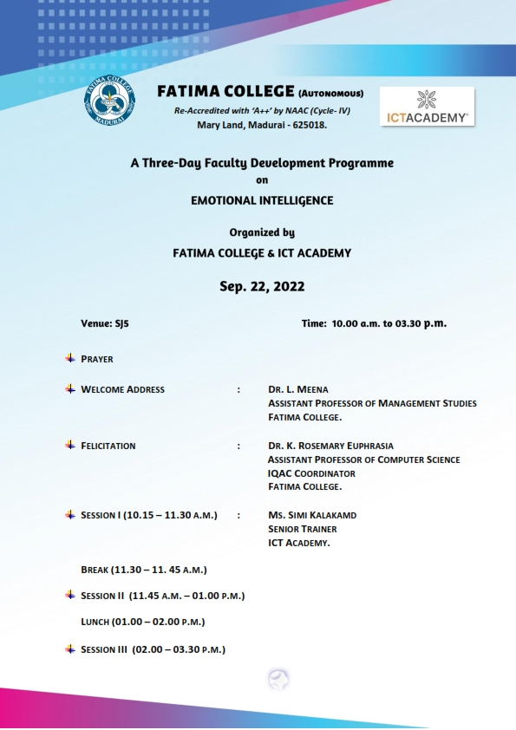

Day-I-Venue-SJ5
Fore Noon Session-10 a.m. -1 p.m.
The first day session onthe three-day Faculty development program on “Emotional Intelligence’ organized by Fatima College, Madurai and ICT Academy, Bangalore began with an invocation to God followed by a welcome address by Dr.Meena, Assistant Professor of Business Administration. Ms.Simi, Senior Soft Skill Trainer, ICT Academy, Bangalore gave a wonderful presentation on ‘Emotional Intelligence’. She briefed on the objectives of Emotional Intelligence, the basics of becoming emotionally intelligent, emotional hijacking, transactional analysis, different ways to deal with a difficult student, empathy and stress management.
The participants were divided into seven groups comprising of five staff each to facilitate team building skills and tap the potentials of the participants. Each team was instructed to design a logo for the team, song and christen a name. The team members introduced one another-their likes and dislikes and this ice-breaking session paved way to gel with one another. A self-assessment exercise was given to the participants.
Afternoon Session- 1 p.m. – 3.30 p.m.
The afternoon session was on core beliefs that a person has in his life. Ms.Simi Madam taught the participants to prepare a positive journal for each day to boost one’s self-confidence. She lectured on ‘Thought Log’. An activity of craft making was given to each team followed by guessing game of the artifacts made from paper craft.
Date-23-09-2022
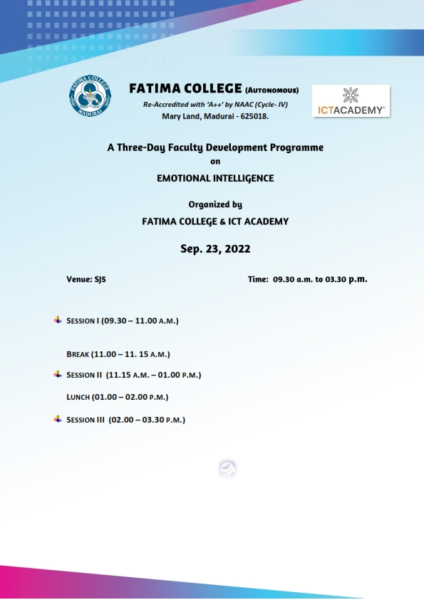

Day-II-Venue-SJ5
Fore Noon Session-10 a.m. -1 p.m.
The second day of the faculty development program began with a paper song. Ms.Simi Madam taught Progressive Muscular Relaxation Exercises to the participant to ease them mentally and emotionally. She stressed on the fact that ‘Emotional Intelligence is not removing emotions or controlling emotions, but suppressing emotions. She highlighted that EI is important to the overall development of an individual. She added that one’s performance at work, helps navigate the social complexities of the college, lead and motivate students and excel in career.
Afternoon Session- 1 p.m. – 3.30 p.m.
The afternoon session was on Physiology of the brain. Ms.Simi Madam spoke on the importance of Social Awareness, Self-Awareness, Self-Management and Relationship Management. An activity on boat making with paper was given to the teams. A self-assessment on Rosenberg Self-Esteem scale was done by the participants.
Date-24-09-2022
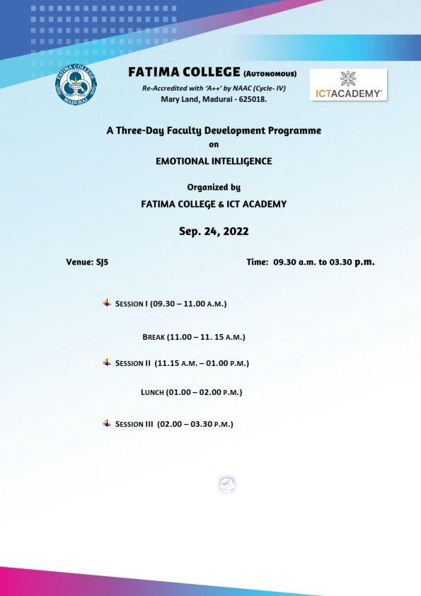
Day-III -Venue-SJ5
Fore Noon Session-10 a.m. -1 p.m.

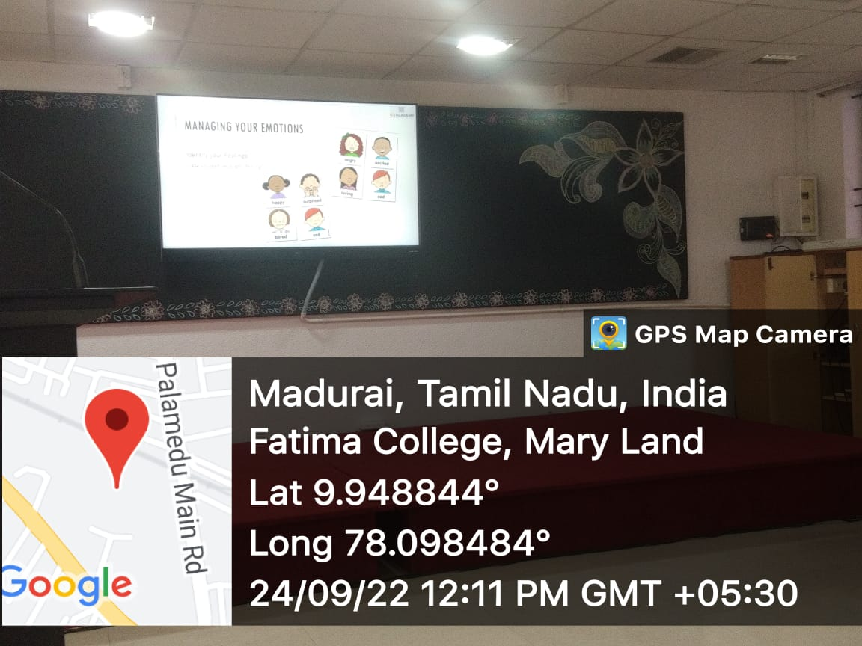

An active in full swing to the participants
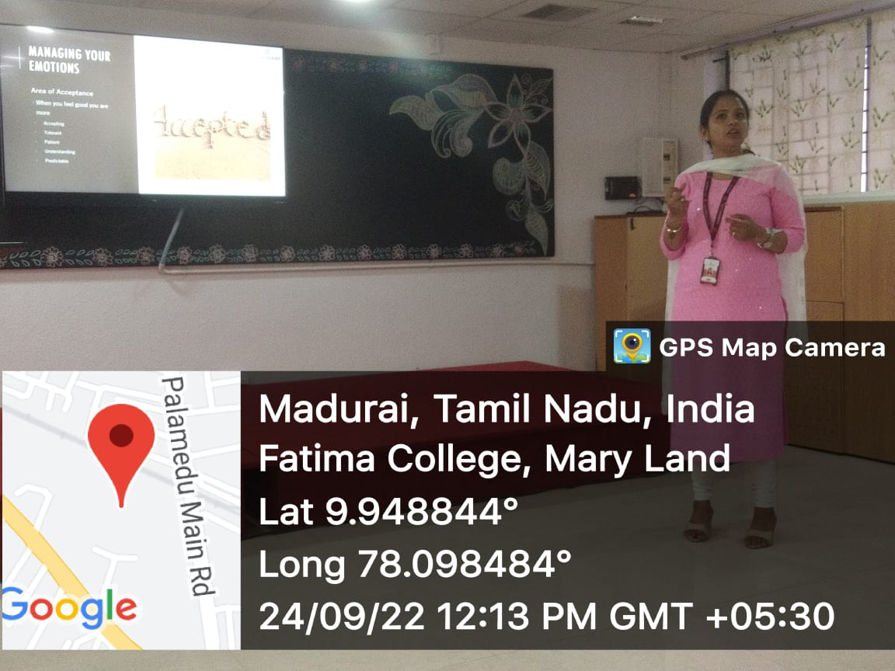

Ms.Simi, Senior Soft Skill Trainer, ICT Academy, Bangalore handling the session on ‘Emotional Intelligence’

The third day session began with a prayer song. . Ms.Simi Madam lectured on ‘Emotional Hijacking’. She elaborated on Amygdala Hijack and its three stages-Fight, Flight and Freeze. She told the participants to respond rather than react emotionally and to become aware of our emotional triggers. She continued with the indicators of Low EQ. She also highlighted the various skills-Stress management, Emotional awareness, Non-verbal communication, Humour and Conflict management. She also briefed about Plutchil’s Wheel of emotions, Parrott’s Emotion types and the different methods to manage one’s emotions.
Afternoon Session- 1 p.m. – 3.30 p.m.

The afternoon session was on the Area of Acceptance, Iceberg Theory and Transactional analysis History. Ms.Simi Madam highlighted on the techniques of EI, which can help students to identify their emotions. A story telling session radiated the afternoon hours of the day. Certain key points and story hints were given to the participants and they were instructed to weave stories with interesting plots. All the team members discussed and came out with gripping tales loaded with emotions. This was followed by Ms.Simi Madam’s lecture on ‘Model Appropriate Behaviour’. An assessment on strengths exploration, Previewed Stress Scale and Optimism Independence were undertaken by the participants. Ms.Simi Madam distributed chocolates to the participants as a token of appreciation. The session ended with a memorable photo session. Dr.RosemaryEuprashia, Associate Professor of Computer Science proposed the vote of thanks.

PHOTOS:

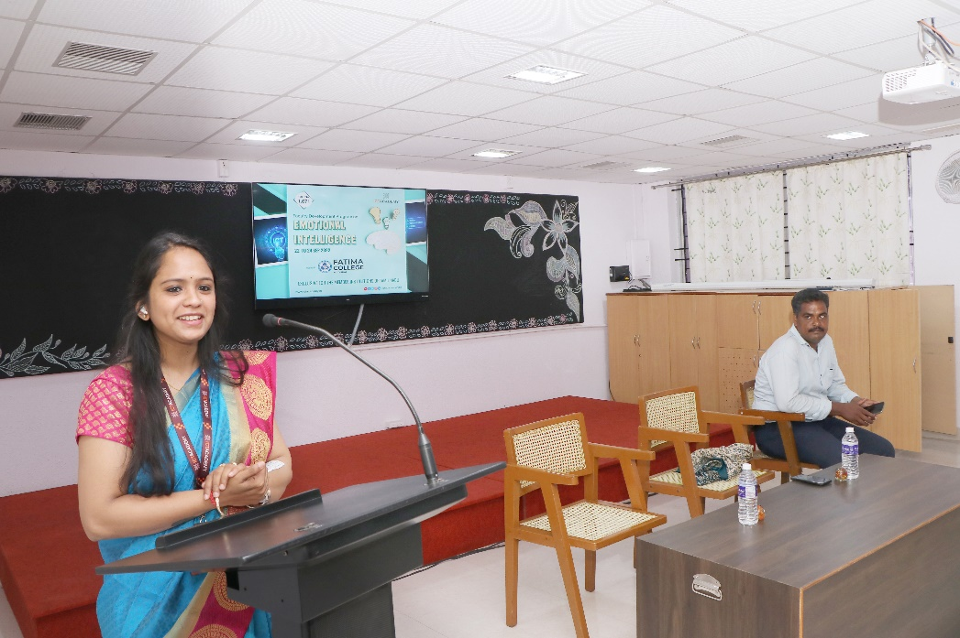
Ms.Simi, Senior Soft Skill Trainer, ICT Academy, Bangalore handling the session on ‘Emotional Intelligence’

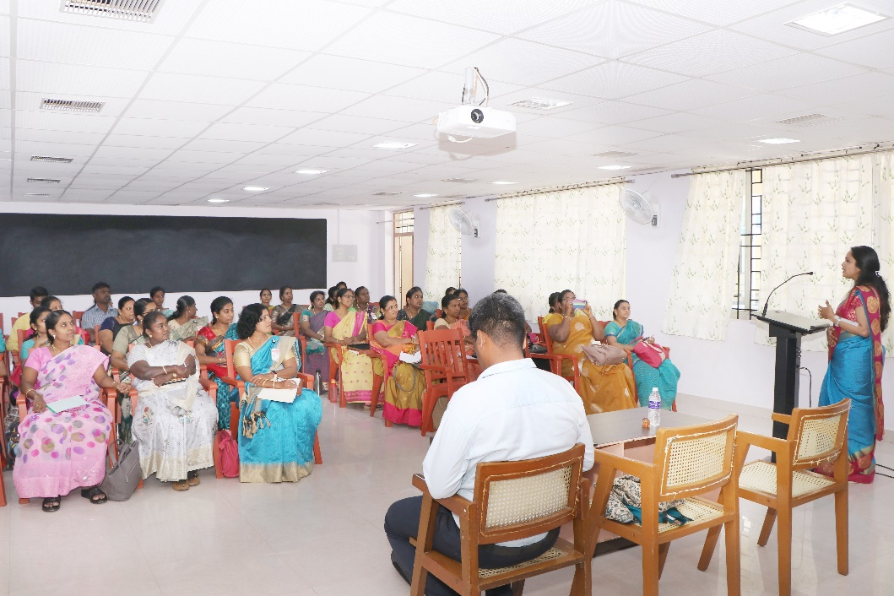

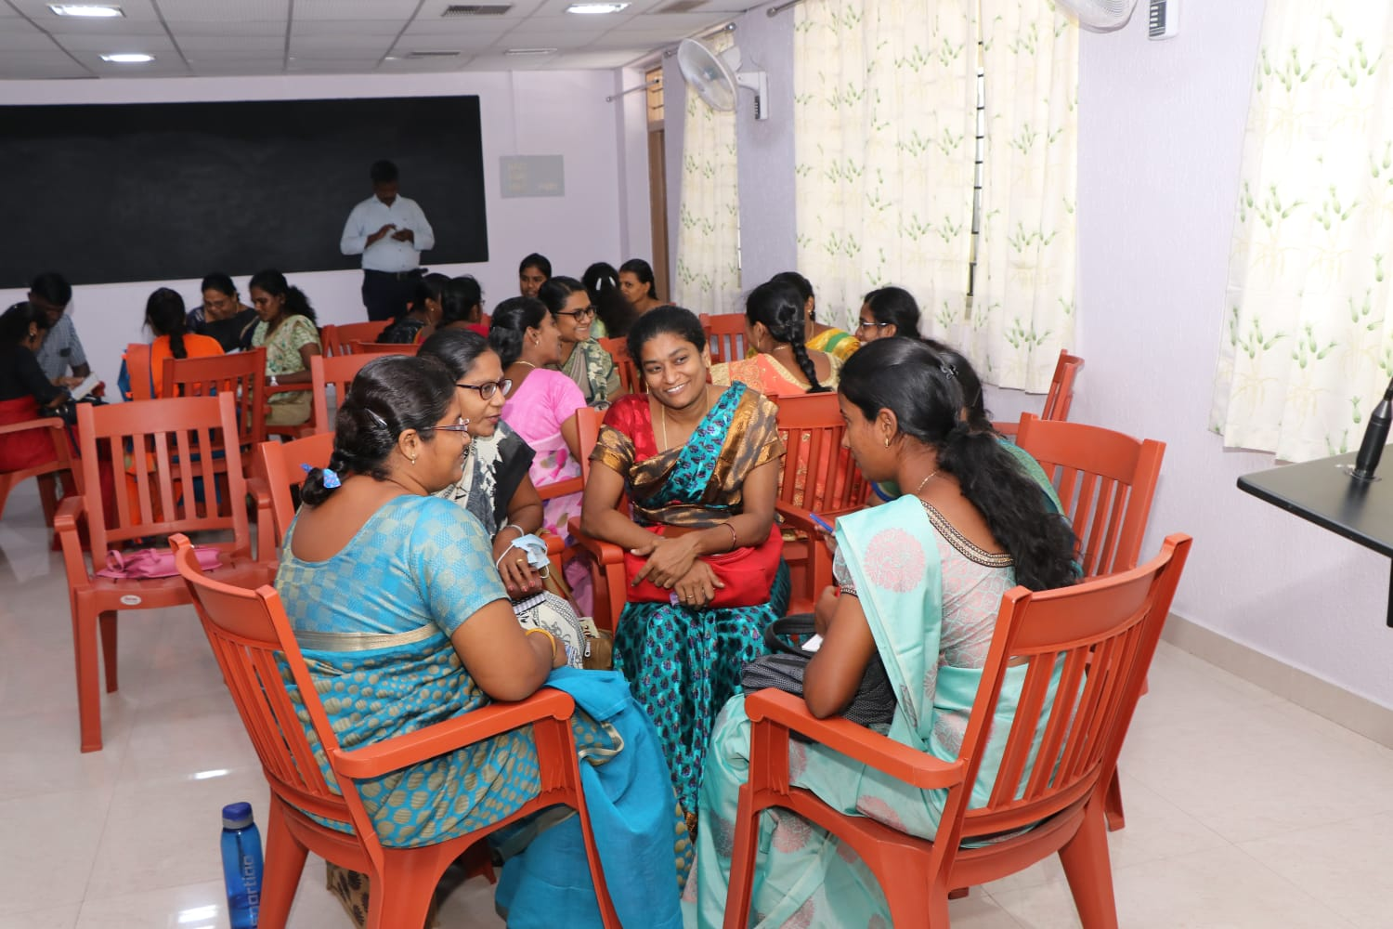

Activities conducted for staff members during the session

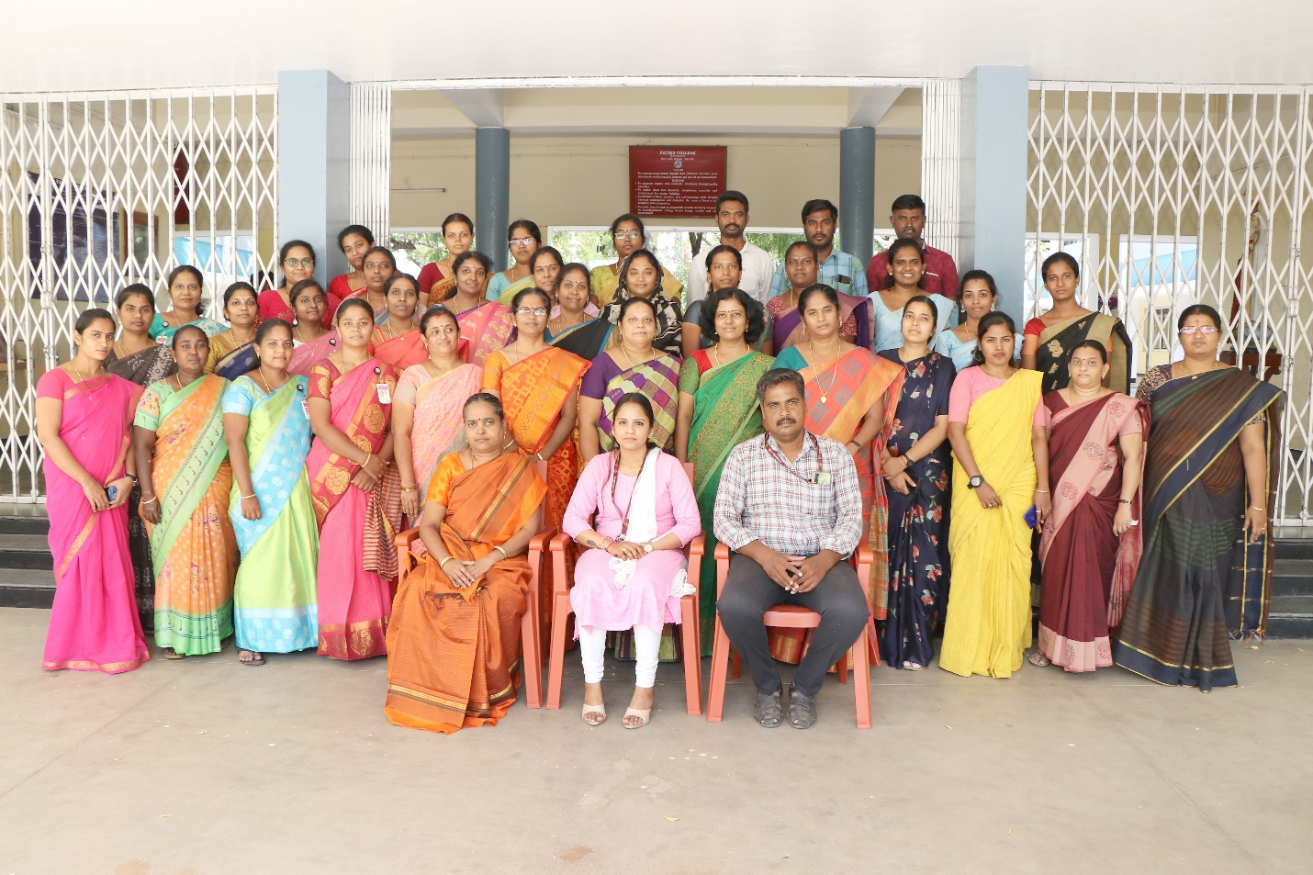

Group Photo with the Resouurce persons at the end of the programme

ATTENDANCE:
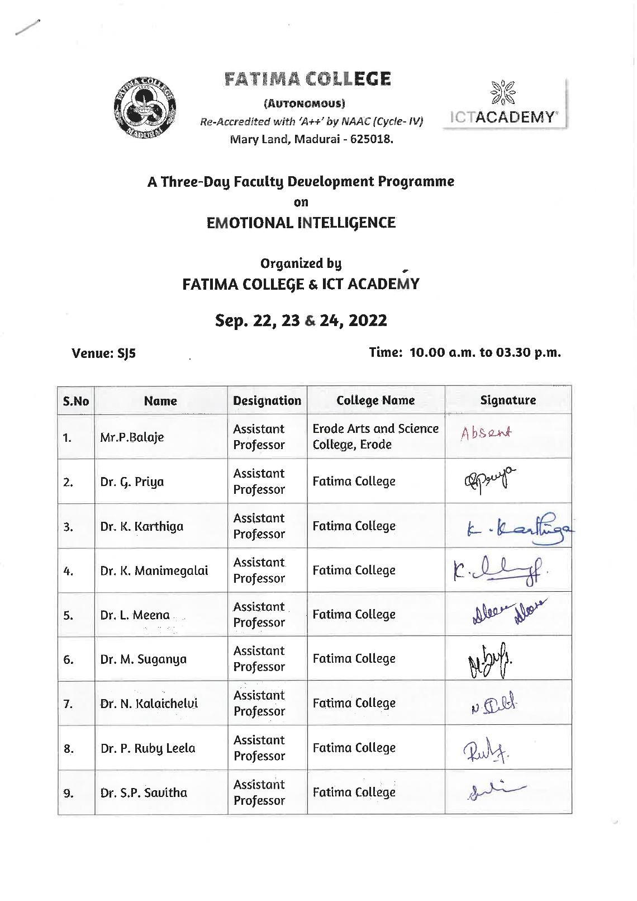

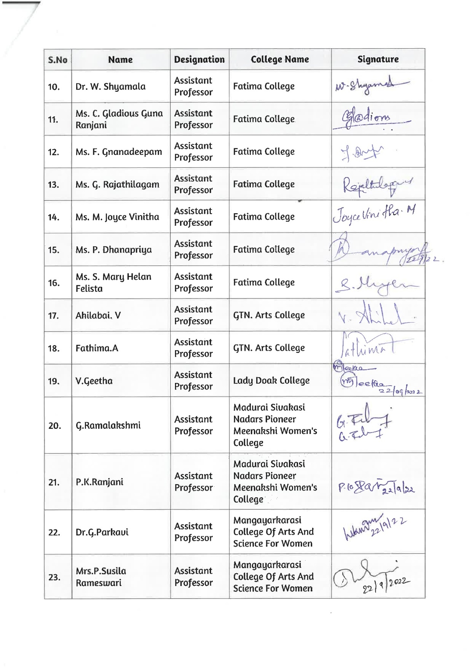

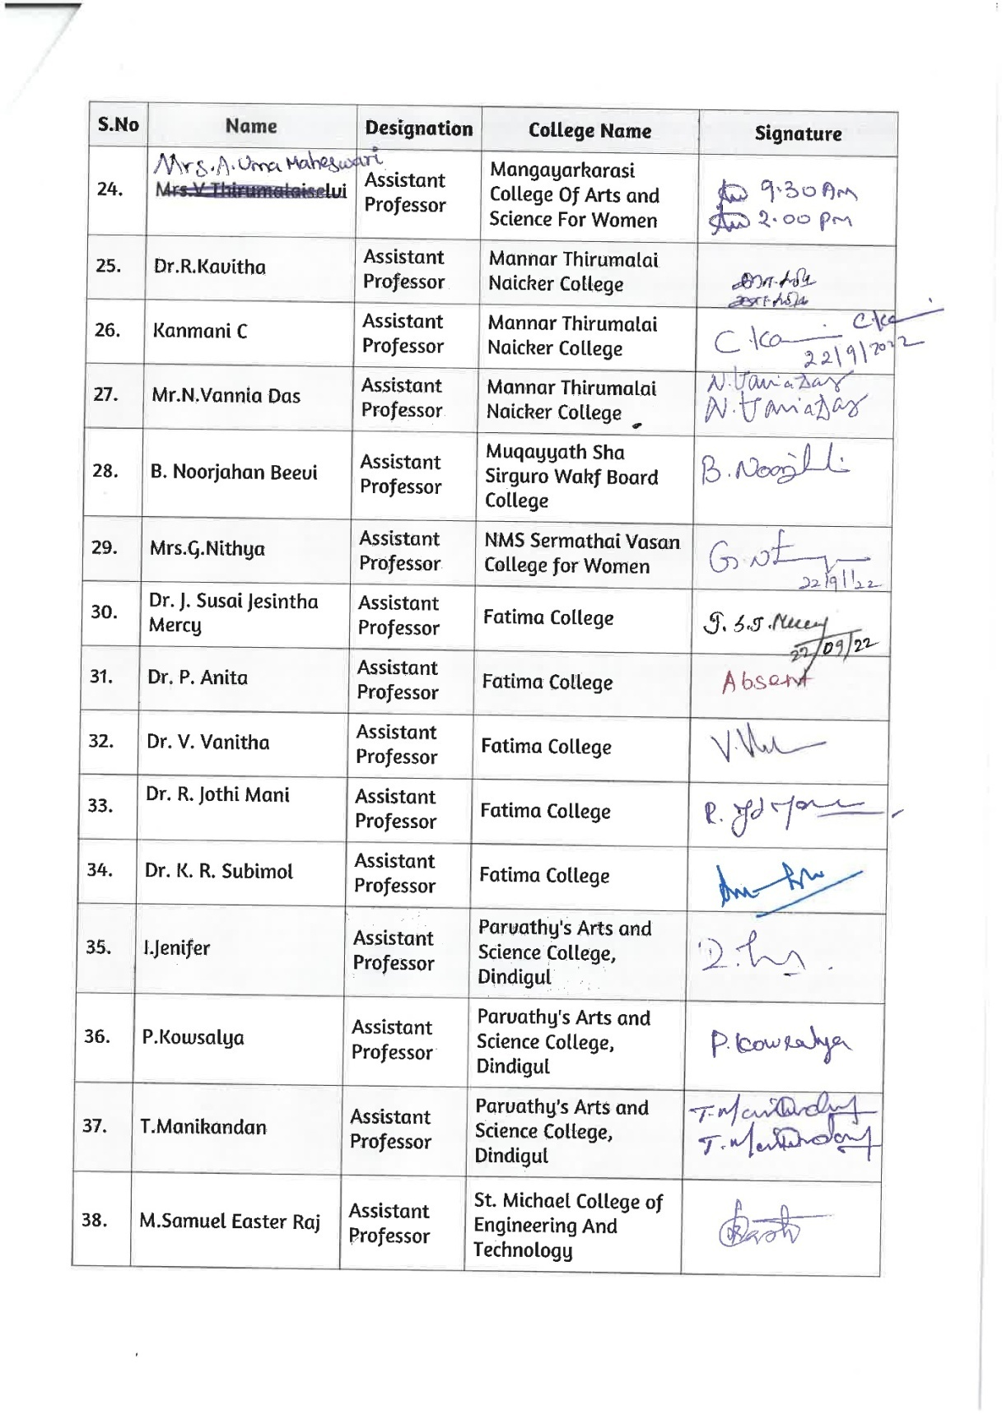

CERTIFICATE:

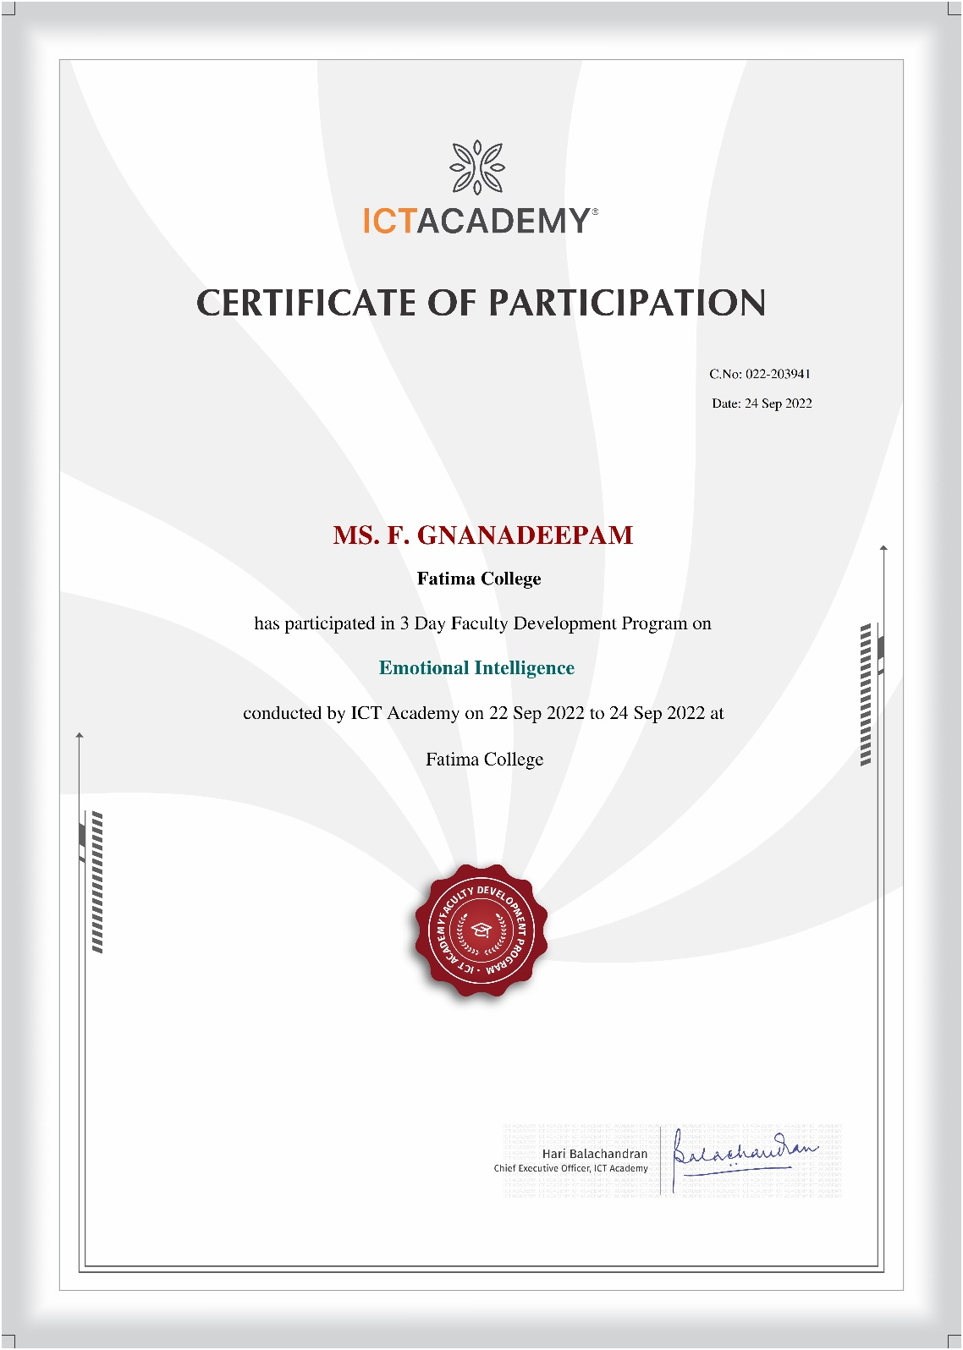
One - Day Faculty Enrichment Programme on
Enhancing Personal and Professional Competencies
October 29, 2022

Faculty Enrichment Programme organised by IQAC

Date: Oct. 29, 2022 Venue: JH

AGENDA

10.00– 10.15 a.m. | PRAYER
 | Welcome Address | Dr. L. Meena  Assistant Professor of Management Studies
10.15 – 11.15 a.m. | Session I | Dr. K. Alex  Associate Professor of Commerce  St. Joseph’s College (Autonomous)  Tiruchirappalli – 620 002.
11.15 – 11.30 a.m. | Break
11.30 – 12.30 p.m. | Session II Dr. K. Alex
12.30 – 01.30 p.m. | Lunch
01.30 – 03.00 p.m. | Session III | Dr. K. Alex
03.00 p.m. | Vote of Thanks | Dr. R. Saktheswari  Assistant Professor of English  Asst. IQAC Coordinator

Invitation

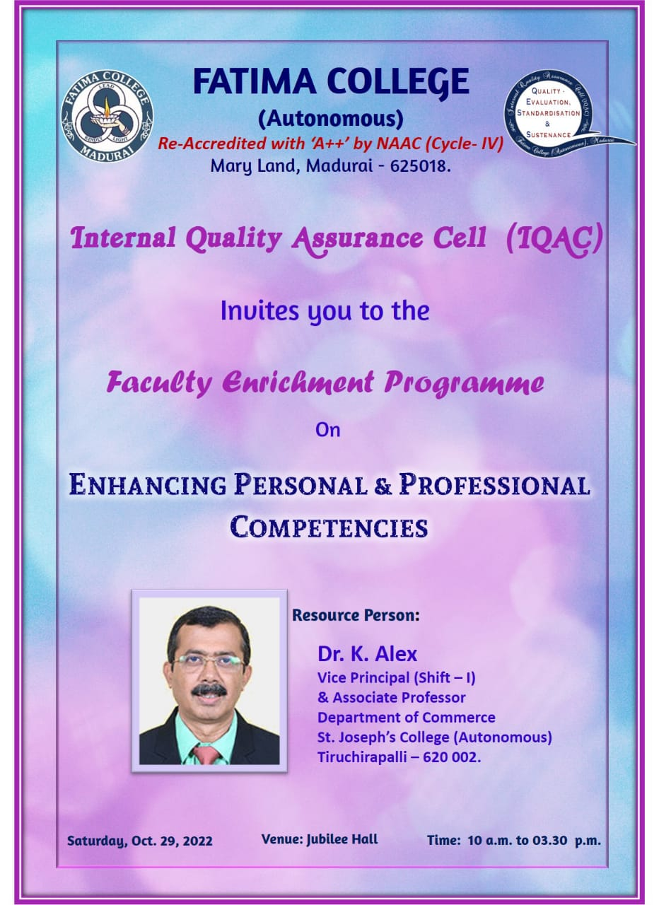

Report
A one – day Faculty Enrichment Programme was successfully conducted by the IQAC of Fatima College on October 29, 2022. The FEP programme received an overwhelming response with around 190 teaching staff from Shift I and Shift II. The entire programme was spearheaded by Dr. K. Rosemary Euphrasia, Coordinator of IQAC. Dr. L. Meena, Assistant Professor, MBA welcomed the audience and introduced the chief guest Dr. Alex, Associate Professor, Department of Commerce, St. Joseph’s College (Autonomous) and briefed some of his academic achievements, highlighting his expertise in training the teachers and entrepreneurs.
The floor was then open to the Guest Speaker to address the audience who began quoting Swami Vivekananda, “You are what you are in darkness.” Dr. K. Alex informed the teachers to know the importance of the place of work. He also went on to distinguish expression and communication and explained that the former is words spoken with feelings whereas the latter is words spoken without expression.
The resource person quoted various examples from history and the life of the Zen philosophers to drive his point home. He also emphasised saying, “If teachers are not updated, they are outdated.”
The entire session was split into three divisions namely Screen time, Transforming and Inspiring. Further he also stressed on the importance of reading quoting “The Society that reads will reach the pinnacle of civilization.” The resource person also narrated few anecdotes that made the session more lively, interactive and interesting. Throughout the programme the audience were very interactive and kept on participating and responding to the questions of the speaker. Dr. Alex also pointed out how a teacher has to “learn, unlearn and relearn”; how a teacher has to be always ready to learn and facilitate the needs of the students in the classroom. The relationship between a teacher and student should be meaningful and productive. He also insisted that finally the students will remember the teacher for his attitude and not essentially for his knowledge and skills.
Sir also stated the responsibility that each teacher must contain towards the institution. The life lessons they were taught by the speaker were enriching and really those were the precious take aways of the day. It was absolutely an enriching session which had rejuvenated the teachers and made them once again enlightened and refreshed.
Dr. R. Saktheswari proposed the vote of thanks and the session came to a close.

Sample Activity Sheet

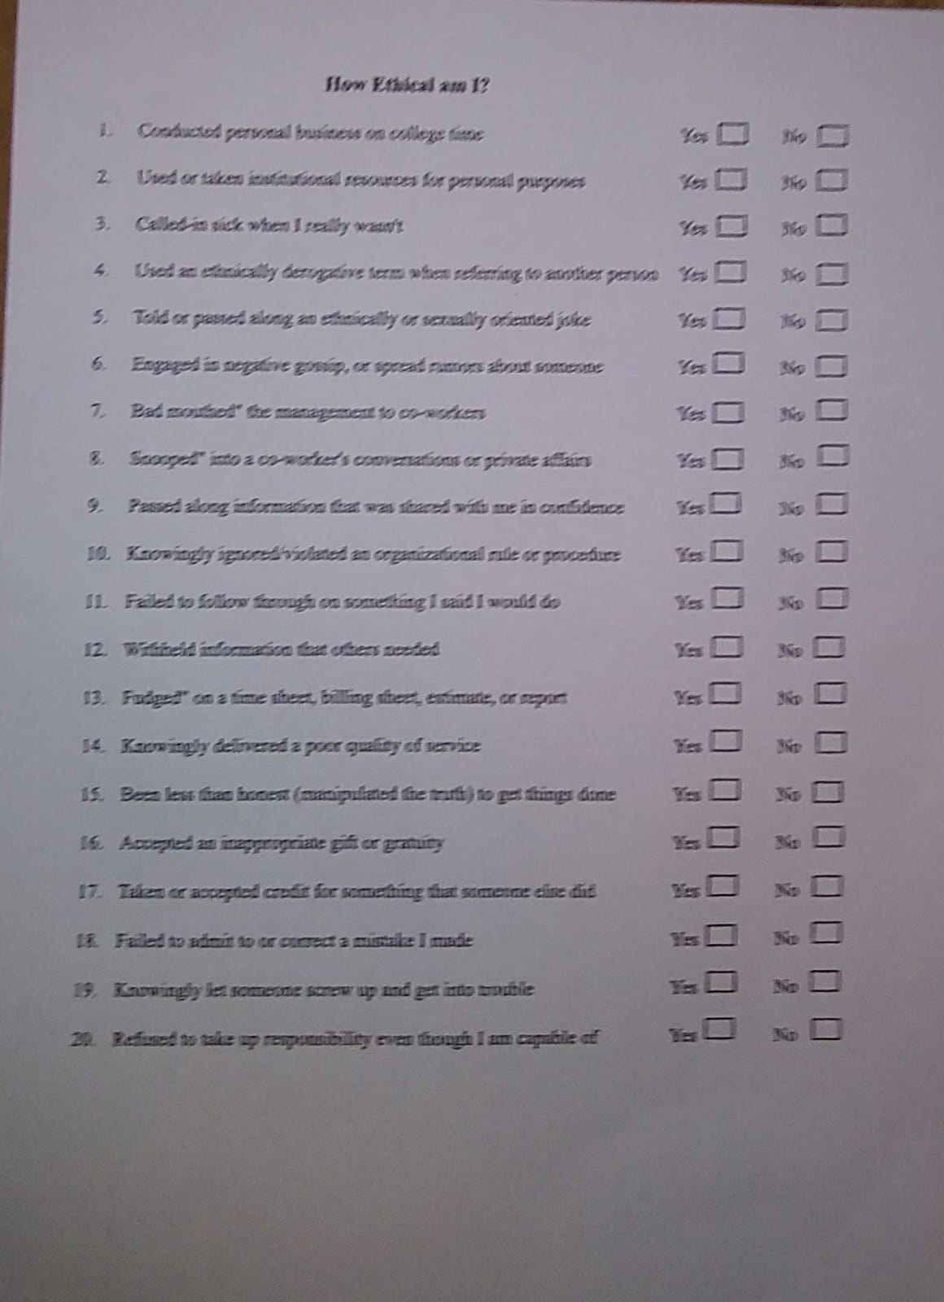
Gallery

Photos
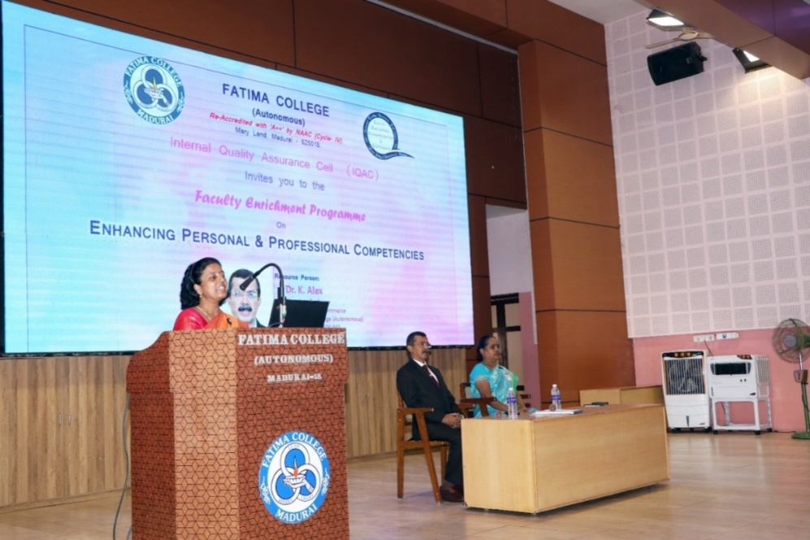

Dr. L. Meena, Assistant Professor, MBA welcomed the audience
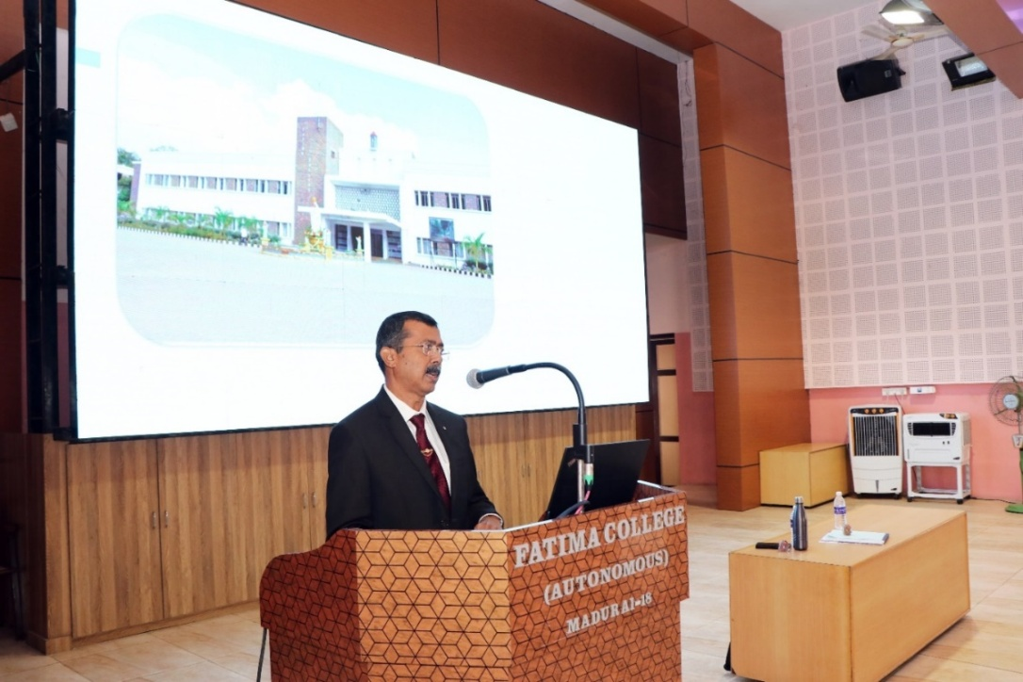

Dr. Alex, Associate Professor, Department of Commerce, St. Joseph’s College (Autonomous) Resource person of the programme addressing the gathering

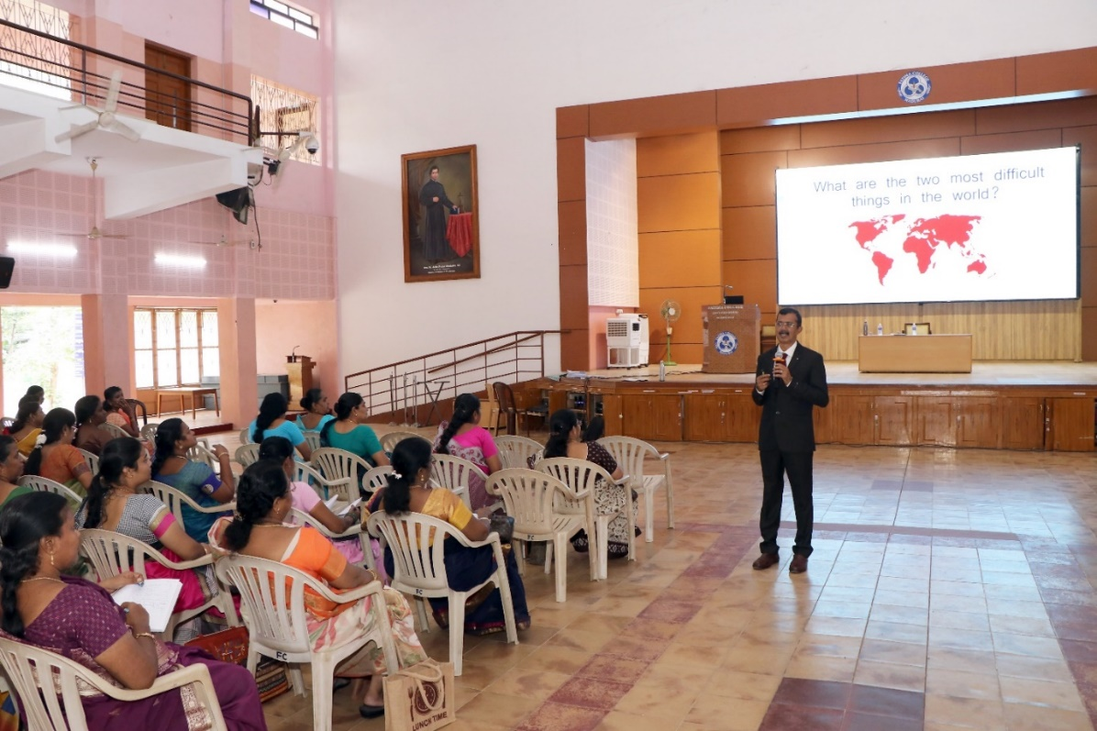

Dr. Alex, Associate Professor, Department of Commerce, St. Joseph’s College (Autonomous) Resource person of the programme addressing the gathering

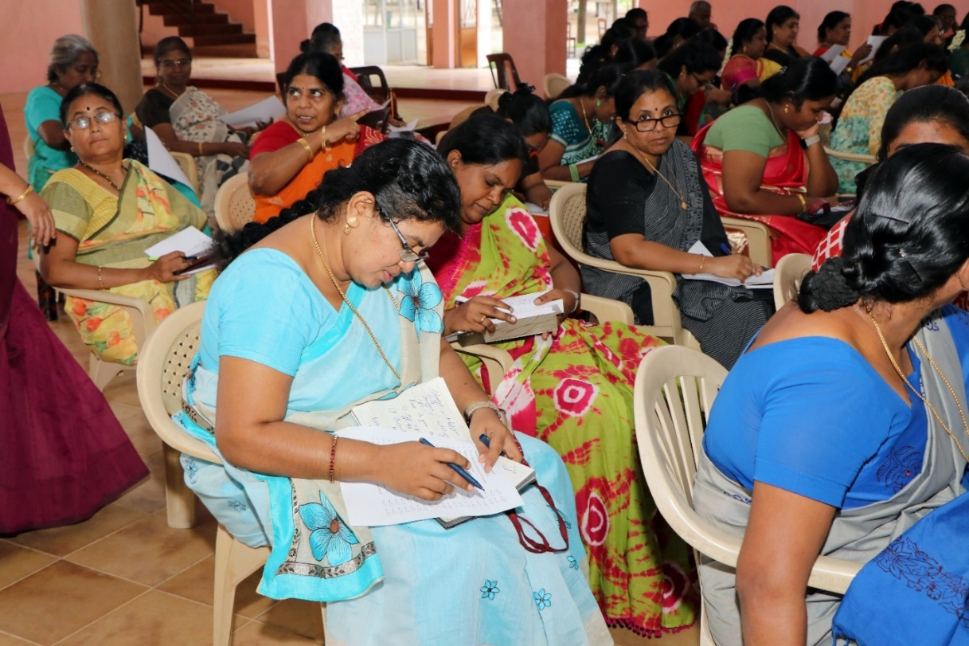

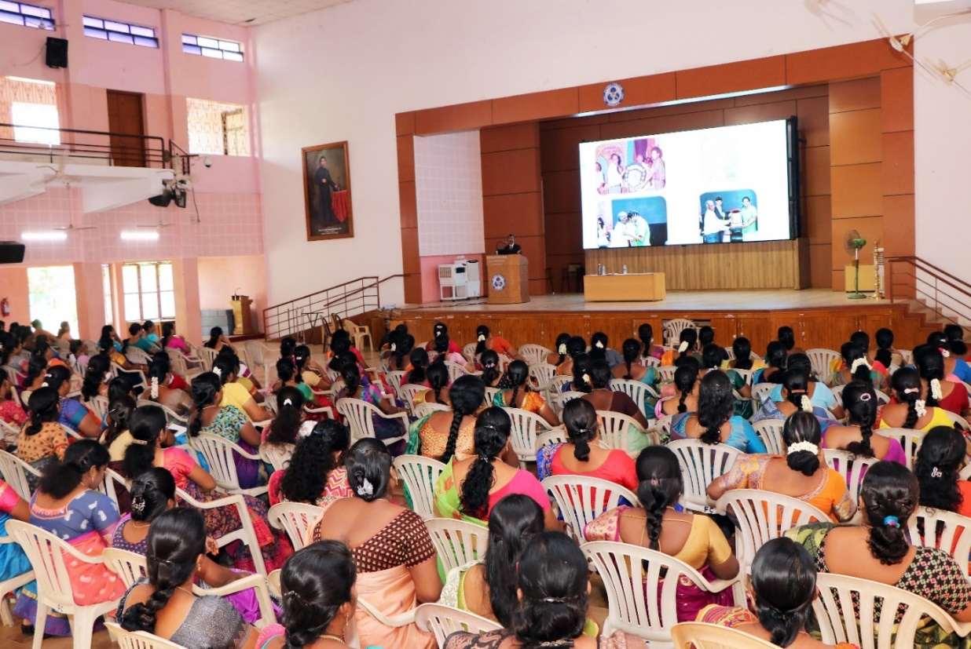

Staff members enthusiastically participated and filled few forms as an activity

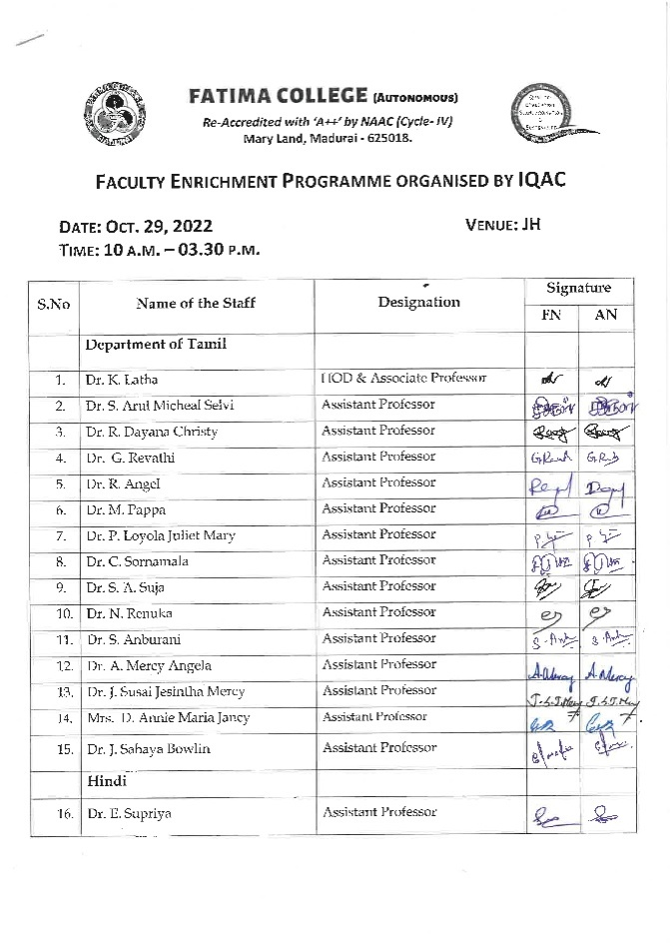
ATTENDANCE
 | 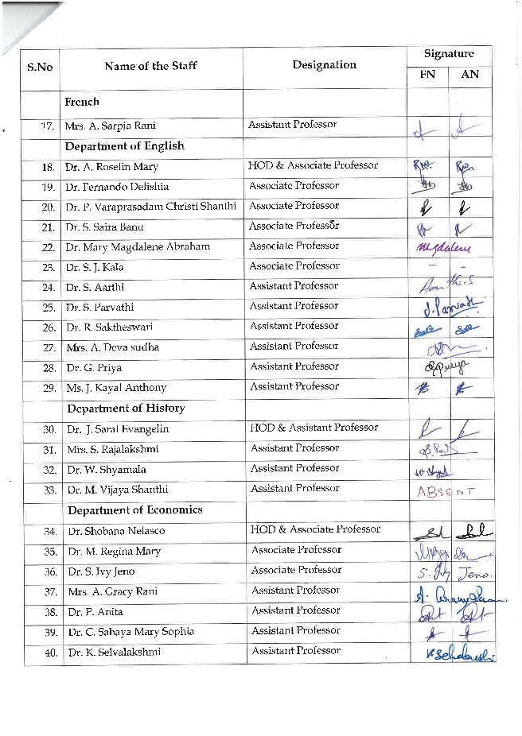
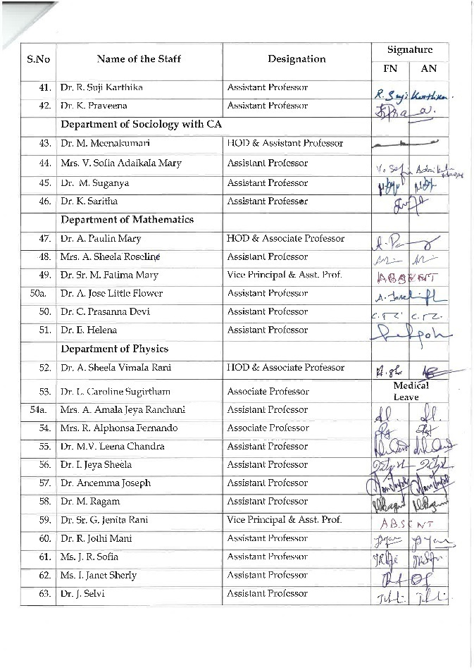 | 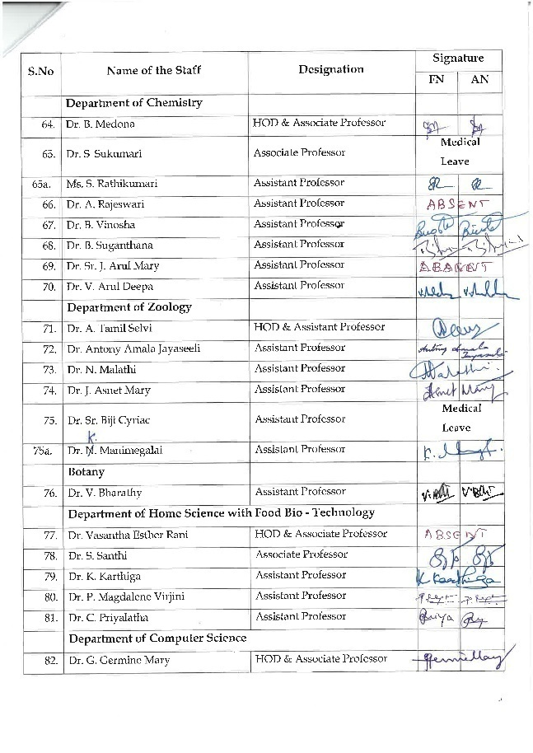
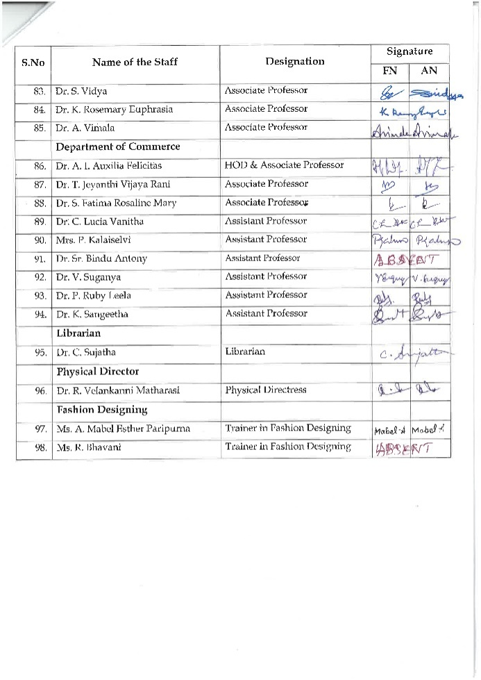 | 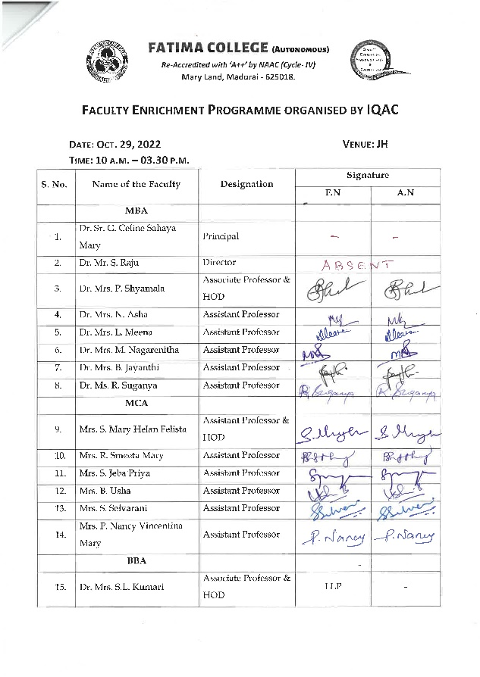
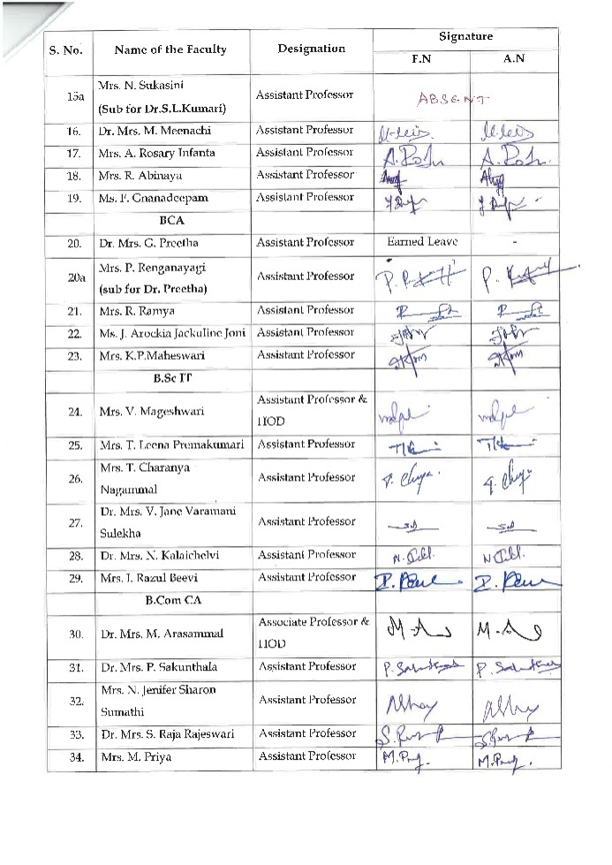 | 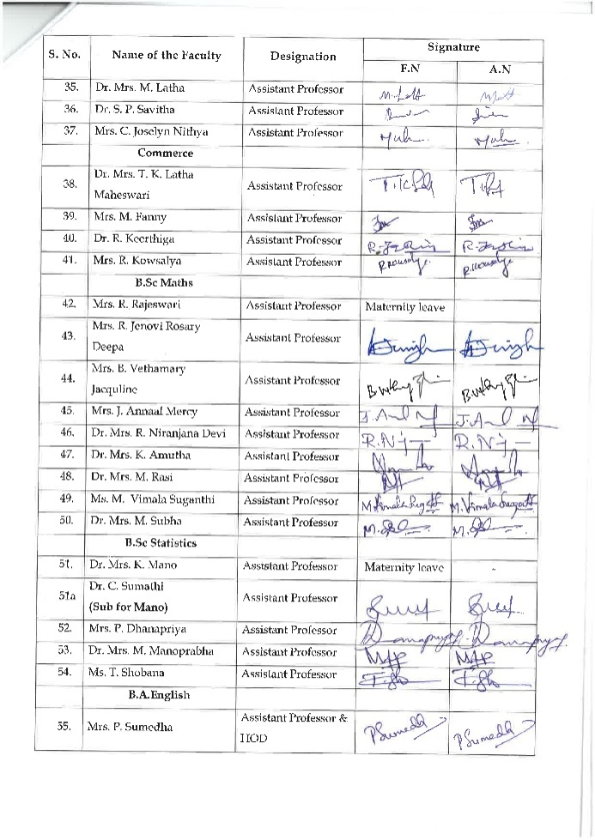
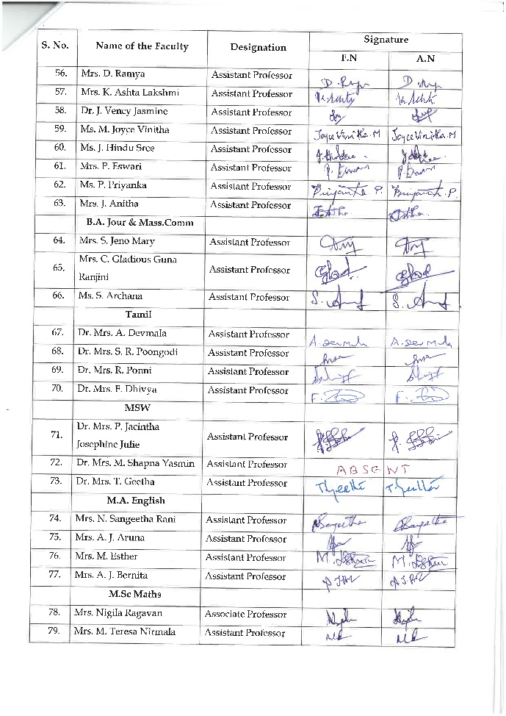 | 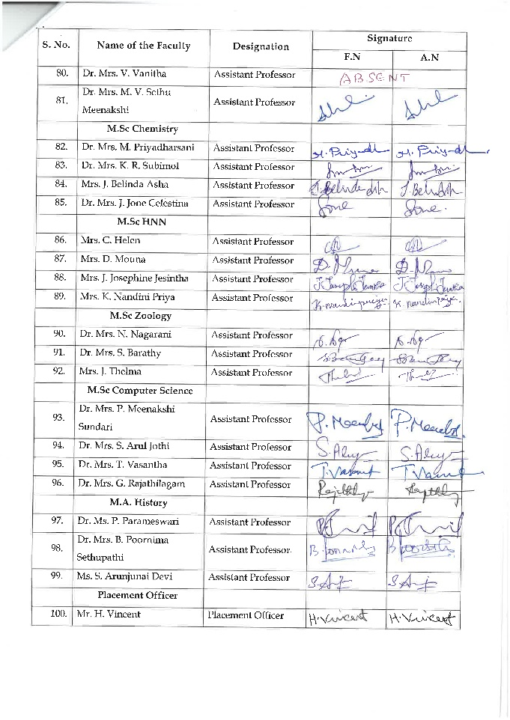

FEEDBACK FORMS

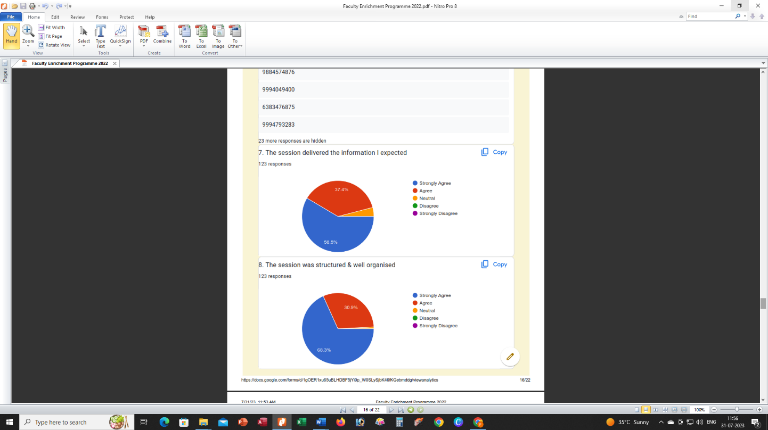
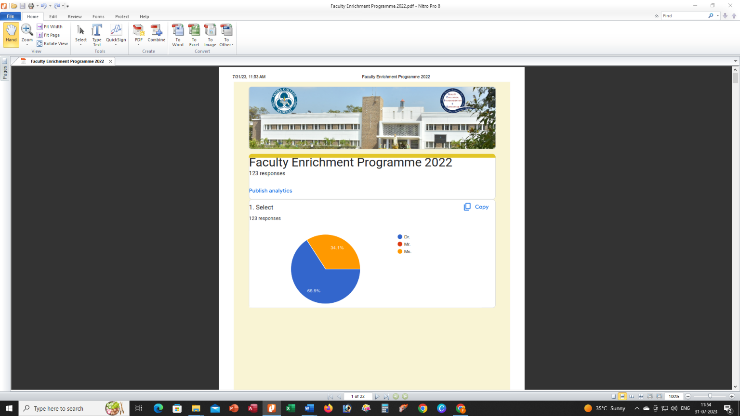

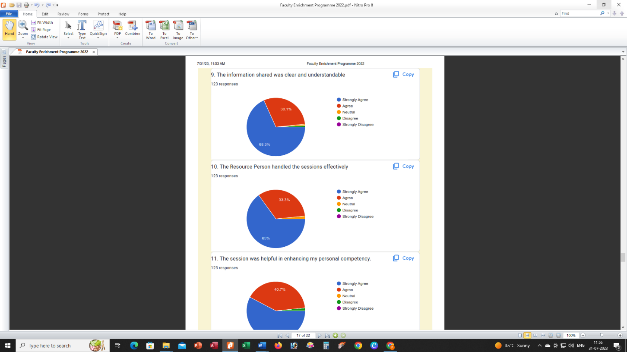
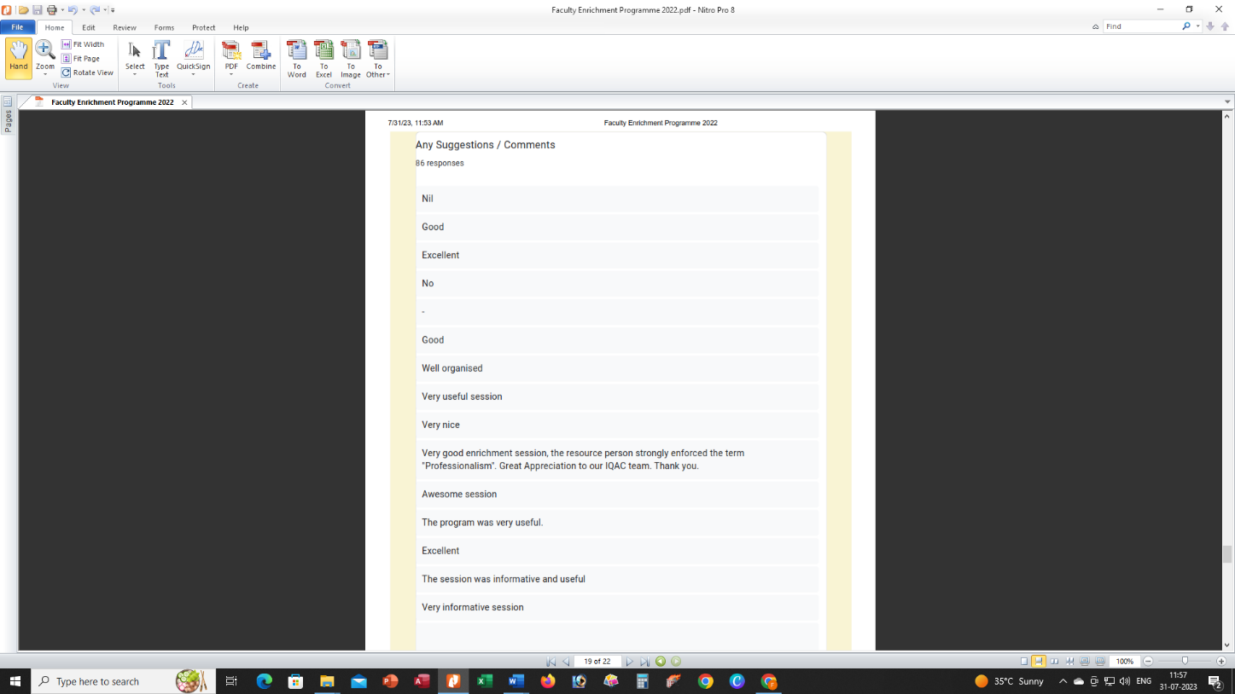

National Level One-Week Faculty Development Programmeon
Proactive Intelligence for Professional Excellence
Date: April 10 - 15, 2023 Time: 03.00 – 4.30 p.m.
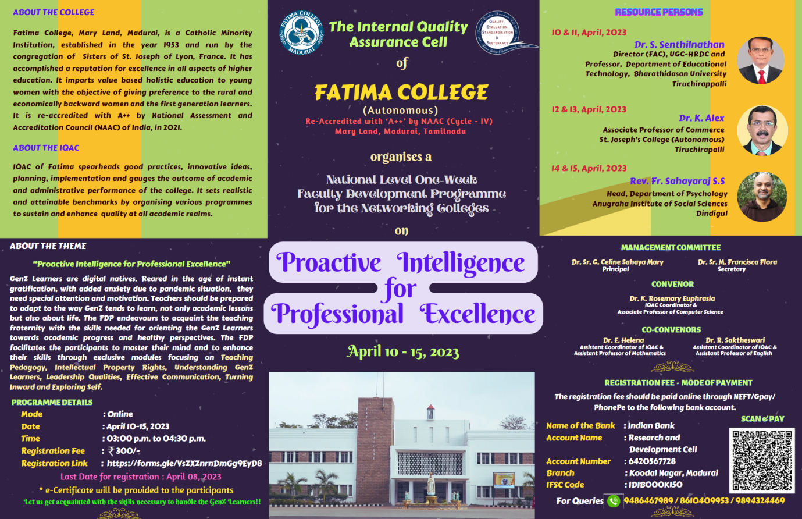
Organized By IQAC

AGENDA
DATE | PROGRAMME | NAME | MODERATOR
April 10, 2023 | Prayer song |  | Dr. L. Meena  Assistant Professor of Management Studies
 | Welcome Address | Dr. K. Rosemary Euphrasia  IQAC Coordinator  Associate Professor of Computer Science
 | Keynote Address | Dr. Sr. G. Celine Sahaya Mary  Principal, Fatima College, Madurai
 | Session | Dr. S. Senthilnathan  Director (FAC), UGC-HRDC and Professor, Department of Educational Technology, Bharathidasan University Tiruchirappalli
April 11, 2023 | Session | Dr. S. Senthilnathan | Dr. S. A. Suja  Assistant Professor of Tamil
 | Vote of Thanks | Dr. R. Saktheswari  IQAC Asst. Coordinator  Assistant Professor of English
April 12, 2023 | Welcome Address | Dr. R. Saktheswari  IQAC Asst. Coordinator  Assistant Professor of English | Dr. E. Helena  IQAC Asst. Coordinator  Assistant Professor of Mathematics
 | Session | Dr. K. Alex, Associate Professor of Commerce  St. Joseph’s College (Autonomous)  Tiruchirapalli
April 13, 2023 | Session | Dr. K. Alex | Dr. C. Sujatha  Librarian
 | Vote of Thanks | Ms. B. Usha  Assistant Professor of Computer Applications (MCA)
April 14, 2023 | Welcome Address | Dr. L. Meena  Assistant Professor of Management Studies | Dr. R. Saktheswari  IQAC Asst. Coordinator  Assistant Professor of English
 | Session | Rev. Fr. Sahayaraj S. S  Head, Department of Psychology Anugraha Institute of Social Sciences, Dindigul
April 15, 2023 | Session | Rev. Fr. Sahayaraj S.S. | Ms. B. Usha  Assistant Professor of Computer Applications (MCA)
 | Vote of Thanks | Dr. E. Helena  IQAC Asst. Coordinator  Assistant Professor of Mathematics

DAY 1 – April 10, 2023
The session was initiated by Dr. Rosemary Euphrasia, IQAC Coorndinator with a welcome note. Then, Keynote address was delivered by Dr. Sr. G. Celine Sahaya Mary , Principal . In her key note address, principal highlighted the importance of professional excellence for faculties in a higher educational institution.
Resource Person
Dr. S. Senthilnathan
Director (FAC), UGC-HRDC and Professor, Department of Educational Technology, Bharathidasan University Tiruchirappalli
Title:
TEACHING PEDAGOGY
Key points Highlighted
- Pedagogy Overview
- Learning Theories and Models
- Learner-Centred Approach
- Technology Integration
- Inclusive Environments

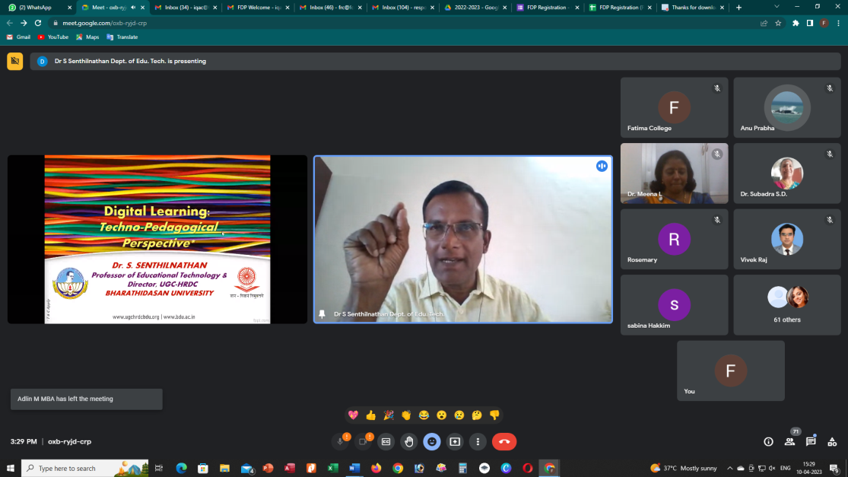
Dr. S. Senthilnathan, Director (FAC), UGC-HRDC and Professor, Department of Educational Technology, Bharathidasan University Tiruchirappalli addressing the gathering on the topic “TEACHING PEDAGOGY”

DAY 2 – April 11, 2023
Resource Person
Dr. S. Senthilnathan
Director (FAC), UGC-HRDC and Professor, Department of Educational Technology, Bharathidasan University Tiruchirappalli
Title :
RESEARCH PUBLICATIONS & IPR
Key points Highlighted
- Professional Visibility
- Career Advancement
- Knowledge Dissemination
- Funding Opportunities
- IPR Protection

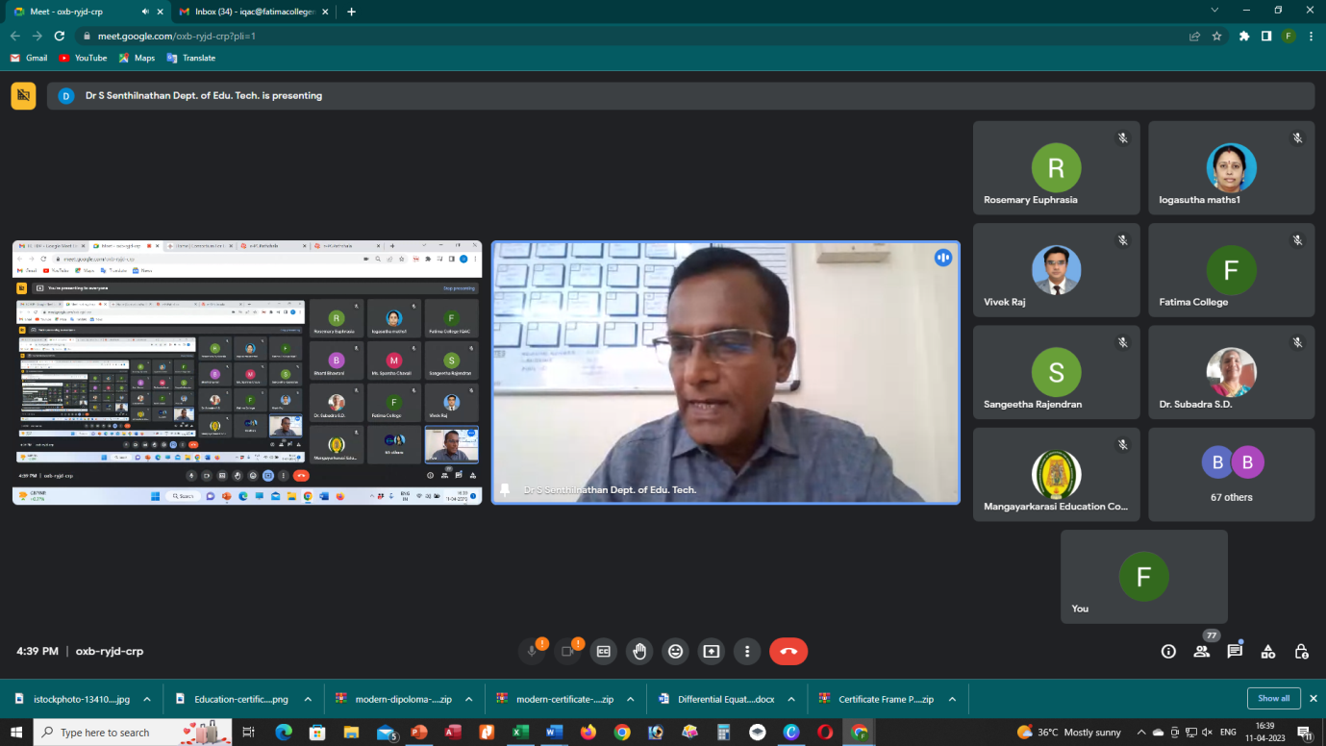
Dr. S. Senthilnathan, Director (FAC), UGC-HRDC and Professor, Department of Educational Technology, Bharathidasan University Tiruchirappalli addressing the gathering on the topic “RESEARCH PUBLICATIONS & IPR”.

DAY 3 – April 12, 2023

Resource Person
Dr. K. Alex, Associate Professor of Commerce
St. Joseph’s College (Autonomous)
Tiruchirapalli
Title :
HANDLING GEN 2 LEARNERS
Key points Highlighted
- Tech Integration
- Shorter, Visual Content:
- Collaborative Learning
- Personalization.
- Feedback and Interaction
- Embrace Diversity

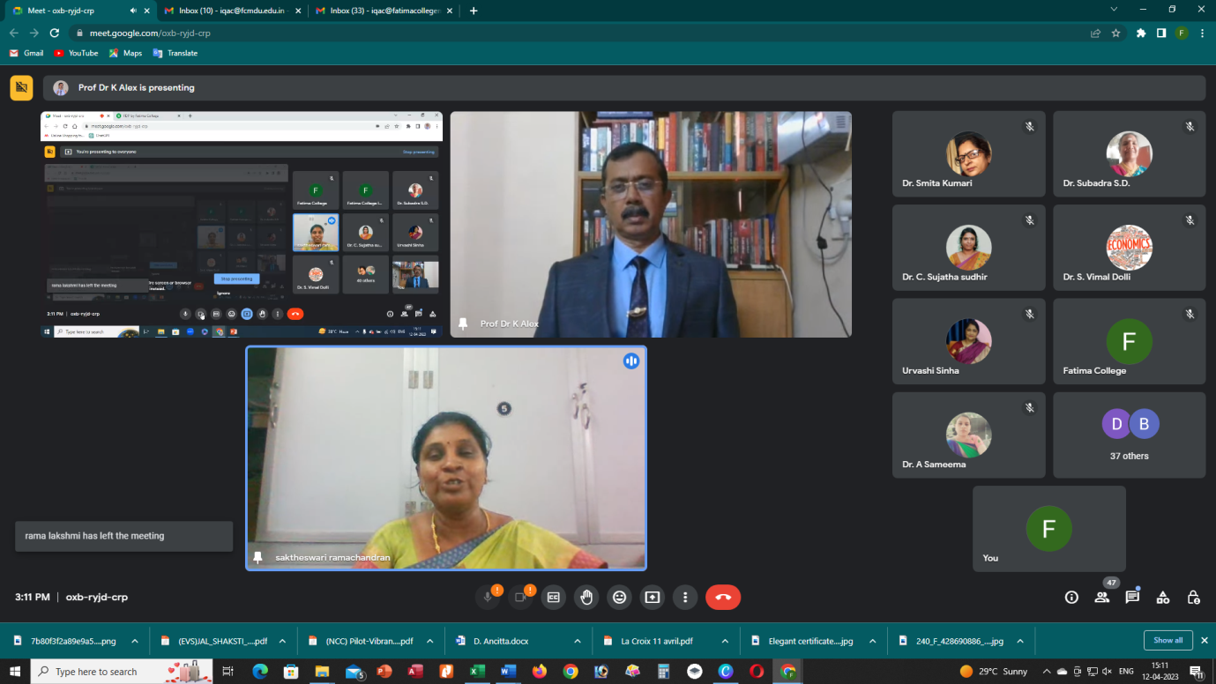
Dr. K. Alex, Associate Professor of Commerce, St. Joseph’s College (Autonomous) addressing the gathering on the topic “HANDLING GEN 2 LEARNERS”
DAY 4 – April 13, 2023
Resource Person
Dr. K. Alex, Associate Professor of Commerce
St. Joseph’s College (Autonomous)
Tiruchirapalli
Title :
TEAM WORKS & COLLOBORATION LEADERSHIP
Key points Highlighted
- Interdisciplinary Projects
- Shared Learning Objectives
- Research Collaborations.
- Team-Based Teaching
- Mentorship and Support
- Professional Development
- Institutional Innovation
- Student-Centric Approach
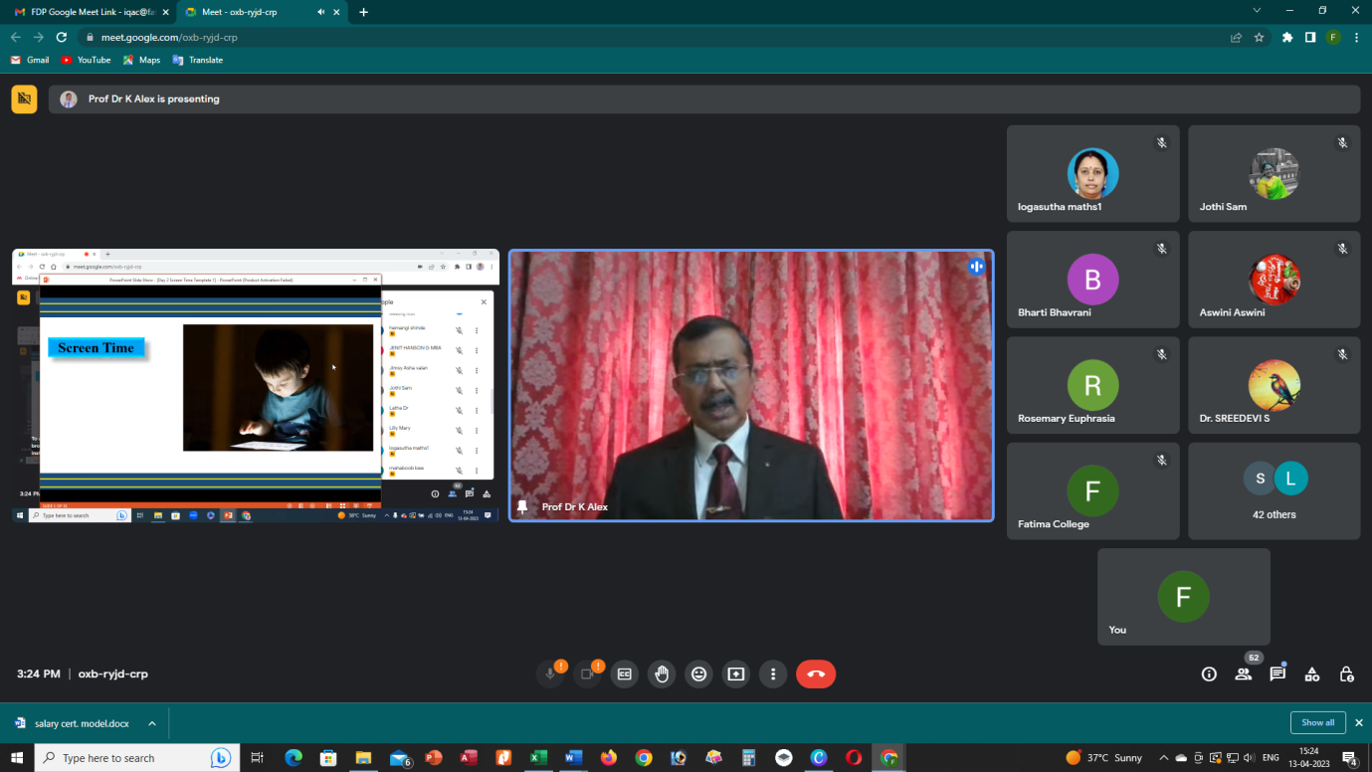
Dr. K. Alex, Associate Professor of Commerce,St. Joseph’s College (Autonomous) addressing the gathering on the topic “TEAM WORKS & COLLOBORATION LEADERSHIP”

DAY 5 – April 14, 2023

Resource Person
Rev. Fr. Sahayaraj S. S
Head, Department of Psychology Anugraha Institute of Social Sciences, Dindigul
Title :
HEALING THE INNER CHILD
Key points Highlighted
- Self-Awareness
- Emotional Healing
- Re-parenting Yourself
- Inner Dialogue
- Therapeutic Techniques
- Boundaries and Self-Car
- Integration and Growth
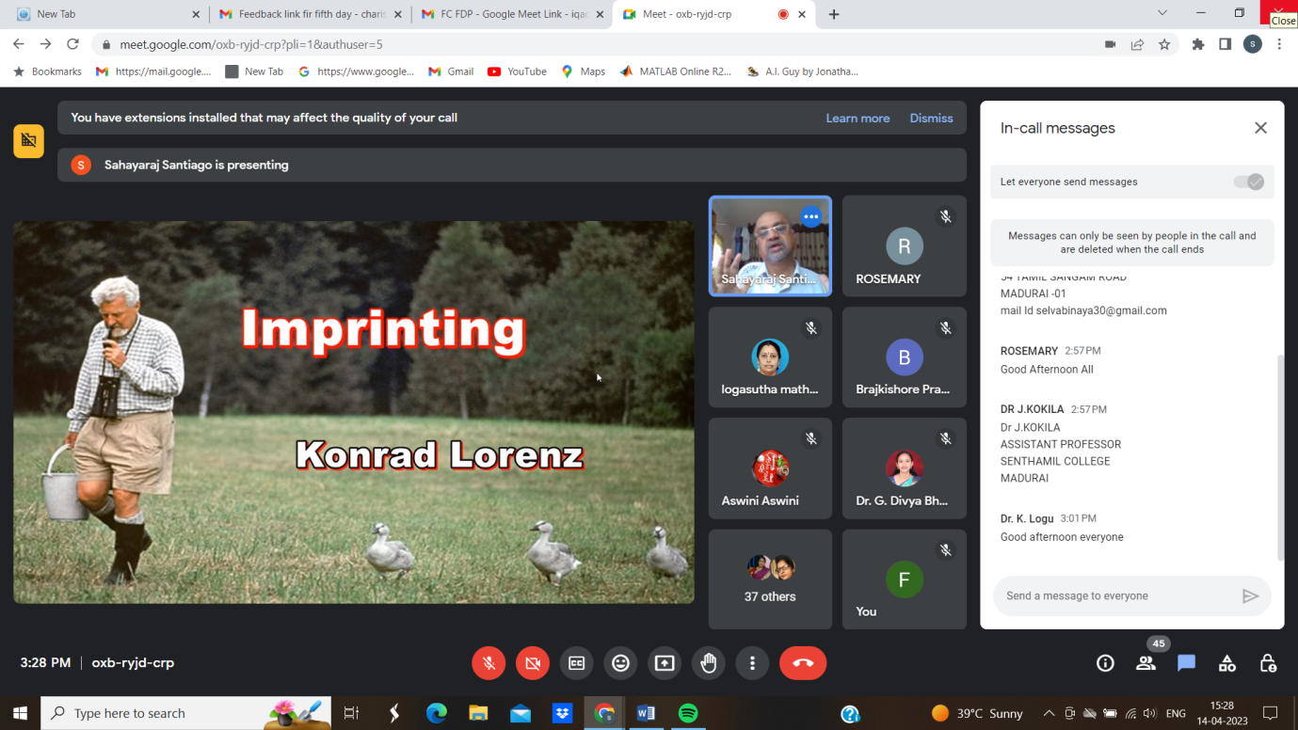
Rev. Fr. Sahayaraj S. S, Head, Department of Psychology Anugraha Institute of Social Sciences, Dindigul, addressing the gathering on the topic “HEALING THE INNER CHILD”

DAY 6 – April 15, 2023

Resource Person
Rev. Fr. Sahayaraj S. S
Head, Department of Psychology Anugraha Institute of Social Sciences, Dindigul
Title :
TOWARDS BETTER SELF
Key points Highlighted
- Goal Setting
- Continuous Learning
- Resilience
- Self-Care
- Mindfulness and Reflection
- Seeking Support

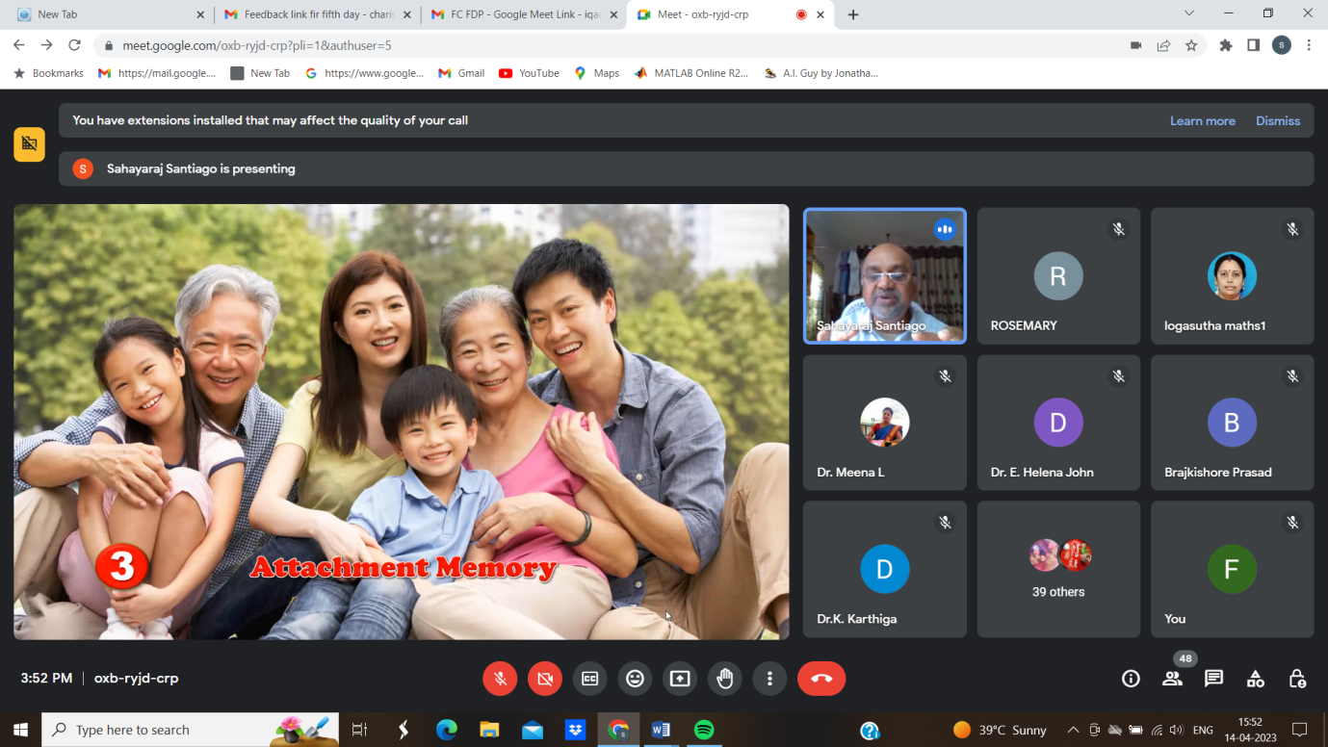

Rev. Fr. Sahayaraj S. S, Head, Department of Psychology Anugraha Institute of Social Sciences, Dindigul addressing the gathering on the topic “TOWARDS BETTER SELF”

Feedback Form:
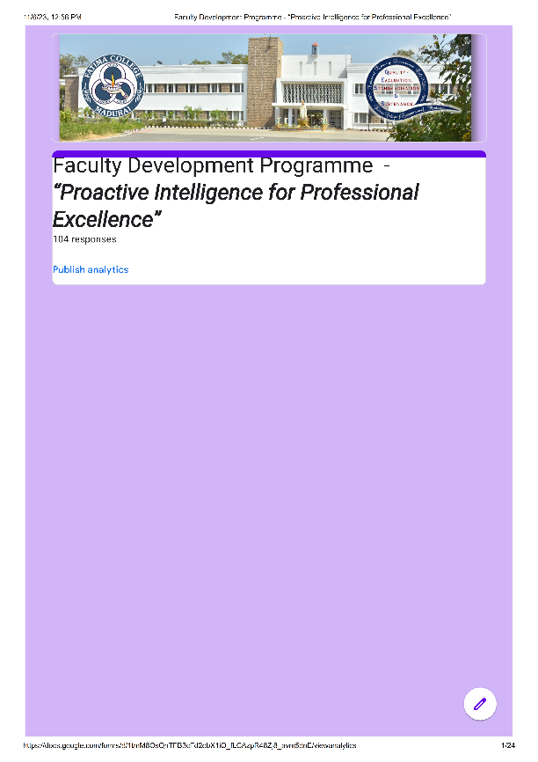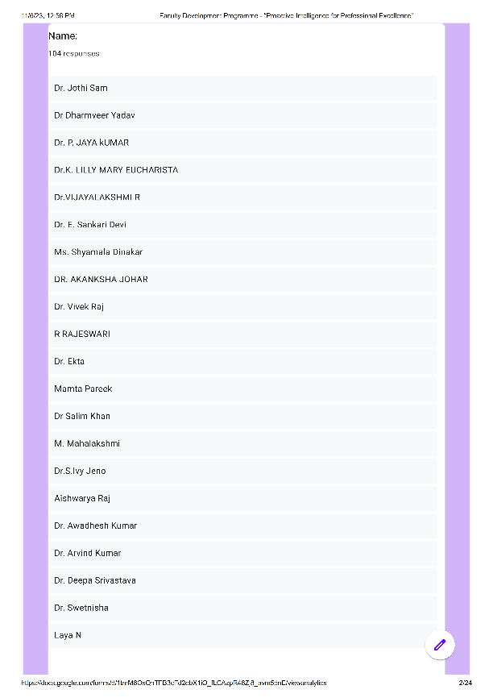
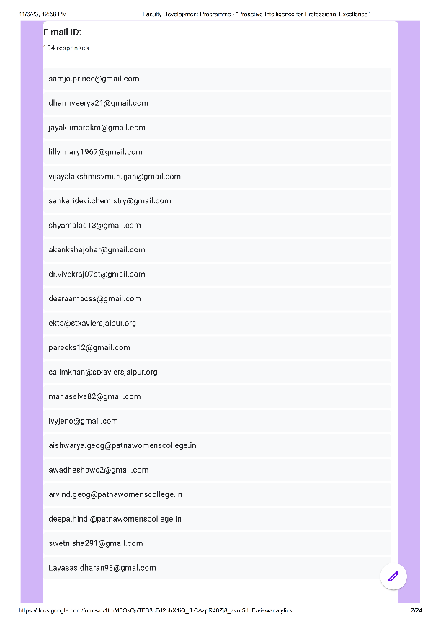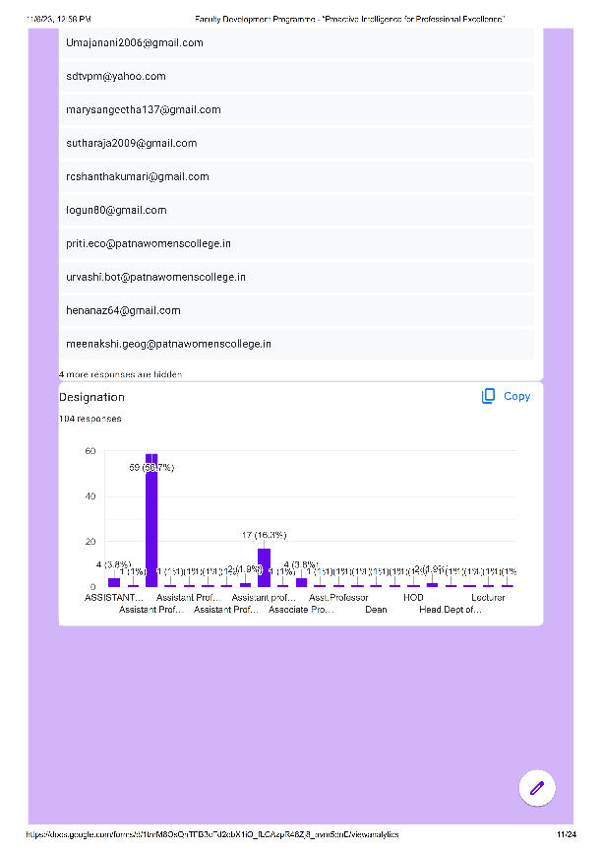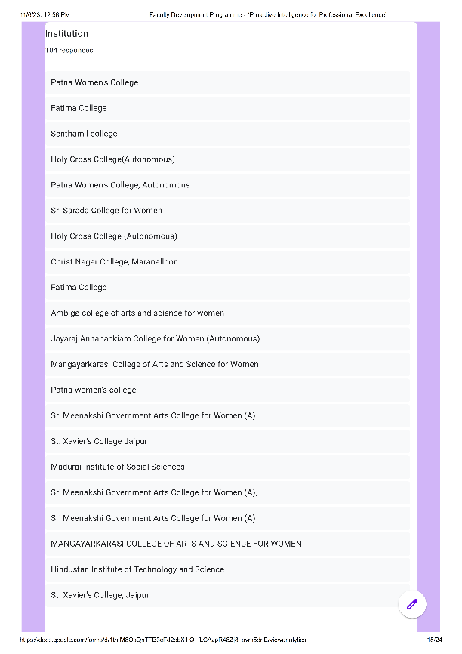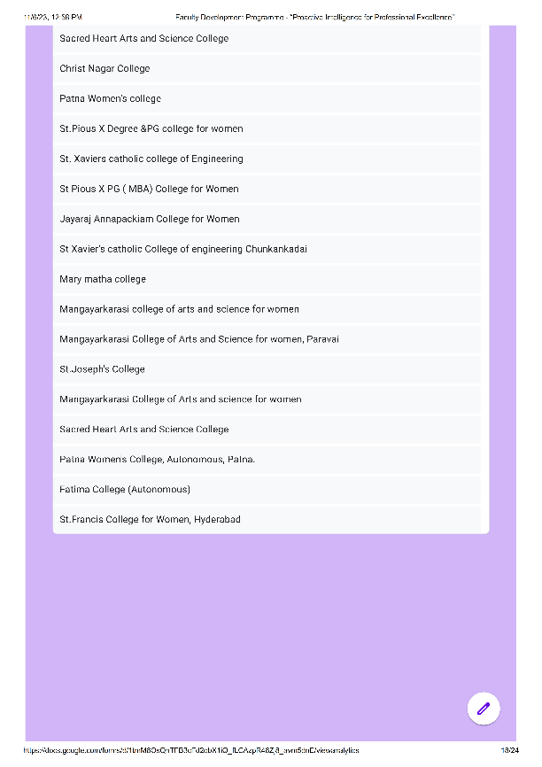
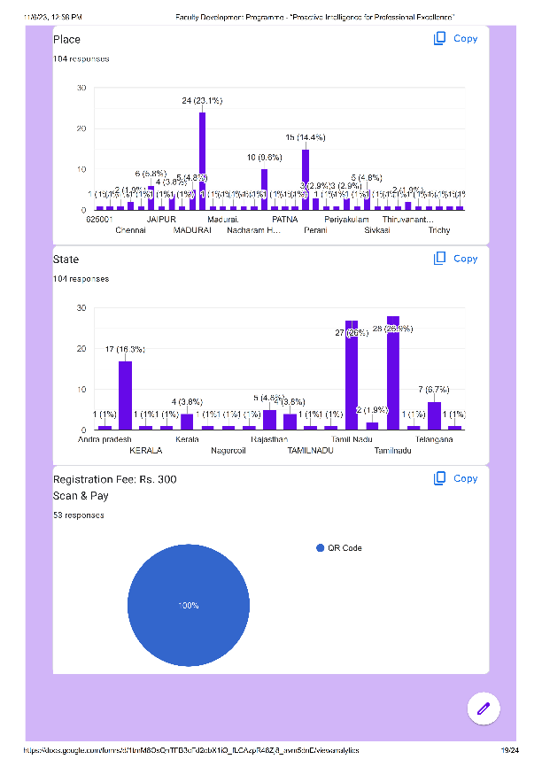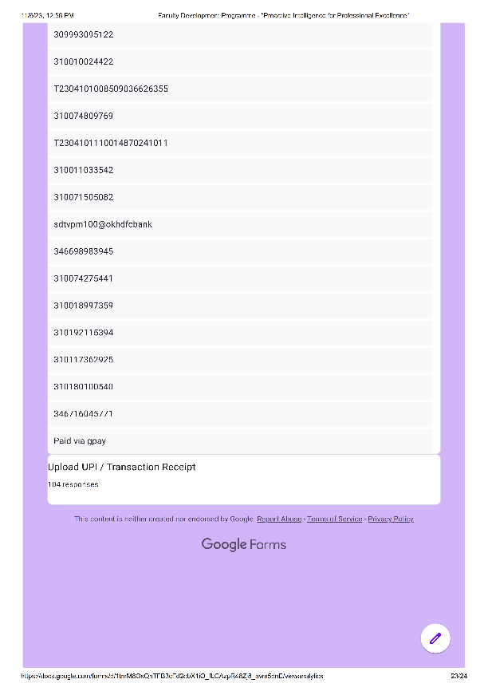

Attendance:
S. No. | Name | E-mail ID | Designation | Department | Institution | Any Other Suggestions / Comments
 | Dr. S. Vimal Dolli | vimaldolli@holycrossngl.edu.in | Assistant Professor | Economics | Holy Cross College (Autonomous) | Very Interesting
 | Dr. Vivek Raj | dr.vivekraj07bt@gmail.com | Assistant Professor | Bio-technology | Patna Women's College | NA
 | Dr. A. Sameema | sameema.a@holycrossngl.edu.in | Assistant Professor | Economics | Holy Cross College(Autonomous) | Interesting
 | Mrs.J.JosephineJesintha | josephinejesintha.hsc@fcmdu.edu.in | Assistant Professor | Home Science | Fatima College | Nil
 | Ms.Meenakshi Mishra | meenakshi.geog@patnawomenscollege.in | Assistant Professor | Department Of Geography | Patna Women’s College, Autonomous | NA
 | Dr.C.Priyalatha | Priya.vision2011@gmail.com | Assistant Professor | The Research Center Of Homescience | Fatima College | Congrats To Organisers
 | Mamta Pareek | pareeks12@gmail.com | Assistant Professor | Political Science | St. Xavier’s College | All Sessions Were Nice And Fruitful
 | Dr.K.Lilly Mary Eucharista | lilly.mary1967@gmail.com | Assistant Professor | Physics | Sri Meenakshi Government Arts College For (A) | Very Useful Fdp
 | B.Vaishnavi | vaishnaviche@annejac.ac.in | Assistant Professor In Chemistry | Chemistry | JayarajAnnapackiam College For Women | Nice Presentation
 | Dr M.Selvatharasi | selvabinaya30@gmail.com | Assistant Professor | Tamil Department | Senthamil College | No .
 | Bharti Ahuja Bhavrani | bhavrani.b@gmail.com | Assistant Professor | Chemistry | St Pious X Degree And PG College For Women | Congratulations To Organizers
 | Mrs.D.Sudha | sudharajan30@gmail.com | Assistant Professor | Physics | Mangayarkarasi College Of Arts And Science For Women, Paravai | Today's Topic Was Excellent
 | Dr. Urvashi Sinha | urvashi.bot@patnawomenscollege.in | Assistant Professor | Botany | Patna Women's Clllege, Autonomous, Patna | Well Organized Sessions.
 | Mary Mettilda Rose V | mety_rose@yahoo.co.in | Hod | Mathematics | Christ Nagar College, Maranalloor | Nil
 | Dr.S.Ganesan | vkc.ganesan@gmail.com | Assistant Professor | Tamil | Senthamil College | Good
 | Dr. E. Sankari Devi | sankaridevi.chemistry@gmail.com | Assistant Professor | Chemistry | Mangayarkarasi College Of Arts And Science For Women | Informative FDP
 | H. Jimsy Asha | jimsyasha@holycrossngl.edu.in | Assistant Professor | English | Holy Cross College | -
 | Dr. C. Sujatha | sujathacsudhir@gmail.com | Librarian | Library | Fatima College (Autonomous) | NO
 | Dr.S.IvyJeno | ivyjeno@gmail.com | Associate Professor | Economics | Fatima College | Very Useful
 | Dr. Sushma Choubey | imsushmachoubey@gmail.com | Assistant Professor | Hindi | Patna Women's College (Autonomous), P. U. | Remembered And Fruitful Session
 | Dr.S.Sujitha | sujitha.s@holycrossngl.edu.in | Assistant Professor | Mathematics | Holy Cross College (Autonomous), Nagercoil | -
 | Dr. Jothi Sam | samjo.prince@gmail.com | Assistant Professor | Zoology | Sri Meenakshi Government Arts College For Women (A) | Thank You And Congratulations
 | Dr. Akanksha Johar | akankshajohar@gmail.com | Assistant Professor | English | St. Xavier’s College, Jaipur | None
 | Dr. K. Selvalakshmi | selvalakshmifc@gmail.com | Assistant Professor | Economics | Fatima College | Was A Wonderful Session
 | K.Logasutha | sutharaja2009@gmail.com | Head OfThe Department | Mathematics | MangayarkarasiCollege Of Arts And Science For Women | Good Organisation
 | Dr.S. Malarvizhi | tamilmalarvizhi@gmail.com | Assistant Professor | Tamil | Senthamil College | Thank You
 | Dr. A. Tamil Selvi | tamilselvi_chem@tcarts.in | Assistant Professor Of Chemistry | Chemistry | Thiagarajar College, Madurai | Nil
 | Dr Kumkum Rani | Kumkum.phi@patnawomenscollege.in | Assistant Professor | Philosophy | Patna Women’s College | Thanks For Such A Wonderful FDP
 | Dr Vijayalakshmi R | vijayalakshmisvmurugan@gmail.com | Assistant Professor | Physics | Sri Meenakshi Government Arts College For Women (A) | Very Effective
 | Braj Kishor Prasad | brajkishore.mca@patnawomenscollege.in | Assistant Professor | Department Of MCA | Patna Women's College | No
 | Dr.G.Selvarani | selvarani.ganesan@gmail.com | Assistant Professor | Physics | Sri Meenakshi Government Arts College For Women (A) | Everything Is Fine.
 | Dr.R.Veeramani | rveeramani281@gmail.com | Head Dept Of Commerce With CA | Commerce With C A | Mangayarkarasi College Of Arts And Science For Women | Nice Session
 | Ms. X. Stella Martina | stellamartina715@gmail.com | Asst Professor, Hod | Dept Of English | St.Francis College For Women, Hyderabad | Very Useful Session
 | Dr.K.Karthiga | karthila@rediffmail.com | Assistant Professor | Research Centre Of Home Science | Fatima College Autonomous | Very Good
 | Dr Manjula Sushila | manjula.hindi@patnawomenscollege.in | Assistant Professor | Hindi | Patna Women's College, Autonomous, PU | Very Well Organised And Very Informative Fdp.
 | Dr HenaNaz | henanaz64@gmail.com | Assistant Professor | Botany | Patna Women's College | Very Informative
 | Aswini.T | aswiniaswini245@gmail.com | Assistant Professor | English | Sacred Heart Arts And Science College ,Perani | ThanksAlot For This Wonderful FDP Congratulation For Fathima College And I Thank You For Giving Such Wonderful Opportunity To Participate.
 | Dr. A. AnamiAugustus Arul | anamiaugustus@gmail.com | Assistant Professor | Botany | Holy Cross College (Autonomous) | Nil
 | Jagadheesh Chandran J. | jagansruthy@gmail.con | Assistant Professor | English | Christ Nagar College | Excellent Session
 | Ms.D.Mouna | mounabala2000@gmail.com | Assistant Professor, | The Research Centre Of Home Science, | Fatima College, | Excellent
 | Dr. Awadhesh Kumar | awadheshpwc2@gmail.com | Assistant Professor | Geography | Patna Women's College, Patna | All Session Was Fruitful And Full Of Knowledge
 | Riju B. Sarajan | rijub300587@gmail.com | Assistant Professor | English | Christ Nagar College | Apart From Certain General Talks, The Session Was Able To Satisfy Me.
 | Dr. Arvind Kumar | arvind.geog@patnawomenscollege.in | Assistant Professor | Department Of Geography | Patna Women's College, Autonomous | Overall It Was Fruitful.
 | Dr.Deepa Srivastava | deepa.hindi@patnawomenscollege.in | Assistant Professor | Hindi | Patna Women's College, Patna | Very Useful ,Informative And Fruitful
 | Dr.Latha E | latha@auxiliumcollege.edu.in | Assistant Professor Of English | English | Auxilium College | Sincerely Thank You For The FDP
 | Dr.M.Arockia Priscilla | priscyangel2010@gmail.com | Principal | Education | Mangayarkarasi College Of Education | Nil
 | N.Jeyabharathi | jeyabharathihari@gmail.com | Asst.Professor | Commerce | Mary Matha College | Informattive Session
 | Dr J.Kokila | senthamil.kokila@gmail.com | Assistant Professor | Tamil | Senthamil College | Very Informative Session
 | Ms. ShyamalaDinakar | shyamalad13@gmail.com | Assistant Professor | Department Of Psychology | Hindustan Institute Of Technology And Science | The Sessions Were Really Helpful And Thought Provoking. It Would Be Much Comfortable To Attend The Future Sessions Also In This Comfortable And Convenient Timing.
 | Sangeetha Rajendran | marysangeetha137@gmail.com | Assistant Professor | Computer Science | Mangayarkarasi College Of Arts And Science For Women | Very Good Session
 | Aishwarya Raj | aishwarya.geog@patnawomenscollege.in | Assistant Professor | Geography | Patna Women's College | Thank You For Your Efforts.
 | M. Mahalakshmi | mahaselva82@gmail.com | Assistant Professor | Physics | Sri Meenakshi Government Arts College For Women | Well And Good
 | A. J. Bernita | bernitasmilin@gmail.com | Assistant Professor | The Research Centre Of English | Fatima College | Nil
 | Dr.A.Sabina | sabihakkim@gmail.com | Assistant Professor | Commerce | Mary Matha College Of Arts And Science Periyakulam | Thank To Institute By Conducting This Usefull FDP
 | SparshaChavali | sparshachavali@gmail.com | Assistant Professor | Mathematics | St.Pious X Degree And PG College For Women | No
 | Dr.S.AjithSinthuja | ajithsinthuja@holycrossngl.edu.in | Assistant Professor | Chemistry | Holy Cross College | Excellent Sessions
 | Drn.Selvalakshmi | vivekan2006@gmail.com | Assistant Professor | Commerce | MannarTirumalai Naicker College(Autonomous) | Excellent
 | C.Vanisree | vanisree3108@gmail.com | Assistant Professor | Biochemistry | St.Pious X Degree &PG College For Women | Thank You
 | Mrs.T.Subha | subhabio86@gmail.com | Assistant Professor | Allied Health Sciences | NoorulIslam Centre For Higher Education, Kumarakoil | No
 | J. Jeevitha Rani | jeevetha3@gmail.com | Assistant Professor | Chemistry | JayarajAnnapackiam College For Women (Autonomous) | Nothing
 | Dr Kumkum Rani | Kumkum.phi@patnawomenscollege.in | Assistant Professor | Philosophy | Patna Women’s College | Wonderful Experience
 | PriyeshRangan | priyeshrangan@gmail.com | Assistant Professor | English | M.V. College, Buxar | Kindly Share The Ppts And Recording Of The Session With The Participants For Future Reference
 | Dr. Ekta | ekta@stxaviersjaipur.org | Assistant Professor | Commerce | St. Xavier's College , Jaipur | No
 | Mrs R Rajeswari | deeraamacss@gmail.com | Assistant Professor | Mathematics | Fatima College | It Was Really A Nice Experience To Be Part Of This FDP Programme. I Have Learned A Lot. Thank You So Much
 | Dr.PreetiSwarupa | preeti.mbio@patnawomenscollege.in | Assistant Professor | Microbiology | Patna Women' College | FDP Was Enlightning And Knowledgeable
 | Dr. M. Subha | subhaamsc@gmail.com | Assistant Professor | Mathematics | Fatima College (Autonomous) | Good
 | K. V. M. Udaya Lakshmi | udayalakshmikvm@stpiouscollege.org | Head Of The Department | Computer Science | St. Pious X Degree And PG College For Women | Nothing
 | Dr Meena Juliet Monteiro | pereirameenaj@gmail.com | Dean | Msw | School Of Social Work, Roshni Nilaya | Network Connectivity Needs To Be Improved
 | Dr Meeta Sharma | meetasharma@stxaviersjaipur.org | Assistant Professor | Department Of Political Science | St Xavier's College | Good
 | Dr T.Ramalakshmi | ramaalibrarian@gmail.com | Asst.Professor | Lis | SVAGRICULTURAL College | Thank You Very Much
 | Dr. K. Loganathan | logun80@gmail.com | Assistant Professor | Zoology | Sacred Heart Arts And Science College | Very Excellent
 | Dr. R. Renuka Devi | rrenukadeviphd@gmail.com | Assistant Professor | English | Sri Sarada College For Women (Autonomous) Salem | Excellent Work, Kudos To The Organisers
 | Dr.R.Rajesh | rajdhivo@gmail.com | Assistant Professor | Zoology | Sacred Heart Arts And College | It's A Package Of Fully Essential Things For Faculty
 | Dr G. Subbulakshmi | reshumi1970@gmail.com | Asst. Proffessor | Tamil | Sentamil College | Good
 | Dr. Swetnisha291@Gmail.Com | swetnisha291@gmail.com | Assistant Professor | Microbiology | Patna Women's College | Such Sessions Should Be Conducted At Regular Intervals
 | Dr. R. Akash | akash@srcas.ac.in | Assistant Professor | Commerce | Sri Ramakrishna College Of Arts & Science | Good
 | Sumeshkumar K P | sumeshputhuppallil@gmail.com | Assistant Professor | Malayalam | Christ Nagar College Maranalloor Trivandrum | Nice
 | Dr. J. Sharmila Devi | sharmiramya92@gmail.com | Assistant Professor | English | Sri Sarada College For Women | Innovative Session
 | Hemangi Shinde | hemangi.shinde@aissmsioit.org | Assistant Professor | Electronics AndTelecommunication Engineering | AISSMS Institute Of Information Technology | Excellent Sessions
 | Dr Salim Khan | salimkhan@stxaviersjaipur.org | Former Head Andcassistant Professor | Business Administration | St Xavier's College | Informatic Session
 | Dr. A. Arulprakash | apzoomicro@gmail.com | Assistant Profeesor | Zoology | St. Joseph's College Of Arts And Science (Autonomous) | Good
 | E. Narmatha | narmathaemmanuel@gmail.com | Assistant Professor | English | Sacred Heart Arts And Science College | Nil
 | G Anuprabha | ganuprabhamdu@gmail.com | Assistant Professor | Physics | Ambiga College Of Arts And Science For Women | It's Very Useful
 | Ms. S. Maria Esther | mestherche@annejac.ac.in | Assistant Professor | Chemistry | JayarajAnnapackiam College For Women (Autonomous) | Good
 | Dr.G.Divya Bharathi | drdivyabharathi.bot@gmail.com | Assistant Professor | Department Of Botany | Sri Sarada College For Women Salem | It Was Great To Be A Part Of This FDP Thank You
 | Ms.R.C.Shantha Kumari | rcshanthakumari@gmail.com | Head & Assistant Professor | Business Administration | Mangayarkarasi College Of Arts And Science For Women | Excellent
 | Dr. A. Revathi | revathiamaresan93@gmail.com | Assistant Professor Of English | Department Of English | Sri Sarada College For Women (Autonomous) | Nothing
 | Dr.R.Saritha | rsaritha12@gmail.com | Assistant Professor | English | Sri Sarada College For Women | No Suggestions
 | Dr.Sreedevi.S | sdtvpm@yahoo.com | Assistant Professor | Hindi | St.Joseph's College | Nice
 | Umamathi S | umajanani2006@gmail.com | Assistant Professor | Bba | Ambiga College For Arts And Science For Women | Good Experience
 | K. Sulochana | ksulochana1426@gmail.com | Assistant Professor | Commerce | Sacred Heart Arts And Science College, Perani. | Overall The Entire Session Was Very Nice And Highly Useful To The Faculty Members Thank You🙏.
 | Dr.Smita Kumari | Ksmitapwc19@gmail.com | Associate Professor | Sanskrit | Patna Women's College, Autonomous, Patna University, Patna. | Very Useful And Motivational FDP.
 | Laya.N | Layasasidharan93@gmail.com | Assistant Professor | Hindi | Ayya Nadar Janaki Ammal College | Thank You Organisers
 | Dr J Mahaboob Bee | mahaboobbee30@gmail.com | Assistant Professor | English | Sri Sarada College For Women | Very Useful
 | Priti Kumari | priti.eco@patnawomenscollege.in | Assistant Professor | Economics | Patna Women's College | NA
 | N.Mathanki | mathankin@ldc.edu.in | Assistant Professor | Costume Designing And Fashion Technology | Ambiga College Of Arts And Science For Women | Looking Forward For Many Such Programs
 | Dr.R.Sushama | sushama@stpiouscollege.org | Associate Professor | Business Management | St.Pious X Mba College For Women | Sessions Were Quite Refreshing

