6.5.3 QUALTY ASSURANCE INITIATIVES OF THE INSTITUTION
IQAC spearheads good practices, innovative ideas, planning & implementation and gauges the outcome of academic and administrative performance of the college. It sets realistic and attainable benchmarks manifested in the following activities organized by IQAC.
Feedback

Annual Feedback from students | 3,035 participants | Jan. 11, 2023
Parents Survey for the academic year 2022 - 2023 | 1155 Responses | Jan 11, 2023
Annual Feedback from Alumnae | 985 Responses | July 12, 2022
Annual Feedback from Employers | 81 Responses | July 12, 2022

Feedback From parents

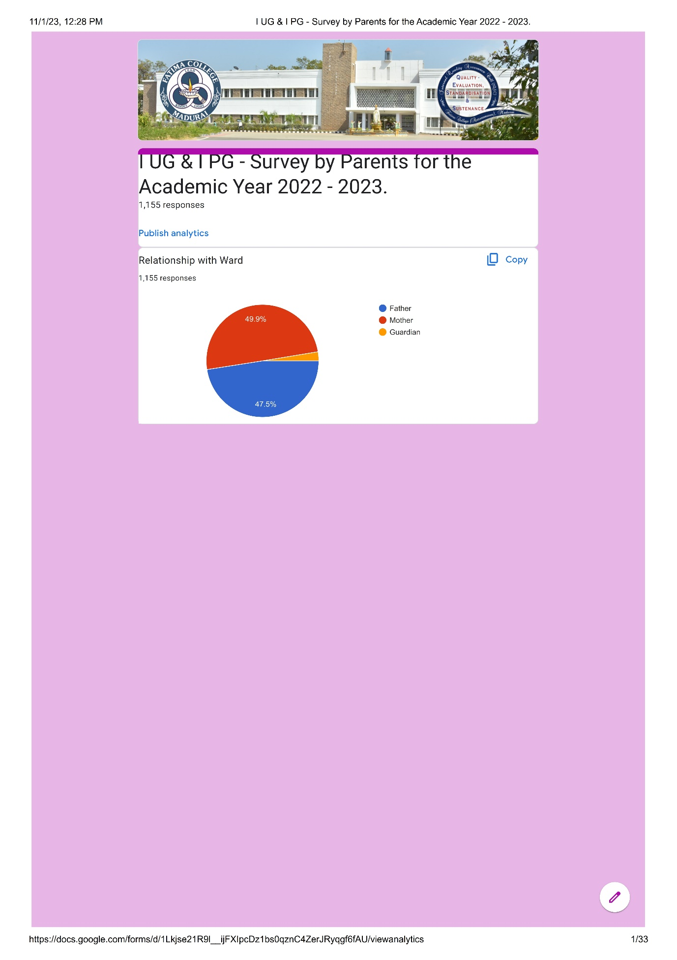
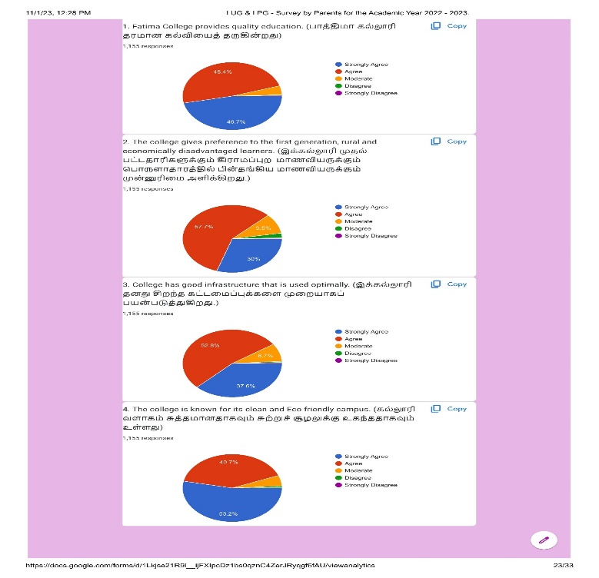
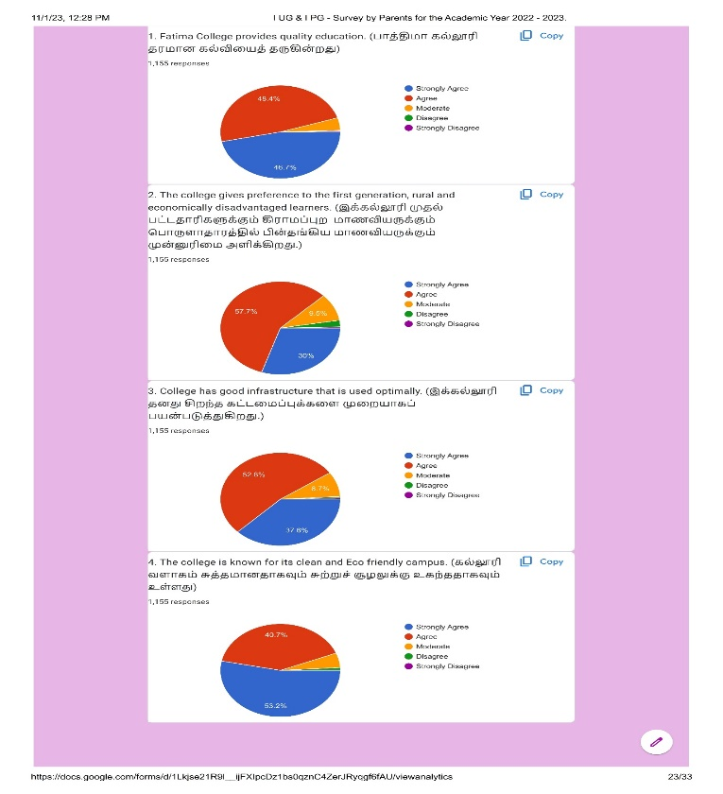

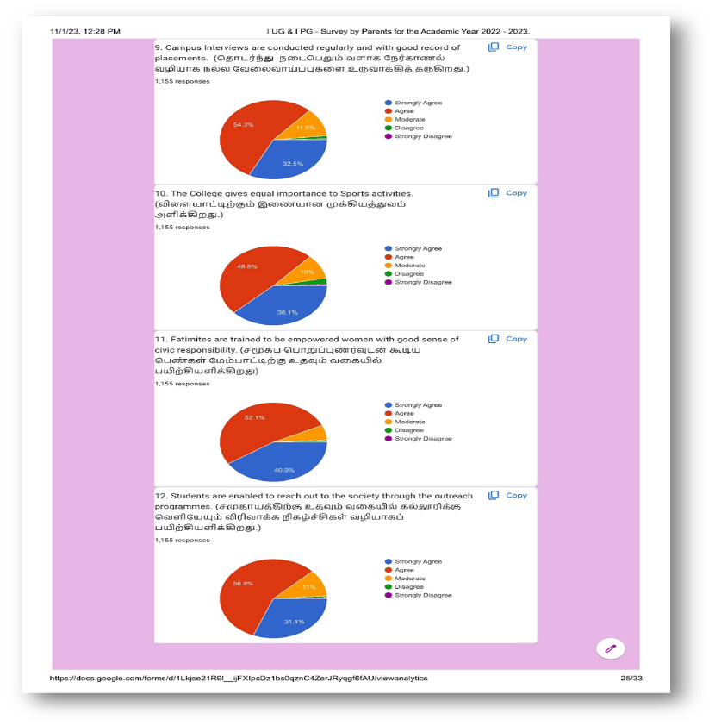
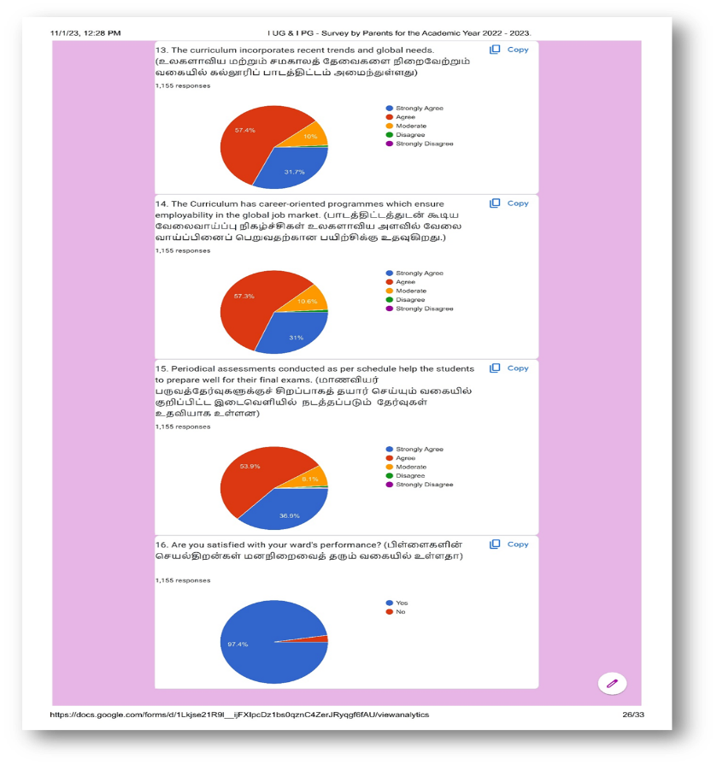

Action Taken On Feedback Collected From Parents

S. No. | Observation / Analysis | Action taken
 | Buses can be arranged for nearby villages | - The college collaborates with Transport Corporation and special buses are arranged only to certain locations
 | Water facility can be improved | - Drinking water tanks and aqua guard water points are established on campus
 | Reading culture can be improved | - Rosa Mystica Library has Reading Corner that has reading materials and newspapers  - Book Fest is conducted  - Competitions are organised to encourage reading habit
 | Cell phones can be allowed | - Students can bring cell phone to college by getting special permission from the Vice-principals

Feedback From Students
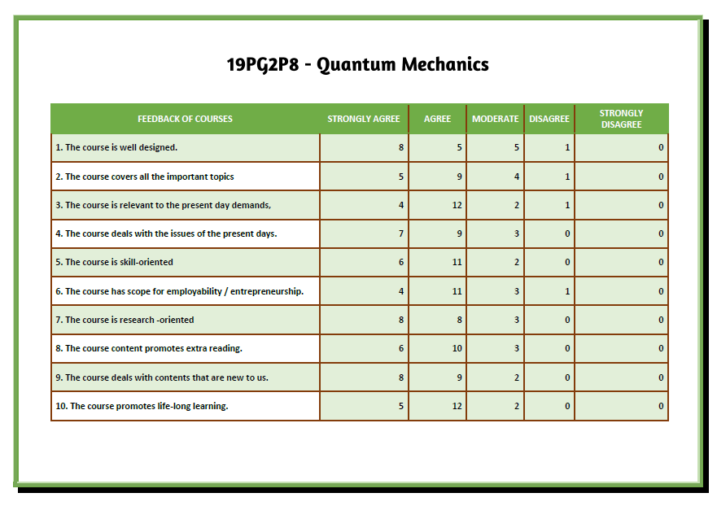
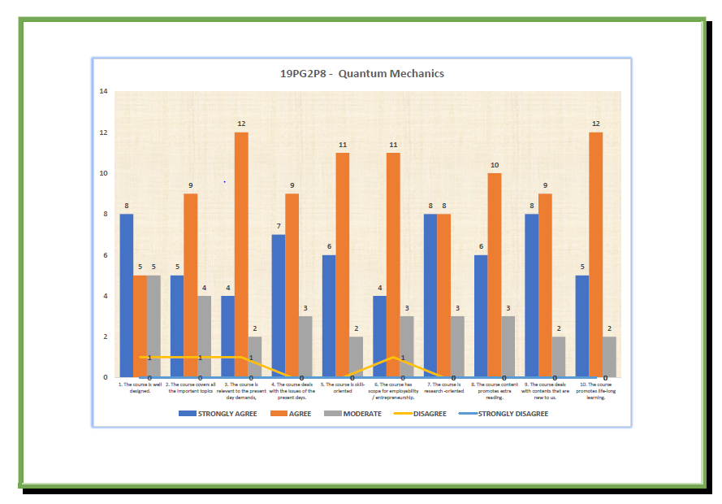
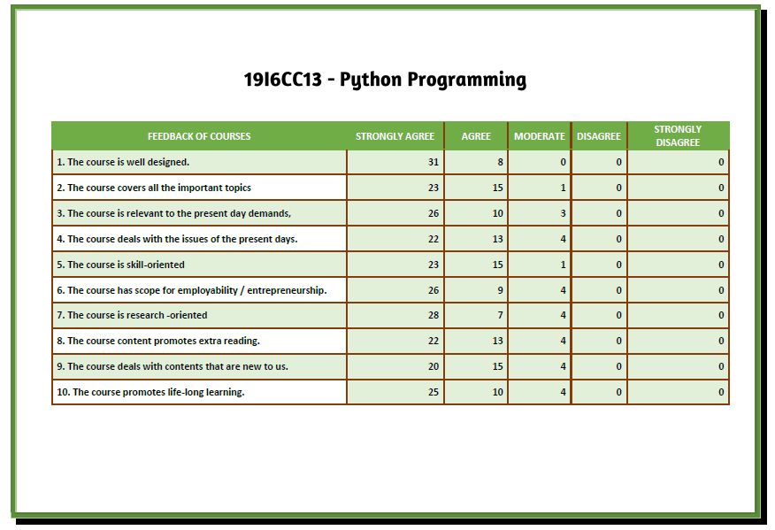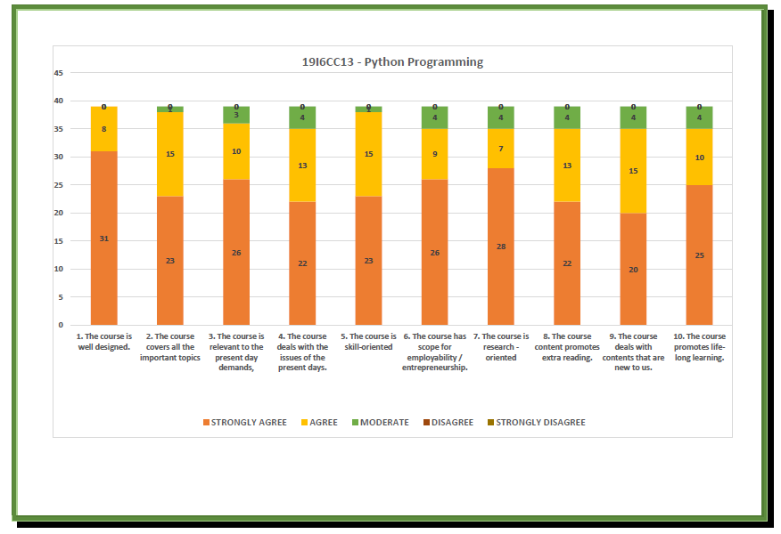

Action Taken On Feedback Collected From Students
S. NO. | OBSERVATION / ANALYSIS | ACTION TAKEN
 | Teaching to be application oriented | - Staff to upgrade teaching styles.
 | More exposure to practical learning needed | - Practical learning is supplemented through internships and fieldtrips.
 | Placement training requested | - Placement week was celebrated and students were given tips and techniques to face interviews
 | Campus interview needed | - More campus interviews were arranged in collaboration with local industries and MNCs.
 | Suggestions given to reduce / increase syllabus for some courses | - Suggestions to be placed before respective boards.
S. NO. | OBSERVATION / ANALYSIS | ACTION TAKEN
 | Need of skill-oriented courses | - All departments have incorporated Skill-bases courses  - Off-class programmes are offered in Computer skills to I UG students and I PG students.
 | Need of Field visits and Industrial Visits | - Internship is mandated for all PG students thereby encouraging them to gain practical knowledge  - Students are taken to Industrial Visits and Field Trips based on their curriculum
 | Syllabus in tune with facing NET & Competitive Exams | - Syllabus is frequently updated integrating current developments in the respective field.

Feedback From alumnae
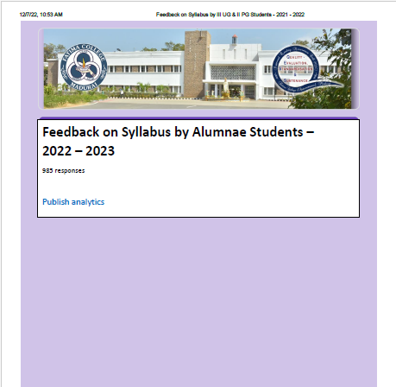

Action Taken On Feedback Collected From Alumnae

S. No. | Observation / Analysis | Action taken
 | Internship is required | - Internship is mandated for all PG students  - UG students are also encouraged to take up Internship
 | - New modules in syllabus required  - Suggestions from the students should be considered for framing syllabus | - As per the need of the hour, the syllabus is revamped with a maximum of 20% revision  - Feedback Mechanism is developed mainly to incorporate the suggestions from the students
 | Coaching for Competitive Examinations can be given | - Some Departments conduct coaching classes for Competitive Examinations  - Special training and Mock Tests are given to the interested students through online courses

Feedback From employers

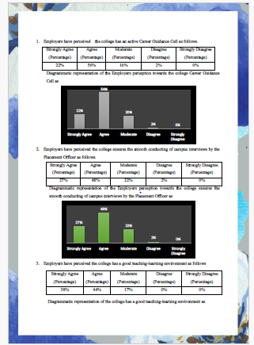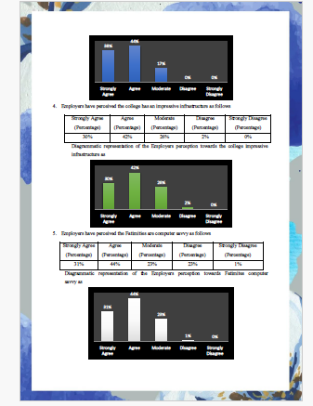

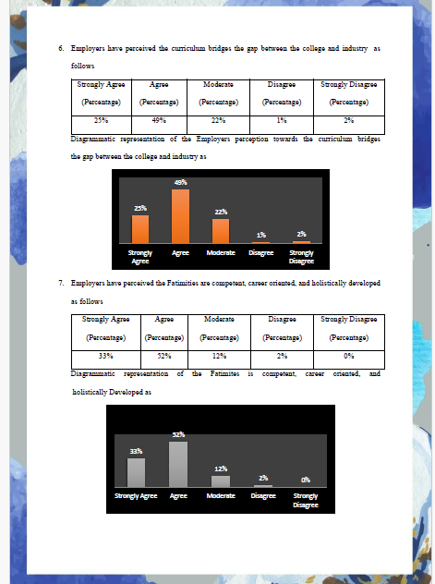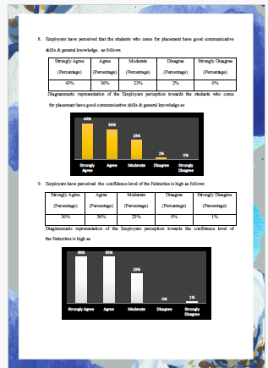

Action Taken On Feedback Collected From employers

S. No. | Observation / Analysis | Action taken
 | Employers are expecting more employability skills from the students | For the final year students Interview skill training and the technical training by MNC s were organized.
 | More number of MNC’S are need for the campus interview. | More efforts have been taken to invite MNC’S for the campus interview Employers feedback.

Newly Introduced Health Insurance Products by Indian Bank
June 07, 2022 & Sep. 26, 2022
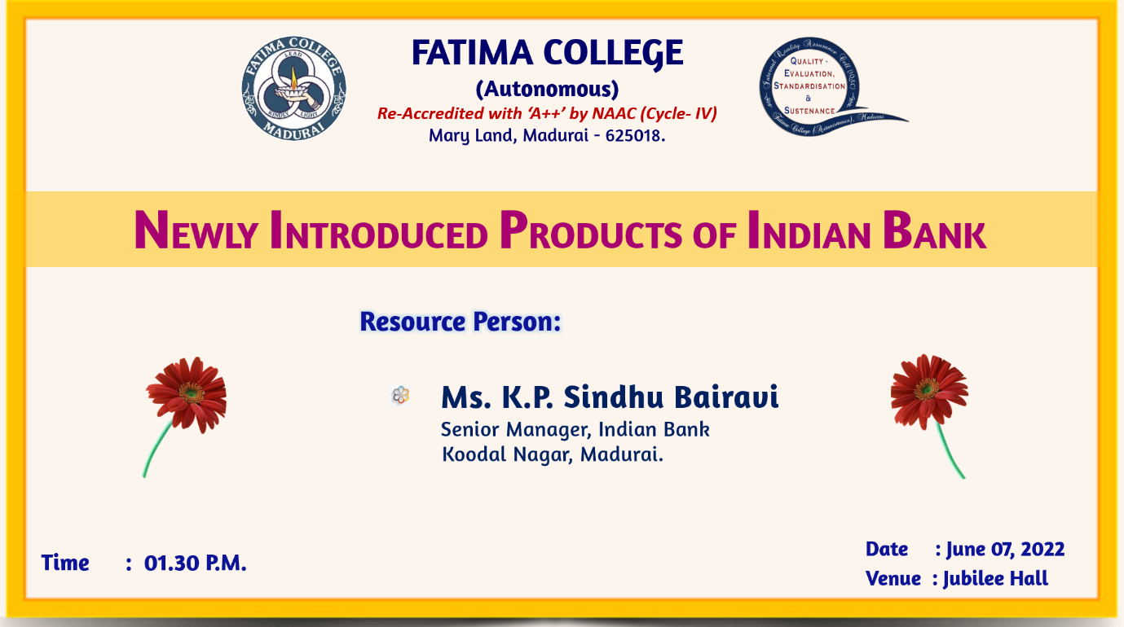

As an initiative to create an awareness about the newly introduced schemes of the Indian Bank, the IQAC arranged for a session for the teaching and non- teaching staff of Fatima College. Around 165 members actively participated in the session. The Programme was spilt into two sessions. Session one was held on June 07, 2022 in Jubilee Hall at 1.30 pm. Ms. K. P. Sindhu Bairavi, Senior Manager, Indian Bank, Koodal Nagar, Madurai was the resource person. Ms. Bairavi oriented on the newly introduced schemes of the Indian Bank
. 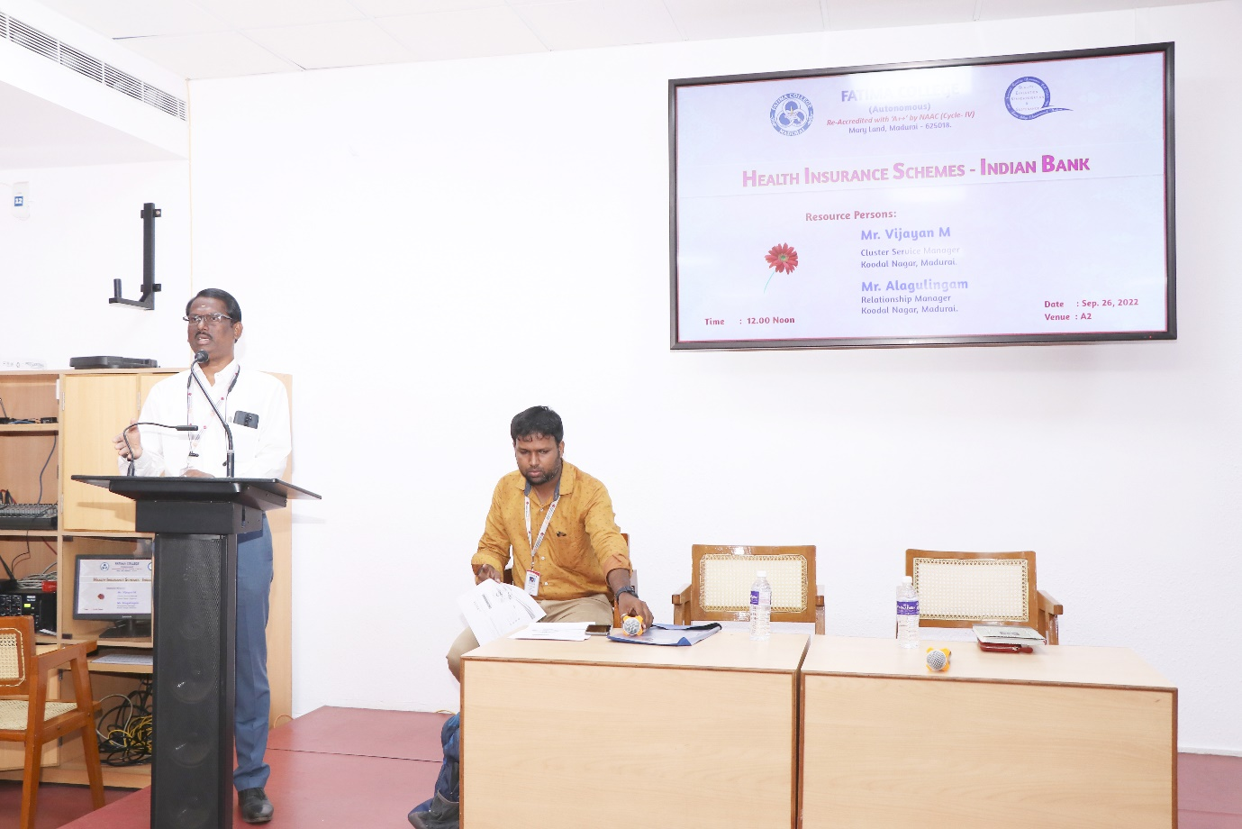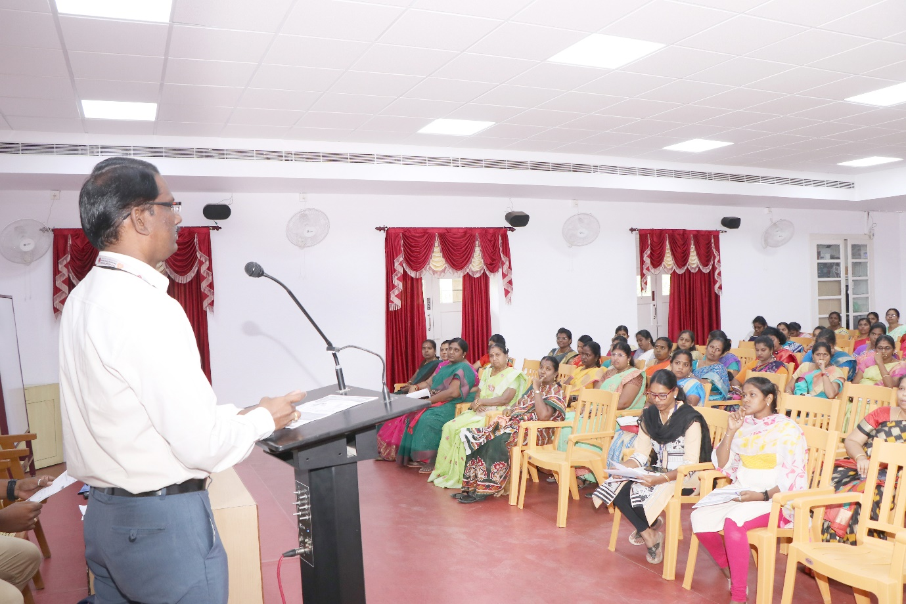
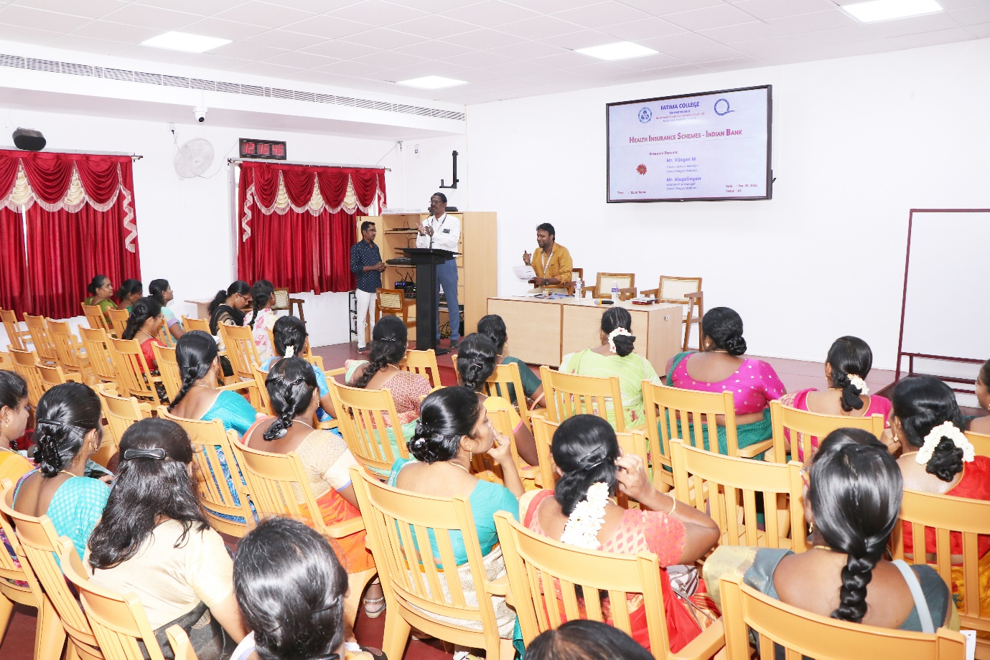

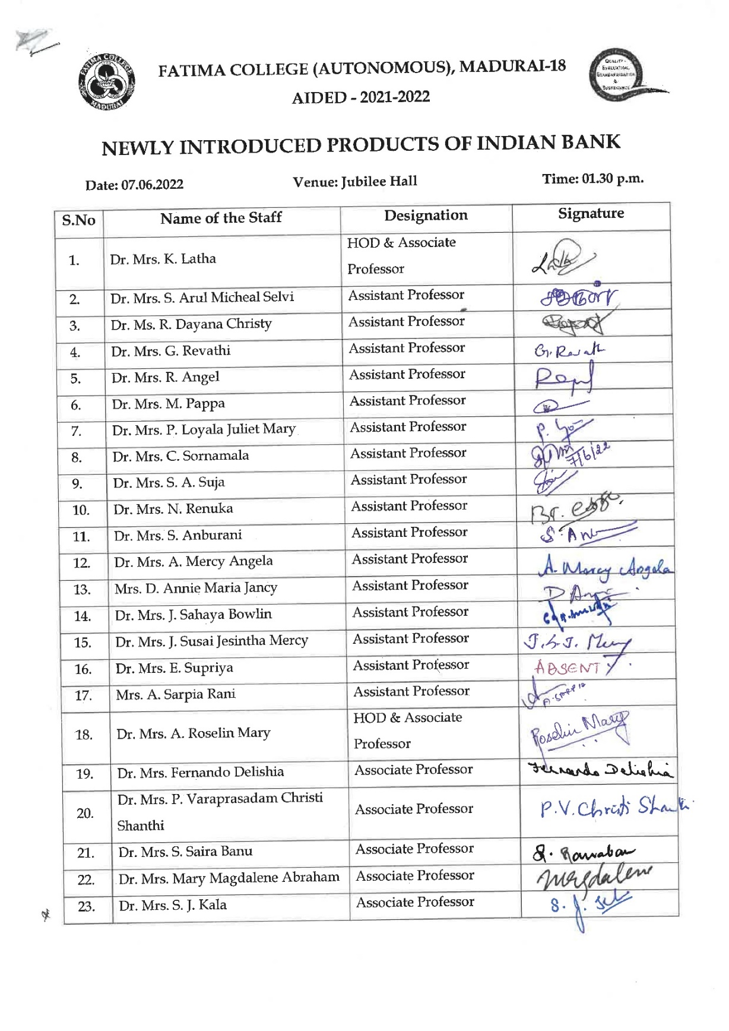
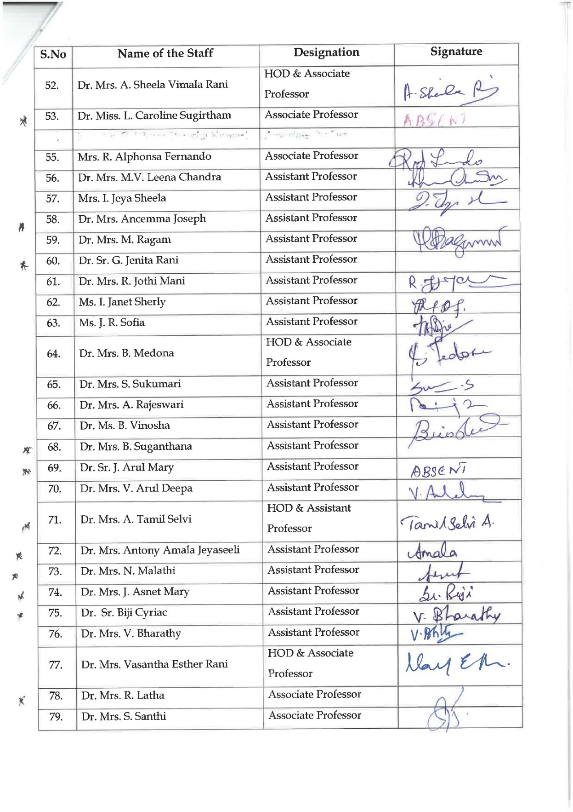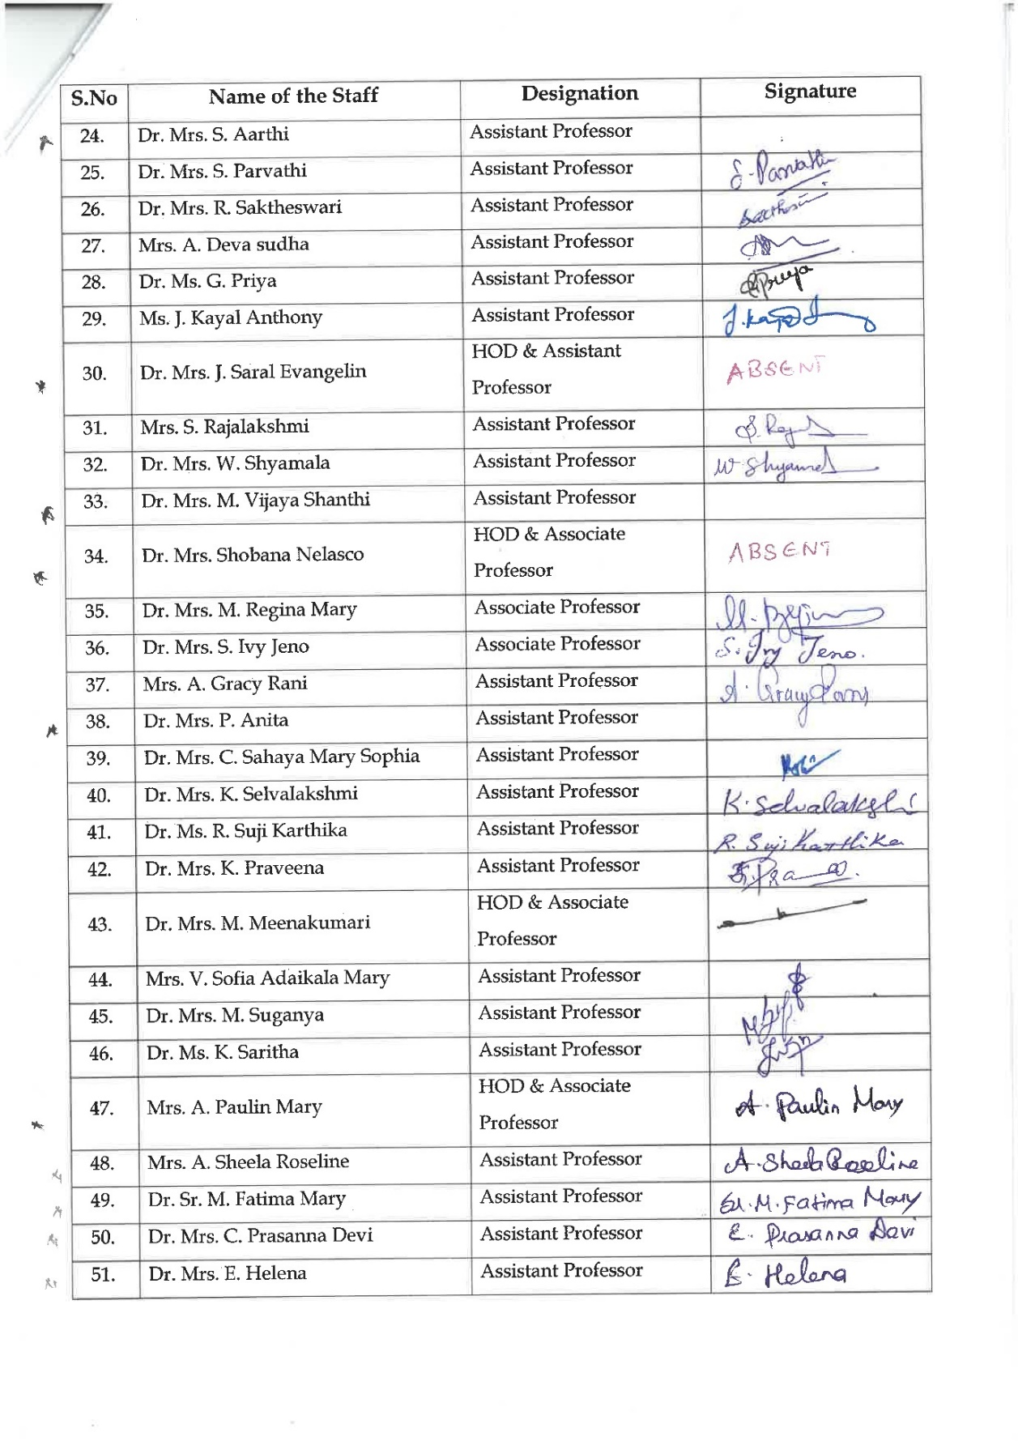
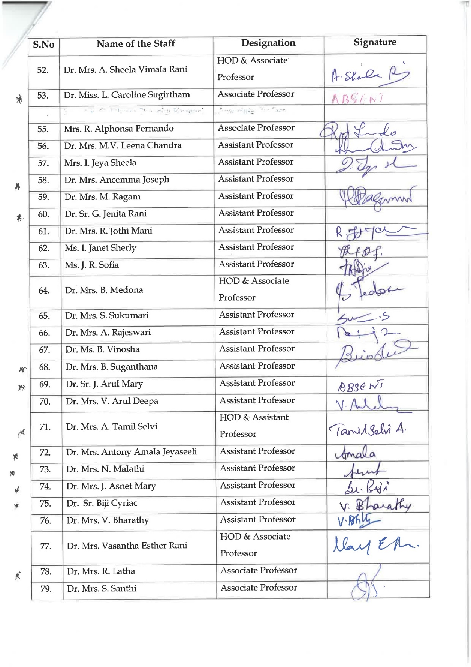
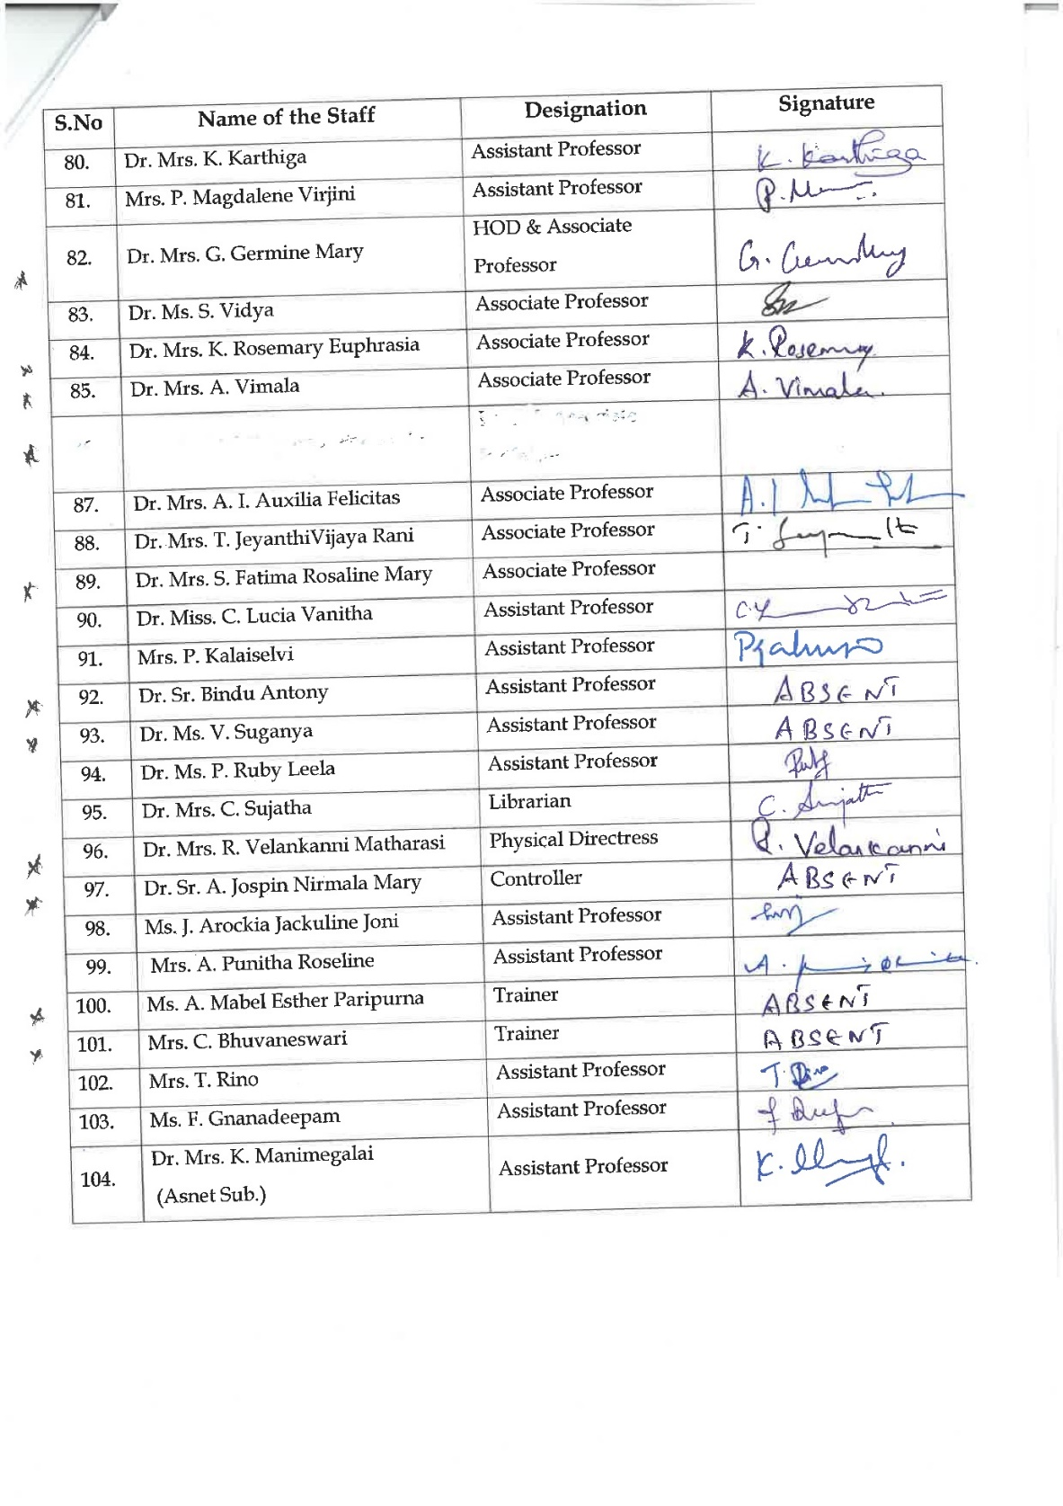
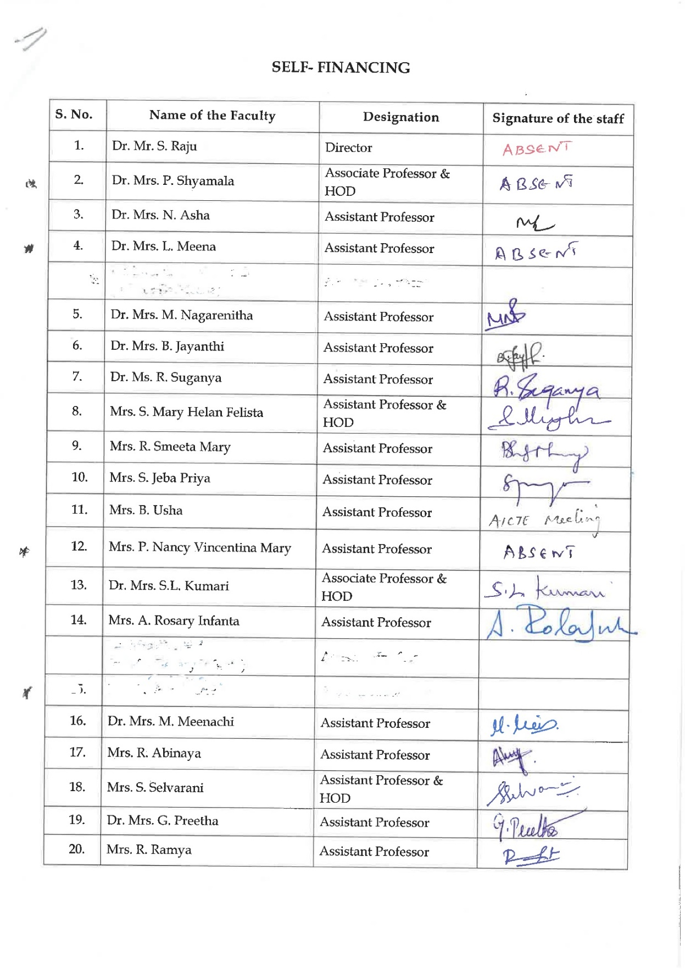
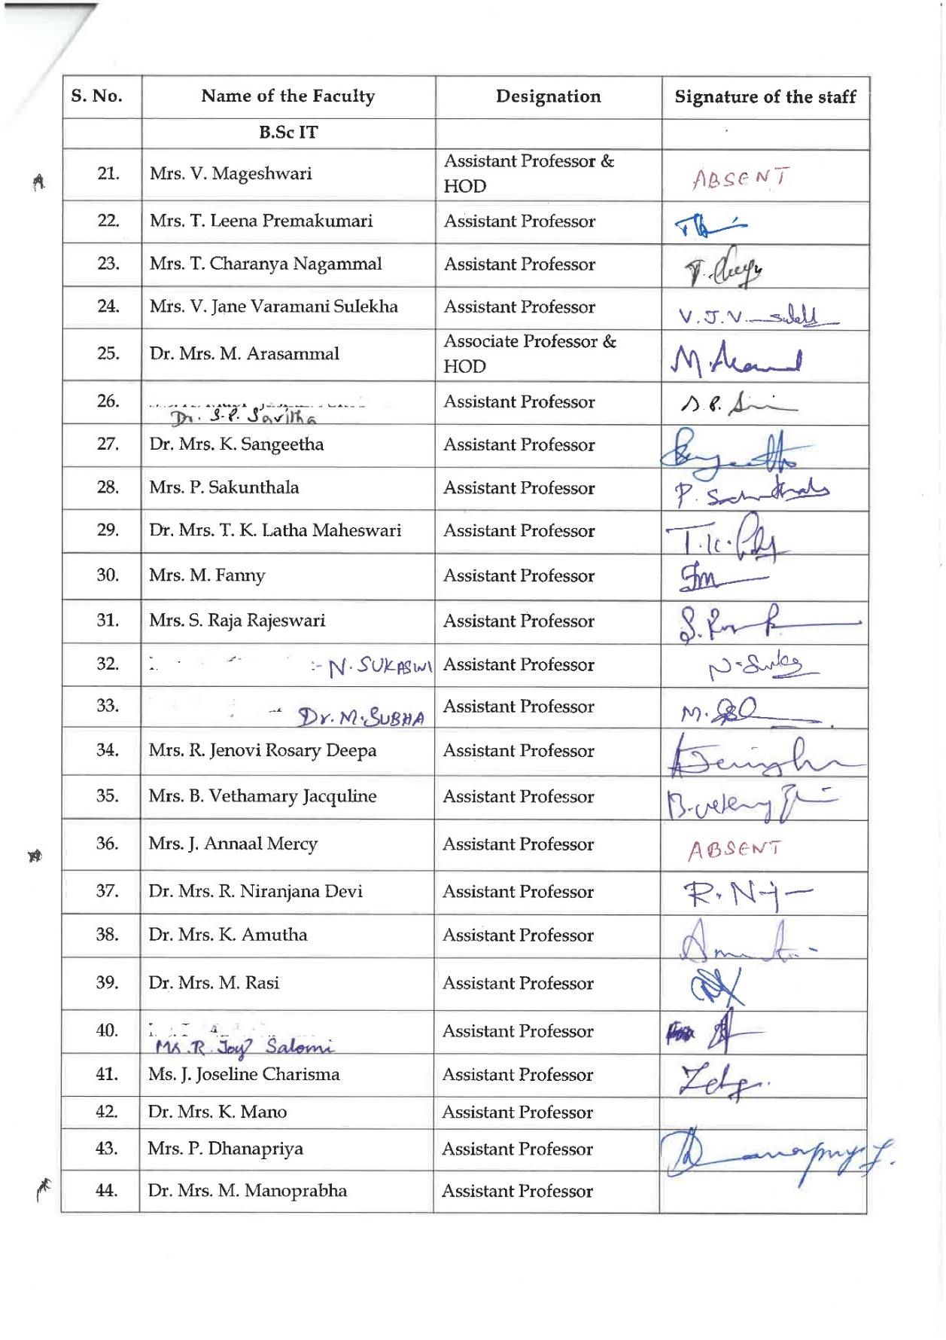
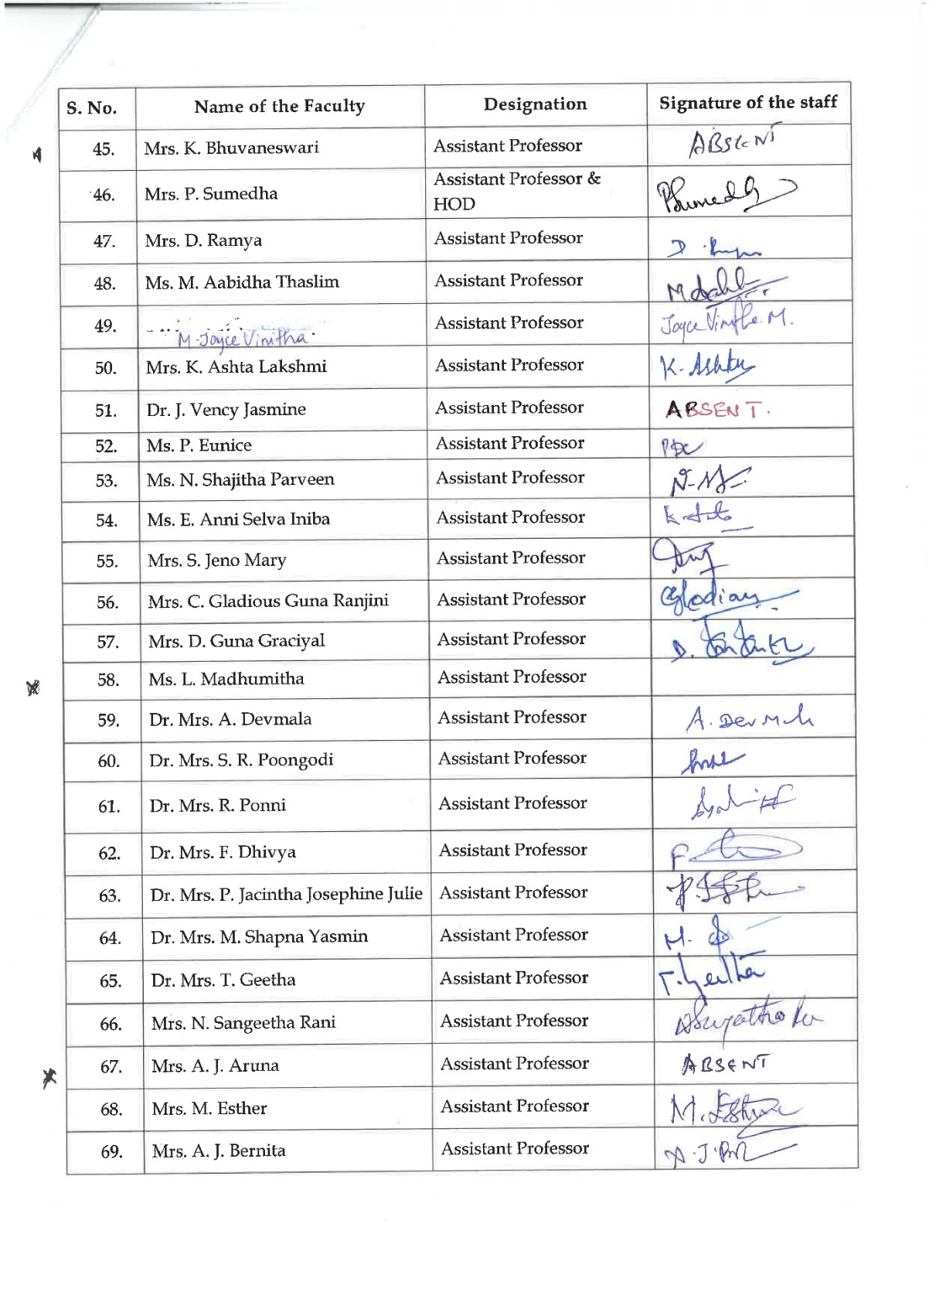
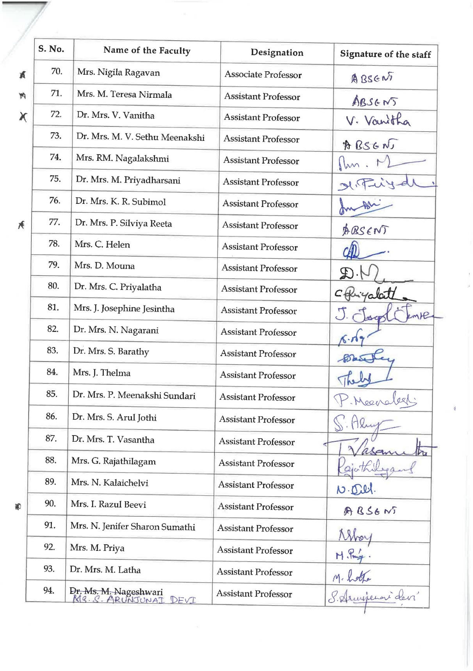
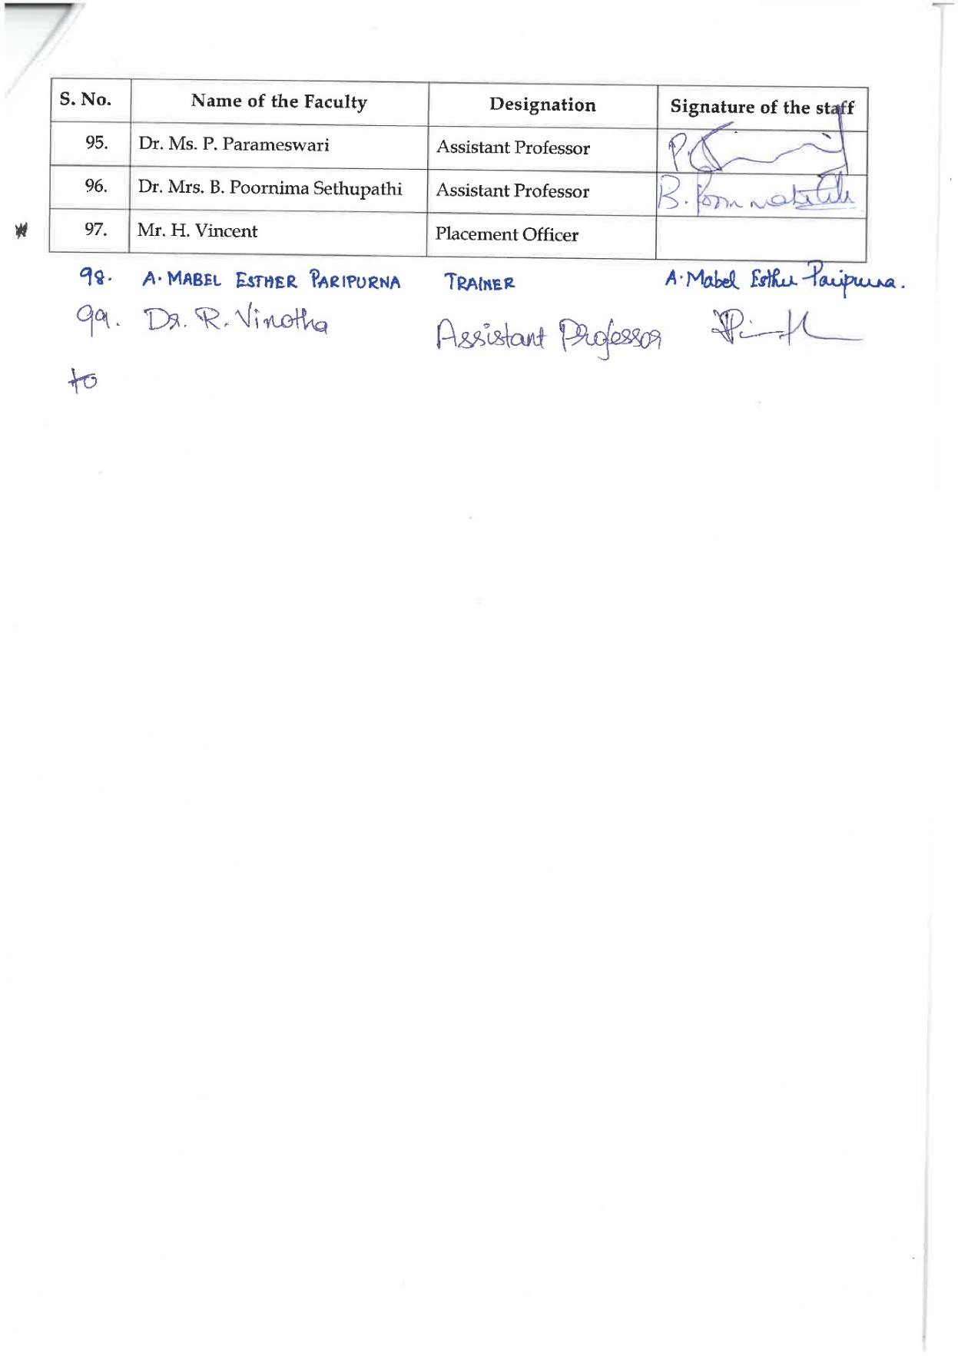

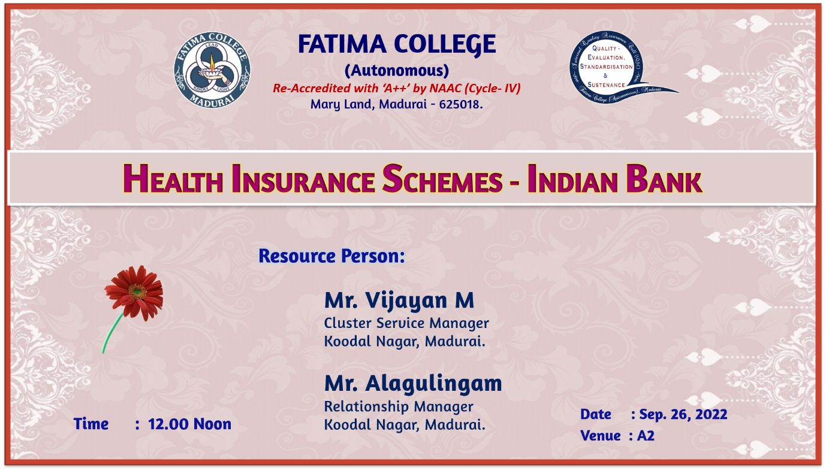
The second session was scheduled on September 26, 2022 in A2 at 12 noon. Mr. M. Vijayan, Cluster Service Manager & Mr. Alagulingam, Relationship Manager, Koodal Nagar, Madurai were the resource persons. Both created awareness on the various health insurance schemes on the Indian Bank. The audience which consisted of both teaching and non - teaching faculty members clarified their doubts and were also highly benefitted.

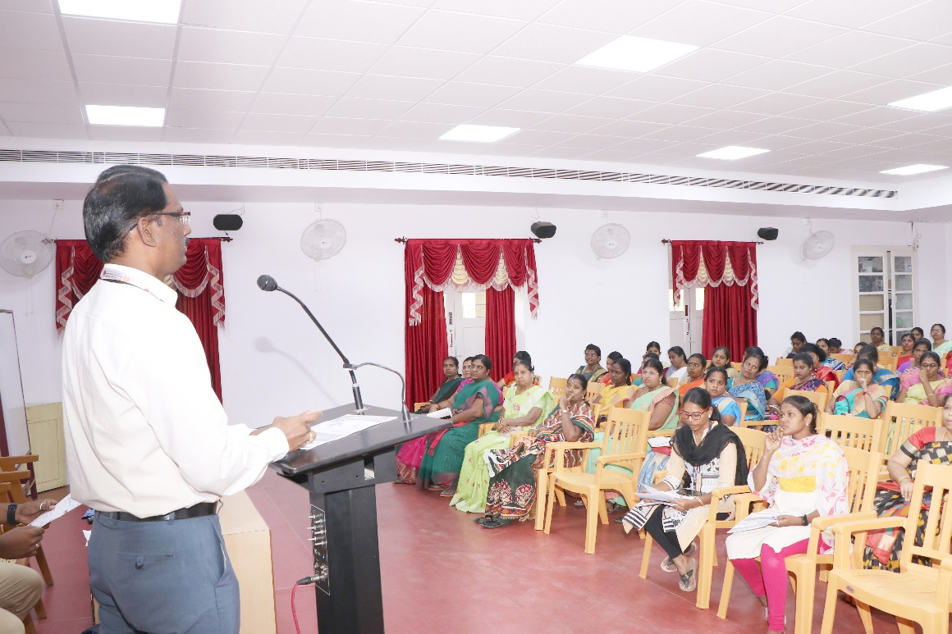
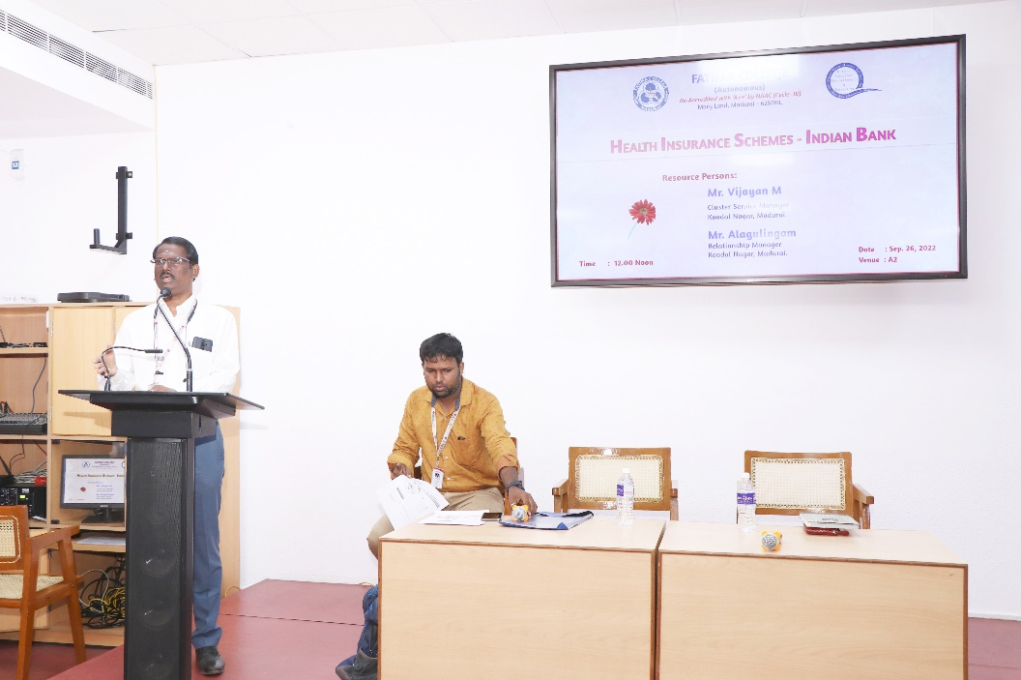
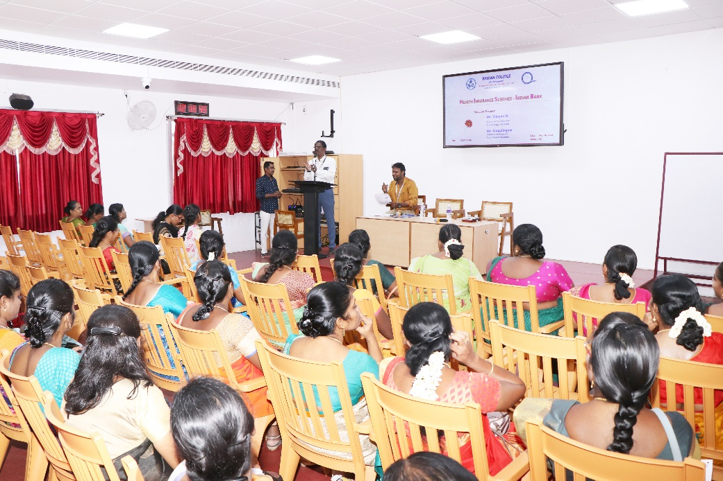

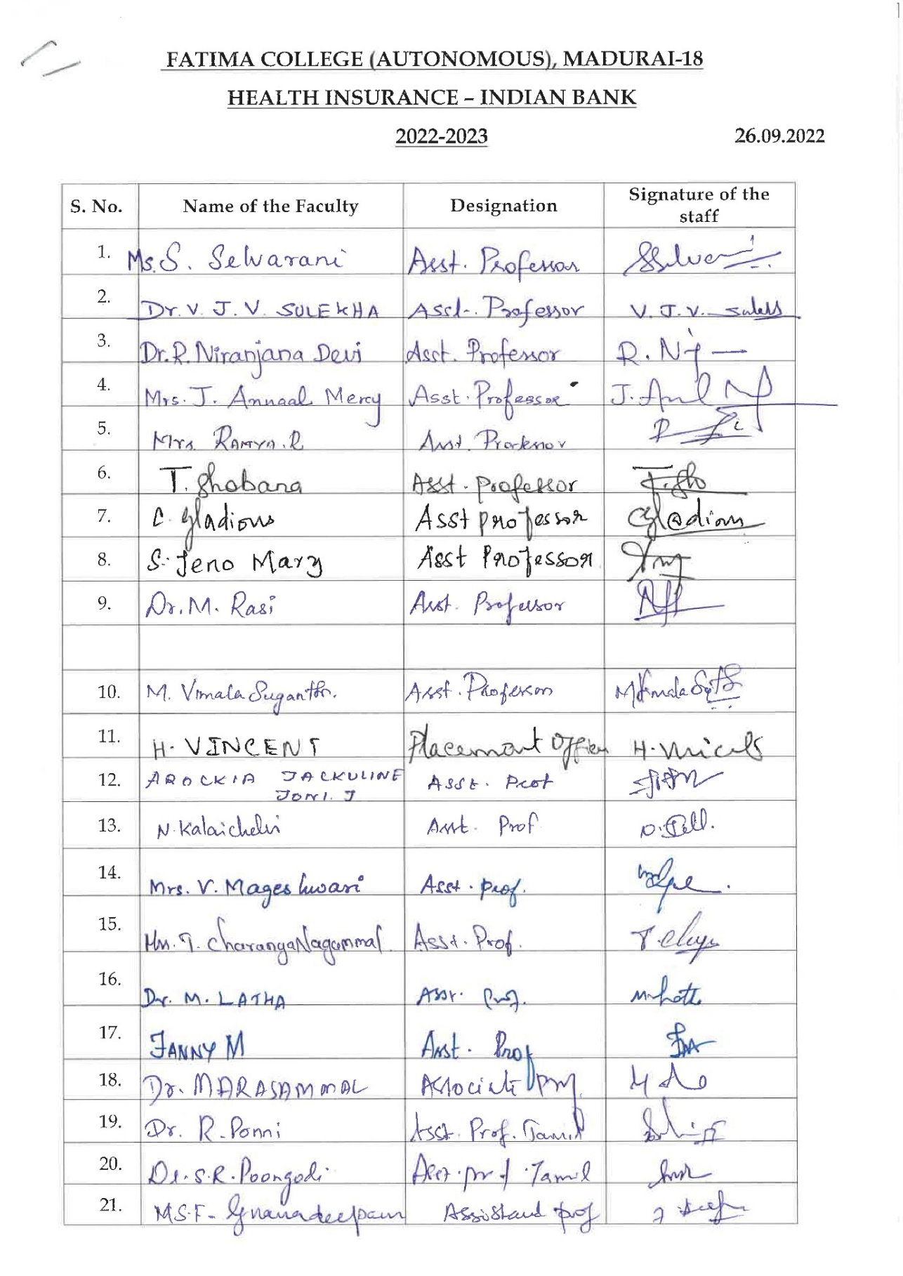
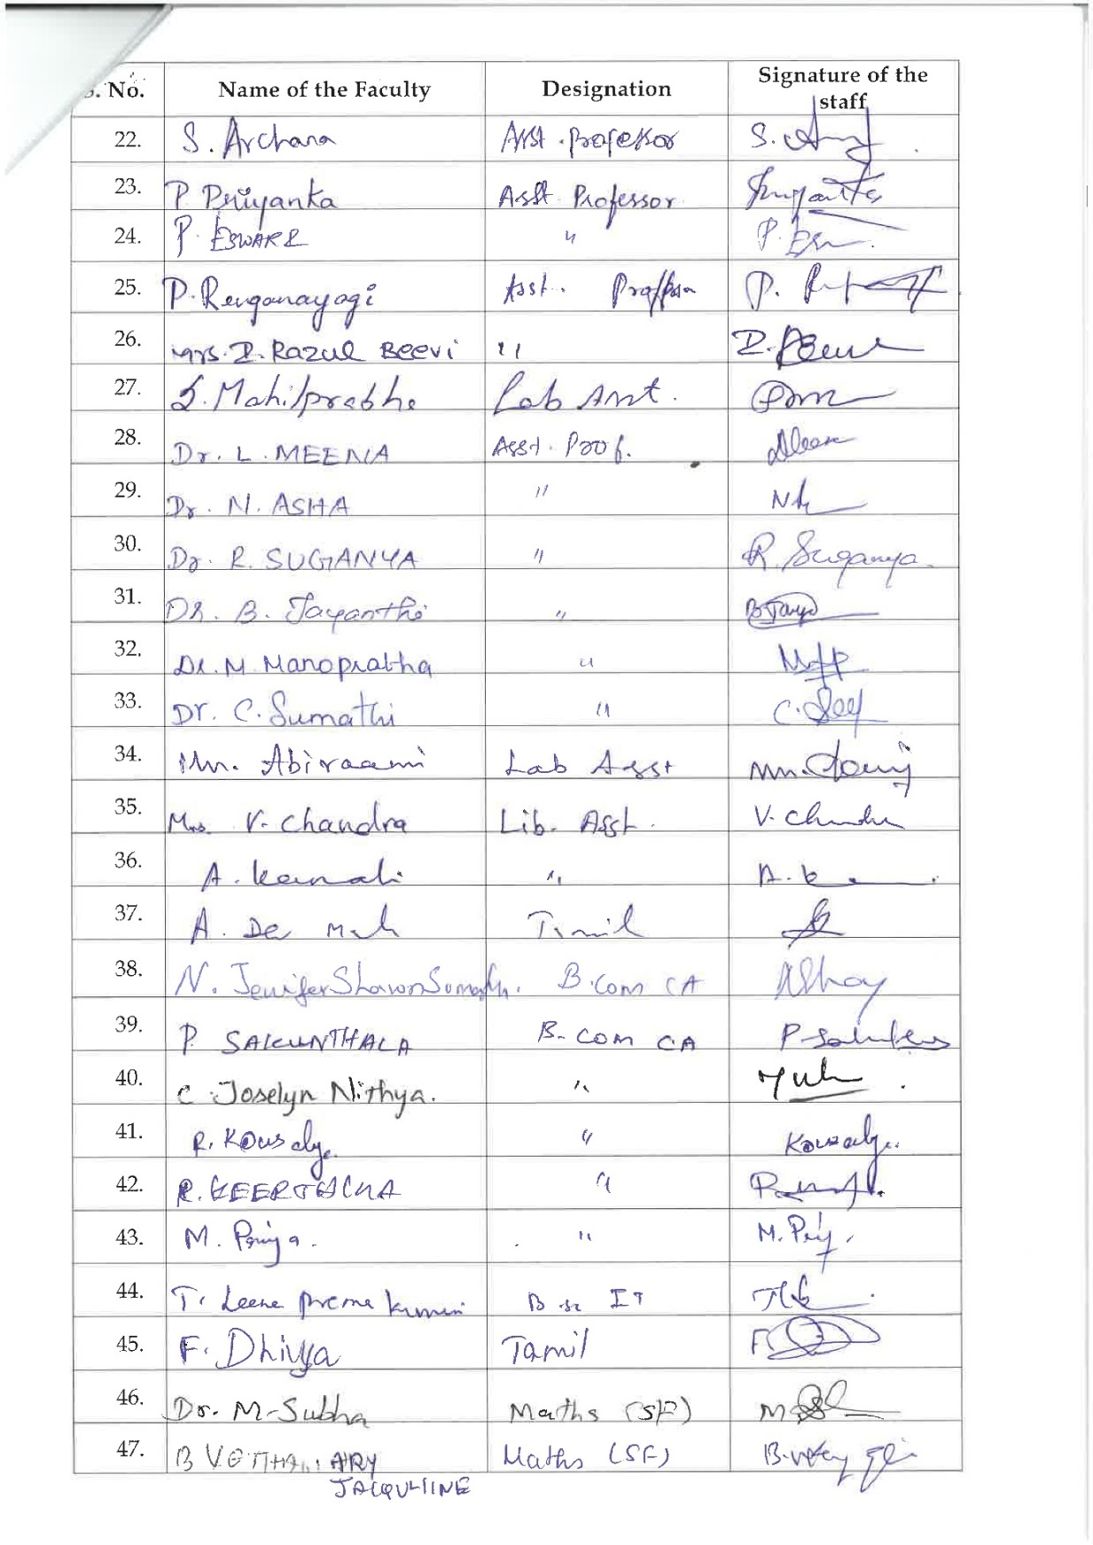
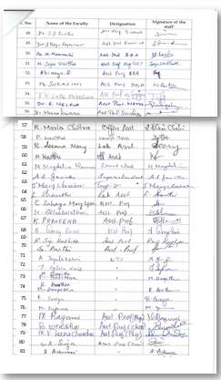

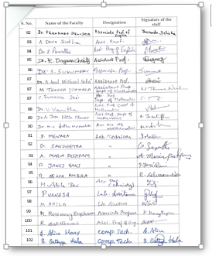
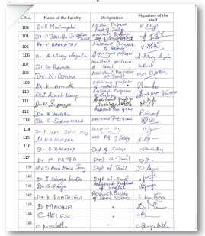

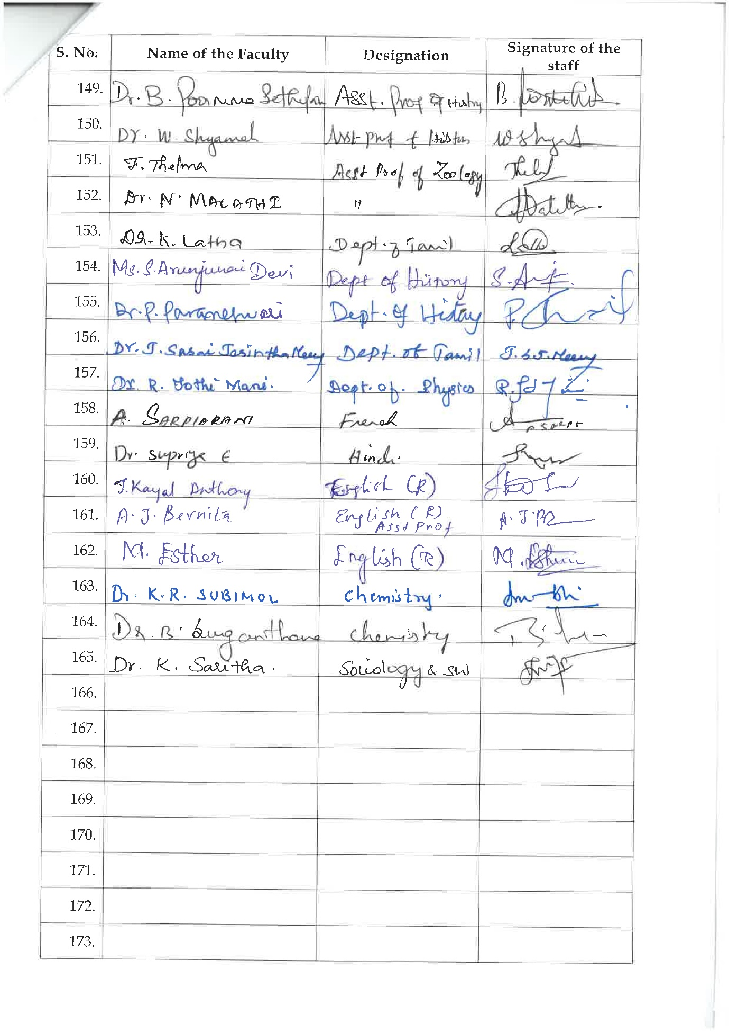

Student Induction Programme (DEEKSHARAMB) - July 25 to August 01, 2022

87
85
organized by IQAC

Date / Time | 08.30 – 9.00 a.m. | 09.00 – 10.15 a.m. | 10:15-10:45 | 10:45-11:45 (SIP – Session I) |  |  | 11.45 am – 1:00 p.m.
25.07.2022  (Monday) | Attendance  (Before Administrative Block) | Orientation Program | Break | The Journey Begins - Dr. S. Saira Banu  Associate Professor of English & Head, Dept, of JMC  Binary University - Dr. Sr. J. Arul Mary  Assistant Professor of Chemistry and Chief  Warden, Fatima College Hostel  Being a Fatimite - Ms. Deepthika  Treasurer, Student council |  |  | English Attainment Test (EAT)
08.30 - 9.00 a.m. |  | 9.00- 10.30 a.m. |  |  |  |  | 10.30 – 10.45 a.m. | 10.45 - 01.30 p.m.
26.07.2022  (Tuesday) | Major wise Attendance (Dept. Should Take care) | SIP - Session-II–  Holistic Formation at Fatima  Dr. S. J. Kala  Associate Professor of English | SIP- Session-III - Activities  Ms. A. Sheela Roselin  Assistant Professor of Mathematics |  | 10:00 – 10:30AM  Campus Tour |  | BREAK | Bridge Course – I UG  10.45 – 11:40 a.m.  11:40 – 12:35 p.m.  12:35 - 1:30 p.m.
27.07.2022  (Wednesday) |  | SIP - Session-IV – Quality Standards  Dr. S. Vidya  Associate Professor of Computer Science | SIP- Session-V - Fitness  Dr. G. Velankanni Matharasi  Directress of Physical Education
28.07.2022  (Thursday) |  | SIP - Session-VI – Finding Yourself Through Community Service  Dr. M. Ragam Dr. R. Ponni  Assistant Professor of Physics Assistant Professor of Tamil (SF) |  |  | SIP- Session-VII  Rosa Mystica Library: An Overview  Dr. C. Sujatha, Librarian
29.07.2022  (Friday) |  | SIP - Session-VIII  Making the Best Out of Challenges  Dr. Sr. Jenita  Vice Principal (Shift II) | SIP - Session-IX  Exploring Talents through Cultural Activities  Dr. M. Pappa  Assistant Professor of Tamil |  | SIP - Session-X  Environment:  Be Aware & Awake  Dr. G. Revathy  Assistant Professor of Tamil
30.07.2022  (Saturday) |  | SIP- Session-XI  Dimensions for Progressive Life  Dr. K. Rosemary Euphrasia  Associate Professor of Computer Science | SIP- Session-XII  What it means to be a Fatimite  Dr. Mary Magdalene Abraham  Associate Professor of English |  | BREAK  10.30 – 10.45 a.m. | Bridge Course  10.45 a.m. – 12.15 p.m. | Welcome party  12:30 – 1 p.m. – Jubilee Hall  1 - 1:30 p.m. – Dept. Get-together
01.08.2022  (Monday) |  | SIP-Session-XIII  Research – A Formalized Curiosity!  Mrs. S. Selvarani  Assistant Professor & Head, Dept. of BCA | SIP - Session-XIV  Introduction to Placement  Mr. H. Vincent  Coordinator & Institute Industry Liaison Officer |  | SIP - Session-XV  Student Talent Finding  Student Council |  | BREAK | Bridge Course – I UG  10.45 – 11:40 a.m.  11:40 – 12:35 p.m.  12:35 - 1:30 p.m.
02, 03 & 04.08.2022  (Tue., Wed.& Thurs.) | 8.30 – 9.30 a.m.  Major Class | 9.30 – 10.25 a.m.  Language Class | 10.25 – 10.45 a.m.  Break |  | 10.45 a.m. – 1.30 p.m.  Bridge Course – I UG

STUDENT INDUCTION PROGRAMME (SIP)
2022- 2023
The Student Induction Programme (SIP) was organized by IQAC to the Undergraduate First year students who had stepped into the portals of Fatima. The SIP comprised various sessions, from 9.30 to 11.00 a.m. from 25th July to 1st August 2022.
The coordinators Mrs. A. Sheela Roselin, Assistant Professor, Department of Mathematics and Mrs. Sumedha, Assistant Professor, Department of English (SF) lead the programme with a Prayer song followed by College Prayer.
The first day SIP session I was handled by Dr.S.Saira Banu, Associate Professor of English and Head, Department of JMC. She gave an outline about “The Journey Begins”.
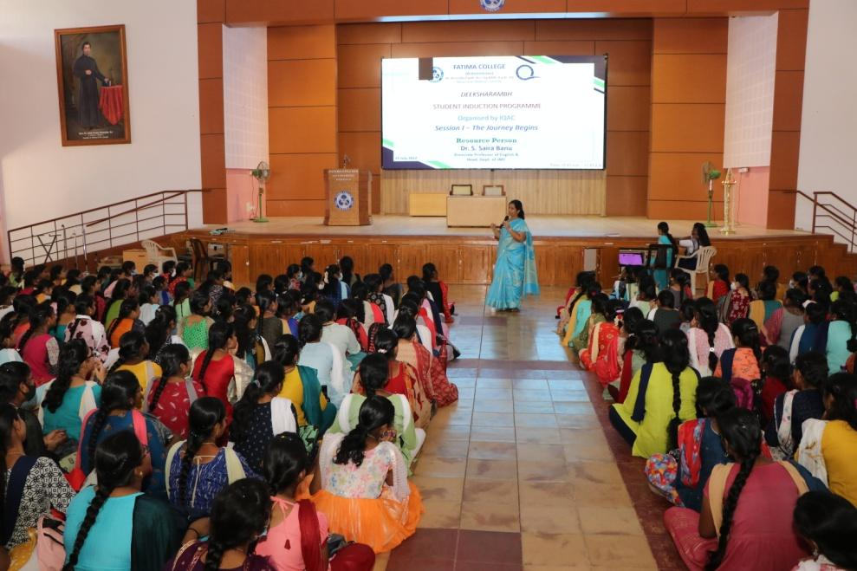
The next session SIP was captured by Dr. S. J. Kala, Dean of Academic Affairs (Arts),Associate Professor, The Research Centre of English. She clearly explained on Holistic formation at Fatima. She explored on Keybodies in Higher Education, Quality Based Curriculum Designing, Outcome Based Education, Examination System.

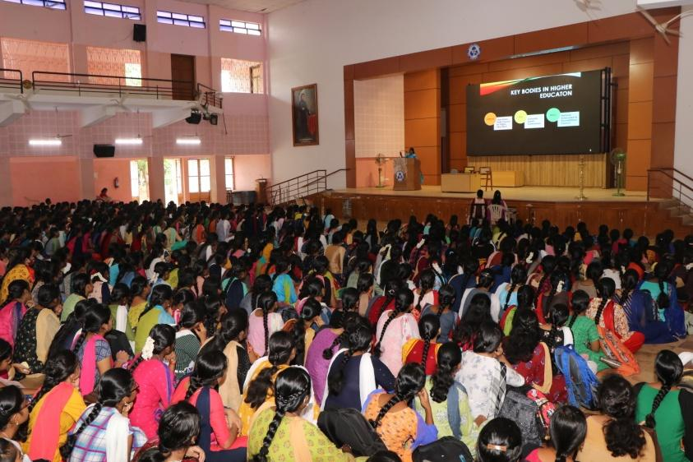
On 27 July 2022, Dr.S.Vidya, Associate Professor, Department of Computer Science and Coordinator of International Collaboration and Foreign Students Welfare Cell handled the session on “Quality Standards” The Resource person gave a wide exposure regarding National Assessment and Accreditation Council (NAAC) and National Institutional Ranking Framework (NIRF).
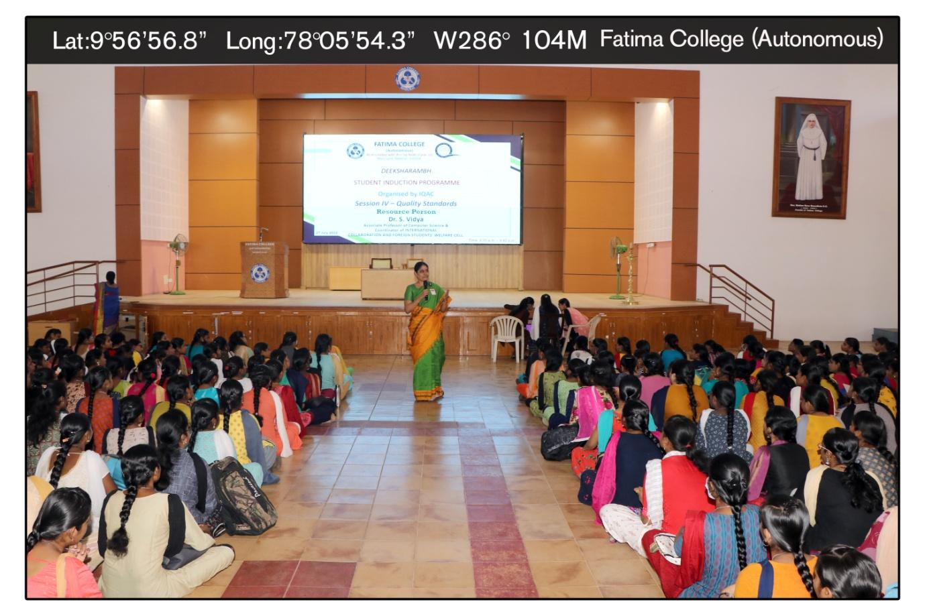
The next session was taken by Dr. Velankanni Matharasi, Directress of Physical Education. She described on Self Confidence and Emotional Control. She clarified the difference between Confidence and Self-Confidence.It included Next Rotation, Finger Shoot, Wrist Rotation, Shoulder Rotation, Arm Rotation, Hip Rotation, Knee Rotation, Ankle Rotation, etc…

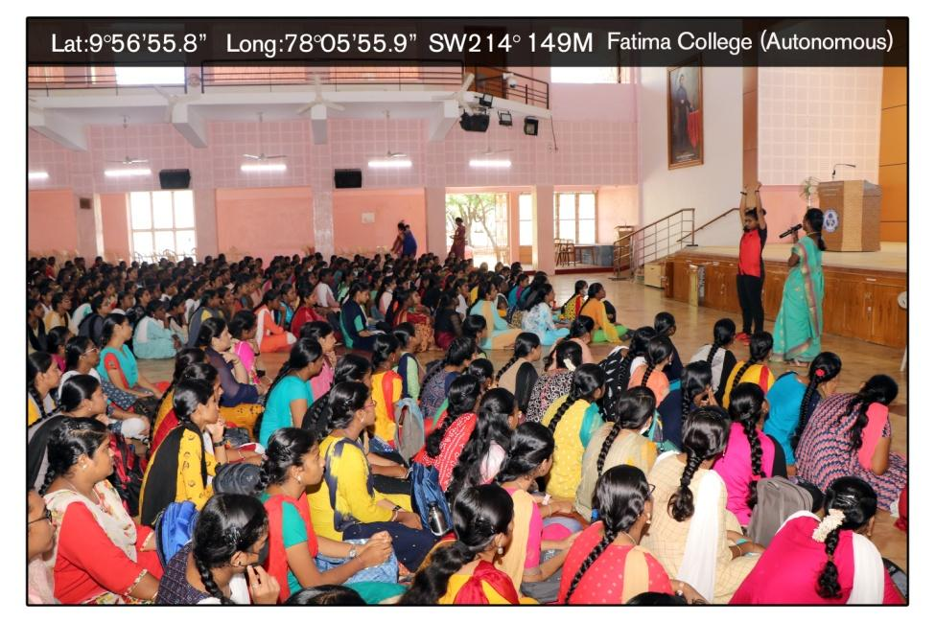
On 28 ^{th} July 2022, All the Part V Coordinators introduced and gave and brief note on the various Part V activities on the topic “Finding yourself through Community Service”
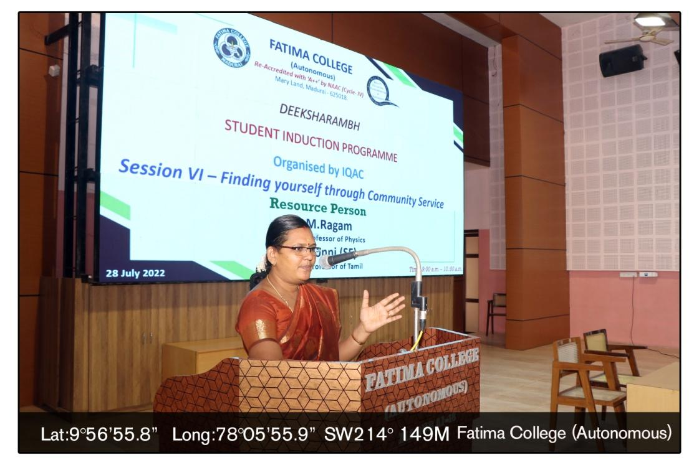
The Session on ‘Dimensions for Progressive Life’ was captured by Dr. K. Rosemary Euphrasia, IQAC Coordinator, Associate Professor of Computer Science. The resource person focussed the students to have different perceptions in life.

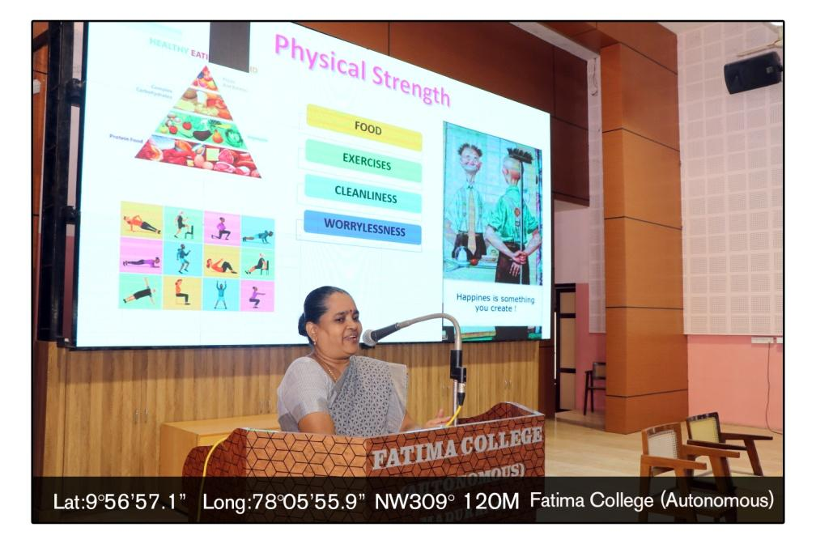

On 29th July SIP was handled by Dr.Pappa, Assistant Professor, The Research Centre of Tamil on “Exploring Talents through Cultural Activities” followed by Dr.G.Revathy on “Be Aware & Awake”
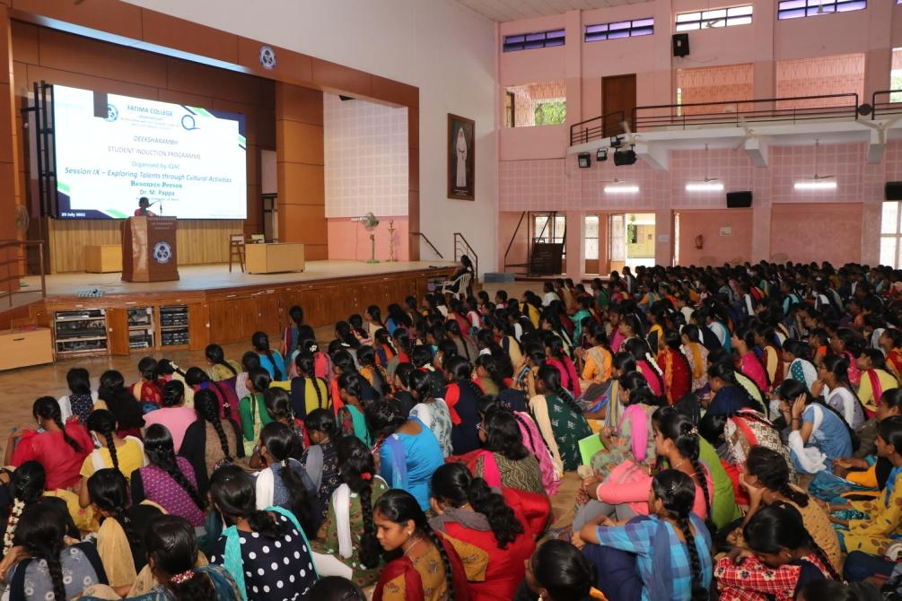
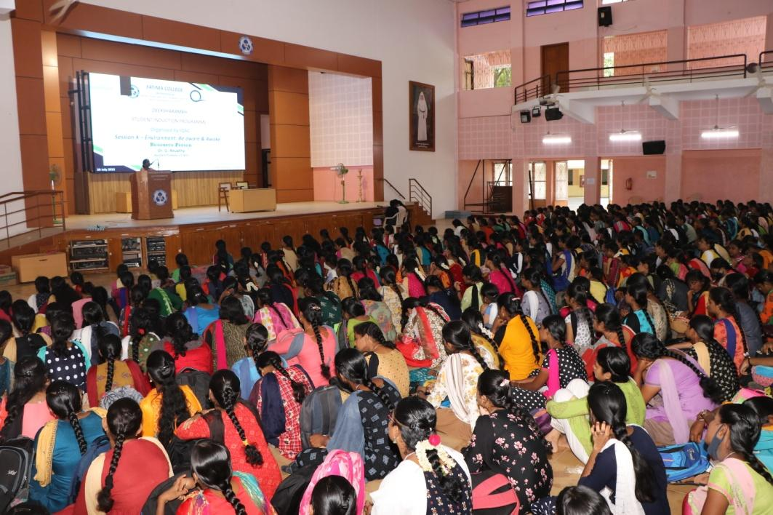
On 30 July 2022, Dr.Sr.G.Jenita Rani, Vice Principal (Shift II) addressed the students on “Making the Best Out of Challenges”
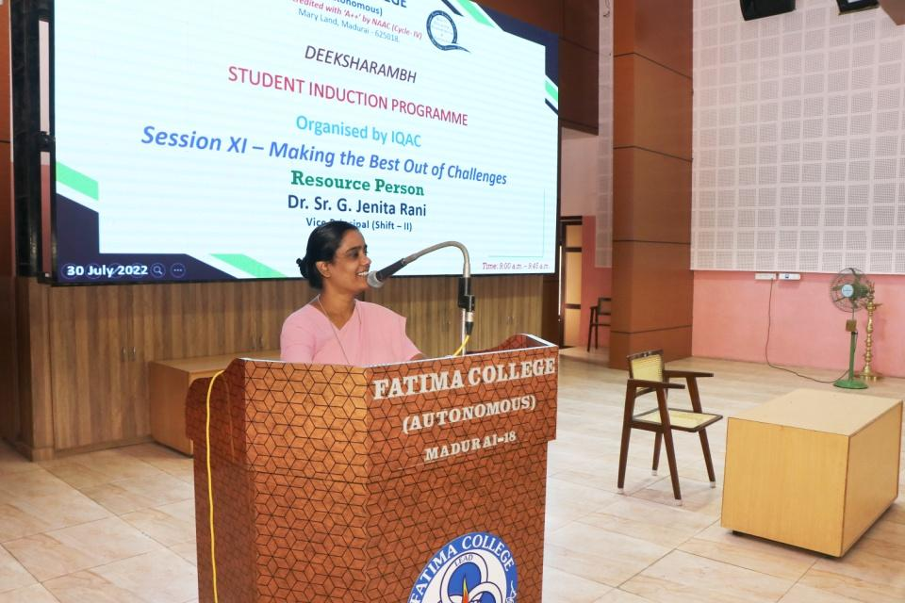
On the same day, Dr. Magdalene Abraham, Assistant Coordinator, IQAC, addressed the students on “What it means to be a Fatimite”. She spoke about the Culture in Fatima.

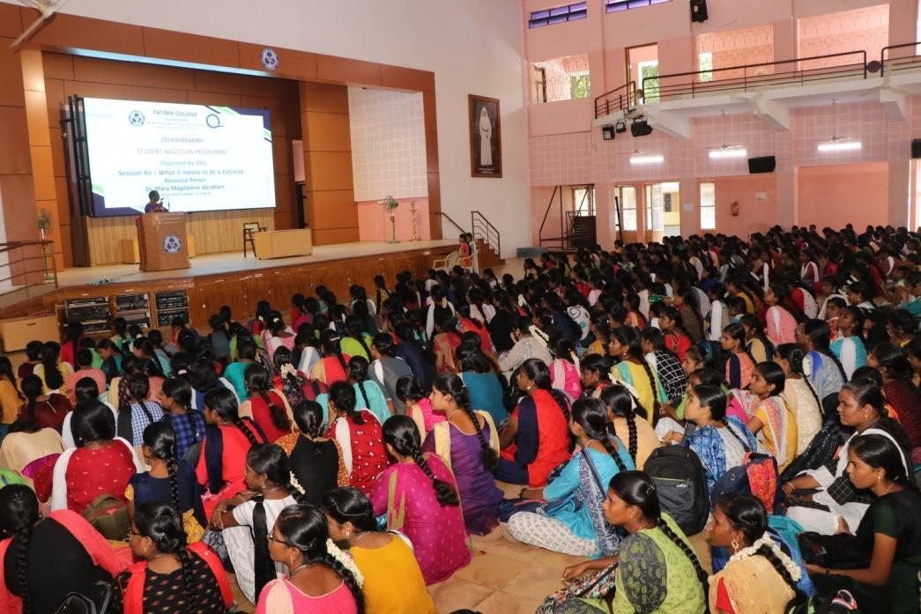
The Session about Rosa Mystica Library: An Overview handled by Dr.C.Sujatha, Librarian. She gave a wide exposure on Library and other related online portals. She insisted students to inculcate knowledge in their own discipline as well as in other Programmes.

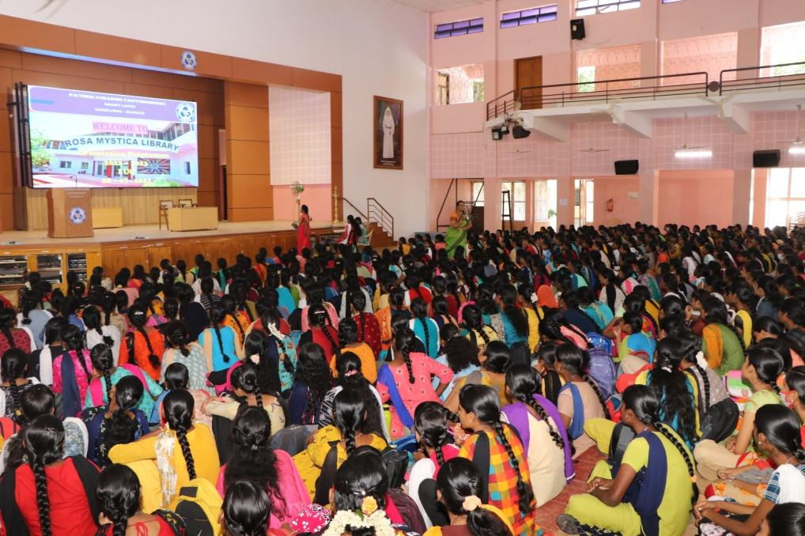
Mrs. Selvarani, Head & Assistant Professor, Department of BCA, addressed the gathering on Research Activities in Fatima
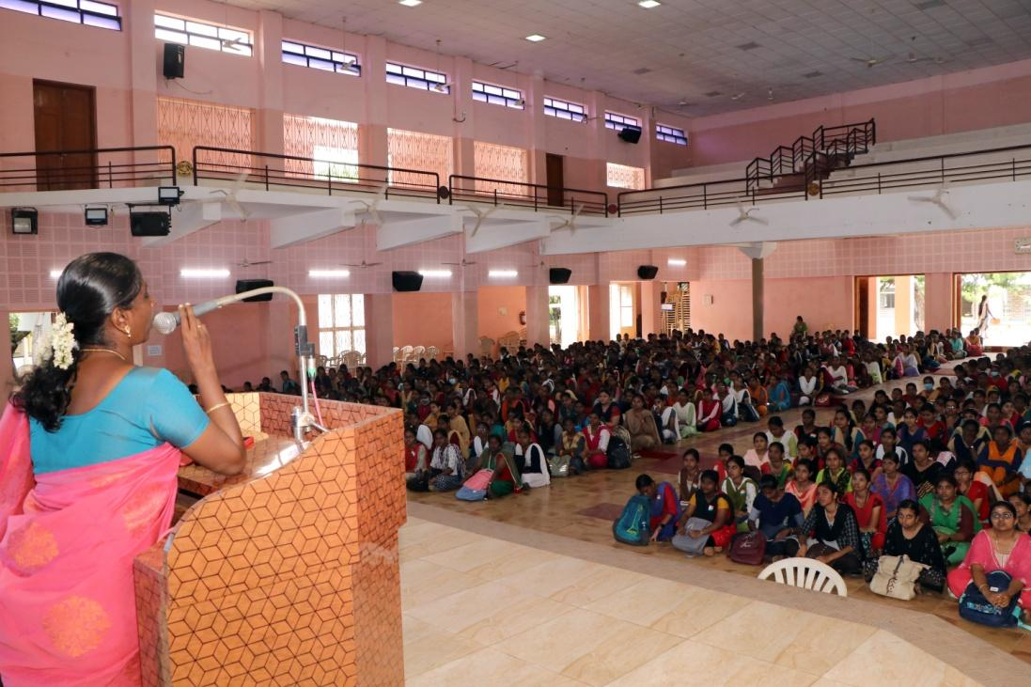
The last day of SIP was handled by Mr.H.Vincent, Placement Officer. He gave a brief note on “Introduction to Placement”
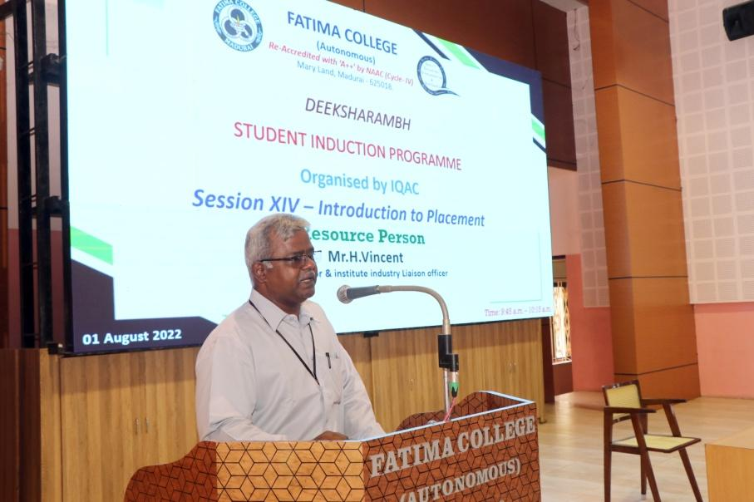
SIP feedback were collected online. The students exhibited their talents in “Talent Finding” and all the students enjoyed participating in it.
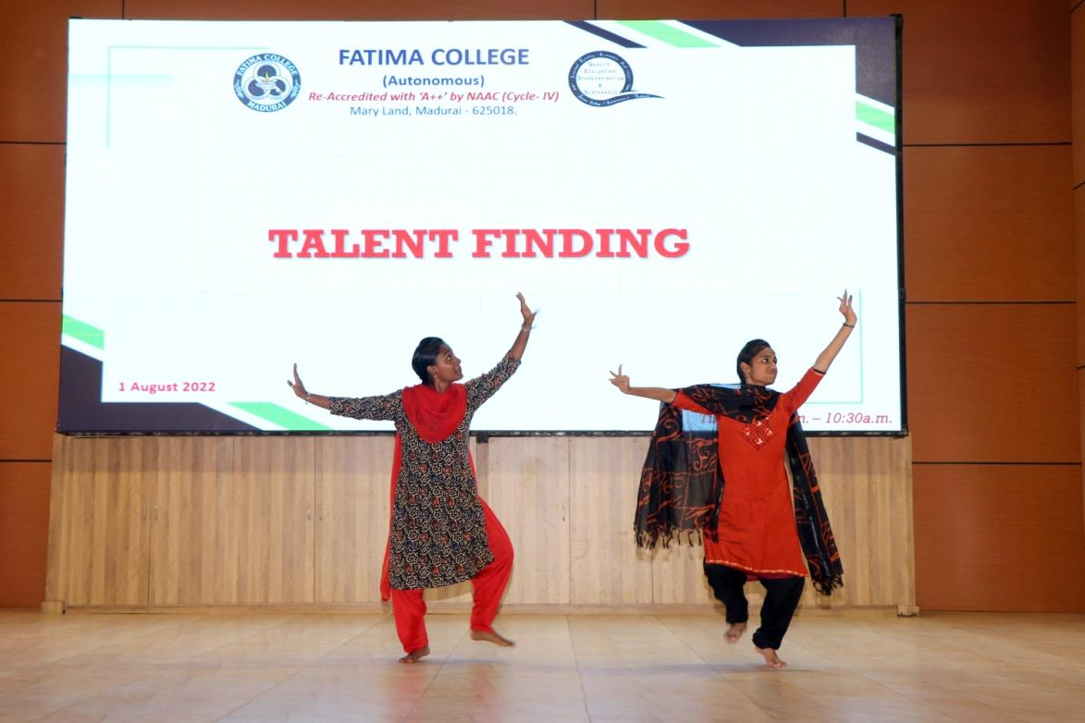
Feedback Form
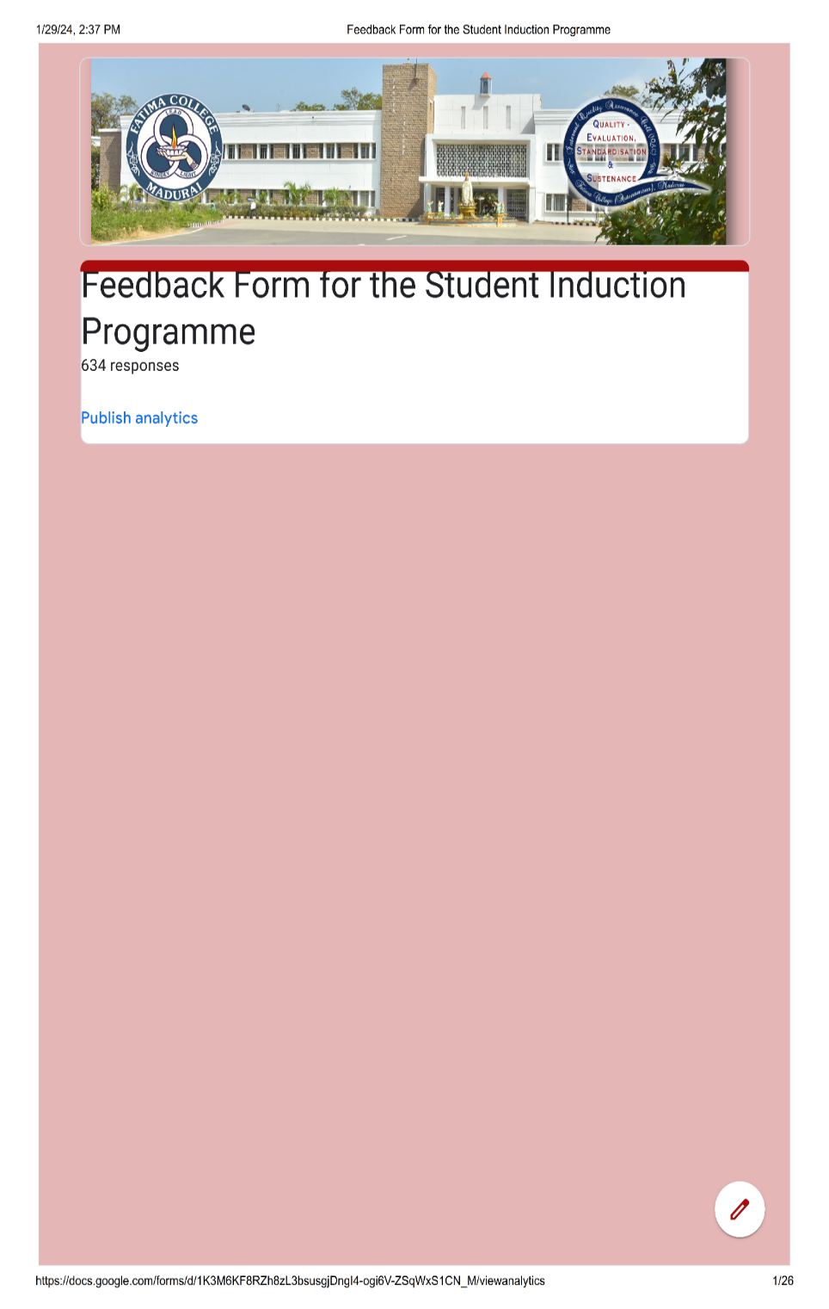:
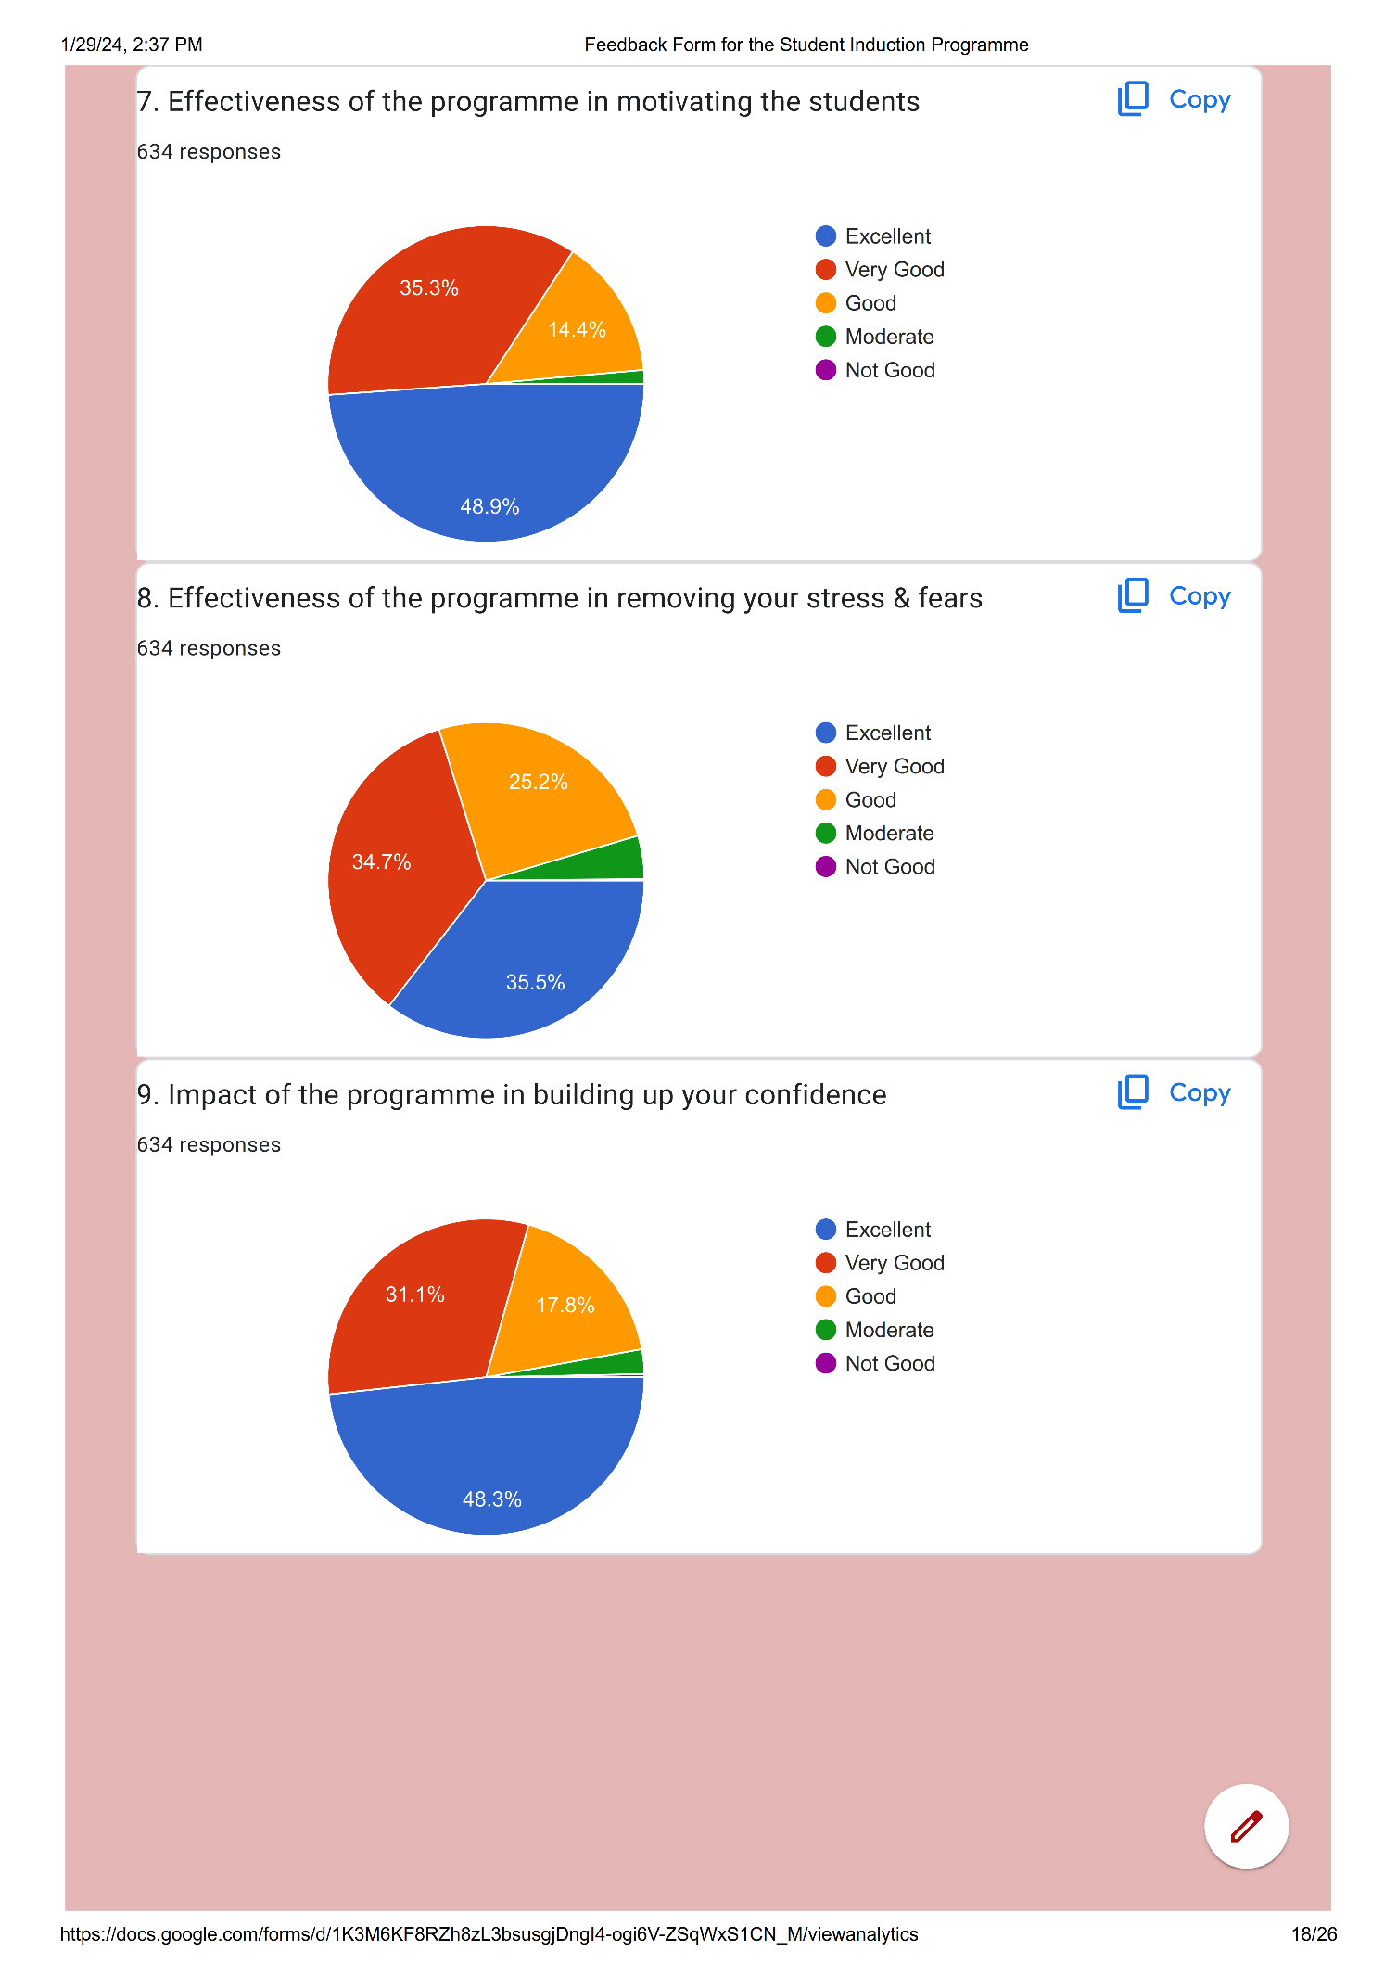
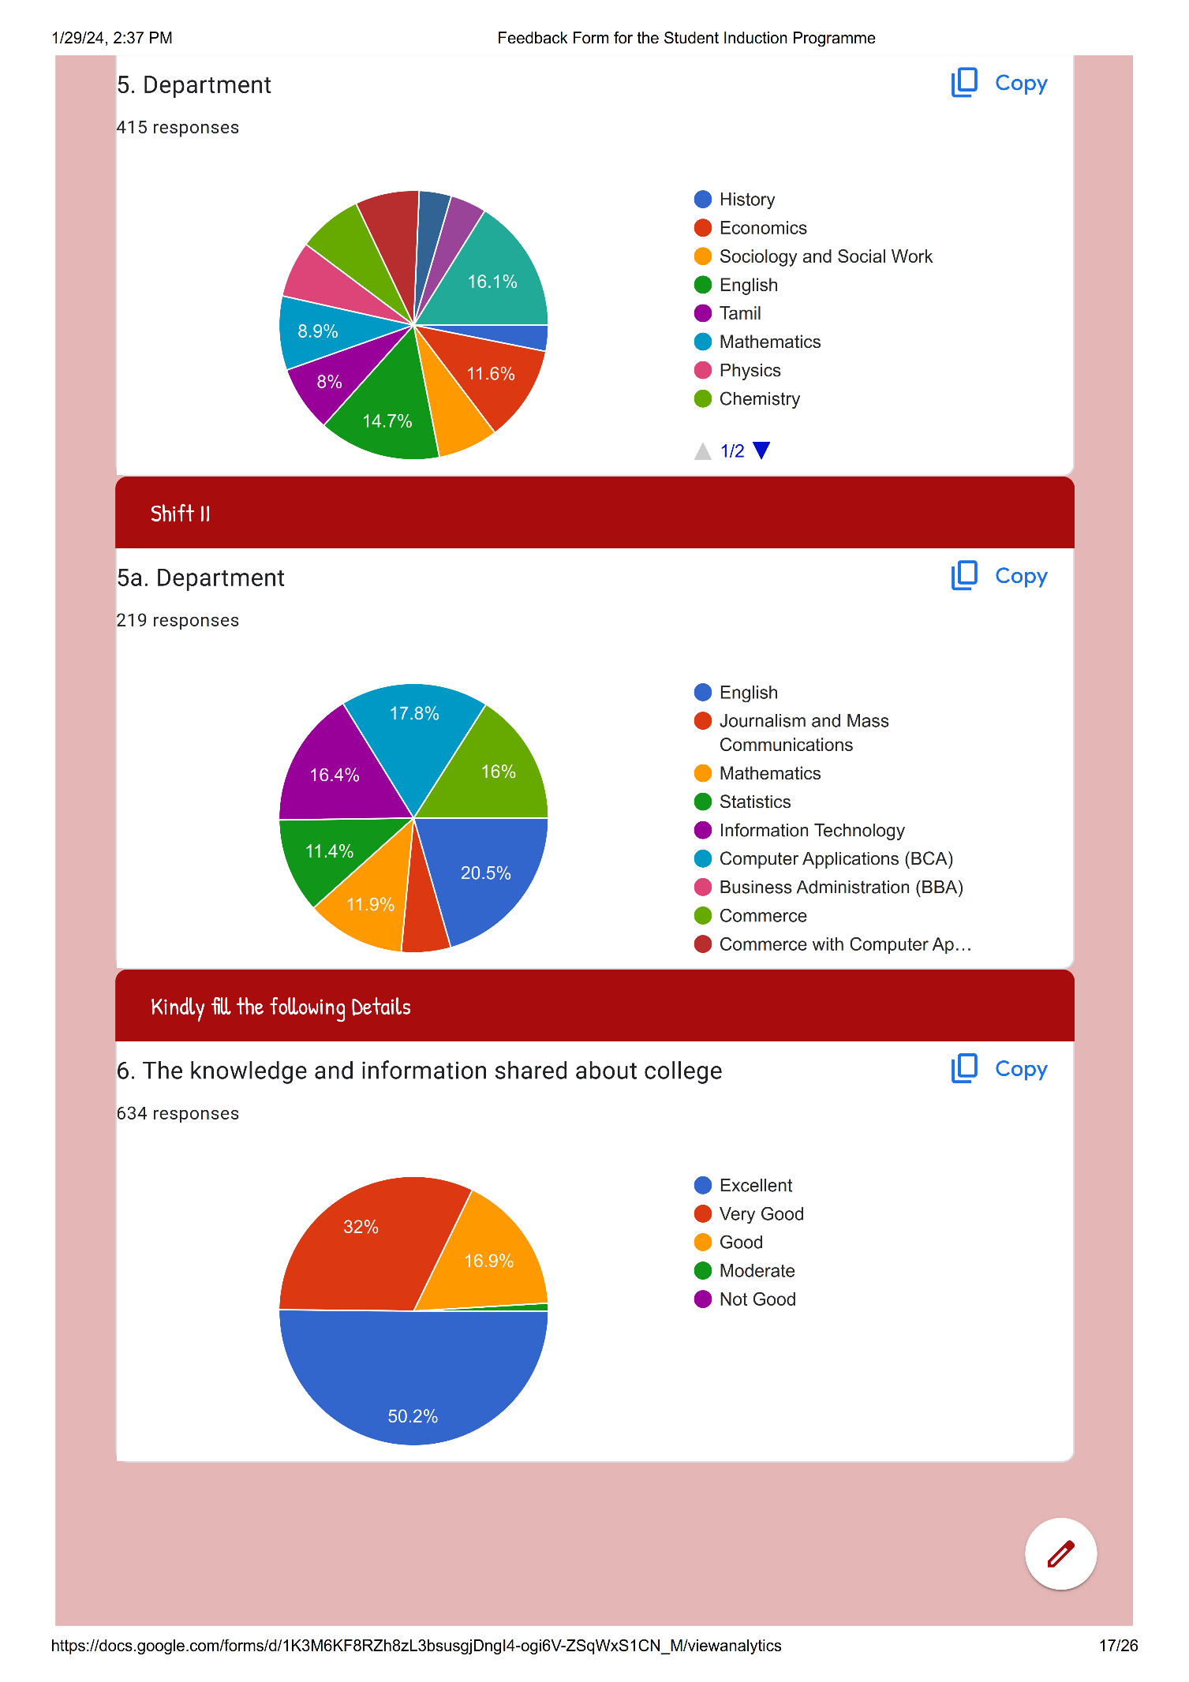
Student Responses: 634
S. No | Participant Name: | E-Mail: | Department | Any other Remarks / Suggestions
 | M.Sundareshwari | murugesan90925@gmail.com | Computer Applications (BCA) | Good
 | J. Heena Ali | nazrineali3@gmail.com | Computer Applications (BCA) | Good
 | J.Thabitha Suji | thabithasuji10@gmail.com | History | Good
 | G.Priyaveni | sivaramagopal1@gmail.com | History | Good
 | K. Mari Mohana | Marimohana2420@gmail.com | Computer Applications (BCA) | Good
 | N.Rajashree | Shreers2703@gmail.com | Computer Applications (BCA) | I want more motivation like this program
 | S.Sowmiya | S.sowmiyashanmugam9@gmail.com | Computer Applications (BCA) | Well & good experience
 | M.Jeevajothi | jeevajothimurugan2005@gmail.com | Computer Applications (BCA) | I have a lot of experience
 | Thasmitha.T | thasmit8@gmail.com | Tamil | Good
 | A. Auxilia | auxilia051@gmail.com | Commerce | No
 | Shree Gayathri | Shreegayathri68@gmail.com | Commerce | -
 | Shifa Fathima .S | sithiks1976@gmail.com | Commerce | No
 | S.Udaya | udhaya2855@gmail.com | Commerce | Good
 | A.Joe Thrisha | joethrisha@gmail.com | Commerce | Good
 | S Ranjani | sranjanisomasundaram@gmail.com | Chemistry | Good
 | Tony Prisha | tonyprisha0@gmail.com | Commerce | is a self-motivated to students
 | M. Maria Swetha | mariaswethams@gmail.Com | Commerce
 | A.Saniya Jenat | Saniyajenat1204@gmail.com | Commerce | It is useful to know about the college
 | S. Santhia | rameshsudha6774@gmail.com | Commerce | It changed my thoughts ..and the program was very helpful for me to get comfortable with the college. Good step towards student's welfare
 | M.Shabeeha Roshan | Shabeeharoshan8@gmail.com | Commerce | It's very useful to me to briefly know about the college
 | Sangeetha Jasmine .L | sangeejas01@gmail.com | Commerce | Yeah it's gud no any remarks
 | K.Loshini | jiviradhika45@gmail.com | Commerce | No
 | K.R.Aashika | aashika2005.18@gmail.com | Commerce | -
 | N.Irfana Nisha | nishairf1009@gmail.com | English | no suggestion everything has excellent
 | U.Yamini | y14200411@gmail.com | Commerce | I am highly thankful to you for providing me with an opportunity to be a part of your college.
 | Suganya V | suganyavinayagamoorthi@gmail.com | Commerce | Everything was good
 | F.Hepshiba Santhiya Roshini | arunarani1398@gmail.com | Commerce | All Good
 | A.Dilraz | dilraz2427@gmail.com | English | All Good
 | Shobana R | shobanaram2003@gmail.com | English | All Good
 | R.Sneka | rk2602592@gmail.com | English | All Good
 | V Carmel Theresa | Carmelvictor06@gmail.com | Commerce | -
 | K. Madhumitha | madhumithak19042005@gmail.com | English | No
 | P.Gracy Ruby | princeisac2005@gmail.com | Commerce | Good College
 | R.Janani | jananykanmany@gmail.com | English
 | A. Poorna Sankari | Poorna190804@gamail.Com | Commerce | I am highly thankful to you for providing me with an opportunity to be a part of your college.
 | Merlin Vinnarasi | merlinvinnarasi1207@gmail.com | English
 | C.Karthiga | karthigac2005@gmail.com | Commerce | No
 | S.Anu Priya | anupriya88004@gmail.com | Commerce | -
 | G.Swetha | Swethagopi539@gmail.com | Computer Applications (BCA) | -
 | Febricia Berlyn . D | febriciaberlyn02@gmail.com | English | Noo...
 | Harshini B. J. K | Harshini5858@gmail.com | Commerce | Everything is gud and excellent in our campus... One req is to plz allow to bring phone... Coz it's may useful for the student who coming through buses.... Thank you
 | Ramya I | Ilangoi724@gmail.com | English | This program was very useful to us  This program help us to better know about the college.
 | Hairoon Nisha | hairoonnisha13@gmail.com | English | All Good
 | G.Priyadharshini | lakshmi27041986@gmail.com | English | All Good
 | Viyashini | Viyashinisubramanian@gmail.com | English | No
 | Hajira | hhajira293@gmail.com | English | All Good
 | Angalaeswari | msundaram493@gmail.com | Commerce | All Good
 | J.Farhaana Jahir Hussain | Jahirhussain13021978@gmail.com | English | No
 | S.Varshini | gskumartn@gmail.com | Chemistry | All Good
 | C.S.Shalini | Shalinicss2004@gmail.com | English | All Good
 | Chethana.M | sasirekharadhakrishnan86@gmail.com | English | Nothing
 | Naina Toppo | nainatoppo16@gmail.com | English | All Good
 | Thahirun Nisha | thahirunnishat@gmail.com | English | Good
 | S. Sulthan Rukshana | Sulruk1234@gmail.com | English | All Good
 | B.Poorna | manjunlata@gmail.com | Commerce | All Good
 | A.Rizwana | ayishakani02@gmail.com | Chemistry | Nothing
 | Nivetha.A | Nivenirmal2010@gmail.com | Commerce | No
 | Krishna Ranjini .M | krishnaranjini2005@gmail.com | Commerce | Nothing
 | Archana Devi. M | marchanadevi2004@gmail.com | English | Everybody is good in the campus
 | M Kaviya | kaviyalogesh17@gmail.com | Commerce | All Good
 | Yuvasrigomathi.M | Yuvasrigomathi04@gmail.com | English | All Good
 | X.Persiya | persiyajothi@gmail.com | Commerce | No
 | M.Angalaeswari | msundram495@gamil.com | Commerce | Not only answer
 | Hajira. A | hajtf786@gmail.com | English | Nothing
 | Samreen J | samreenjahir15101975@gmail.com | Computer Applications (BCA) | -Nil-
 | X.Josephine Teresa | j72636173@gamail.com | Chemistry | Nothing
 | Y Jerlin Reega | jinojerlinsisters@gmail.com | Chemistry | Nothing
 | Keerthana. A | Keerthanaarivalagan01@gmail.com | English | No
 | Kalkitha N | kalkithanimalan@gmail.com | Commerce | Nil
 | Muthumari M | kittumari76@gmail.com | Commerce | All Good
 | A.S.Mary Jesli | maryjesli62@gmail.com | English | Super👌
 | V. Hema Priya | hemzzz571@gmail.com | Information Technology | All Good
 | K.Kalaiarasi | kalaiarasi4316@gmail.com | Chemistry | All Good
 | M.Priya Dharshini | pd7380847@gmail.com | English | No
 | J.Dayana Therasal | dayanatherasal@gmail.com | English | No
 | B.Infant Helina | infanthelina02@gmail.com | English | Nil
 | K. S. Tharshini Priya | tharshinikannan19@gmail.com | Computer Applications (BCA) | Nothing
 | Yazhini. S | yazhinisubramani004@gmail.com | English | All Good
 | D.Krishna Dharshini. | krishnadharshini54@gmail.com | English | All Good
 | M.Archana | archanamarimuthu54@gmail.com | English | No
 | M. Revathi | mkrishnaraju1970@gmail.com | English | Nothing
 | R.Mithuna | rmithuna75@gmail.com | English | All Good
 | Divya | divyam.31072003@gmail.com | Chemistry | Very usefull program for me
 | Akshaya | akshaya29012005@gmail.com | English | No
 | P.Shobika | Shobiprabu15@gmail.com | English | Nothing
 | Kavibala K S | kavibalakavibala05@gmail.com | English | All Good
 | Thirisana.R | rajajothiraja03@gmail.com | Commerce | All Good
 | Muskan Jaiswal. D | mj5160158@gmail.com | English | No suggestion
 | J.Vincy Rebeena | Vincyrebeena2005@gmail.com | Commerce | No
 | A.Yuga Shree | yugashree2004@gmail.com | Commerce | All Good
 | S. Varshini | Varshinisd100@gmail.com | English | No, I think the college rules are enough for us
 | S.Alvaseela Banu | Vaseelabanu14@gmail.com | English | All Good
 | D.Rajalakshmi | ezhilmemiste@gmail.com | Tamil | Good
 | V.Elizabeth | ebeth3268@gmail.com | English | I join the college after 3 days so I don't know about previous section kindly make some arrangements for that late admission students
 | S.Pradeepa | nsivamku@gmail.com | English | Nothing
 | P.Anamika | abishakepushparaj@gmail.com | Commerce | All Good
 | M Atchaya Dharshini | aswinatsaya@gmail.com | Chemistry | EXCELLENT
 | Gobika.S | gobisenthil.@g8mal.com | English | All Good
 | J.Kanish Rahima | ravinthkanish@gmail.com | Computer Applications (BCA) | Nothing
 | Abinaya.R | rajendranv725@gmail.com | English | Nil
 | Ninfa Annie J.C | ninfakodai@gmail.com | English | Nothing
 | Yaamini R | yaaminilaura58@gmail.com | English | All Good
 | F.Antony Maria Robisha | antonymariarobisha@gmail.com | Commerce | Nothing
 | S.Prathiba | prissilaprathiba0@gmail.com | English | The sessions were so informative
 | Swetha. S | swethasethu03@gmail.com | English | The programme helped us know about the details of the college which we might have not known if it was not conducted😇✨The terms curriculum,programme and course were clearly explained to us which was a new thing to learn😁We got an idea that we have several competitions coming ahead to explore our talents and this woke us up to develop our skills🤩We realized the features that are available in our Rosa mystica library too🤯❤Thank yu for the information that made us well informed before entering our majors😌
 | K.Thangam | guru20572@gmail.com | Physics | All Good
 | Bhavani. V | bhavacute2725@gmail.com | English | All Good
 | Geetha Varshini | geethavarshinig@gmail.com | Mathematics | Nothing
 | G.Geetha Hasini | geethahasinig@gmail.com | Mathematics | Kindly please put sitting tables for students!!
 | S.Abirami | abiparu2005@gmail.com | Tamil | No
 | Swarna Latha | shankarpoongodi376@gmail.com | Sociology and Social Work | I proud to be fatimites
 | Arul Jays.A | arulj2004henry@gmail.com | English | We want chair to set...
 | B.Infant Princy | infantprincy2004@gmail.com | Mathematics | I felt so sleepy throughout the programme
 | M.Bhavani Manikandan | bb0292446@gmail.com | Information Technology | This student induction programme is very useful to me . And I known about fatima college .
 | A. Carolina | Carolinaarasu33vi@gamil.com | Mathematics | No
 | U. Abinaya | abichitra2005@gmail.com | Commerce | No
 | A.Arulmancy | Arulmancy19742020@gmail.com | Mathematics | No
 | A. Jemila Michline | jayaroselin1980.jr@gmail.com | Mathematics | No
 | C.Shantha Chelva Gifta | giftagifta21@gmail.com | English | No
 | M.Maria Amala | aamalimani@gmail.com | Commerce | No
 | K.Yogeshwari | kaviparvathi2002@gmail.com | Commerce | All Good
 | Abinaya Raji,Nagaraj | kavinnila7474@gmail.com | Home Science | No
 | Gayathri G | ganeshan2017.p@gmail.com | Mathematics | All Good
 | A. Sopiya Jeyaseelin | Sopiyasopiya589@gmail.com | Commerce | All Good
 | N.Vaishnavi | ushaashamary1983@gmail.com | Mathematics | No Remaks
 | S.Sameena Banu | saminabhanu6369@gmail.com | Home Science | It's very useful to us...I. very proud to Study in this college...
 | M.Kaviyadevi | kaviyadevi91508@gmail.com | Mathematics | This program is very good for first year students to know about the Fatima college
 | A.Martina Celin | celinamalraj022@gmail.com | Mathematics | All Good
 | A. Immaculate Ratsinga | ratsingaimmaculate@gmail.com | Mathematics | All the programs are very useful and help me to motivate myself
 | M. Mukila | Moorthymukila@gmail.com | Mathematics | All Good
 | A. H. Humnna | jeharahumnna@gmail.com | Home Science | All Good
 | Arputha.K | kubendrank83@gmail.com | English | All Good
 | P. Murugeshwari | pandiyarajandharmaraj@gmail.com | Physics | All Good
 | N. Sweety | Jhokulins@gmail.com | English | No
 | S.Harini | harinisaravana638@gmail.com | Information Technology | All Good
 | S.Subarna | subarnasivaraj13@gmail.com | Physics | Way of explaining is excellent
 | R.Selvarani | selvarani.r1234@gmail.com | Mathematics | All Good
 | Saranya .A | Saranaya4040@gmail.com | Home Science | All Good
 | M.Abinaya | abi945827@gmail.com | Physics | I learned many information tq
 | A.Tansila | tansilaagcee@gmail.com | Chemistry | All Good
 | Lavanya N | lavanyalavanya1952@gmail.com | Computer Applications (BCA) | All Good
 | M.Yuvasri | yuvasrichitra770@gmail.com | Mathematics | All Good
 | Renitta | jospinrenitta2005@gmail.com | English | All Good
 | P.Deborah | mphilipesther@gmail.com | English | Everything is good
 | K R Lavanyadevi | lavanya2022ems@gmail.com | Home Science | -
 | B. Gomathi | gomathiboominathan357@gmail.com | Sociology and Social Work | Nothing
 | R.Rathi Priya | rbanumathi272@gmail.com | English | All Good
 | B.L.Meenalochini | meenulakshmanan2005@gamil.com | Sociology and Social Work | All Good
 | Roselin Mary | roselinm399@gmail.com | Commerce | All Good
 | V.Priyadharshini | Priyavenkatv0@gmail.com | Mathematics | No
 | A. Maryshelma | Shelmamary17@gmail.com | English | Helpful
 | Macrina | macrina0731@gmail.com | English | -
 | Idhaya Franklina. A | elizaidhaya@gmail.com | Commerce | None
 | A.Preethi | preethiannadurai23@gmail.com | Commerce | No suggestion
 | M. Vinothini | muthumaniaruthiramanim@gmail.com | Sociology and Social Work | All Good
 | B.Aishwarya | aishwaryabalamurali18@gmail.com | English | All Good
 | K. Kayal Vizhi | Kannankkannank811@gmail.com | Home Science | All Good
 | A.Remi | remiarockiasamy@gmail.com | Commerce | All Good
 | S.Shaliha | ibrahimibrahim74856@gmail.com | English | No  . Everything is good
 | A. Deepthi Lynette | deepthilynette972@gmail.com | English | All Good
 | R.Luckya | luckya0409@gmail.com | Commerce | All Good
 | P.Muruges Wari | Ambikap2867@gmail.com | Tamil | All Good
 | M.Nasrin Banu | haseenabanu86@gmail.com | Commerce | Program has been very useful to me
 | S.Indumathi | srinivasantvs1973@gmail.com | Sociology and Social Work | -
 | J. Carolina | carolinajesudasan@gmail.com | Commerce | No
 | Oviya . S | oviya3059@gmail.com | Chemistry | -
 | Dulaitta Mary . T | dulaittamary@gmail.com | Physics | Very good
 | S. Shwetha | vsatheeshkumar81@gmail.com | Information Technology | No
 | Muthu Priya | Mmuthupriya16@gmail.com | Tamil | All Good
 | K. Divya | divyababu701@gmail.com | Mathematics | All Good
 | M. Sahaya Roselin Jenifer | jenijasjenijas891@gmail.com | Commerce | All Good
 | S.J Akchaya Dharshini | akchayadharshinijeyabal@gmail.com | Mathematics | All Good
 | Manju Sree.E | e.manjusree@gmail.com | Mathematics | All Good
 | M Muthu Santhiya | mmsanthi555@gmail.com | Physics | M MUTHU SANTHIYA
 | A. Bhavani | abibhavani@gamil.com | Tamil | -
 | M.Mareeshwari | karupukarupu693@gmail.com | Tamil | -
 | V.Jenifer | jenifertriumph1033@gmail.com | Mathematics | Nothing
 | Aiswarya S | jayanthiradjakrishnan@gmail.com | Mathematics | Really It was an wonderful experience.
 | Harini.N | Senthoorvanitha@gmail.com | Mathematics | Good program of welcome party by our seniors
 | Harsini S B | harsinisb86@gmail.com | English | 5 minutes relaxation could be given inbetween the session as we sit for too long
 | A. Joice Rajam | orithamakthalin11@gmail.com | Commerce | -
 | K.Swetha | pavithrakarthi186@gmail.com | Mathematics | -
 | Ilakkiya Jothi.R | mkail3583@gmail.com | History | No
 | Rubhika P | rubhika.p@gmail.com | Mathematics | No
 | R Hema Sree | Selvikalaiselvi172@gmail.com | Tamil | All the induction programme for the first years is good for them to analysis their knowledge level about college
 | V. Monika Devi | visaganhemanath@gmail.com | Tamil
 | M.Miraclin Chella Vailankanni | miraclinchellavailankanni@gmail.com | English | The program served as a great way of communication and helped students to build confidence to excel in various fields .More programs like this should be conducted by the college in upcoming years
 | A.Amirtha Varshini | amirtha2004@gmail.com | Physics | All the sessions are useful and movitave myself
 | J Akshitha | padhu.akshu@gmail.com | English | Nil
 | Amirtha.S | jeyapackiamsethu@gail.com | Mathematics | All Good
 | M.Bharathi Priya | vennilamuthusamy17@gmail.com | Home Science | All Good
 | Malathi.M | Josilin75@gmail.com | History | All Good
 | Joshna Berlin Roy J | joshnajerard24@gmail.com | Computer Science | All Good
 | C.Sarojini | mudhupandic2006@gmail.com | Tamil | All Good
 | C.M.Azhagu Sabari Bala | Azhagusabaribala2675@gmail.com | Sociology and Social Work | Good
 | Karolin Mini . R | Karolinmini5@gmail.com | English | No
 | P.Kaviya | rajakuttys12345@gmail.com | Tamil | Good
 | Rinoviola. X | rinoviola107@gmail.com | Computer Science | Enjoyed a lot..
 | Lalima R | lalimalalima29@gmail.com | Information Technology | I like all mam speech and all mam's are so kindly say all the information about college i like it.
 | Dharshini. A | dharshinialagumurugan645@gmail.com | Commerce | -
 | S.Mahalakshmi | mahalakshmidhanam2005@gmail.com | Tamil | No
 | S.Abirami | alagappanmdu222@gmil.com | Tamil | S.Abirami
 | C.Iswarya | Jegansami6@gmail.com | Tamil | Very good
 | J. Janet Rodrigo | judysherlinjanet@gmail.com | English | All Good
 | R.Priyadharshini | pd838721@gmail.com | Computer Science | All Good
 | A.Baveena | arumugambaveena@gmail.com | Mathematics | Nothing
 | Varshine R.S | varshinersb@gmail.com | Computer Applications (BCA) | All the activities are excellent and mind-blowing
 | P.Akila | v.pandikamala@gmail.com | Chemistry | -
 | Kosalai P | kingbell555@gmail.com | Tamil | All are good...
 | K.Deepika | deepika200519@gmail.com | Computer Applications (BCA) | No
 | S.Selvi | sherinselvi31@gmail.com | English | -
 | Mohana | mohana1105t@gmail.com | Commerce | No , remarks
 | Varshini | shanthimathav@gmail.com | Physics | Good
 | R.Kamatchi | kamatchiramar2004@gmail.com | Computer Applications (BCA) | Overall,it was such a good program
 | S.Narkees | Narkeess25@gmail.com | Mathematics | Freshers party is excellent
 | M.Gatlin Swetha | Nivethasuvetha2005@gmail.com | History | Great experience
 | N. Keerthana | Keerthananagendran@gmail.com | English | It's very Useful.. Learnt many things about College and Studies.. Very Excellent..
 | A.Thasneem Begam | thas5992@gmail.com | English | No
 | Anusiya.B | b.anusiyadevi2005@gmail.com | English | No
 | L.Kiruba | kirubakiru2004@gmail.com | Computer Science | -
 | M.Gayathri | Mahalingampandian1969@gmail.com | Tamil | No
 | J. Sherline Nishaa | Sherlinenishaa2004@gmail.com | Commerce | No
 | A. Meenalosini | meenalosini233@gmail.Com | Chemistry | No remarks.. Useful program
 | A.Arokiya Amala Santhiya | jamesalpin931@gmail.com | Computer Science | -
 | Sr. G. Celine Sahaya Mary | Subha2612@gmail.com | Tamil | Good
 | S.Lizy | Johnnoel.lvb@gmail.com | English | No
 | Pavithra | Sankarpavithra14@gmail.com | Information Technology | -
 | B.Dharini | dharini352005@gmail.com | English | No
 | V.Arockia Christina | arockiaroobina@gmail.com | Chemistry | -
 | A.Hema Kanikkai Tresa | hemakanikkaitresa2004@gmail.com | Computer Science | No
 | Fathima Zohara.R | hussainraja445@gmail.com | Chemistry | Nothing ,its good
 | Hamza Hassain | rockhamzahassain@gmail.com | Sociology and Social Work | Bhd
 | D.Gayathri | gayathritharmendran2003@gmail.com | Mathematics | No
 | M. Ramya | muthuramya252@gmail.com | Chemistry | No
 | M.Dhanya Shree | Dhanyashree2995@gmail.com | Chemistry | Nothing
 | Fathima John | sumaiyafathima9716@gmail.com | English | -
 | Yuvarani.S | 2020L17@fcmdu.edu.in | English | No suggestions
 | A.Betchi Bavya | rajamedilta@gmail.com | Computer Science | -
 | Jemima .A | jemiabraham123@gmail.com | Computer Science | All Good
 | Ashifa | saithabanu83@gmail.com | Home Science | -
 | Janane S | mailtosasikumar1973@gmail.com | Computer Applications (BCA) | No
 | V. R. Swathi Priya | swathiravikumar2404@gmail.com | Economics | -
 | S.Dhiviya Darisini | dhiviyadarisini@gmail.com | Mathematics | All Good
 | Anushya | Anushyaravisterraj@gmail.com | Tamil | No
 | Sophia Shas N | sophiashas1804@gmail.com | Mathematics | -
 | B.Janani | jananijanani74350@gmail.com | Economics | -
 | S.Siva Roobini | Selvasnkl24@gmail.com | Chemistry | It was very helpful. It helps me to know about the college infrastructures and the opportunities as well as the credit courses. Thank u for all the teachers to motivate us.....thank u so much
 | R.Ilakkiya | rilakkiyarilakkiya08@gmail.com | Mathematics | Very Good
 | Maria Jeba Thimona | theresalveethustheresal@gmail.com | Home Science | No
 | Jeevitha K | jeevikarnan@gmail.com | Chemistry | Great session
 | Mini Priya M | priyamini047@gmail.com | Zoology | No remarks
 | T. Kunthavai | tmkunthavai@gmail.com | Economics | -
 | A. Kavitha | attukarankavitha@gmail.com | Economics | I like that all MOTIVATIONAL SPEECH to useful 👍 for my life
 | Dharaniselvam | dharaniselvam2608@gmail.com | Economics | All Good
 | V Karthika | karthikavengadesan2k5@gmail.com | Economics | -
 | P.Sandhiya | Prabakaransivakami68@gmail.comcom | Chemistry | All Good
 | A.Jainual Juhaina | Ahamedfaleela@gmail.com | Home Science | No remarks
 | Karpaga Varthini .V | genkatg278@gmail.com | Economics | All Good
 | Asma S | asma30102004@gmail.com | Mathematics | All Good
 | T.Seyathali Fathima | Seyathaifathima1901@gmail.com | Economics | Nope
 | N.S.Mythili | mythilins05@gmail.com | Computer Science | All Good
 | Mini Kavitha.P | minikavi11@gmail.com | Home Science | I really enjoyed and gain some knowledge from this programme
 | R.Shalini | priyar0809@gmail.com | Zoology | Nothing to say. All programmes is very useful to me.
 | S. Licy Winslet | licysujivan@gmail.com | Zoology | All Good
 | Aisashithikka. N | naisashithikka764@gmail.com | Zoology | All Good
 | M.Archana | archanaarchu36786@gmail.com | English | All Good
 | A. Devishri | elakkiyaayyappan016@gmail.com | Mathematics | It is very useful for me for knowing this college
 | K.K.Devaki | devakikannan4@gmail.com | Economics | -
 | V.Rashmitha | vrasmithar@gmail.com | Economics | Good
 | P.Vinotha | Vinoth9842859151@gmail.com | Mathematics | All Good
 | R.Jessintha Mary | jessinthamary2@gmail.com | English | No suggestions
 | M.Sandhiya | ilamathivanan@gmail.com | Chemistry | Nothing
 | A.Pavithra | Anitha21mdu@gmail.com | Sociology and Social Work | All Good
 | S.Thirumalar | Thirumalarsuresh2005@gmail.com | Chemistry | No
 | I.Jeba Cathrin | jelinjeba7@gmail.com | English | It's nice
 | Anusanthalika | Santhalika2005@gmail.com | Chemistry | Nothing
 | Varshini | Varshuk311004@gmail.com | Economics | No remarks
 | M.Nithya | nithyamalaiyappan@gmail.com | Commerce | No
 | Gifta Angelin.D | giftaregina@gmail.com | Home Science | All Good
 | K.Shefana Banu | afsiyaafsiya7@gmail.com | Physics | No
 | Iswarya.G | iswaryaganesh2124@gmail.com | Economics | All Good
 | Denita Vinish Radan Sr | denitaradan.dvr2004@gmail.com | Zoology | All things are good.no other suggestions.
 | M. Kanmani | Kanmanim646@gmail.com | Tamil | Student Induction programme is Good
 | M. Riya | riyaraju30@gmail.com | English | No
 | Dhanusri.S | dhanusrisrithar@gmail.com | Zoology | It is really useful for me to understand more about college
 | S .Swathi | Swathisivachandran11@gmail.com | Sociology and Social Work | All Good
 | R.Vedha Valli | rajagopalthanasekaran@gmail.com | Economics | No Remarks
 | S.Parthasarathi Priyai | arasu.kumar73@gmail.com | Commerce | No remarks
 | R.Panimalar | Panim2005@gmail.com | Commerce | No
 | P.Priyanka | priyankapalpandi13@gmail.com | English | No
 | R.Kaleeswari | kaleeswarir2005@gmail.com | Economics | No
 | S.Sivacelcya | Petsenthil5@gmail.com | English | It is very useful for me
 | Sandhiya.G | gopalsandhiya923@gmail.com | Economics | 492
 | M Soma Sundari | mrlingam569@gmail.com | Economics | No
 | Soorya Preethi C | sooryapreethoi0612@gmail.com | Zoology | On the whole it was good for building up confidence and for socializing with my peer groups
 | Preethi A | arumugamramaiah8@gamil.co. | Economics | No
 | S.Srinithi | srinithi233@gmail.com | Physics | All Good
 | B.Gayathri | Gayathribalachandran11@gmail.com | English | All Good
 | K.J.Sakana Sri | Sakanasrijothikavitha@gmail.com | Chemistry | All Good
 | Swetha.S | swethaselvam964@gmail.com | Sociology and Social Work | Overall program is very good.
 | K.Bhavani | amuthabhavani74@gmail.com | Physics | No
 | Madhumitha. D | madhumithadeivendran@gmail.com | English | Very useful&nice experience thanks a lot to all of our mams and seniors
 | P. Gayathri | ggayu2381@gmail.com | Economics | No
 | Karan Priya G | vasanthiganesan07@gmail.com | English | The program was interesting and motivate the students to achieve their goals
 | D.Karishma | mahimajudi@gmail.com | Economics | No
 | G.Renukaa | ganeshanmani617.@gmail.com | Zoology | This is excellent college with many good infrastructure and in teaching manners it will help for us and for our good career thank you so much
 | V.P.Srinithi | vpsrinithi87@gmail.com | Information Technology | All Good
 | S.Madhumitha | atrpathy02@gmail.com | Zoology | Good
 | S.Sivacelcya | Petsenthil5@gmail.com | English | It is very useful for me
 | T. Lakshmi Priya | Priyatlakshmi1@gmail.com | Zoology | All are good
 | P.Harini | ganamharini@gmail.com | Economics | All Good
 | Samyuktaa V | samyuktaabarathi@gmail.com | Physics | Can include many other innovative programs in SIP to make the students feel more engaged.
 | Jayalalitha. P | jayalalitha573@gmail.com | Economics | No
 | Meenamba.A | meenamba.akil@gmail.com | Zoology | All Good
 | Yazhini.P | Pandiarajanyazhini@gmail.com | Zoology | All Good
 | Gr Ratsaka | grratsakar2004@gmail.com | Economics | No
 | P.Sharini | sharinichelvan@gmail.com | Economics | Very good 👍🏻
 | M.Vimala | Michaelrajraj570@gmail.com | Economics | No
 | Kanniga R | kannigarathina@gmail.com | Zoology | No
 | M.. Arockia Annie Nilofer | nilofarniloson@gmail.com | English | No
 | G.Karthiga | rguna8347@gmail.com | Zoology | All Good
 | F.Helan | f.helan2005@gmail.com | Commerce | No remarks
 | K.Arulnathi | rpkumarrpkumar3@gmail.com | Economics | Good
 | Bhava Shree A | abhavashree2004@gmail.com | Economics | All Good
 | Shobana | Deepakmanikandan2905@gmail.com | Zoology | All Good
 | M.Mahalakshmi | mahalakshmi25062005@gamil.com | Tamil | The programme is very useful.
 | B.Sasi Rubiya | Viratjeeva1425@gmail.com | Economics | All Good
 | J.Nandhini Devi | nandhinijaisankar@gmail.com | Economics | All Good
 | Anu Rahini . D | dee15pak@gmail.com | Tamil | All Good
 | S.Nachammai | nachammai.sundaram@yahoo.com | Information Technology | Program is More useful to us,give us Confidence towards the College and the Course
 | J.Christina Infenta | Christinainfenta@gmail.com | Computer Science | All Good
 | D.Jaclin | Jaclind47@gmail.com | Commerce | All Good
 | Aeonachawla.T | manchysuyha@gmail.com | English | Nothing..
 | Hajira Banu | rasik028bazzar@gmail.com | Economics | Induction programme is very useful for me our education system and enjoy very well. I learn knowledge and information about the college.
 | A.Jessica Angelin | jessicaannadurai@gmail.com | Home Science | We gain a lot of information about college facilities and it's rules.it helped and also will help me a lot for upcoming days.Thank you for this session and this is really useful for us.
 | Angel Hepshepa | jenifer041999@gmail.com | History | All Good
 | K.Janani Shree | Kannan101214@gmail.com | Zoology | No
 | Bharathi M | bharathi.economics22@gmail.com | Economics | No
 | R. Uma | 2019mb10dharani@gmail.com | English | No
 | Jayaharitha.J | jayaharithajaiganesh@gmail.com | Economics | Keep it up
 | A.Iris Jessica | irisjessica2712@gmail.com | Information Technology | All Good
 | S. Santhiya | Jeyasenthil37@gmail.com | English | All Good
 | Mahalakshmi K | deepimaha22@gmail.com | Information Technology | All Good
 | R. Dhanusha | rk9075540@gmail.com | Zoology | No
 | V. Mani Bharathi | Bharathimani344@gmail.com | Economics | No
 | J.Heeramathi | vannamathij@gmail.com | Tamil | No
 | M.Nithiyasree | hemamurugan1357@gmail.com | English | All Good
 | R.Sugirtha | Sugirtha24r@gmail.com | Economics | All Good
 | K.Pooja | Kjeevashobha@gmail.com | Commerce | Helped me gain confidence...
 | Sanjudha .M | suregasanju@gmail.com | Commerce | Noo
 | P.Parkavi | sk8128968@gmail.com | Tamil | No
 | K. Sarumathy | nandhinikumar2k2@gmail.com | Economics | Phone allow panunga
 | Lara Angel | jpauldoniyal@gmail.com | Computer Science | No
 | Kesavika.K | gurukifs@gmail.com | Commerce | no
 | K.Samayalakshmi | Samayalakshmi05102004@gmail.com | Commerce | All Good
 | Joan Lity Infanta A | joan01278@gmail.com | Chemistry | All Good
 | S. Prithiga | chitraprithi8887@gmail.com | Economics | Nothing
 | C.M.Rohini | briyani18mku2004@gmail.com | Chemistry | This programme is very useful
 | N. Shivani Rajashree | Shivanirajashree@gmail.com | Physics | All Good
 | Girija Velpandi | murugeshwari7@gmail.com | Chemistry | No. I don't
 | K. Amala Jency | amalajency310@gmail.com | Commerce | I am highly thankful to you for providing me with an opportunity to be a part of your college
 | J.Jasmine Packiya | Jasminepackiya088@gmail.com | Computer Science | No
 | Sabana Yasmin.S | Yasminsabana304@gmail.com | English | No
 | P.Iswarya Sarojini | ISWARYASAROJINI@GMAIL.COM | Economics | Nothing
 | Swetha K | m1349487@gmail.com | English | All Good
 | Rameena I | rameenai653@gmail.com | Tamil | All Good
 | S Dhivyabharathi | sdhivyab@gamil.com | Economics | All Good
 | S.N.Shanthini | Shanthinisn2205@gmail.com | English | I like it very much
 | Kavya.V | sripriyavijaysundar@gmail.com | Physics | Satisfied with the way of teaching of the assistant professors
 | M.Potheswari | smuthupandi610@gmail.com | English | All Good
 | S. Priyadharshini | spriyadharshini05122004@gmail.com | Information Technology | All Good
 | R.Hema Dharshini | hemadharshini834@gmail.com | Information Technology | All Good
 | M. Gayathri | gmgayathri67@gmail.com | Tamil | I love collage
 | M . M Utheeshwari | qdazzling43@gmail.com | Economics | Nothing
 | S.Rajeshwari | strrajeshwari@gmail.com | Information Technology | All Good
 | S.Noaline Flora | fizzyflora1306@gmail.com | English | All Good
 | Reenga.J | Reengakeerthi@gmail.co | Economics | No
 | K.Sameena Begum | K.sameenabegum241@gmail.com | Computer Applications (BCA) | All Good
 | S. Sobhikadevi | solaikumar809@gmail.com | Computer Science | All Good
 | S. Bhuvaneshwari | Siva46228@gmail.com | Chemistry | All Good
 | S. Sathieswari | Ssuresh78331@gmail.com | Information Technology | All Good
 | S.Sahaya Ancy Sugirtha | sahayamejemes@gmail.com | Commerce | No suggestions
 | S.Thaarani | Thaaranisukumar@gmail.com | Information Technology | No
 | V. Rohini | 0516rohinimurugan@gmail.com | Commerce | All Good
 | M.Mala | malamuthuraj64@gmail.com | Economics | No
 | R.Abinaya | Abinayaselvimadurai2005@gmail.com | Zoology | Nothing else
 | M. Rohini | rohinipapa298@gmail.com | Chemistry | மிகவும் நல்ல கல்லூரி
 | V.Manimegalai | manimegalaiv18102004@gmail.com | Zoology | No
 | Dr.Sr.G.Celine Sahaya Mary | arockiyasalomiyad@gmail.com | Economics | Improve
 | P.Nithishree | nithishree2004@gmail.com | Zoology | All Good
 | Lakshmi Priya | priyaishu164@gmail.com | Economics | Noo
 | J.Imakulin Sweetika | sweetistella@gmail.com | Computer Science | Good
 | A.Abitha | abishekashok16@gmail.com | Chemistry | Good
 | R.Kaviya | Kaviyavisalachi@gmail.com | Computer Applications (BCA) | All Good
 | C.Kiruba Jasper | jaspercibi@gmail.com | Commerce | All Good
 | S.Shanthini | Sonavikraman20@gmail.com | Sociology and Social Work | Nothing
 | M.Karthiga Prrasanna | karthigaprrasannamurugan@gmail.com | Home Science | All Good
 | S.Mariyammal | suresh63696@gmail.com | English | No
 | Vanitha.J | vini35204@gmail.com | Chemistry | Nothing
 | Faisul Rifana.A | allahpitchaiallahpitchai131@gmail.com | Computer Applications (BCA) | No
 | Varshini.N | natarajan201069@gmail.com | Information Technology | All Good
 | A.Harene | jojerlin04@gmail.com | Zoology | All Good
 | Lavanya Shanmugam | 14lavanya2005@gmail.com | Information Technology | I like my college
 | Ajitha E | theekar0410@gmail.com | Physics | No
 | Rubica.P | Rubica2806@gmail.com | English
 | Roshika. P | Pandi141179@gmail.com | Zoology | Everything is nice
 | Santhiya .C | santhiyadevi1606@gmail.com | Computer Applications (BCA) | Nope
 | M. Srimathi | boomikasri06@gmail.com | Information Technology | All Good
 | R. Madhumitha | madhu.raj0913@gmail.com | Information Technology | Well & Good
 | J.Deepika | deepijeya16@gmail.com | Zoology | It is very useful.
 | M.Rajakumari | Kumariraja68960@gmail.com | Information Technology | Very good
 | P .Henisha | Pawnraj06@gmail.com | English | All Good
 | R.Dhanusri | dhanusrir84@gmail.com | Information Technology | No
 | V.Subalakshmi | swethapappa0708@gmail.com | Tamil | Good
 | M.Sowmiya | muuganchidambaram@gmail.com | Information Technology | All Good
 | M.Booma Devi | boomadevim33@gmail.com | Information Technology | No suggestion
 | Subhiksha | sekaranvijaya73@gmail.com | History | I feel to be good in the college campus ,thank you for your infrastructure to all the students..
 | Santhiya | Mathanmathannn@gmail.com | Economics | All Good
 | G.Sharmili | gsharmili2010@gmail.com | Information Technology | No
 | P.Felixya Merlin | felixyamerlin@gmail.com | Computer Applications (BCA) | All Good
 | J.Pagampriyal | jpagampriyal@gmail.com | Physics | All Good
 | A.Nandhini | asumathi087@gmail.com | Computer Applications (BCA) | All Good
 | M.Krishna Priya | mjayarani0@gmail.com | Computer Applications (BCA) | Bridge course was very usefull to improve our English knowledge
 | B. K. Agalya | www.akalyaasmitha123@gmail.com | Computer Applications (BCA) | Yess.. This program is very useful to me.. To face without fear in any things
 | V. M.Divya Dharshini | divyadmuruganantham123@gamil.con | Computer Applications (BCA) | All Good
 | T. Sivadharshini | selvamthiru955@gmail.com | Computer Applications (BCA) | No
 | Priyanka | priyanka197004@gmail.com | Computer Applications (BCA) | No
 | Mahalakshmi | mahabalram02@gmail.com | Computer Applications (BCA) | All Good
 | K.Viveka Srilakshmi | subhasubha9480@gmail.com | Computer Applications (BCA) | All Good
 | Bharathi.R | nagavijay1303@gmail.com | Computer Applications (BCA) | No
 | S.Cecilia Mary | Sesuliander@gmail.com | Computer Applications (BCA) | All Good
 | J.Nancy | Johnkennedy120705@gmail.com | Information Technology | Excellent
 | Sindhuvaliyammai | sknagappan@yahoo.com | Computer Applications (BCA) | Excellent 👍🏽
 | M.Suganthi | Suganthisugan876@gmail.com | Computer Applications (BCA) | All Good
 | R. Bhala Shivani | bhalajeya@gmail.com | Computer Applications (BCA) | All Good
 | M.Dowlathul Kathira | dowlathulkathira@gmail.com | English | Yes..it's really good
 | M. Lavanya | ml0795016@gmail.com | Information Technology | No
 | M.Muthu Bhavani | seguprabhav@gmail.com | Information Technology | Very good
 | Hershel Rayen.P | hershelrayen2004@gamil.com | Computer Applications (BCA) | No
 | M.Priyadharshini Vinnarasi | mariasahayaraja1969@gmail.com | Computer Science | Good
 | Jemima Josi.J | josijemima@gmail.com | Information Technology | All are super excellent
 | M.Udhaya Sri | udhaya221204@gmail.com | Computer Applications (BCA) | Good
 | Soundarya | nithisponraj2007@gmail.com | Physics | Good
 | Belinda B | belindabenjamin04@gmail.com | Computer Applications (BCA) | Excellent 👍🏽
 | Pramika | Pramikarani24@gmail.com | Computer Applications (BCA) | Good
 | Santhiya. T | Lovelysiva0204@gmail.com | Zoology | No
 | N.Krithika | nkrithika1706@gmail.com | History | Smooth going bridge course, thank u for the initiation
 | R V Deepthi Thangam | rvdeepthi1609@gmail.com | English | Good
 | Merlin.S | merlinsedm27@gmail.com | Physics | Good
 | S.Suchithra Benaticta | suchithrabenaticta@gmail.com | Chemistry | Excellent
 | V Sujitha | vsujitha649@gmail.com | History | Good
 | A.Jeba | jebabeula13@gmail.com | Home Science | No
 | S. B. Anbu Asha | ammukutty@gmail.com | Information Technology | No
 | M.Logeshwari | gomathimurukeshan@mail.com | Tamil | I feel lonely in my class
 | Devadharshini | Kdevadharshinik705@gmail.com | Sociology and Social Work | Good
 | R.Balasubetha | subethavenirajendran888@email.com | Zoology | The program was very good but the day of the session was more, So I feel little bored. The opportunity was given in the college was excellent.
 | M. Vishnupriya | moorthi1978s@gmail.com | Physics | No
 | B.Maria Christina Jefrin | mariajefrin13@gmail.com | Computer Applications (BCA) | Good
 | V.Kaviya | Kaviyavijayan243@gmail.com | History | Nill
 | R. Priyanka | priyaramesh767@gmail.com | English | No
 | J Arockiya Mesiya | mesiyaarockiya@gmail.com | English | Good
 | J Annie Joselin | jrboso1976@gmail.com | Physics | Good
 | S.Arockia Silviya | arockiasilviyasilviya@gmail.com | English | No
 | B. Elakkiya Arasi | elakkiyaarasi74@gmail.com | Sociology and Social Work | Everything was good
 | S.Sangeetha | Senthil.jaihind@gmail.com | Mathematics | No. The programme is perfect
 | Almas Banu.Y | 20052007almu@gmail.com | Information Technology | Good
 | S. Infant Jesly | josuva4549@gmail.com | Chemistry | Good
 | T. Deva Dharani | devadharani6090@gmail.com | Sociology and Social Work | Good
 | Mareeswari M | mareeswari5795@gmail.com | Tamil | All the arrangements are very good
 | Praveena | nmnv3656@gmail.com | Sociology and Social Work | Suggest
 | Tamilselvi | T.tamilselvi2435@gmail.com | Sociology and Social Work | Good
 | M.Priya | mpriya31122004@gmail.com | Sociology and Social Work | No
 | Dharshini.B | dharshinib011@gmail.com | Sociology and Social Work | No
 | K.Kaviya | k.kaviyakanagavel0@gmail.com | Mathematics | Good experience
 | K . Bhuvaneshwari | pooranam4050@gmail.com | History | Good
 | S.Indhuja | indhujasaravanan776@gmail.com | Computer Applications (BCA) | Well and good
 | S.Abitha Devi | abithadevi2004@gmail.com | Sociology and Social Work | No
 | P.Abinaya | vapdeva12@gmail.com | Information Technology | This program will very useful to me
 | B. Priyadharshini | barathi93451@gmail.com | Information Technology | Good
 | A.Bhuvanalakshmi | Panju8903633256@gmail.com | Mathematics | Nothing
 | Muthu Mathi.A | mathiarun2004@gmail.com | Computer Science | Thnks for the useful and excellent program
 | U. Ajitha | Indraajitha@gmail.com | History | Good
 | W. Sherlyn Lourdu Mary | wsherlynlourdumary@gmail.com | Home Science | Good
 | Maria Antonio Noyella A | Noyella2002@gmail.com | Information Technology | I really like the students induction programme, the time i have spent on the programme was very useful for me. I would like to say thank you to the teachers for such an amazing time.
 | M.Dhaniya Shree | dhaniyaindia@gmail.com | Economics | No
 | B.Janani | Karnanbhawani23@gmail.com | Sociology and Social Work | No
 | B. Nageshwari | Balamuruganb393@gmail.com | Tamil | The program very use ful my life and college study's ✨😻
 | A.Shreenithi | Shreenithi1105@gmail.com | English | Good
 | M. Ebro Nimisha | nimisham061@gmail.com | English | Good
 | Flaciya | flaciya17@gmail.com | English | Good
 | V.Kaviyadharshini | Kaviyadharshini.200544@gmail.com | Physics | Good
 | B.Jenita | antojeni004@gmail.com | Information Technology | Good
 | M. Sahaya Shalini | Sahayashalini75@gmail.com | English | Good
 | T.Kiruthiga | tamilarasan1974@gmail.com | Physics | No
 | Dharshini | dharshinib011@gmail.com | Sociology and Social Work | No,I like the programme
 | P.Vindhiya | Vindhiyapuruchothaman@gmail.com | Sociology and Social Work | No
 | A. Kani Priya | Kp6702728@gmail.com | Tamil | Good
 | Sameera S | sameeras0309@gmail.com | Sociology and Social Work | Good
 | A.Sakthi | a.saky1712@gmail.com | Sociology and Social Work | Good experience❤️
 | Narmadha | porselvi150@gmail.com | English | Very good.
 | Dhanalakshmi V | dl20002003@gmail.com | Sociology and Social Work | Good
 | Deni Flencia | dflencia@gmail.com | Computer Science | Good
 | K.R.Harshini | harshinikalidasss@gmail.com | Commerce | Good
 | Dhanalakshmi.M | Sumanraj10907@gmail.com | Physics | Good
 | G. Sivapackia | sivapackia2@gmail.com | Economics | Nothing
 | R.P.Leelavinodha | leelavinodha5@gmail.com | Information Technology | No
 | K.Gowri | gowri84388@gmail.com | Sociology and Social Work | Good
 | Brindha | brinthavivetha@gmail.com | Economics | All are good😍❤️
 | T.M.Kaleeshwari | Kaleeshwari23042004@gmail.com | English | Nil
 | Saraswathi.R | swethalakshmanan2002@gmail.com | Economics | Nothing
 | A.J.R. Princy | princyajr@gmail.com | Computer Science | It's very useful to us
 | Suvathi.M | Muthu123p45@gmail.com | Sociology and Social Work | Nil
 | M.Menaga | Murugesanm456@gmail.com | Tamil | Student Induction programme is good
 | Ramya | vasanthakumar2306@gmail.com | History | It's very useful to us
 | M.Nithiya Jenifer | nithiyajenifer13@gmail.com | Sociology and Social Work | Amazing college ,amazing infrastructure
 | Kannan.R | Kannanpriya3070@gmail.com | Physics | Good
 | J.Roseline Jebiya | jaganatharajaa@gmail.com | Physics | Good
 | R. Bhavani | mahibhuvana07@gmail.com | Tamil | Good
 | Mahimaprasleen.V | venish1971@gmail.com | Physics | Good
 | V.Jeyapriya | vppriya0123@gmail.com | Economics | Good
 | Karishma Devi .P | Sound921991@gmail.com | Physics | Good
 | Varshini.J | maalaa.sis2@gmail.com | Sociology and Social Work | Everything was good
 | V.Amirthavarshini | Shanmuammu@gmail.com | Sociology and Social Work | Nothing
 | K.Harivathana | harivathana20@gmail.com | Mathematics | Good
 | J.Gopika | jayagopikagopika@gmail.com | Tamil | Very good
 | T. Jeevana | jeevanat45@gmail.com | Zoology | No comments everything was good..
 | Sarunikaa.B | sarunikab@gmail.com | Zoology | Very useful programmes
 | J. Selastin Beaula | ajustinmanohar@gmail.com | Zoology | No
 | Sowjanya.M | manisowsi32@gmail.com | Zoology | Noo
 | Sangeerthana. M | nareshkannan518@gmail.com | Physics | Good
 | Prekshitha Gayathri.P | pgps3320@gmail.com | Zoology | Good
 | Kayalvizhi | Kayalvizhikayalvizhi2922@gmail.com | Zoology | Good
 | Divya. B | baladeepak14@gmail.com | Statistics | Good
 | K. Harishma | Kumarharishma72@gmail.com | Statistics | Good
 | Shreen Jawahar Bee | sshreen228@gmail.com | Mathematics | Good
 | Shobana.S | shobanasomasundharam99@gmail.com | Mathematics | Good
 | S. Akshaya | Akshaya12240761@gmail.com | Statistics | Good
 | Ashima.M. Marlin | ashimasutha3@gmail.com | Statistics | Its very useful for me
 | S.Thendral | aruniniyavan9585@gmail.com | Statistics | Nil
 | M. Rubba Sri | jeyaanandhi057@gmail.com | Mathematics | Collage facilities is good.
 | J.Pavithra | pavij1702@gmail.com | Statistics | Good
 | S.Nadanapriyadharshini | nadana3124@gmail.com | Mathematics | Good
 | M. Rathi Sri | rathisri12a3@gmail.com | Mathematics | Infrastructure is nice
 | Harini | Harinibalu1405@gamil.com | Statistics | No
 | Thanisha Sivasri.S | sivakumarpss491@gmail.com | Statistics | Good
 | G.Subhalakshmi | subhagopal420@gmail.com | Statistics | No words to say.because this college is very excellent
 | V.Harshini | vharshini015@gmail.com | Statistics | Good
 | S.Abinayashree | abinayashree192@gmail.com | Statistics | Good
 | R.Keerthana | Keerthanaramjothi@gmail.com | Mathematics | I like this college very much for its sincerity to create students in a good manner and their way of teaching all are very good .
 | M.Rathika | Rathikamoorthi22@gmail.com | Statistics | Good
 | Santhiya.S | santhiyasenthil03@gmail.com | Statistics | Good
 | K.P.Janani | sweetjanu1504@gmail.com | Mathematics | Good
 | Deebadharani | deebadharani1@gmail.com | Mathematics | Good
 | K.Jeevitha | jeevithakrishnamoorthy73@gmail.com | Mathematics | Good
 | S Pooja | poojsowmi@gmail.com | Mathematics | Nothing
 | G.Lakshmi Prabha | gowthamnarayanan2001@gmail.com | Statistics | That's Nice
 | V.P.Nandhitha | Umaperiyasamy46@gmail.com | Mathematics | Good
 | Jaharna Shree | jaharnasriayyappan@gmail.com | Statistics | Good
 | D.Dhalanya | Dhalanya2324@gamil.com | Mathematics | Good
 | T. Tharshini | starcastedreamworld@gmail.com | Statistics | Nil
 | A.Rabiya | rabiyaabdulrajak@g.mail.com | Mathematics | Good
 | M S Prethipa | Prethipa20517358@gmail.com | Mathematics | I’m Happy
 | R Prathija | prathija2110@gmail.com | Information Technology | Good
 | N.Yogalakshmi | yogupnr@gmail.com | Statistics | Good
 | M.Durga Devi | durgadevi071727@gmail.com | Mathematics | Good
 | N.Yogalakshmi | yogupnr@gmail.com | Statistics | No remarks
 | A.Aafia Zunairah | aafiazunairah12a1@gmail.com | Mathematics
 | S.Keerthika | keerthisrinivasan2020@gmail.com | Mathematics | Good
 | S. Devashree | Srideva338@gmail.com | Statistics | No
 | S.Sangeswari | ssangari419@gmail.com | Statistics
 | Vaishnavi . K | Kannankrishnan8778@gmail.com | Mathematics | Actually it was awesome but try to make it more intresting
 | Subashini Iswarya | Subashiniiswarya3@email.com | Journalism and Mass Communications
 | M.Abinaya | m.abinaya.chhssmadurai@gmail.com | Mathematics | Good
 | J.Shrilakshmi | www.svijayalakshmi1904@gmail.com | Mathematics | No remarks
 | S.Athilakshmi | ponlakshmisundatrajan@gmail.com | Mathematics | Good
 | R.Dhivya | rdhivya9345@gamil.com | Mathematics | Nil
 | K Yuva Shree | Priyayoga.k@gmail.com | Journalism and Mass Communications
 | M.Mugil | rathimuthu1677@gmail.com | Journalism and Mass Communications | Nil
 | Hema Suja.N | hemasuja123@gmail.com | Journalism and Mass Communications | I am happy
 | Kamali Muthu .V | krishnavenivengadesang3011@gmail.com | Journalism and Mass Communications | It was an awesome experience . Thank you for making us this wonderful opportunity
 | C.Shuruthi | Chinn0612@gmail.com | Journalism and Mass Communications | No remarks are there
 | G. Swathi | Swathi1422005@gmail.com | Mathematics
 | Kathija Reeshman. E | Ethullasait@gamil.com | Journalism and Mass Communications
 | N.Karpparatchambigai | karpparatchambigainatarajan@gmail.com | Statistics | I expect more motivative speech and I think students should talk in english that thing is little bit problematic but please should take some effort like Bridge course and kindly do something to overcome their hesitation to come forward and make all of them to attend the jubilee Hall upcoming speech programmes
 | Lakshitha | lakshithajeyakumar916@gmail.com | Journalism and Mass Communications | Good
 | C.Preethiga | preethisaro32@gmail.com | Journalism and Mass Communications | All about good ..keep it up
 | Lathika.P | Lathikaprithivirajan@gmail.com | Journalism and Mass Communications
 | T.Boomika | boomikathirumalait@gmail.com | Journalism and Mass Communications | No
 | M Manjula | mmanjumadasamy@gmail.com | Journalism and Mass Communications | Very usefully of bridge course
 | S Siva Priya | Sivapriyasubbiah2005@gmail.com | Journalism and Mass Communications | Use full and worth for bridge course
 | K.Abinaya | 2021M02@fcmdu.edu.in | Statistics | Good
 | Deeshika.B | Deeshika0303@gmail.com | Statistics | Everything was good
 | S. Sumaiya Banu | sumaiyabanu.ug@gmail.com | Statistics | Good
 | Nandhika K | kumaresank53@gmail.com | Mathematics | Good
 | K.Ukthigasri | ssdevi056@gmail.com | Mathematics | Good
 | S.Sugirtha | sugirtharaj@gmail.com | Commerce | Nil
 | S.Yuvalakshmi | sankarrajabcd2020@gmail.com | Commerce | Good
 | S.Harshini | harshusaran03@gmail.com | Commerce | Good
 | Ishwariya Radha | radhaishwariya@gmail.com | Commerce | Good
 | M.Dhivya Dharshini | dhivyadharshini2403@gmail.com | Commerce | Nope
 | G.Hari Chitra | Harichitra2004@gmail.com | Commerce | Good
 | K.Kamali | kamalik1607@gmail.com | Commerce | Good
 | Rithi. R | ritheefire@gmail.com | Commerce | Good
 | Swetha Umayal.Ct | swethaumayal@gmail.com | Commerce | You can extend the Bridgecourse classes for us one week. All the session were good. Thank You
 | B.Tharshika | kishoreff123123@gmail.com | Commerce | Good
 | Sn. Maheshwari | Snmaheshwari4@gmail.com | Commerce | Good
 | Sandhiya R | saisandhiya2005@gmail.com | Commerce | I was useful for us to know everything about the college for induction program
 | G.Boomijasri | boomijasrig@gmail.com | Commerce | Good
 | T. Harshitha Lakshmi | harshithathinakaran2005@gmail.com | Commerce | Good
 | V.G Harini | harinivg02@gmail.com | Commerce | Studies, extra curricular activities and discipline are good
 | M. Yamuna | yamunarevathi26@gmail.com | Commerce | No
 | Janani.H | selvajanani1101@gmail.com | Commerce | -NIL-
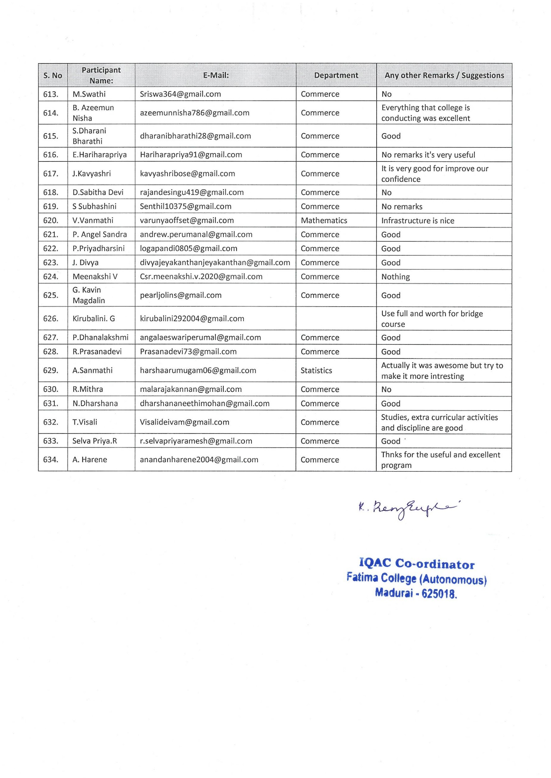

International Youth Day on August 12, 2022
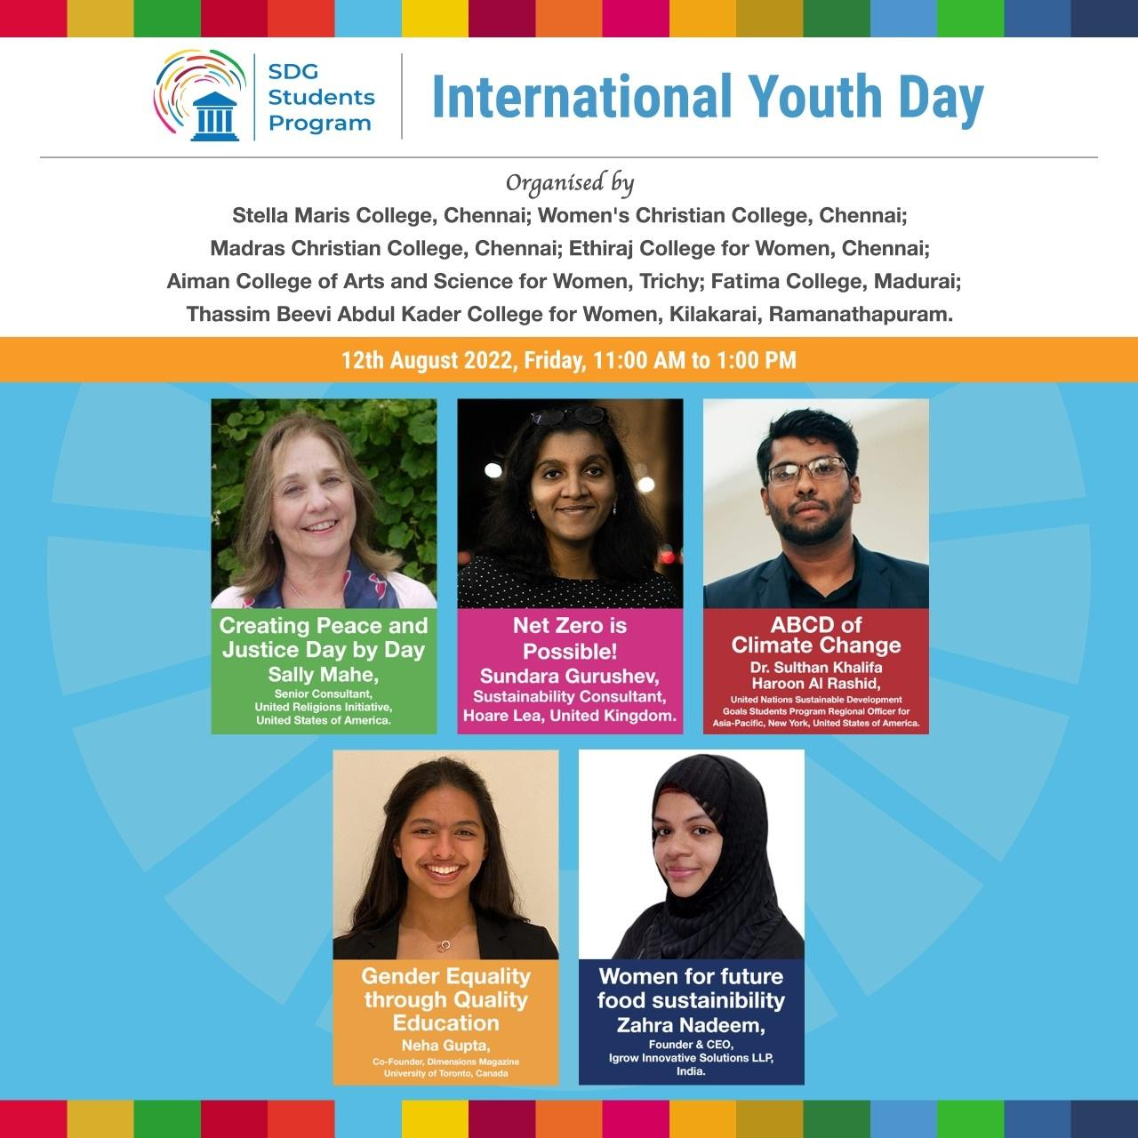

International Youth Day
International Youth Day is celebrated annually on August 12th, serving as a platform to recognize and celebrate the potential of young people as catalysts for change and development worldwide. This observance aims to raise awareness about the challenges and issues faced by the youth globally while promoting their active engagement in social, economic, and political spheres.
In accordance with this, the IQAC of Fatima College, Madurai organized a panel discussion on the following themes which were conferred by prominent young resource persons across the globe.
- Creating Peace and Justice Day by Day

Resource Person
Ms. Sally Mahe
Senior Consultant
United Religions Initiative
United States of America

This presentation encouraged the individuals to engage in acts of kindness, social justice advocacy, and conflict resolution on a daily basis. By fostering empathy and understanding, this discussion aimed at building a society where peace and justice prevail in everyday interactions. It insisted that, Creating Peace and Justice Day by Day underscores the importance of individual responsibility in creating a more peaceful and just society.
- Net Zero is Possible!

Resource Person
Ms. Sundara Gurushev
Sustainability Consultant
Hoane Lea, United Kingdom

The concept of achieving net zero refers to balancing the amount of greenhouse gases emitted into the atmosphere with an equivalent amount removed, effectively mitigating the impacts of climate change. This session emphasized that, despite challenges, achieving net zero emissions is not only necessary to combat climate change but also feasible with concerted global efforts.
- ABCD of Climate Change

Resource Person
Dr. Sulthan Khalifa
United Nations Sustainable Development
Goals Students Progam Regional Officer for
Asia – Pacific, New Yor, USA

The discussion shed light on the Climate change which is a pressing global issue with far-reaching implications for the environment, economy, and society. It insisted that understanding its fundamental aspects is essential for effective mitigation and adaptation efforts.
- Gender Equity through Quality Education

Resource Person
Ms. Neha Gupta
Co – Founder, Dimensions Magazine
University of Toronto, Canads
The presentation expounded that gender equity through quality education is a vital component of achieving sustainable development and social progress. It also highlighted that ensuring equal educational opportunities for all genders not only fosters individual empowerment but also contributes significantly to breaking the cycle of poverty and promoting gender equality in various spheres of life.
- Women for Future Food Sustainability

Resource Person
Ms. Zahra Nadeem
Founder & CEO
Igrow Innovative Solutions LLP, India
The discussion focused on the critical role of young people, especially women, in transforming food systems for a sustainable future. It emphasized the need for innovative solutions and youth-led initiatives to address issues related to food security, agricultural sustainability, and climate change.
OUTCOME
- International Youth Day serves as a reminder of the potential and enthusiasm of young people in shaping a better world.
- Harnessing the energy and creativity of the youth to address global challenges and work towards a more sustainable and inclusive future.
- Empowering the younger generation to become active agents of change, ensuring a brighter tomorrow for all.
PHOTOS
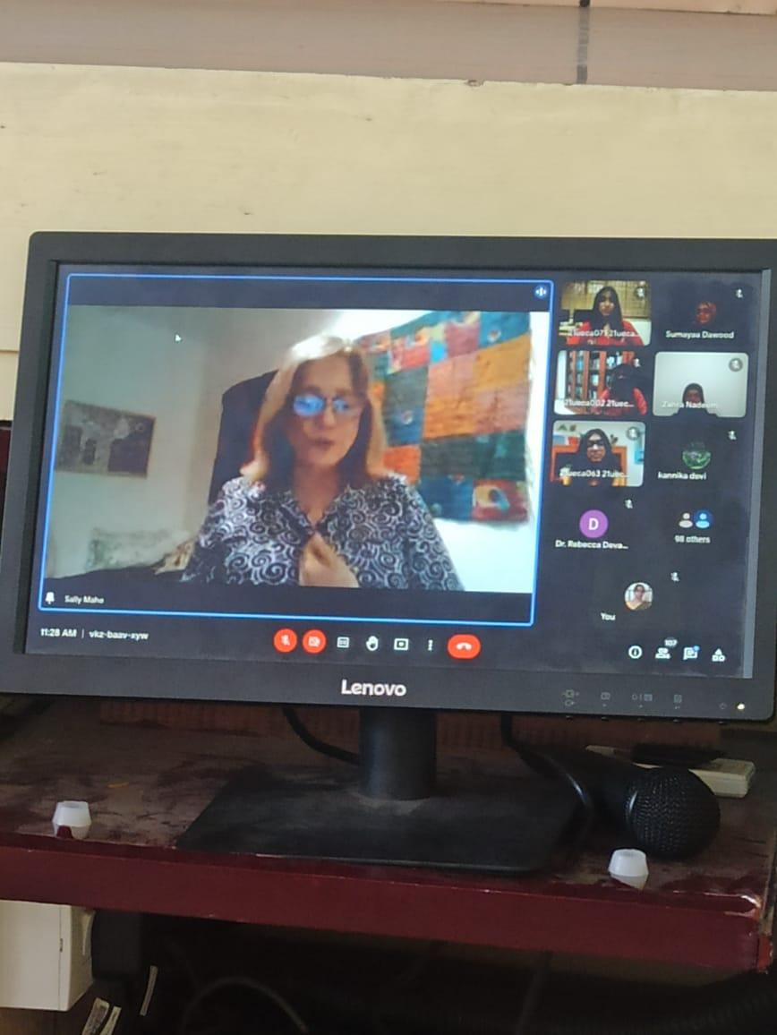

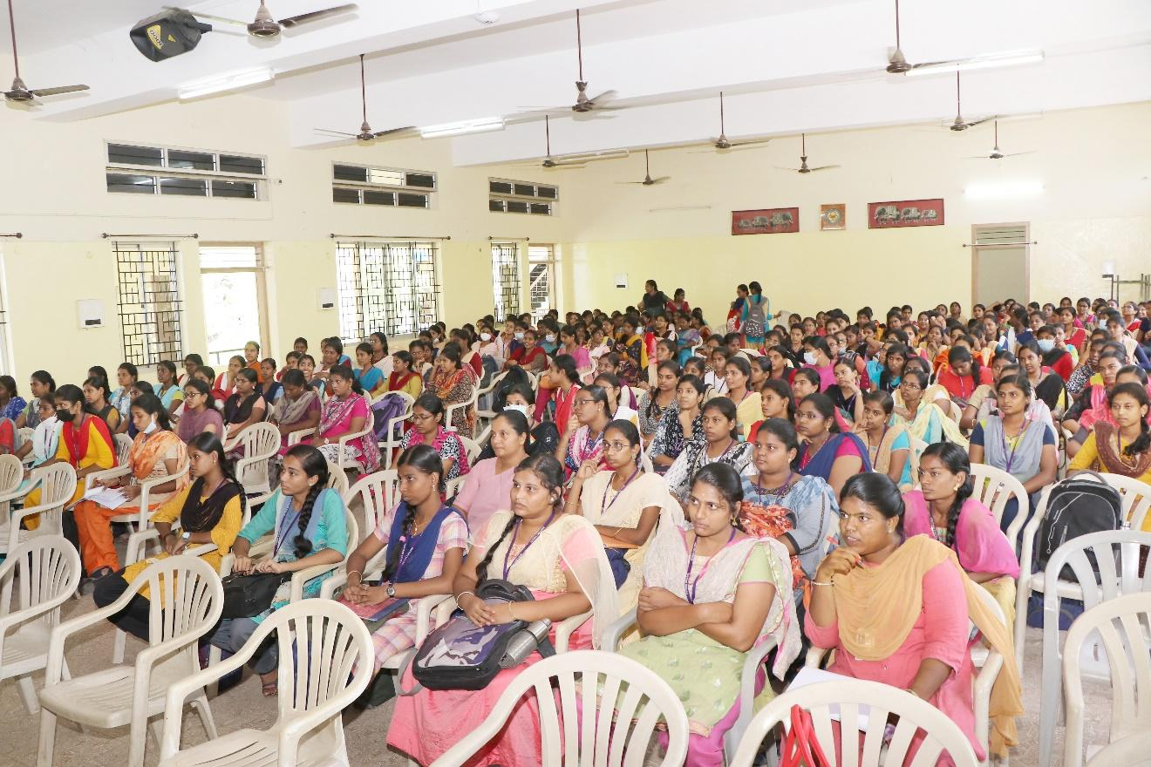

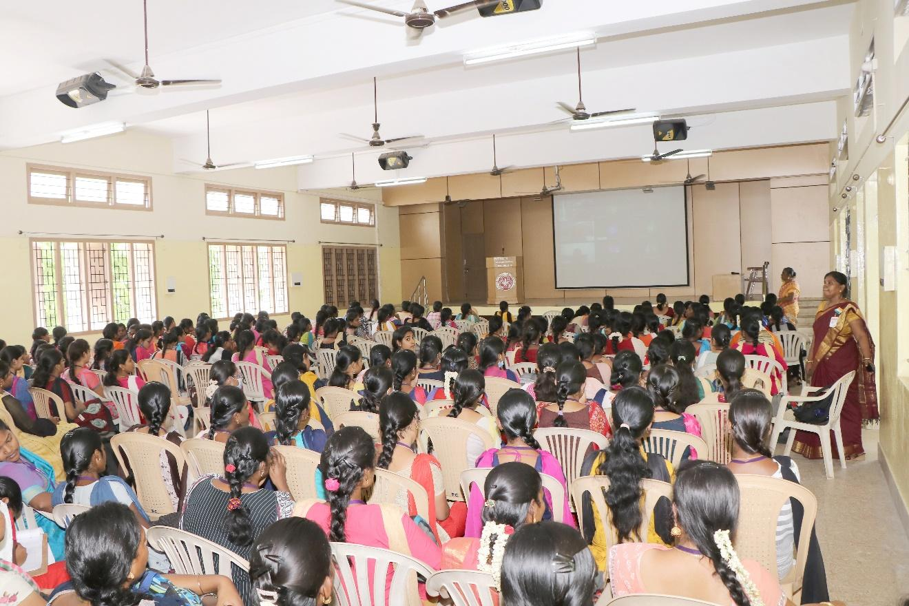

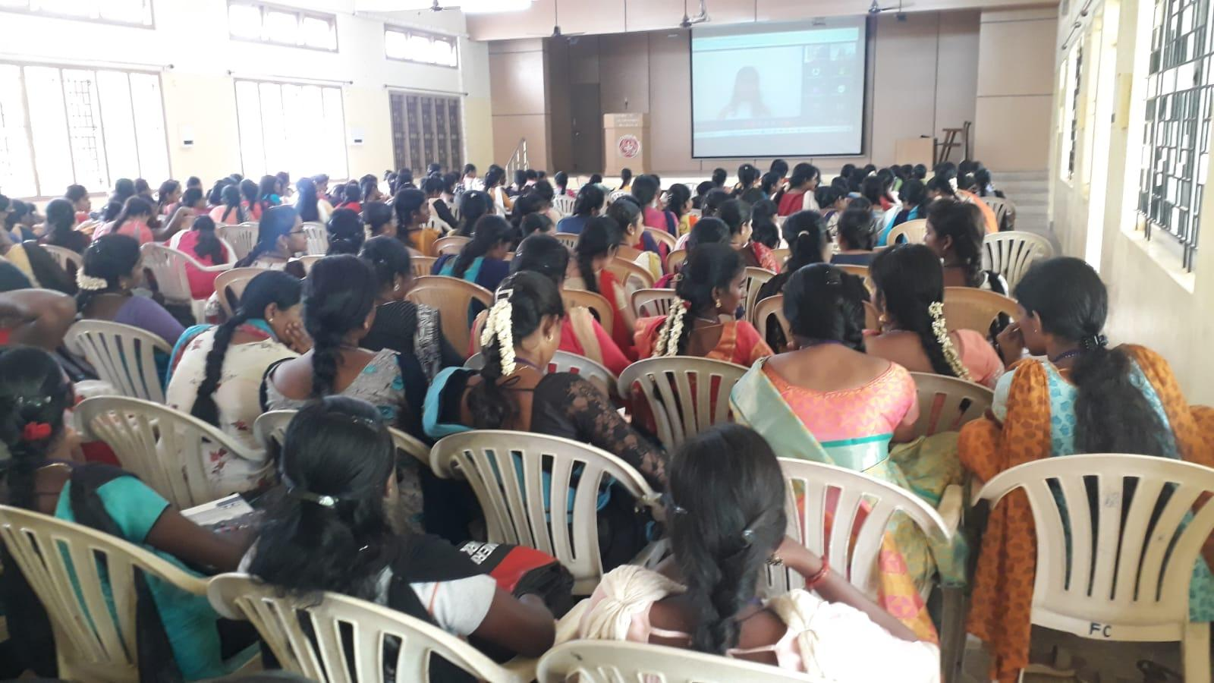

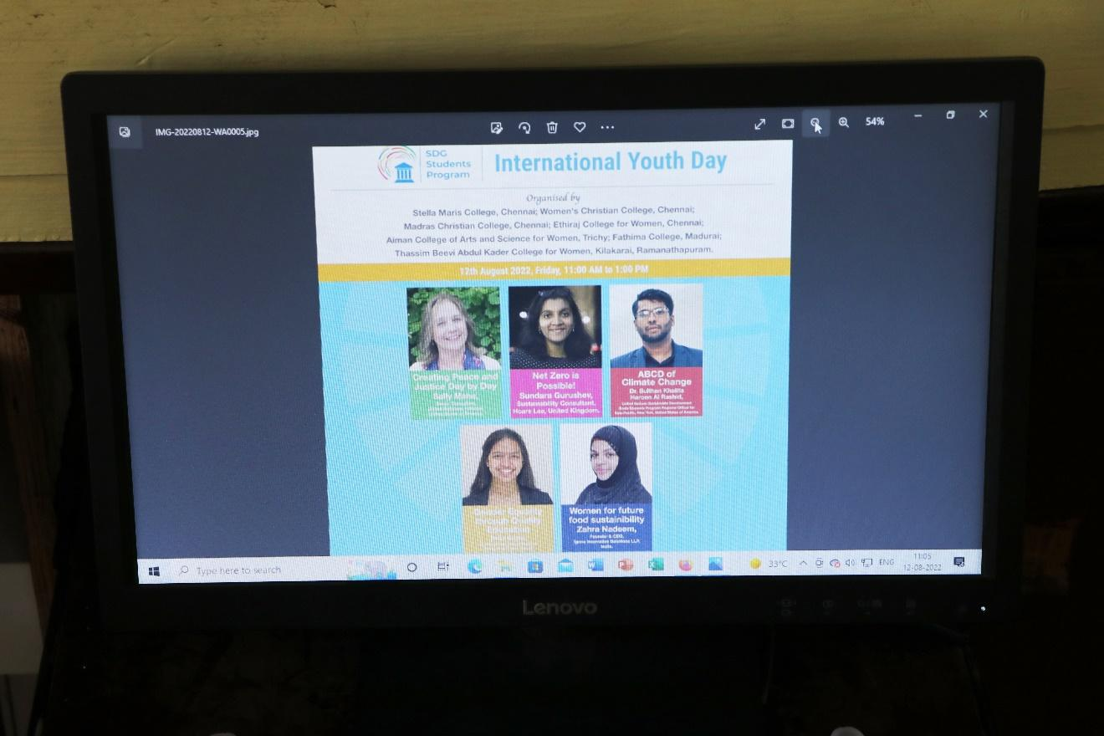
PARTICIPANTS - 265
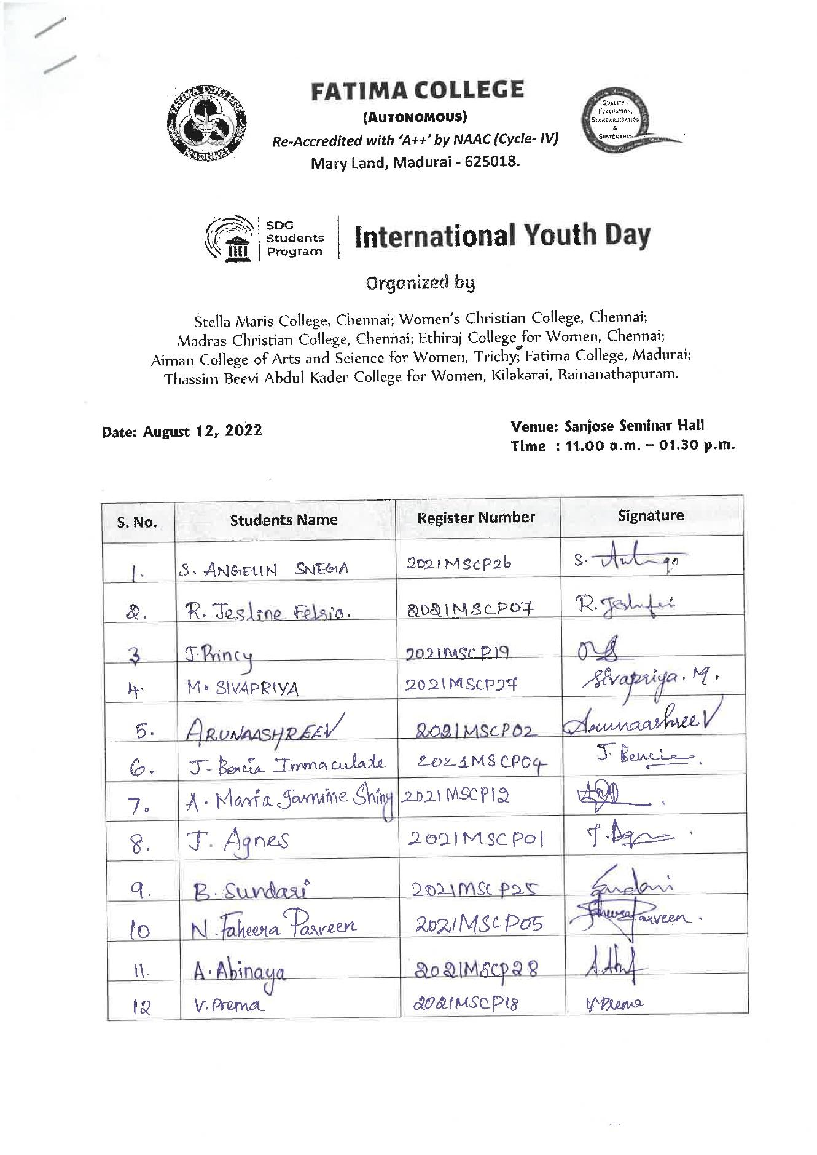
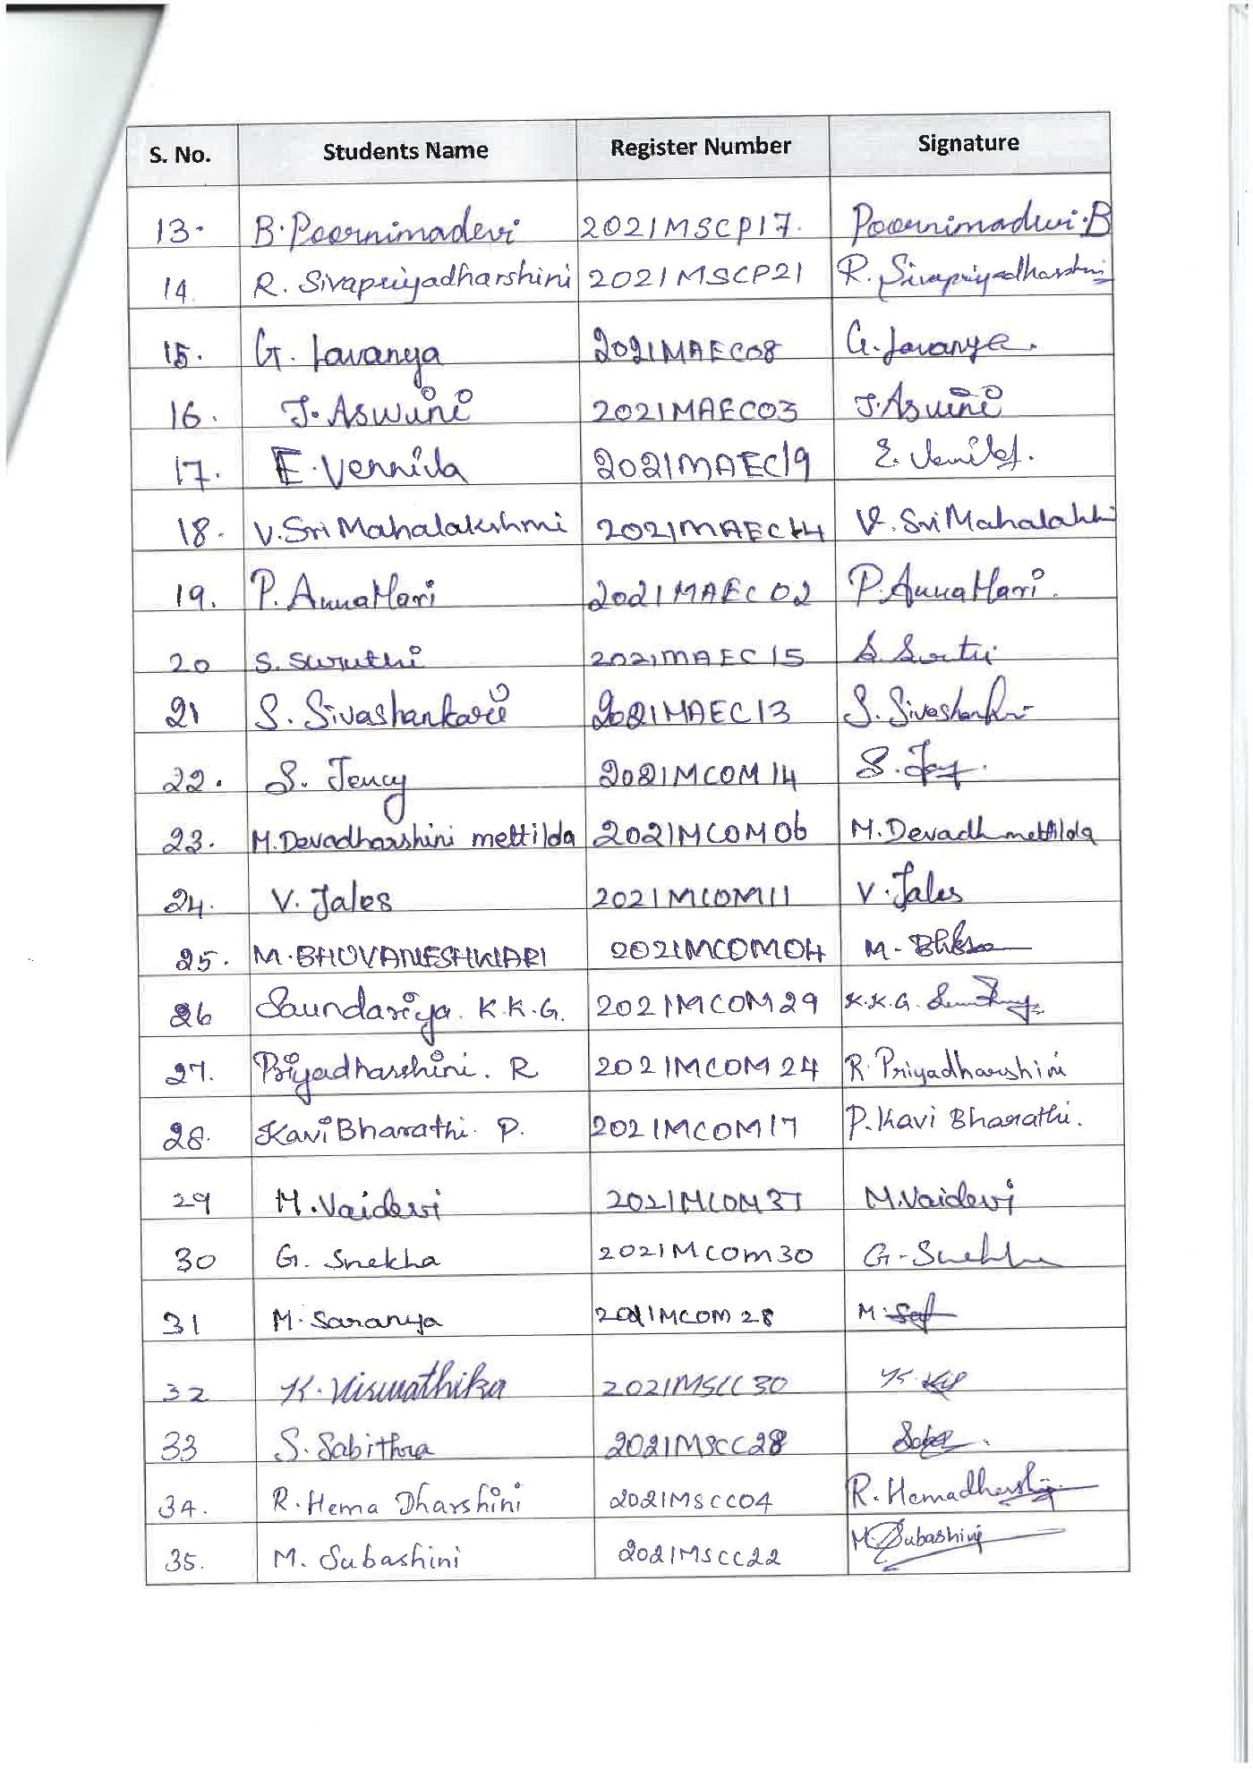
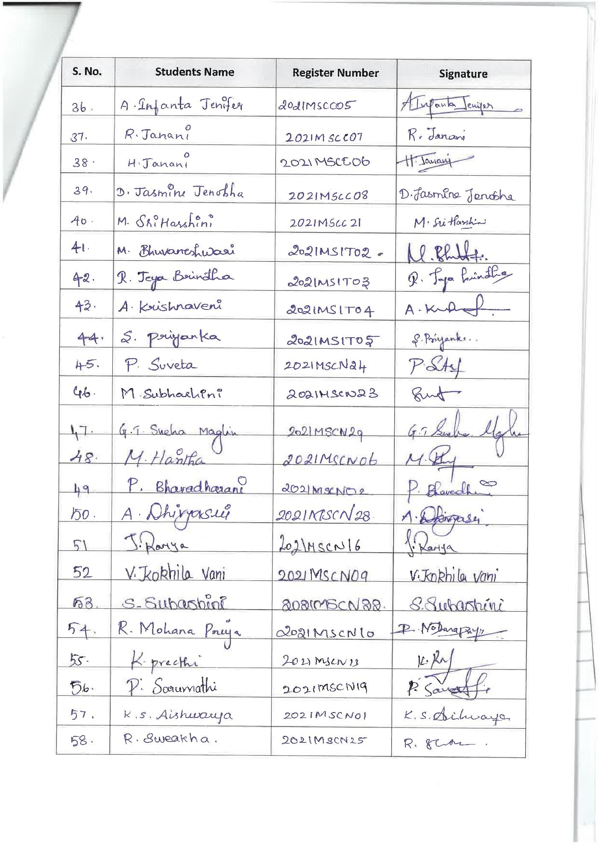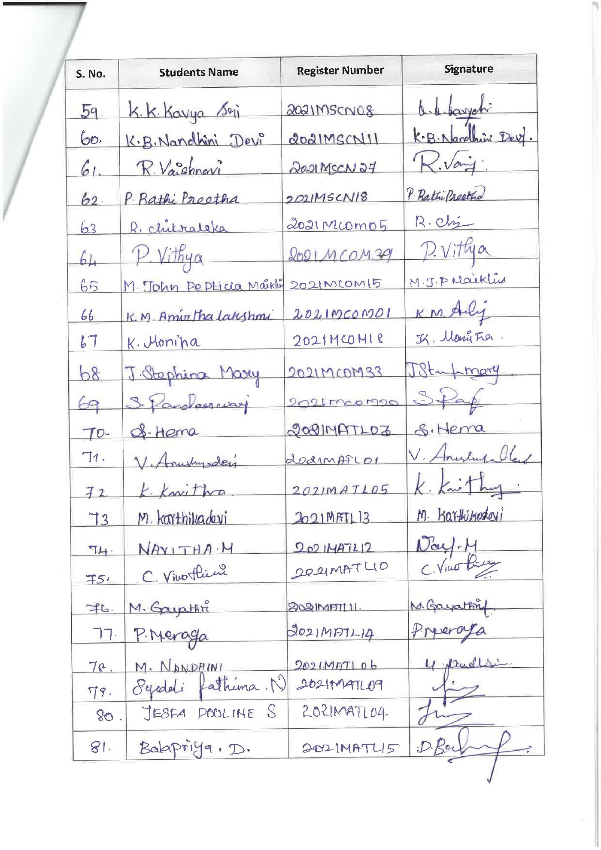
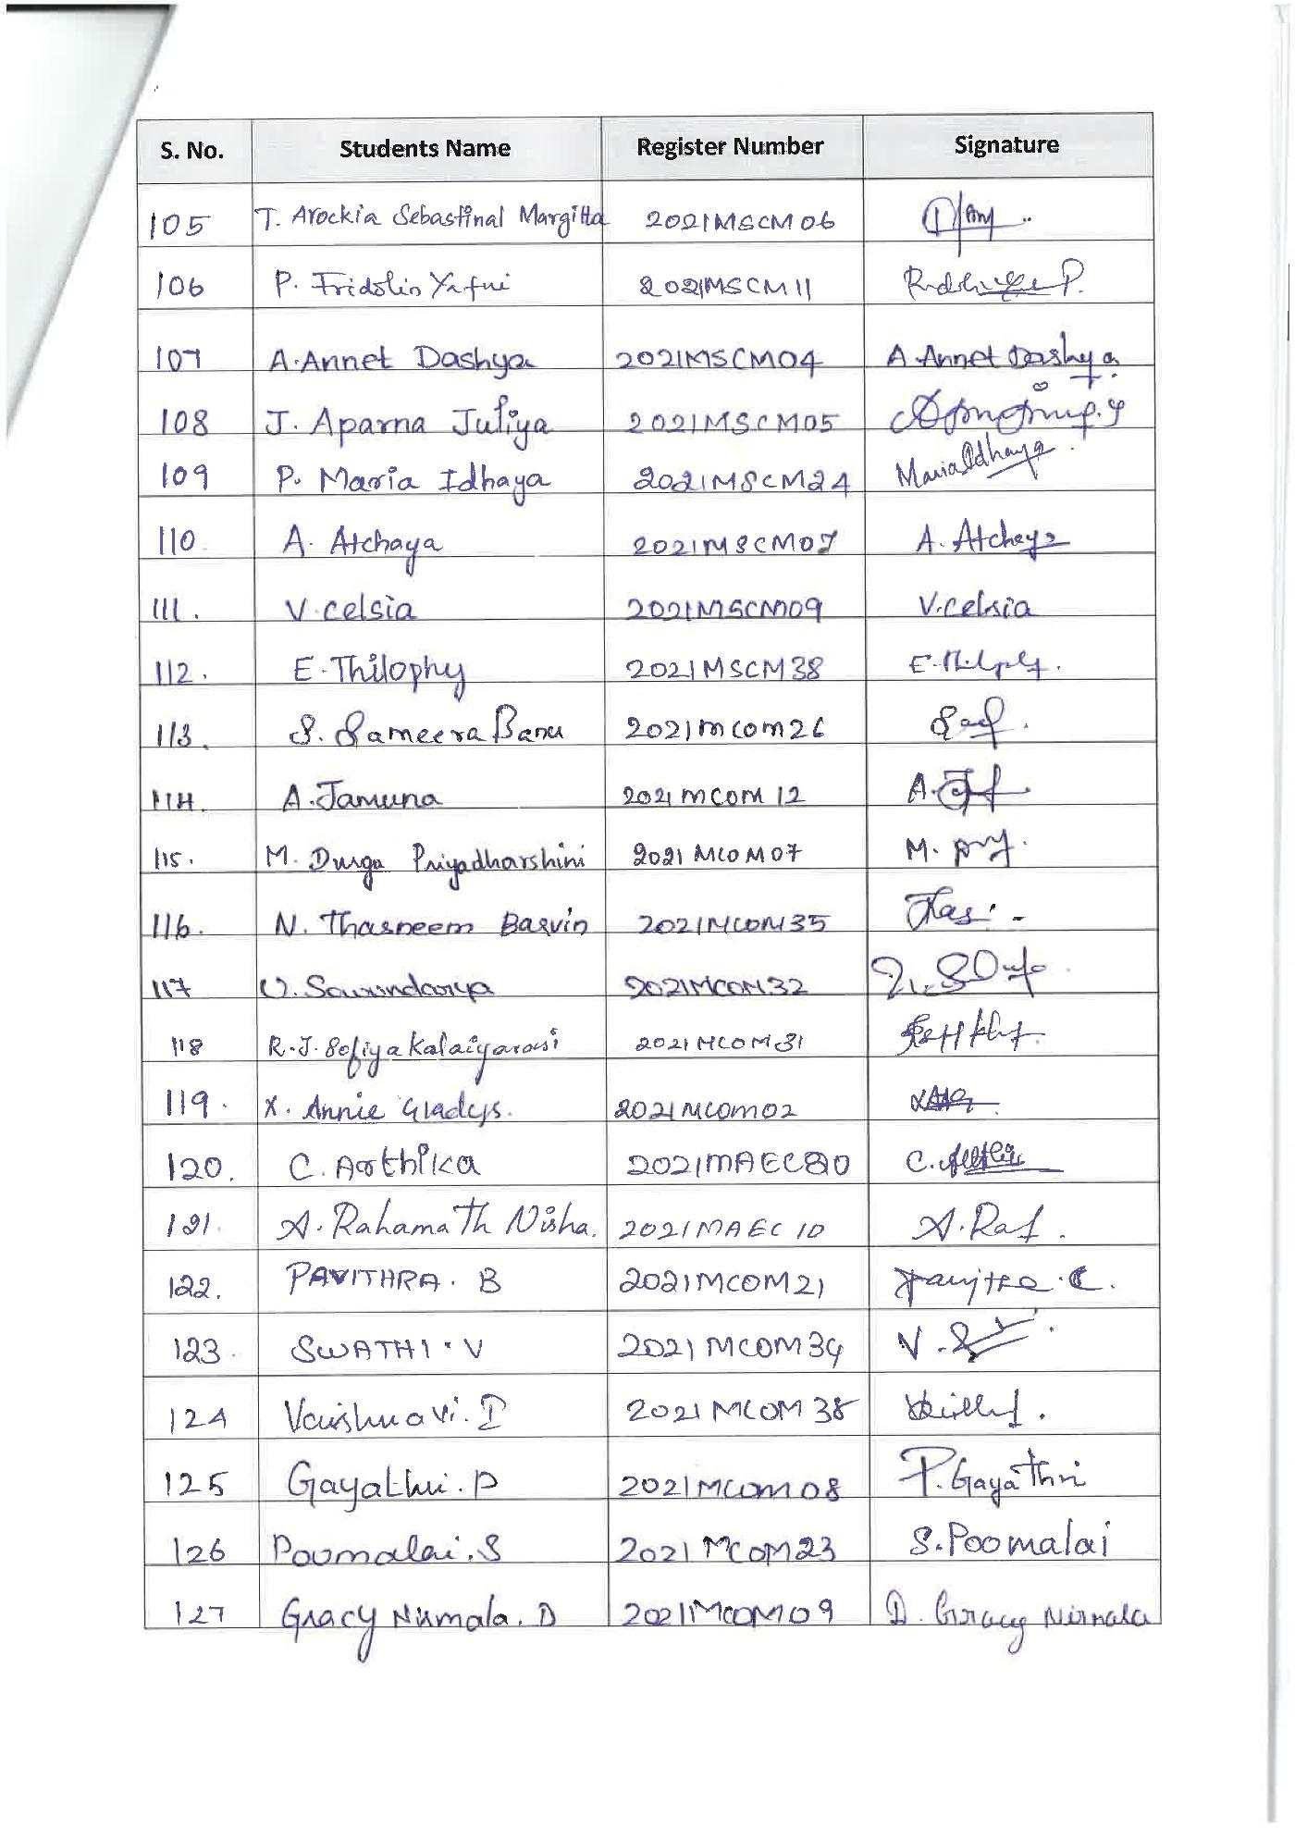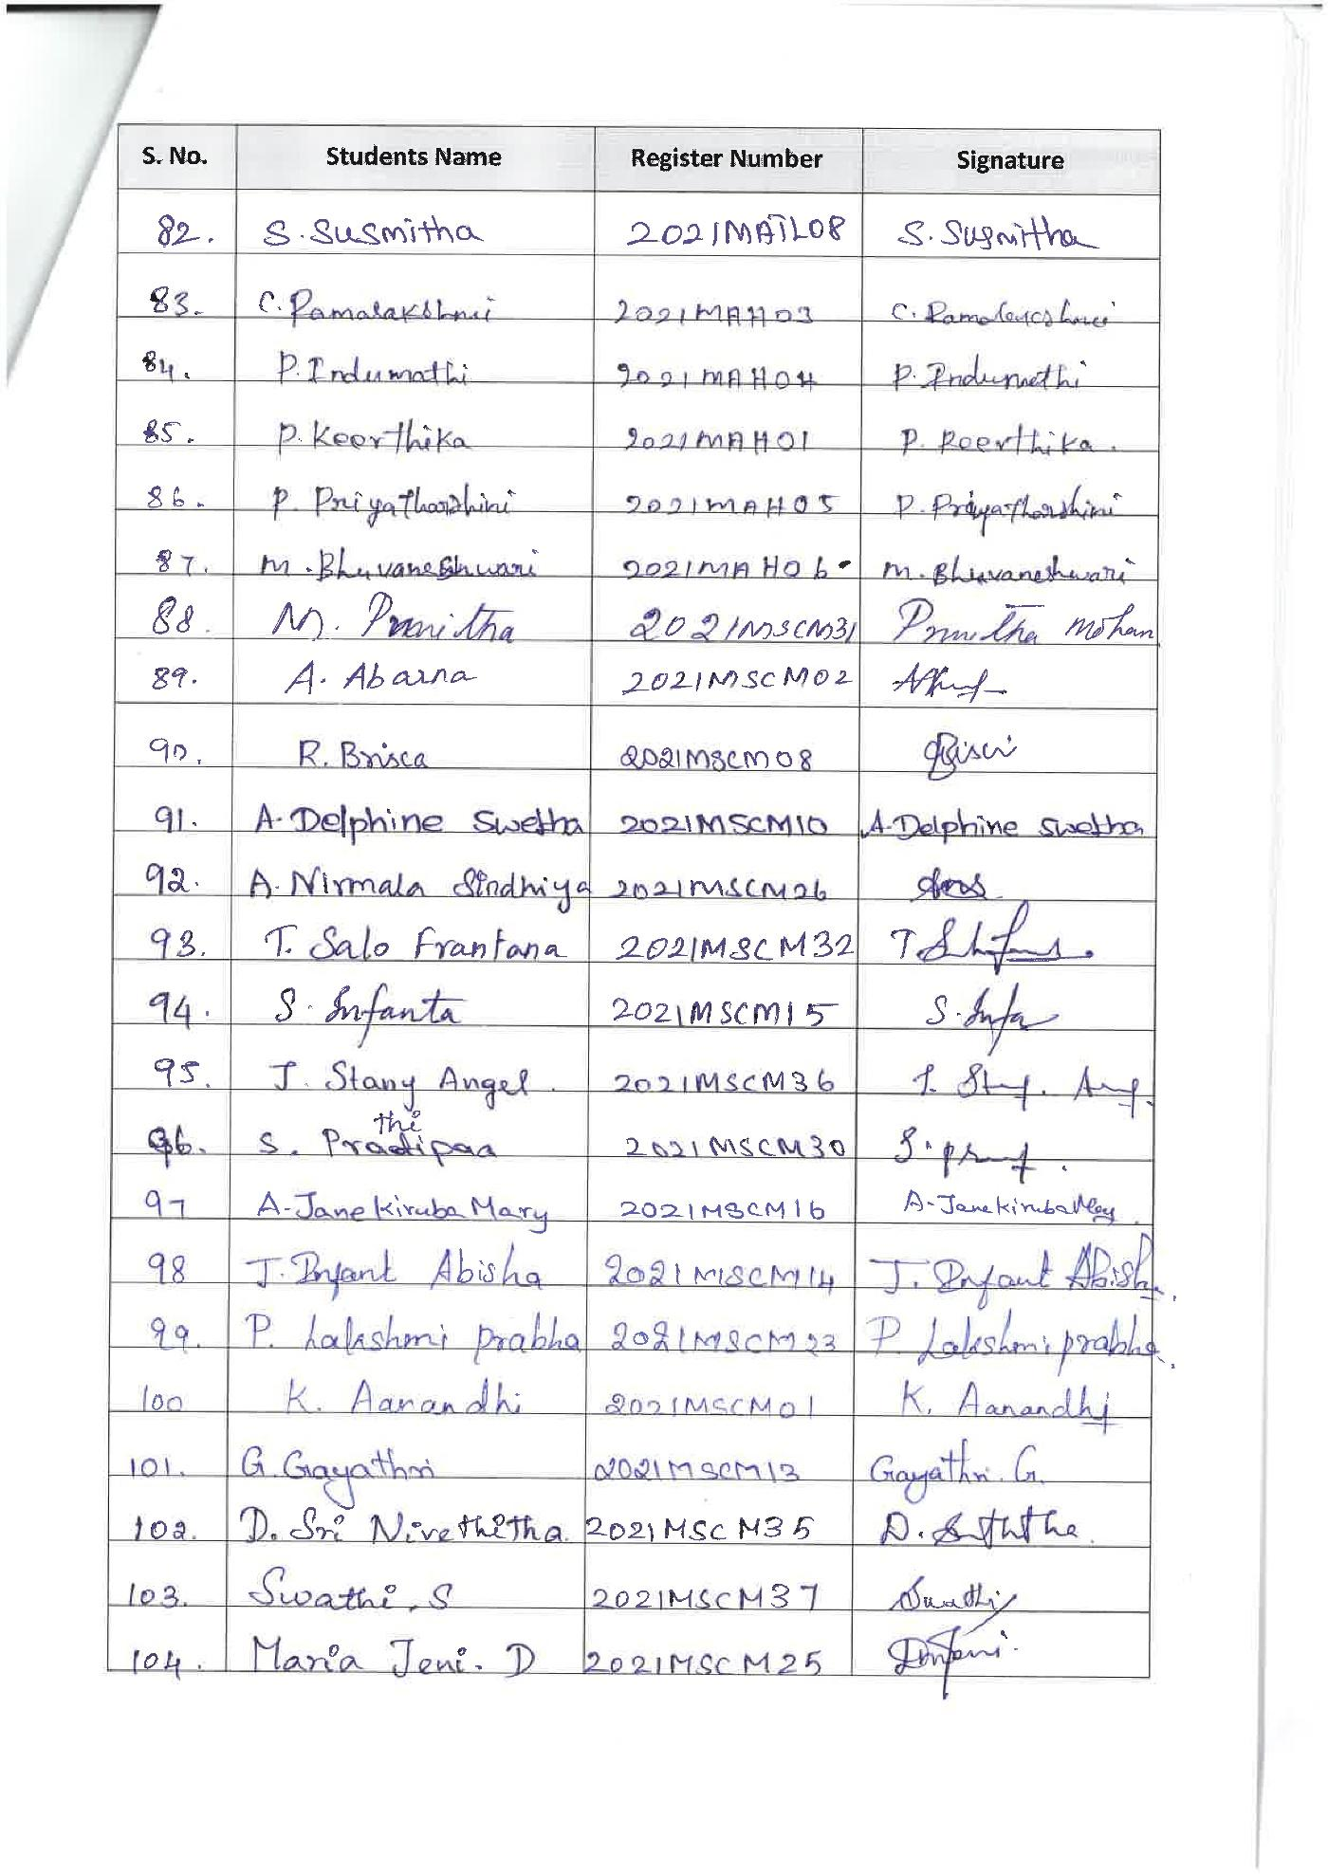
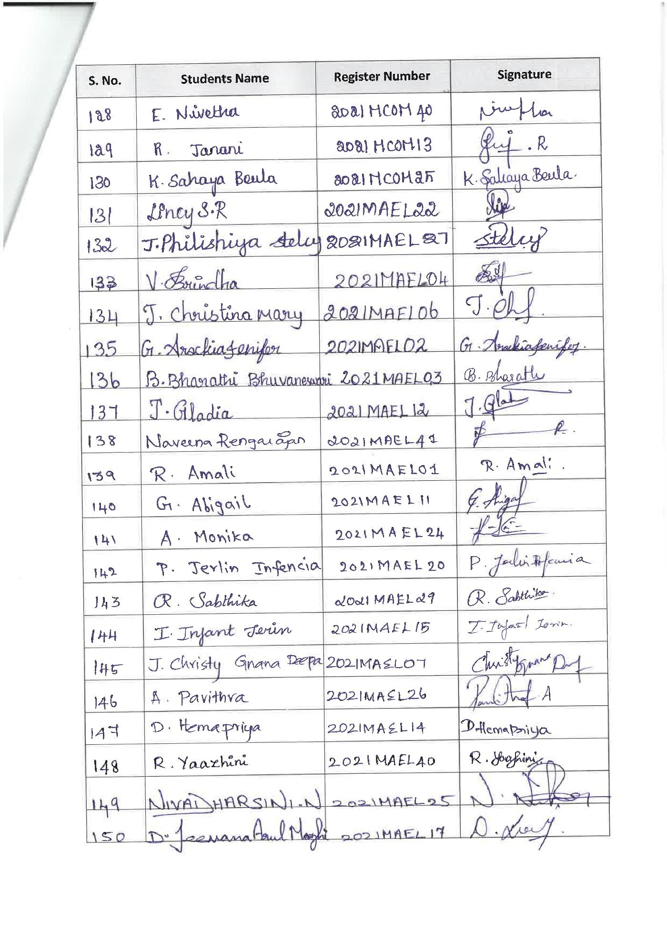
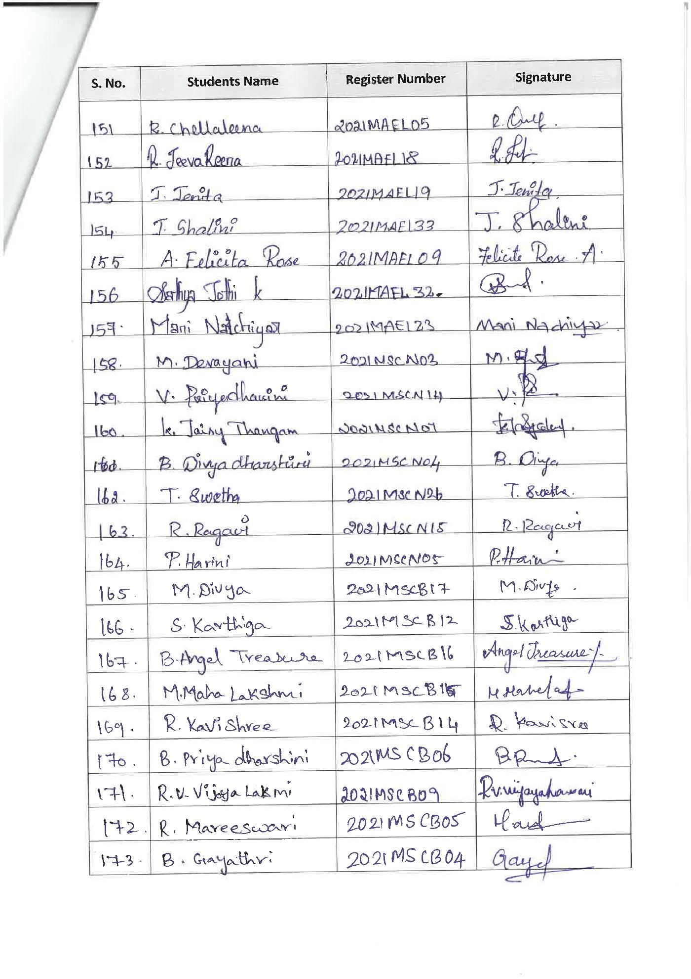
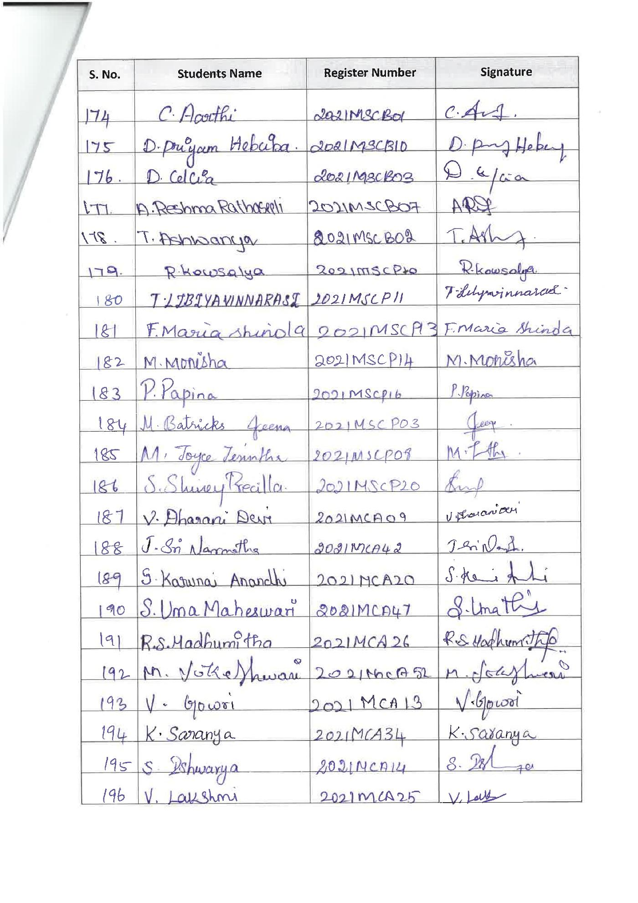
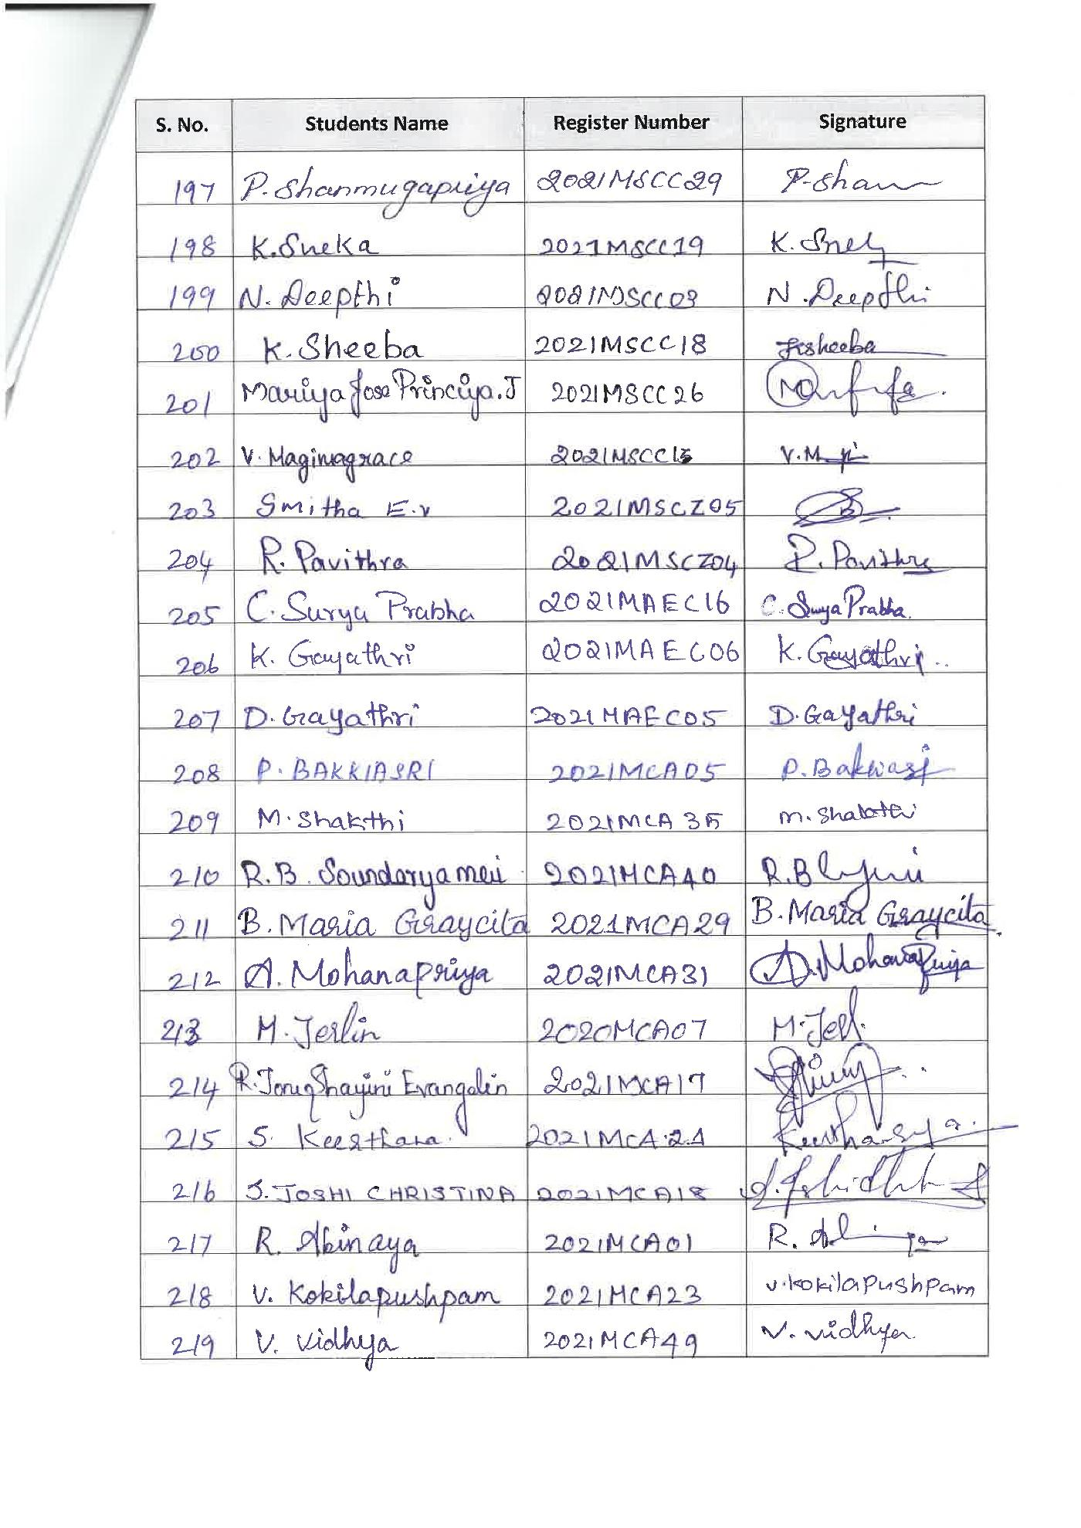
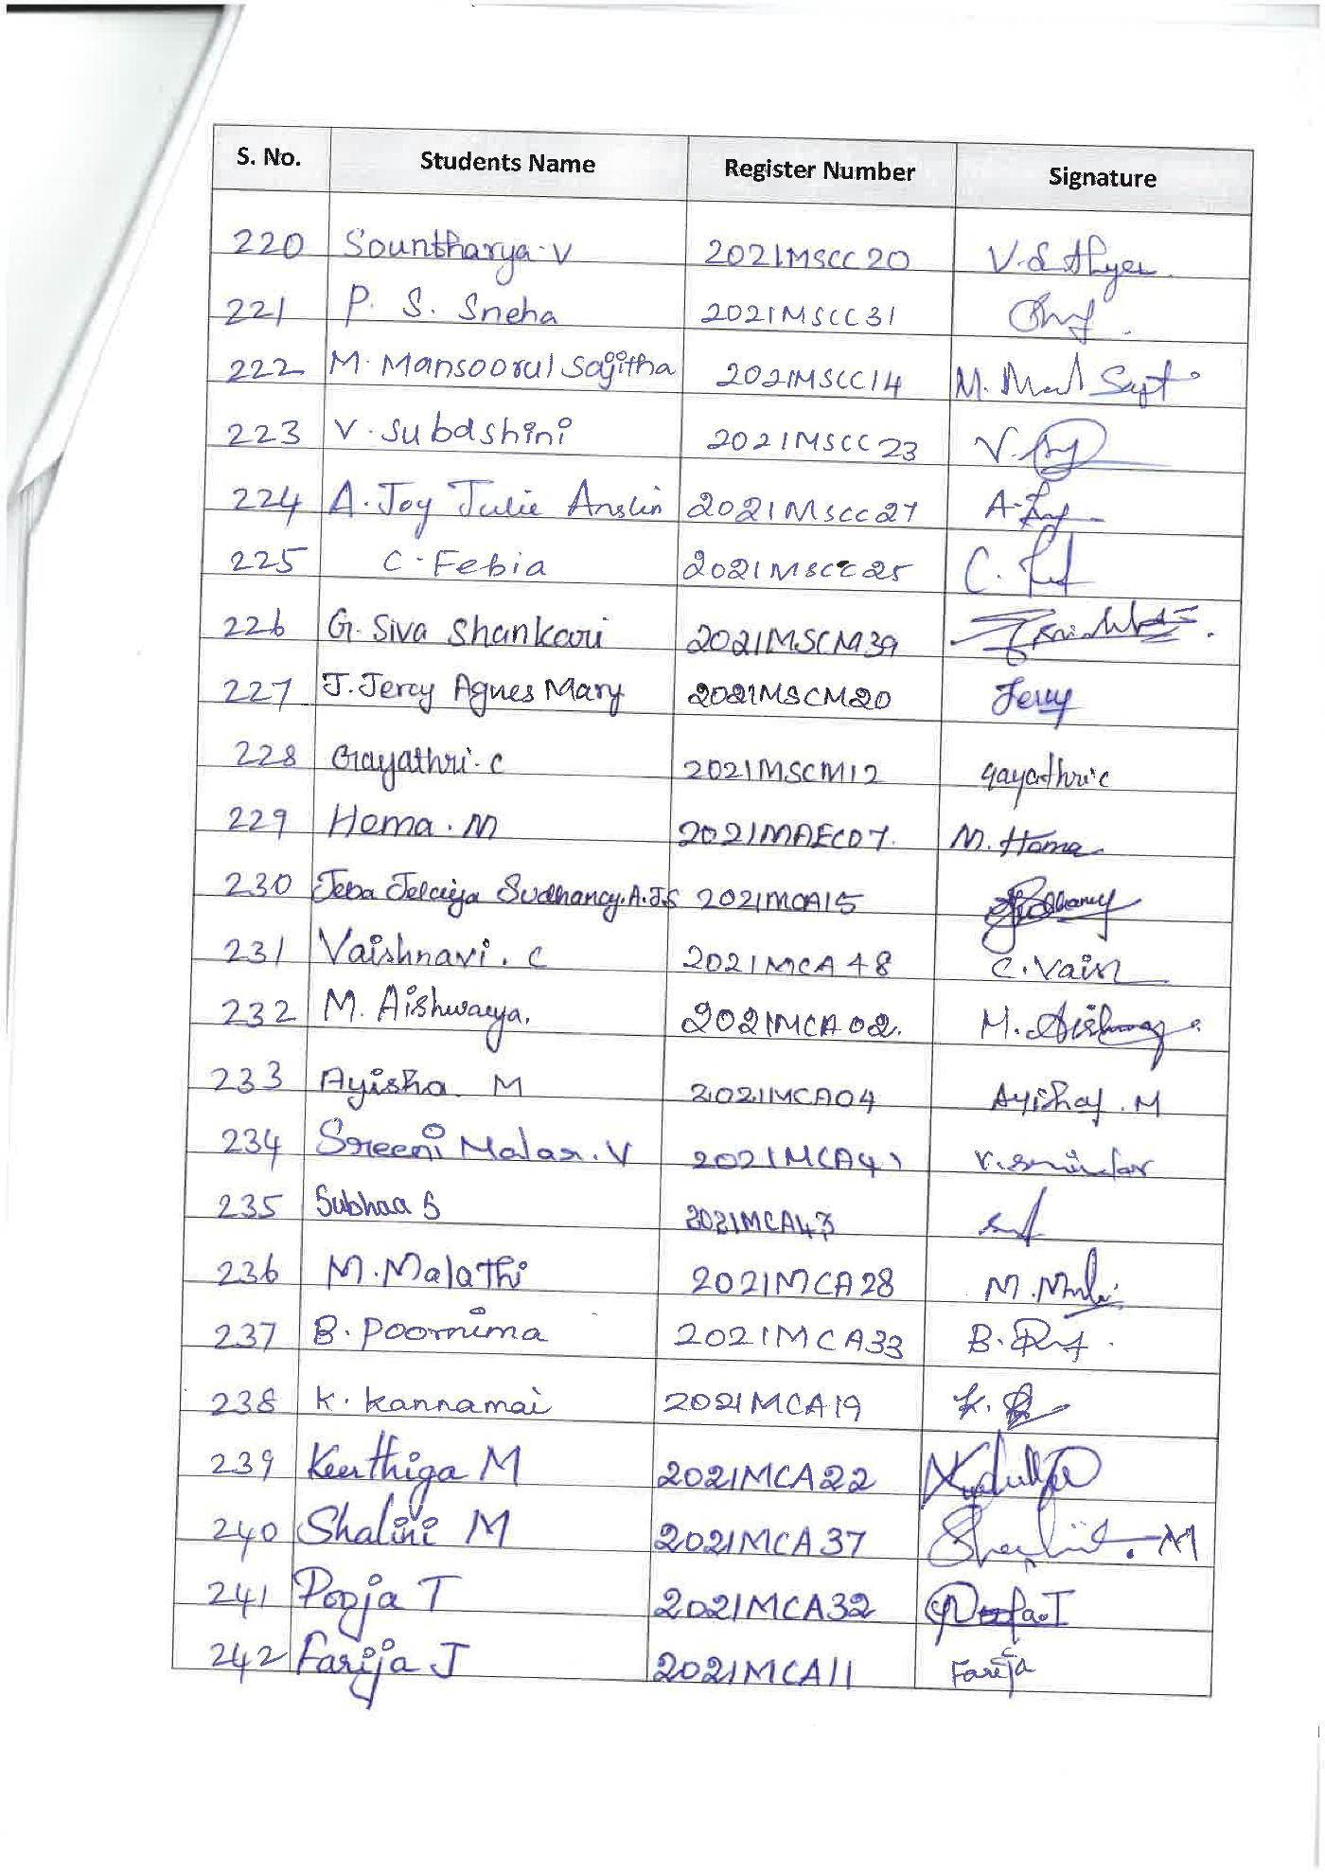
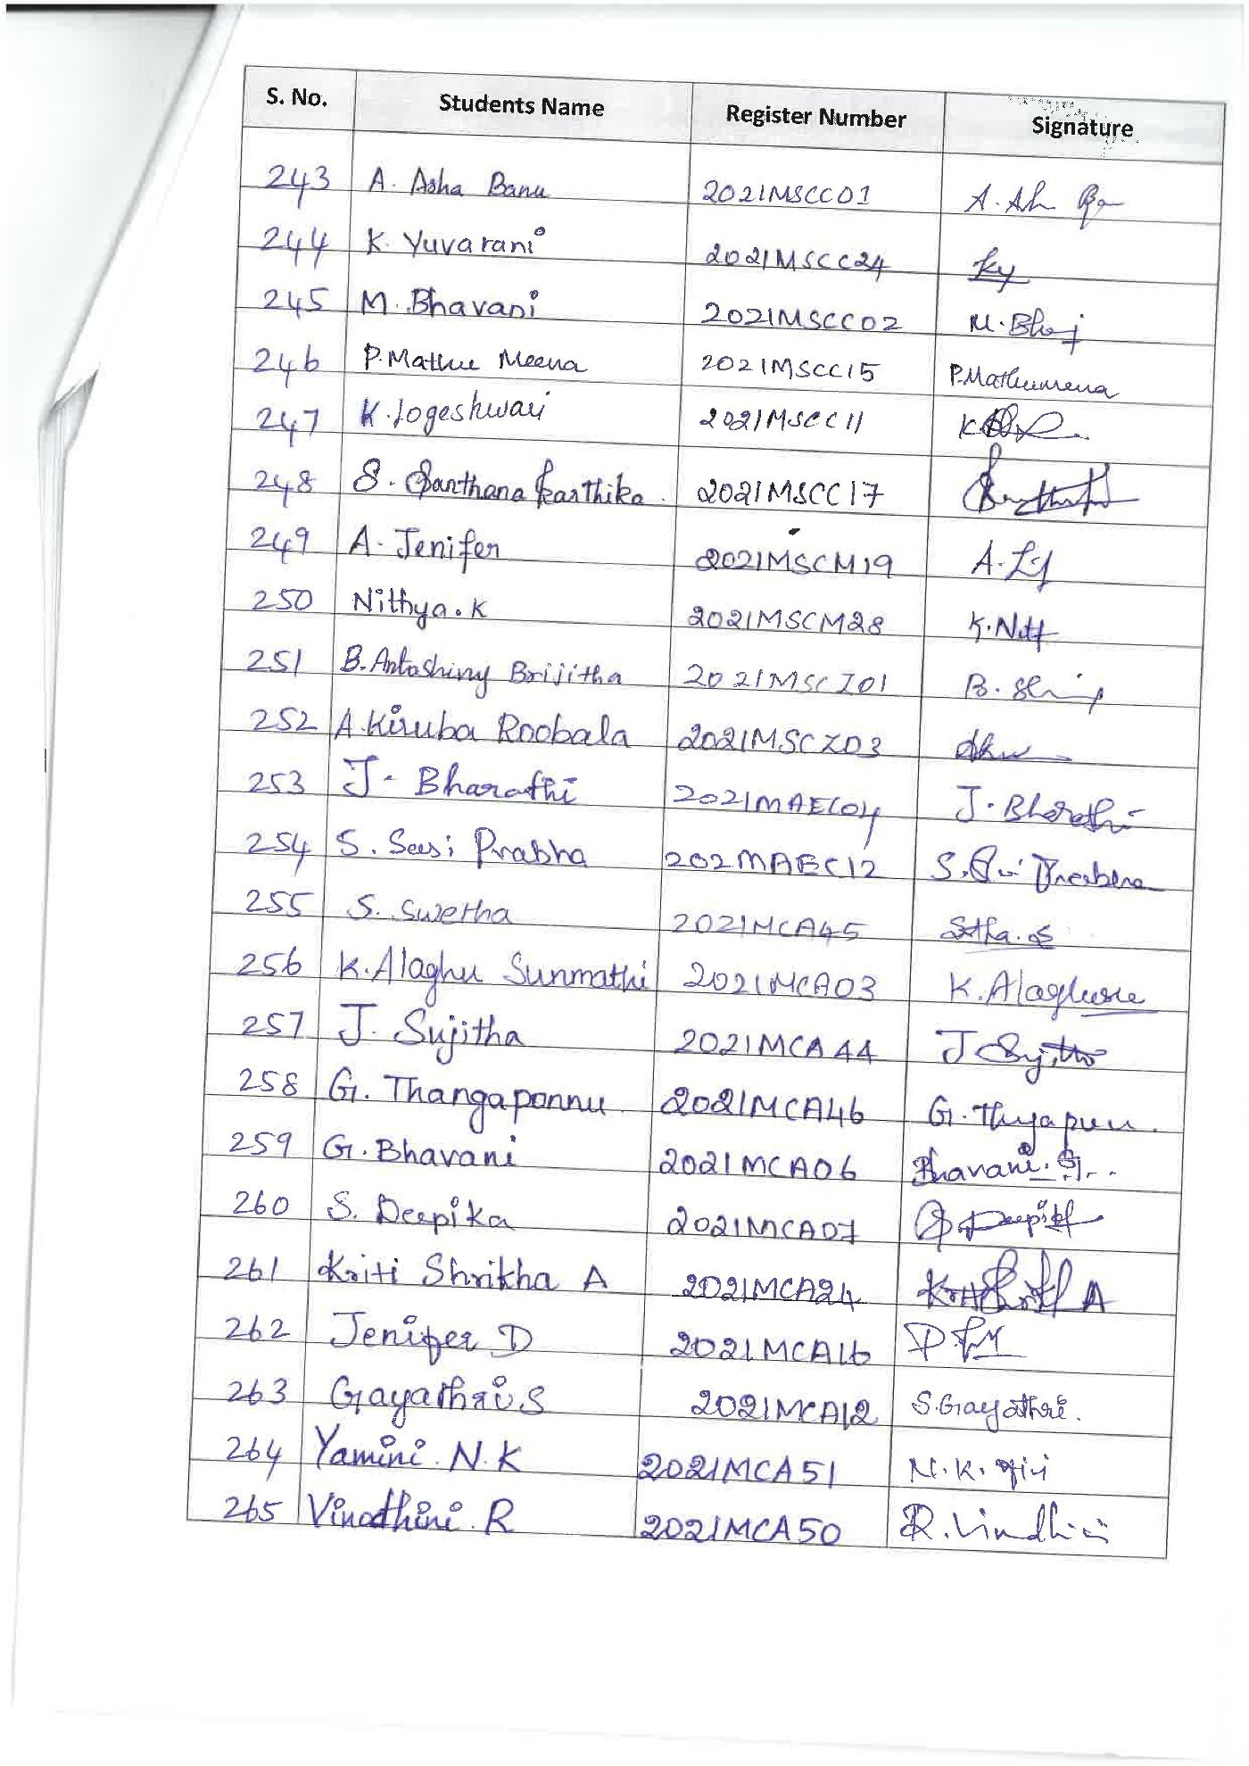

PANEL DISCUSSION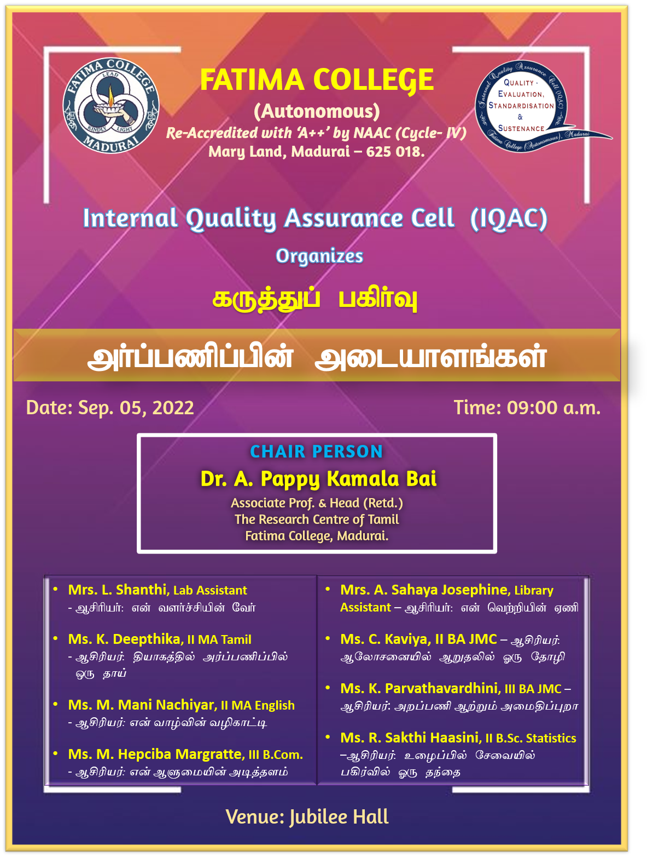
Report:
Date: 05.09.2022
Fatima College organised a special event to commemorate Teacher’s Day. A panel discussion with Dr. A. Pappy Kamala Bai, former Head of the Research centre of Tamil as Chairperson was held. Dr. Sr. M. Francisca Flora, Secretary graced the occasion. The panellists comprised of staff and students. They spoke on topics such as “Teachers - the roots of success”, “Teachers - guiding lamp”, “Teachers as a friend, philosopher and guide” to name a few. Setting the tone, Dr. Kamala Bai recalled the services of stalwarts like Dr. S. Radhakrishnan and motivated the audience to draw inspiration from thinkers like him. The speakers stressed on the role of the teachers in mentoring the academic life and moulding student personality. All the speakers expressed gratitude for the immense and immeasurable services rendered by teachers. The eventful session was organised and co-ordinated by the IQAC team.
There was gaiety on the campus as students of the respective departments felicitated their teachers in a creative manner. Floral tribute was paid to the Founder of Fatima College, Mother Rose, at her statue in the old University campus.

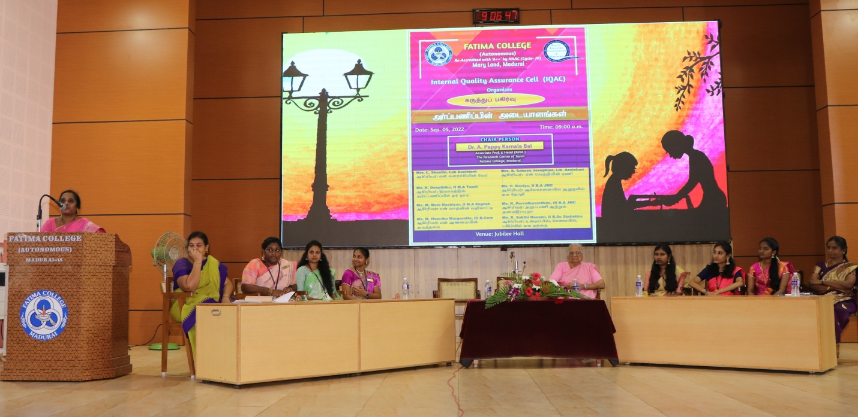

Dr. A. Pappy Kamala Bai, former Head of the Research Centre of Tamil, chairing the
panel discussion on Teachers Day in the presence of Dr. Sr. M. Francisca Flora, Secretary.

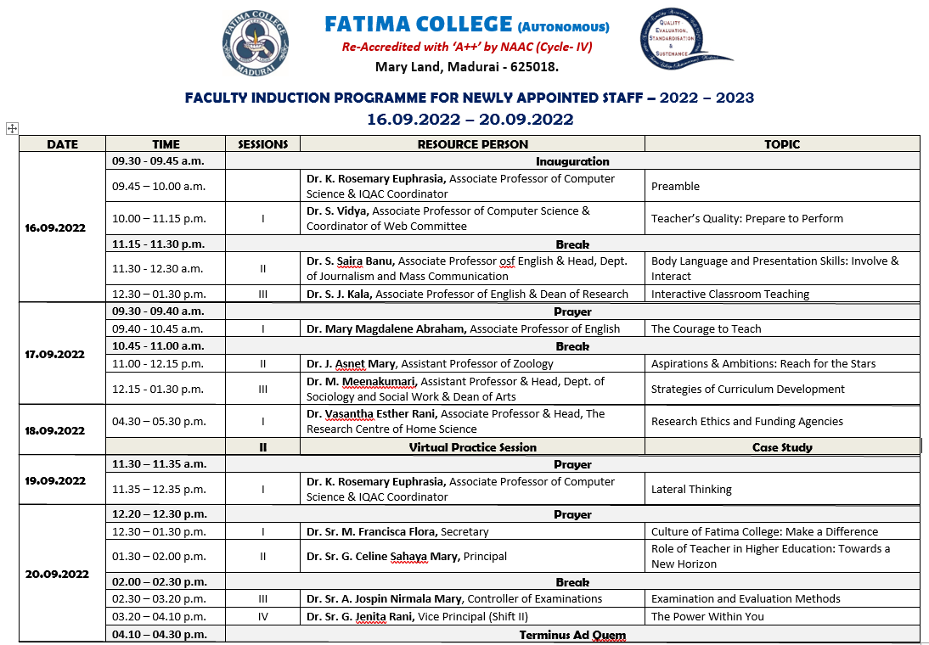

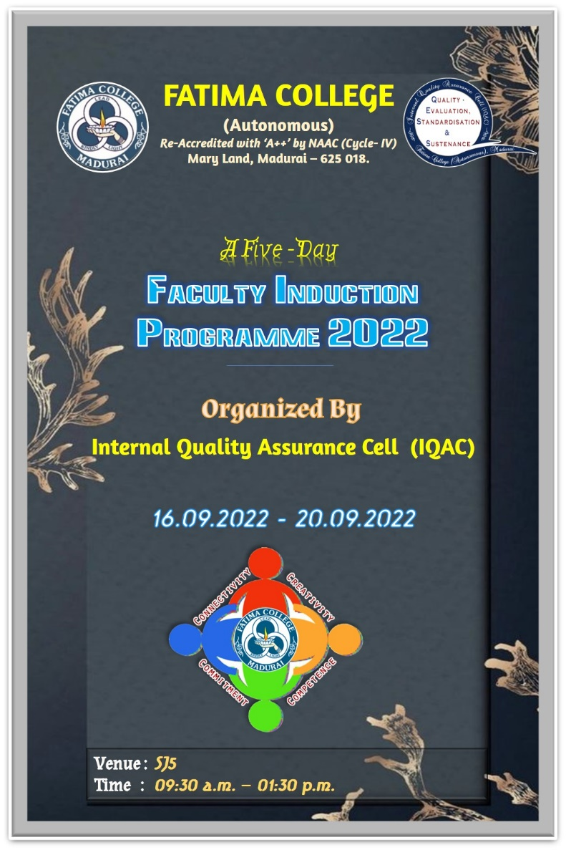

Date: 16.09.2022
Teaching is an ethically and intellectually demanding profession. New teachers need rigorous preparation and opportunities for continuous professional development along with academic and professional support.
The Faculty Induction Programme can help new teachers to improve their teaching and management skills, adjust to the culture of the institution, and better understand their professional responsibilities.
The Faculty Induction Programme begins with the prayer and Dr. R. Saktheswari, Assistant IQAC Coordinator and Assistant Professor in English welcomed the gathering.
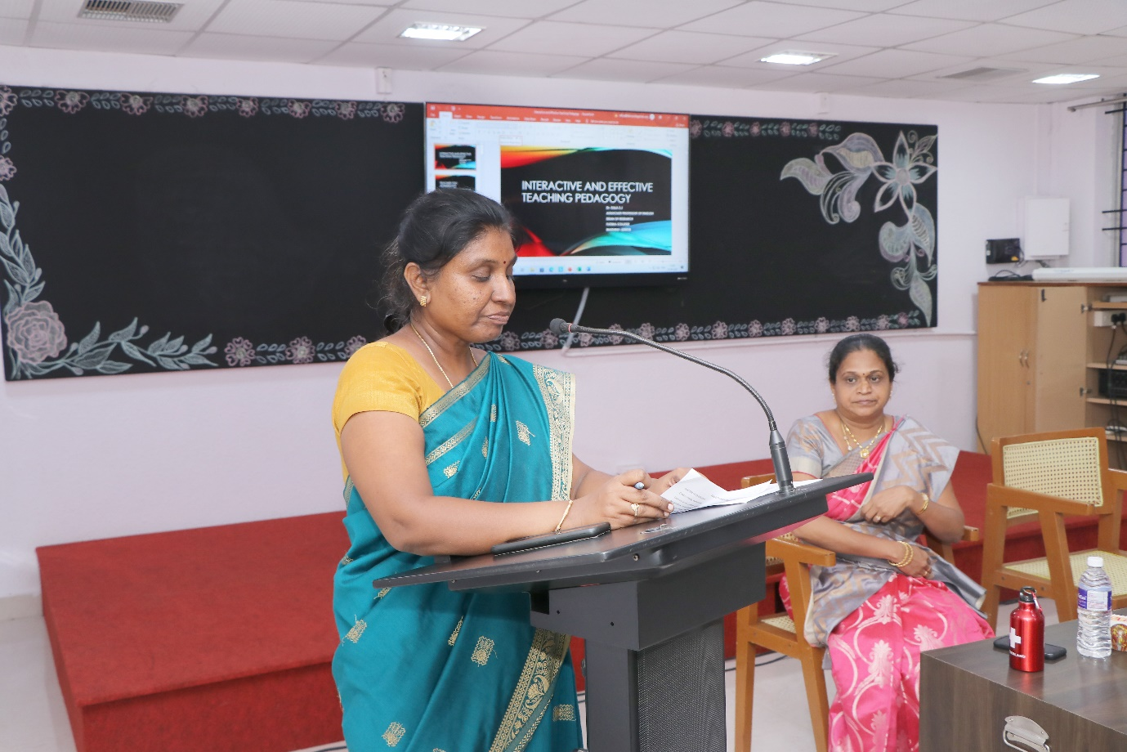

The IQAC Coordinator, Dr. K. Rosemary Euphrasia, Associate Professor of Computer Science explained the objective of the programme
The Faculty Induction Programme aims to help new teachers:
a. Understand their roles and responsibilities as faculty members
b. Familiarize themselves with the structure, functioning, governance, rules, regulations and professional expectations in the institution
c. Explore pedagogical processes - aims of higher education, curriculum, instructional planning, classroom management and transaction, use of resources and assessment
d. Recognise the importance of self-development, socio-emotional development of students and the importance of nurturing ethics and values in higher education
Dr. S. Saira Banu, Associate Professor of English & Head, Dept. of Journalism and Mass Communication handled the first session on Body Language and Presentation Skills: Involve & interact.
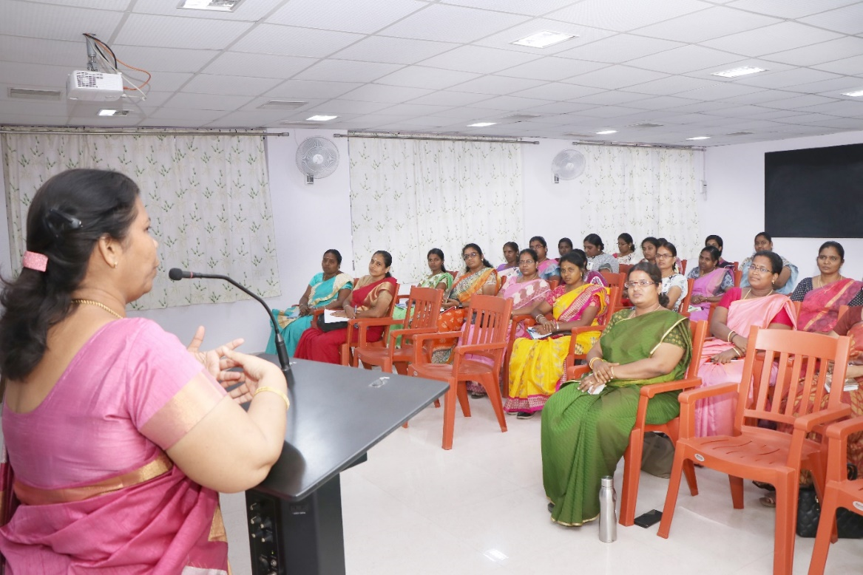

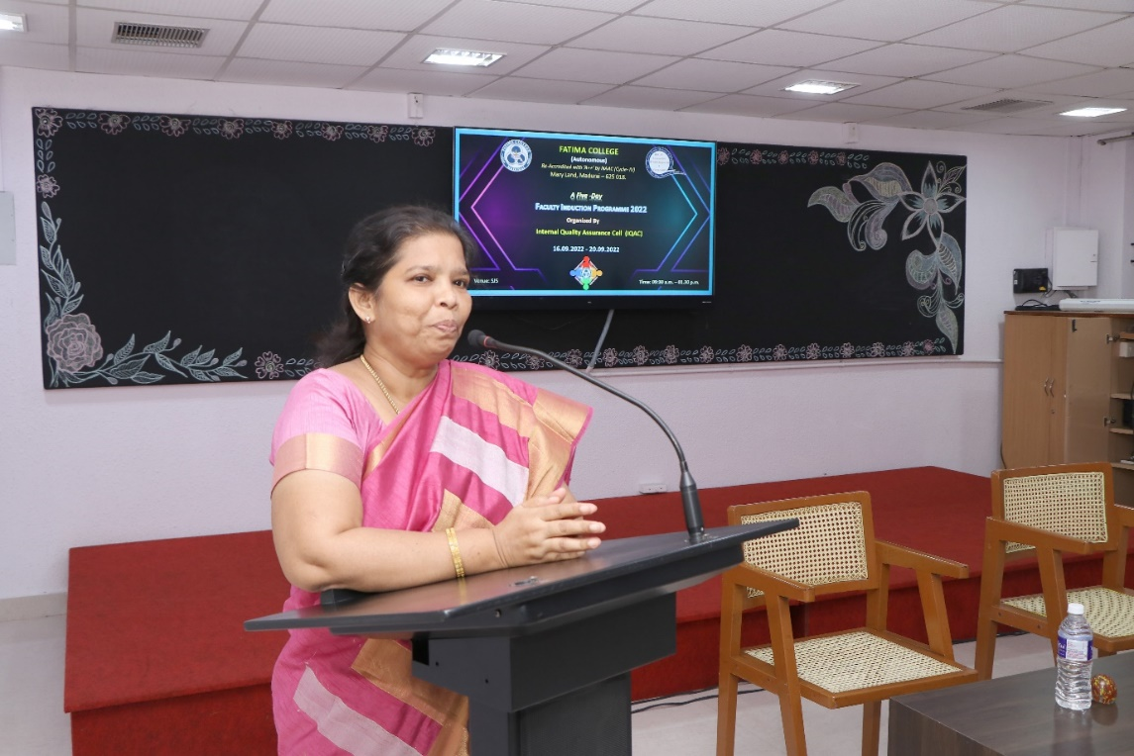
The Second session was handled by Dr. S. J. Kala, Associate Professor of English & Dean of Research who described the Interactive Classroom Teaching.
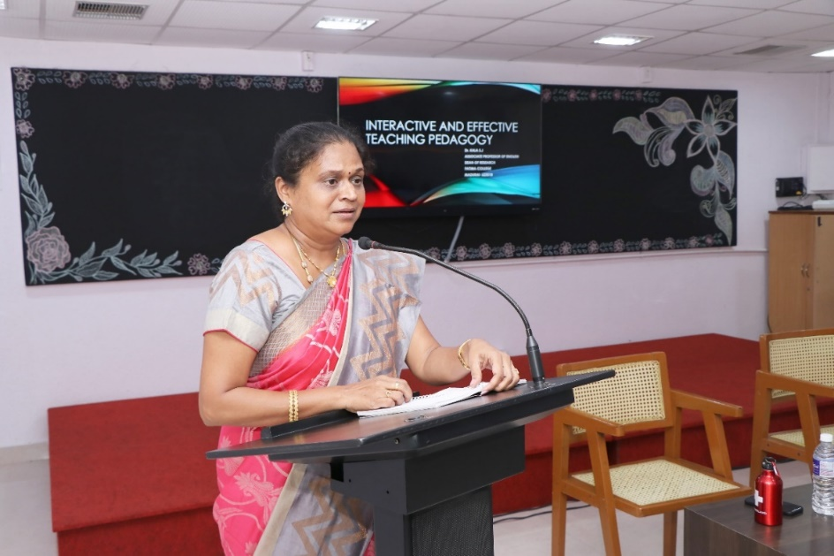

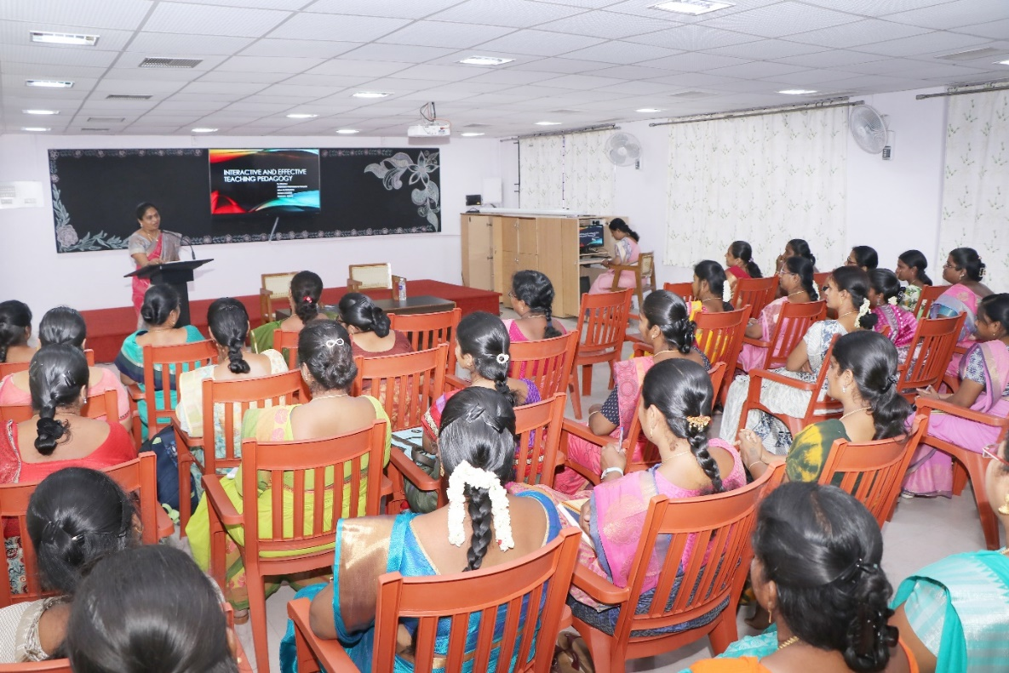

Date: 17.09.2022
Session 1: The Courage to Teach
The day started with a prayer song. Dr. Magdalene Abraham, Associate Professor, PG & Research Centre of English, Fatima College, was the resource person for the first session.
Dr. L. Meena, Assistant Professor of Management Studies, introduced and welcomed the chief guest, IQAC members and the participants. Dr. Magdalene started the session by recollecting her good-old memories of being a significant member in all IQAC initiatives. She kick started her speech by insisting on the importance of learning. She quoted Socrates’s lines “An unexamined living is not worth living” and she emphasized on her philosophical call to examine into the inner landscape as a teacher. She appreciated and recognized the college as a secular institution. Further, Dr.Magdalene gave her deliberations on the necessary etiquettes that a teacher of Fatima College should practice by touching upon the topics like proper teacher-student language of communication, saying ‘no’ at the right time and how to respond elegantly. Later, she posed the question “Why do you want to teach?” to the participants and made them to think deeply about their purpose of choosing this noble profession. Few teachers shared their own stories of inspiration. After this sharing session, Dr. Magdalene shared her personal anecdote of how she became the professor of English after going through so much difficulties and challenges in her life and it was truly inspiring. She highlighted the courage and joy that a professor needs to become an empathetic teacher.
Furthermore, she encouraged the teachers to have courage not only to question something or someone, but also to have courage to give some concrete solution to the problems stated by the students.

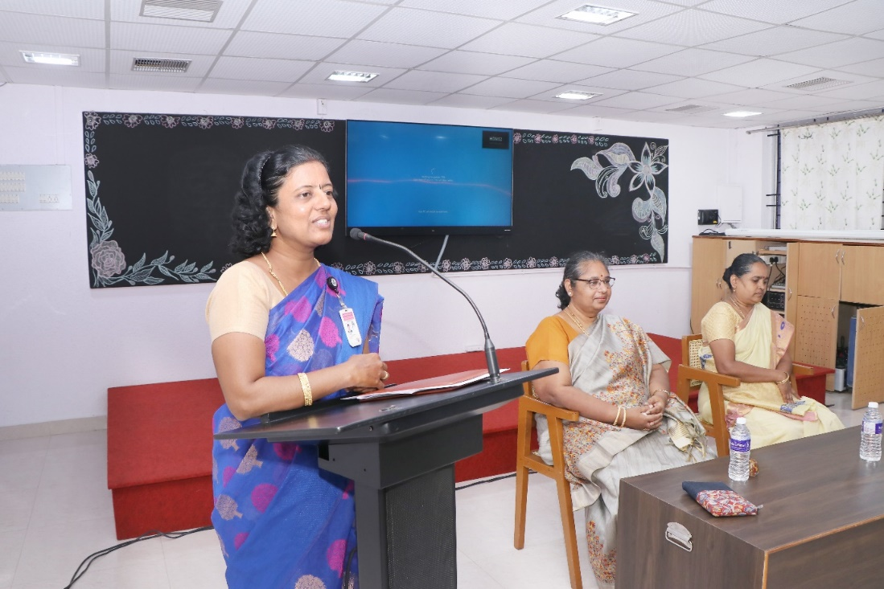
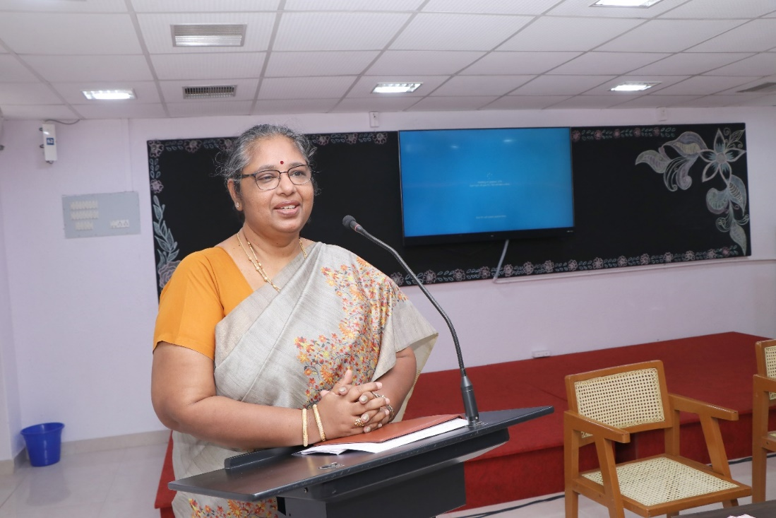
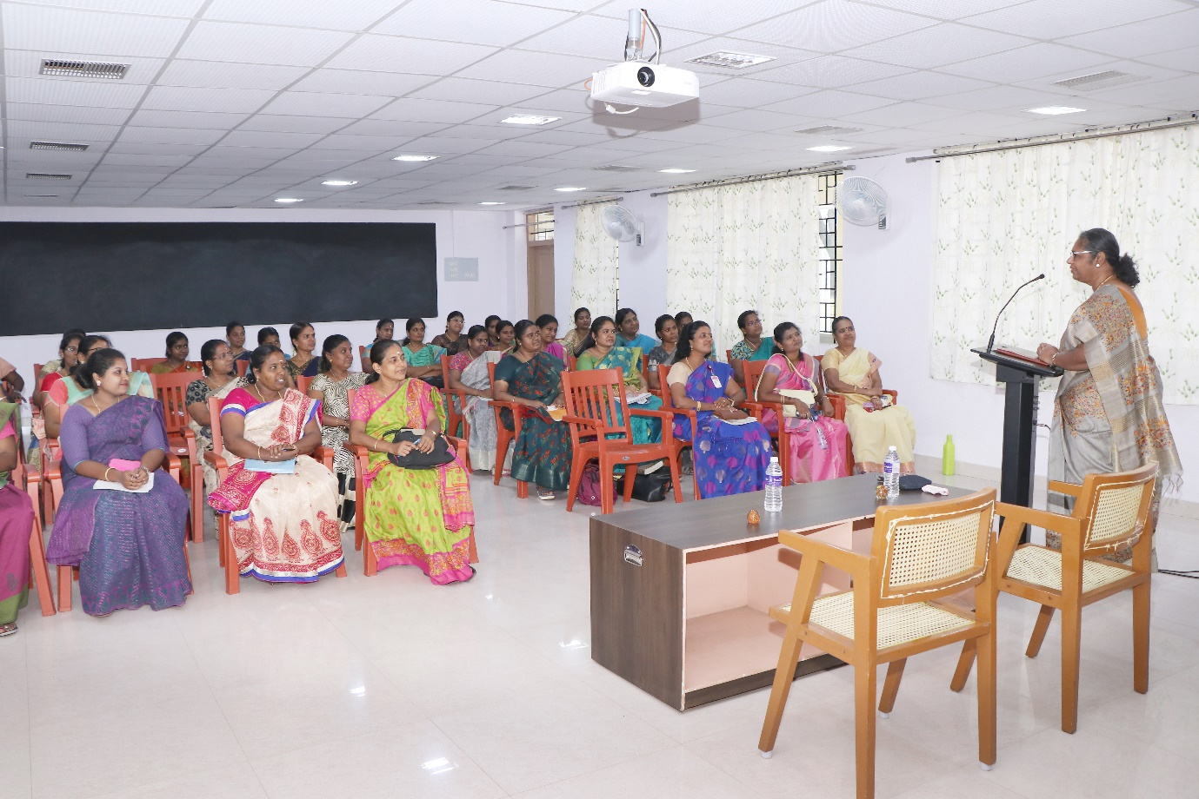
Session 2: “Ambitions and Aspirant on- Reach to Stars”
Dr. J. Asnet Mary, Assistant Professor of Zoology, Fatima College, was the resource person for the session. Mrs. P. Sumedha, Head & Assistant Professor of English introduced the chief guest. She started her session deliberating on the effectiveness of the teacher in terms of personal, professional and interpersonal qualities. Dr. J. Asnet Mary encouraged the fellow teachers to transform from ordinary to extraordinary teachers. She beautifully connected the effectiveness of teaching to two important concepts such as Pendulum principle and Effectiveness Equation. She further highlighted on Aristotle’s statement “Excellence is not an act, but a habit” to bring out the constructive changes in the methods and strategies of teaching. Her metaphor of comparing this change with the right amount of different qualitative ingredients to yield a quality product was so thought provoking. Her in-depth deliberations on the difference between proactive and reactive persons were really useful and teachers were asked to self-examine themselves on these terms. Her most engaging session was on the topic “Begin with the End in Mind”. After which, teachers were asked to write their own mission statements as an individual and as a teacher. Her interesting motivational songs were the highlights of the session. The session ended with her personal miraculous story of the completion of Ph.D, followed by an activity named “Human Knot” insisting on the team spirit needed to achieve common goals of the institution.
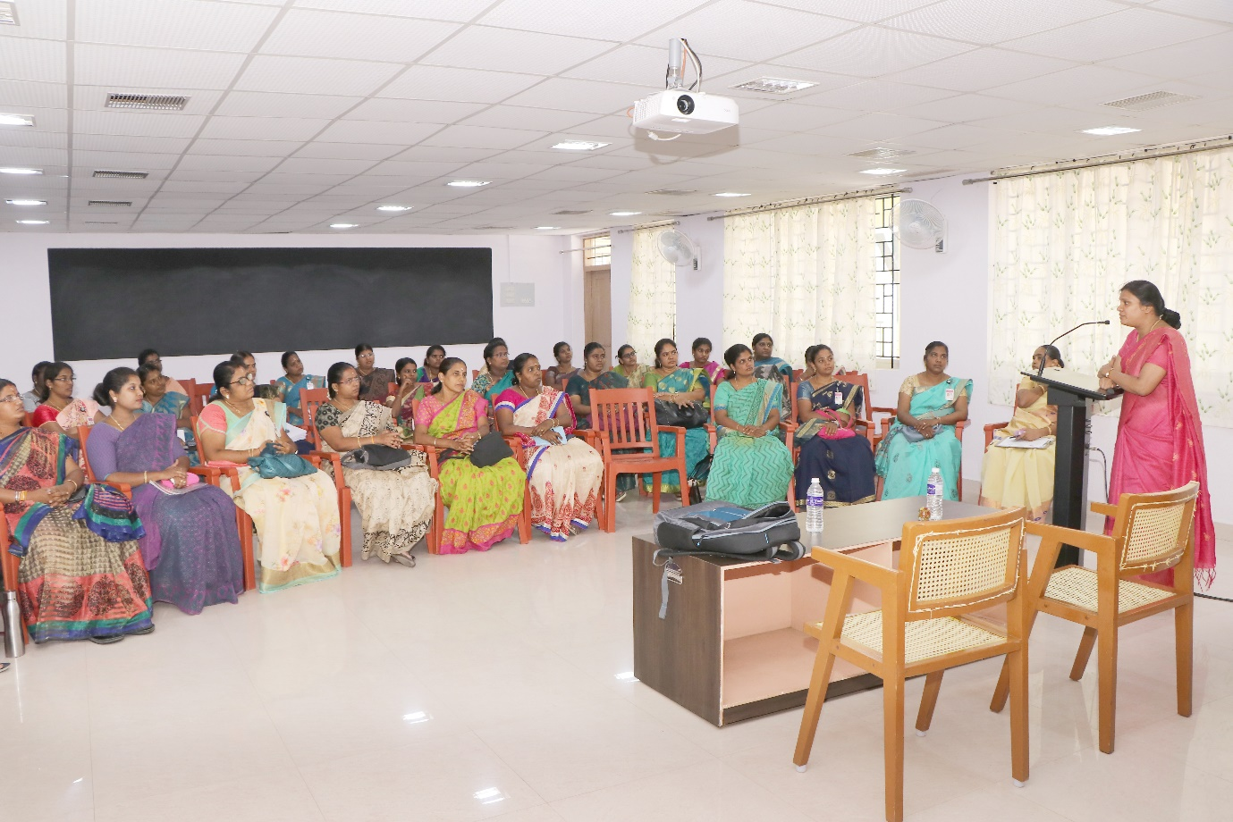

Session 3: “Strategies of Curriculum Development”
Dr. M. Meenakumari, Head & Assistant Professor of Sociology and Social Work, Dean of Academic Affairs (Arts) was the resource person for the session.
Mrs. P. Sumedha, HOD & Assistant Professor of English (SF) introduced the chief guest. She started her session by quoting a line from Kothari Commission that destiny of India is shaped in the classroom insisting on the significance of curriculum development in Higher Education. Her detailed deliberations on the current OBE pattern and mapping of vision and mission of the college with Program Educational Objectives (PEOs), Program Outcomes (POs) and Course Outcomes (Cos) were really productive and gave a clear- cut idea of how a higher education would design its curriculum. She also briefly explained about the Board of Studies and its role in designing and revision of curriculum in Fatima College. She laid emphasis on how curriculum designed in the college matches with graduate attributes. Further, she vividly explicated the concept of bloom’s taxonomy and its role in the curriculum development and also discussed its role in course design and in setting K levels (specific to Fatima College). Moreover, she elucidated the difference between the old OBE and new OBE pattern and explained in detail about the credit distribution for both UG and PG. Especially, this session was really useful to the new recruits as they were enriched with the holistic knowledge of curriculum development in Fatima College. The session ended with her appeal to the new staff to adapt different strategies to address the different category of students (free will, adopted, rebellious) and their needs through the concept of transaction analysis.

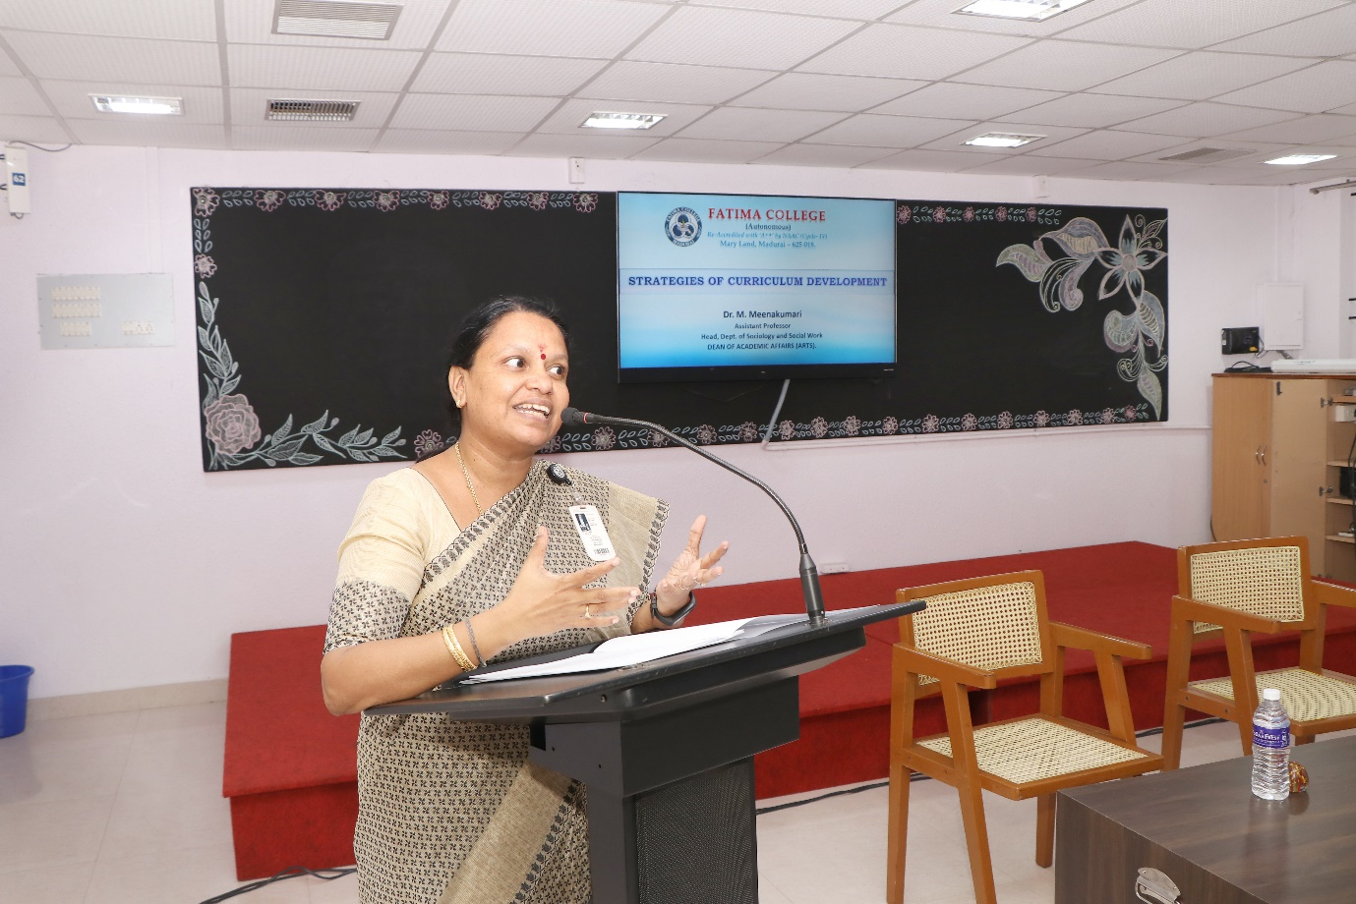

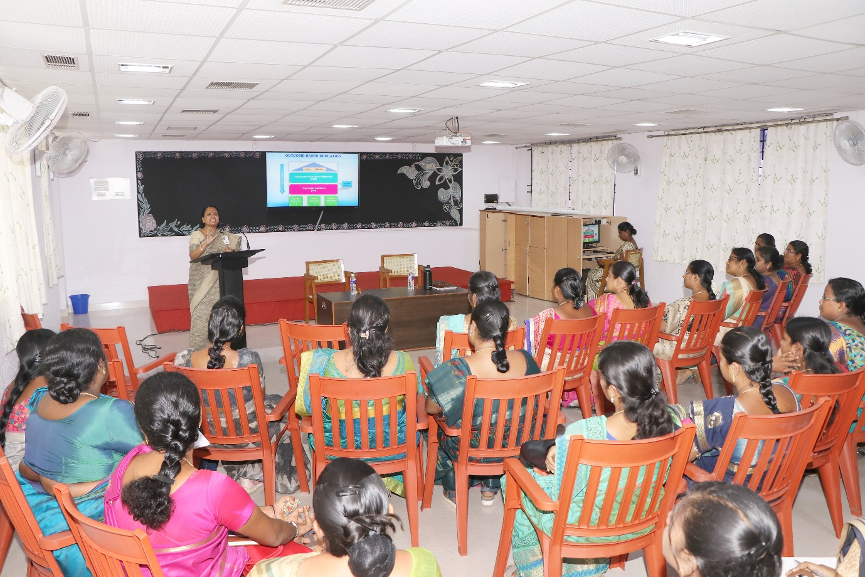

Date: 18.9.2022.
Session: 1 Research Ethics and Funding Agencies.
The resource person for this session was Dr. Vasantha Esther Rani, Associated Professor and Head, The Research center of Home Science, Fatima College, Madurai. Mrs. B. Usha, Assistant Professor of MCA introduced the Chief Guest.
The Chief Guest started the session with an introduction to research a formalized curiosity. She explained about pre-research and stage in pre-research. She gave detailed description about the stages of pre-research. Then she shared some tips for selecting a topic. After that, she discussed about Research ethics quoting that Research ethics are the application of fundamental ethical principles to research activities including the design and implementation of research. Research ethics are set of rules of our own and others behavior. She explained about the research ethics committee. Institutional Review Board reviews whether the research is ethical enough or not to protect the rights dignity and welfare of the respondents. Then she discussed about the five broad categories of research ethics namely, minimizing the risk of harm next, minimizing the risk of the research, obtaining informed consent, protecting anonymity and confidentiality and to avoid misleading practices. She also explained about the advantages of research ethics like how research ethics promotes the aim of the research. Also she explained about the limitations of research ethics. She discussed about ensuring ethics at every step of research. Then she gave us the list of various funding agencies. She gave us few tips to reduce stress level during research. She motivated us saying if the research is rejected try again. She concluded the session by sharing her personal experiences in research. Vote of thanks was delivered by Mrs. B. Usha, Assistance Professor of MCA, Fatima College, Madurai.

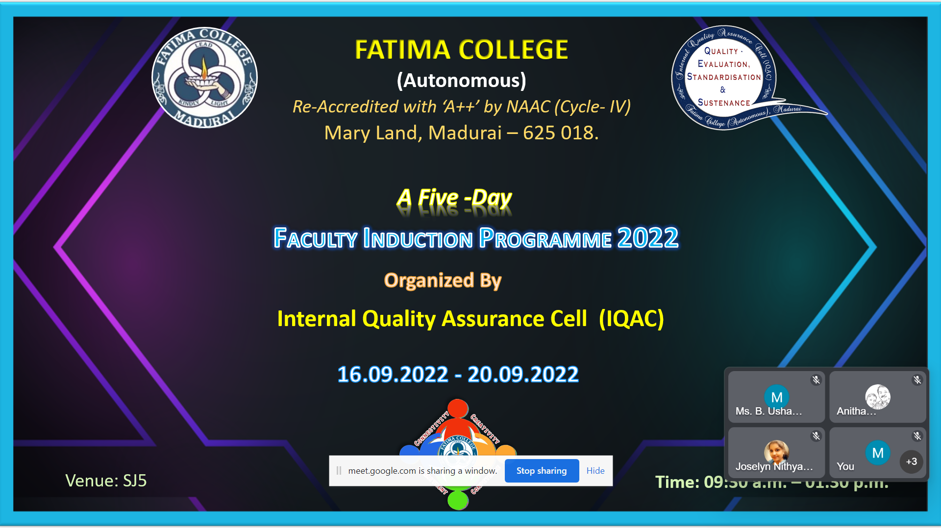

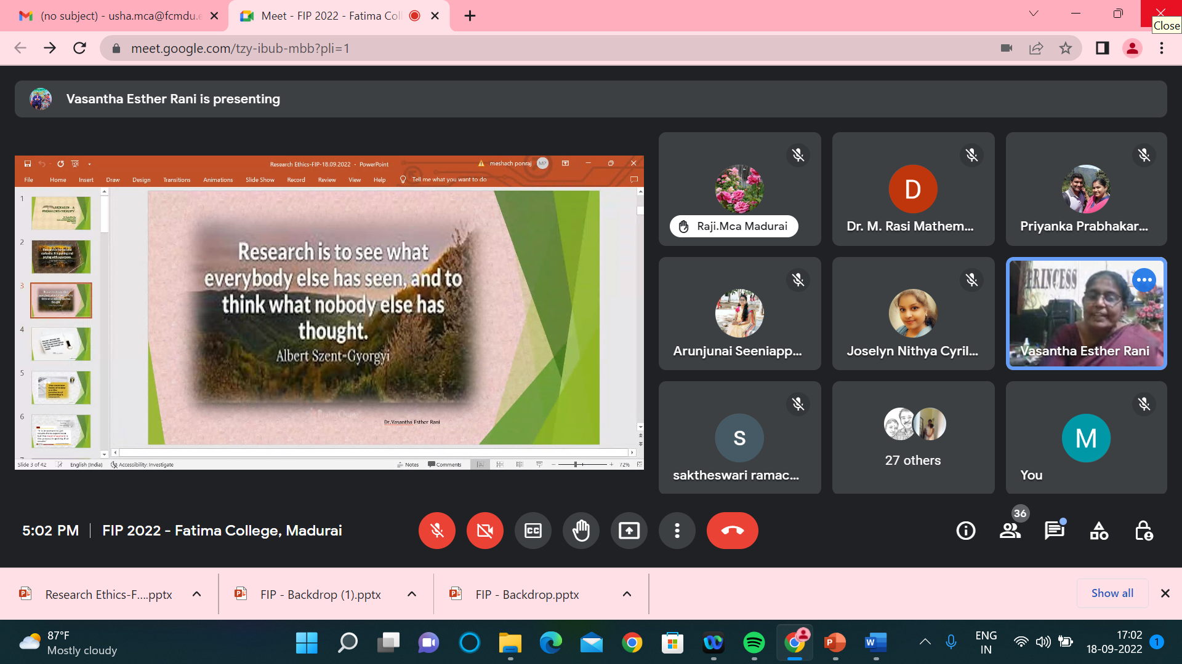
https://youtu.be/hs2MPINcFeI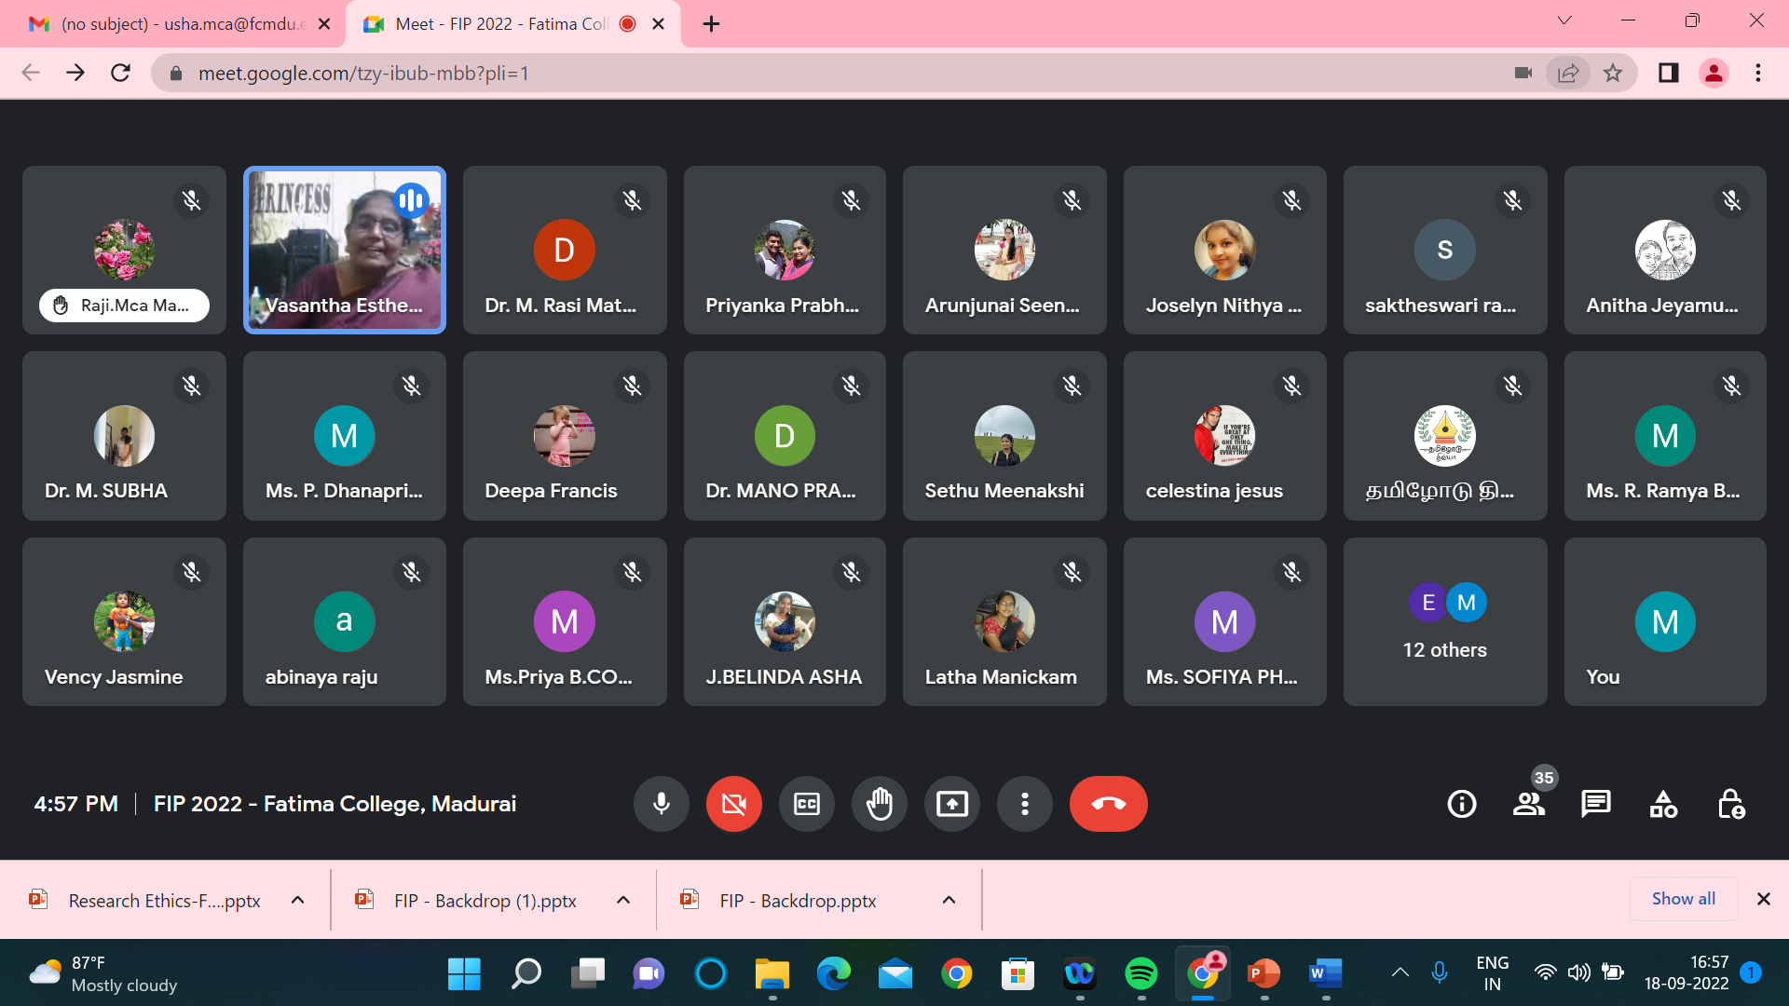

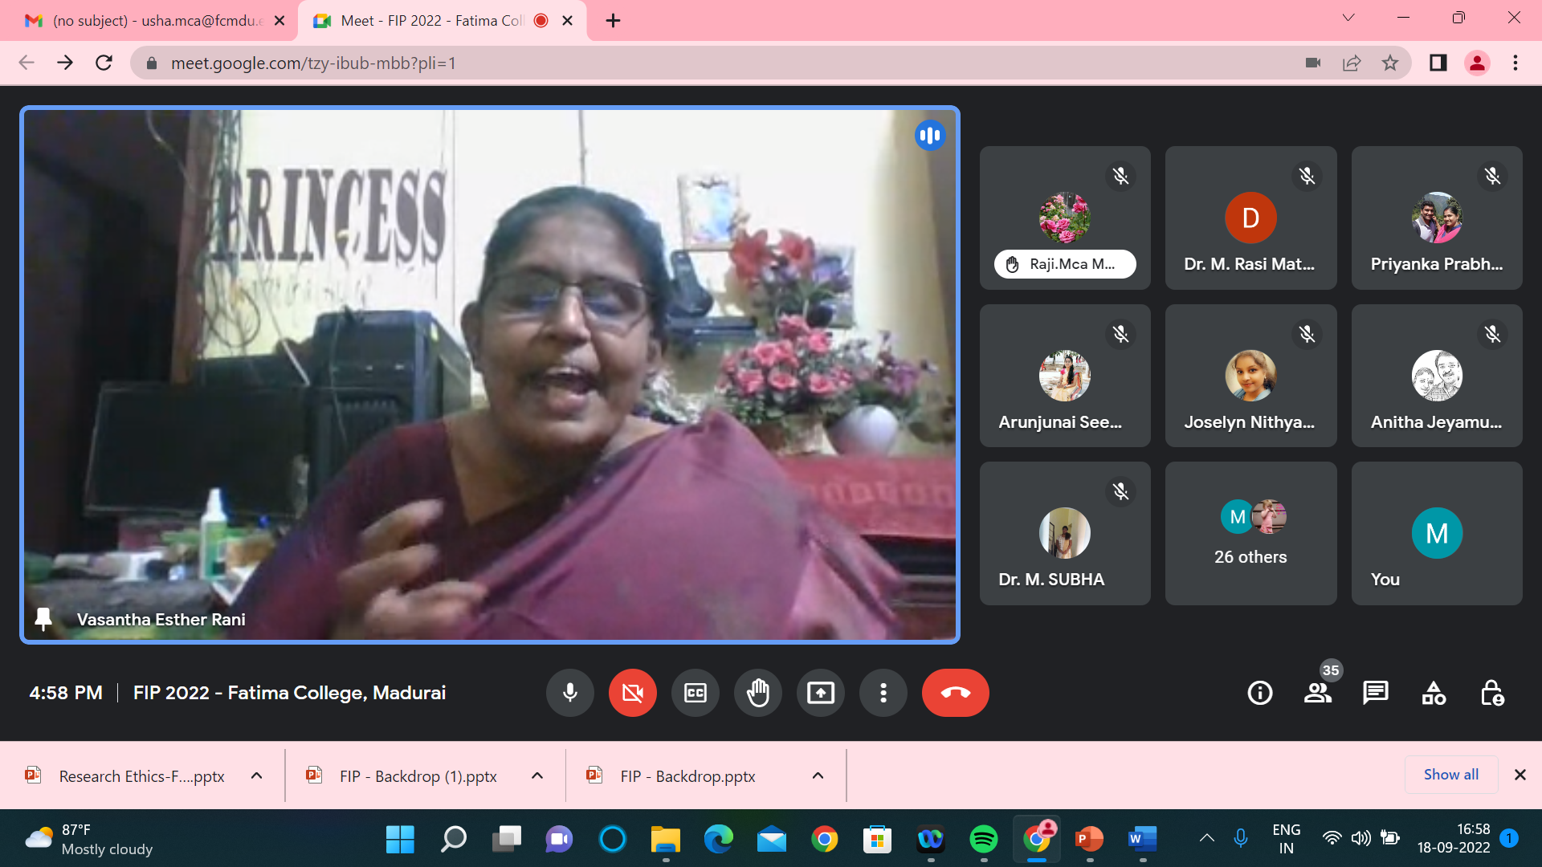

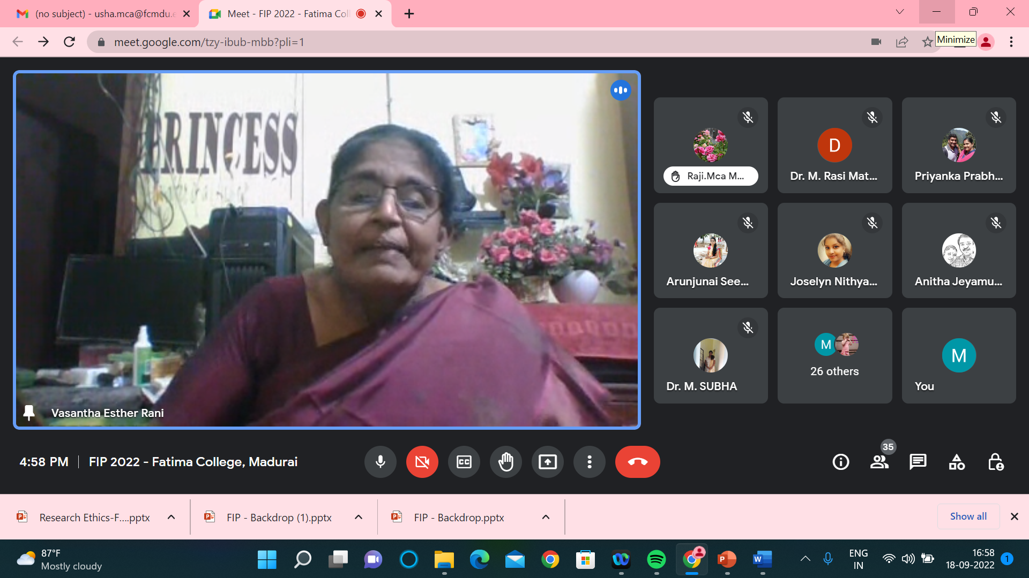

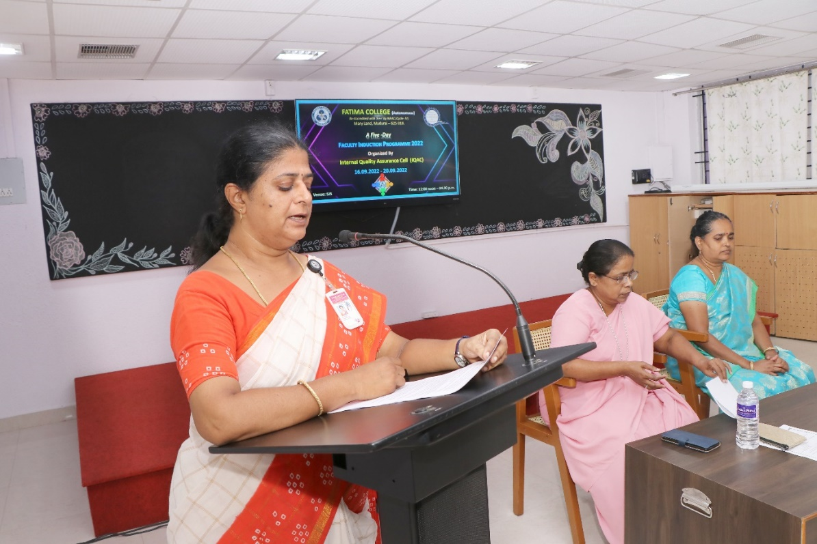

Date: 19.09.2022
Session 1: LATERAL THINKING
The session was addressed by Dr. K. Rosemary Euphrasia, Associate Professor of Computer Science & IQAC Coordinator, Fatima College. She enlightened the participants about LATERAL THINKING, required to be a competent teacher. Various innovative methods on problems and solutions were elaborated in detail. She highlighted certain techniques to think from a different perspective – OUT OF BOX THINKING. As an add-on credit to the topic, she gave an insight towards two categories of thinking – convergent and divergent.
She cited the story of Hare and the Tortoise as an example to make the attainment of the session very clear. To conclude, she motivated the faculty regarding the ‘change’ to be instigated in young minds to develop their creativity. She quoted that creativity leads to ultimate happiness for the students. Exercises on out of box, lateral and logical thinking, picture illusion, rebuzz puzzles, few other games etc. were conducted which made the session lively. The lecture was very beneficial and provided the perception which a teacher educator has to overcome all challenges.

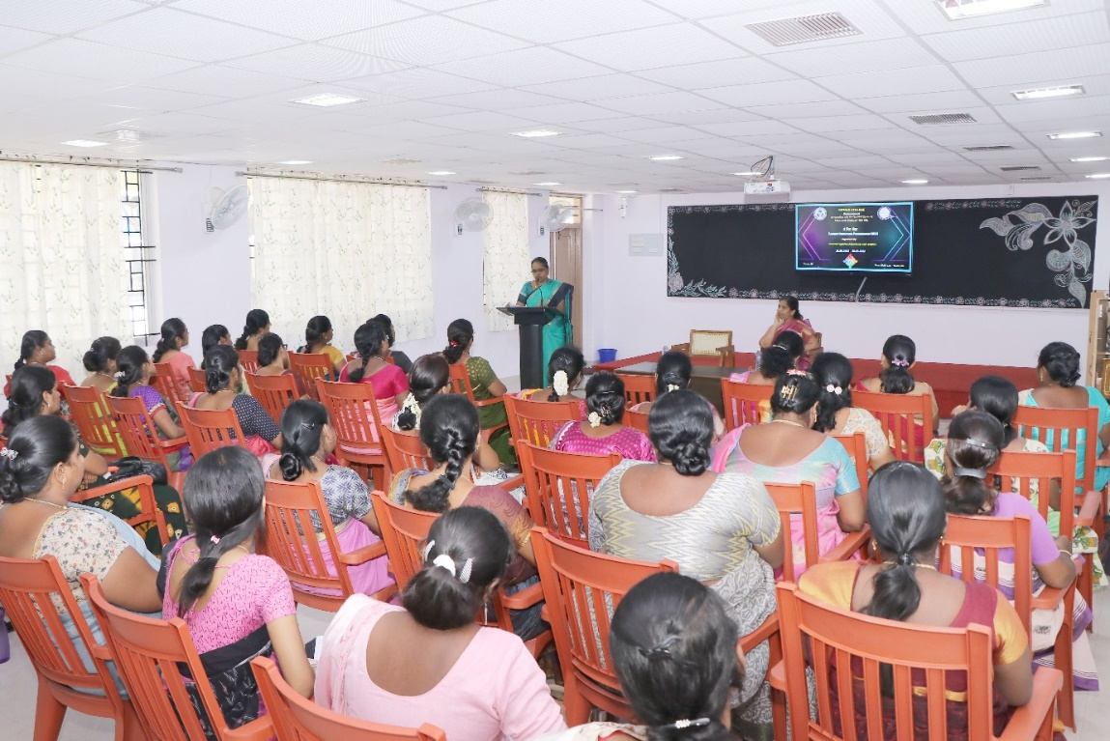

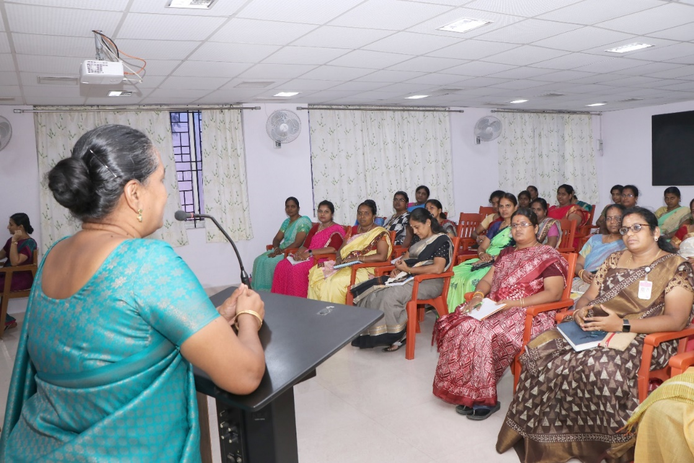
Date: 20.09.2022
The session started with prayer followed by welcome address which was delivered by Mrs. P. Sumedha, Head and Assistant Professor of English.
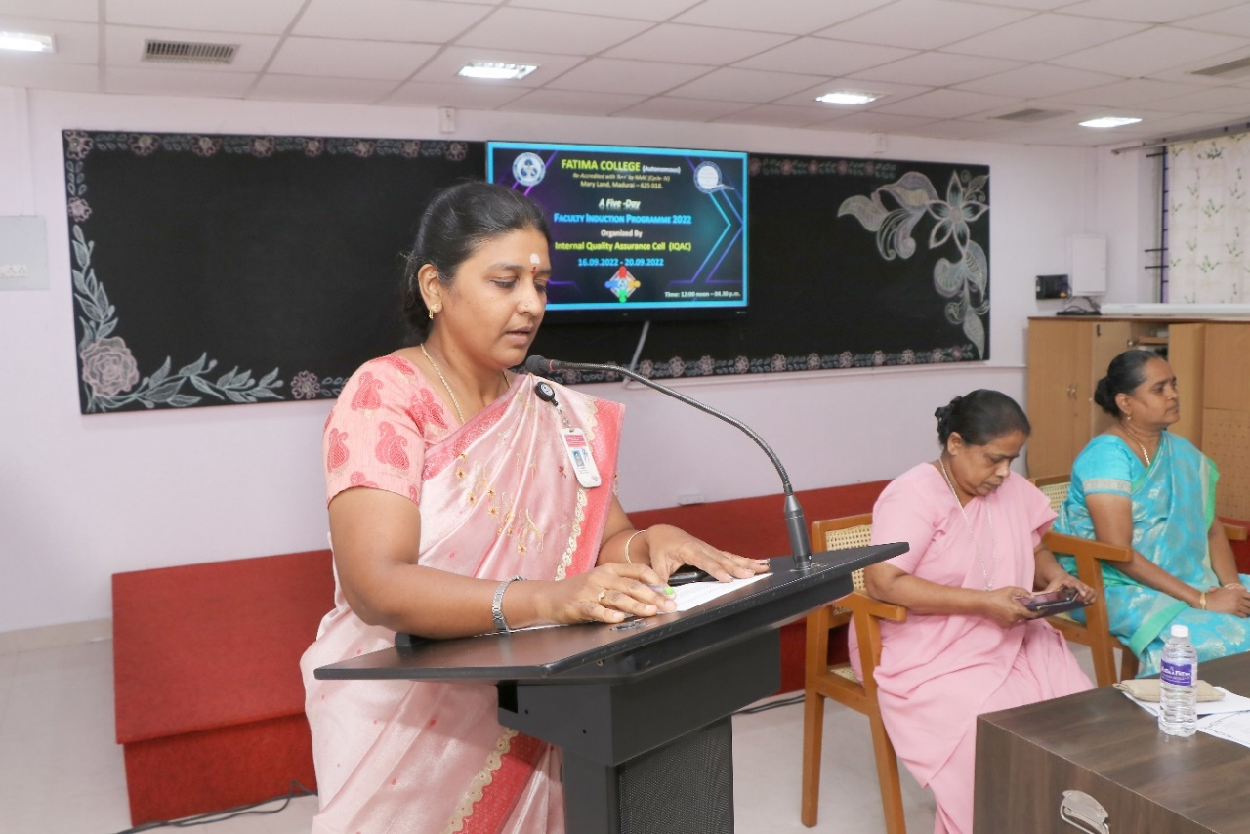
The first session was delivered by the Principal Rev. Dr. G.Celine Sahaya Mary.
The aim of the session was about to highlight the aim of higher education and the role of teachers. ‘Who am I’ is a sensitive question highlighted to the teachers. The sense of unity was sensitized and emphasized by the founder’s vision. The importance of meditation was brought out through which self-mastery could be attained. Besides this she emphasis on contentment in one’s professional life is explained through stories. The importance of counselling to the students was explained. Teachers were told about the professional ethics, class preparation, and active presence during the meetings, taking casual leaves and to keep a pleasant smile amidst the students.
The next session was delivered by Secretary Rev. Dr. M. Fransica Flora who talked about the founder’s vision and the culture of Fatima College. Gender inequality was referred with Tamil poet Bharathiyaar’s Poetic lines. The vision of Mother Rose was insisted that it is communication in which contact becomes connection. Later on the terms and conditions of Fatima College was listed out by sister Secretary. Authoritative powers were explained to the new teacher’s right from President to the Superintendent of the college. The session was concluded with the note of the code of conduct that to be instilled.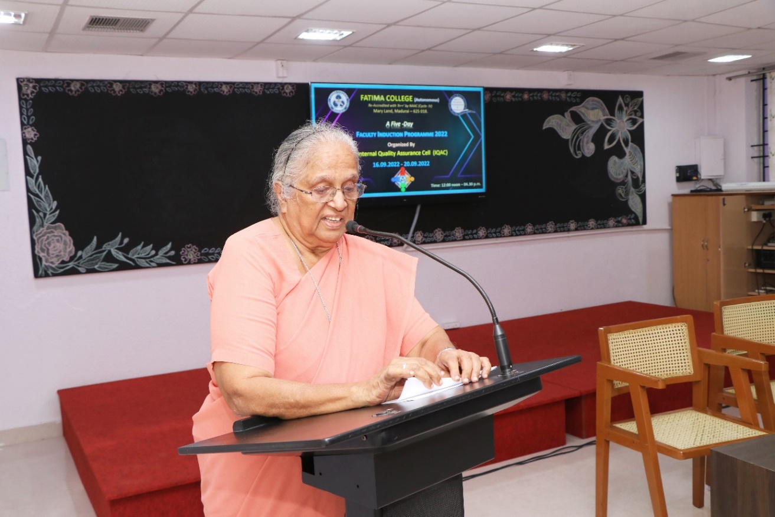
The third session was delivered by Controller of Examinations, Rev. Dr. A. Jospin Nirmala Mary.
The session began with the introduction of examination pattern and the presentation slides were displayed in which key aspects- accuracy, credibility & time, efficiency are shown. Self-learning courses for the students to update and

deepen the subject knowledge was explained. The lecture was concluded with the care and love of the students that to be showered by the teachers.
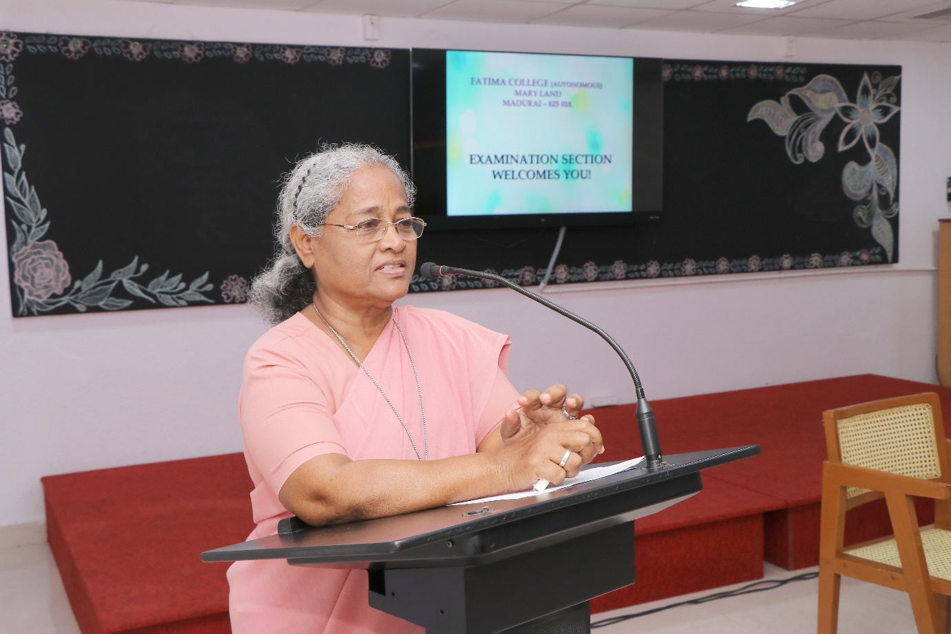
The final session was delivered by Vice Principal Rev. Dr. G. Jenita Rani.
The lecture was started with a note of the quality of a best teacher. The teachers were insisted to adopt various teaching methods based on the understanding level of the students. The session was really engaged with Shankar D. Sharma’s stories – how the teacher influenced the students and created a spark in all of us through various incidents. Finally the session was oriented with the story video played to bring in the idea of essence of teaching.
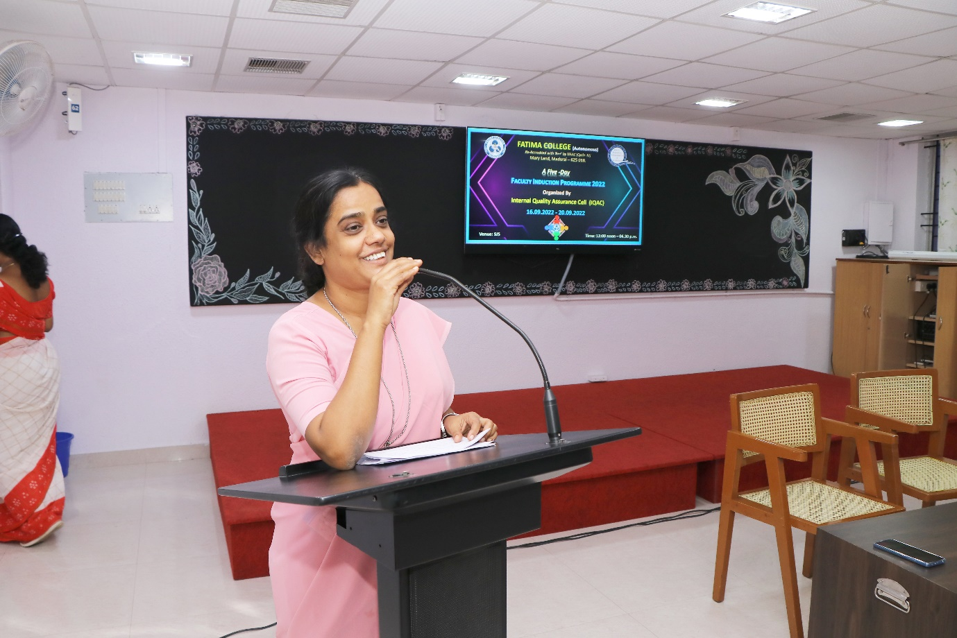

Attendance:
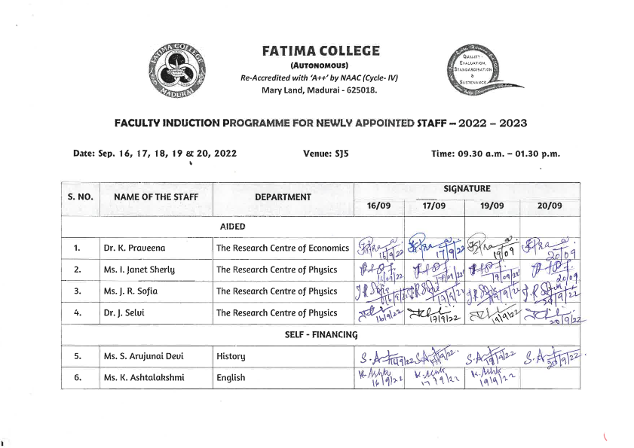
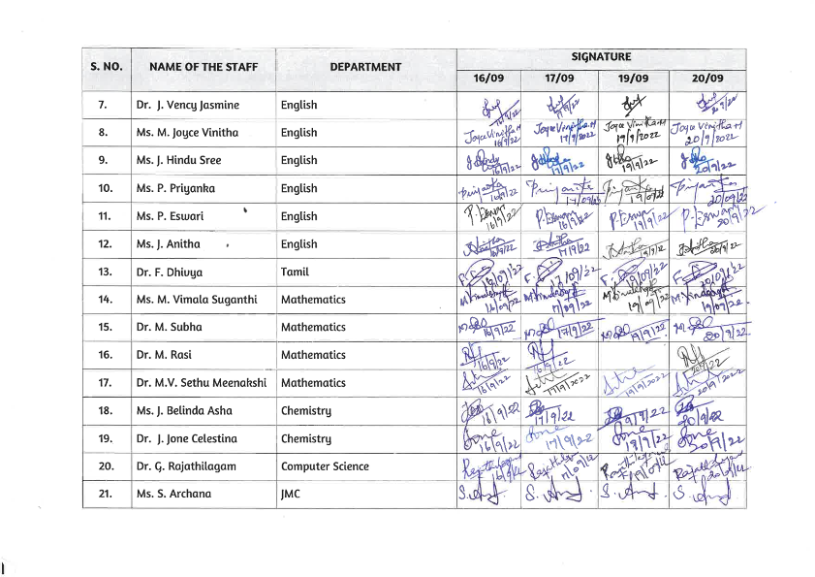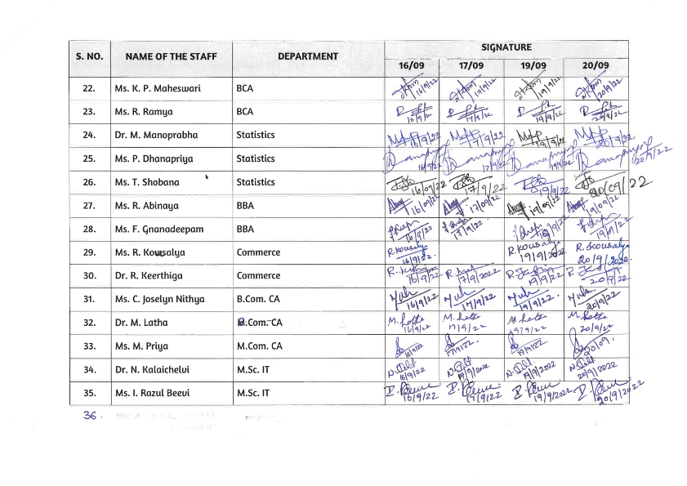

Certificates
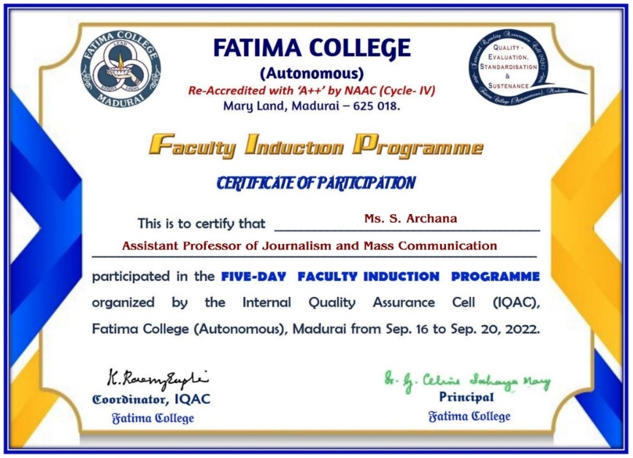
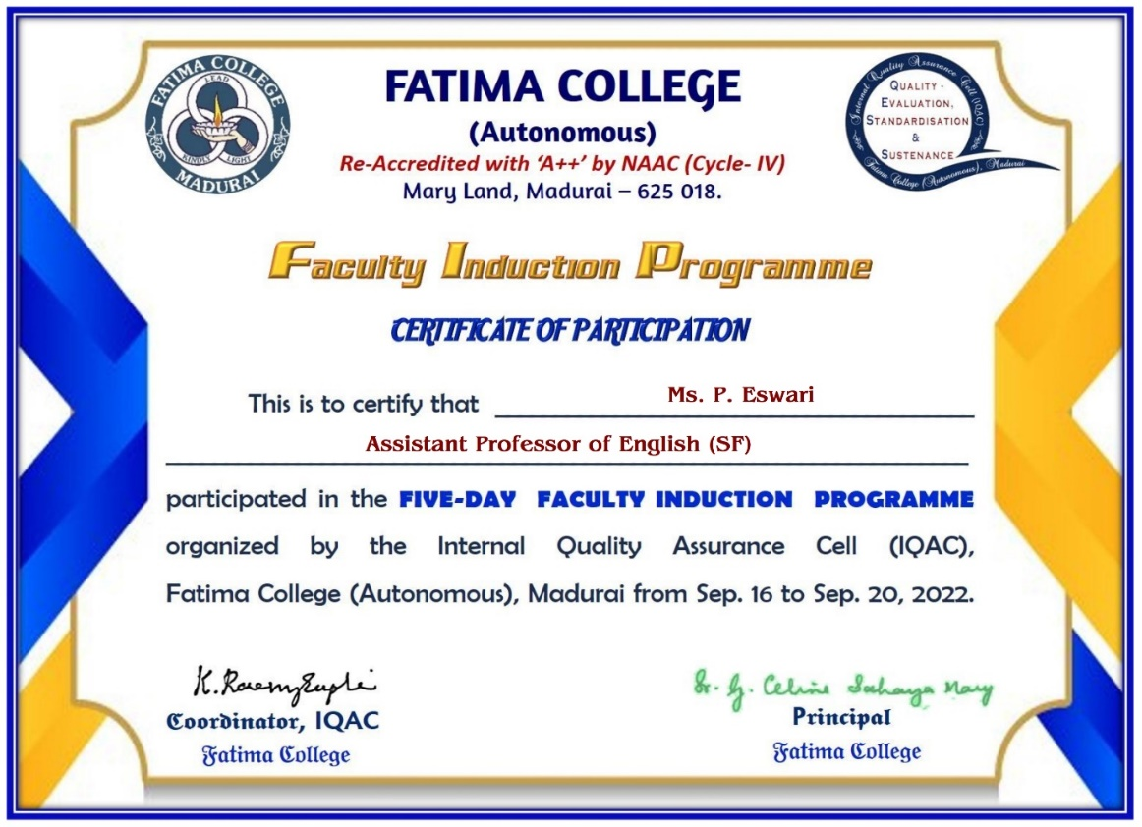

Google Form:
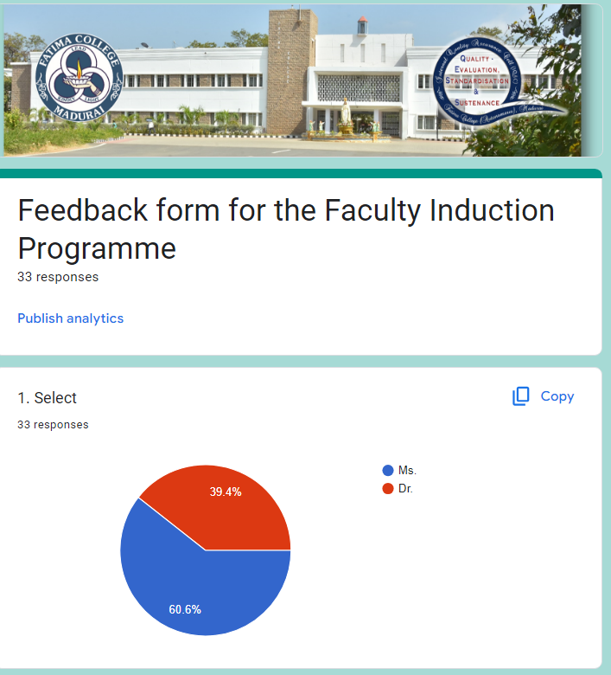
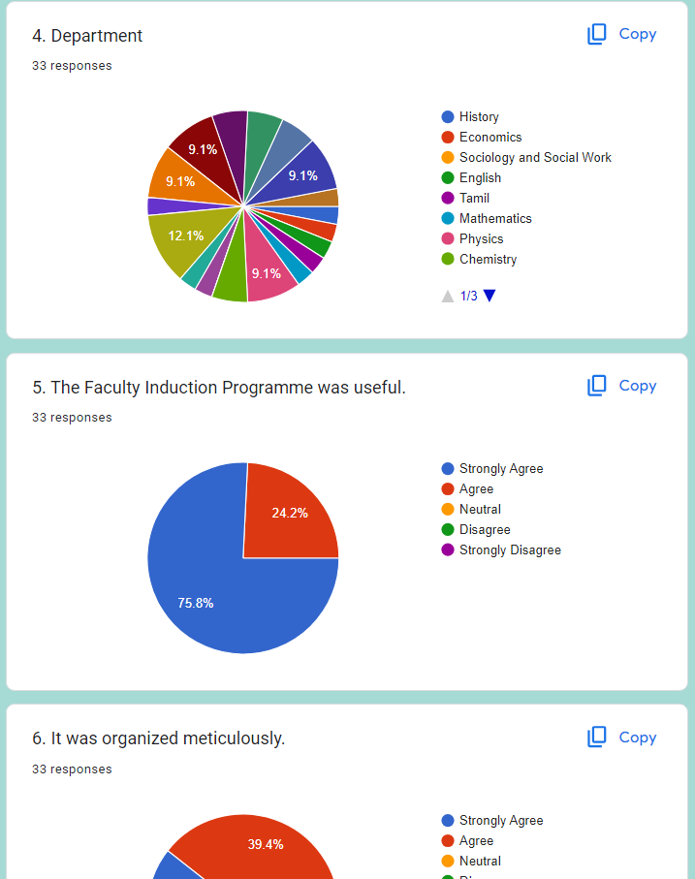
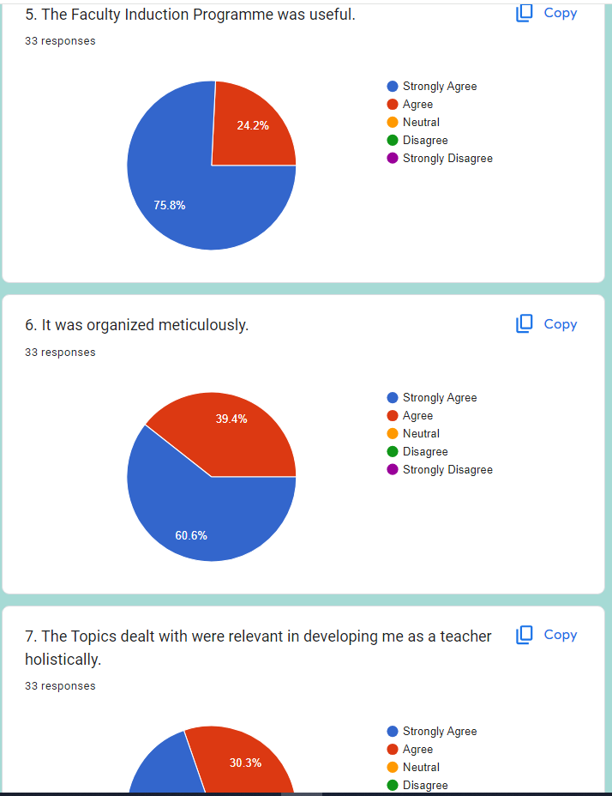

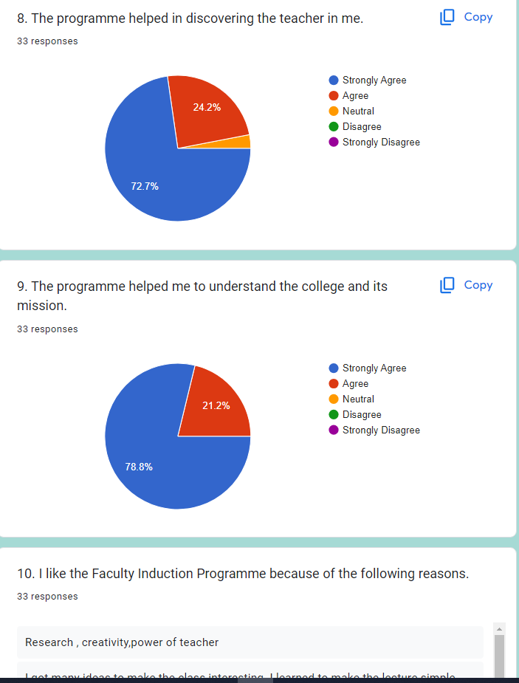

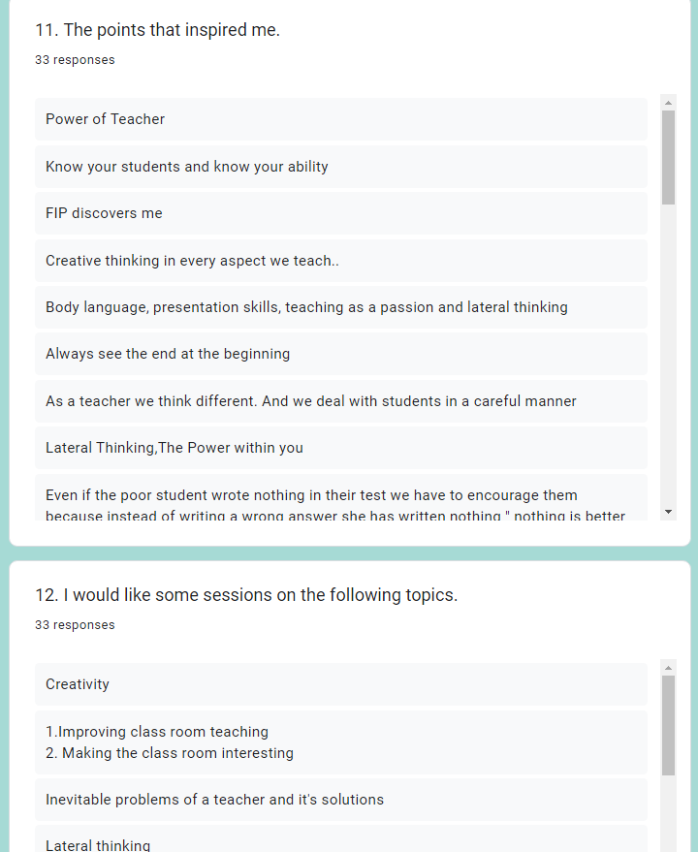

SPECIAL LECTURE ON NON-VIOLENT ECONOMY – LOCAL LIVELIHOODS AND CLIMATE CHANGE FOR STUDENTS- SEP. 21, 2022
Date : 21.09.2022
Time : 12.30 to 1.30 p.m.
Venue : San Jose Seminar Hall
Name of the Organizers : IQAC
Participants : 136 Students
Title/Topic of the activity : Special Lecture – Non-Violent Economy: Local
Livelihoods and Climate Change
Speaker’s name : Mr. Ananthoo
Founder, Organic Farmer’s Market
Tula

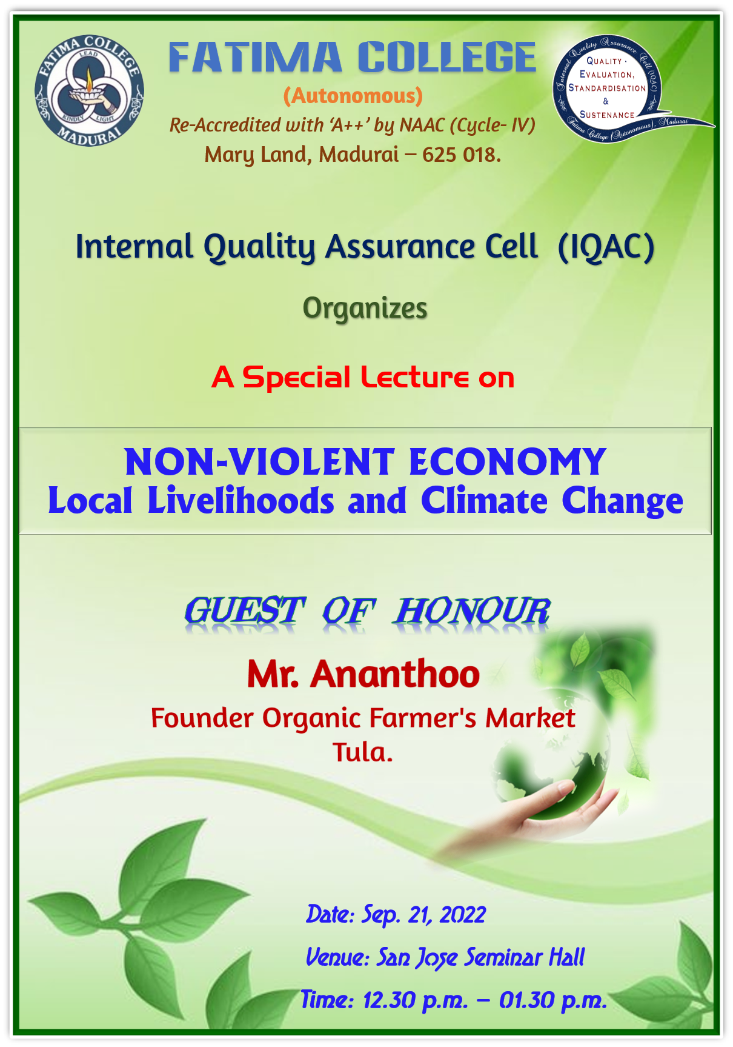

REPORT
The IQAC of Fatima College organised a special lecture on “Non-Violent Economy: Local Livelihoods and Climate Change” on September 21, 2022 at San Jose Seminar Hall from 12.30 to 1.30 p.m., as a part of Ahimsa Santhae programme. Mr. Ananthoo, Founder, Organic Farmers’ Market, Tula, was the Guest of Honour.

The programme started with a prayer song. The members of the Student Council welcomed the gathering and introduced the chief guest. Dr. K. Rosemary Euphrasia, IQAC Coordinator honoured Dr. Ananthoo with a shawl and a memento. Dr. Ananthoo, in his special address, highlighted the importance of the food culture that the young generation should adopt. He explained the term Non-Violent Economy and stressed the importance of adopting such economy that Mahatma Gandhiji had advocated. Focusing on adulteration and junk food, he requested the students to be aware of the deficiencies they cause and the hormonal changes they fabricate. Starting from snack items, he elaborated on the need to choose a diet made of nutrient-rich food. He also emphasized the need to consume food items that are rich in vitamins, minerals as they nourish the body and help keep us healthy. They can reduce the risk to chronic diseases. He also talked about the change in life style that has resulted in climate change. A proper diet with local products and a simple life style without complicating our mind and body with unnecessary things will definitely lead to a better future for our globe, he concluded. After the lecture, some students posed questions to Mr. Ananthoo and clarified their doubts.

The students got awareness on local livelihoods and climate change. They also understood the need to consume nutrient-rich food. They appreciated the efforts of Mr. Ananthoo in encouraging the people to live a less complicated and simple life that guarantees contentment and peace.

PHOTO GALLERY
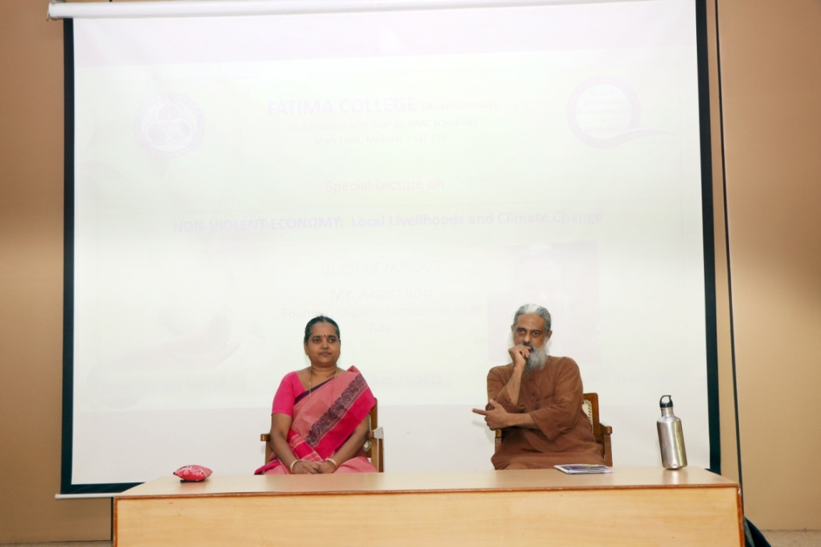
Mr. Ananthoo, Founder, Organic Farmers’ Market, Tula and Dr. K. Rosemary Euphrasia, IQAC Coordinator on dais

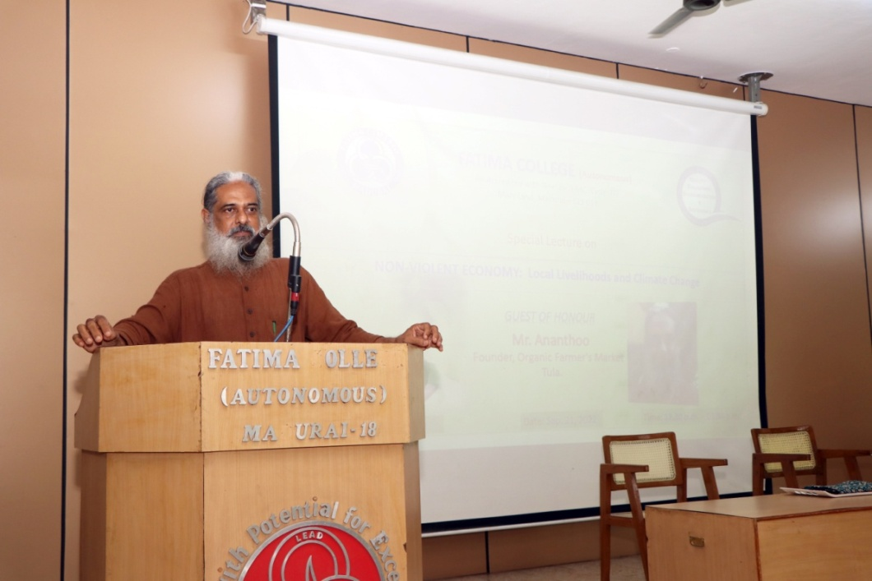
Mr. Ananthoo stressing the importance of Non-Violent Economy

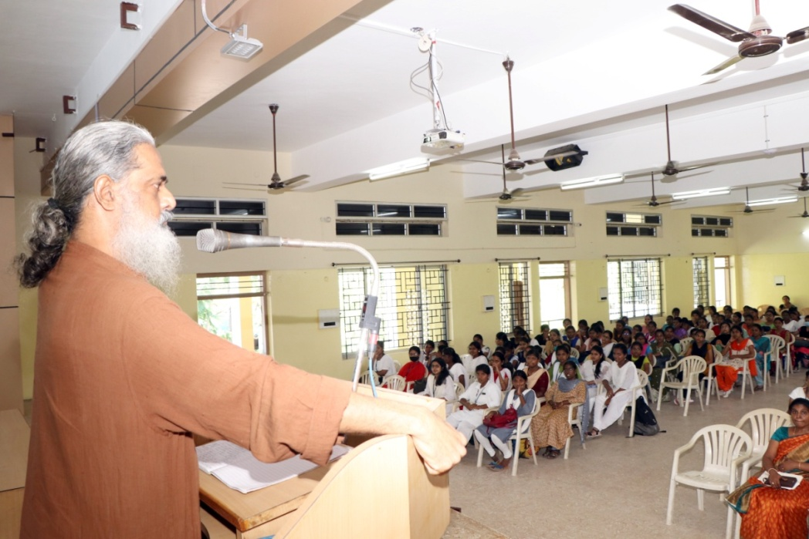
Mr. Ananthoo addressing the students on Climate Change and Food culture
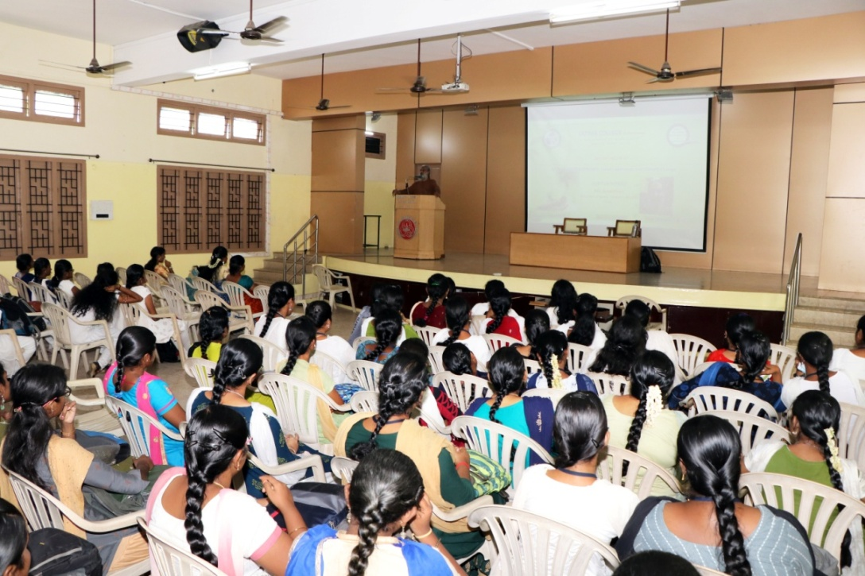

Attendance:

S. No. | REG. NO. | NAME
 | 2021C01 | AGNES MARY A
 | 2021C02 | AMUDHA A
 | 2021C04 | BHAVADHARANI M
 | 2021C05 | CAROLINE FABINAA N
 | 2021C48 | CATHERIN SIBA J
 | 2021C06 | CHERIN PRINCY V
 | 2021C07 | CRISPIN VIRGILA A
 | 2021C08 | DHARANI S
 | 2021C44 | DHAROSHINI M
 | 2021C09 | DHARSHINI M
 | 2021C10 | DINA MAGLIN G
 | 2021C11 | DIVYA PRIYA R
 | 2021C12 | DURGADEVI BR
 | 2021C13 | DURGALAKSHMI C
 | 2021C15 | HARINI M
 | 2021C16 | HARISHMA T
 | 2021C17 | HENCY LISHA M
 | 2021C18 | INFANT HEVEENA C
 | 2021C19 | JAFRINA BARVIN Z
 | 2021C20 | JANIKA M
 | 2021C21 | MAHALAKSHMI G
 | 2021C22 | MAHESWARI S
 | 2021C23 | MUTHUPRIYA M
 | 2021C24 | P NIVETHA
 | 2021C30 | RIYASHINI S
 | 2021C31 | RONICA ALICE J
 | 2021C43 | SAHAYA SHERLY JOICE J
 | 2021C32 | SHERYL PEACELIN W
 | 2021C33 | SHINISHA BRIJET D
 | 2021C46 | SHIVA RANJANI P
 | 2021C34 | SILPAL P
 | 2021C47 | SWETHA B
 | 2021C37 | UDAYA TERESA F
 | 2021C38 | VAISHNAVI R
 | 2021C39 | VANATHI K
 | 2021C40 | VINOTHINI R
 | 2021C42 | VISHALINI A
 | 2021C41 | VISHALINI A
 | 2021N01 | ABIRAMI S
 | 2021N02 | AKSHAYA N
 | 2021N03 | AMIRTHAVARSHINI R
 | 2021N04 | ANITHA B
 | 2021N05 | AROCKIA VINCY M
 | 2021N06 | ASHIMA GEO A
 | 2021N41 | AYESHA NAUFA A S
 | 2021N07 | BARGANA S
 | 2021N39 | FARGANA THASLIMA S
 | 2021N20 | GNANA SUJA P
 | 2021N29 | HEMALATHA T
 | 2021N11 | HEMAPRAMEELA R
 | 2021N12 | JASILIYA QUEEN M
 | 2021N13 | JEYAVEERALAKSHMI K
 | 2021N34 | KEERTHIGA R
 | 2021N15 | LINCY S
 | 2021N16 | MAHALAKSHMI P
 | 2021N35 | MUTHULAKSHMI M
 | 2021N17 | NAGA SHREE S
 | 2021N18 | NALINA JOTHI S
 | 2021N19 | NASRIN SARIFA S
 | 2021N30 | NIVETHA K
 | 2021N32 | SWATHI V
 | 2021N33 | THAHIRA S
 | 2021N26 | THIRISHA K
 | 2021N36 | VIJAYA PRIYA S
 | 2021N27 | YUREKHA SOWNDARIYA V
 | 2021P01 | AARTHI T
 | 2021P02 | ABINAYA SRI U
 | 2021P03 | ABIRAMI M
 | 2021P42 | ABIRAMI P R
 | 2021P46 | ABOORVA LAKSHMI D
 | 2021P04 | ANUJA S
 | 2021P06 | BAVANI M S
 | 2021P07 | CYNTHIAA L
 | 2021P08 | DHANA SRI V
 | 2021P09 | DHANANEE R
 | 2021P11 | ESAKKIYAMMAL K
 | 2021P12 | JASMINE SAHAY OVIYA S
 | 2021P14 | JERLIN E
 | 2021P15 | JOYLIN DHARSHINI C
 | 2021P18 | KAREN BEAULAH ROSE S
 | 2021P19 | KARISHMA BHARGAVI R
 | 2021P47 | KAVIYA M
 | 2021P20 | KEERTHANA K
 | 2021P22 | M HARINI
 | 2021P23 | MAHALAKSHMI D
 | 2021P24 | MARIA ROSELIN RANI B
 | 2021P25 | MARIAM JAMILA S
 | 2021P31 | ROFFINA E
 | 2021P32 | ROOPA ROSLIN S
 | 2021P33 | SAHANA PARVIN M
 | 2021P34 | SARU MATHI C
 | 2021P49 | SHALINI B
 | 2021P35 | SHARINA JOE KATHRIN A
 | 2021P43 | SOBHIYA ANBARASI K
 | 2021P36 | SOFIYA DEVI K
 | 2021P37 | SREETHI JINANI RAJ M
 | 2021P38 | SRI DEVI U
 | 2021P39 | SWAATHY B
 | 2021P44 | SWATHI R
 | 2021P40 | THAIS J
 | 2021P41 | VEERA PANDEESWARI S
 | 2021Z01 | ABISRI M
 | 2021Z02 | AMIRTHAVARSHINI S
 | 2021Z43 | ANITHA C
 | 2021Z30 | BHAVANI K
 | 2021Z04 | BRINDHA S
 | 2021Z05 | DAISY DAYANA J
 | 2021Z45 | DHANAMAYILPRIYA S
 | 2021Z06 | GAYATHRI M
 | 2021Z31 | HARINI K
 | 2021Z07 | JEYASRI S
 | 2021Z08 | JOTHI PRIYA M
 | 2021Z09 | K JENCY POULIN MARY
 | 2021Z10 | K SUSMITHA
 | 2021Z11 | KAREN S
 | 2021Z40 | KAVIPPRIYA R
 | 2021Z47 | MATHAVA PRIYA B
 | 2021Z12 | MEDONA J
 | 2021Z14 | NAGAJOTHI S
 | 2021Z32 | NARMATHA M
 | 2021Z33 | PANDISELVI M
 | 2021Z50 | PREETHA S
 | 2021Z19 | SELVI E
 | 2021Z20 | SETHURAMYA M
 | 2021Z21 | SHANMATHY S
 | 2021Z36 | SINDHUJA C
 | 2021Z22 | SNEKA A
 | 2021Z37 | SRIRATHI NANDHIJA M
 | 2021Z24 | SUBANU S
 | 2021Z42 | SUREKHA S
 | 2021Z28 | VARSHINI G
 | 2021Z25 | VASHNI ABIYA J
 | 2021Z38 | VIYAGULA DEEPTHI D
 | 2021Z26 | YAZHINI S
 | 2021Z49 | YUVARANI K
 | 2021Z27 | YUVATHI S

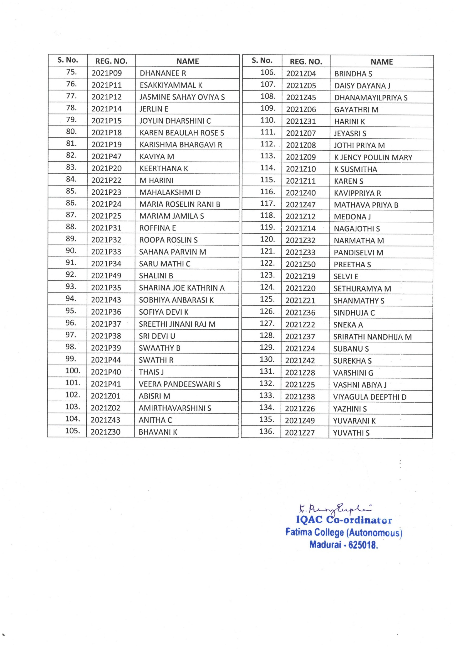
THREE-DAY FACULTY DEVELOPMENT PROGRAM ON
‘EMOTIONAL INTELLIGENCE’ on 22.09.2022
Invitation:
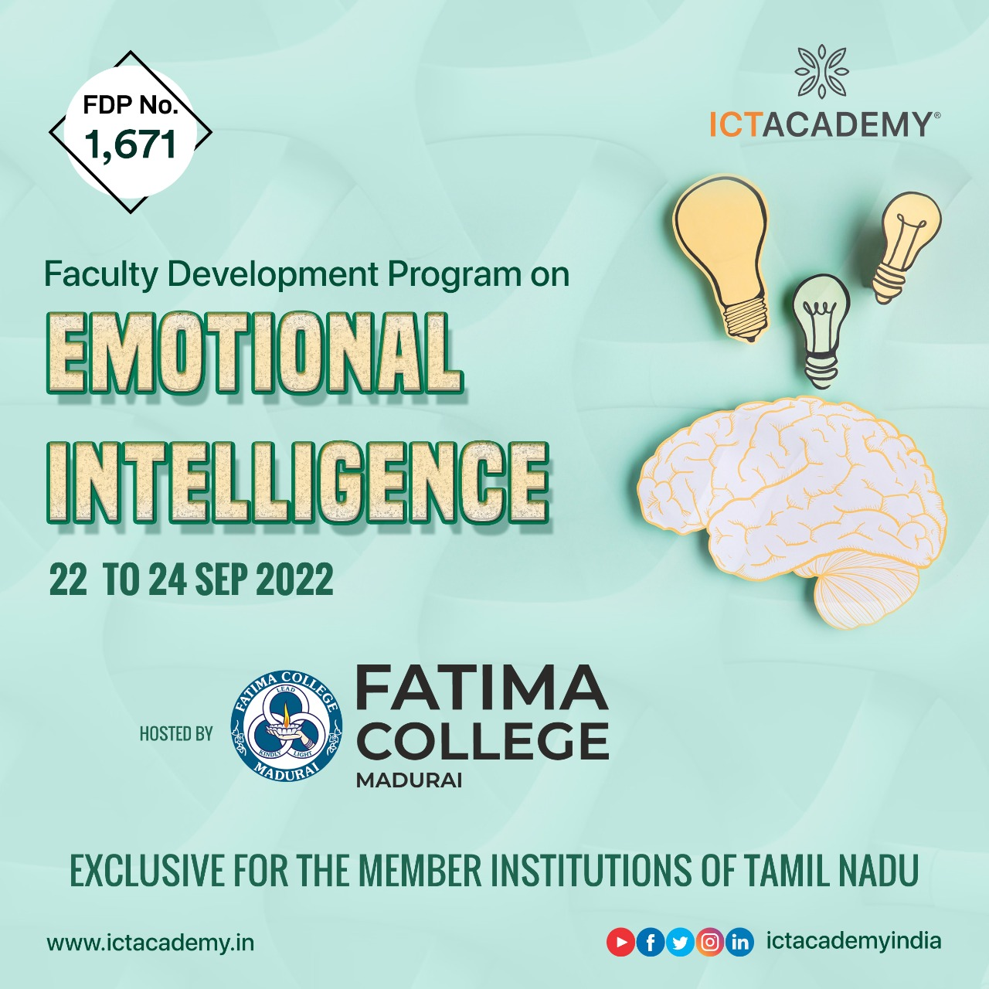
Date-22-09-2022
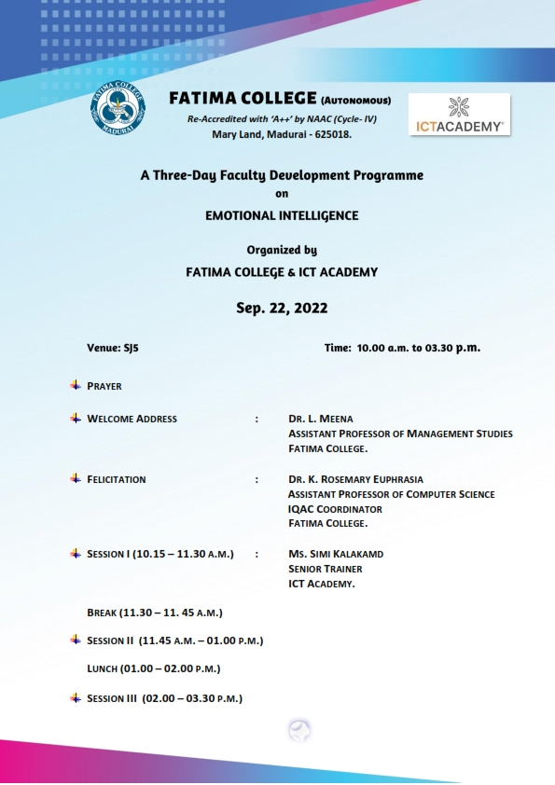

Day-I-Venue-SJ5
Fore Noon Session-10 a.m. -1 p.m.
The first day session on the three-day Faculty development program on “Emotional Intelligence’ organized by Fatima College, Madurai and ICT Academy, Bangalore began with an invocation to God followed by a welcome address by Dr.Meena, Assistant Professor of Business Administration. Ms.Simi, Senior Soft Skill Trainer, ICT Academy, Bangalore gave a wonderful presentation on ‘Emotional Intelligence’. She briefed on the objectives of Emotional Intelligence, the basics of becoming emotionally intelligent, emotional hijacking, transactional analysis, different ways to deal with a difficult student, empathy and stress management.
The participants were divided into seven groups comprising of five staff each to facilitate team building skills and tap the potentials of the participants. Each team was instructed to design a logo for the team, song and christen a name. The team members introduced one another-their likes and dislikes and this ice-breaking session paved way to gel with one another. A self-assessment exercise was given to the participants.
Afternoon Session- 1 p.m. – 3.30 p.m.
The afternoon session was on core beliefs that a person has in his life. Ms.Simi Madam taught the participants to prepare a positive journal for each day to boost one’s self-confidence. She lectured on ‘Thought Log’. An activity of craft making was given to each team followed by guessing game of the artifacts made from paper craft.
Date-23-09-2022
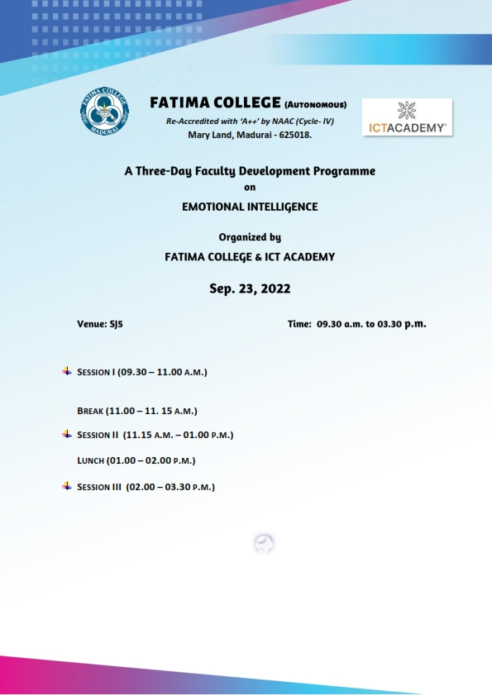

Day-II-Venue-SJ5
Fore Noon Session-10 a.m. -1 p.m.
The second day of the faculty development program began with a paper song. Ms.Simi Madam taught Progressive Muscular Relaxation Exercises to the participant to ease them mentally and emotionally. She stressed on the fact that ‘Emotional Intelligence is not removing emotions or controlling emotions, but suppressing emotions. She highlighted that EI is important to the overall development of an individual. She added that one’s performance at work, helps navigate the social complexities of the college, lead and motivate students and excel in career.

Afternoon Session- 1 p.m. – 3.30 p.m.
The afternoon session was on Physiology of the brain. Ms.Simi Madam spoke on the importance of Social Awareness, Self-Awareness, Self-Management and Relationship Management. An activity on boat making with paper was given to the teams. A self-assessment on Rosenberg Self-Esteem scale was done by the participants.
Date-24-09-2022
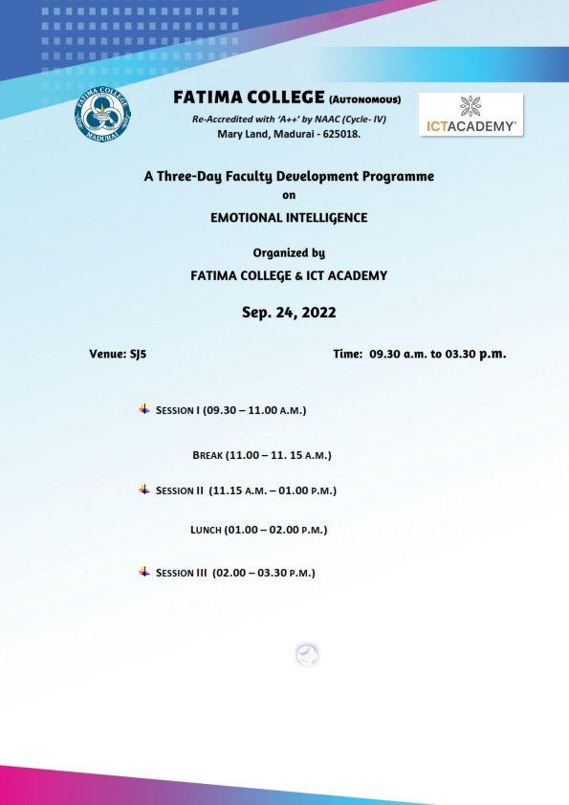
Day-III-Venue-SJ5
Fore Noon Session-10 a.m. -1 p.m.
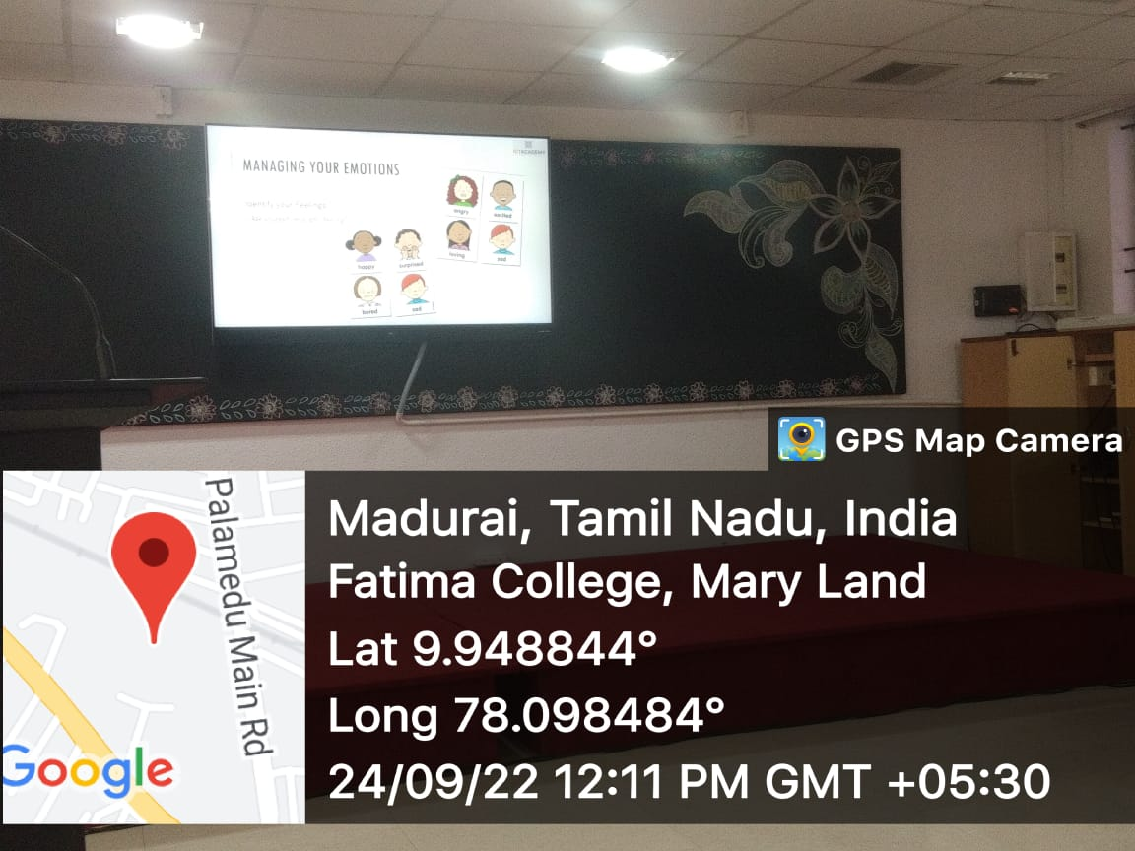
An active in full swing to the participants
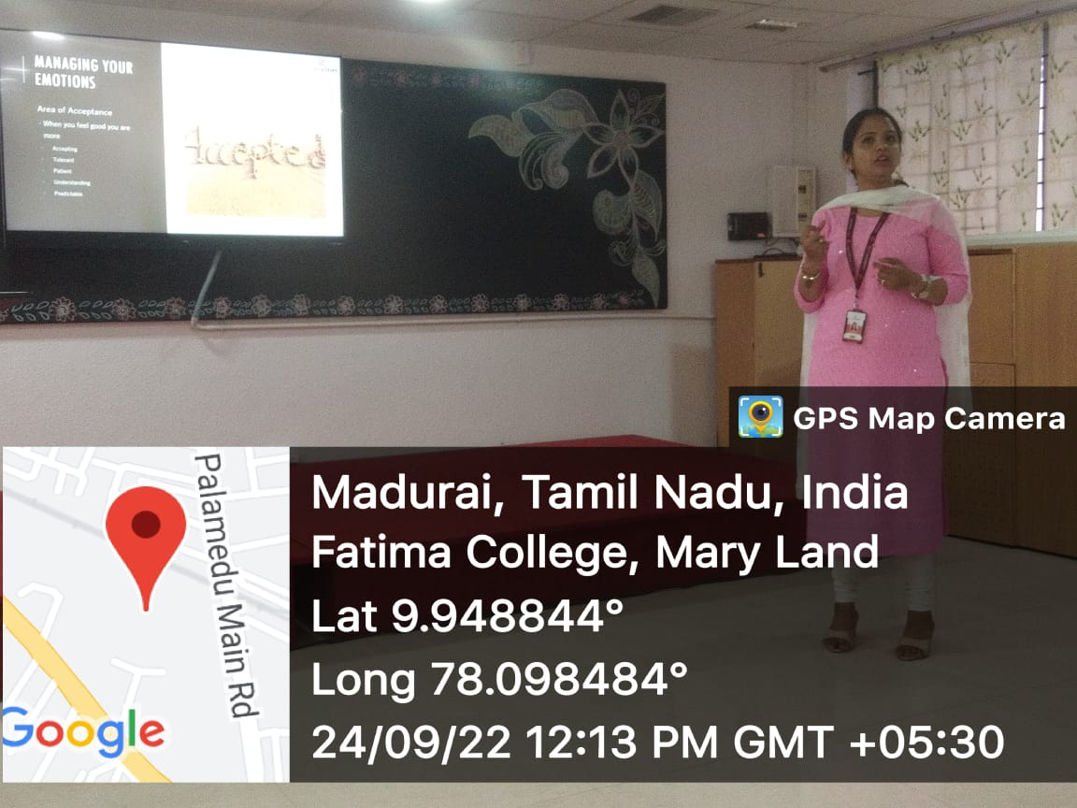
Ms.Simi, Senior Soft Skill Trainer, ICT Academy, Bangalore handling the session on ‘Emotional Intelligence’
The third day session began with a prayer song. . Ms.Simi Madam lectured on ‘Emotional Hijacking’. She elaborated on Amygdala Hijack and its three stages-Fight, Flight and Freeze. She told the participants to respond rather than react emotionally and to become aware of our emotional triggers. She continued with the indicators of Low EQ. She also highlighted the various skills-Stress management, Emotional awareness, Non-verbal communication, Humour and Conflict management. She also briefed about Plutchil’s Wheel of emotions, Parrott’s Emotion types and the different methods to manage one’s emotions.
Afternoon Session- 1 p.m. – 3.30 p.m.

The afternoon session was on the Area of Acceptance, Iceberg Theory and Transactional analysis History. Ms.Simi Madam highlighted on the techniques of EI, which can help students to identify their emotions. A story telling session radiated the afternoon hours of the day. Certain key points and story hints were given to the participants and they were instructed to weave stories with interesting plots. All the team members discussed and came out with gripping tales loaded with emotions. This was followed by Ms.Simi Madam’s lecture on ‘Model Appropriate Behaviour’. An assessment on strengths exploration, Previewed Stress Scale and Optimism Independence were undertaken by the participants. Ms.Simi Madam distributed chocolates to the participants as a token of appreciation. The session ended with a memorable photo session. Dr.Rosemary Euprashia, Associate Professor of Computer Science proposed the vote of thanks.
PHOTOS:
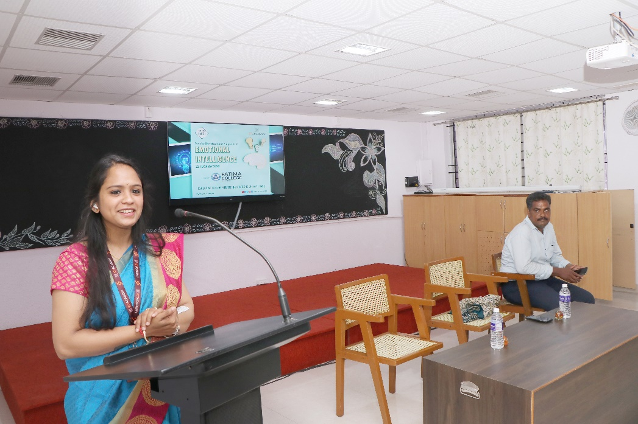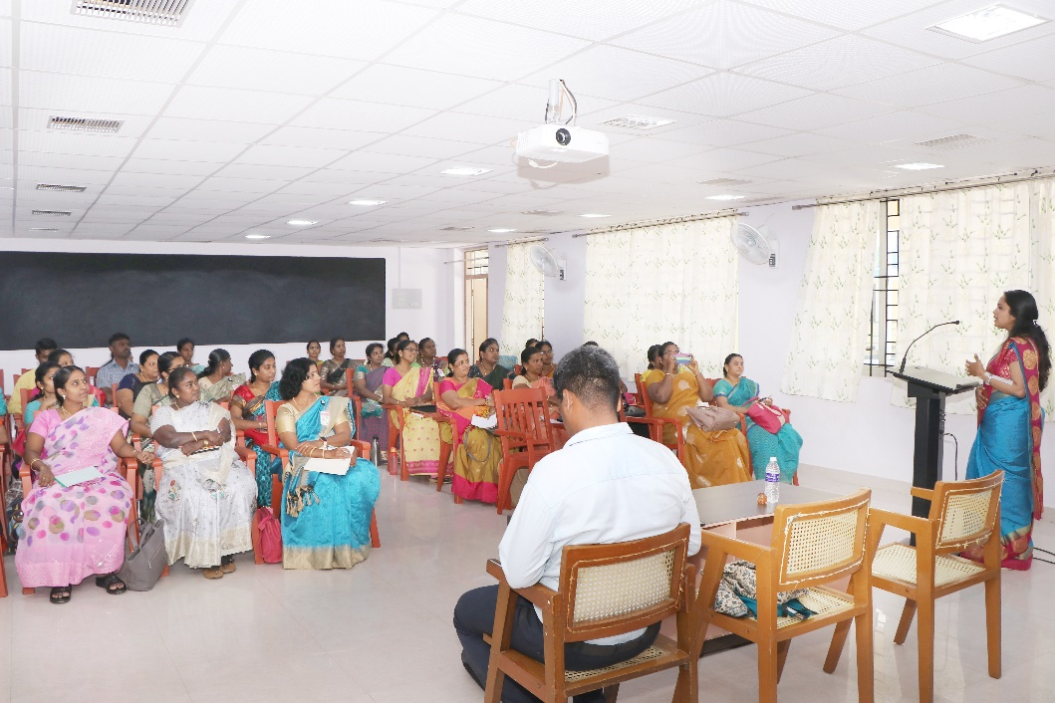
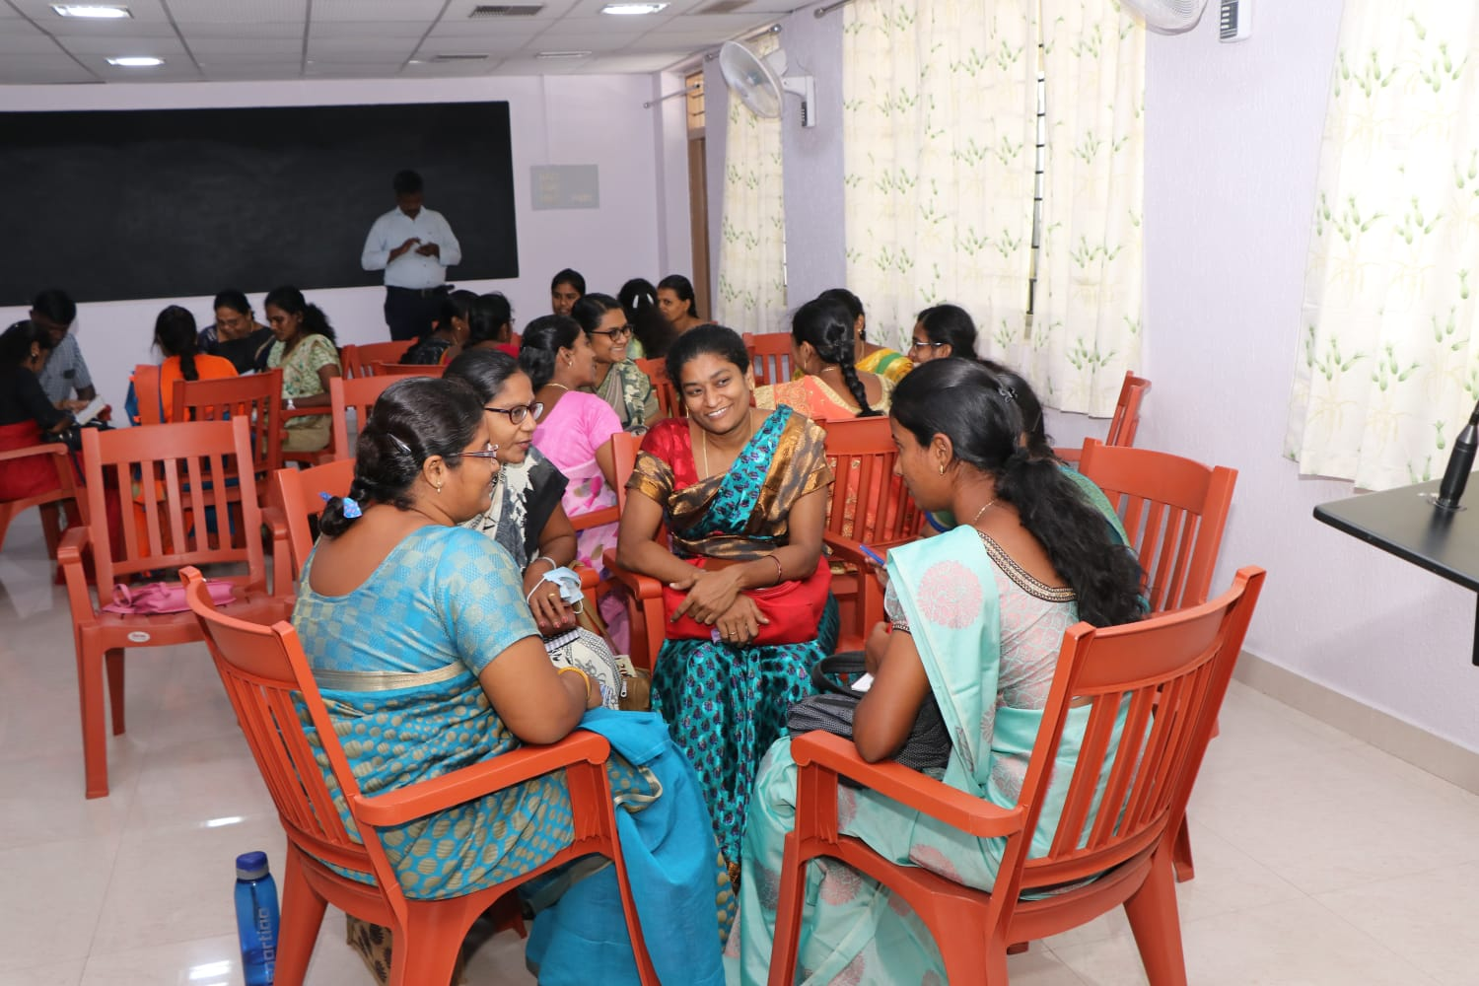
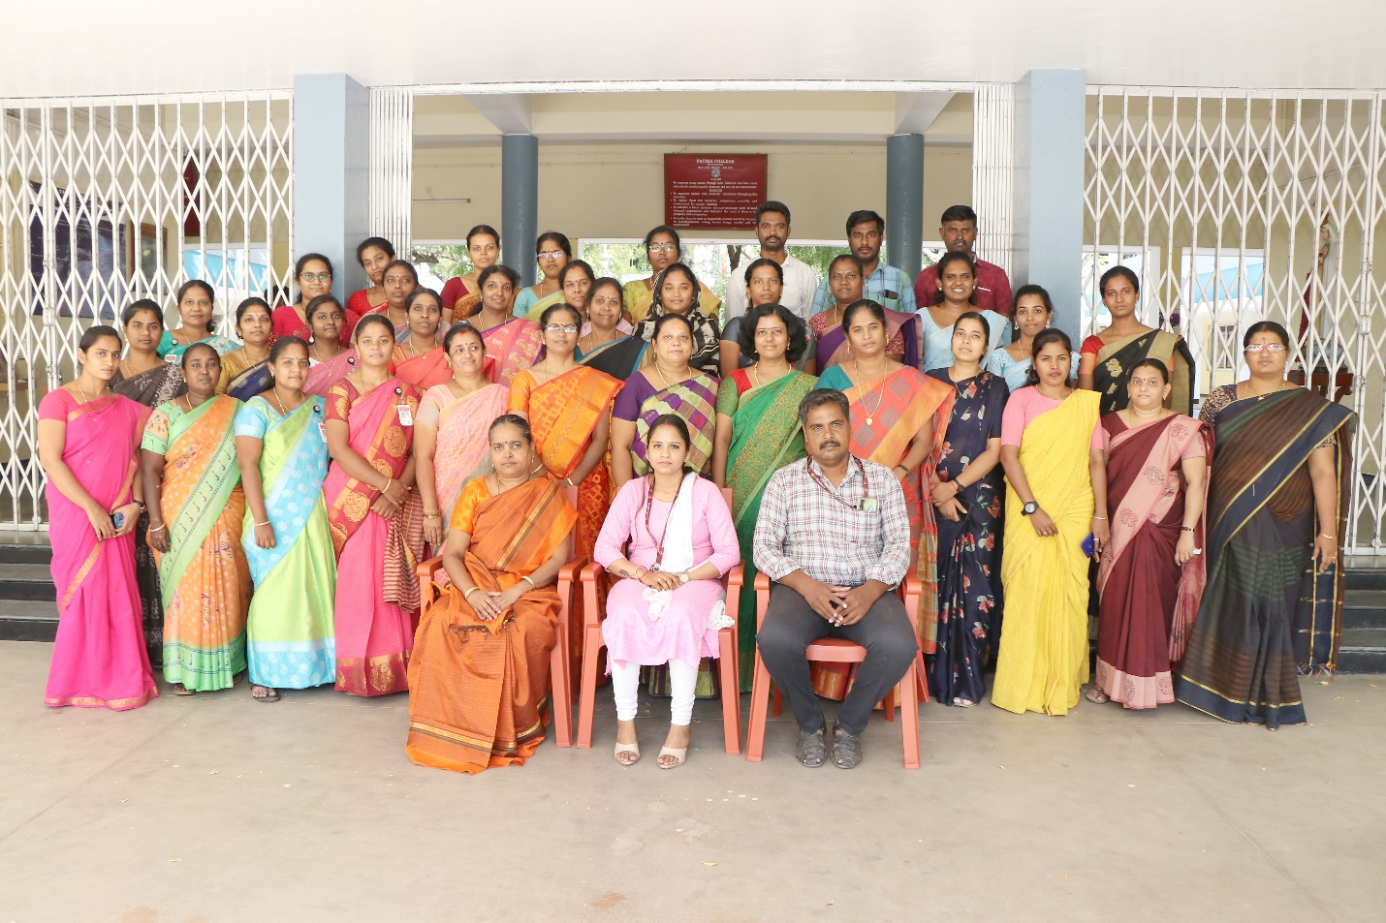

Attendance
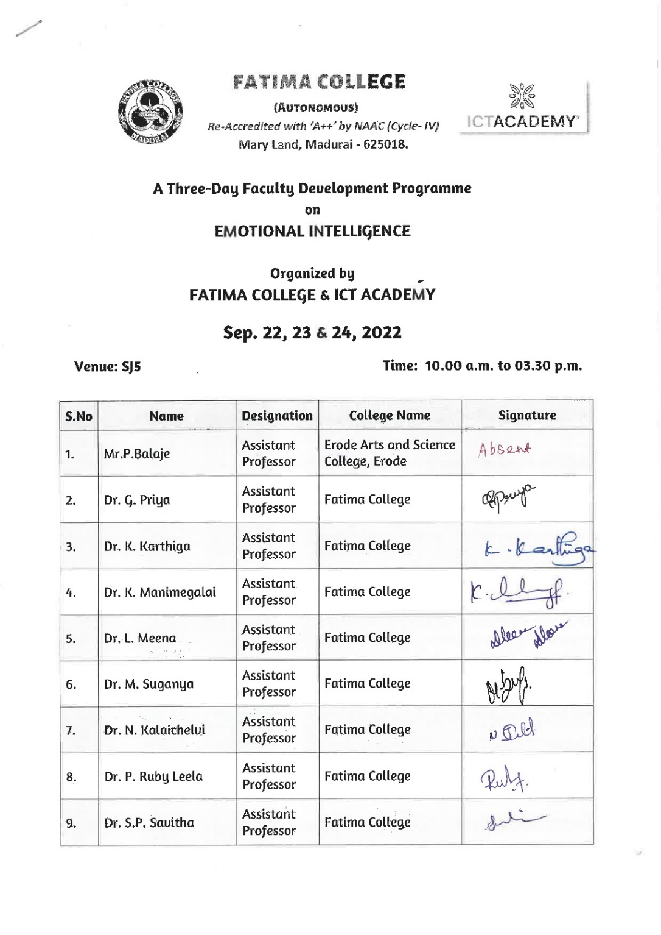
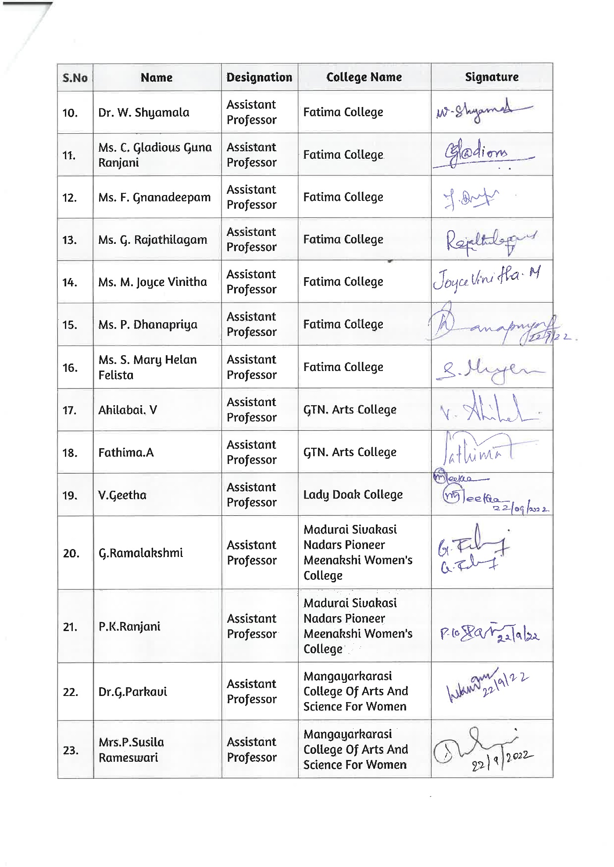
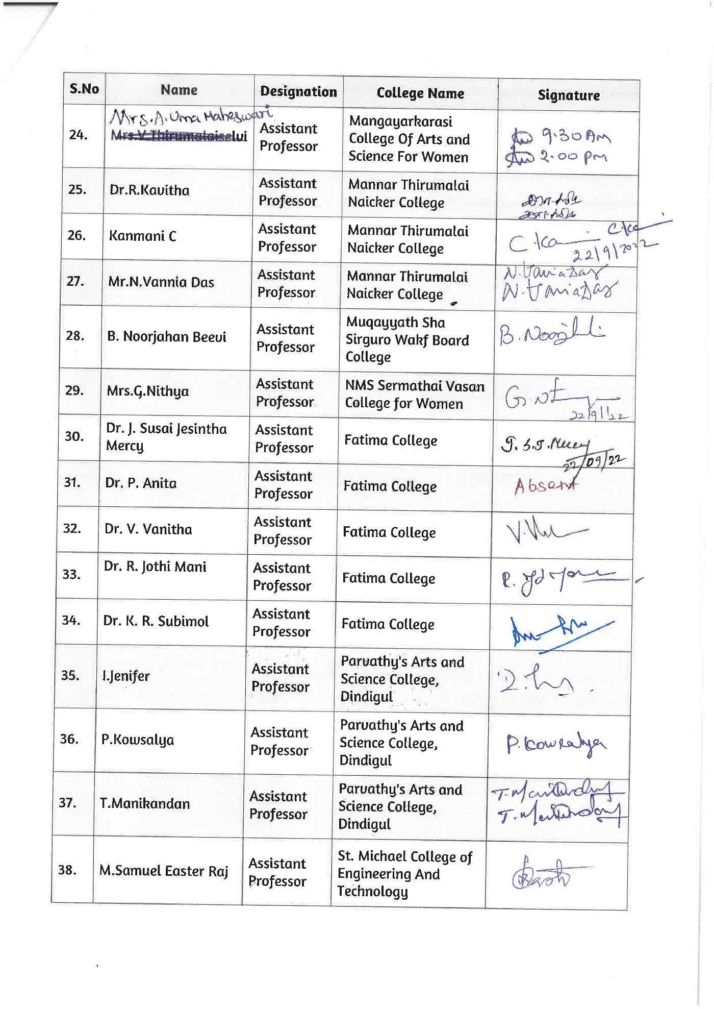
CERTIFICATE:
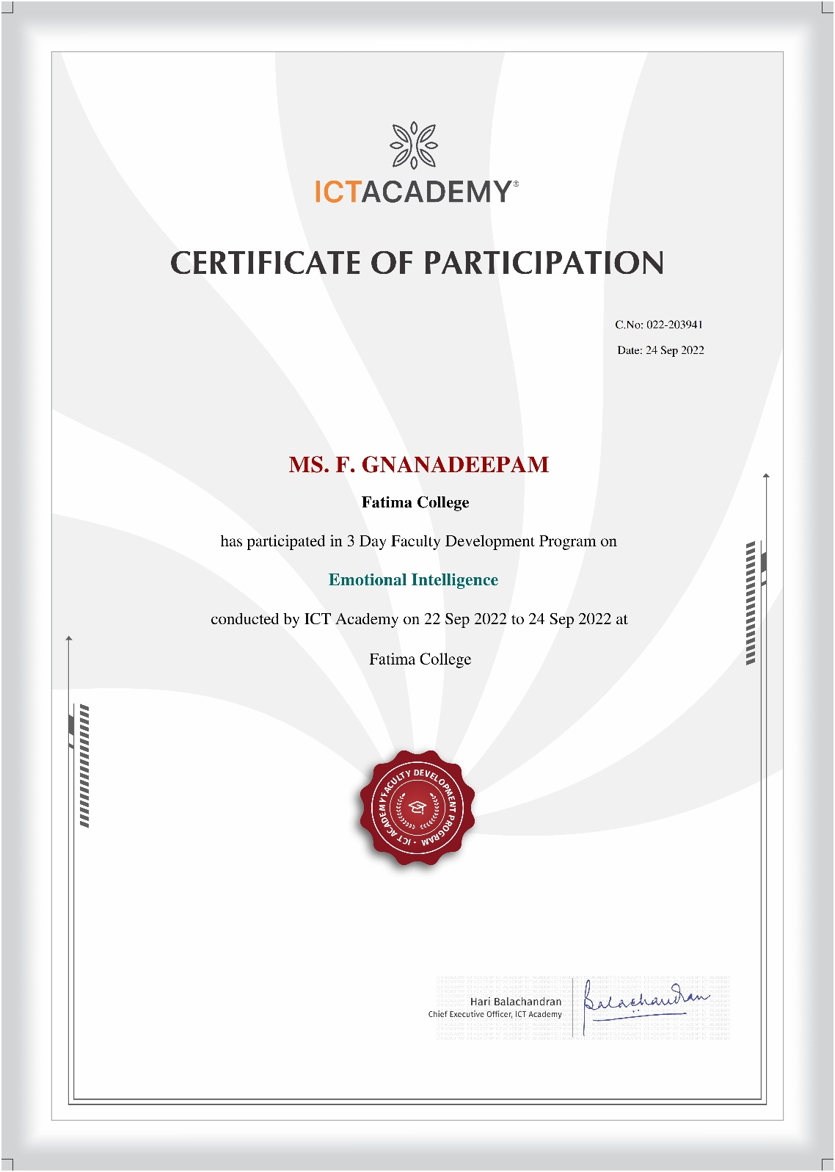
One - Day Faculty Enrichment Programme On
Enhancing Personal And Professional Competencies
October 29, 2022

Date: Oct. 29, 2022 Venue: JH
AGENDA
10.00– 10.15 a.m. | PRAYER
 | Welcome Address | Dr. L. Meena  Assistant Professor of Management Studies
10.15 – 11.15 a.m. | Session I | Dr. K. Alex  Associate Professor of Commerce  St. Joseph’s College (Autonomous)  Tiruchirappalli – 620 002.
11.15 – 11.30 a.m. | Break
11.30 – 12.30 p.m. | Session II Dr. K. Alex
12.30 – 01.30 p.m. | Lunch
01.30 – 03.00 p.m. | Session III | Dr. K. Alex
03.00 p.m. | Vote of Thanks | Dr. R. Saktheswari  Assistant Professor of English  Asst. IQAC Coordinator

Report
A one – day Faculty Enrichment Programme was successfully conducted by the IQAC of Fatima College on October 29, 2022. The FEP programme received an overwhelming response with around 190 teaching staff from Shift I and Shift II. The entire programme was spearheaded by Dr. K. Rosemary Euphrasia, Coordinator of IQAC. Dr. L. Meena, Assistant Professor, MBA welcomed the audience and introduced the chief guest Dr. Alex, Associate Professor, Department of Commerce, St. Joseph’s College (Autonomous) and briefed some of his academic achievements, highlighting his expertise in training the teachers and entrepreneurs.
The floor was then open to the Guest Speaker to address the audience who began quoting Swami Vivekananda, “You are what you are in darkness.” Dr. K. Alex informed the teachers to know the importance of the place of work. He also went on to distinguish expression and communication and explained that the former is words spoken with feelings whereas the latter is words spoken without expression.
The resource person quoted various examples from history and the life of the Zen philosophers to drive his point home. He also emphasised saying, “If teachers are not updated, they are outdated.”
The entire session was split into three divisions namely Screen time, Transforming and Inspiring. Further he also stressed on the importance of reading quoting “The Society that reads will reach the pinnacle of civilization.” The resource person also narrated few anecdotes that made the session more lively, interactive and interesting. Throughout the programme the audience were very interactive and kept on participating and responding to the questions of the speaker. Dr. Alex also pointed out how a teacher has to “learn, unlearn and relearn”; how a teacher has to be always ready to learn and facilitate the needs of the students in the classroom. The relationship between a teacher and student should be meaningful and productive. He also insisted that finally the students will remember the teacher for his attitude and not essentially for his knowledge and skills.

Sir also stated the responsibility that each teacher must contain towards the institution. The life lessons they were taught by the speaker were enriching and really those were the precious take aways of the day. It was absolutely an enriching session which had rejuvenated the teachers and made them once again enlightened and refreshed.
Dr. R. Saktheswari proposed the vote of thanks and the session came to a close.

Invitation

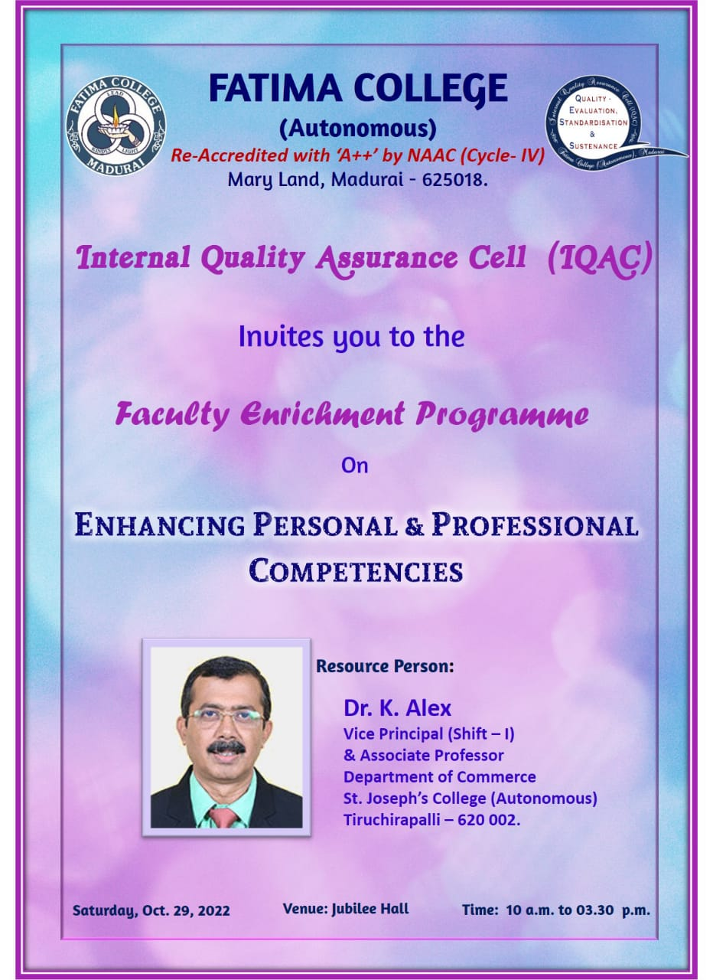

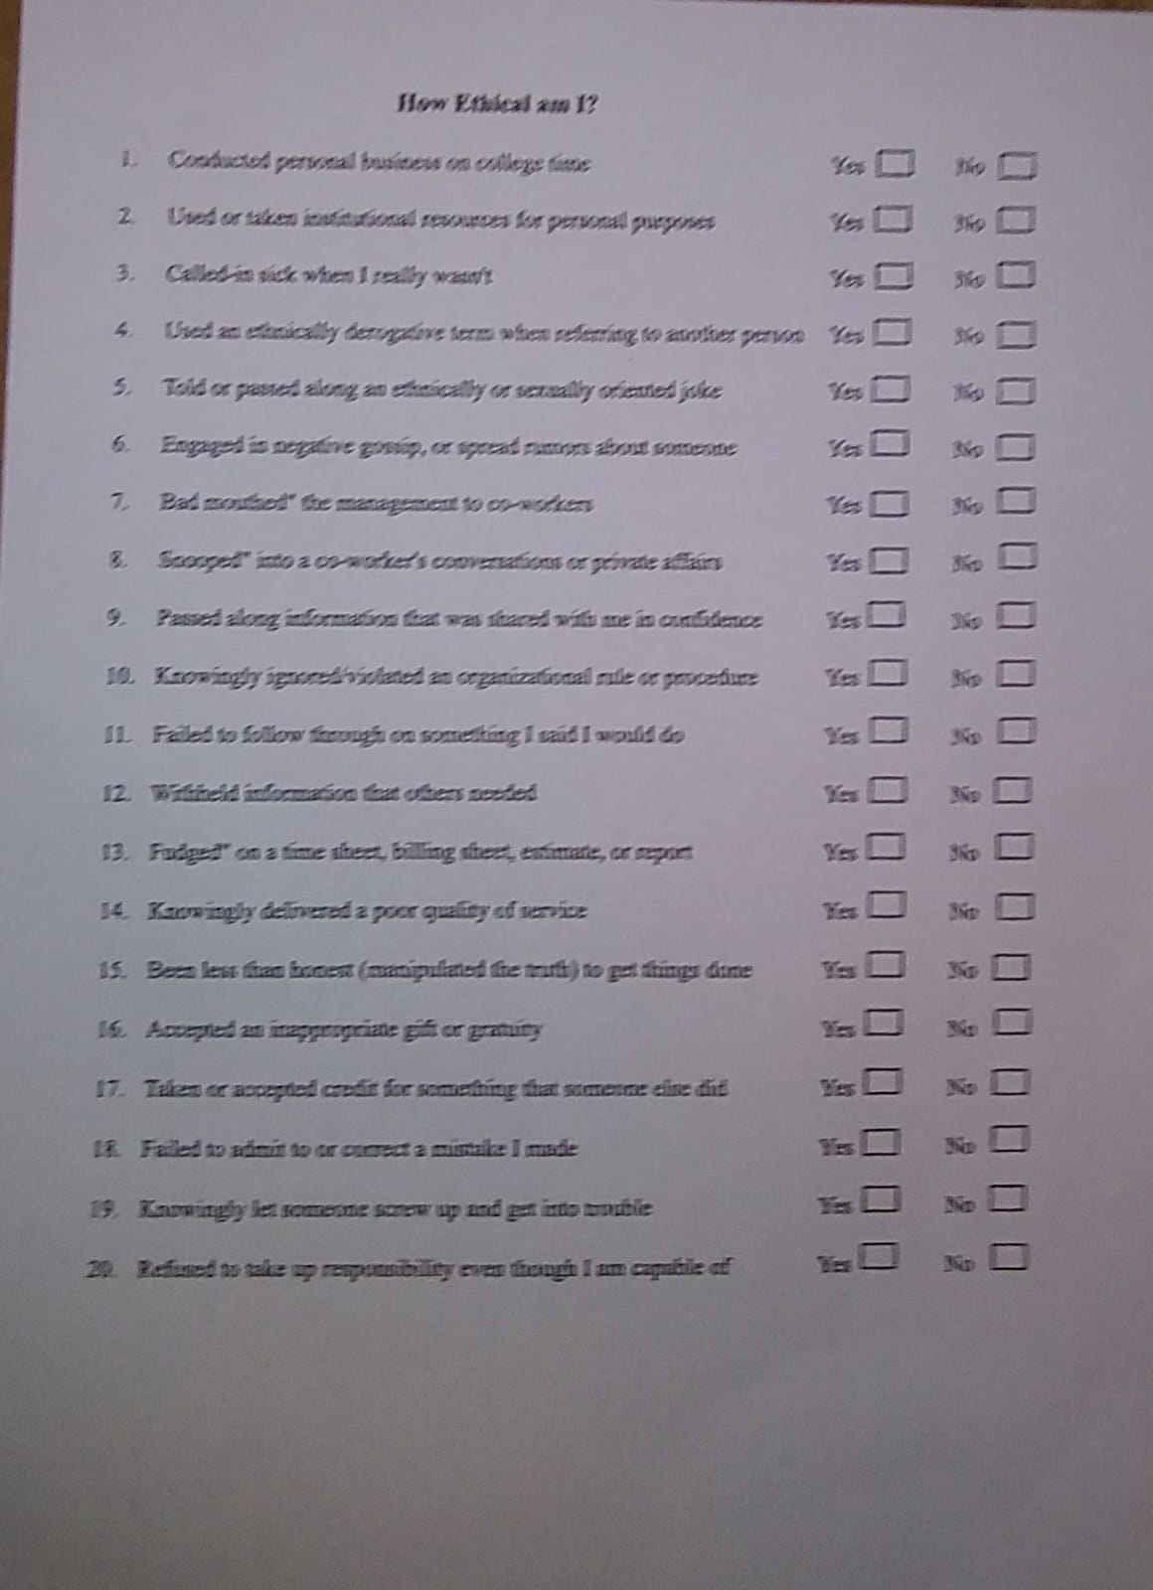
Sample Activity Sheet

GALLERY

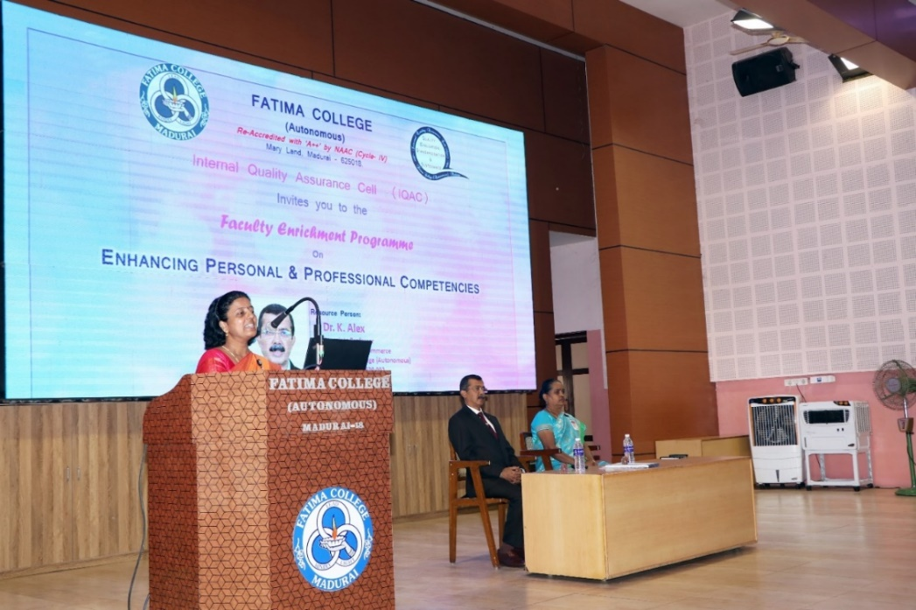

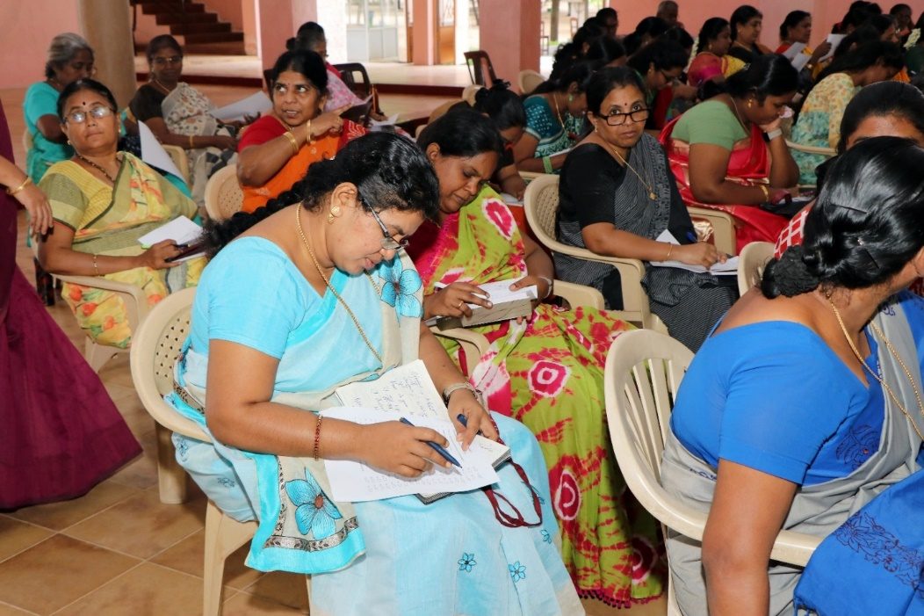
ATTENDANCE
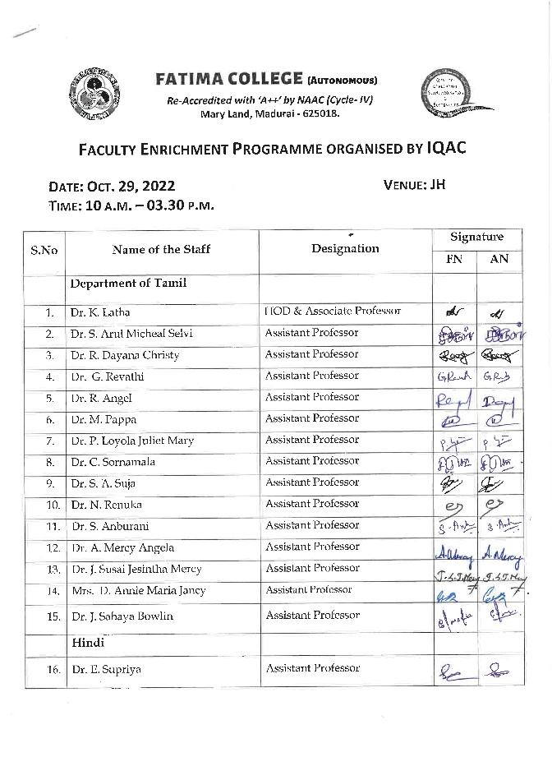 | 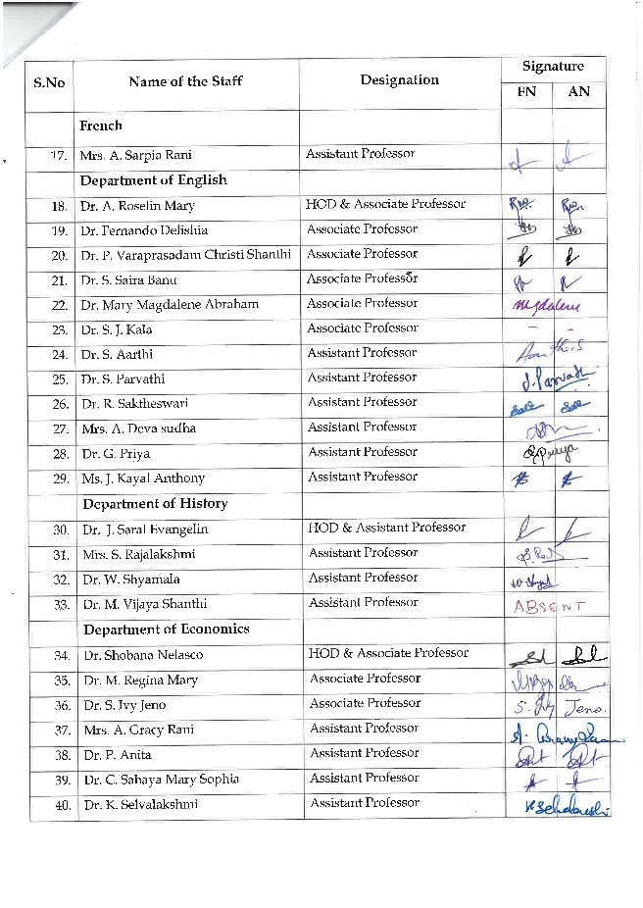
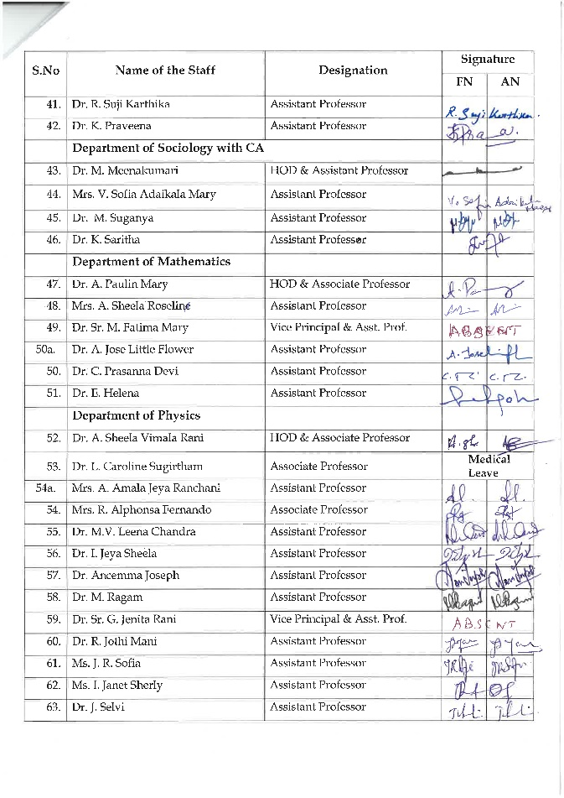 | 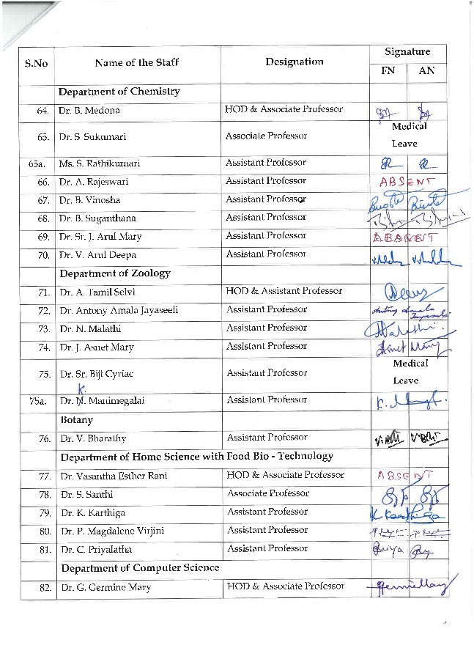
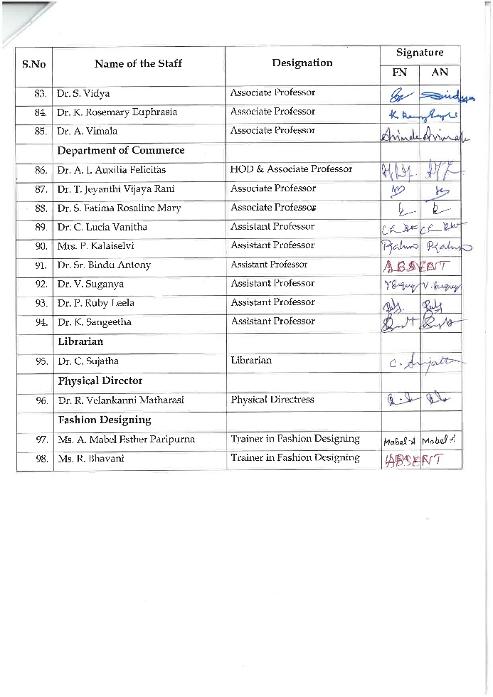 | 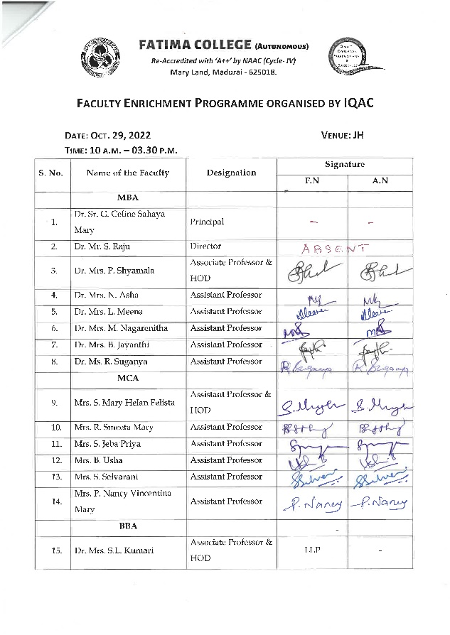
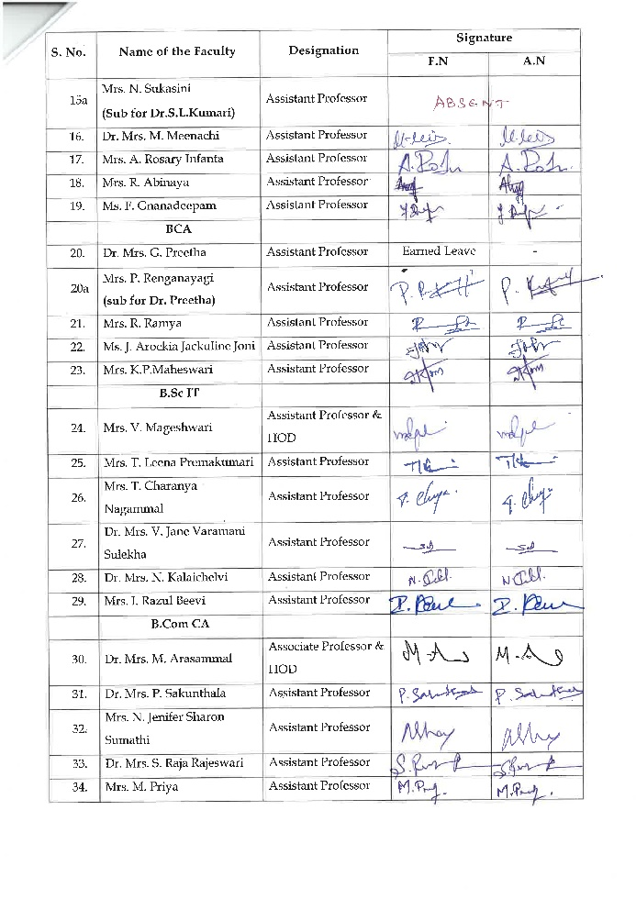 | 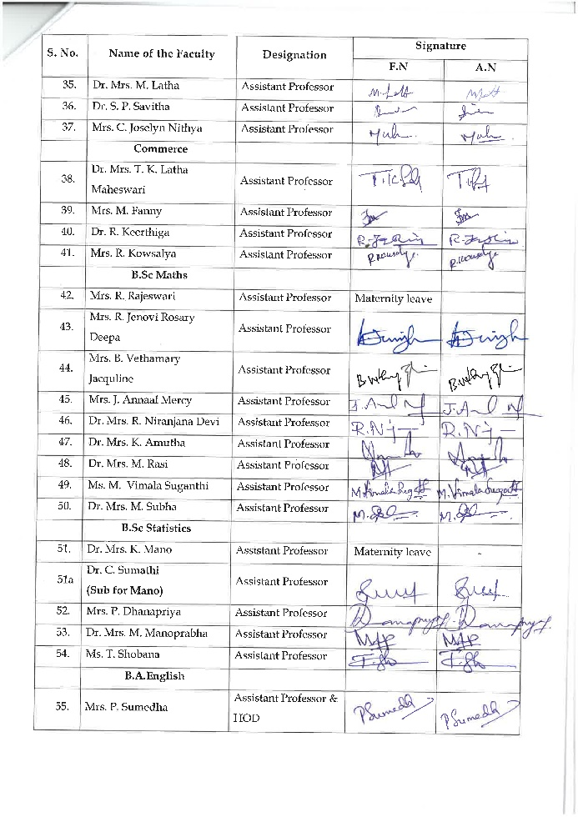
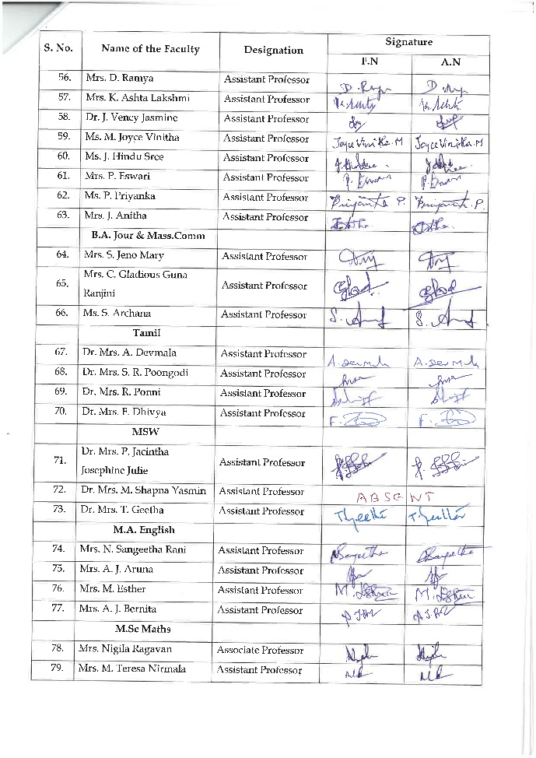 | 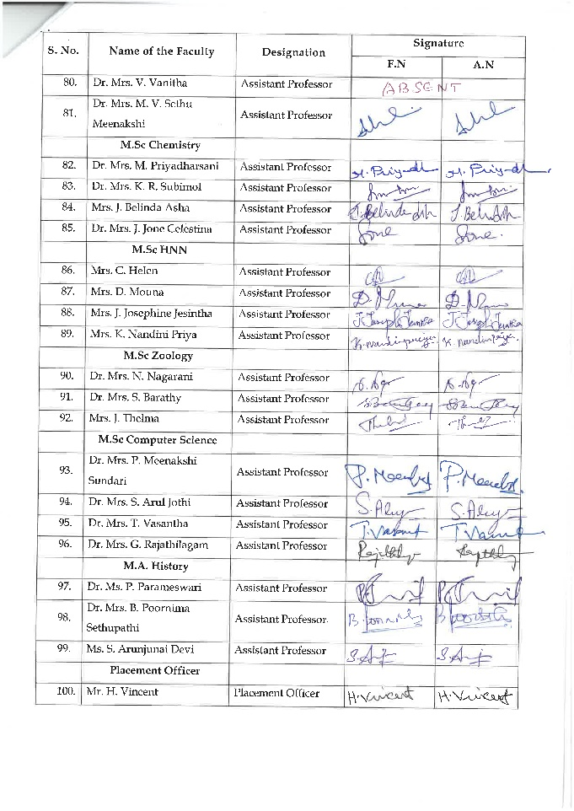

FEEDBACK FORMS
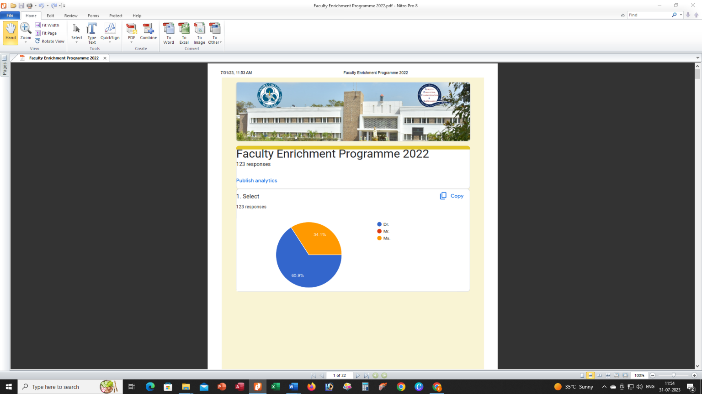

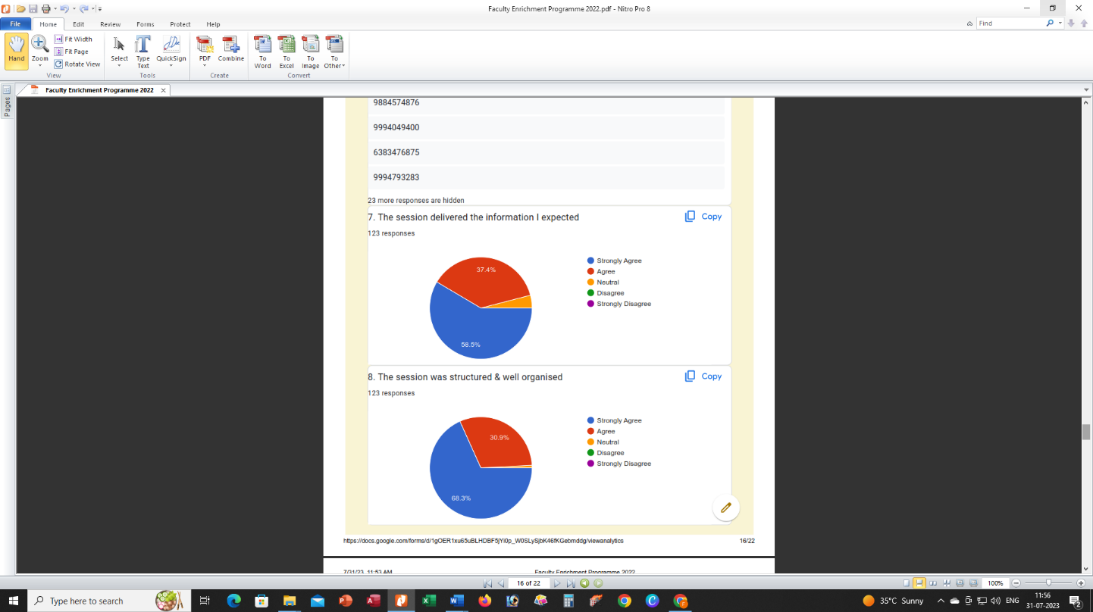
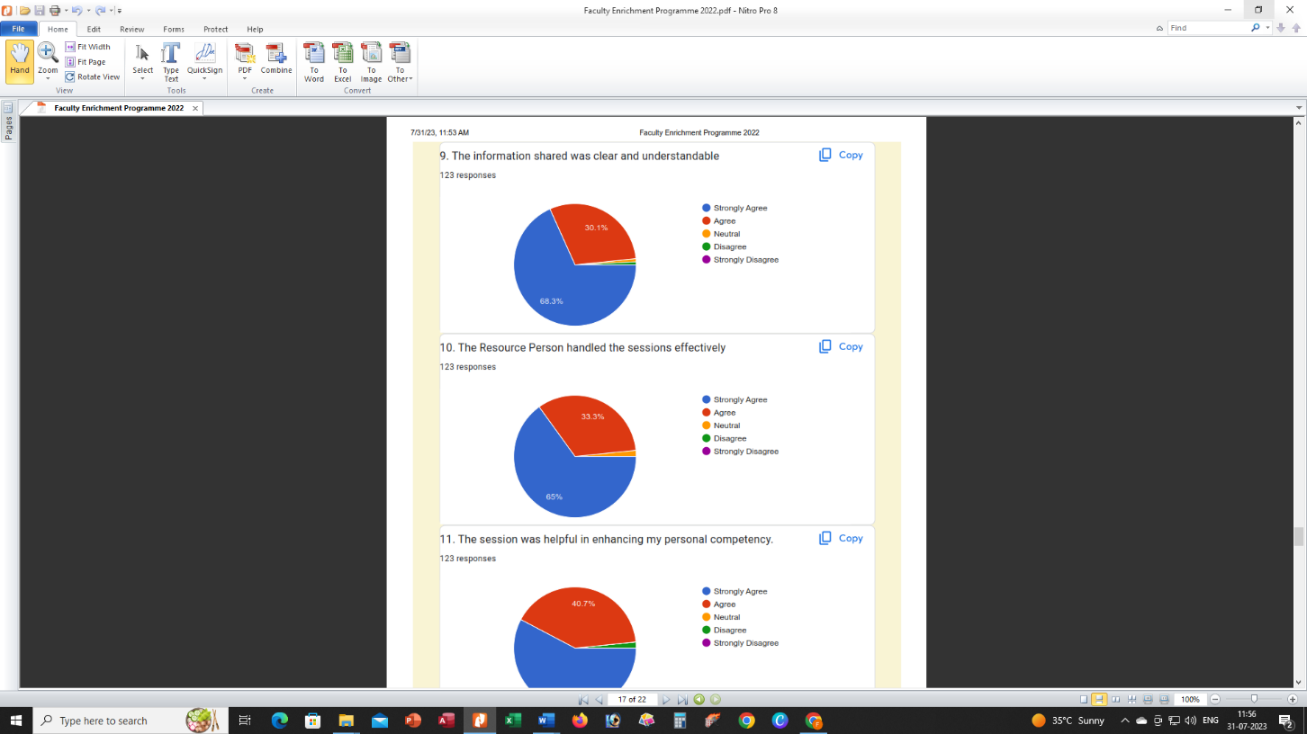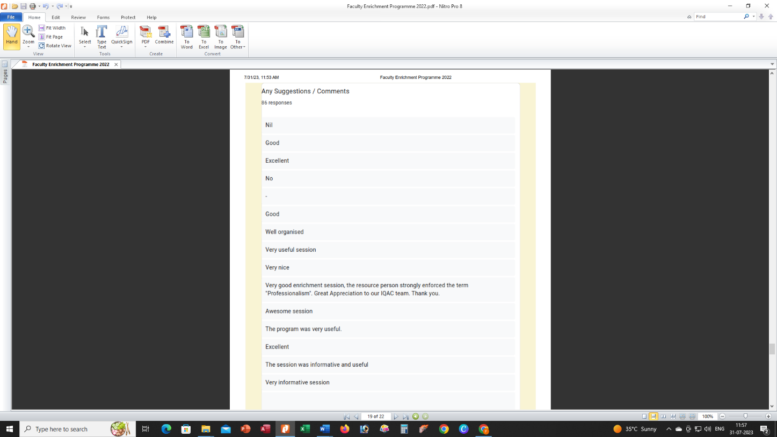

Resource Persons in the Cyber Security Workshop (Hybrid Mode) organised by St. Xavier’s College, Jaipur Nov. 30, 2022
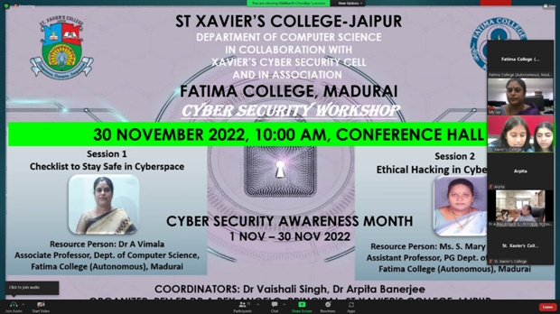
Xavier’s Cyber Security Cell and the Department of Computer Science, organized a Cyber Security Workshop (Hybrid Mode) on 30 November 2022 in collaboration with Fatima College (Autonomous) Madurai, to mark the end of the Cyber Security Awareness Month, celebrated by the Department of Computer Science from 1 Nov 2022 to 30 Nov 2022.
Workshop Details:
Timing: 10:00 am to 12:00 Noon
Venue: Conference Hall
Zoom Link: https:/us06web.zoom.us/j/83239575922

Session & Resource Persons:
1. Session on “Checklist to Stay Safe in Cyberspace” by
Resource Person: Dr A Vimala
Associate Professor, Dept. of Computer Science
2. Session on “Ethical Hacking in Cyber Security”
Resource Person: Ms. S. Mary Helan Felista,
Assistant Professor, PG Dept. of Computer Applications

Outcome:
Security awareness is created among students to focus attention on Ethical Hacking, security, creating sensitivity to the threats and vulnerabilities of computer systems and recognition of the need to protect data, information and systems.
Cyber Security awareness is important because it protects all categories of data from theft and damage.This includes sensitive data, personally identifiable information (PII), protected health information (PHI), personal information, intellectual property, data, and governmental and industry information systems.

Photos:
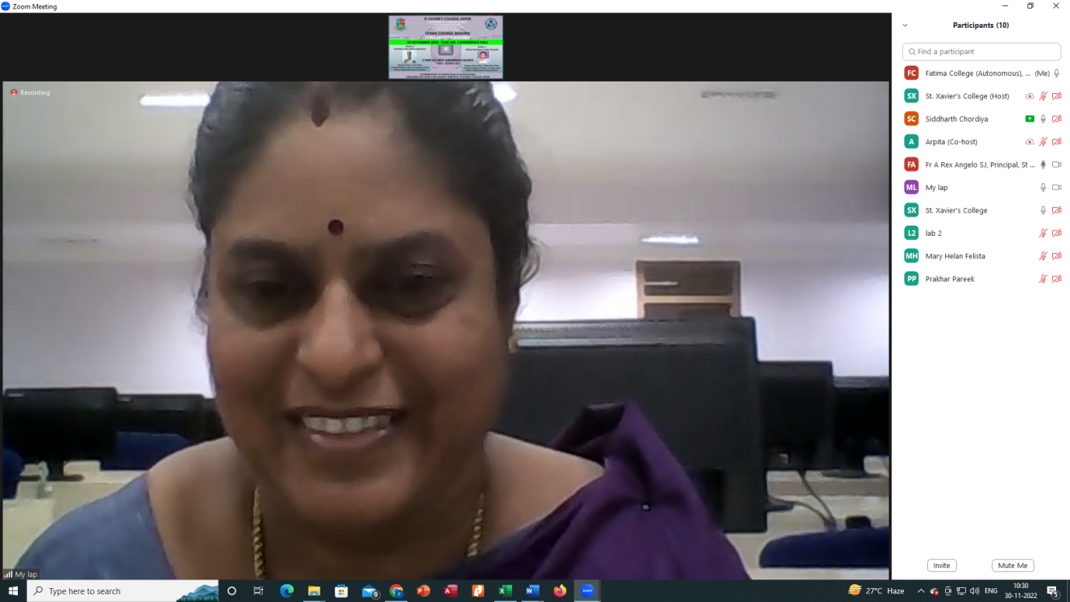

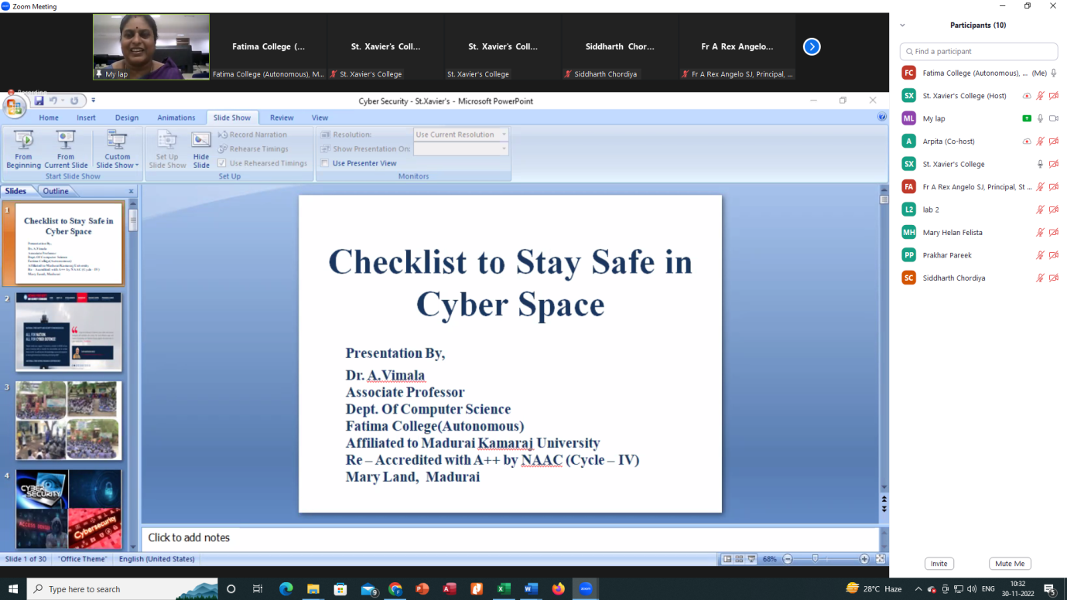

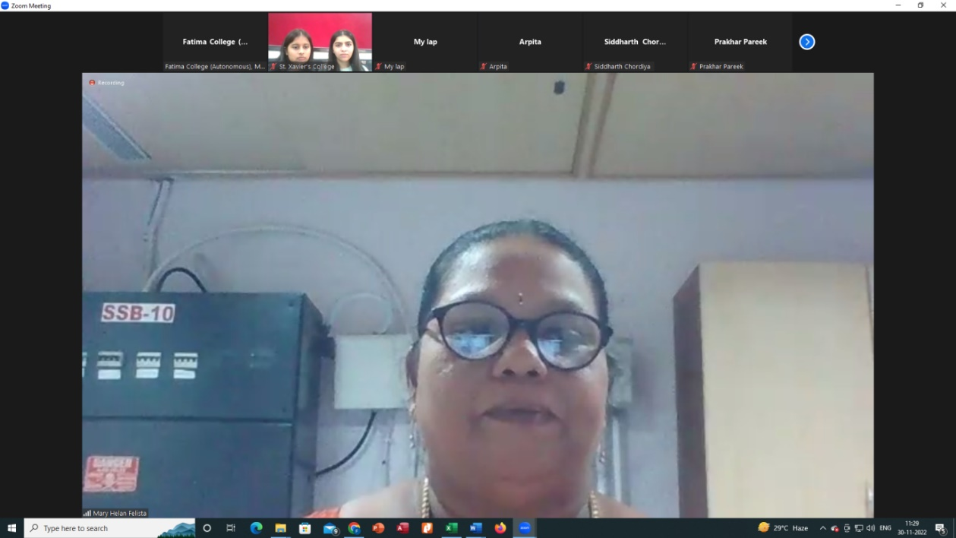





FATIMA COLLEGE
(Autonomous)
Re-Accredited with ‘A++’ Grade by NAAC (4rd Cycle)
Mary Land, Madurai - 625018

A THREE MONTH-CORPORATE TRAINING PROGRAMME
IN
FUNCTIONAL ENGLISH
for the Staff of Hi Tech Arai, Madurai

ORGANISED BY
INTERNAL QUALITY ASSURANCE CELL (IQAC)
&
ENGLISH LANGUAGE TEACHING & TRAINING CENTRE (ELTTC)
THE RESEARCH CENTRE OF ENGLISH

February 03 - May 03, 2023

VENUE: Sun Square Building TIME: 4 – 6 PM
K. Pudur, Madurai (Monday, Wednesday & Friday)

A THREE MONTH-CORPORATE TRAINING PROGRAMME
IN
FUNCTIONAL ENGLISH
for the Staff of Hi Tech Arai, Madurai

February 03 - May 03, 2023

REPORT

Internal Quality Assurance Cell (IQAC) and English Language Teaching and Training Centre (ELTTC), The Research Centre of English, Fatima College in collaboration with Hi-Tech Arai Private Limited, Madurai jointly organised a Three – Month Corporate training Programme in Functional English for the Staff of Hi-Tech Arai Private Limited, Madurai from February 03 to May 03, 2023 on Monday, Wednesday and Friday in the evening (4– 6 pm) at Sun Square Building, K. Pudur. The 72-hour training programme was organised to acquaint the employees of Hi-Tech Arai Private Limited with the nuances of Functional English and to induce the spirit of learning and using English language as per the demand of the day. Dr. K. Rosemary Euphrasia, IQAC Coordinator and Associate Professor, Department of Computer Science and Dr. A. Roselin Mary, Associate Professor and Head, The Research Centre of English were the Coordinators. Dr. S. Aarthi and Dr. R. Saktheswari were the trainers of the Training programme. 26 staff participated in the programme.
In order to find out the demands of the participants, an online Needs Assessment Survey was conducted on January 20, 2023. The Coordinators and trainers had a discussion with the Managing Director of Hi tech Arai Pvt. Ltd., Shri. B. T. Bangera on January 31, 2023.
The inauguration of the Three- Month Training Programme was held on February 03 at 4 pm in Sun square Building. Dr. K. Durairaj, Deputy General Manager, HRD/ ADMIN, Hitech Arai Pvt. Ltd. introduced and enumerated the

objective of organising the training programme in Functional English. Felicitations were offered by Mr. S. Sukumar, Director, Operations, Hitech Arai Pvt. Ltd. and Dr. K. Rosemary Euphrasia, IQAC Coordinator, Fatima College. Dr. A. Roselin Mary, Associate Professor and Head, the Research Centre of English gave the inaugural address.An Entry Test was conducted after the Inaugural function. All the participants were enthusiastic in attending the training programme. The participants came forward to share their expectations and needs.
Based on the Needs Assessment Survey and oral feedback of the participants, customized teaching and evaluation material were prepared for the classes. A whatsapp group was created and the PPTs were posted in the same. The participants were made to interact and participate in language tasks and games that included components like vocabulary, grammar, short conversations, group discussions, presentations and continuous writing relevant to their work. A Mid Assessment test was conducted on March 10, 2023.The exit test was conducted on April 28, 2023.
Participants gave both written and oral feedback about the training programme. The online feedback questionnaire was based on the personal, psychological impact and general evaluation of the course, material used and trainers. The participants were happy and satisfied with the course and they felt motivated to improve their English language skills and use English in their everyday communication.
The valediction of the course took place on May 31, 2023 at 2.30 pm in JC Residency. All the participants of the Three-Month training programme were present along with their family members and the next batch of participants were also present. Dr. K. Durairaj, Deputy General manager, HRD/ ADMIN, Hitech Arai Pvt. Ltd. Welcomed the gathering and briefed about the training programme to the forthcoming batch. Special addresses were

given by the faculty of Fatima College and Mr. S. Sukumar, Director, Operations, Hitech Arai Pvt. Ltd. Presidential address was given by Shri. B.T. Bangera, the Managing Director of Hi-tech Arai Pvt. Ltd. He spoke about the origin and need of organising the training programme in Functional English. Speeches were made by three of the participants and feedback was given by two. The best three performers of Training programme were honoured with a shield and certificates were issued to all participants. In order to motivate the present and future participants of the Training programme, Everest QC team; that won the National second place; made a presentation of their QC activities. Mr. V. Shanmugasundaram, Senior Manager, Admin./HR/PR proposed the vote of thanks. The valediction was followed by a high- tea.

PHOTO GALLERY
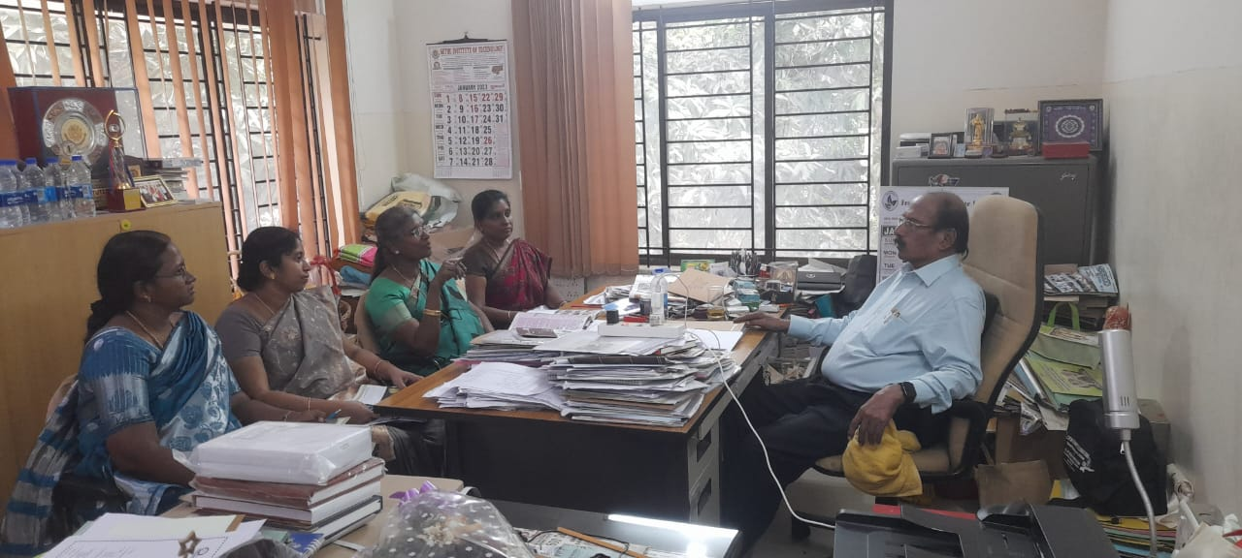
ELTTC team discussing course content of the Training Programme with
Mr. B.T. Bangera, MD, Hi Tech Arai Pvt. Ltd.

INAUGURATION - INVITATION
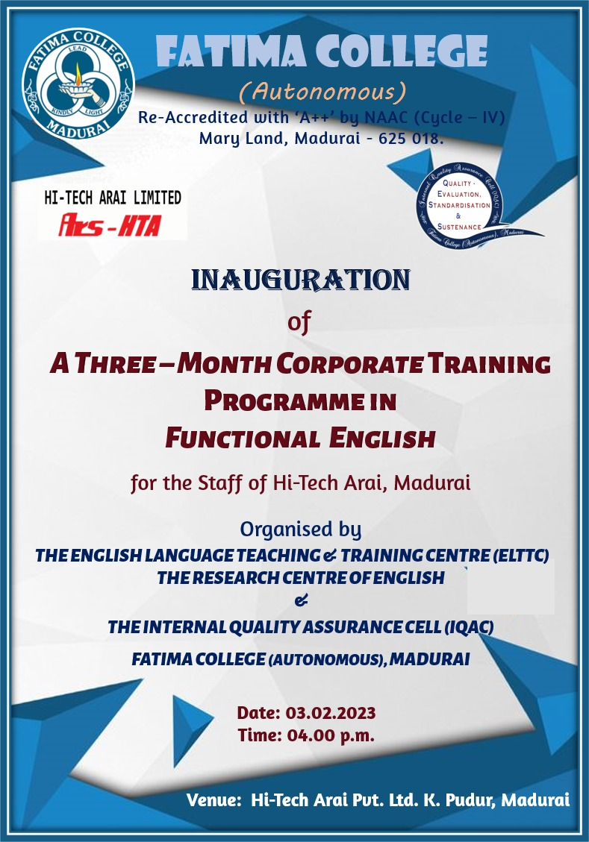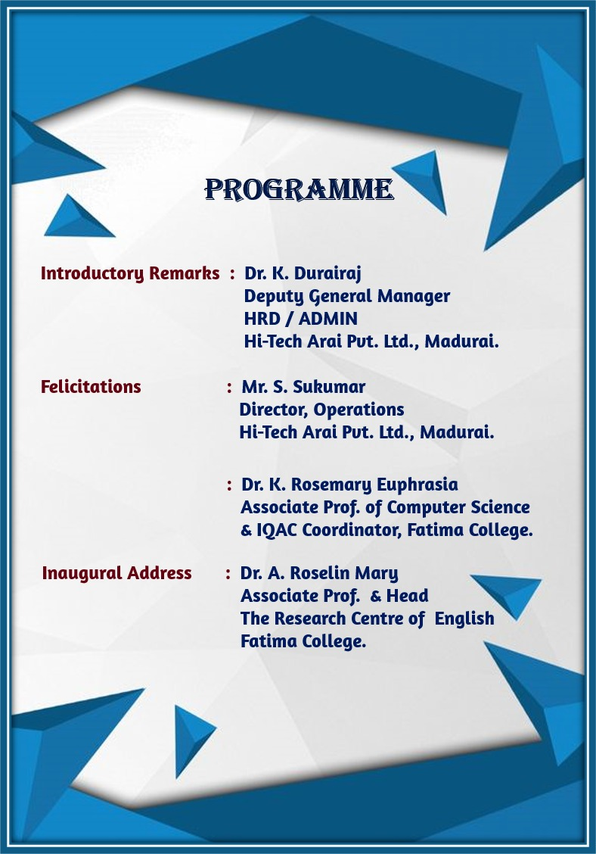

INAUGURAL FUNCTION
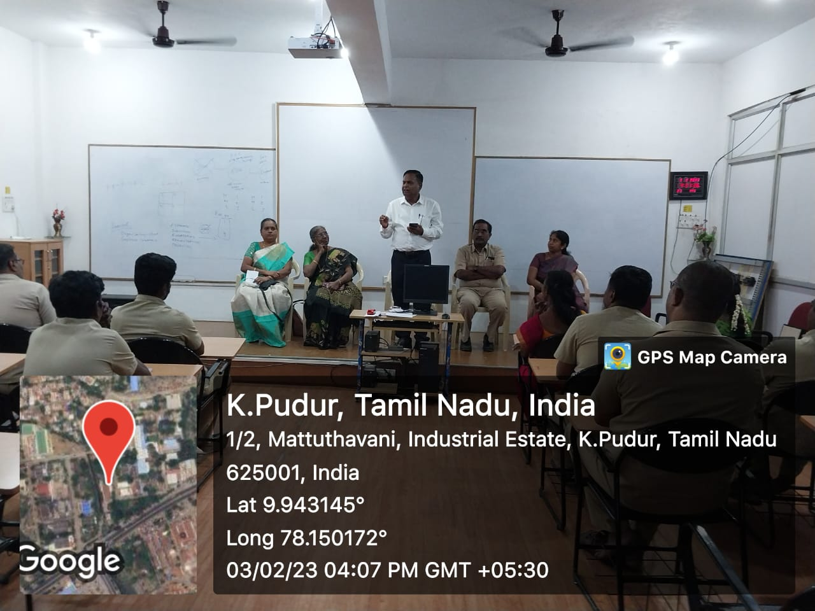
Dr. K. Durairaj, Deputy General Manager, HRD/ ADMIN, Hitech Arai Pvt. Ltd. briefing the objectives of the Training Programme during inauguration

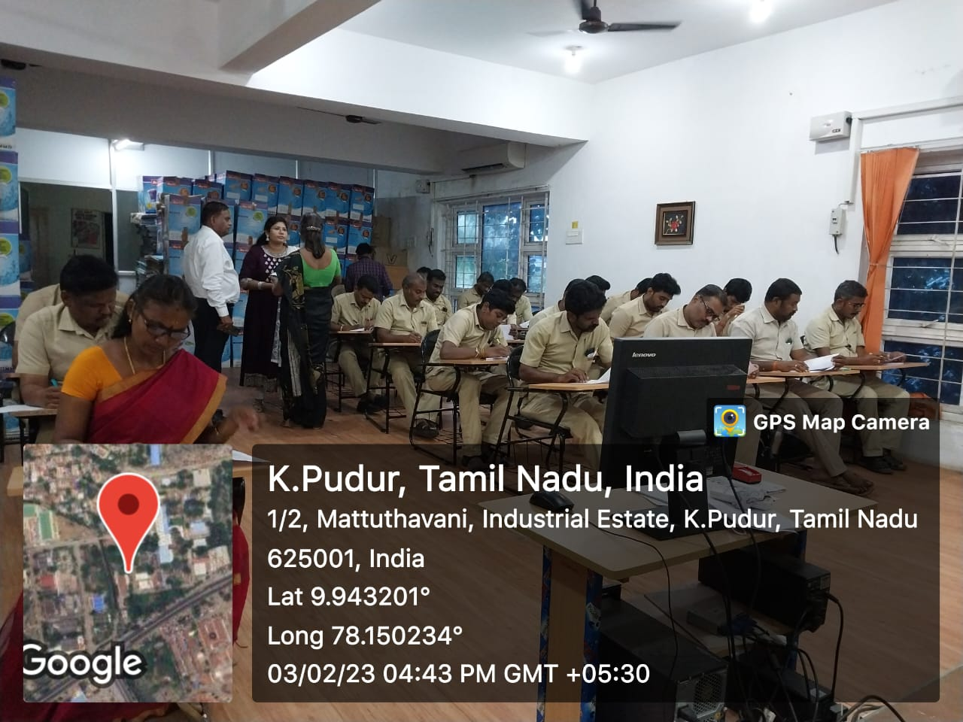

Participants taking up the Entry Test

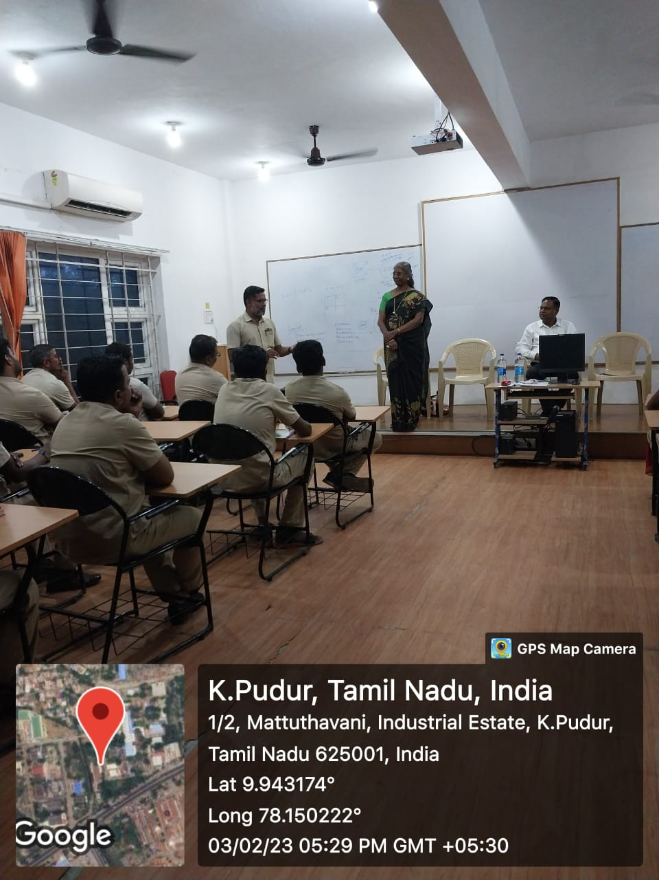
Mr. B. Sundara Pandian expressing his needs and expectations of
the Training programme.

PHOTOS TAKEN DURING THE SESSIONS

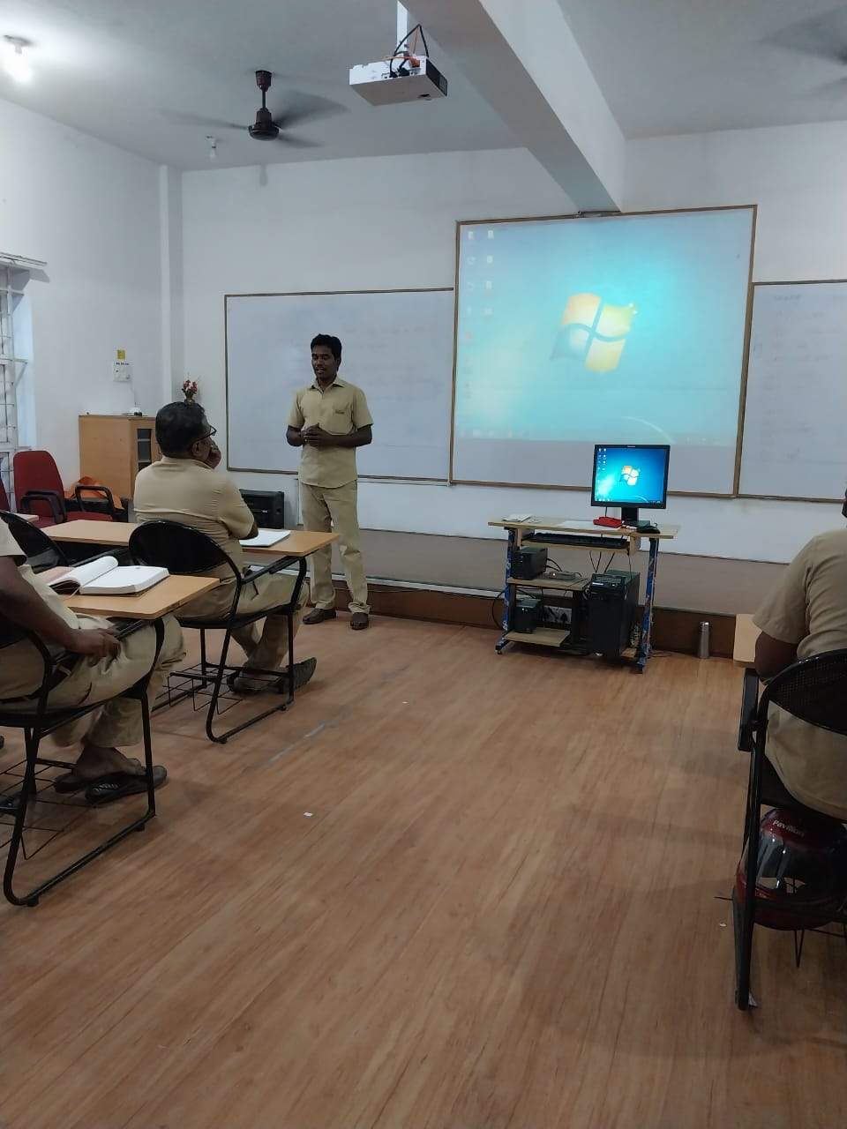
Mr. C. Vairakannu introducing himself

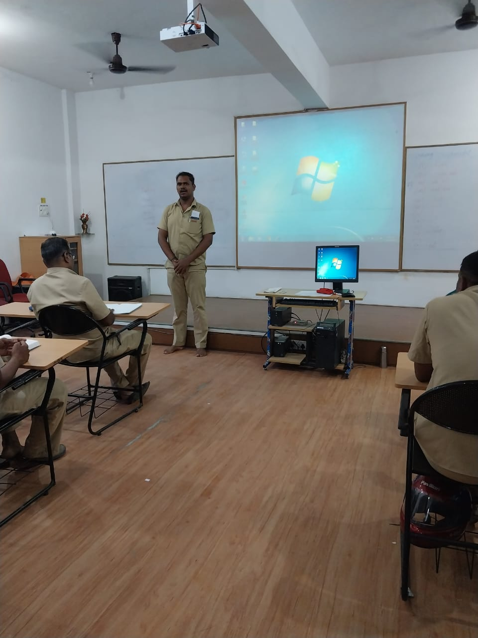

Mr. K. Venkatesh Kumar introducing himself

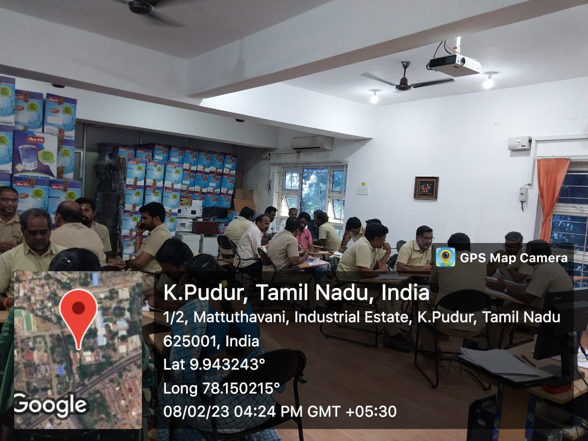

Participants involved in Group discussion

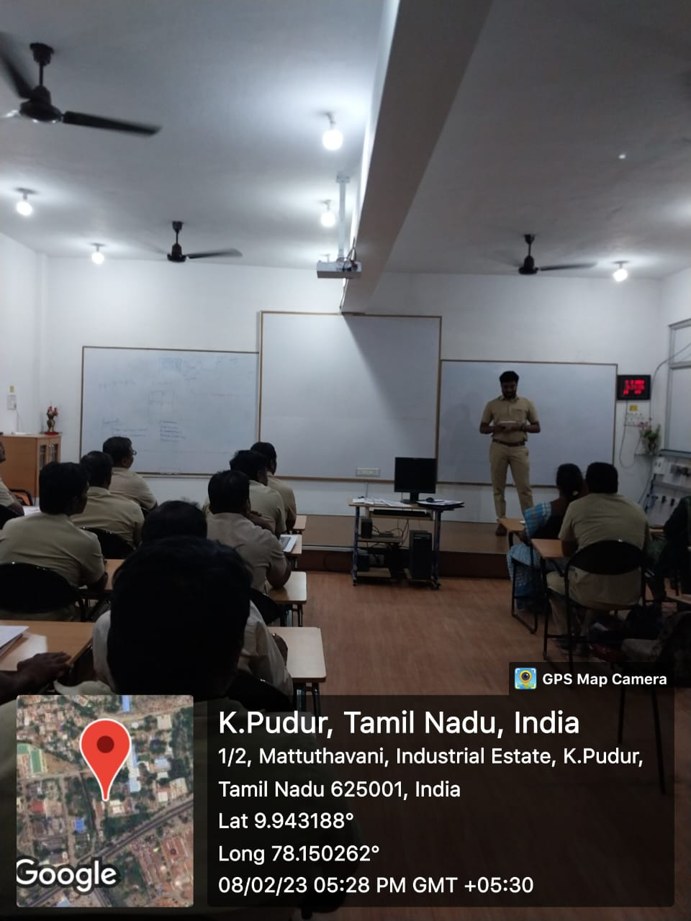

Mr. S. Jeyaseelan presenting the points of the group discussion

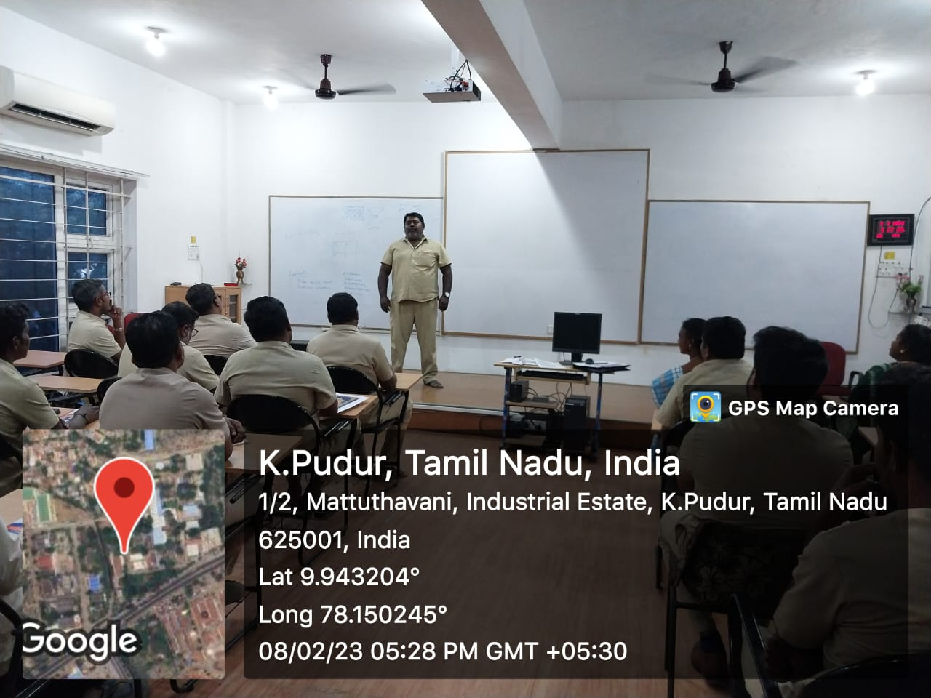

Mr. K. S. A. Raja Mohammed making a presentation on a topic of his choice
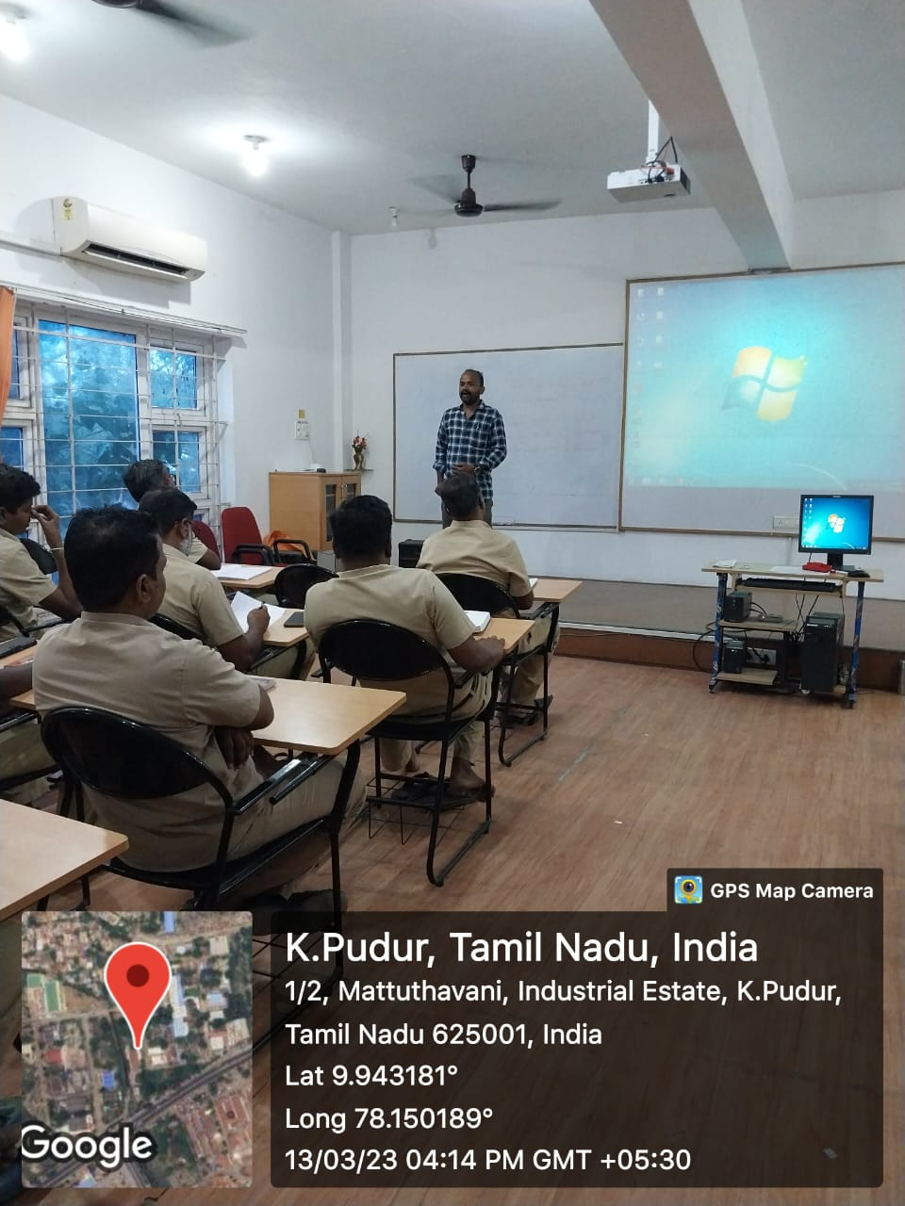

Mr. S. Saravanan spoke about International Rose Day

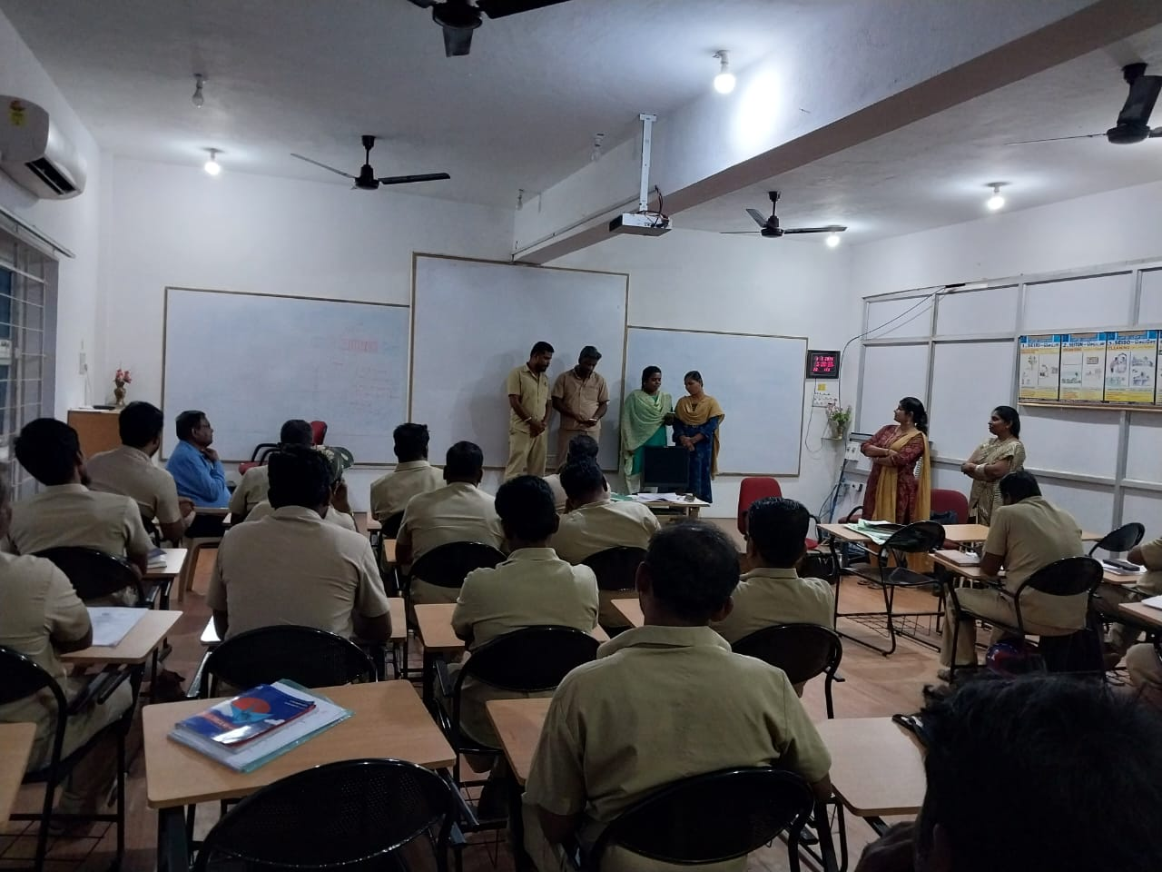
Participants rehearse Prayer Song for Valediction in the presence of Dr. K. Durairaj, Ms. Durga Devi and Dr. R. Saktheswari.

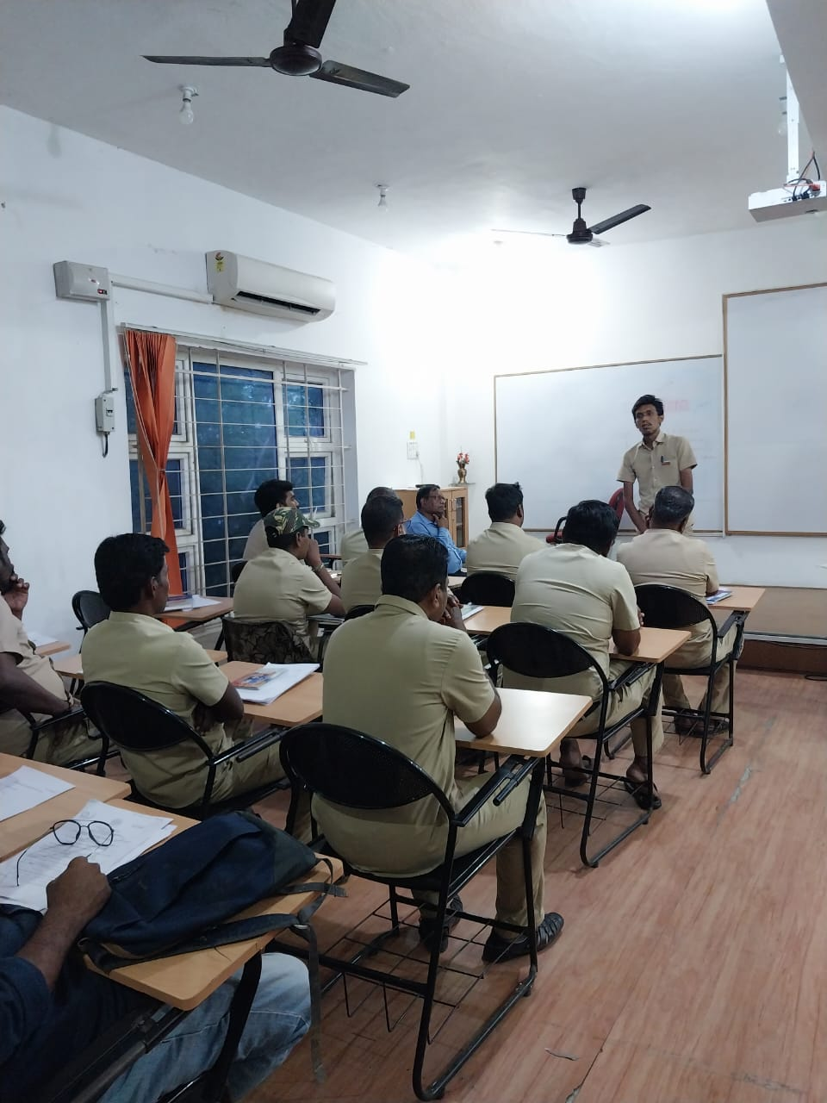

Mr. N. Hari Chandru giving feedback on the Training Programme

VALEDICTION - INVITATION

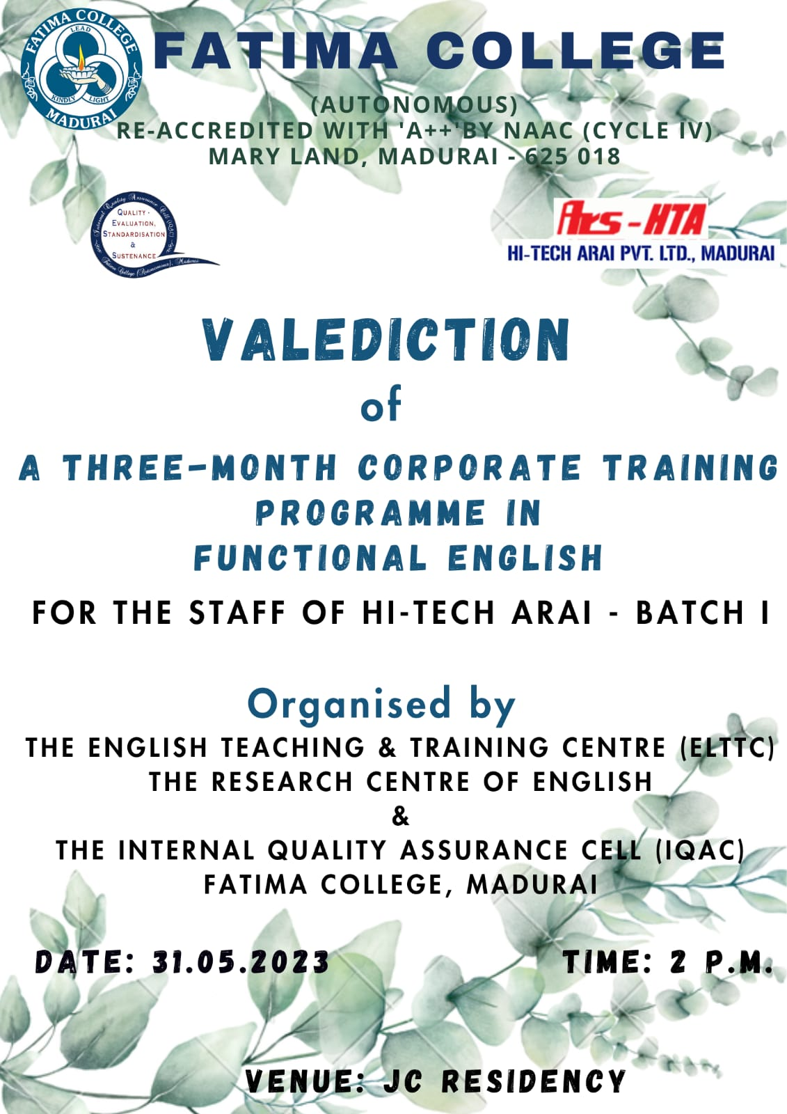

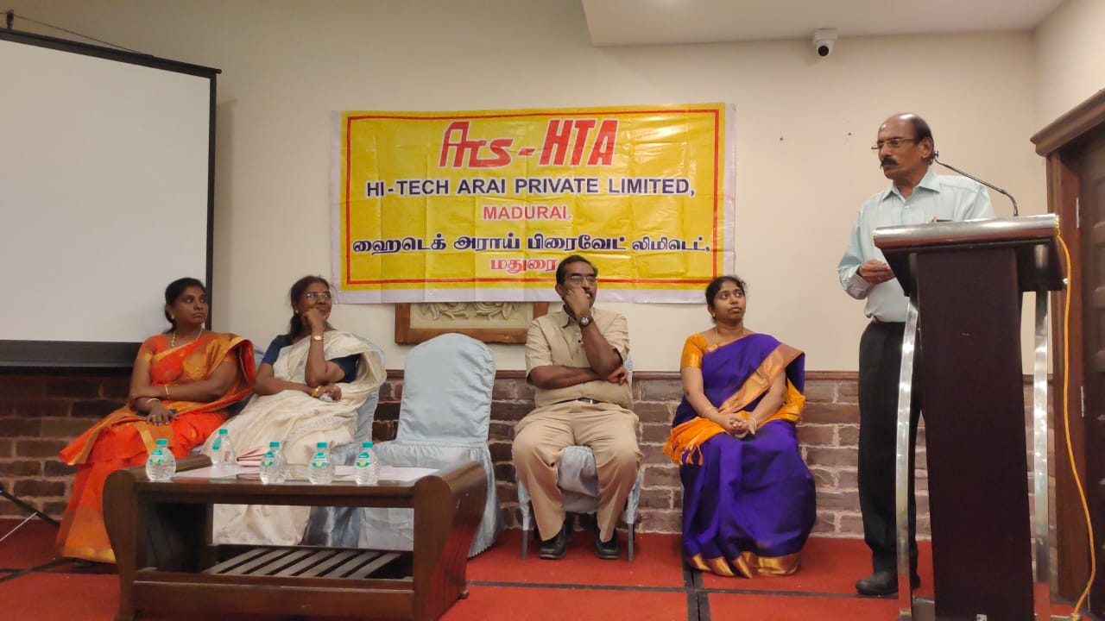

Presidential address given by Shri. B.T. Bangera, the Managing Director of
Hi tech Arai Pvt. Ltd.

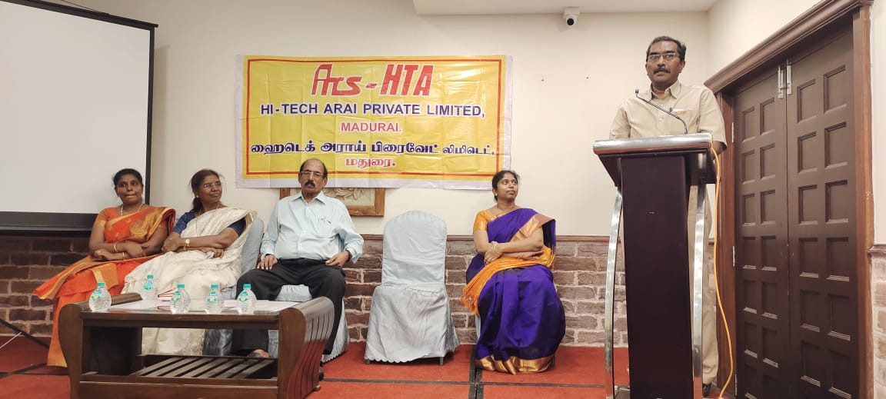

Special address given by Mr. S. Sukumar, Director, Operations, Hitech Arai Pvt. Ltd.

LIST OF PARTICIPANTS

S.No | Employee Code | Employee Name | Designation
1 | 029-009 | B.HARI PRASAD | Senior Tech Asst
2 | 021-139 | C.VAIRAKKANNU | Operator
3 | 021-146 | R.AZHAGU | Operator
4 | 026-019 | B.SUNDARA PANDIAN | Senior Tech Asst
5 | 021-084 | C.BALA MURUGAN | Jr.Tech Asst
6 | 028-016 | K.GANESAN | Senior Tech Asst
7 | 021-011 | S.SARAVANAN | Senior Tech Asst
8 | 021-003 | M.CHARLES BRITTO | TECH ASST
9 | 016-248 | S.SIVAKUMAR | SR.TECH.ASST
10 | 021-043 | S.JEGATHEESWARAN | SR.TECH.ASST
11 | 015-106 | K.VEERA MALAI | TECH.ASST
12 | 016-019 | K.VENKATESH KUMAR | SR.TECH.ASST
13 | 016-051 | A.SULTHAN MOHIDEEN | TECH.ASST
14 | 016-266 | A.ARIYAKRISHNAN | JR. TECH. ASST
15 | 021-007 | P.RAJKUMAR | TECH.ASST
16 | 021-016 | K.S.A RAJA MOHAMAD | TECH.ASST
17 | 021-040 | A.KANNAN | SR.TECH.ASST
18 | 026-011 | V.SELVAKUMAR | SR.TECH.ASST
19 | 015-027 | R.JAHIRHUSSAIN | OFFICER
20 | 016-264 | A.THANA PANDI | JR. TECH. ASST
21 | 016-114 | G.LAKSHMI | TECH.ASST
22 | 013-200 | S.JEYASEELAN | ENGINEER
23 | 013-201 | N.HARI CHANDRU | ENGINEER
24 | 013-180 | M.SAKTHIVEL | TECH.ASST
25 | 015-267 | M.GAYATHRI | TECH.ASST
26 | 016-115 | JOSTHIN JENITHA | TECH.ASST

SAMPLE CERTIFICATES

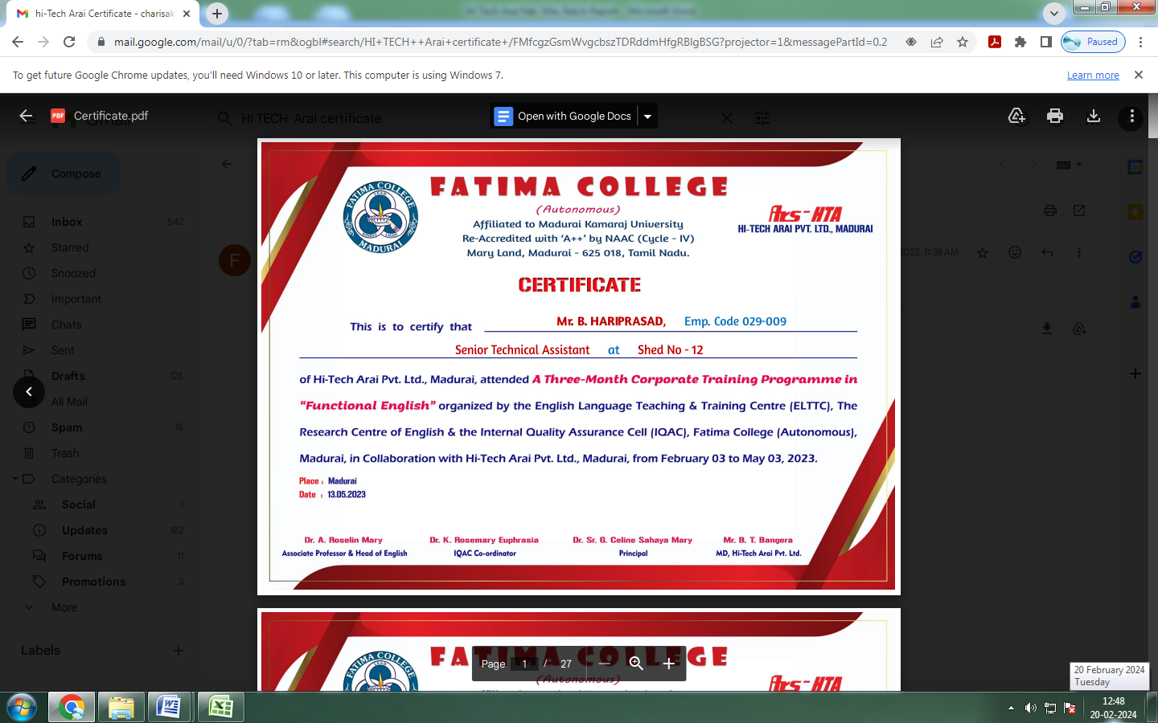

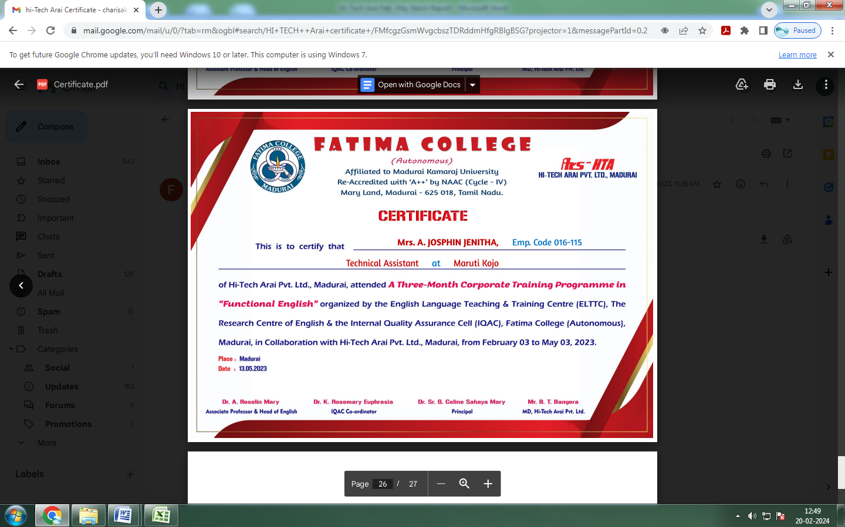

AWARENESS PROGRAMME
on
Health & Therapeutic Benefits of Millets
for the Non-Teaching Staff
Venue: Food Science Lab Date: Feb. 02, 2023
Batch I : 10.00 a.m. – 12.30 p.m.
Batch I : 02.00 p.m. – 04.30 p.m.
Programme Schedule
Prayer
Welcome Address : Dr. Vasantha Esther Rani
Associate Professor of Home Science
Fatima College (Autonomous), Madurai.

Resource Person : Mr. Mariappan
Senior Food processing Consultant
Retired Officer from Food Dept.
Govt. of India.

Vote of Thanks : Mrs. D. Sahaya Hilda Mary, Lab Assistant
Fatima College (Autonomous), Madurai.

***

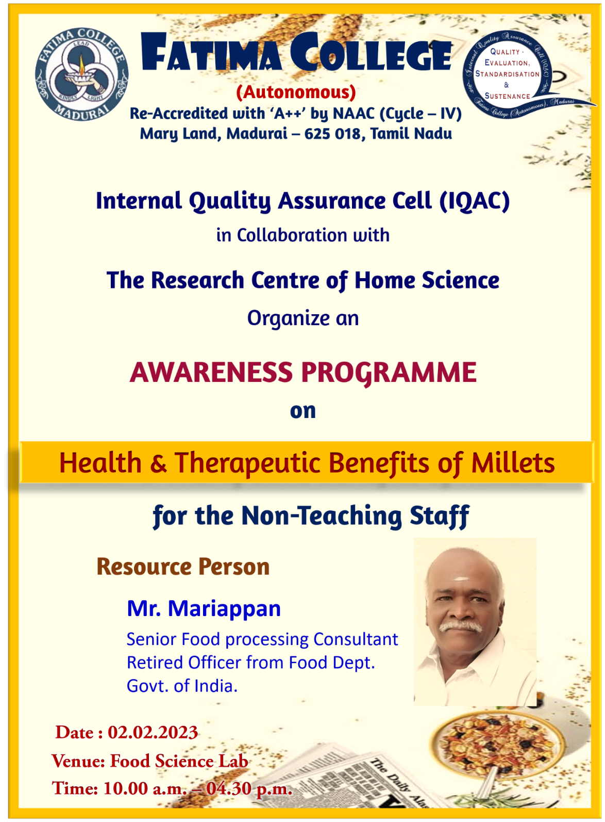

Health and Therapeutic Benefit of Millets

Resource Person:
Mr. Mariappan
Rtd. Senior Food Processing Consultant,
Food Science Department, Government of India

02.02.2023 to 03.02.2023
The 2023 International Year of Millets is a chance to increase public knowledge of the many advantages of millets, ranging from economic growth and environmental sustainability to health and nutrition. The Year will improve the relationship between science and policy, foster collaborations, inspire stakeholders to take initiative in developing and producing millets, and promote millets' use by the general public.

Everyone has a part to play, including home cooks, chefs, young people, and representatives of the public and business sectors. To fully realise millets' potential for improving human and planetary health and wellbeing, we must cooperate.

Day1: To commemorate the International Year of Millets (2023), IQAC of Fatima College and The Research Centre of Home Science jointly organised a two-day' workshop for their non-teaching and sub-staff at the Food Science Lab, The Research Centre of Home Science, Fatima College, Madurai. IQAC members welcomed the chief guest, and Dr. Rosemary, Associate Professor of Computer Science and Co-Ordinator of IQAC, inaugurated the programme. Mr. Mariappan discussed the value of millet and the reasons it's considered a nutritious diet. After giving a demonstration of how to cook using millets, he gave each group a task to prepare a meal using millets. The employees made a variety of foods, including small grains laddu, saamai thosai, varagu Pongal, and small grains thosai. He sampled the cuisine after the session and expressed gratitude to the groups.
Photos: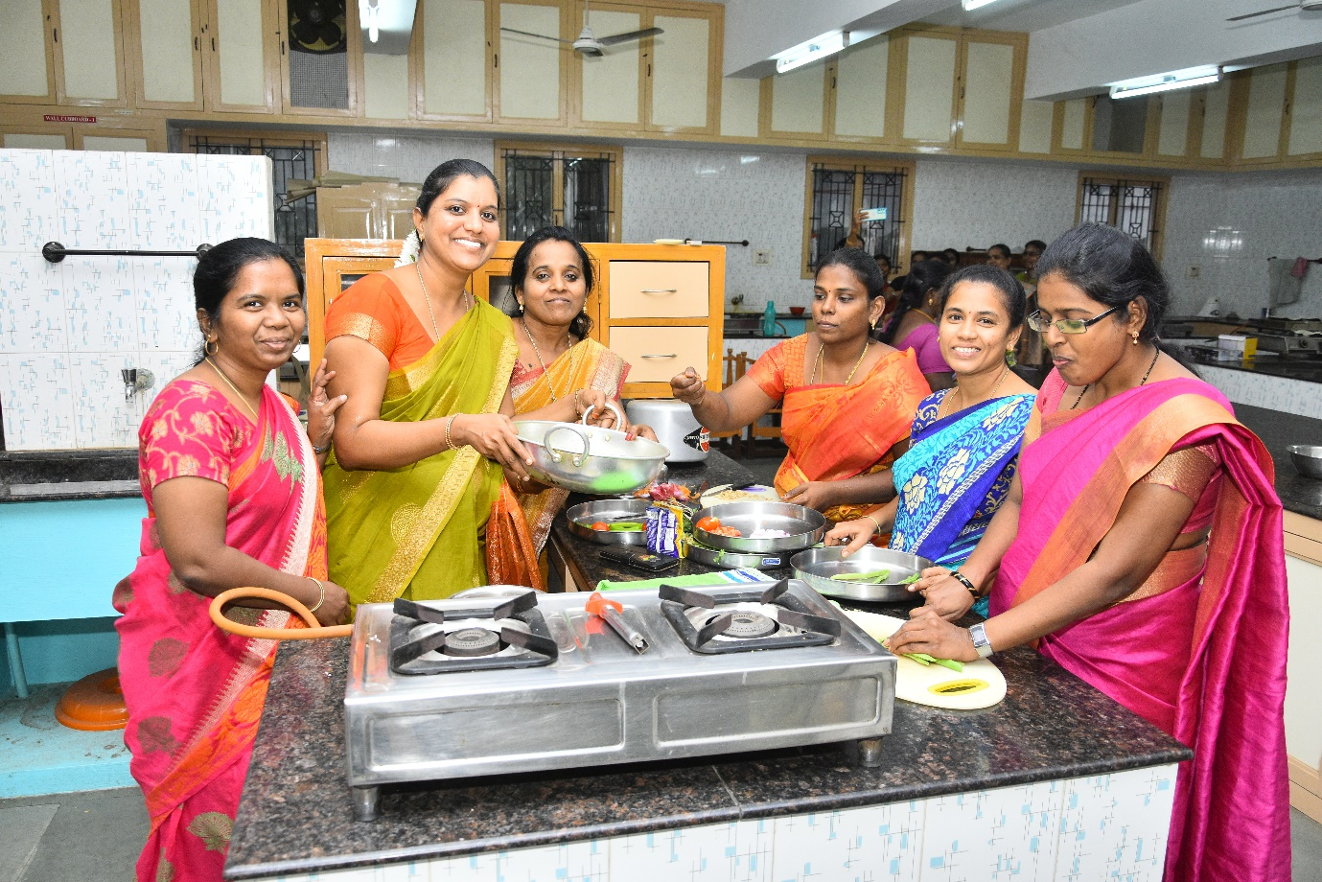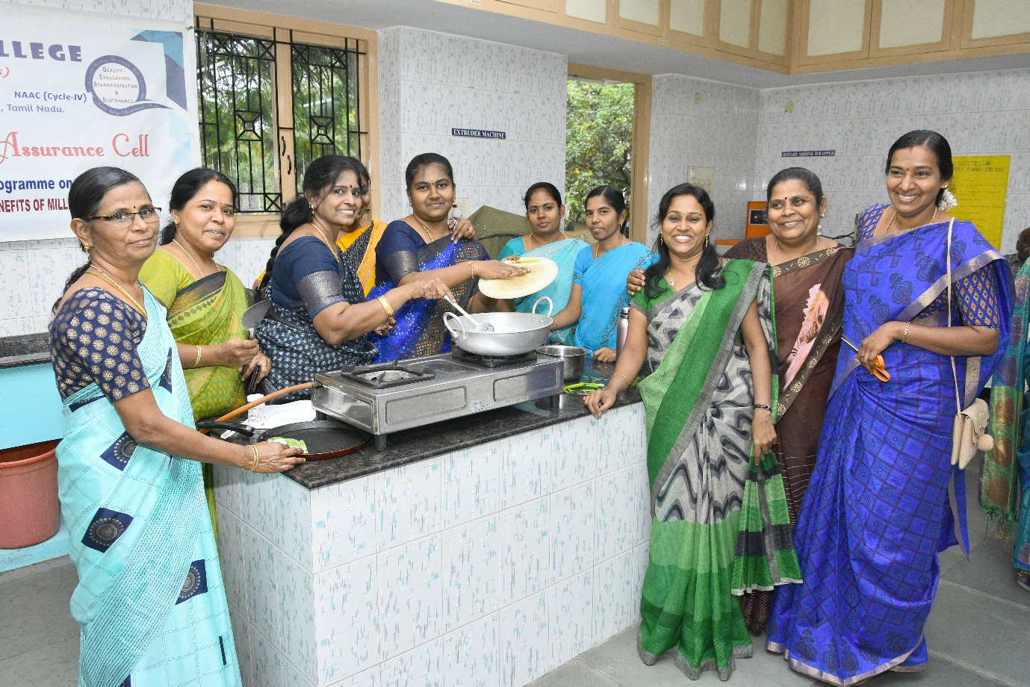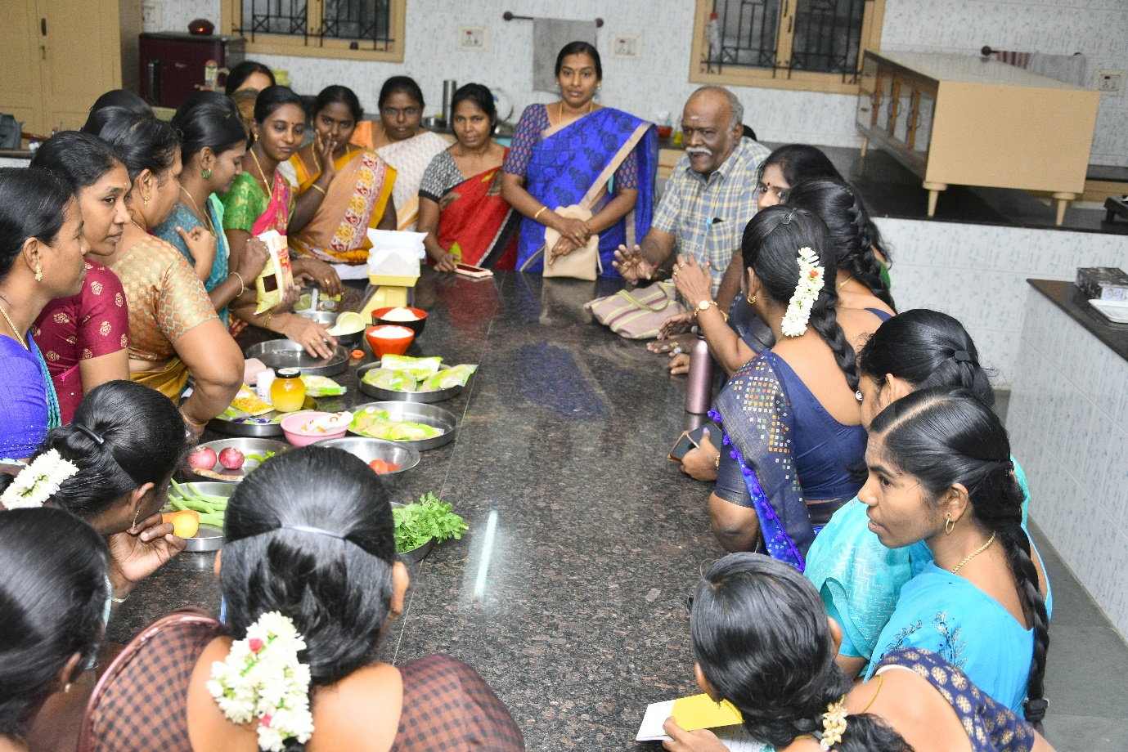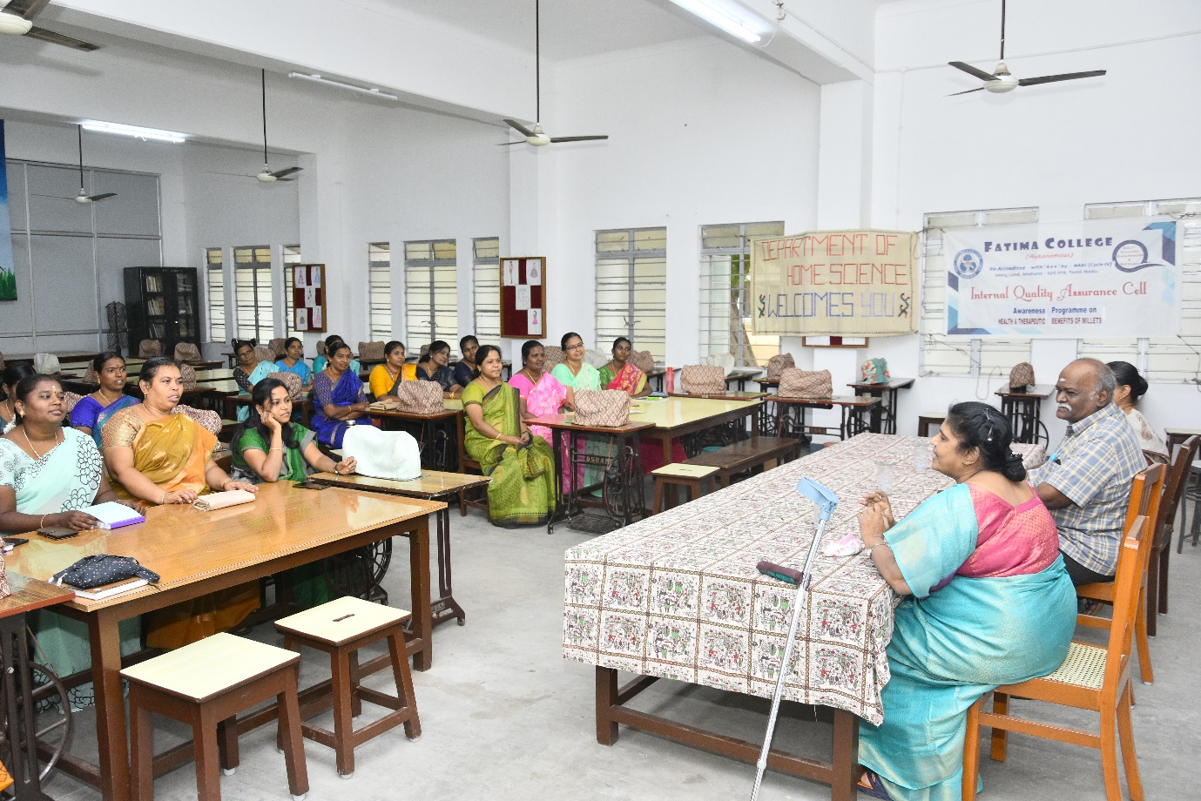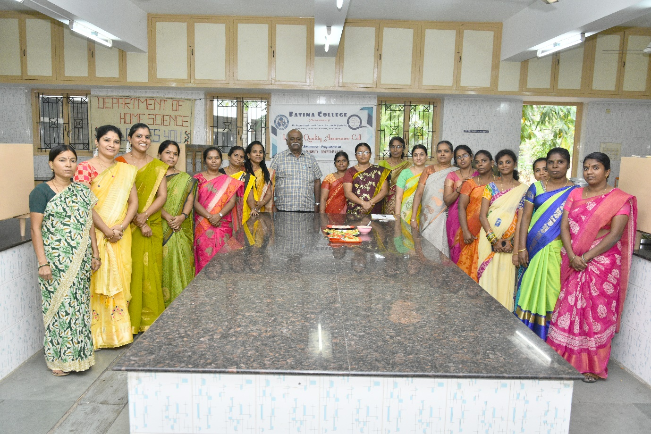

Attendance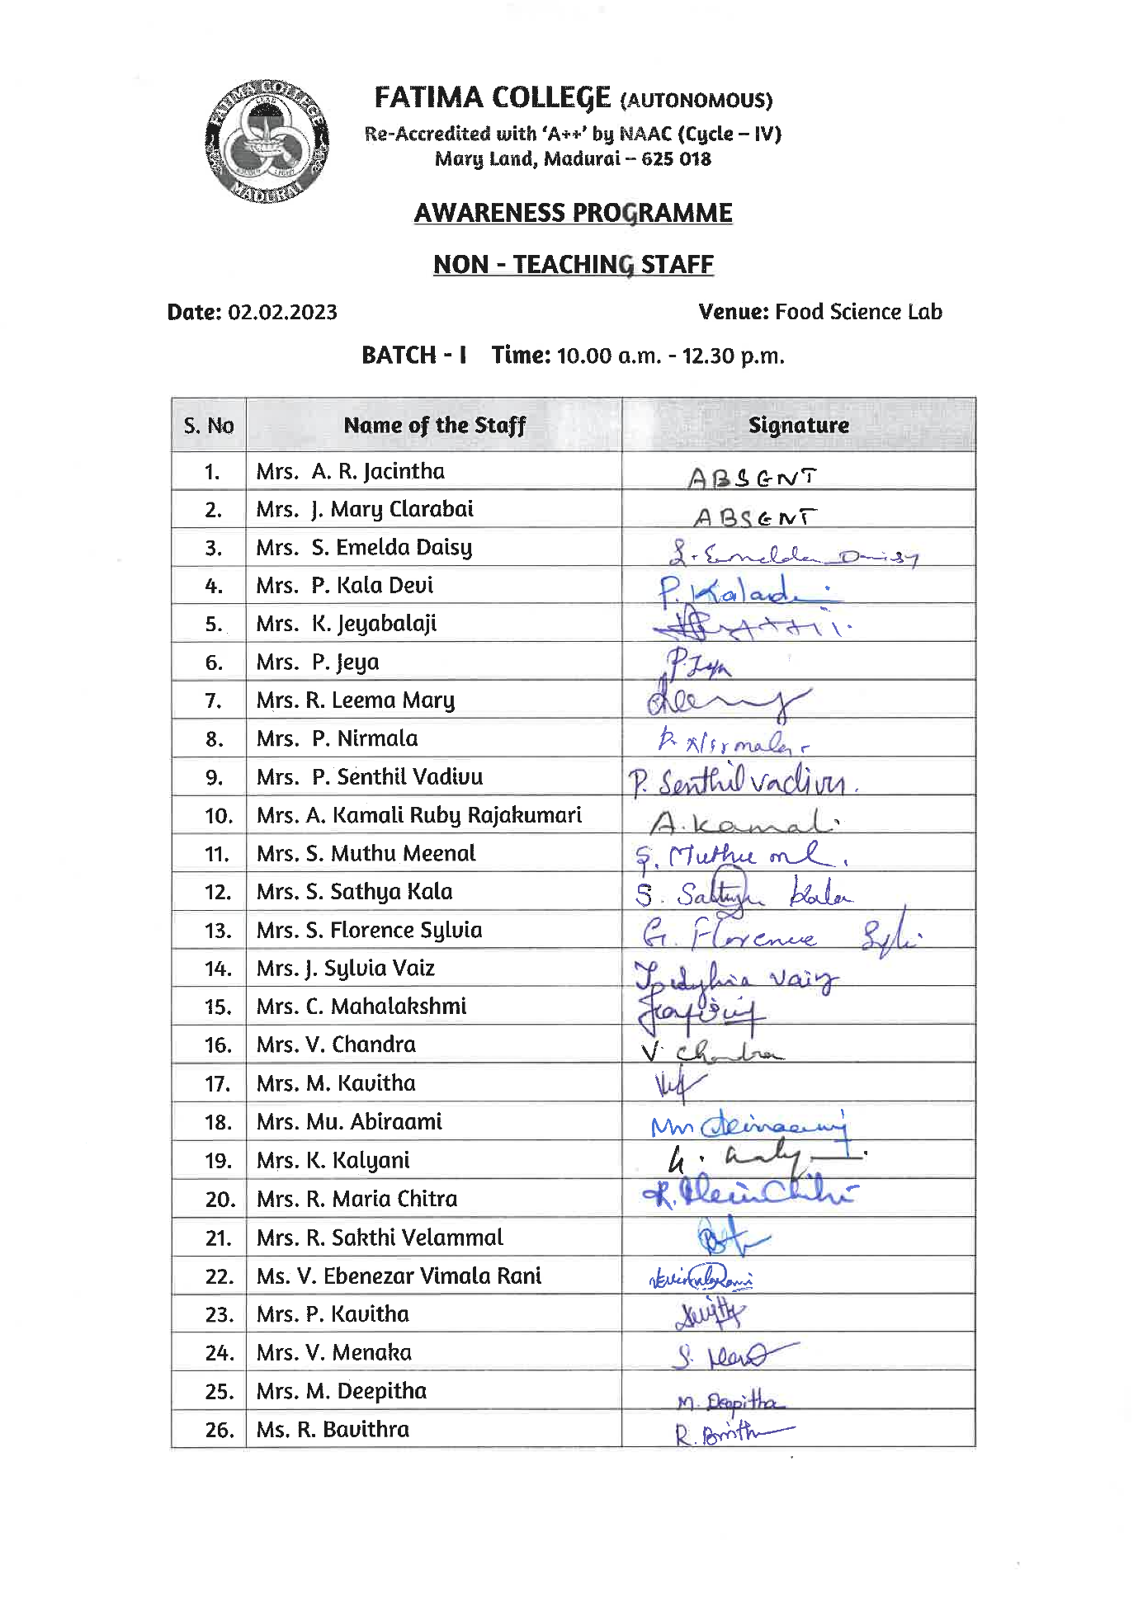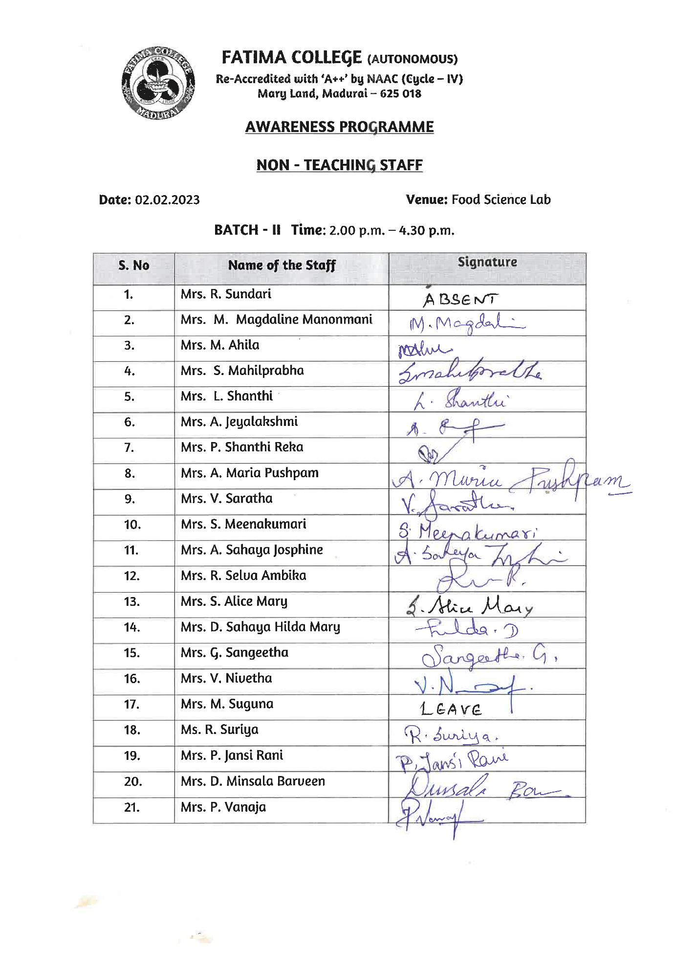

Feedback Form:
: 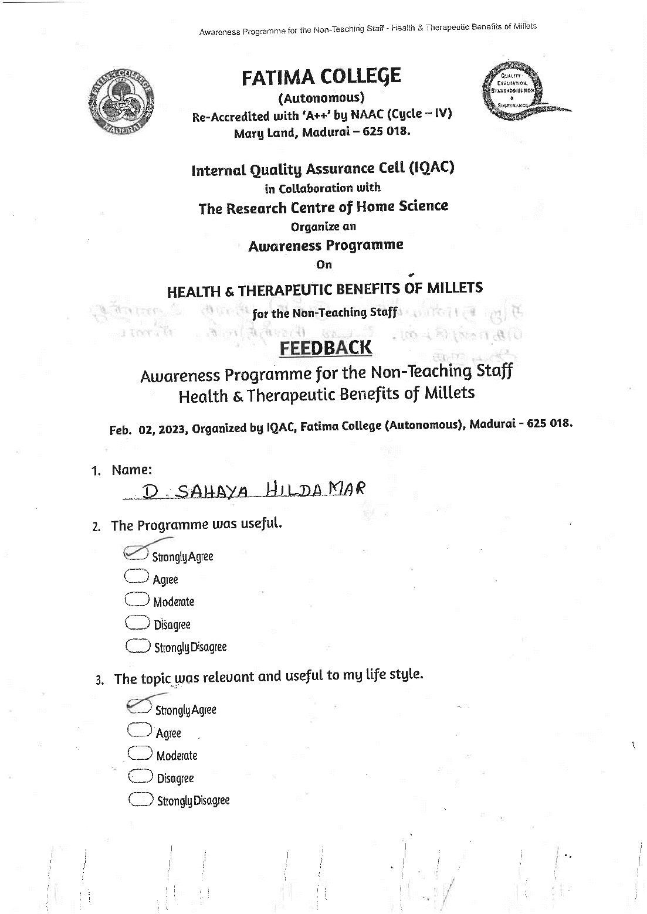
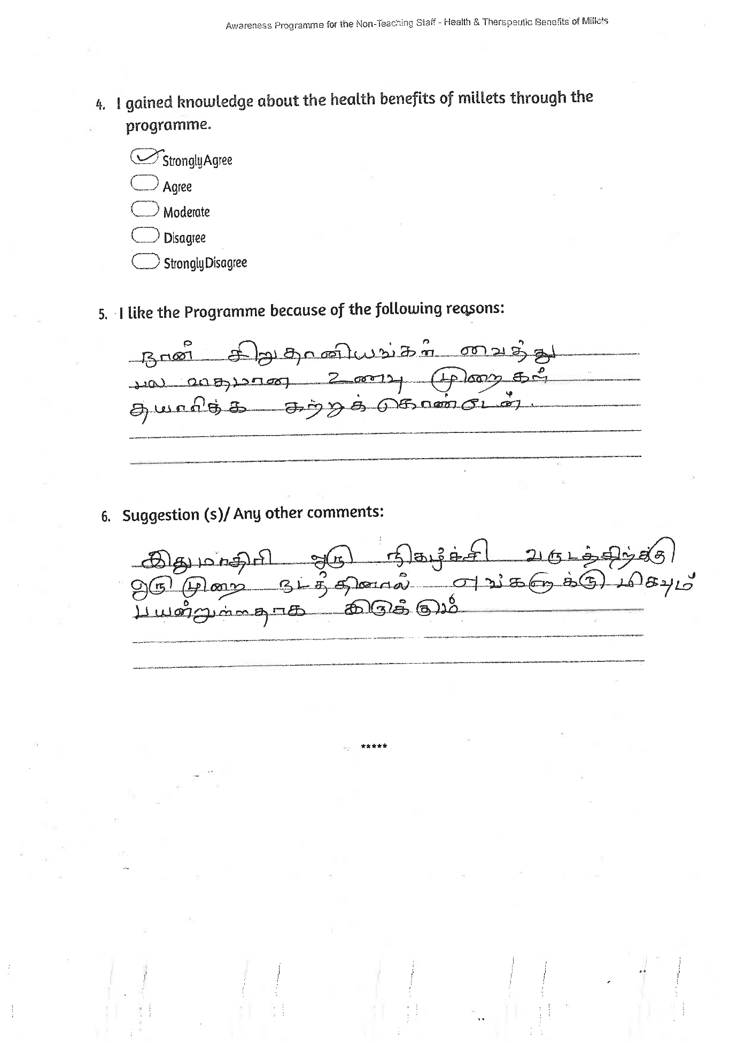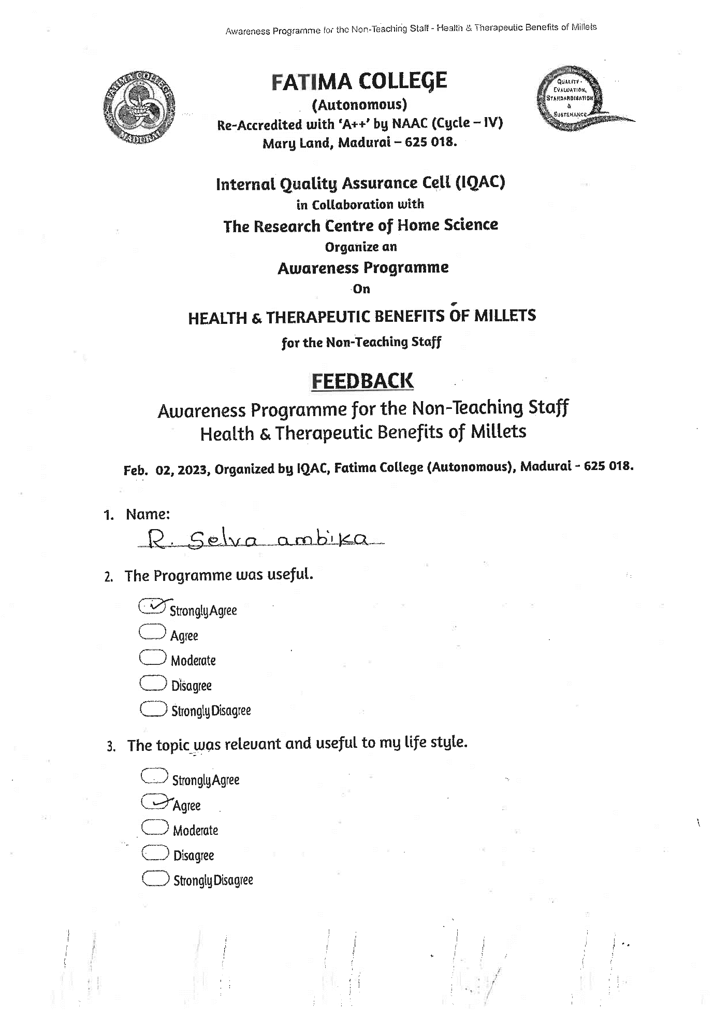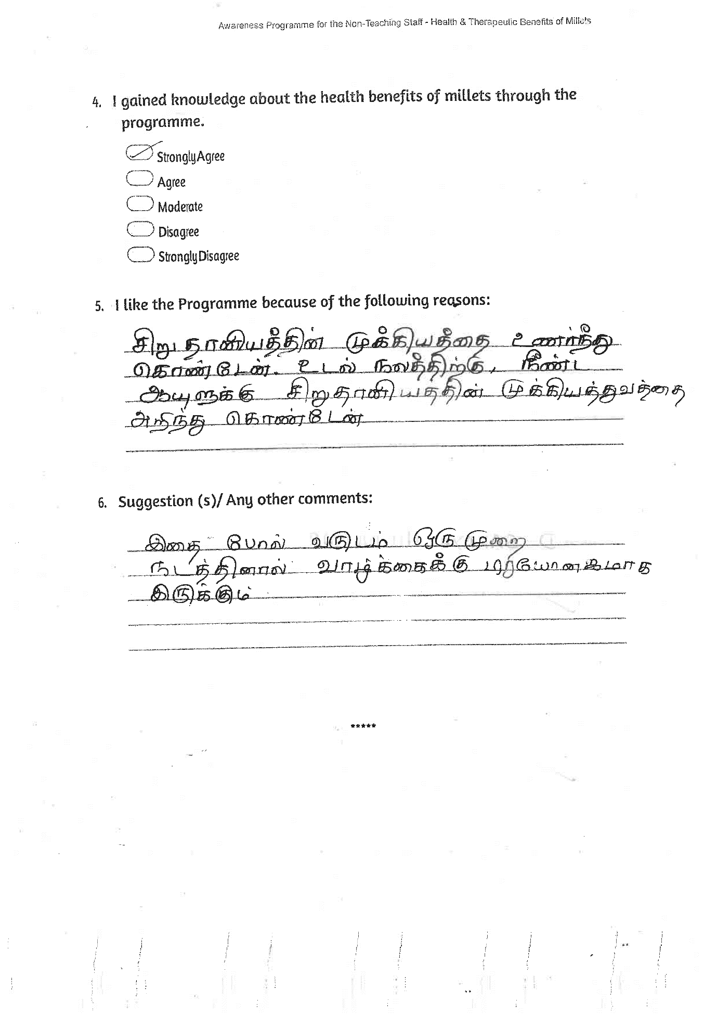
CAPACITY BUILDING PROGRAMME
on
HEALTHY MILLET RECIPES
for the Sub-Staff
Venue: Food Science Lab Date: Feb. 03, 2023

Programme Schedule
Prayer
Welcome Address : Dr. Vasantha Esther Rani
Associate Professor of Home Science
Fatima College (Autonomous), Madurai.

Resource Person : Mr. Mariappan
Senior Food processing Consultant
Retired Officer from Food Dept.
Govt. of India.

Vote of Thanks : Mrs. Annamayil
Fatima College (Autonomous), Madurai.

***
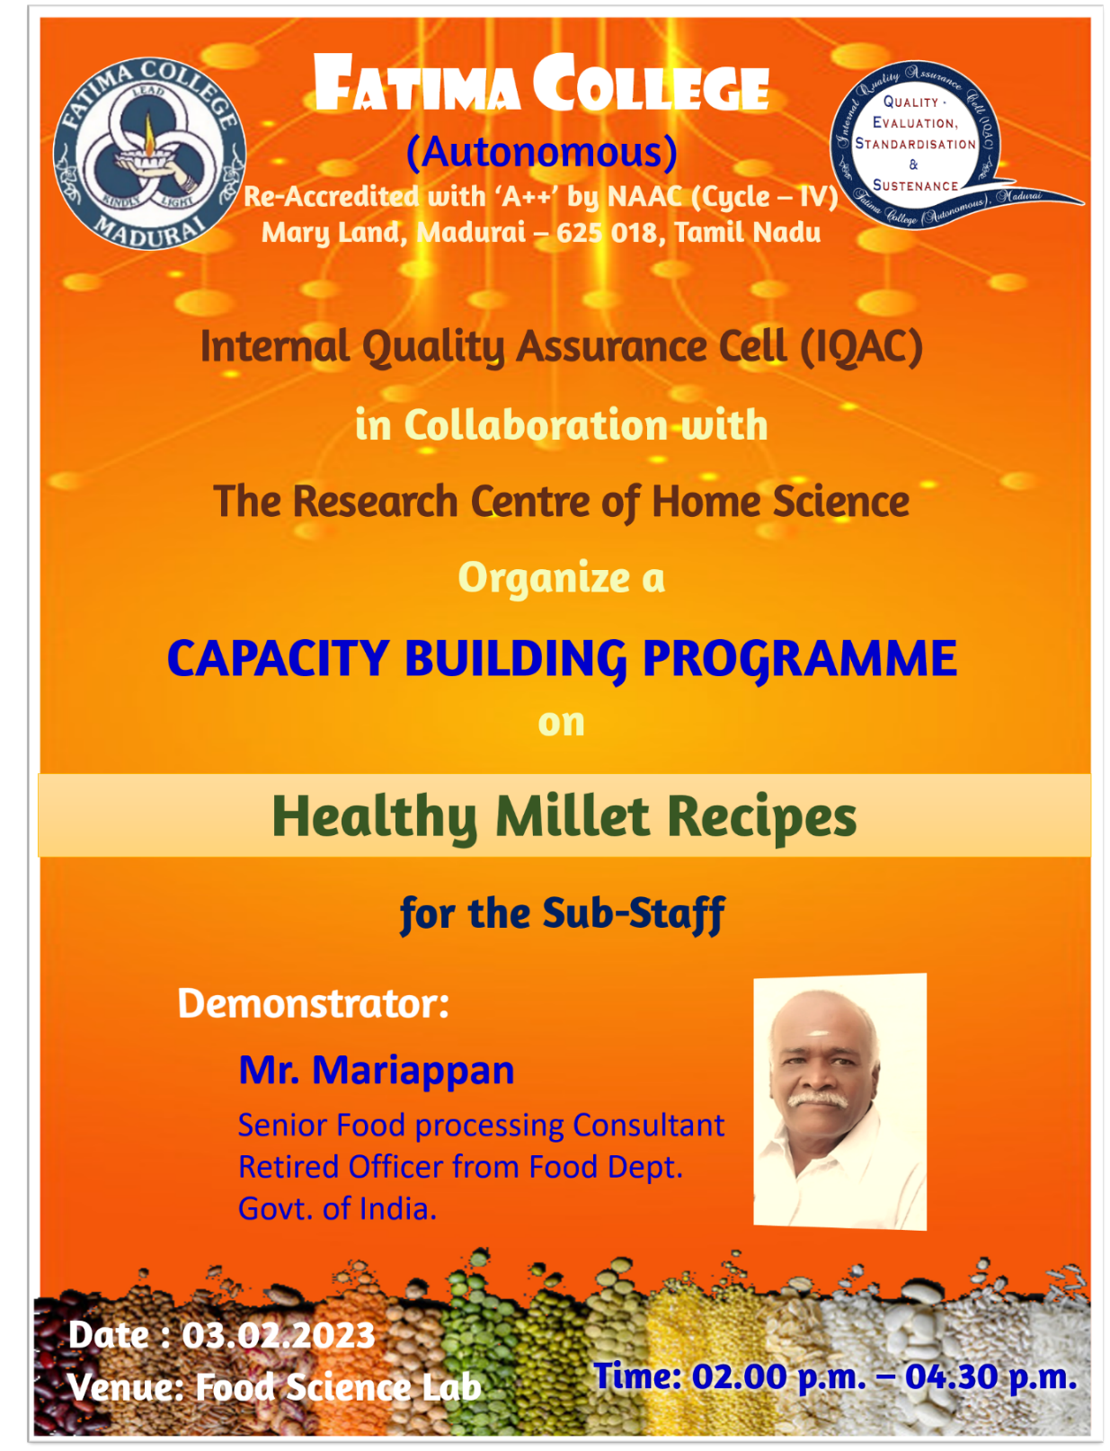

Resource Person:
Mr. Mariappan
Rtd. Senior Food Processing Consultant,
Food Science Department, Government of India

Report:
Day 2: The Fatima College sub-staff members were the target audience for the programme. They enthusiastically engaged in the programme and displayed their abilities in a competitive manner. The main guest acknowledged their curiosity and gave them advice on how to promote the cuisine locally.
Outcome: This event was being recreated by non-teaching and support staff members. They got the notion to start their own business.

Photos:

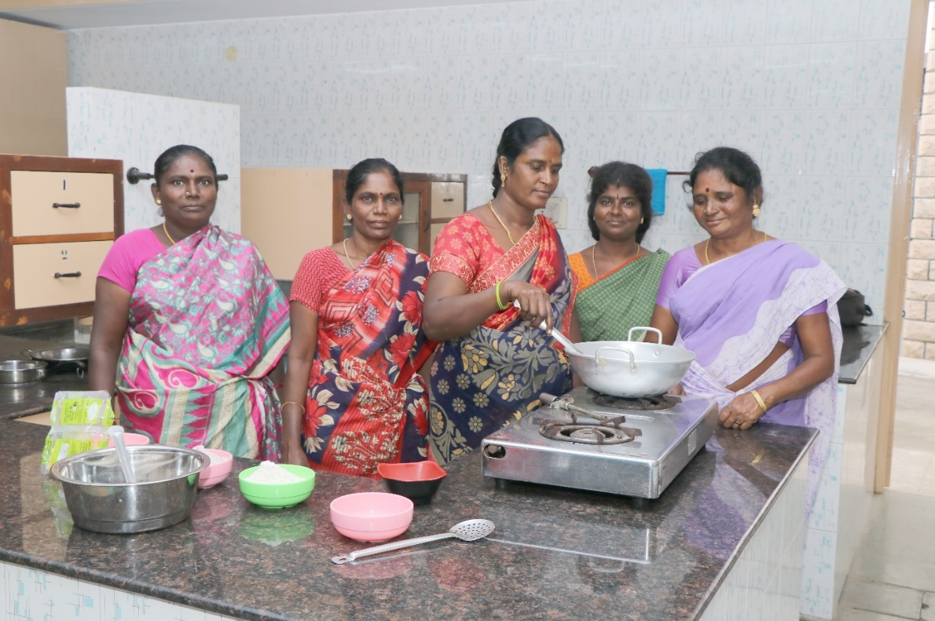

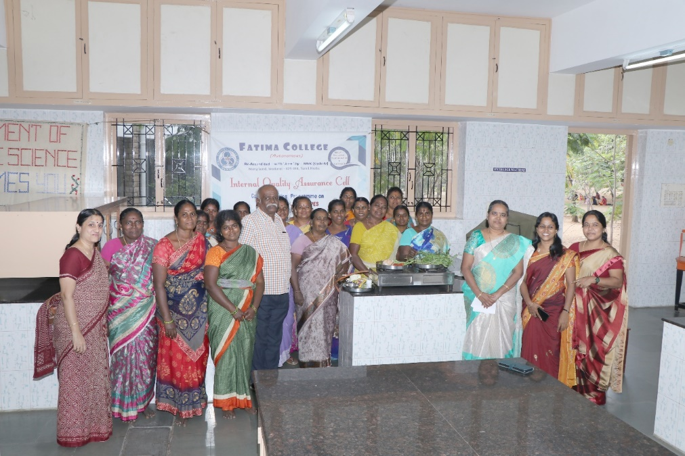

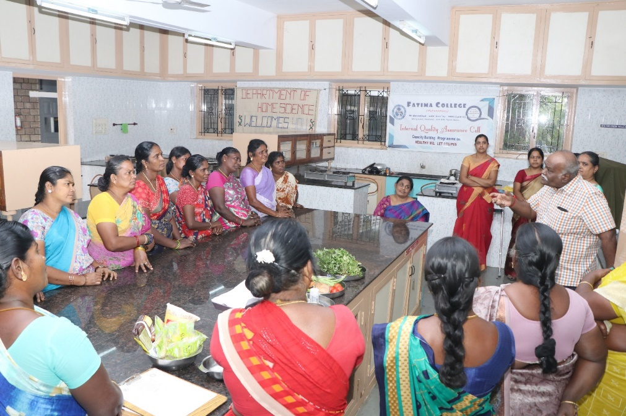

Attendance
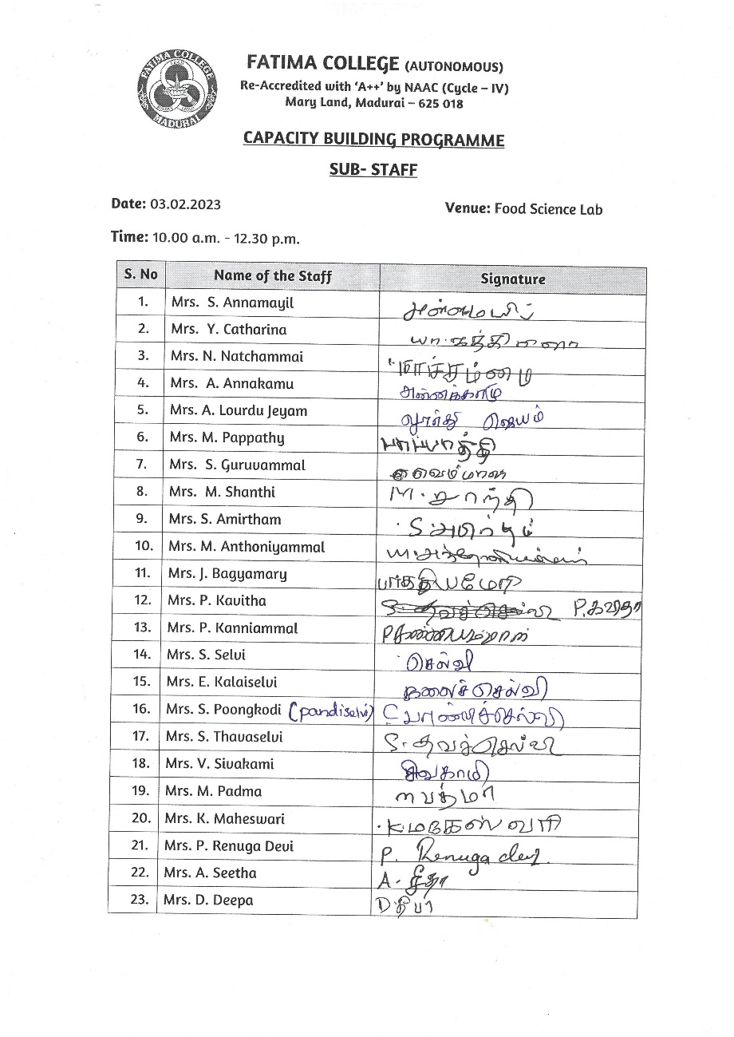

Feedback Form:
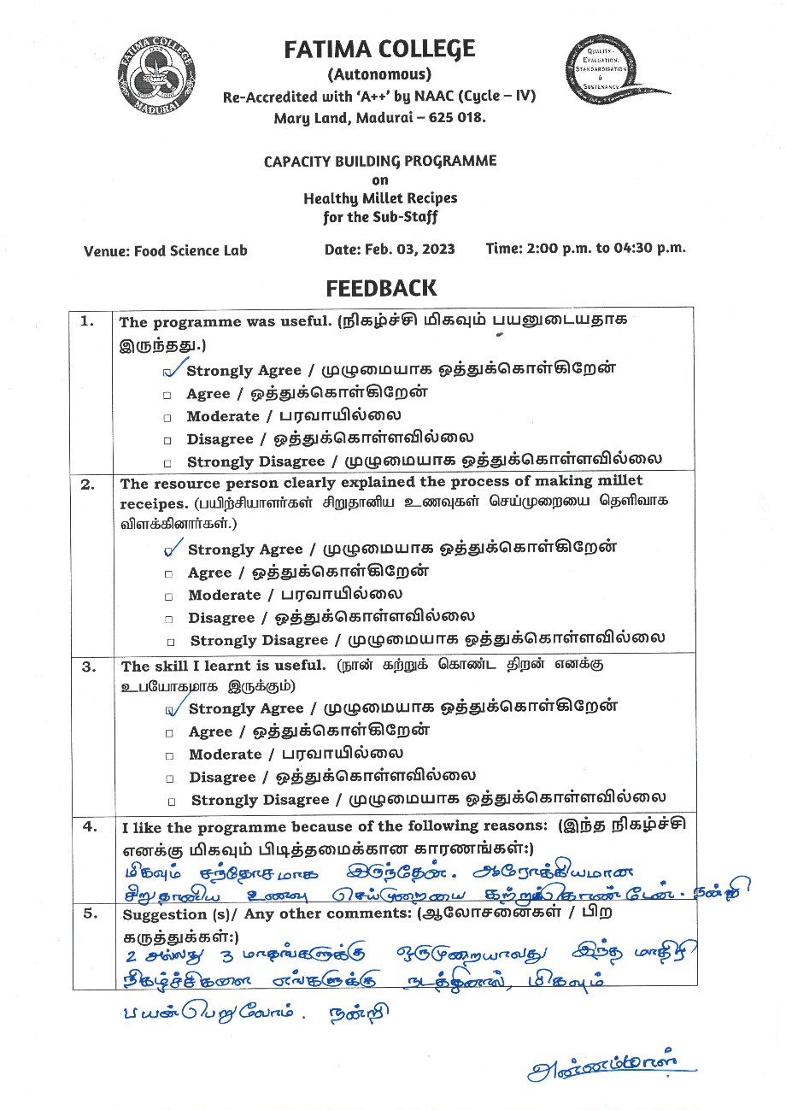
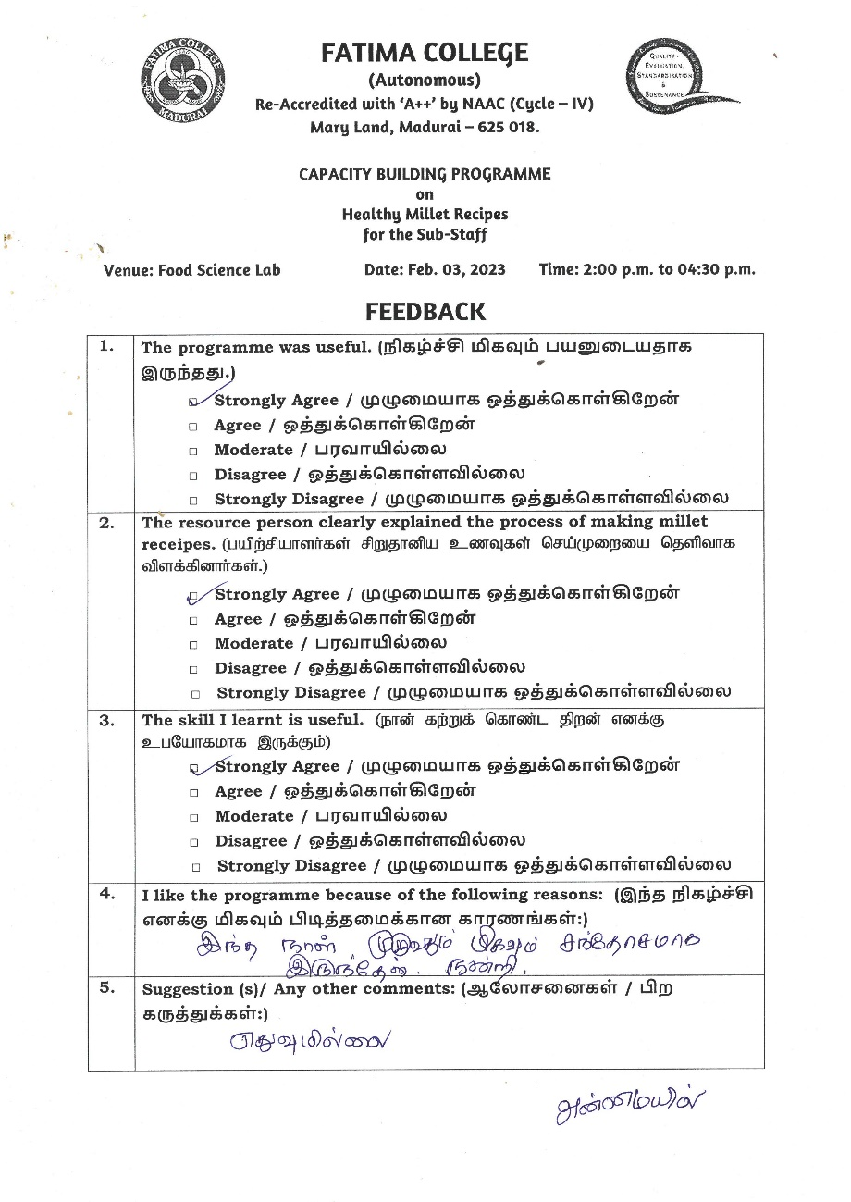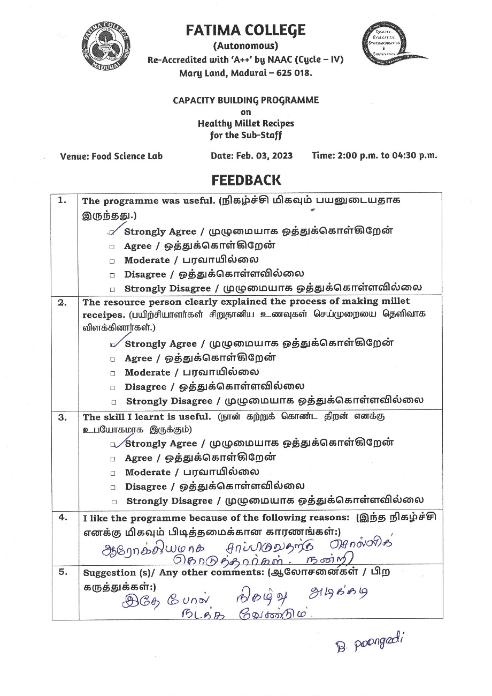

Career Guidance & Motiational Programme on MARCH 18, 2023

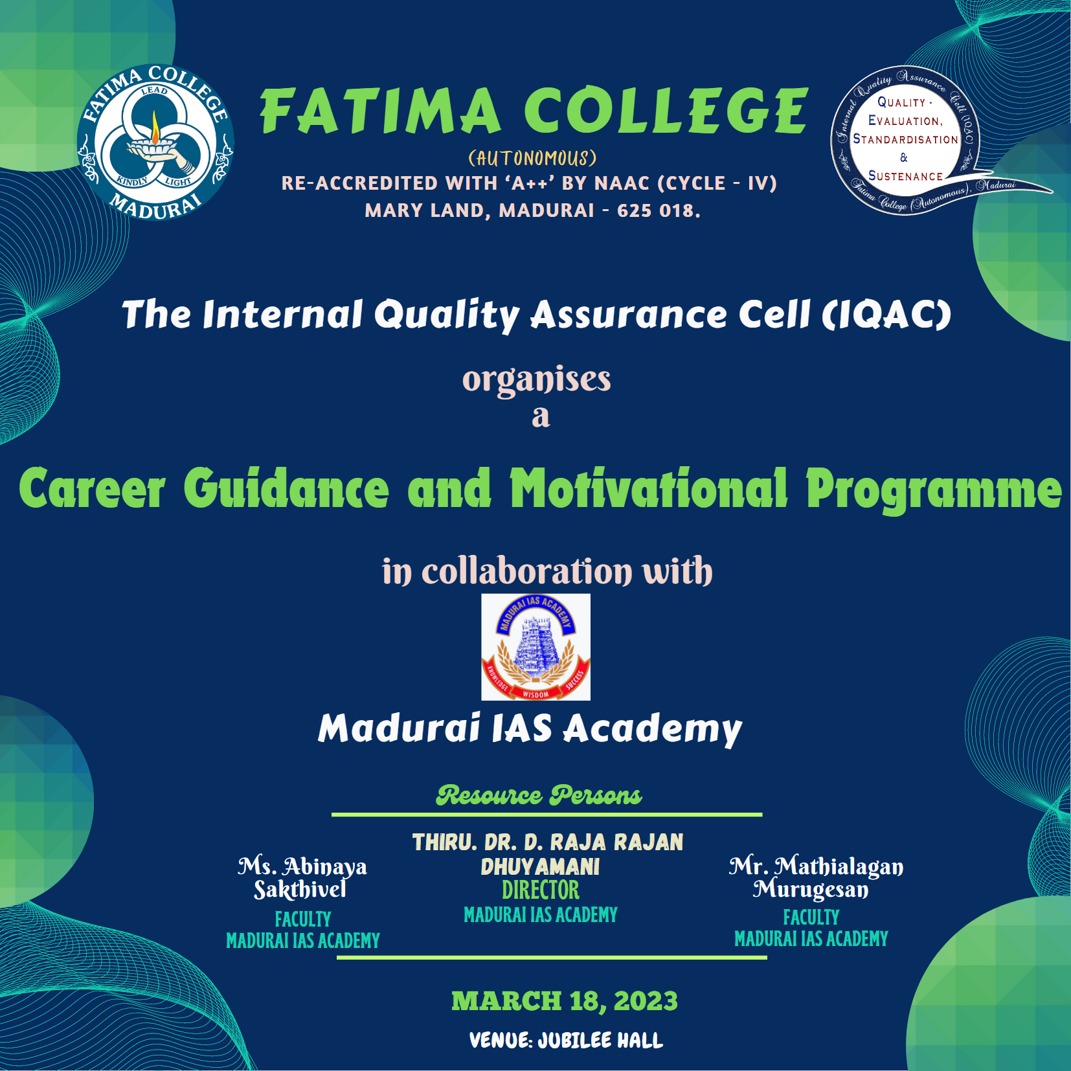
The Internal Quality Assurance Cell (IQAC), Fatima College (Autonomous), organised “Career Guidance and Motivational Programme” on March 18, 2023 for the students in Jubilee Hall. On the III UG, 966 stuudents attended the session. The Resource persons for the session were Thiru. Dr. D. Raja Rajan Dhuyamani, Director, Madurai IAS Academy, Ms. Abinaya Sakthivel, Faculty, Madurai IAS Academy, and Mr. Mathialagan Murugesan, Faculty, Madurai IAS Academy.
The programme commenced with a warm greetings and hearty welcome to the chief guests and the audience. Ms. Abinaya Sakthivel shared about the history of Madurai IAS Academy and the various courses conducted in their centre. She encouraged the students to benefit from their training and frame a successful career.
Mr. Mathialagan Murugesan shared the stories of successful people who got trained from their academy. He shared the experiences of various students and the ways they overcame their struggles.
Dr. D. Raja Rajan Dhuyamani highlighted the social contributions of their institute, by enhancing the quality of life of numerous youngsters. He also motivated the students to aim higher in order to succeed in their career. The chief guest also shared about various Government examinations, and the ways to grab them. He stressed the importance of career guidance programmes organised in the college campus, and also detailed the benefits that students gain through such programmes.
The student attendees eagerly raised their doubts and clarified about their career plans. The session ended up with a formal Vote of thanks.
The students benefitted from the career guidance programme by gaining awareness on the various Government jobs and competitive exams. The audience felt highly motivated with the success stories of achievers.
All the students were highly motivated and enlightened about various opportunities after completing their respective courses. It was a very informative day for the attendees of the session. The experts concluded the session by emphasizing the importance of staying motivated and having a positive attitude. The programme was well-received by the students and was a great success.

Photos
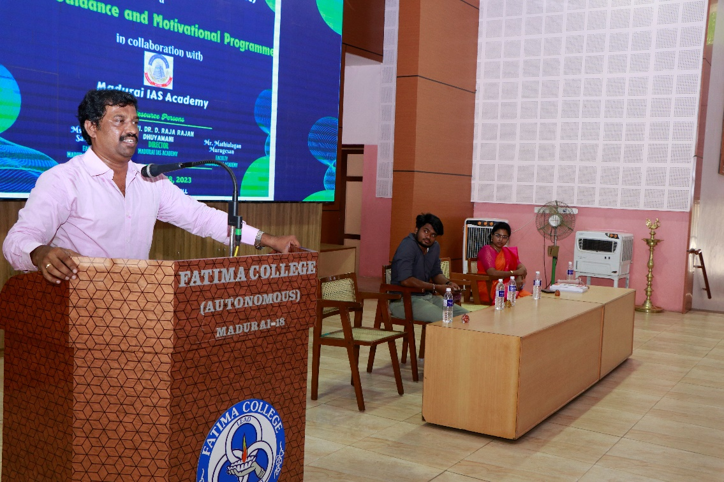
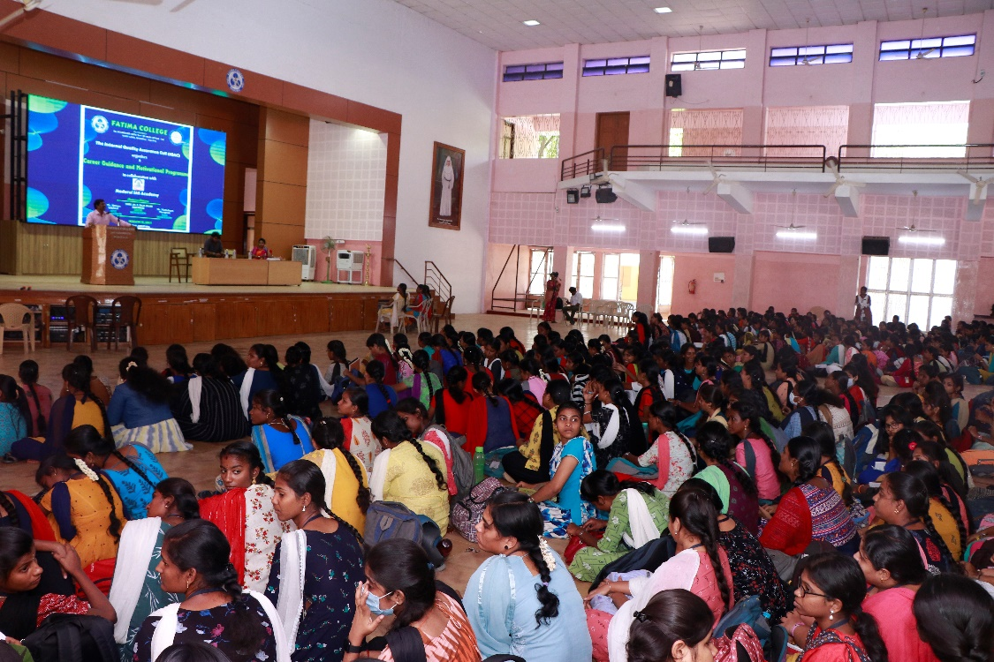
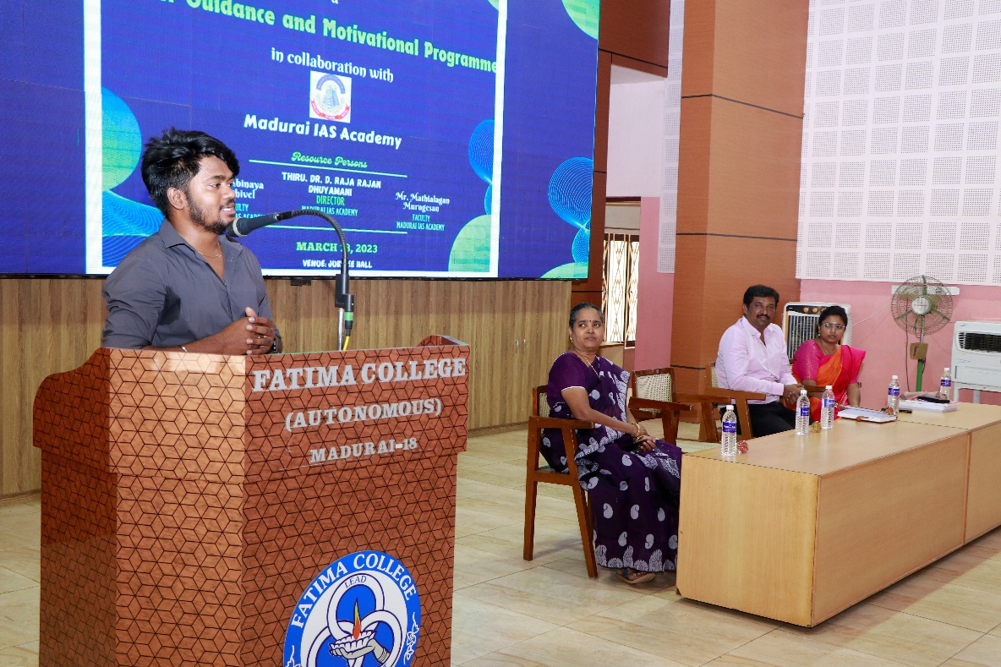
Attendance
Aided: 540

S. No. | Reg. No. | Students Name
 | 2021H01 | AISWARYA D
 | 2021H02 | ANTONY JEYA MONICA S
 | 2021H03 | ANUJA G
 | 2021H04 | ARO EUGINA J
 | 2021H05 | BALAMEENA S
 | 2021H06 | DANNIYA SELVA PRINCY P
 | 2021H07 | DHIVYA DHARSHINI M
 | 2021H08 | DURGA DEVI G
 | 2021H09 | HARINI BALASRI K V
 | 2021H10 | HARINI M
 | 2021H11 | HARITHA B
 | 2021H12 | HEMAAPRIYAA K
 | 2021H14 | ISHWARYA G
 | 2021H15 | ISWARYA A
 | 2021H16 | JANAKI PRIYA B
 | 2021H17 | JEEVA M
 | 2021H18 | KARPAGA ARUNA A
 | 2021H19 | KAYATHRI R
 | 2021H20 | KEERTHIKA S
 | 2021H21 | LOGAMALATHI R
 | 2021H22 | LOSHINI S
 | 2021H24 | NAGANJALI P
 | 2021H25 | PARVATHI K
 | 2021H26 | PRIYADHARSHINI P
 | 2021H29 | SAHITHA NASIN M
 | 2021H30 | SAKTHI MURUGESWARI B
 | 2021H31 | SHALINI LA
 | 2021H32 | SONIA P
 | 2021H33 | SOWMIYA R
 | 2021H35 | SUBHASHINI S
 | 2021H36 | TEENA MEKLIN I
 | 2021H37 | THARANI K
 | 2021H38 | VENI S
 | 2021H39 | VIDHYA P
 | 2021H40 | DHARSHINI P
 | 2021H41 | GOWRI M
 | 2021H42 | ADHITHYA K
 | 2021H43 | GAYATHRI P
 | 2021H44 | KAARTHIKA CS
 | 2021H45 | VARSHA M
 | 2021H46 | AMIRTHA N
 | 2021H47 | MAREESWARI A
 | 2021H50 | JOTHIKA M
 | 2021H52 | NITHIYA P
 | 2021H53 | JAYA HARINI S.K
 | 2021H54 | SANGEETHA M
 | 2021H55 | CELCIA B
 | 2021H56 | DIVYA M
 | 2021E01 | ABIRAMI K
 | 2021E02 | ABIRAMI S
 | 2021E04 | ANANDA PRIYA M
 | 2021E05 | ARSHUSAFORA W
 | 2021E06 | AYESHA FARHANA T
 | 2021E07 | BHANU REKKHA N
 | 2021E08 | BHUVANA SANGARI S
 | 2021E09 | BOOMIKA C
 | 2021E11 | GAYATHIRI B
 | 2021E12 | GAYATHRI A
 | 2021E13 | HARINI V
 | 2021E14 | HARSHINI S
 | 2021E15 | JAI SAKTHI G
 | 2021E16 | JUNAITH RESHMI R
 | 2021E17 | KALPANA K
 | 2021E18 | KAVIYA C
 | 2021E21 | LALITHA B
 | 2021E22 | LAVANYA S
 | 2021E23 | MAHALAKSHMI M
 | 2021E24 | MAMATHY CHARRY B
 | 2021E25 | MONISHA R
 | 2021E27 | NIKHILA SHIVANI K
 | 2021E28 | NIVETHITHA T
 | 2021E29 | PAVITHIRA M
 | 2021E31 | PRIYA DHARSHINI M
 | 2021E32 | RAJESWARI M
 | 2021E33 | RASHIKA M
 | 2021E34 | ROHINI B
 | 2021E35 | ROHINI D
 | 2021E36 | SAMA PRIYA M
 | 2021E37 | SANTHOSHIKA S
 | 2021E38 | SHIFANA BEGUM S
 | 2021E41 | SOBANA SRI G
 | 2021E42 | SRIJA P
 | 2021E44 | SUBHALAKSHMI M
 | 2021E45 | SUJEETHA S
 | 2021E46 | SWETHA K
 | 2021E47 | THENMOZHI G
 | 2021E48 | USHARANI N
 | 2021E49 | VARSHINI M
 | 2021E50 | VENCY A
 | 2021E51 | VIJAYALAKSHMI B
 | 2021E52 | VINOTHA R
 | 2021E53 | VIVEKA P
 | 2021E54 | YOGA DHARSHINI R
 | 2021E56 | NILOPERNISHA I
 | 2021E58 | APARNA J
 | 2021E59 | GAYATHRI S
 | 2021E60 | JERIN SHREEJA E
 | 2021E61 | KEERTHIKA K
 | 2021E62 | PANJAVARNAM D
 | 2021E63 | SANTHANA LAKSHMI K
 | 2021E64 | AISWARYA V
 | 2021E65 | BANUPRIYA L
 | 2021E66 | DEEPIKA P
 | 2021E68 | MANASA BRISKEY M
 | 2021E69 | SOWMIYA B
 | 2021E70 | MEENA P
 | 2021S01 | ABARAJITHA S
 | 2021S04 | BALAYUVALAKSHMI M
 | 2021S05 | BHUVANA DHARSHINI V
 | 2021S07 | CHENBAGA SREE M
 | 2021S08 | DEVADHARSHINI JJ
 | 2021S09 | DHIVYANJALI M
 | 2021S10 | DIVYA B
 | 2021S11 | GOWSALYA DEVI J
 | 2021S13 | HENA S
 | 2021S14 | JAAFRIN J
 | 2021S15 | JASHRA A
 | 2021S18 | KANISHKA VG
 | 2021S19 | KAVIYADHARSHINI G
 | 2021S22 | NITHIYA SREE M
 | 2021S23 | PRIYANKA K
 | 2021S25 | RAMYA R
 | 2021S26 | SANTHIYA S K
 | 2021S27 | SIVAPRIYADHARSHINI M
 | 2021S28 | SRINITHI V
 | 2021S29 | SUBEKSHANA P
 | 2021S30 | SUBITHA K
 | 2021S31 | SUJITHA N
 | 2021S32 | SUSANDHIKA K
 | 2021S33 | SUWETHA MS
 | 2021S35 | YUVASAKTHI V
 | 2021S37 | DEVA DHARSHINI M
 | 2021S39 | INDRA PRIYADHARSH S
 | 2021S40 | KEERTHIKA B
 | 2021S41 | SANGAVI C
 | 2021S44 | SRIDURGA G
 | 2021S45 | THEJA SHRI P
 | 2021S46 | VAITHEESWARI A
 | 2021S48 | MUTHURANI V
 | 2020S05 | AMRITHA SRI P (RE-JOIN FOR V & VI SEM.)
 | 2021L02 | ABHIRAMI S
 | 2021L03 | AKFEYA JEBIN K
 | 2021L04 | ANANCIA JESIKA A
 | 2021L05 | ASCENTANA PANIMALAR A
 | 2021L06 | ASHIKA A
 | 2021L07 | AYESHA S
 | 2021L08 | BARGAVI MM
 | 2021L11 | DHARANI P
 | 2021L12 | FARZANA PARVEEN A
 | 2021L13 | FELCY SEBAS G
 | 2021L14 | GAYETHRI S
 | 2021L15 | GEETHA M
 | 2021L16 | HELIN MALAR A
 | 2021L17 | HEMA PRIYA S
 | 2021L18 | JANANI SRI A
 | 2021L19 | JANE ROSE PAULINE A
 | 2021L20 | JAYA DHARSHENI T
 | 2021L21 | JEEVITHA V
 | 2021L22 | JEFFRIN JUSTICE MARIYA A
 | 2021L23 | JENCY ALEXIA A
 | 2021L25 | MARIYA VARSHNI A
 | 2021L26 | MEGALA G R
 | 2021L30 | RACHEL MIRIYAM A
 | 2021L31 | RACHEL S
 | 2021L32 | RANJITHA S
 | 2021L33 | RENUGA R
 | 2021L34 | SAHAYA BABILA ROSE R
 | 2021L35 | SAHAYA RANI A
 | 2021L36 | SAHAYA ROMILDA C
 | 2021L38 | SELVA INISHA T
 | 2021L39 | SHARMILA DEVI K
 | 2021L40 | SHOBANA P
 | 2021L42 | SOWMIYA LAKSHMI P
 | 2021L46 | VAISHNAVI P M
 | 2021L48 | VANATHI A
 | 2021L49 | YAZHINI TERASA S
 | 2021L50 | CHITHRA DEVI ALIAS JANANI J
 | 2021L51 | DEEPALAKSHMI S
 | 2021L52 | DIVYA A
 | 2021L53 | FATHIMA UMAIYA A
 | 2021L54 | PETHA PRAMILA A
 | 2021L55 | SILAMBU SELVI K
 | 2021L57 | BOOMIKA R
 | 2021L58 | KARTHIGAYINI S
 | 2021L59 | SUBHASHINI J.
 | 2021L60 | ANANTHI J
 | 2021L61 | ASIYA PARVEEN KHAN A
 | 2021L62 | ABIRAMI T S
 | 2021T01 | AARTHI P
 | 2021T02 | ABINAYA M
 | 2021T03 | ABIRAMI R
 | 2021T04 | ANANDHASWATHI A
 | 2021T05 | AROCKIA JOSPHINE D
 | 2021T08 | DHARANI T
 | 2021T09 | DHARSHINI K
 | 2021T10 | DIVYA K
 | 2021T11 | GOWRI T
 | 2021T12 | GRACY ANGEL R
 | 2021T13 | HEMALATHA M
 | 2021T15 | JERMAN VINONCIYA S
 | 2021T17 | KAVITHA M
 | 2021T18 | KAVIYA K
 | 2021T19 | KRISHNA PRIYA R
 | 2021T20 | KRISHNAVENI V
 | 2021T21 | LOGESHWARI T
 | 2021T23 | MUTHULAKSHMI V
 | 2021T24 | NAGARATHINAM N
 | 2021T25 | NIRMALA DEVI A
 | 2021T27 | NISHANTHINI R
 | 2021T28 | POOJA P
 | 2021T30 | RAJESHWARI E
 | 2021T31 | REBAKA R
 | 2021T32 | SARITHA K
 | 2021T33 | SATHIYA C
 | 2021T34 | SELVI P
 | 2021T36 | SOWMIYA A
 | 2021T38 | VINOTHA J
 | 2021T39 | YOGALAKSHMI B
 | 2021T42 | HARSHINI S
 | 2021T43 | KAMATCHI MONISHA K
 | 2021T44 | MAHALAKSHMI P
 | 2021T46 | PARVIN D
 | 2021T48 | YOGASHREE K
 | 2021T50 | MOHANASATHIYA U
 | 2021T52 | SIVARANJANI P
 | 2021T53 | VEERASUNDARI P
 | 2021T54 | YOGALAKSHMI M
 | 2021T56 | PADMA S
 | 2021T57 | ABINAYA C
 | 2021T58 | GEETHA G
 | 2021T59 | THASLIMA BANU S
 | 2021T60 | DEVADHARSHINI B
 | 2021T62 | SAHIRABANU J
 | 2021T63 | YOGESHWARI S
 | 2021T64 | NIRANJANA S
 | 2021T65 | ILAKKIYA M
 | 2021T67 | BHUVANESWARI G
 | 2021M01 | AASHIYA BEGUM M
 | 2021M02 | ABIRAMI K
 | 2021M05 | ARUL ANANTHINI A
 | 2021M08 | BENAZEER ASSLIN A R
 | 2021M09 | BRINDHA CELIN A H
 | 2021M10 | DELYS MARITA D
 | 2021M13 | HEMAPRIYA K
 | 2021M14 | JASMINE J
 | 2021M18 | JEBIRA M
 | 2021M19 | JERLIN JOSHI A
 | 2021M21 | JOICY K
 | 2021M22 | KANNIKA PARAMESWARI B
 | 2021M23 | KARUNYA K
 | 2021M25 | MAHA LAKSHMI A
 | 2021M26 | MAHA LAKSHMI S
 | 2021M28 | MERIL SNOWSY R
 | 2021M29 | MINU DURGA P
 | 2021M31 | MUTHU MEENA A
 | 2021M32 | NANDINI SAROJ J
 | 2021M34 | NOVOMI JOES TRIFFINA J
 | 2021M35 | PAVITHRA N
 | 2021M37 | PRADEEPA N
 | 2021M39 | PUSHPA SWETHA A
 | 2021M40 | REENASHREE V
 | 2021M42 | ROSELIN PRIYATHARSHINI G
 | 2021M43 | SANTHANA MARI K
 | 2021M44 | SANTHIYA ALIAS ASWINI G
 | 2021M45 | SIVASAKTHI J
 | 2021M46 | SIVASHREE D
 | 2021M47 | SOWNDARYA B
 | 2021M49 | SUGHASINI C
 | 2021M50 | SUJITHA C
 | 2021M52 | SWETHA R
 | 2021M53 | USHA NANDHINI R
 | 2021M54 | VASUKI A
 | 2021M55 | VENCY B
 | 2021M56 | VINCY M
 | 2021M58 | YOHAVI R
 | 2021M59 | ASHMITHA VENI N
 | 2021M60 | JEYA ROSHINI S
 | 2021M61 | DEPANCY C
 | 2021M63 | LOHITHAYAZHINI P N
 | 2021M64 | RISHI PRIYA B
 | 2021M65 | SONIYA I
 | 2021M66 | SUGASHREE P
 | 2021M67 | RENSILIBIYA A
 | 2021M68 | LAKSHMI J
 | 2021M69 | VIJI M
 | 2021M70 | JANANI M
 | 2021P01 | AARTHI T
 | 2021P02 | ABINAYA SRI U
 | 2021P03 | ABIRAMI M
 | 2021P04 | ANUJA S
 | 2021P06 | BAVANI M S
 | 2021P07 | CYNTHIAA L
 | 2021P08 | DHANA SRI V
 | 2021P09 | DHANANEE R
 | 2021P10 | DHARSHINI V
 | 2021P11 | ESAKKIYAMMAL K
 | 2021P12 | JASMINE SAHAY OVIYA S
 | 2021P14 | JERLIN E
 | 2021P15 | JOYLIN DHARSHINI C
 | 2021P18 | KAREN BEAULAH ROSE S
 | 2021P19 | KARISHMA BHARGAVI R
 | 2021P20 | KEERTHANA K
 | 2021P22 | M HARINI
 | 2021P23 | MAHALAKSHMI D
 | 2021P24 | MARIA ROSELIN RANI B
 | 2021P25 | MARIAM JAMILA S
 | 2021P26 | MATHIYALINI V
 | 2021P27 | MONICKA SELESTIN A
 | 2021P29 | PRADEEPA S
 | 2021P31 | ROFFINA E
 | 2021P32 | ROOPA ROSLIN S
 | 2021P33 | SAHANA PARVIN M
 | 2021P34 | SARU MATHI C
 | 2021P35 | SHARINA JOE KATHRIN A
 | 2021P36 | SOFIYA DEVI K
 | 2021P37 | SREETHI JINANI RAJ M
 | 2021P38 | SRI DEVI U
 | 2021P39 | SWAATHY B
 | 2021P40 | THAIS J
 | 2021P41 | VEERA PANDEESWARI S
 | 2021P42 | ABIRAMI P.R.
 | 2021P43 | SOBHIYA ANBARASI K
 | 2021P44 | SWATHI R
 | 2021P45 | PATHUVA STRELIN T
 | 2021P46 | ABOORVA LAKSHMI D
 | 2021P47 | KAVIYA M
 | 2021P49 | SHALINI B
 | 2021C01 | AGNES MARY A
 | 2021C02 | AMUDHA A
 | 2021C04 | BHAVADHARANI M
 | 2021C05 | CAROLINE FABINAA N
 | 2021C06 | CHERIN PRINCY V
 | 2021C07 | CRISPIN VIRGILA A
 | 2021C08 | DHARANI S
 | 2021C09 | DHARSHINI M
 | 2021C10 | DINA MAGLIN G
 | 2021C12 | DURGA DEVI B R
 | 2021C13 | DURGALAKSHMI C
 | 2021C16 | HARISHMA T
 | 2021C17 | HENCY LISHA M
 | 2021C18 | INFANT HEVEENA C
 | 2021C19 | JAFRINA BARVIN Z
 | 2021C20 | JANIKA M
 | 2021C21 | MAHA LAKSHMI G
 | 2021C22 | MAHESWARI S
 | 2021C23 | MUTHUPRIYA M
 | 2021C24 | P NIVETHA
 | 2021C25 | PAVITHRA R
 | 2021C26 | PAVITHRA V
 | 2021C27 | PRIYANKA P
 | 2021C28 | RAJASRIARASI G
 | 2021C29 | RITIKA S
 | 2021C30 | RIYASHINI S
 | 2021C31 | RONICA ALICE J
 | 2021C33 | SHINISHA BRIJET D
 | 2021C34 | SILPAL P
 | 2021C35 | SUBHANIYA PARVEEN S
 | 2021C37 | UDAYA TERESA F
 | 2021C38 | VAISHNAVI R
 | 2021C39 | VANATHI K
 | 2021C40 | VINOTHINI R
 | 2021C41 | VISHALINI A (05.01.2004)
 | 2021C42 | VISHALINI A (03.03.2004)
 | 2021C43 | SAHAYA SHERLY JOICE J
 | 2021C44 | DHAROSHINI M
 | 2021C45 | RENUKA DEVI R
 | 2021C46 | SHIVA RANJANI P
 | 2021C47 | SWETHA B
 | 2021C48 | CATHERIN SIBA J
 | 2021Z01 | ABISRI M
 | 2021Z02 | AMIRTHAVARSHINI S
 | 2021Z04 | BRINDHA S
 | 2021Z05 | DAISY DAYANA J
 | 2021Z06 | GAYATHRI M
 | 2021Z08 | JOTHI PRIYA M
 | 2021Z10 | SUSMITHA K
 | 2021Z11 | KAREN S
 | 2021Z14 | NAGAJOTHI S
 | 2021Z16 | RAHILA BANU S
 | 2021Z19 | SELVI E
 | 2021Z20 | SETHU RAMYA M
 | 2021Z21 | SHANMATHY S
 | 2021Z22 | SNEKA A
 | 2021Z24 | SUBANU S
 | 2021Z25 | VASHNI ABIYA J
 | 2021Z26 | YAZHINI S
 | 2021Z27 | YUVATHI S
 | 2021Z28 | VARSHINI G
 | 2021Z30 | BHAVANI K
 | 2021Z31 | HARINI K
 | 2021Z32 | NARMATHA M
 | 2021Z33 | PANDI SELVI M
 | 2021Z34 | SANGEETHA P
 | 2021Z35 | SANTHIYA M
 | 2021Z36 | SINDHUJA C
 | 2021Z37 | SRIRATHI NANDHIJA M
 | 2021Z38 | VIYAGULA DEEPTHI D
 | 2021Z42 | S SUREKHA
 | 2021Z43 | ANITHA C
 | 2021Z45 | DHANAMAYILPRIYA S
 | 2021Z46 | RINSI A
 | 2021Z47 | MATHAVA PRIYA B
 | 2021Z49 | YUVARANI K
 | 2021Z50 | PREETHA S
 | 2019Z02 | ANUMITHA S (RE-JOIN FOR V & VI SEM.)
 | 2021N01 | ABIRAMI S
 | 2021N02 | AKSHAYA N
 | 2021N03 | AMIRTHAVARSHINI R
 | 2021N04 | ANITHA B
 | 2021N05 | AROCKIA VINCY M
 | 2021N06 | ASHIMA GEO A
 | 2021N07 | BARGANA S
 | 2021N11 | HEMAPRAMEELA R
 | 2021N12 | JASILIYA QUEEN M
 | 2021N13 | JEYAVEERALAKSHMI K
 | 2021N15 | LINCY S
 | 2021N16 | MAHALAKSHMI P
 | 2021N17 | NAGA SHREE S
 | 2021N19 | NASRIN SARIFA S
 | 2021N20 | P GNANA SUJA
 | 2021N21 | PRADEEPA M
 | 2021N23 | RAJALAKSHMI M
 | 2021N24 | RENUKHA BE
 | 2021N26 | THIRISHA K
 | 2021N30 | NIVETHA K
 | 2021N31 | SATHYA PRIYA C
 | 2021N32 | SWATHI V
 | 2021N34 | KEERTHIGA R (NOT ELIG. TO WRITE III SEM.)
 | 2021N36 | VIJAYA PRIYA S
 | 2021N39 | FARGANA THASLIMA S
 | 2021N41 | AYESHA NAUFA A S
 | 2021B01 | AKSHAYA M
 | 2021B02 | AKSHAYA S
 | 2021B03 | AMALI JESINA S
 | 2021B05 | ANSHIKA A
 | 2021B06 | ANTHIYA S
 | 2021B07 | ANTO MULLAR WILLMA J
 | 2021B08 | ASIYA H
 | 2021B09 | B JUDITH ASLIN SWARNA
 | 2021B11 | BRINDHA A
 | 2021B12 | CATHEREN CHRISTINA A
 | 2021B13 | CHRISMA SIRUMANI A
 | 2021B14 | DANUJA SREE S
 | 2021B15 | DHIVYA S
 | 2021B16 | DONA BRITTES S
 | 2021B17 | GURU DHARSHINI N
 | 2021B18 | HELEN W
 | 2021B19 | HELVIN AMALA PRABA S
 | 2021B22 | JEY SHREE BOOMIKA T
 | 2021B23 | JOE MARTINA A
 | 2021B24 | KAVIPRIYA S
 | 2021B26 | LINCYMARIYA T
 | 2021B27 | LOGALAKSHMI D
 | 2021B28 | MAANASHA T K
 | 2021B29 | MARIA AMALA SHREE M
 | 2021B30 | MARTINA SHAMIL J
 | 2021B31 | MEENAKSHI R
 | 2021B32 | NIVETHA A
 | 2021B33 | PAVITHRAA P
 | 2021B34 | PRAKASHA DEEPIKA I
 | 2021B35 | PREETHI RIKSHI S
 | 2021B36 | RENISHA J S
 | 2021B37 | RENUGA DEVI S
 | 2021B38 | THANGAMEENA R
 | 2021B39 | THARANGNI GR
 | 2021B40 | THIRISHA P
 | 2021B41 | DURGA M
 | 2021B42 | NAGA RAMYA M
 | 2021B43 | DHARSHINI K
 | 2021B44 | ALAGU MANI B
 | 2021B45 | DHARANI B
 | 2021B46 | PRIYADHARSHINI A
 | 2021B47 | SWETHA V
 | 2021A01 | AANANDABHAIRAVEE S
 | 2021A02 | ABINAYA S
 | 2021A04 | ANGELIN BLESSY BASTINA H
 | 2021A05 | AROCKIA SAHAYA MERCY M
 | 2021A06 | AROCKIYA LINCY M
 | 2021A07 | ASMITHA MRB
 | 2021A08 | ASREEKA S
 | 2021A09 | BEATIN NIVISHA X
 | 2021A10 | BHARGAVI C
 | 2021A11 | BHUVANESHWARI V
 | 2021A12 | BRITINY J
 | 2021A13 | CARLIN LINCY L
 | 2021A14 | DARTHY E
 | 2021A15 | DEEPIKA G
 | 2021A16 | DEEPIKA G
 | 2021A17 | DEEPSI R
 | 2021A18 | FEMI NISHA R
 | 2021A19 | FLORENCE BENCY M
 | 2021A20 | GAYATHRI C
 | 2021A21 | HARINI M
 | 2021A22 | HARSHINI A
 | 2021A23 | HEARTY VERGINA A
 | 2021A24 | JERIN PRAVEENA P
 | 2021A25 | JEYA ANGEL G
 | 2021A26 | JULIA SHEREN S
 | 2021A27 | KEERTHANA K
 | 2021A28 | KEERTHI M
 | 2021A30 | LATHIKA K
 | 2021A31 | LINDA MARY A
 | 2021A32 | MAHIMA T
 | 2021A33 | MALAR S
 | 2021A34 | MALINI R
 | 2021A35 | MELONY INFANTA M
 | 2021A38 | MOTCHA YAZHINI F X
 | 2021A39 | NANCY M
 | 2021A40 | NIVASHINI M
 | 2021A41 | NIVEDHA N
 | 2021A42 | NIVETHA MEENATCHI S
 | 2021A43 | PRISHILA A
 | 2021A44 | PRIYA M
 | 2021A45 | RAKSHANA R
 | 2021A46 | RAMU T
 | 2021A48 | REMI JASMINE S
 | 2021A49 | RESHMAA S
 | 2021A50 | ROSLINE S
 | 2021A52 | SAHAYA SINTHIYA J
 | 2021A53 | SALETH MOXLIN J
 | 2021A54 | SAMATHANA PRINCY S
 | 2021A55 | SANGEETHA P
 | 2021A56 | SANGITA C
 | 2021A57 | SATHYAGAYATHRI S
 | 2021A58 | SHERLI A P
 | 2021A59 | SIRILLA JERSHILIN J
 | 2021A61 | SUSHRUTHA J
 | 2021A62 | SWATHIKA K
 | 2021A63 | TEPHILA FERNANDO L
 | 2021A64 | VINCY LOURTHU KALA S
 | 2021A65 | VINOFIA ARO JONES J
 | 2021A66 | KEERTHANA G
 | 2021A67 | ROSELIN SHEEBHA S
 | 2021A68 | SAHAYA NISHA A
 | 2021A69 | VIGNESHWARI K
 | 2021A70 | MUTHU LAKSHMI M
 | 2021A71 | LAVANYA M
 | 2021A72 | MUTHULAKSHMI M
 | 2021A73 | PREETHI P
 | 2021A74 | VIVEKA K

Self-Finance:424

S. No. | Reg.No. | Name
BBA
 | 2021BB01 | Aaisha Nihad S
 | 2021BB02 | Anancia Janet A
 | 2021BB03 | Ashaparveen N
 | 2021BB04 | Ashwini Jain P
 | 2021BB05 | Aysara Naginin N
 | 2021BB06 | Deepika K
 | 2021BB07 | Dhanushree J
 | 2021BB08 | Dhivya Prabha K
 | 2021BB09 | Divyabharathi M
 | 2021BB11 | Divya R
 | 2021BB12 | Gopika K
 | 2021BB14 | Harithaarani M
 | 2021BB15 | Jaishivalini G
 | 2021BB17 | Javitha Hasmath S H
 | 2021BB18 | Jaya Varshini S
 | 2021BB19 | Keerthana M
 | 2021BB20 | Kiruthikkaa M
 | 2021BB21 | Krishna O
 | 2021BB22 | Lavanya K
 | 2021BB23 | Madhumitha P
 | 2021BB25 | Meghna Rajeev
 | 2021BB26 | Muthuselvi G
 | 2021BB27 | Naga Muhilini T
 | 2021BB28 | Nagananthithaa S
 | 2021BB29 | Nandhana S
 | 2021BB30 | Nandhitha R
 | 2021BB31 | Nisha R
 | 2021BB32 | Nithya Sri S
 | 2021BB33 | Nithyashree S
 | 2021BB34 | Pabitha K
 | 2021BB35 | Pandi Meena M
 | 2021BB37 | Pon Ananya V
 | 2021BB38 | Raaghavi S
 | 2021BB39 | Rajashree R
 | 2021BB40 | Rajeswari K
 | 2021BB41 | Ramya K
 | 2021BB44 | Roobini K
 | 2021BB45 | Samuqtha B
 | 2021BB46 | Santhiya B
 | 2021BB47 | Santhiya R
 | 2021BB48 | Shalini M
 | 2021BB49 | Sridharshini M
 | 2021BB50 | Suba Shree R
 | 2021BB51 | Suganya R
 | 2021BB52 | Sujaa S
 | 2021BB53 | Swathi V
 | 2021BB54 | Swetha B
 | 2021BB56 | Thilagavathi E
 | 2021BB57 | Uma Priya P
 | 2021BB59 | Yazhini B
 | 2021BB60 | Yuva Shree K
 | 2021BB61 | Arthi S V
 | 2021BB63 | Harini Priya M
 | 2021BB64 | Harini R
 | 2021BB65 | Priyadharshini P
 | 2021BB66 | Saumiya P
 | 2021BB67 | Varshini R
 | 2021BB68 | Sheetal D Patel
 | 2021BB69 | Santhiya J
 | 2021BB70 | Suhashini S
 | 2021BB71 | Shalini D
B.A. English
 | 2021LB01 | Aasima S
 | 2021LB02 | Alagu Meenakshi M
 | 2021LB03 | Annapooranam M
 | 2021LB05 | Arockia Aswitha S
 | 2021LB06 | Bharathi B
 | 2021LB07 | Charumathy R
 | 2021LB09 | Deva Dharsini S
 | 2021LB12 | Hajira Rockkya Jalwa M
 | 2021LB13 | Harini R
 | 2021LB14 | Harini Sri R
 | 2021LB16 | Harunya G
 | 2021LB17 | Jehoshimah G
 | 2021LB18 | Jenefa Sharon J R
 | 2021LB21 | Kalainaya Rajeswari J
 | 2021LB22 | Kamatchi Gayathri T
 | 2021LB23 | Karthika V
 | 2021LB24 | Keerthana V
 | 2021LB25 | Mahesha S
 | 2021LB26 | Merlin Soffia M
 | 2021LB27 | Mubeena M
 | 2021LB28 | Mufritha N
 | 2021LB29 | Mutharasi B
 | 2021LB31 | Naga Nandhini N
 | 2021LB32 | Naganithila A
 | 2021LB36 | Ragavi S
 | 2021LB37 | Rebecca Premilla R
 | 2021LB40 | Roshni S
 | 2021LB41 | Sahana G
 | 2021LB42 | Samreen Anjum E S
 | 2021LB43 | Saniyah Anjum E S
 | 2021LB44 | Shiny Rosani R
 | 2021LB45 | Shruthy J
 | 2021LB49 | Srikayathri N
 | 2021LB50 | Subhasri Krishnaa M G
 | 2021LB51 | Varshini Mala S A
 | 2021LB52 | Vinothini Sri M
 | 2021LB53 | Aarthy V
 | 2021LB54 | Anju K
 | 2021LB55 | Divya Dharani R
 | 2021LB56 | Janani S
 | 2021LB57 | Jeya Shree A
 | 2021LB58 | Keerthika S
 | 2021LB59 | Mercymmal M
 | 2021LB60 | Priya Dharshini T
 | 2021LB63 | Vaishnavi A
 | 2021LB64 | Varshini K
 | 2021LB69 | Renoz Fathima A
 | 2021LB70 | Sunmithra M
 | 2021LB71 | Devisagupraka R
B.A. J&M.C
 | 2021JM01 | Aishwarya V
 | 2021JM02 | Dharani A
 | 2021JM03 | Harini D
 | 2021JM04 | Kaviya M
 | 2021JM05 | Mathina K
 | 2021JM06 | Meena K
 | 2021JM09 | Swarna Meena R
 | 2021JM10 | Vinothini M
 | 2021JM12 | Kavitha C
 | 2021JM13 | Sarumathi V
 | 2021JM14 | Amreen S
 | 2021JM16 | Joycilin Soosan N.A
 | 2021JM17 | Amrin M
 | 2021JM18 | Sriharini S
 | 2021JM19 | Divya Bharathi R
B.Sc Maths A
 | 2021MB01 | Abirami R
 | 2021MB02 | Anitha P
 | 2021MB03 | Ashuruthi M.
 | 2021MB04 | Avaidhaa Sarojini A M
 | 2021MB05 | Deepika V
 | 2021MB06 | Dhaarmini M S I
 | 2021MB07 | Dharanisri N
 | 2021MB08 | Dharshini S
 | 2021MB09 | Hemapathi C
 | 2021MB12 | Jegadeeswari B
 | 2021MB13 | Kalpana K
 | 2021MB14 | Karishma S
 | 2021MB16 | Keerthiga S
 | 2021MB17 | Kisha Penni T
 | 2021MB18 | Lakshmi S
 | 2021MB19 | Mahalakshmi @ Aruna S
 | 2021MB20 | Maheswari V
 | 2021MB21 | Mohana Supriya A
 | 2021MB22 | Monisha K
 | 2021MB23 | Murugeshwari G
 | 2021MB24 | Nasreen Nilopher J
 | 2021MB25 | Nivethitha T
 | 2021MB26 | Pradhikshaa M
 | 2021MB27 | Praveena D
 | 2021MB28 | Priyadharshini P S
 | 2021MB29 | Ramya V
 | 2021MB30 | Ranjani K S
 | 2021MB31 | Rinthiya S
 | 2021MB34 | Shanmuga Priya K
 | 2021MB35 | Shobikashri S
 | 2021MB36 | Shuruthi M
 | 2021MB37 | Sneha N
 | 2021MB39 | Sudharshana Priya S
 | 2021MB40 | Sujitha M
 | 2021MB41 | Sumithra M
 | 2021MB42 | Swetha S
 | 2021MB43 | Syed Asmitha H
 | 2021MB45 | Varsha M
 | 2021MB46 | Varshini M
 | 2021MB47 | Varshini V
 | 2021MB48 | Viji E
 | 2021MB50 | Yuva Dharshini M
 | 2020MB92 | Thanga Meenakshi N
B.Sc Maths B
 | 2021MB51 | Ajitha S
 | 2021MB52 | Aparna S
 | 2021MB53 | Atchaya B S
 | 2021MB56 | Deepika A
 | 2021MB57 | Devadharshini T
 | 2021MB60 | Dhurgga Dharshini M
 | 2021MB61 | Firthous A
 | 2021MB62 | Ishwarya J
 | 2021MB63 | Jayasri M
 | 2021MB65 | Kanchana S
 | 2021MB66 | Karthiga N
 | 2021MB67 | Kavitharshini T
 | 2021MB69 | Lakshmipriya A
 | 2021MB71 | Maha Alagumathi J
 | 2021MB73 | Muneeswari I
 | 2021MB74 | Nagarathinam S
 | 2021MB76 | Poornima E
 | 2021MB77 | Pragatheeswari K
 | 2021MB79 | Ragavi C
 | 2021MB80 | Riswana Parveen T
 | 2021MB81 | Rubadharshini V
 | 2021MB82 | Selva Praja V
 | 2021MB83 | Shobika M
 | 2021MB85 | Siva Meera R
 | 2021MB87 | Sonashree S R
 | 2021MB90 | Sujitha V
 | 2021MB91 | Suvitha M
 | 2021MB92 | Swetha S
 | 2021MB93 | Vanisha R
 | 2021MB95 | Vishvamahalakshmi M
 | 2021MB96 | Noor Mymoon M
 | 2021MB97 | Rajapriya V
 | 2021MB98 | Sarmila S
 | 2021MB99 | Jayam Shivashangari K
 | 2021MB100 | Abirami R
 | 2021MB101 | Hema M
 | 2021MB102 | Pamina J
 | 2021MB103 | Madhumitha M
 | 2021MB104 | Surekha C
 | 2021MB105 | Vidhya Sree P
 | 2021MB106 | Ramchitra R
 | 2021MB107 | Sowmiya R
 | 2021MB108 | Durgadevi R
 | 2021MB109 | Mohanapriya A
 | 2021MB110 | Thasbiha Banu A
 | 2021MB111 | Vishnupriya M
B.Sc Statistics
 | 2021ST01 | Agashiya Jasmine J C
 | 2021ST02 | Angel Refana S
 | 2021ST03 | Aparna P
 | 2021ST04 | Backiya Lakshmi K
 | 2021ST05 | Dharani P
 | 2021ST06 | Gladies Regininal A
 | 2021ST07 | Gowreeshwari K
 | 2021ST08 | Harini N
 | 2021ST09 | Hemalakshmi S
 | 2021ST10 | Joice Jersha Mary B J
 | 2021ST11 | Monisa A
 | 2021ST13 | Nandhini K
 | 2021ST14 | Rithika M S
 | 2021ST15 | Sahirabanu A
 | 2021ST16 | Sakthi Haasini R
 | 2021ST19 | Vasuntra M
 | 2021ST21 | Kaleeswari K
 | 2021ST22 | Durga Devi V
 | 2021ST23 | Sangavi M
 | 2021ST25 | Olier Mathi R
 | 2021ST26 | Abigayel V
 | 2021ST27 | Sneha G
 | 2021ST28 | Teenusha D
B.Sc IT
 | 2021IT01 | Aarthisreetha K
 | 2021IT02 | Akchaya J
 | 2021IT03 | Amirthavarshini R
 | 2021IT04 | Angala Esuwari S
 | 2021IT05 | Anisha N
 | 2021IT06 | Archana K
 | 2021IT07 | Aruna M
 | 2021IT08 | Booma K
 | 2021IT09 | Chithra A
 | 2021IT10 | Christina Nivetha JJ
 | 2021IT12 | Divya Dharshini S
 | 2021IT14 | Infant Namitha A
 | 2021IT15 | Jenithapriyadharshini K
 | 2021IT16 | Kavisri S
 | 2021IT19 | Kreeshma K
 | 2021IT20 | Monika V
 | 2021IT21 | Nagalakshmi K
 | 2021IT22 | Nagammai S
 | 2021IT23 | Nivetha R
 | 2021IT24 | Parivarthini S
 | 2021IT25 | Poornima A
 | 2021IT26 | Preethi V
 | 2021IT27 | Sankareswari V
 | 2021IT28 | Sarumathi S
 | 2021IT29 | Shahin Barhana P
 | 2021IT30 | Shanofin Azmi B
 | 2021IT32 | Sharumathy R
 | 2021IT33 | Sherin Aathifa S
 | 2021IT34 | Shri Abishini M G
 | 2021IT35 | Soniya R
 | 2021IT36 | Sowmiya Sri T
 | 2021IT37 | Sri Varshini T N
 | 2021IT38 | Subha Sri B
 | 2021IT39 | Supraja R
 | 2021IT40 | Supraja V
 | 2021IT41 | Suruthikesh S
 | 2021IT42 | Swathi R C
 | 2021IT43 | Thanika Devi K
 | 2021IT44 | Thirishika G
 | 2021IT45 | Viveka N R
 | 2021IT46 | Nagakeshika G
 | 2021IT47 | Shara Afrin M
 | 2018IT24 | Mohana T M
BCA
 | 2021BC01 | Aashna Roshini R
 | 2021BC03 | Amala Renitha B
 | 2021BC04 | Asna J
 | 2021BC05 | Carolin Mercy L
 | 2021BC06 | Divya M
 | 2021BC07 | Durgarajeswari R
 | 2021BC08 | Durgeshwari S
 | 2021BC09 | Fazlina Z
 | 2021BC11 | Induja P T
 | 2021BC12 | Jeya Dharshini J
 | 2021BC13 | Jeya Praba T
 | 2021BC14 | Jeyalakshmi R
 | 2021BC15 | Kanimozhi S
 | 2021BC16 | Karthika P
 | 2021BC17 | Karthiyayeni N
 | 2021BC18 | Kavipriya M
 | 2021BC19 | Kavitha K
 | 2021BC20 | Mahadharshini R
 | 2021BC21 | Masani Malathi S
 | 2021BC22 | Meera Priyadharshini S
 | 2021BC23 | Midhuna S
 | 2021BC24 | Nagameenalokchini P
 | 2021BC25 | Narmadhadevi M
 | 2021BC26 | Niroshini R
 | 2021BC27 | Pavithra J T
 | 2021BC28 | Preethi R A
 | 2021BC30 | Samyuktha J
 | 2021BC31 | Shanmugapriya S
 | 2021BC32 | Sreenithi G
 | 2021BC33 | Subathra B
 | 2021BC34 | Swetha K
 | 2021BC35 | Thillai Indhu T
 | 2021BC36 | Vincily Mol V
 | 2021BC37 | Keerthi M
 | 2021BC38 | Linga Sneha M
 | 2021BC40 | Mathi S
 | 2021BC41 | Nivetha R
 | 2021BC42 | Sowbarnika M
 | 2021BC43 | Suthanthiradevi S
 | 2021BC44 | Gayathiri M
 | 2021BC45 | Aparnaa K
B.Com CA
 | 2021AB01 | Abinaya V
 | 2021AB02 | Agnes Minnu J
 | 2021AB03 | Akshaya G
 | 2021AB05 | Belsi Renitta Lucy A
 | 2021AB06 | Bhuvaneswari N
 | 2021AB08 | Eswari R
 | 2021AB09 | Farjana J
 | 2021AB10 | Gayathiri S
 | 2021AB11 | Idhaya S
 | 2021AB12 | Ilakiyasree I
 | 2021AB14 | Kalyani S
 | 2021AB15 | Karthigai Selvi M
 | 2021AB17 | Mahalakshmi B
 | 2021AB18 | Monika Evanjalin S
 | 2021AB19 | Muthupriya C
 | 2021AB20 | Priyadharshini B
 | 2021AB21 | Ramya J
 | 2021AB22 | Reena Mary A
 | 2021AB23 | Renetta P
 | 2021AB24 | Rosita Jenifer J
 | 2021AB25 | Sadhana B
 | 2021AB27 | Selciya Mary J
 | 2021AB28 | Sowmiya J
 | 2021AB29 | Suba Shree P
 | 2021AB30 | Suvitha R
 | 2021AB31 | Thriksha Janipher P
 | 2021AB32 | Tina Christina L
 | 2021AB33 | Vidya Lakshmi S K
 | 2021AB34 | Vijitha Priya P
 | 2021AB35 | Vishnupriya G
 | 2021AB36 | Amirtha Varshini M
 | 2021AB37 | Harini S
 | 2021AB38 | Srikanitha C
 | 2021AB40 | Geetha S
 | 2021AB42 | Karpaga Poorani K G
 | 2021AB43 | Koushika H
 | 2021AB45 | Nithila M
 | 2021AB46 | Suba CM
 | 2021AB47 | Jaisree S
 | 2021AB48 | Sowmiya K
B.Com
 | 2021AC02 | Abirami M
 | 2021AC03 | Amrutha K S
 | 2021AC05 | Aparna A
 | 2021AC06 | Aruna T
 | 2021AC07 | Bala Sri Sneha S
 | 2021AC08 | Chandralekha R
 | 2021AC09 | Dharshana M
 | 2021AC11 | Dhivya T
 | 2021AC12 | Divya Bharathi K
 | 2021AC13 | Gayathri K
 | 2021AC15 | Harini Mahesh S S
 | 2021AC16 | Harini V
 | 2021AC17 | Hema Purani M G
 | 2021AC18 | Hemini V
 | 2021AC19 | Iswarya A
 | 2021AC22 | Jeya Surya K
 | 2021AC24 | Karthikeyani V
 | 2021AC25 | Karunya A
 | 2021AC26 | Kavipriya G
 | 2021AC27 | Kaviya Shree G
 | 2021AC28 | Kavya K
 | 2021AC29 | Keerthana K
 | 2021AC30 | Keerthika R
 | 2021AC31 | Kiruthiga S
 | 2021AC33 | Kowsalyadevi K
 | 2021AC34 | Lakshmi O
 | 2021AC41 | Nandhitha A
 | 2021AC42 | Nasira Banu M
 | 2021AC44 | Nivetha N
 | 2021AC45 | Pavithra R
 | 2021AC46 | Preethi C
 | 2021AC48 | Priyadharshini S
 | 2021AC49 | Priya Dharshini B
 | 2021AC51 | Rayhana Begum R
 | 2021AC52 | Roobini A
 | 2021AC54 | Santhiya M
 | 2021AC55 | Santhiya Rexchiba A
 | 2021AC56 | Saranya L
 | 2021AC57 | Shanmugapriya R
 | 2021AC58 | Shetra M S
 | 2021AC59 | Shiba Fathima S
 | 2021AC60 | Shobika B
 | 2021AC62 | Shyama M
 | 2021AC64 | Sinisha N
 | 2021AC65 | Sofia Ruth H
 | 2021AC67 | Srenethe T S
 | 2021AC68 | Sritharsha S
 | 2021AC69 | Srinithi G P
 | 2021AC72 | Susmitha Jen A
 | 2021AC73 | Suvetha M
 | 2021AC74 | Swetha K
 | 2021AC75 | Tharankgini M S
 | 2021AC76 | Vaishali B
 | 2021AC77 | Vaishnavi A
 | 2021AC78 | Varsha R
 | 2021AC79 | Varshini K
 | 2021AC81 | Waheeda Afreen R
 | 2021AC82 | Yogalakshmi C
 | 2021AC83 | Yuthikaa V
 | 2021AC84 | Jenisha Konshakga J
 | 2021AC85 | Raajapriyadharshana A M M
 | 2021AC86 | Veeraharini C
 | 2020AC38 | Rithiswari S

CAREER GUIDANCE PROGRAMME
Date: 05.04.2023
Venue: JH Time: 12 noon- 02.00p.m.
AGENDA
 | Prayer
 | Welcome Address | : | Ms. M. Hepciba Margarate  Students President, Student Council
 | Session I | : | Employability Skills & Career Opportunities  Fr. S. K. Jose Robinson  Director  Nanjil Career Academy Mama Ada Centre, Nagercoil
 | Session II | : | What Next?...  Mrs. Dhivya Christy  Prog. Coordinator  Nanjil Career Academy Mama Ada Centre, Nagercoil
 | Vote of Thanks | : | Ms. V. Deepthi  President, Student Union

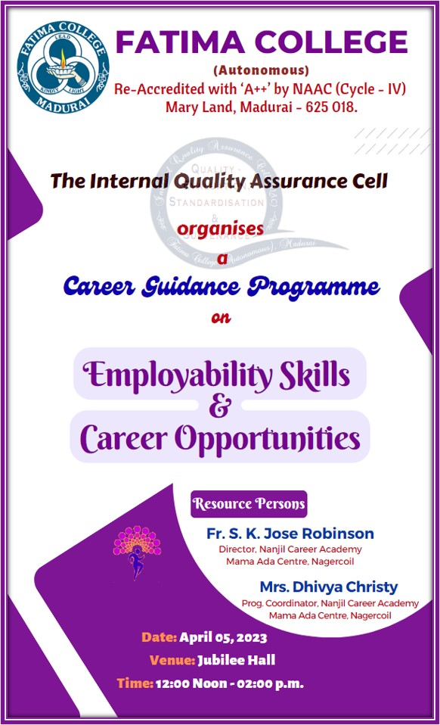
Report:
Career guidance programme was organised for the final year students of UG and PG programmes on April 5, 2023. The programme started with prayer followed by welcome address. Rev. Fr. Jose Robinson, Director of Nanjil Career Academy address the students on Employability skills. In his talk he highlighted all the skills a person should possess to achieve greater heights in life. He made the session more interesting and informative by screening suitable video clippings. Next session was handled by Mrs. Dhivya Christy, Programme coordinator, Nanjil Career Academy. She explored all career opportunities and the competitive exams through which a student can get job opportunities either in Government or in Private sectors. She also pointed out the probable month of conducting the exams. Students were motivated through these sessions and they clarified their doubts during the interactive session.
Photos:
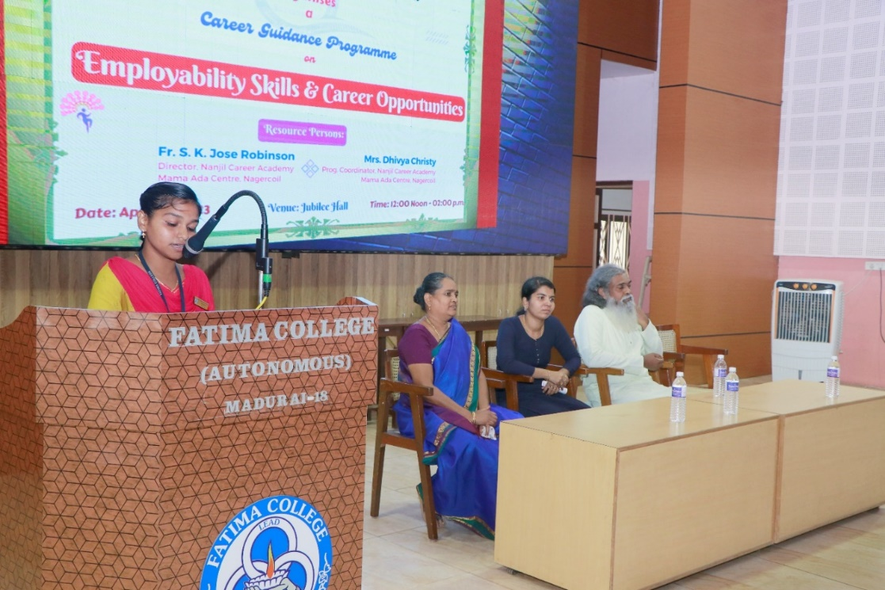
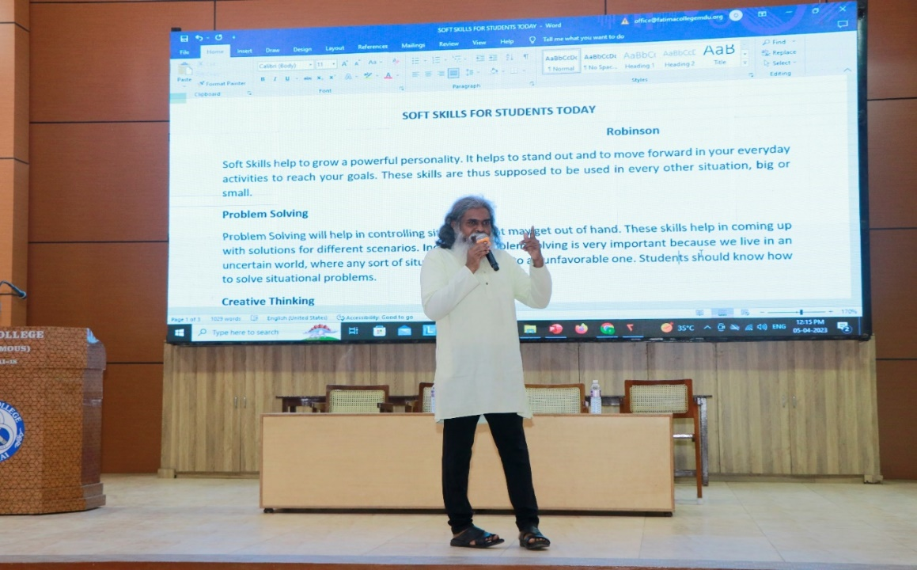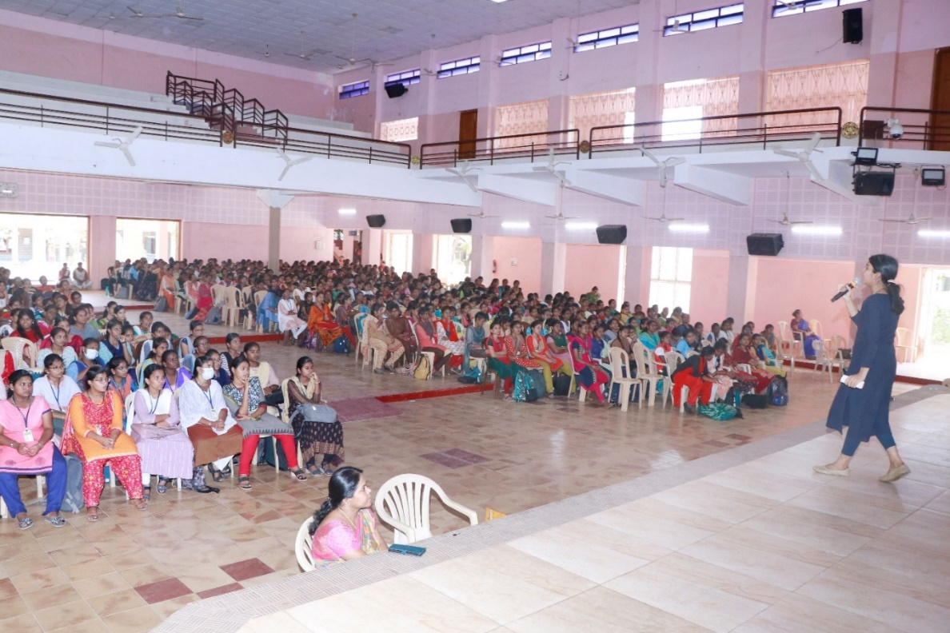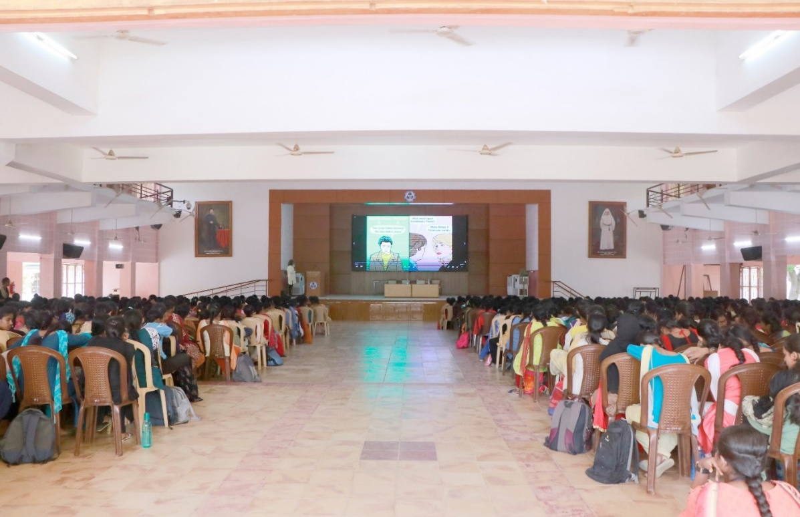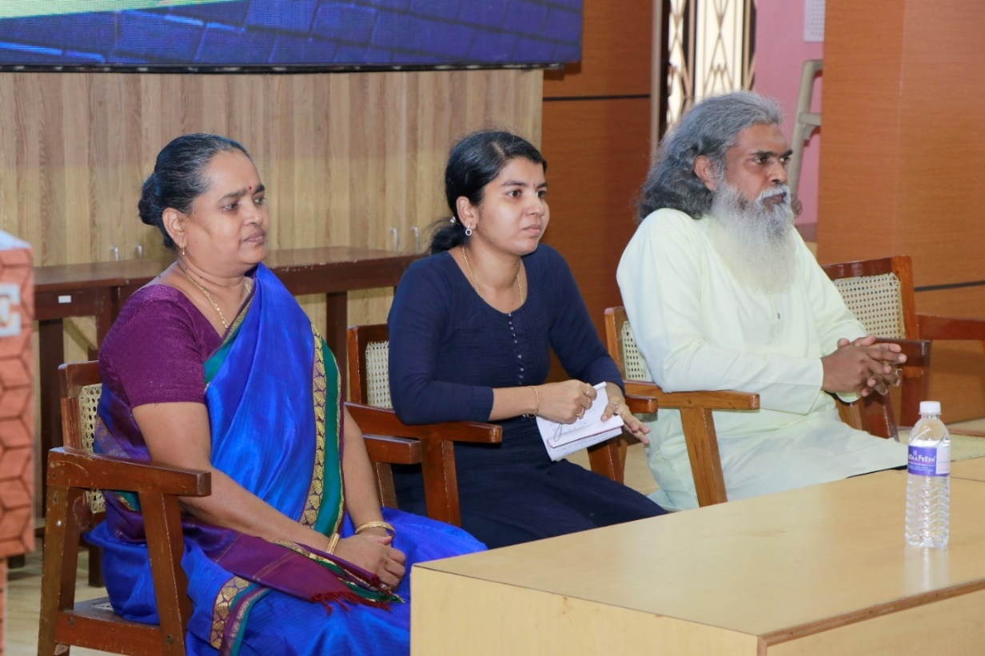

Attendance
Aided: 540

S. No. | Reg. No. | Students Name
 | 2021H01 | AISWARYA D
 | 2021H02 | ANTONY JEYA MONICA S
 | 2021H03 | ANUJA G
 | 2021H04 | ARO EUGINA J
 | 2021H05 | BALAMEENA S
 | 2021H06 | DANNIYA SELVA PRINCY P
 | 2021H07 | DHIVYA DHARSHINI M
 | 2021H08 | DURGA DEVI G
 | 2021H09 | HARINI BALASRI K V
 | 2021H10 | HARINI M
 | 2021H11 | HARITHA B
 | 2021H12 | HEMAAPRIYAA K
 | 2021H14 | ISHWARYA G
 | 2021H15 | ISWARYA A
 | 2021H16 | JANAKI PRIYA B
 | 2021H17 | JEEVA M
 | 2021H18 | KARPAGA ARUNA A
 | 2021H19 | KAYATHRI R
 | 2021H20 | KEERTHIKA S
 | 2021H21 | LOGAMALATHI R
 | 2021H22 | LOSHINI S
 | 2021H24 | NAGANJALI P
 | 2021H25 | PARVATHI K
 | 2021H26 | PRIYADHARSHINI P
 | 2021H29 | SAHITHA NASIN M
 | 2021H30 | SAKTHI MURUGESWARI B
 | 2021H31 | SHALINI LA
 | 2021H32 | SONIA P
 | 2021H33 | SOWMIYA R
 | 2021H35 | SUBHASHINI S
 | 2021H36 | TEENA MEKLIN I
 | 2021H37 | THARANI K
 | 2021H38 | VENI S
 | 2021H39 | VIDHYA P
 | 2021H40 | DHARSHINI P
 | 2021H41 | GOWRI M
 | 2021H42 | ADHITHYA K
 | 2021H43 | GAYATHRI P
 | 2021H44 | KAARTHIKA CS
 | 2021H45 | VARSHA M
 | 2021H46 | AMIRTHA N
 | 2021H47 | MAREESWARI A
 | 2021H50 | JOTHIKA M
 | 2021H52 | NITHIYA P
 | 2021H53 | JAYA HARINI S.K
 | 2021H54 | SANGEETHA M
 | 2021H55 | CELCIA B
 | 2021H56 | DIVYA M
 | 2021E01 | ABIRAMI K
 | 2021E02 | ABIRAMI S
 | 2021E04 | ANANDA PRIYA M
 | 2021E05 | ARSHUSAFORA W
 | 2021E06 | AYESHA FARHANA T
 | 2021E07 | BHANU REKKHA N
 | 2021E08 | BHUVANA SANGARI S
 | 2021E09 | BOOMIKA C
 | 2021E11 | GAYATHIRI B
 | 2021E12 | GAYATHRI A
 | 2021E13 | HARINI V
 | 2021E14 | HARSHINI S
 | 2021E15 | JAI SAKTHI G
 | 2021E16 | JUNAITH RESHMI R
 | 2021E17 | KALPANA K
 | 2021E18 | KAVIYA C
 | 2021E21 | LALITHA B
 | 2021E22 | LAVANYA S
 | 2021E23 | MAHALAKSHMI M
 | 2021E24 | MAMATHY CHARRY B
 | 2021E25 | MONISHA R
 | 2021E27 | NIKHILA SHIVANI K
 | 2021E28 | NIVETHITHA T
 | 2021E29 | PAVITHIRA M
 | 2021E31 | PRIYA DHARSHINI M
 | 2021E32 | RAJESWARI M
 | 2021E33 | RASHIKA M
 | 2021E34 | ROHINI B
 | 2021E35 | ROHINI D
 | 2021E36 | SAMA PRIYA M
 | 2021E37 | SANTHOSHIKA S
 | 2021E38 | SHIFANA BEGUM S
 | 2021E41 | SOBANA SRI G
 | 2021E42 | SRIJA P
 | 2021E44 | SUBHALAKSHMI M
 | 2021E45 | SUJEETHA S
 | 2021E46 | SWETHA K
 | 2021E47 | THENMOZHI G
 | 2021E48 | USHARANI N
 | 2021E49 | VARSHINI M
 | 2021E50 | VENCY A
 | 2021E51 | VIJAYALAKSHMI B
 | 2021E52 | VINOTHA R
 | 2021E53 | VIVEKA P
 | 2021E54 | YOGA DHARSHINI R
 | 2021E56 | NILOPERNISHA I
 | 2021E58 | APARNA J
 | 2021E59 | GAYATHRI S
 | 2021E60 | JERIN SHREEJA E
 | 2021E61 | KEERTHIKA K
 | 2021E62 | PANJAVARNAM D
 | 2021E63 | SANTHANA LAKSHMI K
 | 2021E64 | AISWARYA V
 | 2021E65 | BANUPRIYA L
 | 2021E66 | DEEPIKA P
 | 2021E68 | MANASA BRISKEY M
 | 2021E69 | SOWMIYA B
 | 2021E70 | MEENA P
 | 2021S01 | ABARAJITHA S
 | 2021S04 | BALAYUVALAKSHMI M
 | 2021S05 | BHUVANA DHARSHINI V
 | 2021S07 | CHENBAGA SREE M
 | 2021S08 | DEVADHARSHINI JJ
 | 2021S09 | DHIVYANJALI M
 | 2021S10 | DIVYA B
 | 2021S11 | GOWSALYA DEVI J
 | 2021S13 | HENA S
 | 2021S14 | JAAFRIN J
 | 2021S15 | JASHRA A
 | 2021S18 | KANISHKA VG
 | 2021S19 | KAVIYADHARSHINI G
 | 2021S22 | NITHIYA SREE M
 | 2021S23 | PRIYANKA K
 | 2021S25 | RAMYA R
 | 2021S26 | SANTHIYA S K
 | 2021S27 | SIVAPRIYADHARSHINI M
 | 2021S28 | SRINITHI V
 | 2021S29 | SUBEKSHANA P
 | 2021S30 | SUBITHA K
 | 2021S31 | SUJITHA N
 | 2021S32 | SUSANDHIKA K
 | 2021S33 | SUWETHA MS
 | 2021S35 | YUVASAKTHI V
 | 2021S37 | DEVA DHARSHINI M
 | 2021S39 | INDRA PRIYADHARSH S
 | 2021S40 | KEERTHIKA B
 | 2021S41 | SANGAVI C
 | 2021S44 | SRIDURGA G
 | 2021S45 | THEJA SHRI P
 | 2021S46 | VAITHEESWARI A
 | 2021S48 | MUTHURANI V
 | 2020S05 | AMRITHA SRI P (RE-JOIN FOR V & VI SEM.)
 | 2021L02 | ABHIRAMI S
 | 2021L03 | AKFEYA JEBIN K
 | 2021L04 | ANANCIA JESIKA A
 | 2021L05 | ASCENTANA PANIMALAR A
 | 2021L06 | ASHIKA A
 | 2021L07 | AYESHA S
 | 2021L08 | BARGAVI MM
 | 2021L11 | DHARANI P
 | 2021L12 | FARZANA PARVEEN A
 | 2021L13 | FELCY SEBAS G
 | 2021L14 | GAYETHRI S
 | 2021L15 | GEETHA M
 | 2021L16 | HELIN MALAR A
 | 2021L17 | HEMA PRIYA S
 | 2021L18 | JANANI SRI A
 | 2021L19 | JANE ROSE PAULINE A
 | 2021L20 | JAYA DHARSHENI T
 | 2021L21 | JEEVITHA V
 | 2021L22 | JEFFRIN JUSTICE MARIYA A
 | 2021L23 | JENCY ALEXIA A
 | 2021L25 | MARIYA VARSHNI A
 | 2021L26 | MEGALA G R
 | 2021L30 | RACHEL MIRIYAM A
 | 2021L31 | RACHEL S
 | 2021L32 | RANJITHA S
 | 2021L33 | RENUGA R
 | 2021L34 | SAHAYA BABILA ROSE R
 | 2021L35 | SAHAYA RANI A
 | 2021L36 | SAHAYA ROMILDA C
 | 2021L38 | SELVA INISHA T
 | 2021L39 | SHARMILA DEVI K
 | 2021L40 | SHOBANA P
 | 2021L42 | SOWMIYA LAKSHMI P
 | 2021L46 | VAISHNAVI P M
 | 2021L48 | VANATHI A
 | 2021L49 | YAZHINI TERASA S
 | 2021L50 | CHITHRA DEVI ALIAS JANANI J
 | 2021L51 | DEEPALAKSHMI S
 | 2021L52 | DIVYA A
 | 2021L53 | FATHIMA UMAIYA A
 | 2021L54 | PETHA PRAMILA A
 | 2021L55 | SILAMBU SELVI K
 | 2021L57 | BOOMIKA R
 | 2021L58 | KARTHIGAYINI S
 | 2021L59 | SUBHASHINI J.
 | 2021L60 | ANANTHI J
 | 2021L61 | ASIYA PARVEEN KHAN A
 | 2021L62 | ABIRAMI T S
 | 2021T01 | AARTHI P
 | 2021T02 | ABINAYA M
 | 2021T03 | ABIRAMI R
 | 2021T04 | ANANDHASWATHI A
 | 2021T05 | AROCKIA JOSPHINE D
 | 2021T08 | DHARANI T
 | 2021T09 | DHARSHINI K
 | 2021T10 | DIVYA K
 | 2021T11 | GOWRI T
 | 2021T12 | GRACY ANGEL R
 | 2021T13 | HEMALATHA M
 | 2021T15 | JERMAN VINONCIYA S
 | 2021T17 | KAVITHA M
 | 2021T18 | KAVIYA K
 | 2021T19 | KRISHNA PRIYA R
 | 2021T20 | KRISHNAVENI V
 | 2021T21 | LOGESHWARI T
 | 2021T23 | MUTHULAKSHMI V
 | 2021T24 | NAGARATHINAM N
 | 2021T25 | NIRMALA DEVI A
 | 2021T27 | NISHANTHINI R
 | 2021T28 | POOJA P
 | 2021T30 | RAJESHWARI E
 | 2021T31 | REBAKA R
 | 2021T32 | SARITHA K
 | 2021T33 | SATHIYA C
 | 2021T34 | SELVI P
 | 2021T36 | SOWMIYA A
 | 2021T38 | VINOTHA J
 | 2021T39 | YOGALAKSHMI B
 | 2021T42 | HARSHINI S
 | 2021T43 | KAMATCHI MONISHA K
 | 2021T44 | MAHALAKSHMI P
 | 2021T46 | PARVIN D
 | 2021T48 | YOGASHREE K
 | 2021T50 | MOHANASATHIYA U
 | 2021T52 | SIVARANJANI P
 | 2021T53 | VEERASUNDARI P
 | 2021T54 | YOGALAKSHMI M
 | 2021T56 | PADMA S
 | 2021T57 | ABINAYA C
 | 2021T58 | GEETHA G
 | 2021T59 | THASLIMA BANU S
 | 2021T60 | DEVADHARSHINI B
 | 2021T62 | SAHIRABANU J
 | 2021T63 | YOGESHWARI S
 | 2021T64 | NIRANJANA S
 | 2021T65 | ILAKKIYA M
 | 2021T67 | BHUVANESWARI G
 | 2021M01 | AASHIYA BEGUM M
 | 2021M02 | ABIRAMI K
 | 2021M05 | ARUL ANANTHINI A
 | 2021M08 | BENAZEER ASSLIN A R
 | 2021M09 | BRINDHA CELIN A H
 | 2021M10 | DELYS MARITA D
 | 2021M13 | HEMAPRIYA K
 | 2021M14 | JASMINE J
 | 2021M18 | JEBIRA M
 | 2021M19 | JERLIN JOSHI A
 | 2021M21 | JOICY K
 | 2021M22 | KANNIKA PARAMESWARI B
 | 2021M23 | KARUNYA K
 | 2021M25 | MAHA LAKSHMI A
 | 2021M26 | MAHA LAKSHMI S
 | 2021M28 | MERIL SNOWSY R
 | 2021M29 | MINU DURGA P
 | 2021M31 | MUTHU MEENA A
 | 2021M32 | NANDINI SAROJ J
 | 2021M34 | NOVOMI JOES TRIFFINA J
 | 2021M35 | PAVITHRA N
 | 2021M37 | PRADEEPA N
 | 2021M39 | PUSHPA SWETHA A
 | 2021M40 | REENASHREE V
 | 2021M42 | ROSELIN PRIYATHARSHINI G
 | 2021M43 | SANTHANA MARI K
 | 2021M44 | SANTHIYA ALIAS ASWINI G
 | 2021M45 | SIVASAKTHI J
 | 2021M46 | SIVASHREE D
 | 2021M47 | SOWNDARYA B
 | 2021M49 | SUGHASINI C
 | 2021M50 | SUJITHA C
 | 2021M52 | SWETHA R
 | 2021M53 | USHA NANDHINI R
 | 2021M54 | VASUKI A
 | 2021M55 | VENCY B
 | 2021M56 | VINCY M
 | 2021M58 | YOHAVI R
 | 2021M59 | ASHMITHA VENI N
 | 2021M60 | JEYA ROSHINI S
 | 2021M61 | DEPANCY C
 | 2021M63 | LOHITHAYAZHINI P N
 | 2021M64 | RISHI PRIYA B
 | 2021M65 | SONIYA I
 | 2021M66 | SUGASHREE P
 | 2021M67 | RENSILIBIYA A
 | 2021M68 | LAKSHMI J
 | 2021M69 | VIJI M
 | 2021M70 | JANANI M
 | 2021P01 | AARTHI T
 | 2021P02 | ABINAYA SRI U
 | 2021P03 | ABIRAMI M
 | 2021P04 | ANUJA S
 | 2021P06 | BAVANI M S
 | 2021P07 | CYNTHIAA L
 | 2021P08 | DHANA SRI V
 | 2021P09 | DHANANEE R
 | 2021P10 | DHARSHINI V
 | 2021P11 | ESAKKIYAMMAL K
 | 2021P12 | JASMINE SAHAY OVIYA S
 | 2021P14 | JERLIN E
 | 2021P15 | JOYLIN DHARSHINI C
 | 2021P18 | KAREN BEAULAH ROSE S
 | 2021P19 | KARISHMA BHARGAVI R
 | 2021P20 | KEERTHANA K
 | 2021P22 | M HARINI
 | 2021P23 | MAHALAKSHMI D
 | 2021P24 | MARIA ROSELIN RANI B
 | 2021P25 | MARIAM JAMILA S
 | 2021P26 | MATHIYALINI V
 | 2021P27 | MONICKA SELESTIN A
 | 2021P29 | PRADEEPA S
 | 2021P31 | ROFFINA E
 | 2021P32 | ROOPA ROSLIN S
 | 2021P33 | SAHANA PARVIN M
 | 2021P34 | SARU MATHI C
 | 2021P35 | SHARINA JOE KATHRIN A
 | 2021P36 | SOFIYA DEVI K
 | 2021P37 | SREETHI JINANI RAJ M
 | 2021P38 | SRI DEVI U
 | 2021P39 | SWAATHY B
 | 2021P40 | THAIS J
 | 2021P41 | VEERA PANDEESWARI S
 | 2021P42 | ABIRAMI P.R.
 | 2021P43 | SOBHIYA ANBARASI K
 | 2021P44 | SWATHI R
 | 2021P45 | PATHUVA STRELIN T
 | 2021P46 | ABOORVA LAKSHMI D
 | 2021P47 | KAVIYA M
 | 2021P49 | SHALINI B
 | 2021C01 | AGNES MARY A
 | 2021C02 | AMUDHA A
 | 2021C04 | BHAVADHARANI M
 | 2021C05 | CAROLINE FABINAA N
 | 2021C06 | CHERIN PRINCY V
 | 2021C07 | CRISPIN VIRGILA A
 | 2021C08 | DHARANI S
 | 2021C09 | DHARSHINI M
 | 2021C10 | DINA MAGLIN G
 | 2021C12 | DURGA DEVI B R
 | 2021C13 | DURGALAKSHMI C
 | 2021C16 | HARISHMA T
 | 2021C17 | HENCY LISHA M
 | 2021C18 | INFANT HEVEENA C
 | 2021C19 | JAFRINA BARVIN Z
 | 2021C20 | JANIKA M
 | 2021C21 | MAHA LAKSHMI G
 | 2021C22 | MAHESWARI S
 | 2021C23 | MUTHUPRIYA M
 | 2021C24 | P NIVETHA
 | 2021C25 | PAVITHRA R
 | 2021C26 | PAVITHRA V
 | 2021C27 | PRIYANKA P
 | 2021C28 | RAJASRIARASI G
 | 2021C29 | RITIKA S
 | 2021C30 | RIYASHINI S
 | 2021C31 | RONICA ALICE J
 | 2021C33 | SHINISHA BRIJET D
 | 2021C34 | SILPAL P
 | 2021C35 | SUBHANIYA PARVEEN S
 | 2021C37 | UDAYA TERESA F
 | 2021C38 | VAISHNAVI R
 | 2021C39 | VANATHI K
 | 2021C40 | VINOTHINI R
 | 2021C41 | VISHALINI A (05.01.2004)
 | 2021C42 | VISHALINI A (03.03.2004)
 | 2021C43 | SAHAYA SHERLY JOICE J
 | 2021C44 | DHAROSHINI M
 | 2021C45 | RENUKA DEVI R
 | 2021C46 | SHIVA RANJANI P
 | 2021C47 | SWETHA B
 | 2021C48 | CATHERIN SIBA J
 | 2021Z01 | ABISRI M
 | 2021Z02 | AMIRTHAVARSHINI S
 | 2021Z04 | BRINDHA S
 | 2021Z05 | DAISY DAYANA J
 | 2021Z06 | GAYATHRI M
 | 2021Z08 | JOTHI PRIYA M
 | 2021Z10 | SUSMITHA K
 | 2021Z11 | KAREN S
 | 2021Z14 | NAGAJOTHI S
 | 2021Z16 | RAHILA BANU S
 | 2021Z19 | SELVI E
 | 2021Z20 | SETHU RAMYA M
 | 2021Z21 | SHANMATHY S
 | 2021Z22 | SNEKA A
 | 2021Z24 | SUBANU S
 | 2021Z25 | VASHNI ABIYA J
 | 2021Z26 | YAZHINI S
 | 2021Z27 | YUVATHI S
 | 2021Z28 | VARSHINI G
 | 2021Z30 | BHAVANI K
 | 2021Z31 | HARINI K
 | 2021Z32 | NARMATHA M
 | 2021Z33 | PANDI SELVI M
 | 2021Z34 | SANGEETHA P
 | 2021Z35 | SANTHIYA M
 | 2021Z36 | SINDHUJA C
 | 2021Z37 | SRIRATHI NANDHIJA M
 | 2021Z38 | VIYAGULA DEEPTHI D
 | 2021Z42 | S SUREKHA
 | 2021Z43 | ANITHA C
 | 2021Z45 | DHANAMAYILPRIYA S
 | 2021Z46 | RINSI A
 | 2021Z47 | MATHAVA PRIYA B
 | 2021Z49 | YUVARANI K
 | 2021Z50 | PREETHA S
 | 2019Z02 | ANUMITHA S (RE-JOIN FOR V & VI SEM.)
 | 2021N01 | ABIRAMI S
 | 2021N02 | AKSHAYA N
 | 2021N03 | AMIRTHAVARSHINI R
 | 2021N04 | ANITHA B
 | 2021N05 | AROCKIA VINCY M
 | 2021N06 | ASHIMA GEO A
 | 2021N07 | BARGANA S
 | 2021N11 | HEMAPRAMEELA R
 | 2021N12 | JASILIYA QUEEN M
 | 2021N13 | JEYAVEERALAKSHMI K
 | 2021N15 | LINCY S
 | 2021N16 | MAHALAKSHMI P
 | 2021N17 | NAGA SHREE S
 | 2021N19 | NASRIN SARIFA S
 | 2021N20 | P GNANA SUJA
 | 2021N21 | PRADEEPA M
 | 2021N23 | RAJALAKSHMI M
 | 2021N24 | RENUKHA BE
 | 2021N26 | THIRISHA K
 | 2021N30 | NIVETHA K
 | 2021N31 | SATHYA PRIYA C
 | 2021N32 | SWATHI V
 | 2021N34 | KEERTHIGA R (NOT ELIG. TO WRITE III SEM.)
 | 2021N36 | VIJAYA PRIYA S
 | 2021N39 | FARGANA THASLIMA S
 | 2021N41 | AYESHA NAUFA A S
 | 2021B01 | AKSHAYA M
 | 2021B02 | AKSHAYA S
 | 2021B03 | AMALI JESINA S
 | 2021B05 | ANSHIKA A
 | 2021B06 | ANTHIYA S
 | 2021B07 | ANTO MULLAR WILLMA J
 | 2021B08 | ASIYA H
 | 2021B09 | B JUDITH ASLIN SWARNA
 | 2021B11 | BRINDHA A
 | 2021B12 | CATHEREN CHRISTINA A
 | 2021B13 | CHRISMA SIRUMANI A
 | 2021B14 | DANUJA SREE S
 | 2021B15 | DHIVYA S
 | 2021B16 | DONA BRITTES S
 | 2021B17 | GURU DHARSHINI N
 | 2021B18 | HELEN W
 | 2021B19 | HELVIN AMALA PRABA S
 | 2021B22 | JEY SHREE BOOMIKA T
 | 2021B23 | JOE MARTINA A
 | 2021B24 | KAVIPRIYA S
 | 2021B26 | LINCYMARIYA T
 | 2021B27 | LOGALAKSHMI D
 | 2021B28 | MAANASHA T K
 | 2021B29 | MARIA AMALA SHREE M
 | 2021B30 | MARTINA SHAMIL J
 | 2021B31 | MEENAKSHI R
 | 2021B32 | NIVETHA A
 | 2021B33 | PAVITHRAA P
 | 2021B34 | PRAKASHA DEEPIKA I
 | 2021B35 | PREETHI RIKSHI S
 | 2021B36 | RENISHA J S
 | 2021B37 | RENUGA DEVI S
 | 2021B38 | THANGAMEENA R
 | 2021B39 | THARANGNI GR
 | 2021B40 | THIRISHA P
 | 2021B41 | DURGA M
 | 2021B42 | NAGA RAMYA M
 | 2021B43 | DHARSHINI K
 | 2021B44 | ALAGU MANI B
 | 2021B45 | DHARANI B
 | 2021B46 | PRIYADHARSHINI A
 | 2021B47 | SWETHA V
 | 2021A01 | AANANDABHAIRAVEE S
 | 2021A02 | ABINAYA S
 | 2021A04 | ANGELIN BLESSY BASTINA H
 | 2021A05 | AROCKIA SAHAYA MERCY M
 | 2021A06 | AROCKIYA LINCY M
 | 2021A07 | ASMITHA MRB
 | 2021A08 | ASREEKA S
 | 2021A09 | BEATIN NIVISHA X
 | 2021A10 | BHARGAVI C
 | 2021A11 | BHUVANESHWARI V
 | 2021A12 | BRITINY J
 | 2021A13 | CARLIN LINCY L
 | 2021A14 | DARTHY E
 | 2021A15 | DEEPIKA G
 | 2021A16 | DEEPIKA G
 | 2021A17 | DEEPSI R
 | 2021A18 | FEMI NISHA R
 | 2021A19 | FLORENCE BENCY M
 | 2021A20 | GAYATHRI C
 | 2021A21 | HARINI M
 | 2021A22 | HARSHINI A
 | 2021A23 | HEARTY VERGINA A
 | 2021A24 | JERIN PRAVEENA P
 | 2021A25 | JEYA ANGEL G
 | 2021A26 | JULIA SHEREN S
 | 2021A27 | KEERTHANA K
 | 2021A28 | KEERTHI M
 | 2021A30 | LATHIKA K
 | 2021A31 | LINDA MARY A
 | 2021A32 | MAHIMA T
 | 2021A33 | MALAR S
 | 2021A34 | MALINI R
 | 2021A35 | MELONY INFANTA M
 | 2021A38 | MOTCHA YAZHINI F X
 | 2021A39 | NANCY M
 | 2021A40 | NIVASHINI M
 | 2021A41 | NIVEDHA N
 | 2021A42 | NIVETHA MEENATCHI S
 | 2021A43 | PRISHILA A
 | 2021A44 | PRIYA M
 | 2021A45 | RAKSHANA R
 | 2021A46 | RAMU T
 | 2021A48 | REMI JASMINE S
 | 2021A49 | RESHMAA S
 | 2021A50 | ROSLINE S
 | 2021A52 | SAHAYA SINTHIYA J
 | 2021A53 | SALETH MOXLIN J
 | 2021A54 | SAMATHANA PRINCY S
 | 2021A55 | SANGEETHA P
 | 2021A56 | SANGITA C
 | 2021A57 | SATHYAGAYATHRI S
 | 2021A58 | SHERLI A P
 | 2021A59 | SIRILLA JERSHILIN J
 | 2021A61 | SUSHRUTHA J
 | 2021A62 | SWATHIKA K
 | 2021A63 | TEPHILA FERNANDO L
 | 2021A64 | VINCY LOURTHU KALA S
 | 2021A65 | VINOFIA ARO JONES J
 | 2021A66 | KEERTHANA G
 | 2021A67 | ROSELIN SHEEBHA S
 | 2021A68 | SAHAYA NISHA A
 | 2021A69 | VIGNESHWARI K
 | 2021A70 | MUTHU LAKSHMI M
 | 2021A71 | LAVANYA M
 | 2021A72 | MUTHULAKSHMI M
 | 2021A73 | PREETHI P
 | 2021A74 | VIVEKA K

Self-Finance:424

S. No. | Reg.No. | Name
BBA
 | 2021BB01 | Aaisha Nihad S
 | 2021BB02 | Anancia Janet A
 | 2021BB03 | Ashaparveen N
 | 2021BB04 | Ashwini Jain P
 | 2021BB05 | Aysara Naginin N
 | 2021BB06 | Deepika K
 | 2021BB07 | Dhanushree J
 | 2021BB08 | Dhivya Prabha K
 | 2021BB09 | Divyabharathi M
 | 2021BB11 | Divya R
 | 2021BB12 | Gopika K
 | 2021BB14 | Harithaarani M
 | 2021BB15 | Jaishivalini G
 | 2021BB17 | Javitha Hasmath S H
 | 2021BB18 | Jaya Varshini S
 | 2021BB19 | Keerthana M
 | 2021BB20 | Kiruthikkaa M
 | 2021BB21 | Krishna O
 | 2021BB22 | Lavanya K
 | 2021BB23 | Madhumitha P
 | 2021BB25 | Meghna Rajeev
 | 2021BB26 | Muthuselvi G
 | 2021BB27 | Naga Muhilini T
 | 2021BB28 | Nagananthithaa S
 | 2021BB29 | Nandhana S
 | 2021BB30 | Nandhitha R
 | 2021BB31 | Nisha R
 | 2021BB32 | Nithya Sri S
 | 2021BB33 | Nithyashree S
 | 2021BB34 | Pabitha K
 | 2021BB35 | Pandi Meena M
 | 2021BB37 | Pon Ananya V
 | 2021BB38 | Raaghavi S
 | 2021BB39 | Rajashree R
 | 2021BB40 | Rajeswari K
 | 2021BB41 | Ramya K
 | 2021BB44 | Roobini K
 | 2021BB45 | Samuqtha B
 | 2021BB46 | Santhiya B
 | 2021BB47 | Santhiya R
 | 2021BB48 | Shalini M
 | 2021BB49 | Sridharshini M
 | 2021BB50 | Suba Shree R
 | 2021BB51 | Suganya R
 | 2021BB52 | Sujaa S
 | 2021BB53 | Swathi V
 | 2021BB54 | Swetha B
 | 2021BB56 | Thilagavathi E
 | 2021BB57 | Uma Priya P
 | 2021BB59 | Yazhini B
 | 2021BB60 | Yuva Shree K
 | 2021BB61 | Arthi S V
 | 2021BB63 | Harini Priya M
 | 2021BB64 | Harini R
 | 2021BB65 | Priyadharshini P
 | 2021BB66 | Saumiya P
 | 2021BB67 | Varshini R
 | 2021BB68 | Sheetal D Patel
 | 2021BB69 | Santhiya J
 | 2021BB70 | Suhashini S
 | 2021BB71 | Shalini D
B.A. English
 | 2021LB01 | Aasima S
 | 2021LB02 | Alagu Meenakshi M
 | 2021LB03 | Annapooranam M
 | 2021LB05 | Arockia Aswitha S
 | 2021LB06 | Bharathi B
 | 2021LB07 | Charumathy R
 | 2021LB09 | Deva Dharsini S
 | 2021LB12 | Hajira Rockkya Jalwa M
 | 2021LB13 | Harini R
 | 2021LB14 | Harini Sri R
 | 2021LB16 | Harunya G
 | 2021LB17 | Jehoshimah G
 | 2021LB18 | Jenefa Sharon J R
 | 2021LB21 | Kalainaya Rajeswari J
 | 2021LB22 | Kamatchi Gayathri T
 | 2021LB23 | Karthika V
 | 2021LB24 | Keerthana V
 | 2021LB25 | Mahesha S
 | 2021LB26 | Merlin Soffia M
 | 2021LB27 | Mubeena M
 | 2021LB28 | Mufritha N
 | 2021LB29 | Mutharasi B
 | 2021LB31 | Naga Nandhini N
 | 2021LB32 | Naganithila A
 | 2021LB36 | Ragavi S
 | 2021LB37 | Rebecca Premilla R
 | 2021LB40 | Roshni S
 | 2021LB41 | Sahana G
 | 2021LB42 | Samreen Anjum E S
 | 2021LB43 | Saniyah Anjum E S
 | 2021LB44 | Shiny Rosani R
 | 2021LB45 | Shruthy J
 | 2021LB49 | Srikayathri N
 | 2021LB50 | Subhasri Krishnaa M G
 | 2021LB51 | Varshini Mala S A
 | 2021LB52 | Vinothini Sri M
 | 2021LB53 | Aarthy V
 | 2021LB54 | Anju K
 | 2021LB55 | Divya Dharani R
 | 2021LB56 | Janani S
 | 2021LB57 | Jeya Shree A
 | 2021LB58 | Keerthika S
 | 2021LB59 | Mercymmal M
 | 2021LB60 | Priya Dharshini T
 | 2021LB63 | Vaishnavi A
 | 2021LB64 | Varshini K
 | 2021LB69 | Renoz Fathima A
 | 2021LB70 | Sunmithra M
 | 2021LB71 | Devisagupraka R
B.A. J&M.C
 | 2021JM01 | Aishwarya V
 | 2021JM02 | Dharani A
 | 2021JM03 | Harini D
 | 2021JM04 | Kaviya M
 | 2021JM05 | Mathina K
 | 2021JM06 | Meena K
 | 2021JM09 | Swarna Meena R
 | 2021JM10 | Vinothini M
 | 2021JM12 | Kavitha C
 | 2021JM13 | Sarumathi V
 | 2021JM14 | Amreen S
 | 2021JM16 | Joycilin Soosan N.A
 | 2021JM17 | Amrin M
 | 2021JM18 | Sriharini S
 | 2021JM19 | Divya Bharathi R
B.Sc Maths A
 | 2021MB01 | Abirami R
 | 2021MB02 | Anitha P
 | 2021MB03 | Ashuruthi M.
 | 2021MB04 | Avaidhaa Sarojini A M
 | 2021MB05 | Deepika V
 | 2021MB06 | Dhaarmini M S I
 | 2021MB07 | Dharanisri N
 | 2021MB08 | Dharshini S
 | 2021MB09 | Hemapathi C
 | 2021MB12 | Jegadeeswari B
 | 2021MB13 | Kalpana K
 | 2021MB14 | Karishma S
 | 2021MB16 | Keerthiga S
 | 2021MB17 | Kisha Penni T
 | 2021MB18 | Lakshmi S
 | 2021MB19 | Mahalakshmi @ Aruna S
 | 2021MB20 | Maheswari V
 | 2021MB21 | Mohana Supriya A
 | 2021MB22 | Monisha K
 | 2021MB23 | Murugeshwari G
 | 2021MB24 | Nasreen Nilopher J
 | 2021MB25 | Nivethitha T
 | 2021MB26 | Pradhikshaa M
 | 2021MB27 | Praveena D
 | 2021MB28 | Priyadharshini P S
 | 2021MB29 | Ramya V
 | 2021MB30 | Ranjani K S
 | 2021MB31 | Rinthiya S
 | 2021MB34 | Shanmuga Priya K
 | 2021MB35 | Shobikashri S
 | 2021MB36 | Shuruthi M
 | 2021MB37 | Sneha N
 | 2021MB39 | Sudharshana Priya S
 | 2021MB40 | Sujitha M
 | 2021MB41 | Sumithra M
 | 2021MB42 | Swetha S
 | 2021MB43 | Syed Asmitha H
 | 2021MB45 | Varsha M
 | 2021MB46 | Varshini M
 | 2021MB47 | Varshini V
 | 2021MB48 | Viji E
 | 2021MB50 | Yuva Dharshini M
 | 2020MB92 | Thanga Meenakshi N
B.Sc Maths B
 | 2021MB51 | Ajitha S
 | 2021MB52 | Aparna S
 | 2021MB53 | Atchaya B S
 | 2021MB56 | Deepika A
 | 2021MB57 | Devadharshini T
 | 2021MB60 | Dhurgga Dharshini M
 | 2021MB61 | Firthous A
 | 2021MB62 | Ishwarya J
 | 2021MB63 | Jayasri M
 | 2021MB65 | Kanchana S
 | 2021MB66 | Karthiga N
 | 2021MB67 | Kavitharshini T
 | 2021MB69 | Lakshmipriya A
 | 2021MB71 | Maha Alagumathi J
 | 2021MB73 | Muneeswari I
 | 2021MB74 | Nagarathinam S
 | 2021MB76 | Poornima E
 | 2021MB77 | Pragatheeswari K
 | 2021MB79 | Ragavi C
 | 2021MB80 | Riswana Parveen T
 | 2021MB81 | Rubadharshini V
 | 2021MB82 | Selva Praja V
 | 2021MB83 | Shobika M
 | 2021MB85 | Siva Meera R
 | 2021MB87 | Sonashree S R
 | 2021MB90 | Sujitha V
 | 2021MB91 | Suvitha M
 | 2021MB92 | Swetha S
 | 2021MB93 | Vanisha R
 | 2021MB95 | Vishvamahalakshmi M
 | 2021MB96 | Noor Mymoon M
 | 2021MB97 | Rajapriya V
 | 2021MB98 | Sarmila S
 | 2021MB99 | Jayam Shivashangari K
 | 2021MB100 | Abirami R
 | 2021MB101 | Hema M
 | 2021MB102 | Pamina J
 | 2021MB103 | Madhumitha M
 | 2021MB104 | Surekha C
 | 2021MB105 | Vidhya Sree P
 | 2021MB106 | Ramchitra R
 | 2021MB107 | Sowmiya R
 | 2021MB108 | Durgadevi R
 | 2021MB109 | Mohanapriya A
 | 2021MB110 | Thasbiha Banu A
 | 2021MB111 | Vishnupriya M
B.Sc Statistics
 | 2021ST01 | Agashiya Jasmine J C
 | 2021ST02 | Angel Refana S
 | 2021ST03 | Aparna P
 | 2021ST04 | Backiya Lakshmi K
 | 2021ST05 | Dharani P
 | 2021ST06 | Gladies Regininal A
 | 2021ST07 | Gowreeshwari K
 | 2021ST08 | Harini N
 | 2021ST09 | Hemalakshmi S
 | 2021ST10 | Joice Jersha Mary B J
 | 2021ST11 | Monisa A
 | 2021ST13 | Nandhini K
 | 2021ST14 | Rithika M S
 | 2021ST15 | Sahirabanu A
 | 2021ST16 | Sakthi Haasini R
 | 2021ST19 | Vasuntra M
 | 2021ST21 | Kaleeswari K
 | 2021ST22 | Durga Devi V
 | 2021ST23 | Sangavi M
 | 2021ST25 | Olier Mathi R
 | 2021ST26 | Abigayel V
 | 2021ST27 | Sneha G
 | 2021ST28 | Teenusha D
B.Sc IT
 | 2021IT01 | Aarthisreetha K
 | 2021IT02 | Akchaya J
 | 2021IT03 | Amirthavarshini R
 | 2021IT04 | Angala Esuwari S
 | 2021IT05 | Anisha N
 | 2021IT06 | Archana K
 | 2021IT07 | Aruna M
 | 2021IT08 | Booma K
 | 2021IT09 | Chithra A
 | 2021IT10 | Christina Nivetha JJ
 | 2021IT12 | Divya Dharshini S
 | 2021IT14 | Infant Namitha A
 | 2021IT15 | Jenithapriyadharshini K
 | 2021IT16 | Kavisri S
 | 2021IT19 | Kreeshma K
 | 2021IT20 | Monika V
 | 2021IT21 | Nagalakshmi K
 | 2021IT22 | Nagammai S
 | 2021IT23 | Nivetha R
 | 2021IT24 | Parivarthini S
 | 2021IT25 | Poornima A
 | 2021IT26 | Preethi V
 | 2021IT27 | Sankareswari V
 | 2021IT28 | Sarumathi S
 | 2021IT29 | Shahin Barhana P
 | 2021IT30 | Shanofin Azmi B
 | 2021IT32 | Sharumathy R
 | 2021IT33 | Sherin Aathifa S
 | 2021IT34 | Shri Abishini M G
 | 2021IT35 | Soniya R
 | 2021IT36 | Sowmiya Sri T
 | 2021IT37 | Sri Varshini T N
 | 2021IT38 | Subha Sri B
 | 2021IT39 | Supraja R
 | 2021IT40 | Supraja V
 | 2021IT41 | Suruthikesh S
 | 2021IT42 | Swathi R C
 | 2021IT43 | Thanika Devi K
 | 2021IT44 | Thirishika G
 | 2021IT45 | Viveka N R
 | 2021IT46 | Nagakeshika G
 | 2021IT47 | Shara Afrin M
 | 2018IT24 | Mohana T M
BCA
 | 2021BC01 | Aashna Roshini R
 | 2021BC03 | Amala Renitha B
 | 2021BC04 | Asna J
 | 2021BC05 | Carolin Mercy L
 | 2021BC06 | Divya M
 | 2021BC07 | Durgarajeswari R
 | 2021BC08 | Durgeshwari S
 | 2021BC09 | Fazlina Z
 | 2021BC11 | Induja P T
 | 2021BC12 | Jeya Dharshini J
 | 2021BC13 | Jeya Praba T
 | 2021BC14 | Jeyalakshmi R
 | 2021BC15 | Kanimozhi S
 | 2021BC16 | Karthika P
 | 2021BC17 | Karthiyayeni N
 | 2021BC18 | Kavipriya M
 | 2021BC19 | Kavitha K
 | 2021BC20 | Mahadharshini R
 | 2021BC21 | Masani Malathi S
 | 2021BC22 | Meera Priyadharshini S
 | 2021BC23 | Midhuna S
 | 2021BC24 | Nagameenalokchini P
 | 2021BC25 | Narmadhadevi M
 | 2021BC26 | Niroshini R
 | 2021BC27 | Pavithra J T
 | 2021BC28 | Preethi R A
 | 2021BC30 | Samyuktha J
 | 2021BC31 | Shanmugapriya S
 | 2021BC32 | Sreenithi G
 | 2021BC33 | Subathra B
 | 2021BC34 | Swetha K
 | 2021BC35 | Thillai Indhu T
 | 2021BC36 | Vincily Mol V
 | 2021BC37 | Keerthi M
 | 2021BC38 | Linga Sneha M
 | 2021BC40 | Mathi S
 | 2021BC41 | Nivetha R
 | 2021BC42 | Sowbarnika M
 | 2021BC43 | Suthanthiradevi S
 | 2021BC44 | Gayathiri M
 | 2021BC45 | Aparnaa K
B.Com CA
 | 2021AB01 | Abinaya V
 | 2021AB02 | Agnes Minnu J
 | 2021AB03 | Akshaya G
 | 2021AB05 | Belsi Renitta Lucy A
 | 2021AB06 | Bhuvaneswari N
 | 2021AB08 | Eswari R
 | 2021AB09 | Farjana J
 | 2021AB10 | Gayathiri S
 | 2021AB11 | Idhaya S
 | 2021AB12 | Ilakiyasree I
 | 2021AB14 | Kalyani S
 | 2021AB15 | Karthigai Selvi M
 | 2021AB17 | Mahalakshmi B
 | 2021AB18 | Monika Evanjalin S
 | 2021AB19 | Muthupriya C
 | 2021AB20 | Priyadharshini B
 | 2021AB21 | Ramya J
 | 2021AB22 | Reena Mary A
 | 2021AB23 | Renetta P
 | 2021AB24 | Rosita Jenifer J
 | 2021AB25 | Sadhana B
 | 2021AB27 | Selciya Mary J
 | 2021AB28 | Sowmiya J
 | 2021AB29 | Suba Shree P
 | 2021AB30 | Suvitha R
 | 2021AB31 | Thriksha Janipher P
 | 2021AB32 | Tina Christina L
 | 2021AB33 | Vidya Lakshmi S K
 | 2021AB34 | Vijitha Priya P
 | 2021AB35 | Vishnupriya G
 | 2021AB36 | Amirtha Varshini M
 | 2021AB37 | Harini S
 | 2021AB38 | Srikanitha C
 | 2021AB40 | Geetha S
 | 2021AB42 | Karpaga Poorani K G
 | 2021AB43 | Koushika H

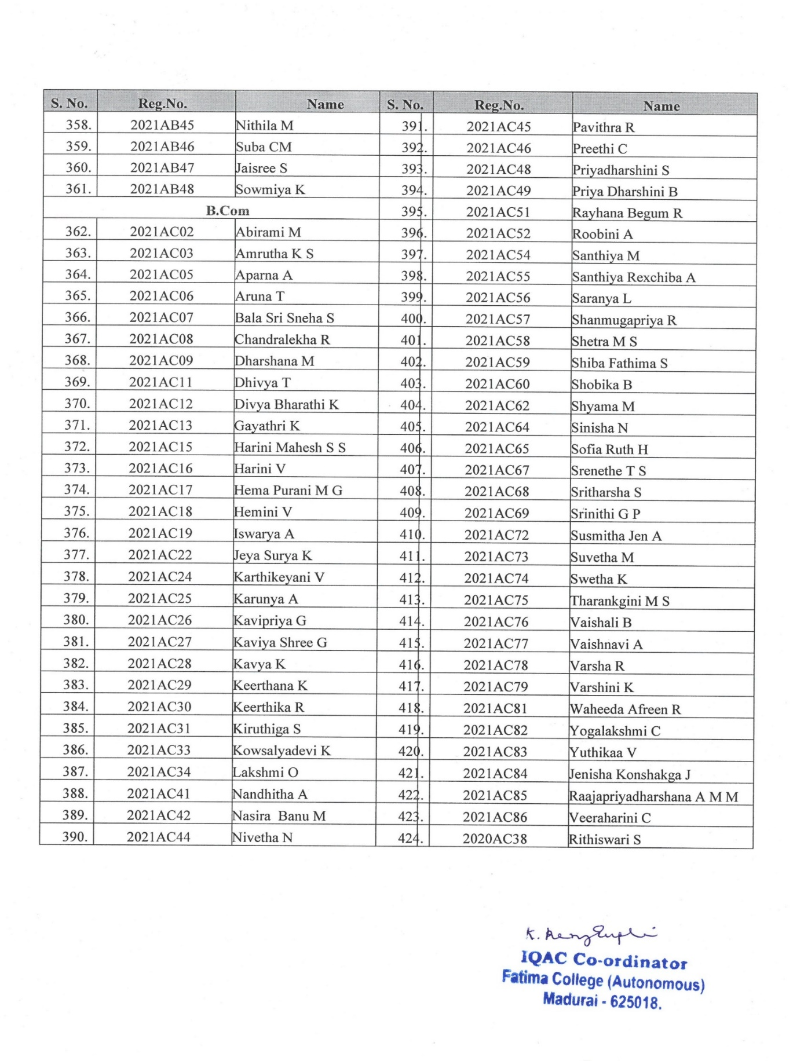

National Level One-Week Faculty Development Programme Organized By IQAC on “Proactive Intelligence for Professional Excellence”
Date: April 10 - 15, 2023 Time: 03.00 – 4.30 p.m.

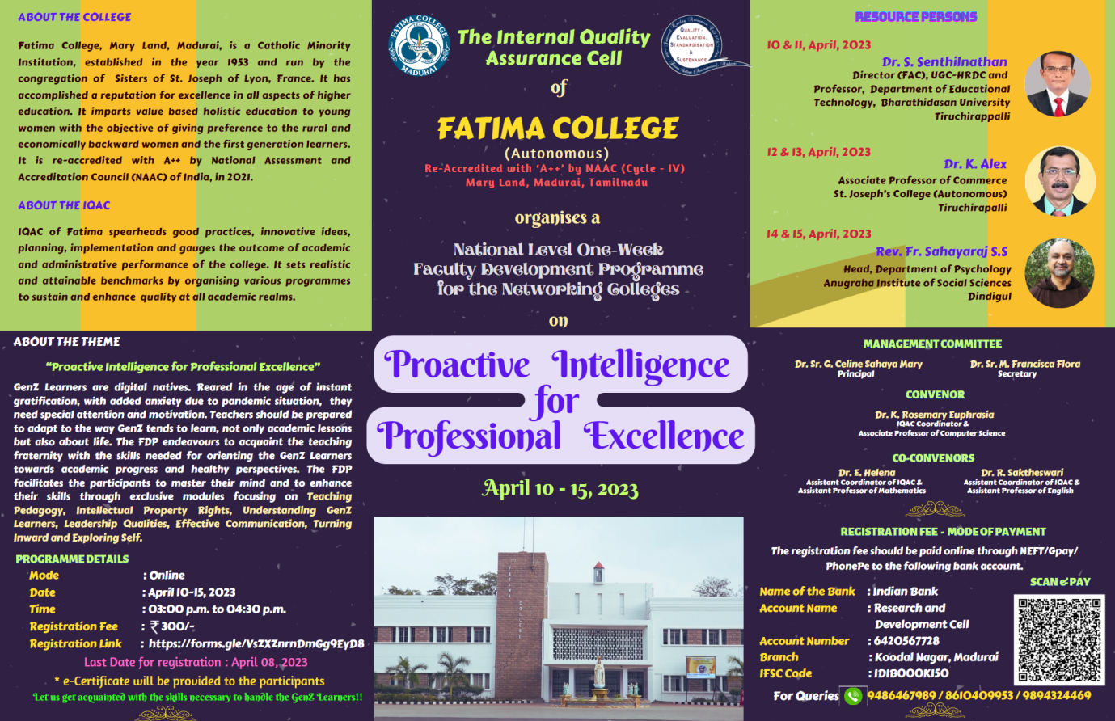

AGENDA
DATE | PROGRAMME | NAME | MODERATOR
April 10, 2023 | Prayer song |  | Dr. L. Meena  Assistant Professor of Management Studies
 | Welcome Address | Dr. K. Rosemary Euphrasia  IQAC Coordinator  Associate Professor of Computer Science
 | Keynote Address | Dr. Sr. G. Celine Sahaya Mary  Principal, Fatima College, Madurai
 | Session | Dr. S. Senthilnathan  Director (FAC), UGC-HRDC and Professor, Department of Educational Technology, Bharathidasan University Tiruchirappalli
April 11, 2023 | Session | Dr. S. Senthilnathan | Dr. S. A. Suja  Assistant Professor of Tamil
 | Vote of Thanks | Dr. R. Saktheswari  IQAC Asst. Coordinator  Assistant Professor of English
April 12, 2023 | Welcome Address | Dr. R. Saktheswari  IQAC Asst. Coordinator  Assistant Professor of English | Dr. E. Helena  IQAC Asst. Coordinator  Assistant Professor of Mathematics
 | Session | Dr. K. Alex, Associate Professor of Commerce  St. Joseph’s College (Autonomous)  Tiruchirapalli
April 13, 2023 | Session | Dr. K. Alex | Dr. C. Sujatha  Librarian
 | Vote of Thanks | Ms. B. Usha  Assistant Professor of Computer Applications (MCA)
April 14, 2023 | Welcome Address | Dr. L. Meena  Assistant Professor of Management Studies | Dr. R. Saktheswari  IQAC Asst. Coordinator  Assistant Professor of English
 | Session | Rev. Fr. Sahayaraj S. S  Head, Department of Psychology Anugraha Institute of Social Sciences, Dindigul
April 15, 2023 | Session | Rev. Fr. Sahayaraj S.S. | Ms. B. Usha  Assistant Professor of Computer Applications (MCA)
 | Vote of Thanks | Dr. E. Helena  IQAC Asst. Coordinator  Assistant Professor of Mathematics

DAY 1 – April 10, 2023
The session was initiated by Dr. Rosemary Euphrasia, IQAC Coorndinator with a welcome note. Then, Keynote address was delivered by Dr. Sr. G. Celine Sahaya Mary , Principal . In her key note address, principal highlighted the importance of professional excellence for faculties in a higher educational institution.
Resource Person
Dr. S. Senthilnathan
Director (FAC), UGC-HRDC and Professor, Department of Educational Technology, Bharathidasan University Tiruchirappalli
Title:
TEACHING PEDAGOGY
Key points Highlighted
- Pedagogy Overview
- Learning Theories and Models
- Learner-Centred Approach
- Technology Integration
- Inclusive Environments

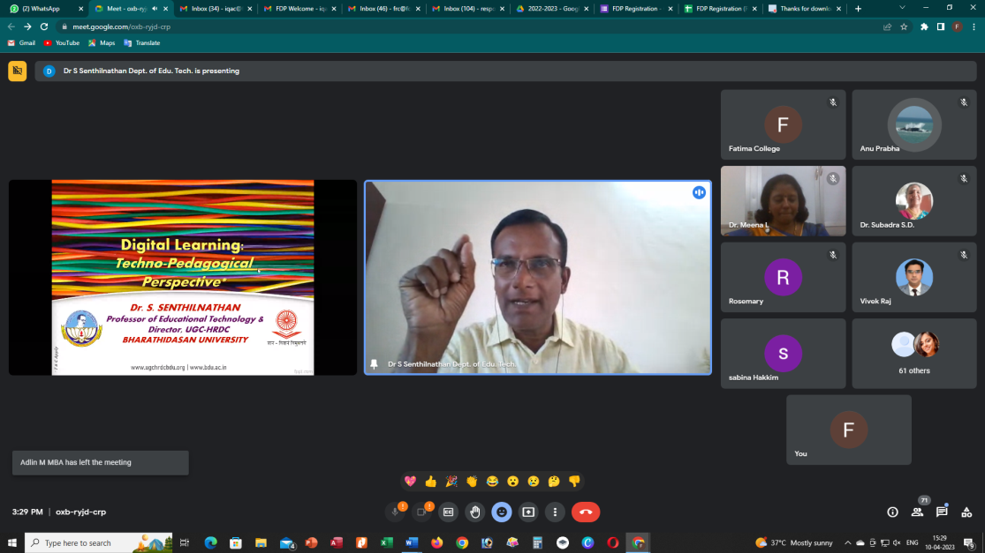
DAY 2 – April 11, 2023
Resource Person
Dr. S. Senthilnathan
Director (FAC), UGC-HRDC and Professor, Department of Educational Technology, Bharathidasan University Tiruchirappalli
Title :
RESEARCH PUBLICATIONS & IPR
Key points Highlighted
- Professional Visibility
- Career Advancement
- Knowledge Dissemination
- Funding Opportunities
- IPR Protection

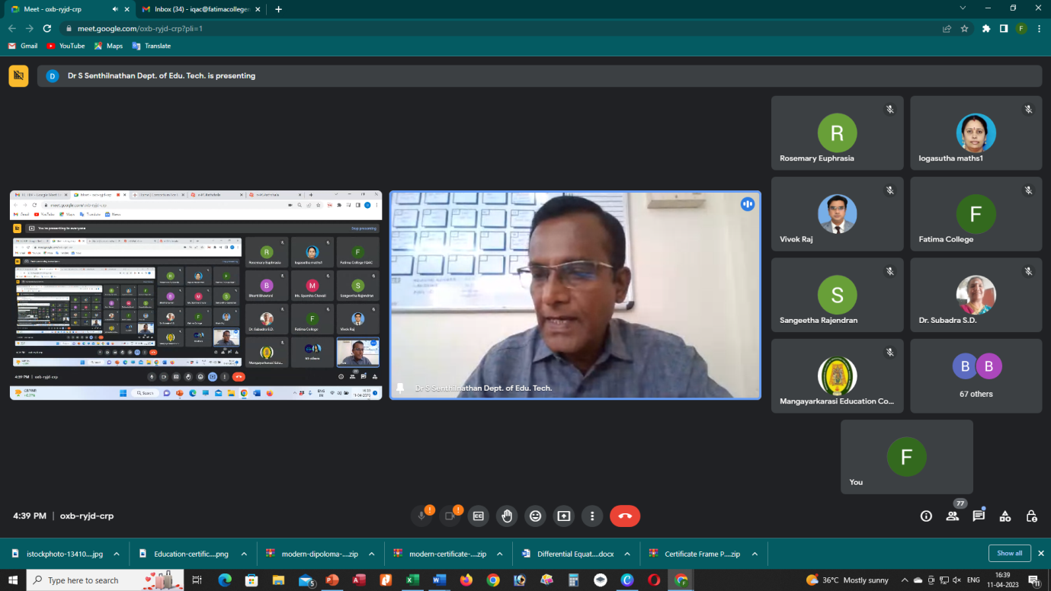

DAY 3 – April 12, 2023
Resource Person
Dr. K. Alex, Associate Professor of Commerce
St. Joseph’s College (Autonomous)
Tiruchirapalli
Title :
HANDLING GEN Z LEARNERS
Key points Highlighted
- Tech Integration
- Shorter, Visual Content:

- Collaborative Learning
- Personalization.
- Feedback and Interaction
- Embrace Diversity

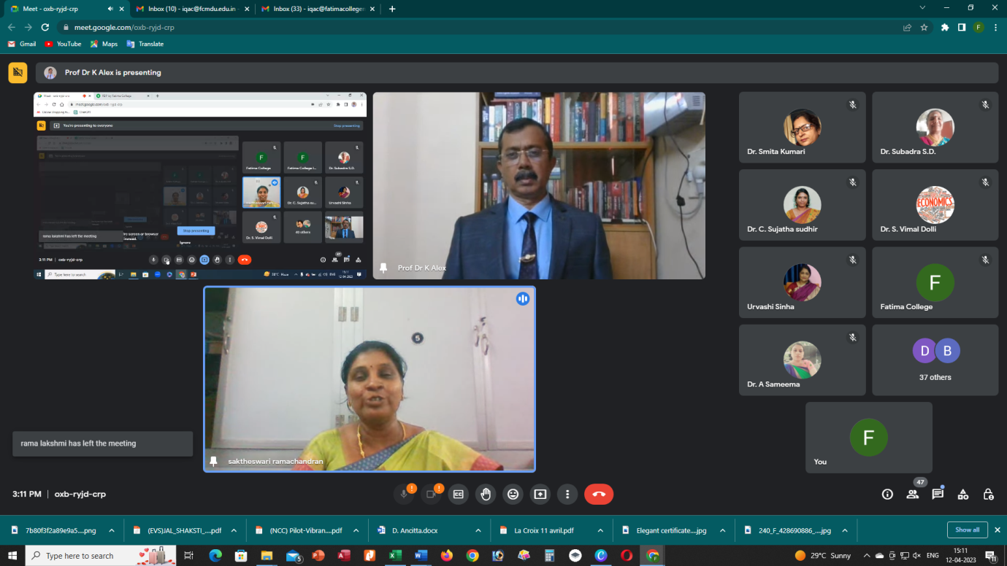

DAY 4 – April 13, 2023
Resource Person
Dr. K. Alex, Associate Professor of Commerce
St. Joseph’s College (Autonomous)
Tiruchirapalli
Title :
TEAM WORKS & COLLOBORATION LEADERSHIP

Key points Highlighted
- Interdisciplinary Projects
- Shared Learning Objectives
- Research Collaborations.
- Team-Based Teaching
- Mentorship and Support
- Professional Development
- Institutional Innovation
- Student-Centric Approach

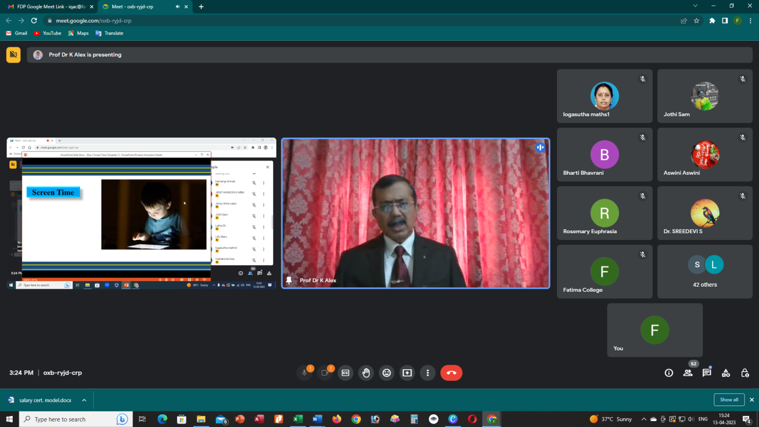

DAY 5 – April 14, 2023
Resource Person
Rev. Fr. Sahayaraj S. S
Head, Department of Psychology Anugraha Institute of Social Sciences, Dindigul
Title :
HEALING THE INNER CHILD
Key points Highlighted
- Self-Awareness
- Emotional Healing
- Re-parenting Yourself
- Inner Dialogue
- Therapeutic Techniques
- Boundaries and Self-Car
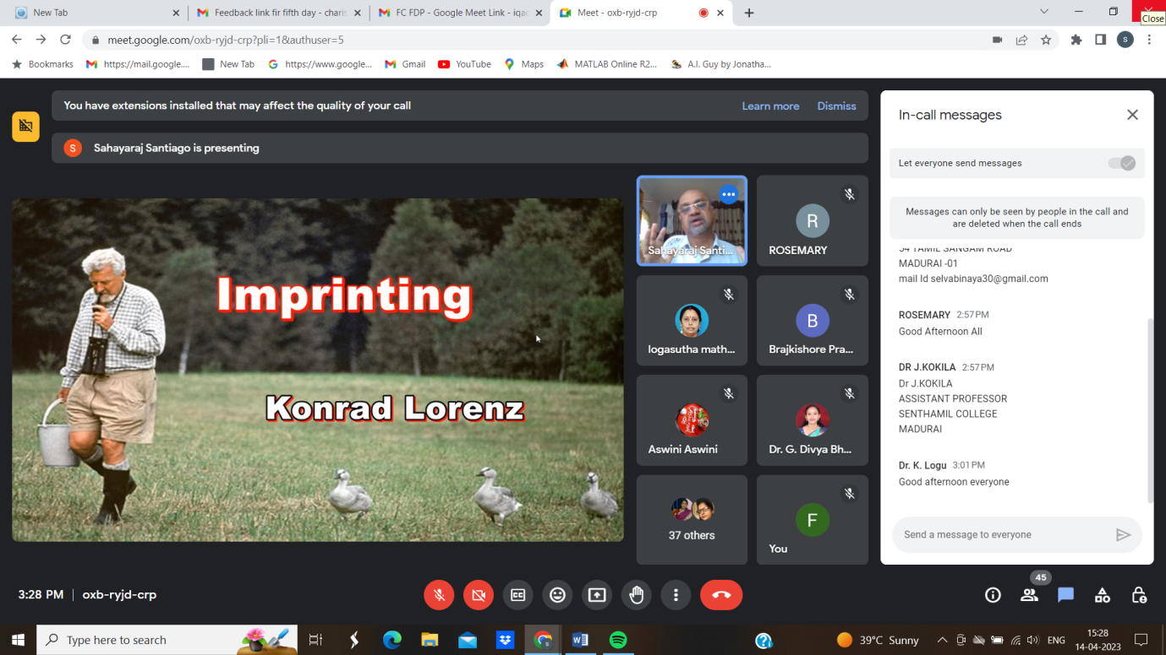

DAY 6 – April 15, 2023

Resource Person
Rev. Fr. Sahayaraj S. S
Head, Department of Psychology Anugraha Institute of Social Sciences, Dindigul
Title :
TOWARDS BETTER SELF
Key points Highlighted
- Goal Setting
- Continuous Learning
- Resilience
- Self-Care
- Mindfulness and Reflection
- Seeking Support
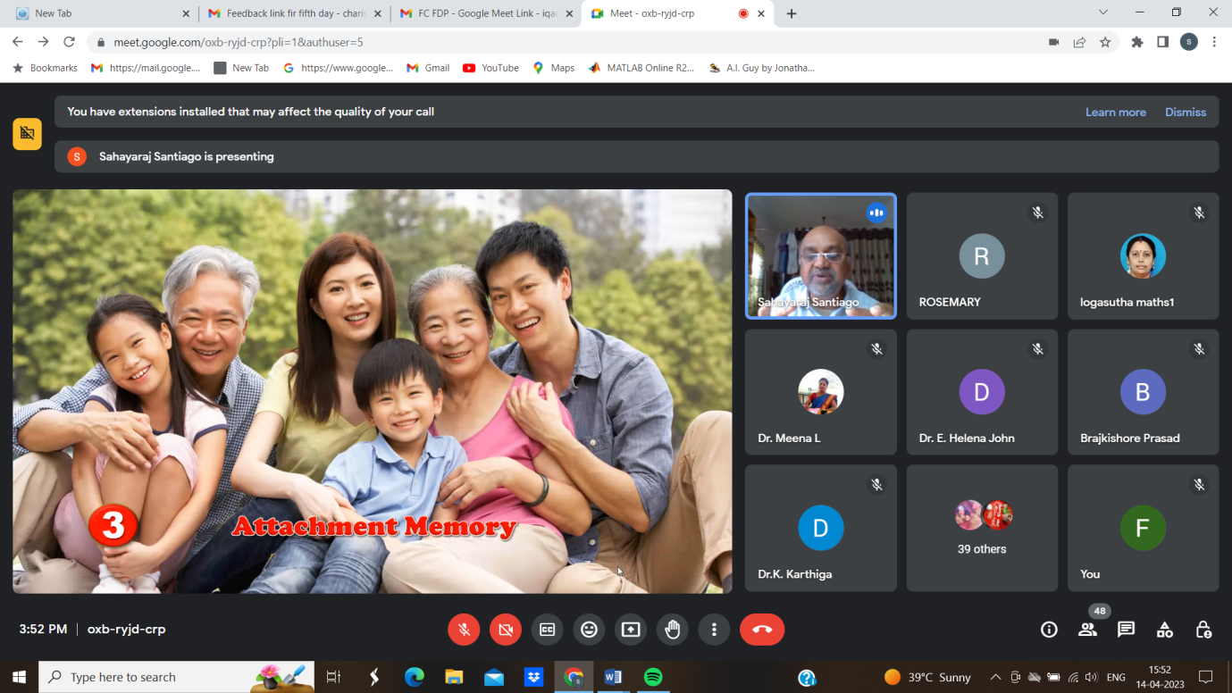

Feedback Form:
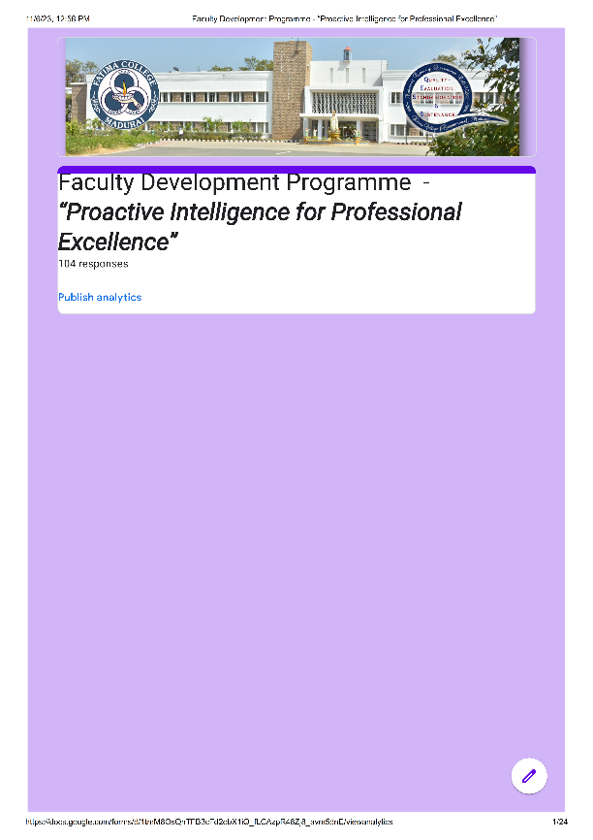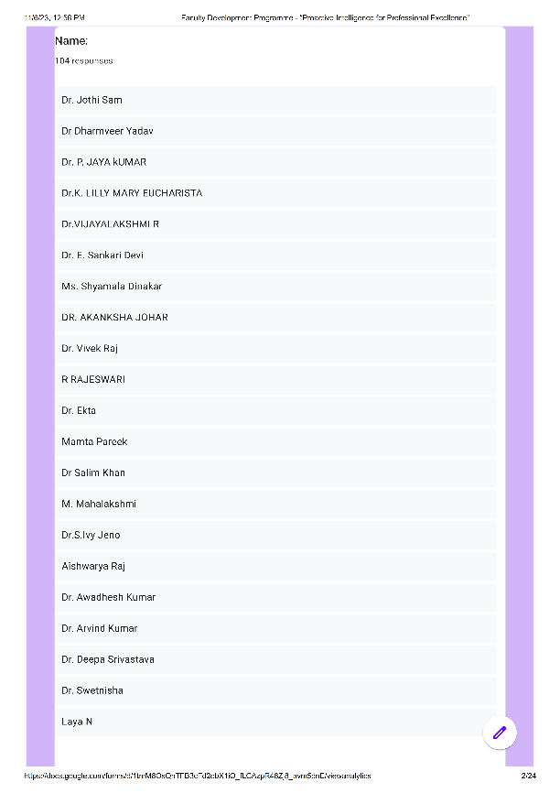
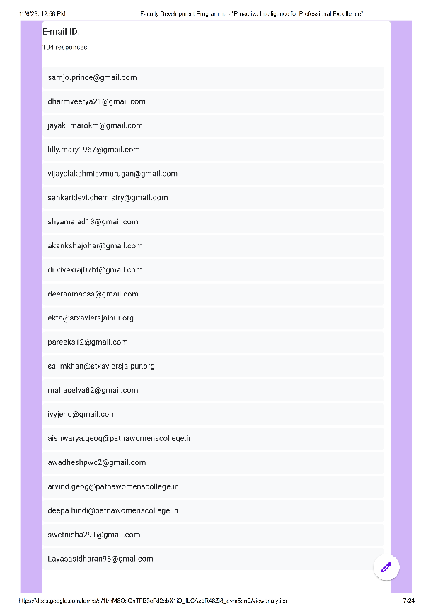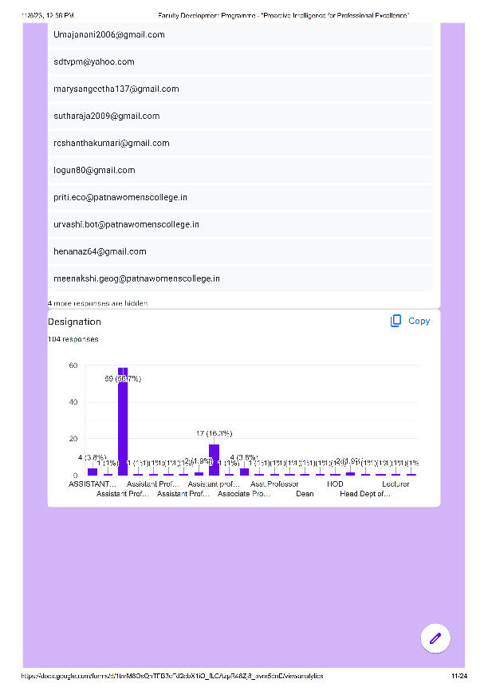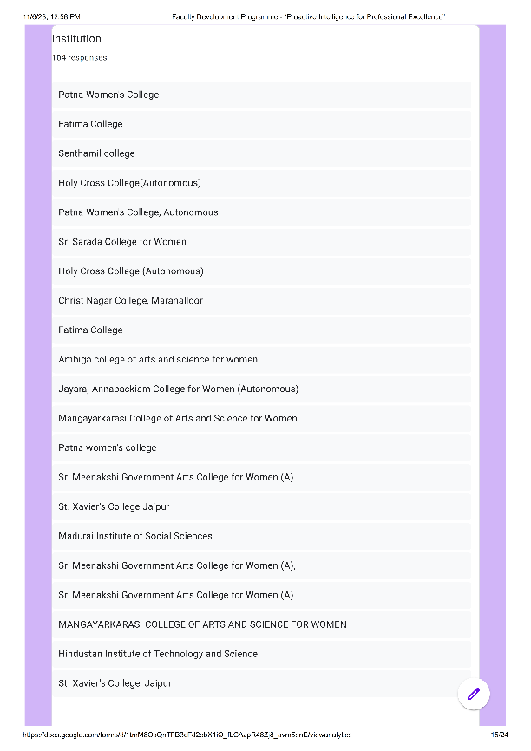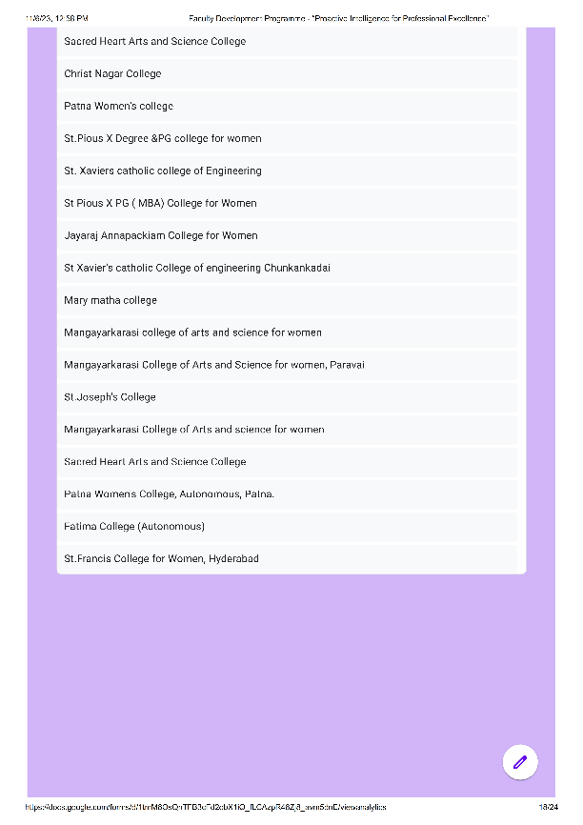
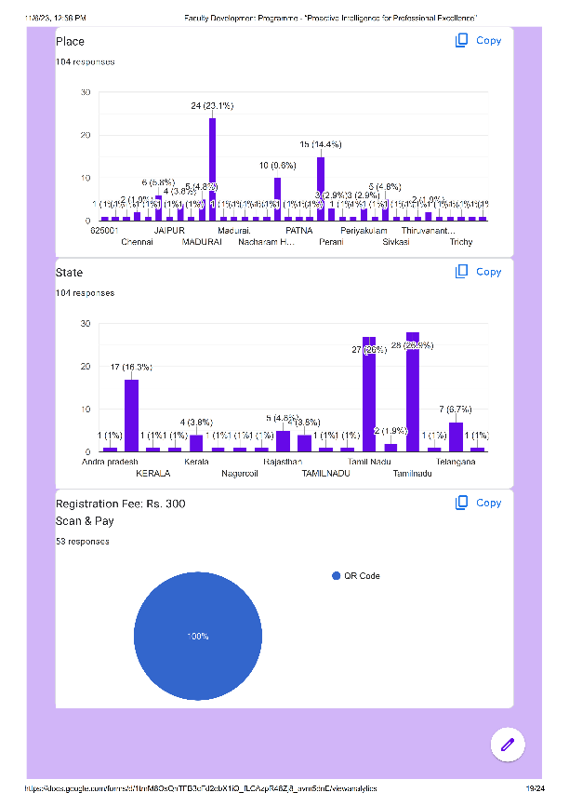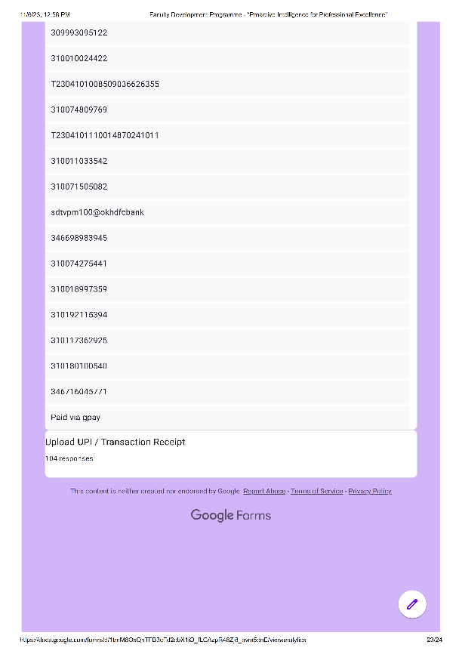

Attendance:
S. No. | Name | E-mail ID | Designation | Department | Institution | Any Other Suggestions / Comments
 | Dr. S. Vimal Dolli | vimaldolli@holycrossngl.edu.in | Assistant Professor | Economics | Holy Cross College (Autonomous) | Very Interesting
 | Dr. Vivek Raj | dr.vivekraj07bt@gmail.com | Assistant Professor | Bio-technology | Patna Women's College | NA
 | Dr. A. Sameema | sameema.a@holycrossngl.edu.in | Assistant Professor | Economics | Holy Cross College(Autonomous) | Interesting
 | Mrs.J.Josephine Jesintha | josephinejesintha.hsc@fcmdu.edu.in | Assistant Professor | Home Science | Fatima College | Nil
 | Ms.Meenakshi Mishra | meenakshi.geog@patnawomenscollege.in | Assistant Professor | Department Of Geography | Patna Women’s College, Autonomous | NA
 | Dr.C.Priyalatha | Priya.vision2011@gmail.com | Assistant Professor | The Research Center Of Homescience | Fatima College | Congrats To Organisers
 | Mamta Pareek | pareeks12@gmail.com | Assistant Professor | Political Science | St. Xavier’s College | All Sessions Were Nice And Fruitful
 | Dr.K.Lilly Mary Eucharista | lilly.mary1967@gmail.com | Assistant Professor | Physics | Sri Meenakshi Government Arts College For (A) | Very Useful Fdp
 | B.Vaishnavi | vaishnaviche@annejac.ac.in | Assistant Professor In Chemistry | Chemistry | Jayaraj Annapackiam College For Women | Nice Presentation
 | Dr M.Selvatharasi | selvabinaya30@gmail.com | Assistant Professor | Tamil Department | Senthamil College | No .
 | Bharti Ahuja Bhavrani | bhavrani.b@gmail.com | Assistant Professor | Chemistry | St Pious X Degree And PG College For Women | Congratulations To Organizers
 | Mrs.D.Sudha | sudharajan30@gmail.com | Assistant Professor | Physics | Mangayarkarasi College Of Arts And Science For Women, Paravai | Today's Topic Was Excellent
 | Dr. Urvashi Sinha | urvashi.bot@patnawomenscollege.in | Assistant Professor | Botany | Patna Women's Clllege, Autonomous, Patna | Well Organized Sessions.
 | Mary Mettilda Rose V | mety_rose@yahoo.co.in | Hod | Mathematics | Christ Nagar College, Maranalloor | Nil
 | Dr.S.Ganesan | vkc.ganesan@gmail.com | Assistant Professor | Tamil | Senthamil College | Good
 | Dr. E. Sankari Devi | sankaridevi.chemistry@gmail.com | Assistant Professor | Chemistry | Mangayarkarasi College Of Arts And Science For Women | Informative FDP
 | H. Jimsy Asha | jimsyasha@holycrossngl.edu.in | Assistant Professor | English | Holy Cross College | -
 | Dr. C. Sujatha | sujathacsudhir@gmail.com | Librarian | Library | Fatima College (Autonomous) | NO
 | Dr.S.Ivy Jeno | ivyjeno@gmail.com | Associate Professor | Economics | Fatima College | Very Useful
 | Dr. Sushma Choubey | imsushmachoubey@gmail.com | Assistant Professor | Hindi | Patna Women's College (Autonomous), P. U. | Remembered And Fruitful Session
 | Dr.S.Sujitha | sujitha.s@holycrossngl.edu.in | Assistant Professor | Mathematics | Holy Cross College (Autonomous), Nagercoil | -
 | Dr. Jothi Sam | samjo.prince@gmail.com | Assistant Professor | Zoology | Sri Meenakshi Government Arts College For Women (A) | Thank You And Congratulations
 | Dr. Akanksha Johar | akankshajohar@gmail.com | Assistant Professor | English | St. Xavier’s College, Jaipur | None
 | Dr. K. Selvalakshmi | selvalakshmifc@gmail.com | Assistant Professor | Economics | Fatima College | Was A Wonderful Session
 | K.Logasutha | sutharaja2009@gmail.com | Head Of The Department | Mathematics | Mangayarkarasi College Of Arts And Science For Women | Good Organisation
 | Dr.S. Malarvizhi | tamilmalarvizhi@gmail.com | Assistant Professor | Tamil | Senthamil College | Thank You
 | Dr. A. Tamil Selvi | tamilselvi_chem@tcarts.in | Assistant Professor Of Chemistry | Chemistry | Thiagarajar College, Madurai | Nil
 | Dr Kumkum Rani | Kumkum.phi@patnawomenscollege.in | Assistant Professor | Philosophy | Patna Women’s College | Thanks For Such A Wonderful FDP
 | Dr Vijayalakshmi R | vijayalakshmisvmurugan@gmail.com | Assistant Professor | Physics | Sri Meenakshi Government Arts College For Women (A) | Very Effective
 | Braj Kishor Prasad | brajkishore.mca@patnawomenscollege.in | Assistant Professor | Department Of MCA | Patna Women's College | No
 | Dr.G.Selvarani | selvarani.ganesan@gmail.com | Assistant Professor | Physics | Sri Meenakshi Government Arts College For Women (A) | Everything Is Fine.
 | Dr.R.Veeramani | rveeramani281@gmail.com | Head Dept Of Commerce With CA | Commerce With C A | Mangayarkarasi College Of Arts And Science For Women | Nice Session
 | Ms. X. Stella Martina | stellamartina715@gmail.com | Asst Professor, Hod | Dept Of English | St.Francis College For Women, Hyderabad | Very Useful Session
 | Dr.K.Karthiga | karthila@rediffmail.com | Assistant Professor | Research Centre Of Home Science | Fatima College Autonomous | Very Good
 | Dr Manjula Sushila | manjula.hindi@patnawomenscollege.in | Assistant Professor | Hindi | Patna Women's College, Autonomous, PU | Very Well Organised And Very Informative Fdp.
 | Dr Hena Naz | henanaz64@gmail.com | Assistant Professor | Botany | Patna Women's College | Very Informative
 | Aswini.T | aswiniaswini245@gmail.com | Assistant Professor | English | Sacred Heart Arts And Science College ,Perani | Thanks Alot For This Wonderful FDP Congratulation For Fathima College And I Thank You For Giving Such Wonderful Opportunity To Participate.
 | Dr. A. Anami Augustus Arul | anamiaugustus@gmail.com | Assistant Professor | Botany | Holy Cross College (Autonomous) | Nil
 | Jagadheesh Chandran J. | jagansruthy@gmail.con | Assistant Professor | English | Christ Nagar College | Excellent Session
 | Ms.D.Mouna | mounabala2000@gmail.com | Assistant Professor, | The Research Centre Of Home Science, | Fatima College, | Excellent
 | Dr. Awadhesh Kumar | awadheshpwc2@gmail.com | Assistant Professor | Geography | Patna Women's College, Patna | All Session Was Fruitful And Full Of Knowledge
 | Riju B. Sarajan | rijub300587@gmail.com | Assistant Professor | English | Christ Nagar College | Apart From Certain General Talks, The Session Was Able To Satisfy Me.
 | Dr. Arvind Kumar | arvind.geog@patnawomenscollege.in | Assistant Professor | Department Of Geography | Patna Women's College, Autonomous | Overall It Was Fruitful.
 | Dr.Deepa Srivastava | deepa.hindi@patnawomenscollege.in | Assistant Professor | Hindi | Patna Women's College, Patna | Very Useful ,Informative And Fruitful
 | Dr. Latha E | latha@auxiliumcollege.edu.in | Assistant Professor Of English | English | Auxilium College | Sincerely Thank You For The FDP
 | Dr.M.Arockia Priscilla | priscyangel2010@gmail.com | Principal | Education | Mangayarkarasi College Of Education | Nil
 | N.Jeyabharathi | jeyabharathihari@gmail.com | Asst.Professor | Commerce | Mary Matha College | Informattive Session
 | Dr J.Kokila | senthamil.kokila@gmail.com | Assistant Professor | Tamil | Senthamil College | Very Informative Session
 | Ms. Shyamala Dinakar | shyamalad13@gmail.com | Assistant Professor | Department Of Psychology | Hindustan Institute Of Technology And Science | The Sessions Were Really Helpful And Thought Provoking. It Would Be Much Comfortable To Attend The Future Sessions Also In This Comfortable And Convenient Timing.
 | Sangeetha Rajendran | marysangeetha137@gmail.com | Assistant Professor | Computer Science | Mangayarkarasi College Of Arts And Science For Women | Very Good Session
 | Aishwarya Raj | aishwarya.geog@patnawomenscollege.in | Assistant Professor | Geography | Patna Women's College | Thank You For Your Efforts.
 | M. Mahalakshmi | mahaselva82@gmail.com | Assistant Professor | Physics | Sri Meenakshi Government Arts College For Women | Well And Good
 | A. J. Bernita | bernitasmilin@gmail.com | Assistant Professor | The Research Centre Of English | Fatima College | Nil
 | Dr.A.Sabina | sabihakkim@gmail.com | Assistant Professor | Commerce | Mary Matha College Of Arts And Science Periyakulam | Thank To Institute By Conducting This Usefull FDP
 | Sparsha Chavali | sparshachavali@gmail.com | Assistant Professor | Mathematics | St.Pious X Degree And PG College For Women | No
 | Dr.S.Ajith Sinthuja | ajithsinthuja@holycrossngl.edu.in | Assistant Professor | Chemistry | Holy Cross College | Excellent Sessions
 | Drn.Selvalakshmi | vivekan2006@gmail.com | Assistant Professor | Commerce | Mannar Tirumalai Naicker College(Autonomous) | Excellent
 | C.Vanisree | vanisree3108@gmail.com | Assistant Professor | Biochemistry | St.Pious X Degree &PG College For Women | Thank You
 | Mrs.T.Subha | subhabio86@gmail.com | Assistant Professor | Allied Health Sciences | Noorul Islam Centre For Higher Education, Kumarakoil | No
 | J. Jeevitha Rani | jeevetha3@gmail.com | Assistant Professor | Chemistry | Jayaraj Annapackiam College For Women (Autonomous) | Nothing
 | Dr Kumkum Rani | Kumkum.phi@patnawomenscollege.in | Assistant Professor | Philosophy | Patna Women’s College | Wonderful Experience
 | Priyesh Rangan | priyeshrangan@gmail.com | Assistant Professor | English | M.V. College, Buxar | Kindly Share The Ppts And Recording Of The Session With The Participants For Future Reference
 | Dr. Ekta | ekta@stxaviersjaipur.org | Assistant Professor | Commerce | St. Xavier's College , Jaipur | No
 | Mrs R Rajeswari | deeraamacss@gmail.com | Assistant Professor | Mathematics | Fatima College | It Was Really A Nice Experience To Be Part Of This FDP Programme. I Have Learned A Lot. Thank You So Much
 | Dr. Preeti Swarupa | preeti.mbio@patnawomenscollege.in | Assistant Professor | Microbiology | Patna Women' College | FDP Was Enlightning And Knowledgeable
 | Dr. M. Subha | subhaamsc@gmail.com | Assistant Professor | Mathematics | Fatima College (Autonomous) | Good
 | K. V. M. Udaya Lakshmi | udayalakshmikvm@stpiouscollege.org | Head Of The Department | Computer Science | St. Pious X Degree And PG College For Women | Nothing
 | Dr Meena Juliet Monteiro | pereirameenaj@gmail.com | Dean | Msw | School Of Social Work, Roshni Nilaya | Network Connectivity Needs To Be Improved
 | Dr Meeta Sharma | meetasharma@stxaviersjaipur.org | Assistant Professor | Department Of Political Science | St Xavier's College | Good
 | Dr T.Ramalakshmi | ramaalibrarian@gmail.com | Asst.Professor | Lis | SVAGRICULTURAL College | Thank You Very Much
 | Dr. K. Loganathan | logun80@gmail.com | Assistant Professor | Zoology | Sacred Heart Arts And Science College | Very Excellent
 | Dr. R. Renuka Devi | rrenukadeviphd@gmail.com | Assistant Professor | English | Sri Sarada College For Women (Autonomous) Salem | Excellent Work, Kudos To The Organisers
 | Dr. R.Rajesh | rajdhivo@gmail.com | Assistant Professor | Zoology | Sacred Heart Arts And College | It's A Package Of Fully Essential Things For Faculty
 | Dr G. Subbulakshmi | reshumi1970@gmail.com | Asst. Proffessor | Tamil | Sentamil College | Good
 | Dr. Swetnisha291@Gmail.Com | swetnisha291@gmail.com | Assistant Professor | Microbiology | Patna Women's College | Such Sessions Should Be Conducted At Regular Intervals
 | Dr. R. Akash | akash@srcas.ac.in | Assistant Professor | Commerce | Sri Ramakrishna College Of Arts & Science | Good
 | Sumeshkumar K P | sumeshputhuppallil@gmail.com | Assistant Professor | Malayalam | Christ Nagar College Maranalloor Trivandrum | Nice
 | Dr. J. Sharmila Devi | sharmiramya92@gmail.com | Assistant Professor | English | Sri Sarada College For Women | Innovative Session
 | Hemangi Shinde | hemangi.shinde@aissmsioit.org | Assistant Professor | Electronics And Telecommunication Engineering | AISSMS Institute Of Information Technology | Excellent Sessions
 | Dr Salim Khan | salimkhan@stxaviersjaipur.org | Former Head Andcassistant Professor | Business Administration | St Xavier's College | Informatic Session
 | Dr. A. Arulprakash | apzoomicro@gmail.com | Assistant Profeesor | Zoology | St. Joseph's College Of Arts And Science (Autonomous) | Good
 | E. Narmatha | narmathaemmanuel@gmail.com | Assistant Professor | English | Sacred Heart Arts And Science College | Nil
 | G Anuprabha | ganuprabhamdu@gmail.com | Assistant Professor | Physics | Ambiga College Of Arts And Science For Women | It's Very Useful
 | Ms. S. Maria Esther | mestherche@annejac.ac.in | Assistant Professor | Chemistry | Jayaraj Annapackiam College For Women (Autonomous) | Good
 | Dr.G.Divya Bharathi | drdivyabharathi.bot@gmail.com | Assistant Professor | Department Of Botany | Sri Sarada College For Women Salem | It Was Great To Be A Part Of This FDP Thank You
 | Ms.R.C.Shantha Kumari | rcshanthakumari@gmail.com | Head & Assistant Professor | Business Administration | Mangayarkarasi College Of Arts And Science For Women | Excellent
 | Dr. A. Revathi | revathiamaresan93@gmail.com | Assistant Professor Of English | Department Of English | Sri Sarada College For Women (Autonomous) | Nothing
 | Dr. R.Saritha | rsaritha12@gmail.com | Assistant Professor | English | Sri Sarada College For Women | No Suggestions
 | Dr.Sreedevi.S | sdtvpm@yahoo.com | Assistant Professor | Hindi | St.Joseph's College | Nice
 | Umamathi S | umajanani2006@gmail.com | Assistant Professor | Bba | Ambiga College For Arts And Science For Women | Good Experience
 | K. Sulochana | ksulochana1426@gmail.com | Assistant Professor | Commerce | Sacred Heart Arts And Science College, Perani. | Overall The Entire Session Was Very Nice And Highly Useful To The Faculty Members Thank You🙏.

