**NAAC ACCREDITATION – A++ GRADE**

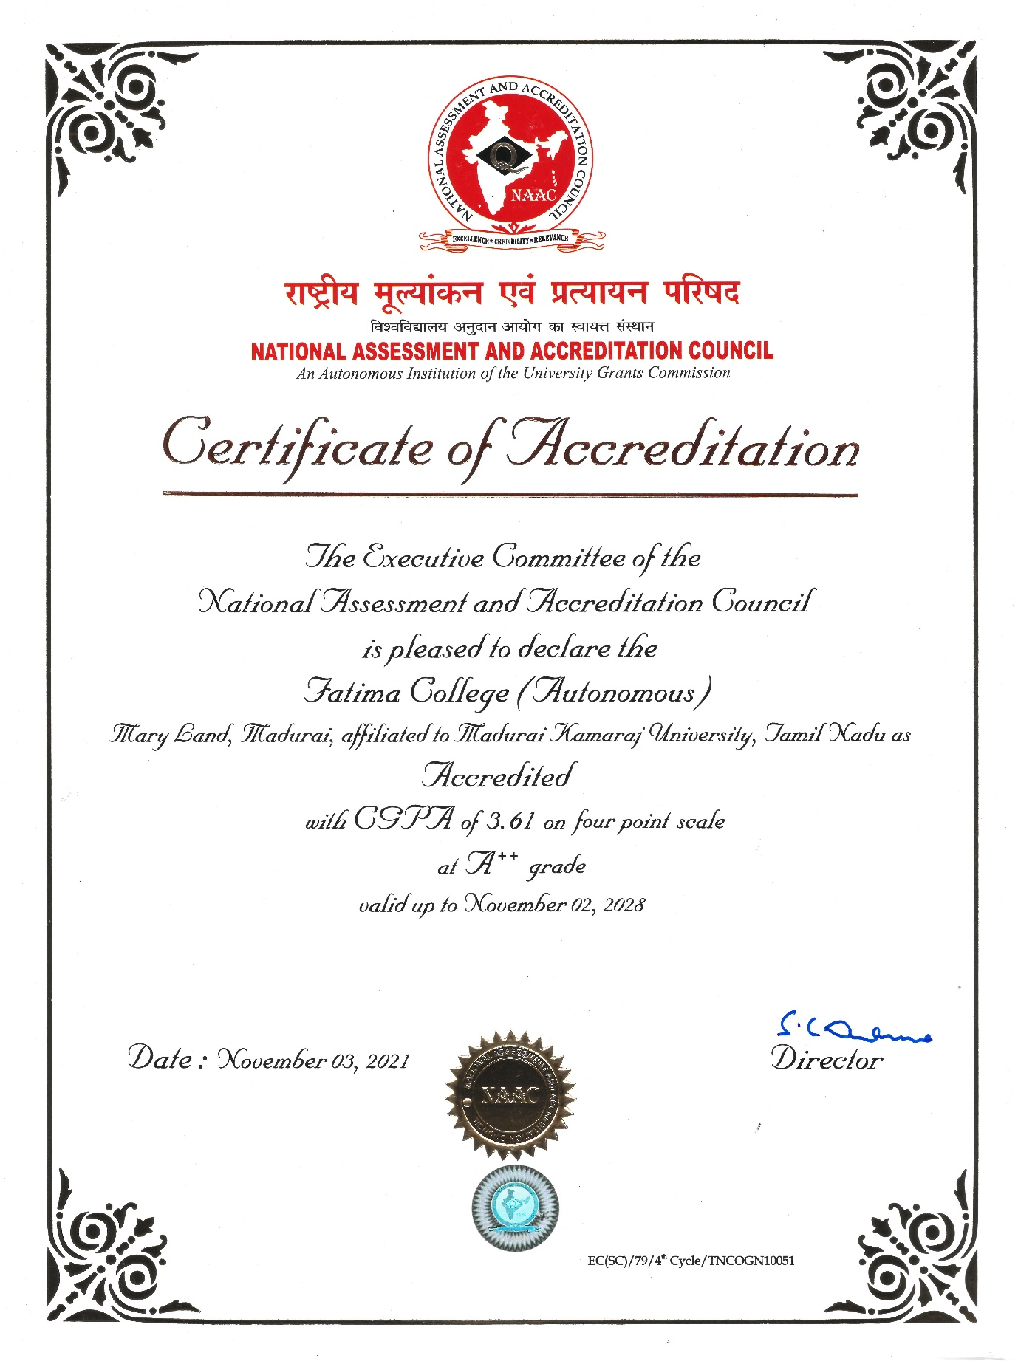

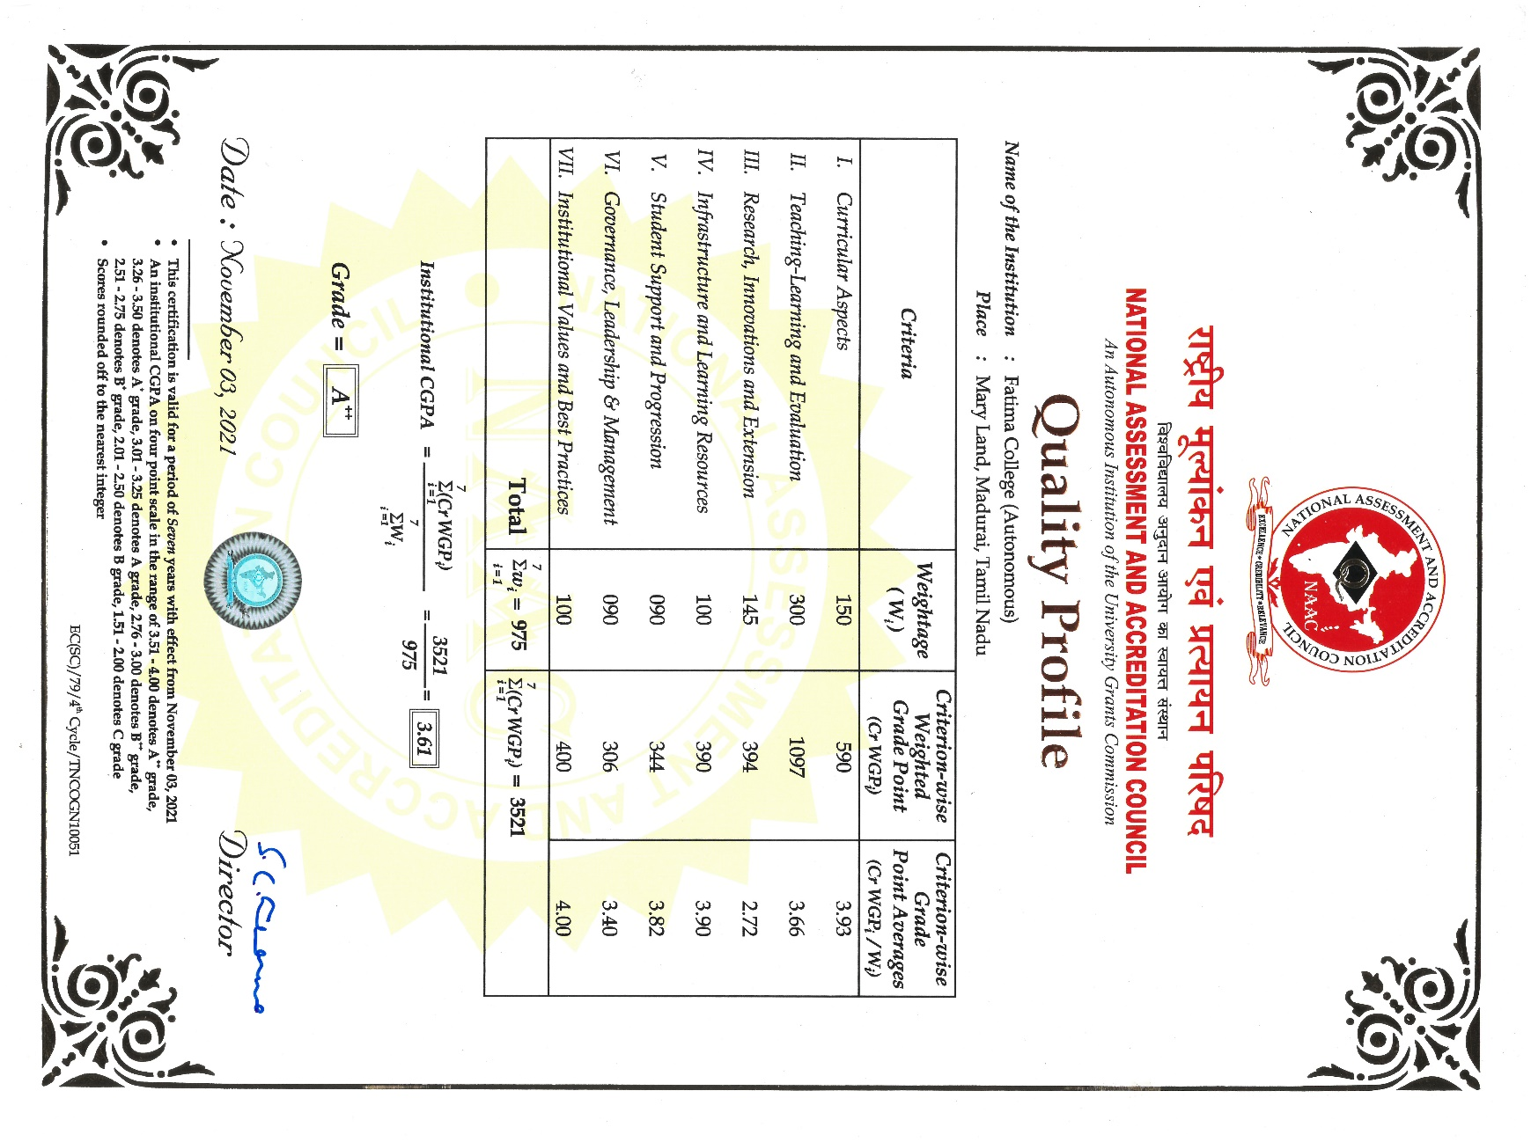

**AUTONOMY REVIEW – EXTENDED FOR 10 YEARS**

**FROM 2022 – 2023 TILL 2031 - 2032**

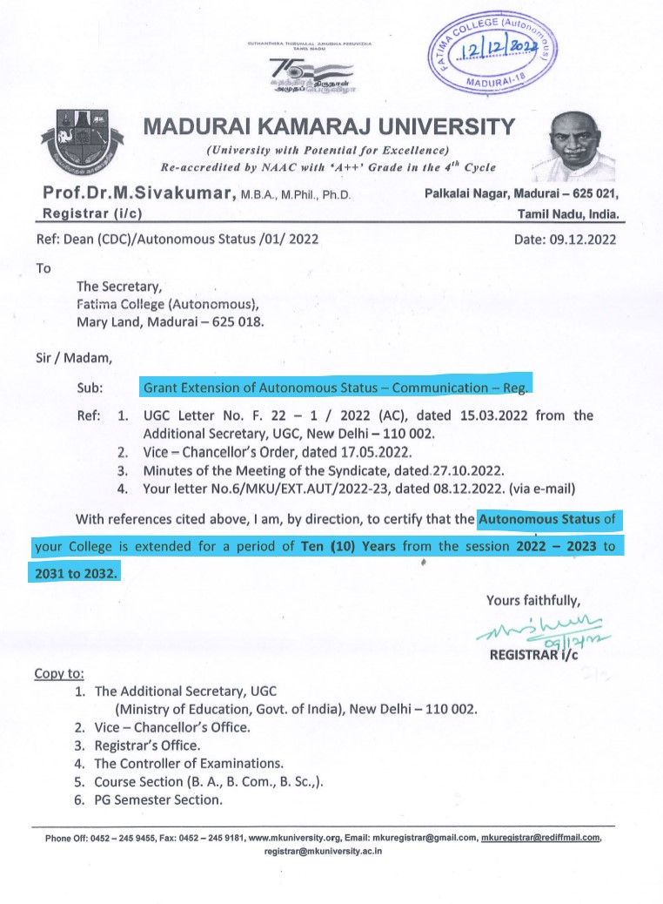

**PARTICIPATION IN NIRF**

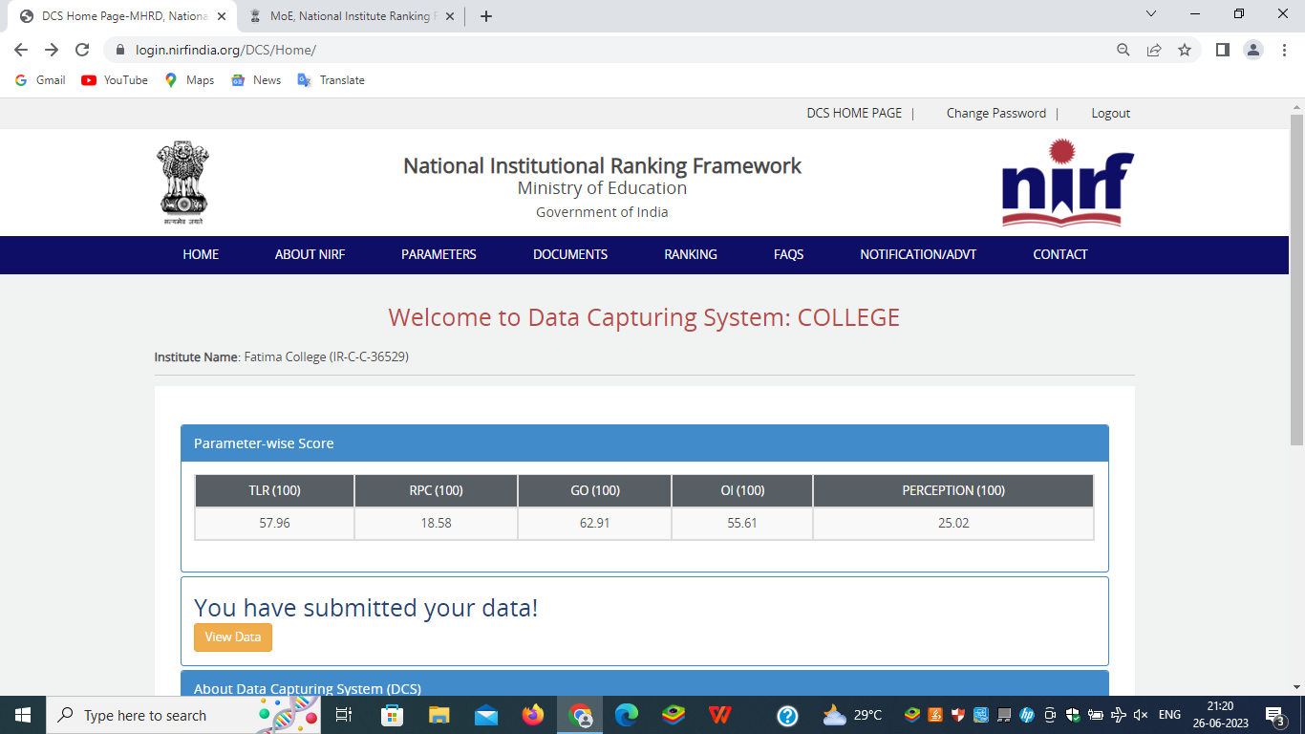

## [**India Rankings 2023**](https://www.nirfindia.org/2023/Ranking.html)

**Parameter-wise Score**

| TLR (100) | RPC (100) | GO (100) | OI (100) | PERCEPTION (100) |
| --- | --- | --- | --- | --- |
| 57.96 | 18.58 | 62.91 | 55.61 | 25.02 |

**India Rankings 2023: College (Rank-band: 101-150)**