FONDE
Multidisciplinary Course :
To facilitate the students to know the basics of other disciplines and to improve their self-learning skills FONDE provides online MULTIDISCIPLINARY COURSE for the first year students as two papers G1FC1 – Arts and G2FC2 - Science during I and II semesters respectively with 3 credits each. MULTIDISCIPLINARY COURSE is offered as online program as the online courses are comfortable, convenient, and flexible also it motivates the students for self-paced learning. The course is available with Syllabus, course content in the form of videos - prepared by our staff with the transcript and question bank with minimum of 50 questions from each stream. At the end of the semester, students take up the online test and get their grade.
Activities:
- To help the first year students to understand the need for online education and foundation course.
- To provide the technical expertise to register & to download the material for the foundation course.
- To upload the Syllabus, Course material, Question bank online in Fatima College Website.
- To Conduct the online test more than once (Shift I Arts & Science, Shift II), with randomly selected questions.
- To monitor the student attendance during the tests.
Online : Activities:
- To encourage departments to offer online certificate courses.
- To Monitor the student registration, (After the fee payment activating the student account)
- To provide technical support to the departments to upload the syllabus, Course material, and Question bank.

- To help the staff members for the conduct of online test.
Apart from the MULTIDISCIPLINARY COURSE, FONDE also facilitate the departments to offer online courses as Value-Added courses. The following departments are offering Online Courses (2019 – 2020) :
Department Name of the Online Course
- History Indian history for competitive exams
- Computer Science Web designing using HTML
Photo Editing Techniques
- BBA Event Management
MOOCs on SWAYAM (‘Study Webs of Active Learning for Young Aspiring Minds’) :

SWAYAM is an indigenous platform of the Government of India which hosts MOOCs(Massive Open Online Course) course to enable students to virtually attend the courses taught by the best faculty. It provides access to high quality reading resources, enables to participate in discussion forums, to take up test and earn academic grades. The UGC has issued UGC(Credit Framework for Online Learning Courses through SWAYAM) Regulation, 2016 – for the credit transfer of MOOCs courses.
- SWAYAM course is a 12-15 weeks structured course comprising of video lecture, Reading material(that can be downloaded/printed), self-assessment test and online discussion forum.
- Students can enroll for MOOCs on June and November every year
- Learner can earn certificate/credit on successful completion of course on SWAYAM
- MOOCs can be offered as Extra Credit or it can offered as part of the curricula to facilitate blended method of Teaching methodology.
- Once the learner acquires the credit, it can be entered in the cumulative marksheet.
- To encourage the students
UG – one course which earns 2 credits – 8 weeks
PG – two courses which earns 4 credits – 12 weeks
for this academic year as Extra credit.
E-CONTENT :

To facilitate the students with precise and better understanding of their subjects, the staff members are requested to prepare at-least 2 videos/semester. This SLO – (Short Learning Object) may help the students to have a quick review of the concepts also it encourages the slow learners to understand the topic in their own pace. The videos are internally reviewed within the department and uploaded in the college website.

Name of the Committee: FONDE – Fatima Online ‘N Digital Education
S. No. | Programme / Activity | Target Group | Outcome of the Event
1. | Foundation course  G1FC1, G2FC2 | All I U.G Students | To improve their self-learning skills  To know the basics of other disciplines  To enhance them with new Learning strategy – Online Education
2. | Online Course | Open to all U.G students | To facilitate the students to take up value added courses through online
3. | SWAYAM Courses | All (UG & PG) Students | To enable students to virtually attend the courses taught by the best faculty.  It provides access to high quality reading resources, enables to participate in discussion forums, to take up test and earn academic grades
4. | E-CONTENT | All staff | To facilitate the students with deeper understanding of the nuances of their subject, the staff members will prepare SLOs and the videos will be uploaded in the college website.

Curriculum Development Cell
The Curriculum Development Cell (CDC) of the College comprises the Principal, Secretary, Vice Principals, IQAC Co-ordinator, Director of Professional Courses, Controllers of Examination, Deans of Academic affairs, Heads and Second Seniors of all the departments. The cell functions with the distinct objectives as stated herein:
- To design and develop curriculum involving Local, National and Global subject and industrial experts to meet the international demands at all Sectors.
- To sustain, enhance and enrich the teaching and learning on campus to bring it on par with the Global Standards
- To train the teaching faculty on the recent trends in teaching and learning
- To orient the members of the Boards of Studies on the vision and mission of the Curriculum Development Cell
- To organize Seminars, Conferences, Workshops on curriculum designing and development; material production, Innovative teaching
- learning pedagogic, Evaluation Reforms and on innovative and need based value added, skill - oriented courses.
- The meeting of the Curriculum Development Cell was held on Feb. 15, 2022.
Curriculum encompassing teaching, learning resources, student activities and support system is the foundation for the holistic education offered at Fatima. Dynamic curriculums are revised and revamped periodically based on the topical demands.
Academic Reforms: Regular, relevant and innovative academic reforms are carried out every year. This year too is no exception.
- Academic Audit is a regular feature of the college.

- Remedial Coaching and Communicative English are the distinctive characteristics.
- Credit carrying self-learning courses has been introduced for the I, II & III in UG and I & II PG Students.
Academic Progress:
- Outcome-Based education successfully entered the third academic year during 2022-2023.
- Summer internships and projects mandated for all PG and UG programmes respectively.
- External Viva for projects made compulsory for all UG programmes.

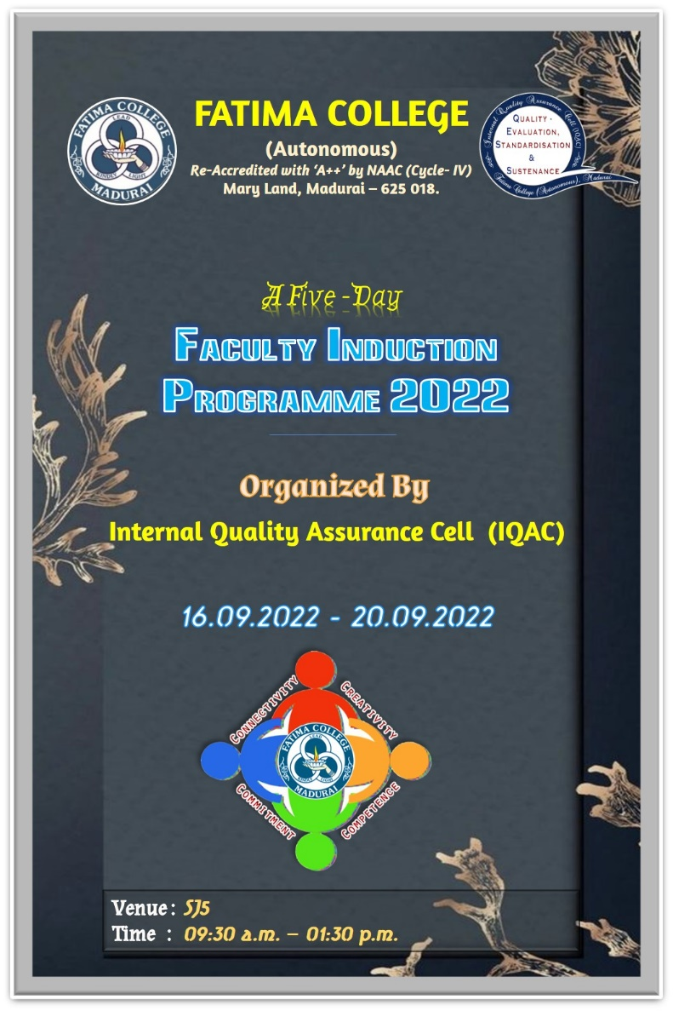

Teaching is an ethically and intellectually demanding profession. New teachers need rigorous preparation and opportunities for continuous professional development along with academic and professional support.
The Faculty Induction Programme can help new teachers to improve their teaching and management skills, adjust to the culture of the institution, and better understand their professional responsibilities.
The Faculty Induction Programme begins with the prayer and Dr. R. Saktheswari, Assistant IQAC Coordinator and Assistant Professor in English welcomed the gathering.
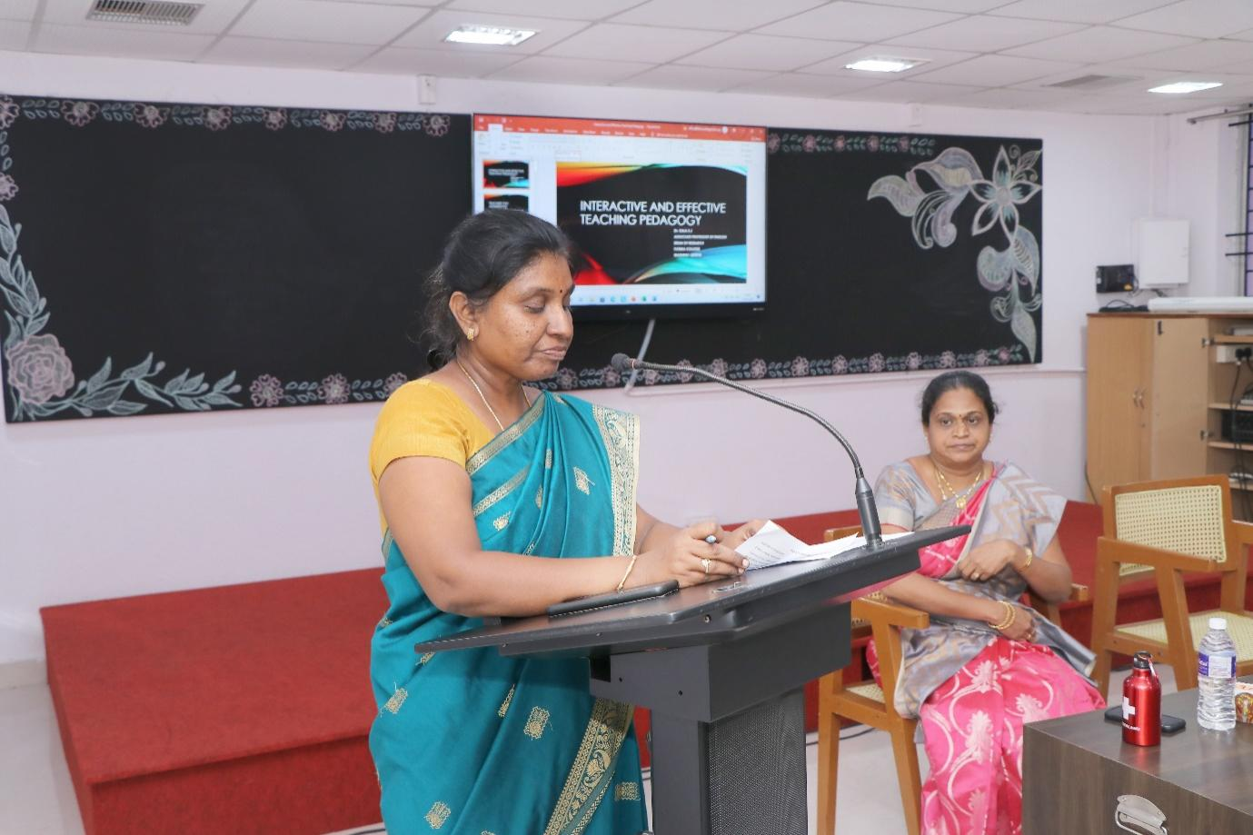
The IQAC Coordinator, Dr. K. Rosemary Euphrasia, Associate Professor of Computer Science explained the objective of the programme
The Faculty Induction Programme aims to help new teachers:
a. Understand their roles and responsibilities as faculty members
b. Familiarize themselves with the structure, functioning, governance, rules, regulations and professional expectations in the institution
c. Explore pedagogical processes - aims of higher education, curriculum, instructional planning, classroom management and transaction, use of resources and assessment
d. Recognise the importance of self-development, socio-emotional development of students and the importance of nurturing ethics and values in higher education
Dr. S. Saira Banu, Associate Professor of English & Head, Dept. of Journalism and Mass Communication handled the first session on Body Language and Presentation Skills: Involve & interact.
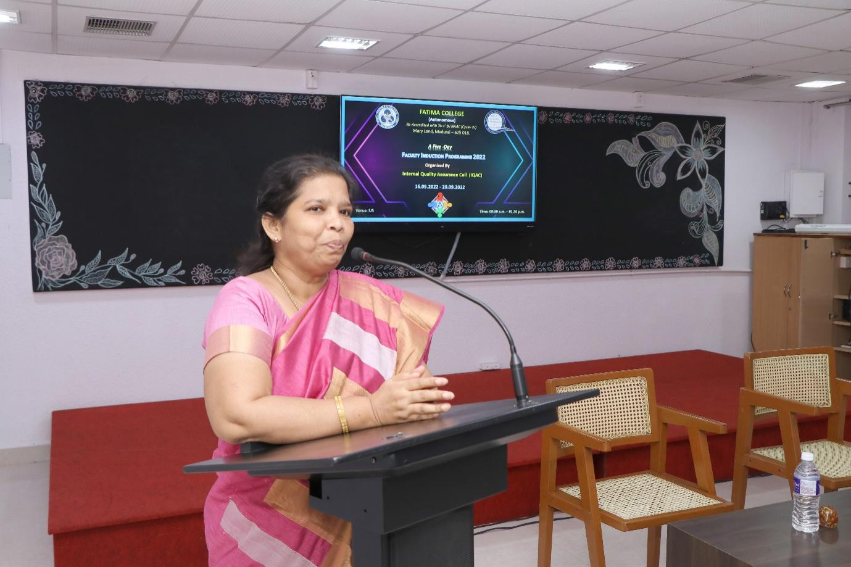
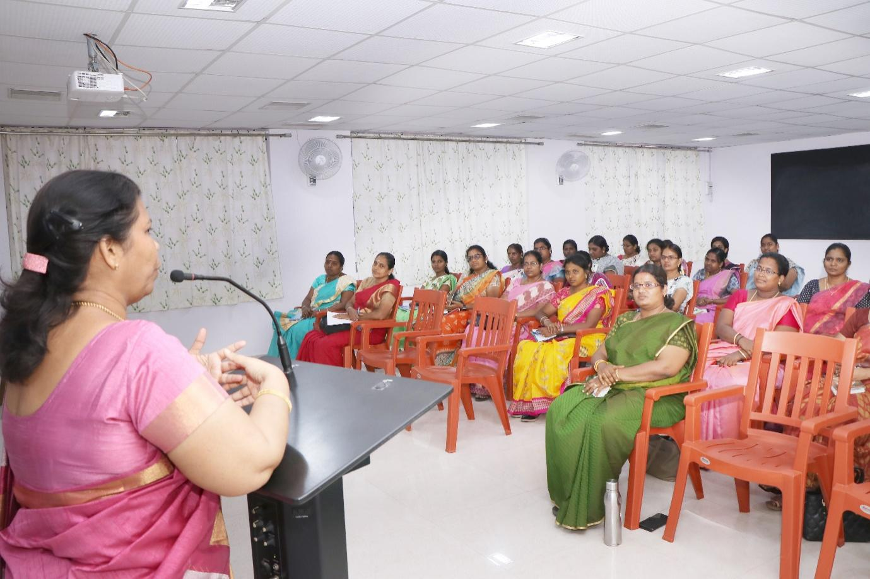The second session was handled by Dr. S. J. Kala, Associate Professor of
English & Dean of Research who described the Interactive Classroom Teaching.
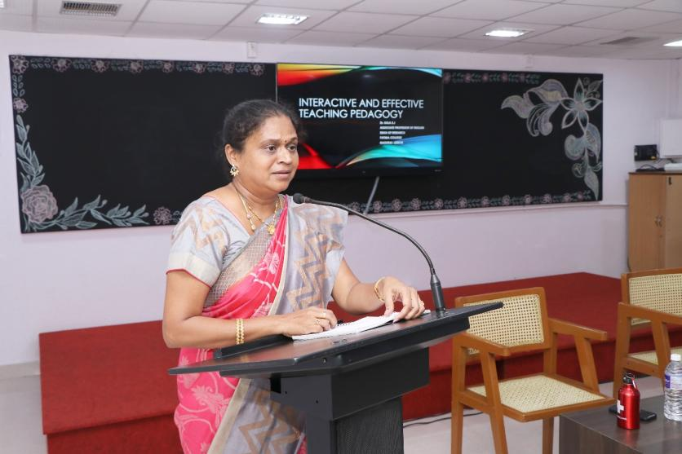

Date: 17.09.2022
Session 1: The Courage to Teach
The day started with a prayer song. Dr. Magdalene Abraham, Associate Professor, PG & Research Centre of English, Fatima College, was the resource person for the first session.
Dr. L. Meena, Assistant Professor of Management Studies, introduced and welcomed the chief guest, IQAC members and the participants. Dr. Magdalene started the session by recollecting her good-old memories of being a significant member in all IQAC initiatives. She kick started her speech by insisting on the importance of learning. She quoted Socrates’s lines “An unexamined living is not worth living” and she emphasized on her philosophical call to examine into the inner landscape as a teacher. She appreciated and recognized the college as a secular institution. Further, Dr.Magdalene gave her deliberations on the necessary etiquettes that a teacher of Fatima College should practice by touching upon the topics like proper teacher-student language of communication, saying ‘no’ at the right time and how to respond elegantly. Later, she posed the question “Why do you want to teach?” to the participants and made them to think deeply about their purpose of choosing this noble profession. Few teachers shared their own stories of inspiration. After this sharing session, Dr. Magdalene shared her personal anecdote of how she became the professor of English after going through so much difficulties and challenges in her life and it was truly inspiring. She highlighted the courage and joy that a professor needs to become an empathetic teacher.
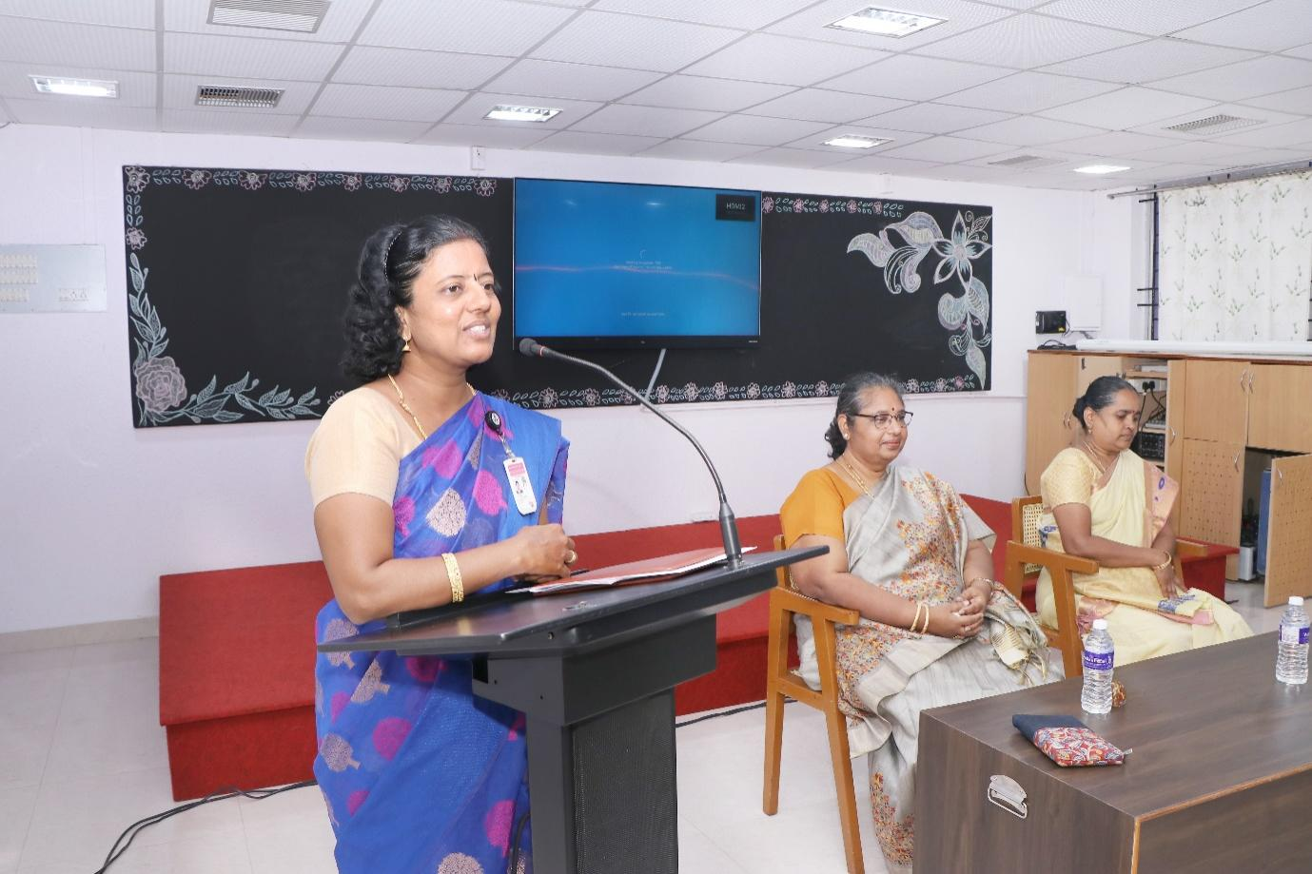
Furthermore, she encouraged the teachers to have courage not only to question something or someone, but also to have courage to give some concrete solution to the problems stated by the students.
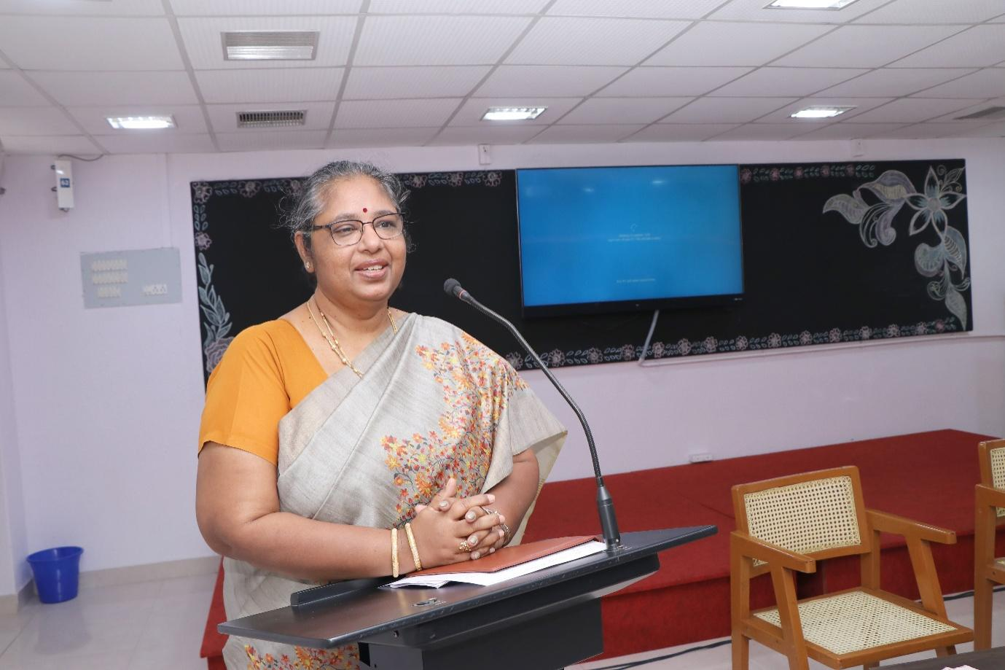
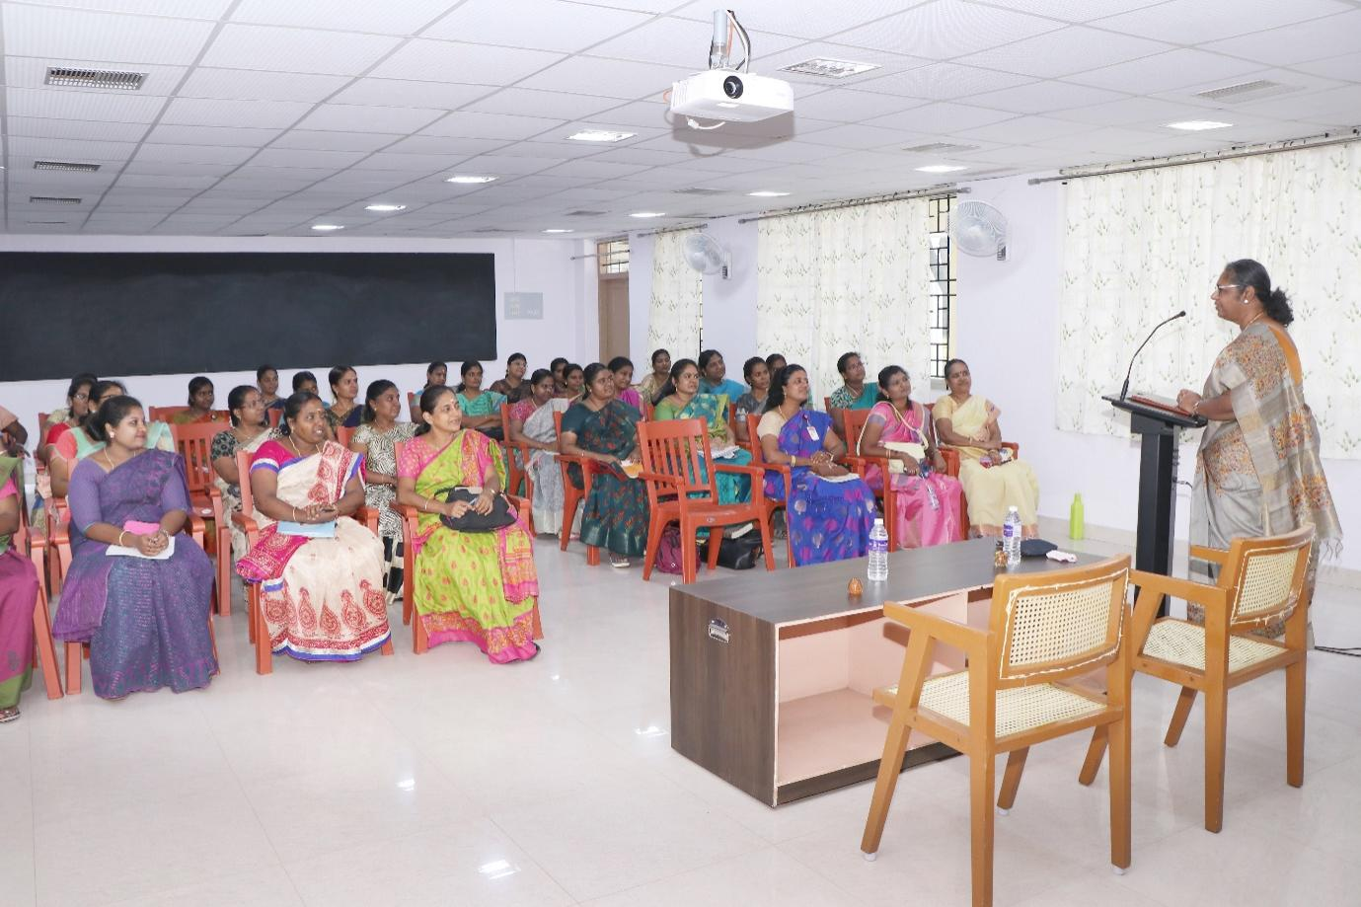
Session 2: “Ambitions and Aspirant on- Reach to Stars”
Dr. J. Asnet Mary, Assistant Professor of Zoology, Fatima College, was the resource person for the session. Mrs. P. Sumedha, Head & Assistant Professor of English introduced the chief guest. She started her session deliberating on the effectiveness of the teacher in terms of personal, professional and interpersonal qualities. Dr. J. Asnet Mary encouraged the fellow teachers to transform from ordinary to extraordinary teachers. She beautifully connected the effectiveness of teaching to two important concepts such as Pendulum principle and Effectiveness Equation. She further highlighted on Aristotle’s statement “Excellence is not an act, but a habit” to bring out the constructive changes in the methods and strategies of teaching. Her metaphor of comparing this change with the right amount of different qualitative ingredients to yield a quality product was so thought provoking. Her in-depth deliberations on the difference between proactive and reactive persons were really useful and teachers were asked to self-examine themselves on these terms. Her most engaging session was on the topic “Begin with the End in Mind”. After which, teachers were asked to write their own mission statements as an individual and as a teacher. Her interesting motivational songs were the highlights of the session. The session ended with her personal miraculous story of the completion of Ph.D, followed by an activity named “Human Knot” insisting on the team spirit needed to achieve common goals of the institution.
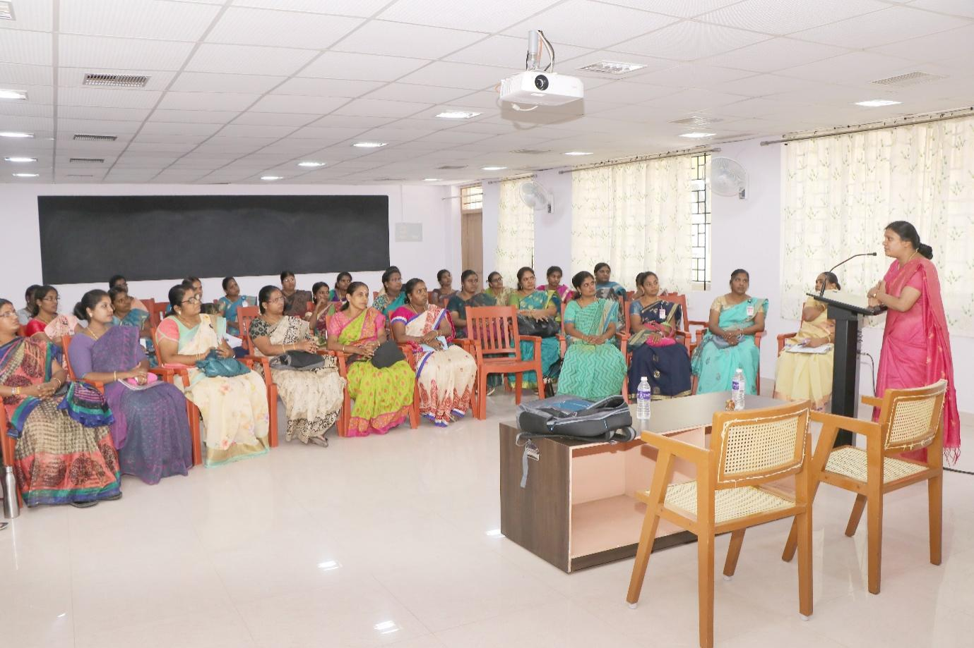
Session 3: “Strategies of Curriculum Development”
Dr. M. Meenakumari, Head & Assistant Professor of Sociology and Social Work, Dean of Academic Affairs (Arts) was the resource person for the session. Mrs. P. Sumedha, HOD & Assistant Professor of English (SF) introduced the chief guest. She started her session by quoting a line from Kothari Commission that destiny of India is shaped in the classroom insisting on the significance of curriculum development in Higher Education. Her detailed deliberations on the current OBE pattern and mapping of vision and mission of the college with Program Educational Objectives (PEOs), Program Outcomes (POs) and Course Outcomes (Cos) were really productive and gave a clear- cut idea of how a higher education would design its curriculum. She also briefly explained about the Board of Studies and its role in designing and revision of curriculum in Fatima College. She laid emphasis on how curriculum designed in the college matches with graduate attributes. Further, she vividly explicated the concept of bloom’s taxonomy and its role in the curriculum development and also discussed its role in course design and in setting K levels (specific to Fatima College). Moreover, she elucidated the difference between the old OBE and new OBE pattern and explained in detail about the credit distribution for both UG and PG. Especially, this session was really useful to the new recruits as they were enriched with the holistic knowledge of curriculum development in Fatima College. The session ended with her appeal to the new staff to adapt different strategies to address the different category of students (free will, adopted, rebellious) and their needs through the concept of transaction analysis.
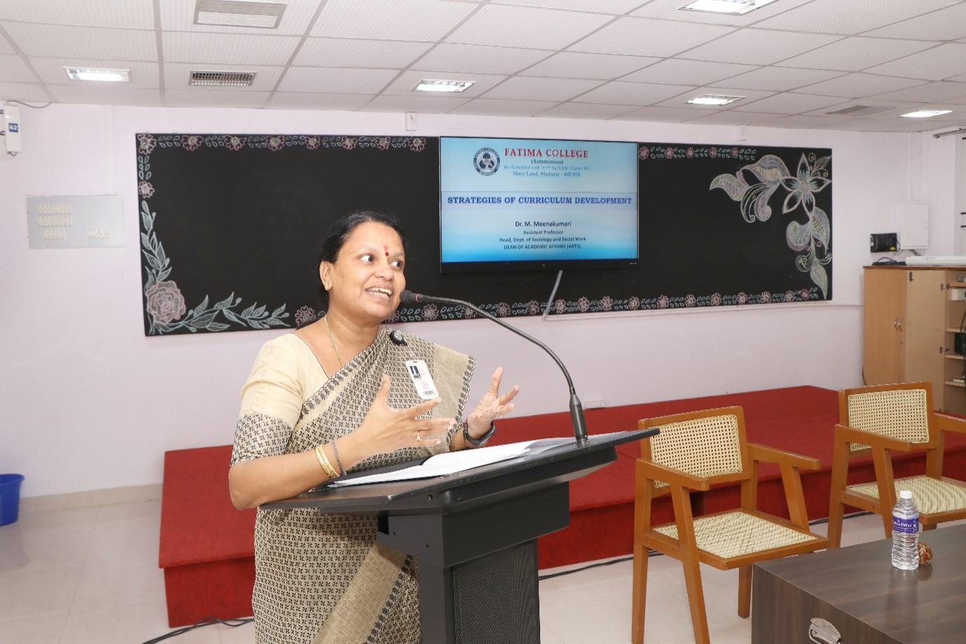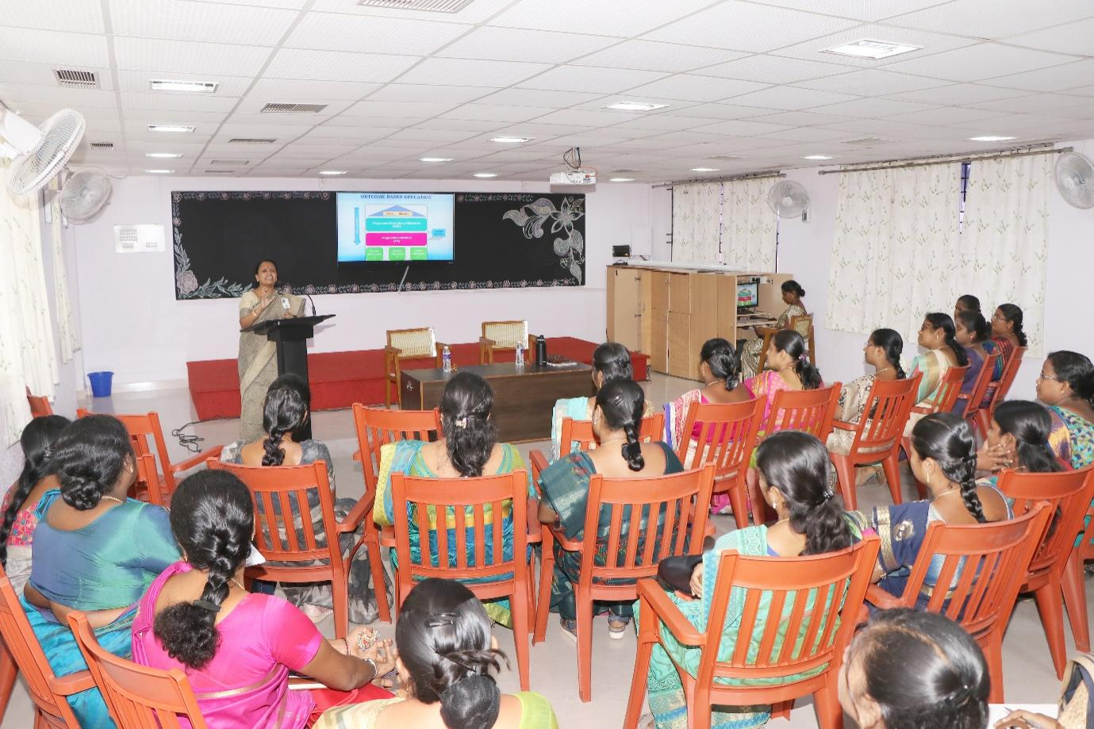
Date: 18.9.2022.
Session: 1 Research Ethics and Funding Agencies.
The resource person for this session was Dr. Vasantha Esther Rani, Associated Professor and Head, The Research center of Home Science, Fatima College, Madurai. Mrs. B. Usha, Assistant Professor of MCA introduced the Chief Guest.
The Chief Guest started the session with an introduction to research a formalized curiosity. She explained about pre-research and stage in pre-research. She gave detailed description about the stages of pre-research. Then she shared some tips for selecting a topic. After that, she discussed about Research ethics quoting that Research ethics are the application of fundamental ethical principles to research activities including the design and implementation of research. Research ethics are set of rules of our own and others behavior. She explained about the research ethics committee. Institutional Review Board reviews whether the research is ethical enough or not to protect the rights dignity and welfare of the respondents. Then she discussed about the five broad categories of research ethics namely, minimizing the risk of harm next, minimizing the risk of the research, obtaining informed consent, protecting anonymity and confidentiality and to avoid misleading practices. She also explained about the advantages of research ethics like how research ethics promotes the aim of the research. Also she explained about the limitations of research ethics. She discussed about ensuring ethics at every step of research. Then she gave us the list of various funding agencies. She gave us few tips to reduce stress level during research. She motivated us saying if the research is rejected try again. She concluded the session by sharing her personal experiences in research. Vote of thanks was delivered by Mrs. B. Usha, Assistance Professor of MCA, Fatima College, Madurai.

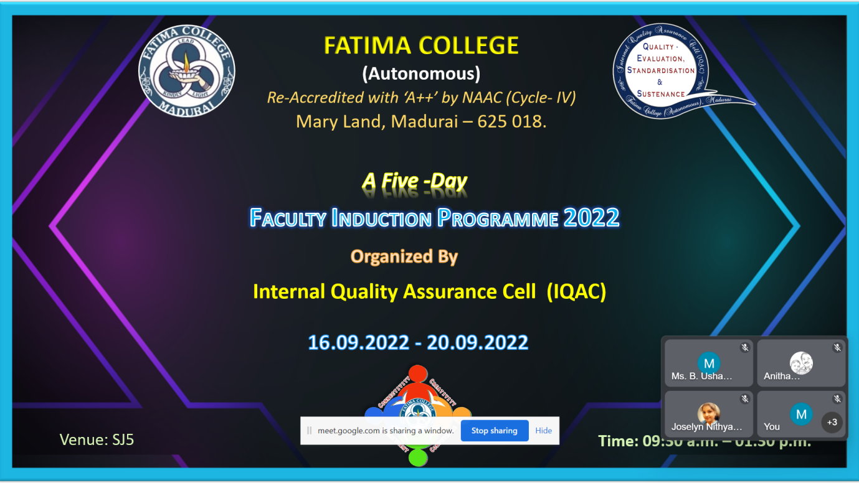

https://youtu.be/hs2MPINcFeI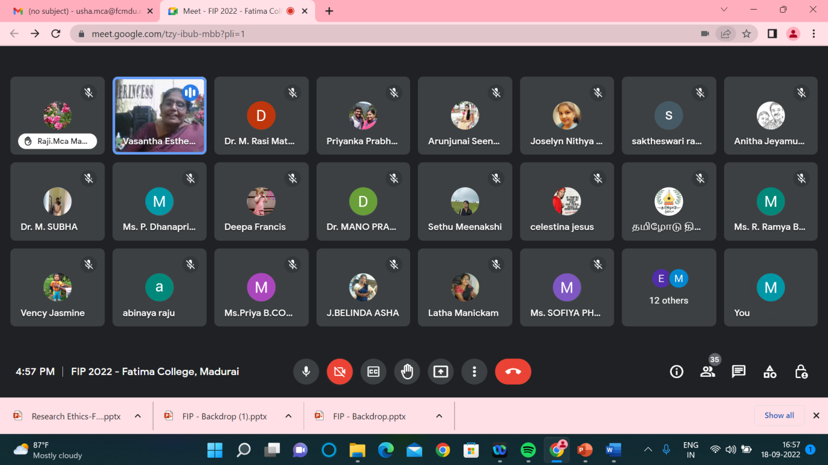

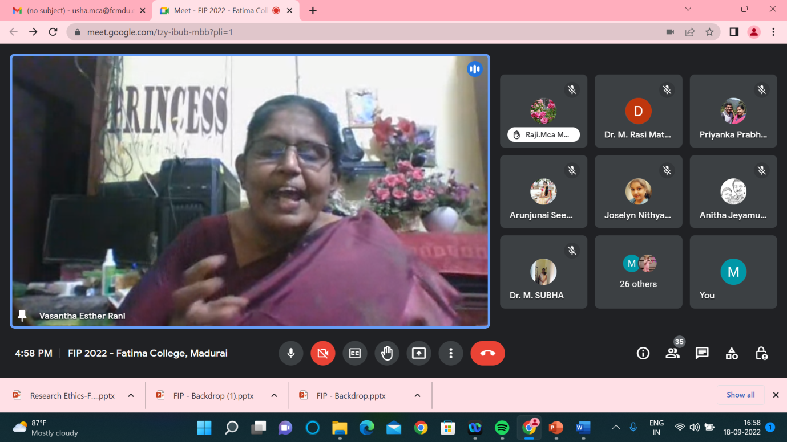

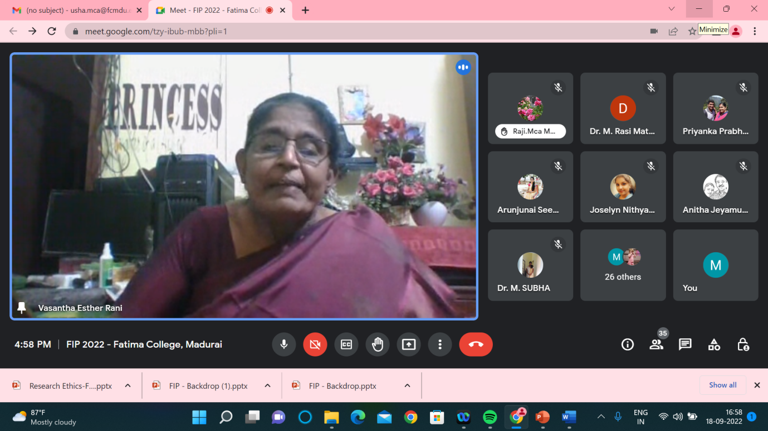

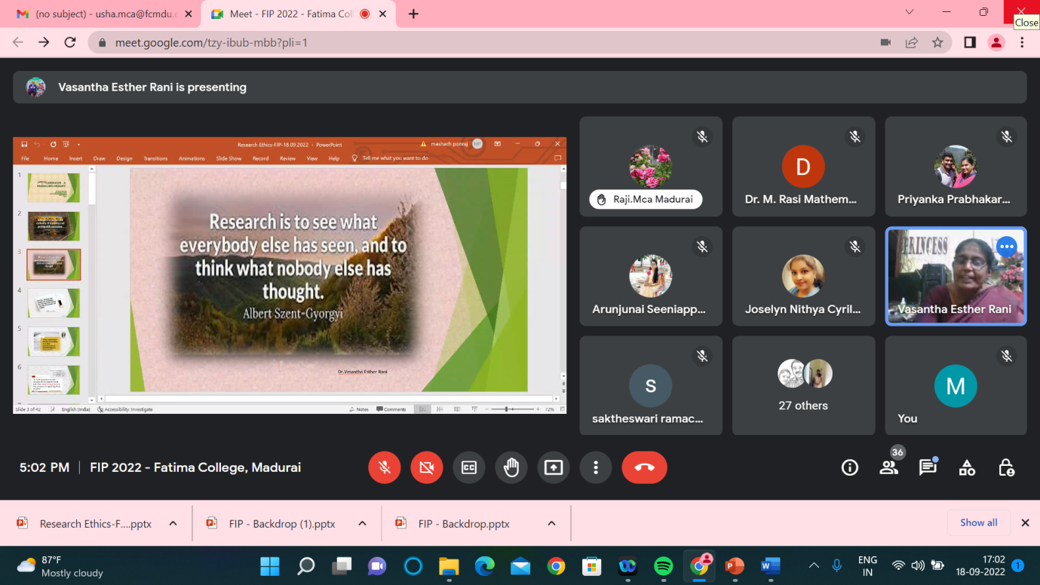

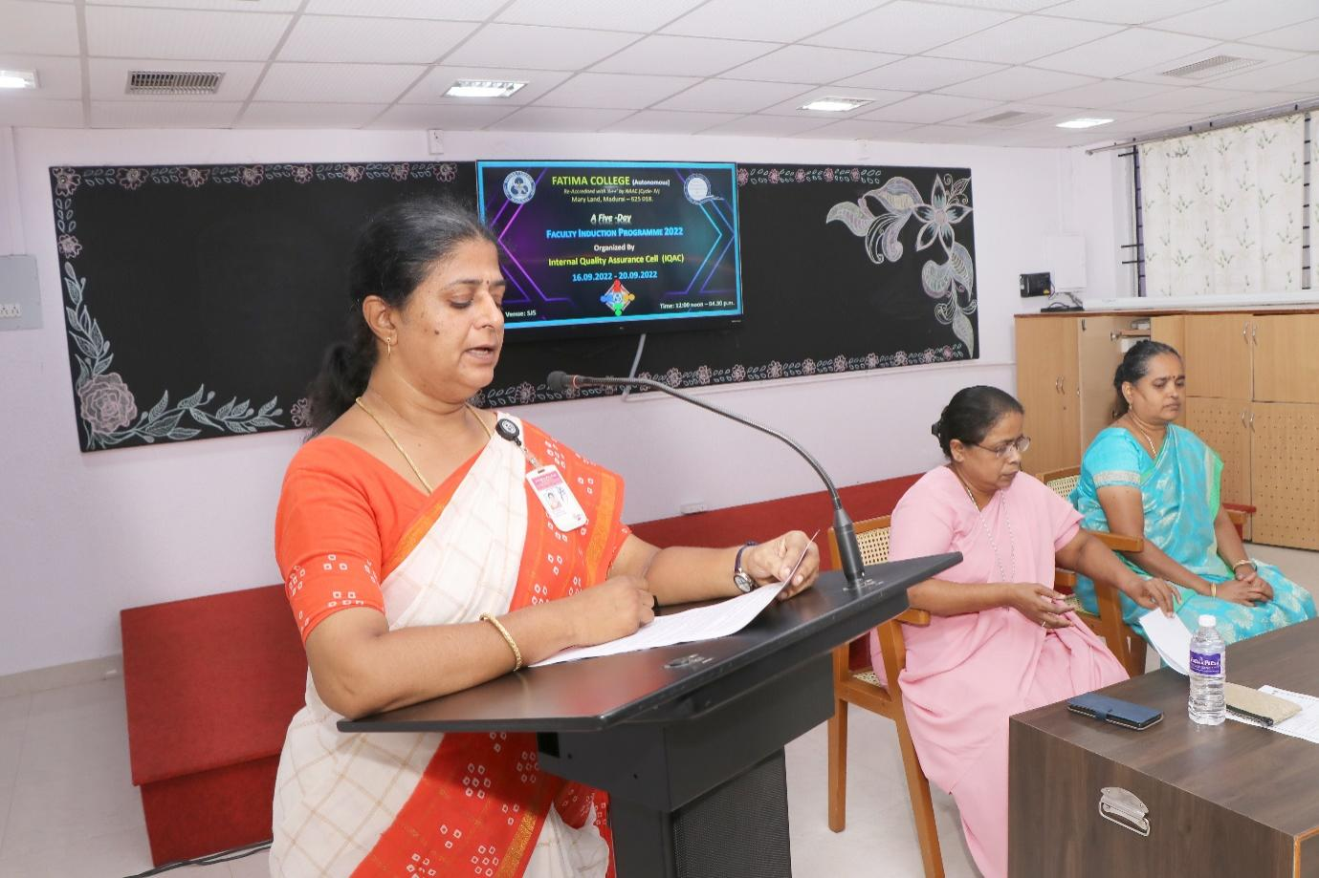
Date: 19.09.2022
Session 1: LATERAL THINKING
The session was addressed by Dr. K. Rosemary Euphrasia, Associate Professor of Computer Science & IQAC Coordinator, Fatima College. She enlightened the participants about LATERAL THINKING, required to be a competent teacher. Various innovative methods on problems and solutions were elaborated in detail. She highlighted certain techniques to think from a different perspective – OUT OF BOX THINKING. As an add-on credit to the topic, she gave an insight towards two categories of thinking – convergent and divergent.
She cited the story of Hare and the Tortoise as an example to make the attainment of the session very clear. To conclude, she motivated the faculty regarding the ‘change’ to be instigated in young minds to develop their creativity. She quoted that creativity leads to ultimate happiness for the students. Exercises on out of box, lateral and logical thinking, picture illusion, rebuzz puzzles, few other games etc. were conducted which made the session lively. The lecture was very beneficial and provided the perception which a teacher educator has to overcome all challenges.
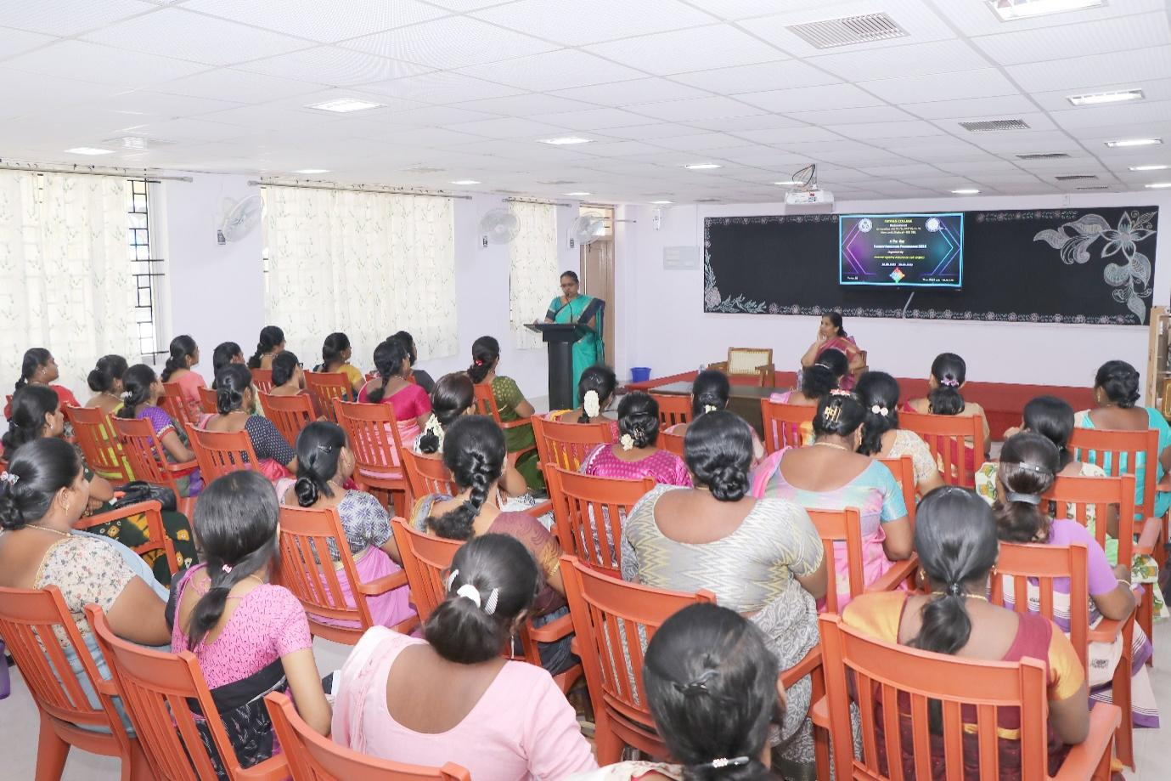
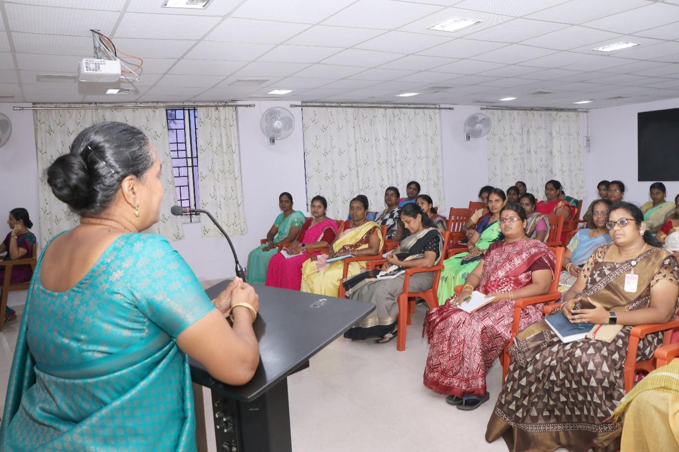
Date: 20.09.2022
The session was started with prayer followed by welcome address which was delivered by Mrs. P. Sumedha, Head and Assistant Professor of English.
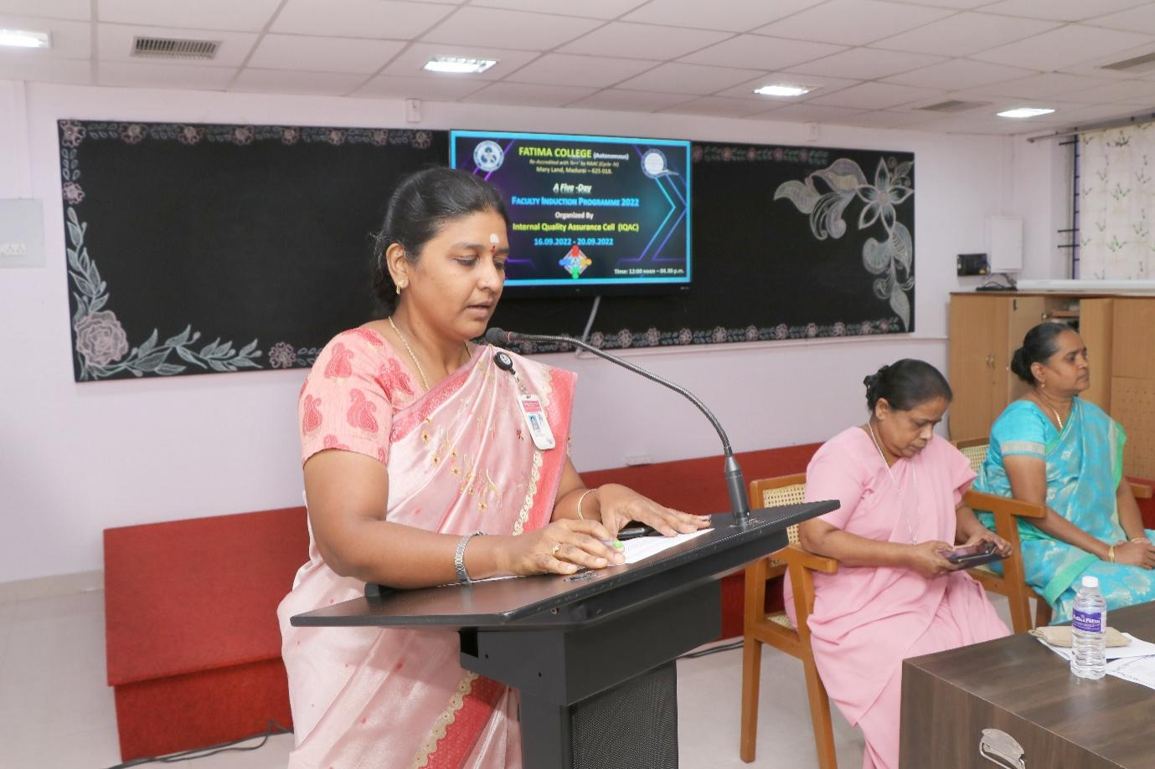The first session was delivered by the Principal Rev. Dr. G.Celine Sahaya Mary.
The aim of the session was about to highlight the aim of higher education and the role of teachers. ‘Who am I’ is a sensitive question highlighted to the teachers. The sense of unity was sensitized and emphasized by the founder’s vision. The importance of meditation was brought out through which self-mastery could be attained. Besides this she emphasis on contentment in one’s professional life is explained through stories. The importance of counselling to the students was explained. Teachers were told about the professional ethics, class preparation, and active presence during the meetings, taking casual leaves and to keep a pleasant smile amidst the students.
The next session was delivered by Secretary Rev. Dr. M. Fransica Flora who talked about the founder’s vision and the culture of Fatima College. Gender inequality was referred with Tamil poet Bharathiyaar’s Poetic lines. The vision of Mother Rose was insisted that it is communication in which contact becomes connection. Later on the terms and conditions of Fatima College was listed out by sister Secretary. Authoritative powers were explained to the new teacher’s right from President to the Superintendent of the college. The session was concluded with the note of the code of conduct that to be instilled.
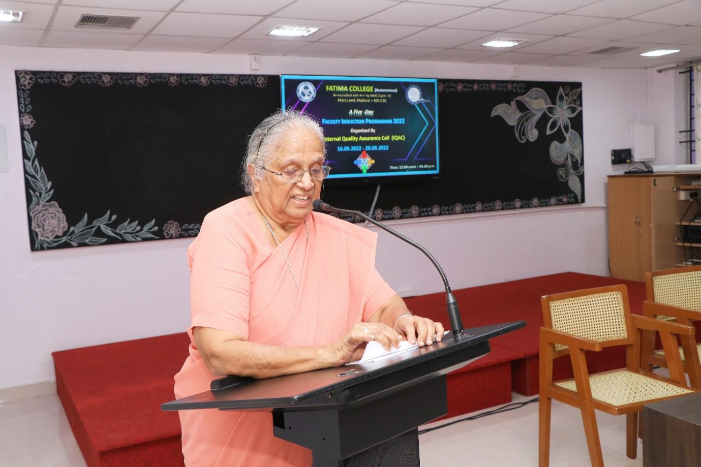
The third session was delivered by Controller of Examinations, Rev. Dr. A. Jospin Nirmala Mary.
The session began with the introduction of examination pattern and the presentation slides were displayed in which key aspects- accuracy, credibility & time, efficiency are shown. Self-learning courses for the students to update and deepen the subject knowledge was explained. The lecture was concluded with the care and love of the students that to be showered by the teachers.
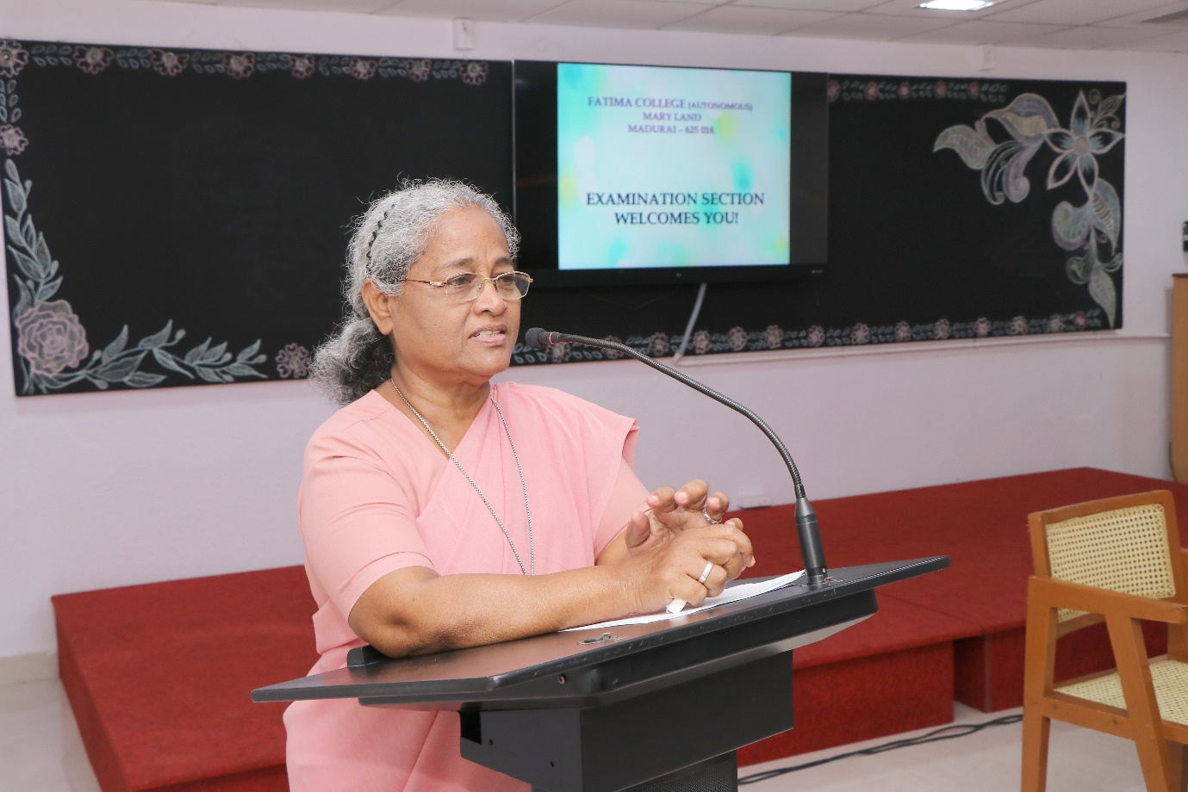
The final session was delivered by Vice Principal Rev. Dr. G. Jenita Rani.
The lecture was started with a note of the quality of a best teacher. The teachers were insisted to adopt various teaching methods based on the understanding level of the students. The session was really engaged with Shankar D. Sharma’s stories – how the teacher influenced the students and created a spark in all of us through various incidents. Finally the session was oriented with the story video played to bring in the idea of essence of teaching.

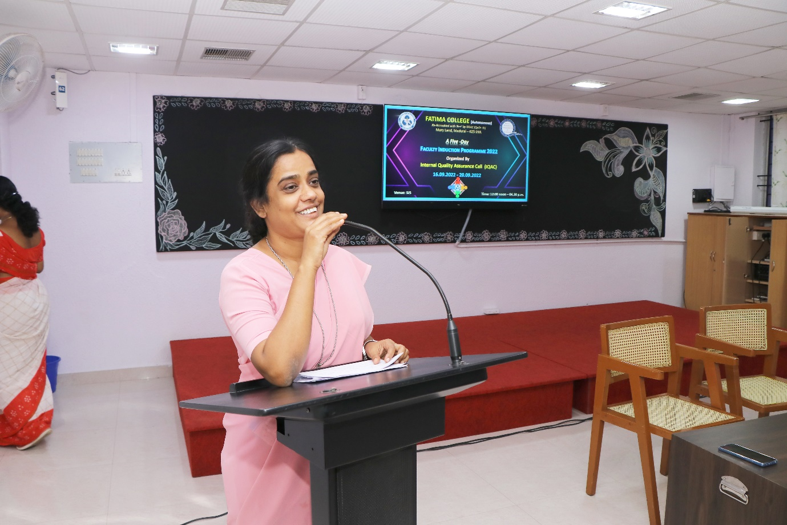
Attendance:
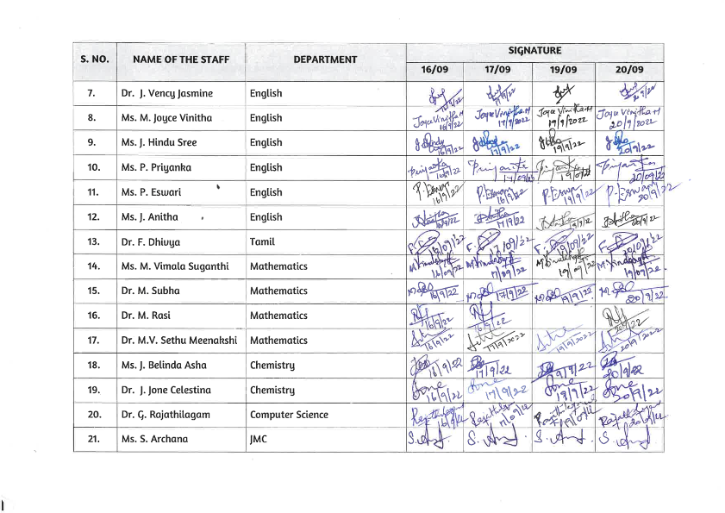

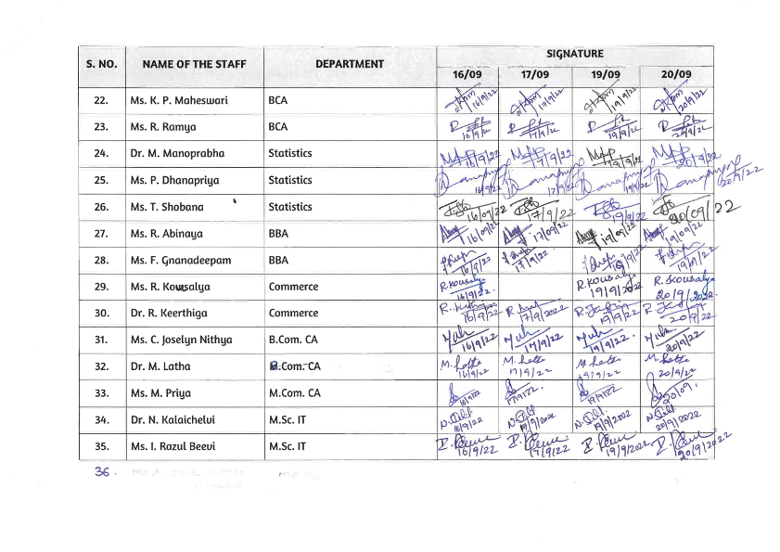

Certificates:
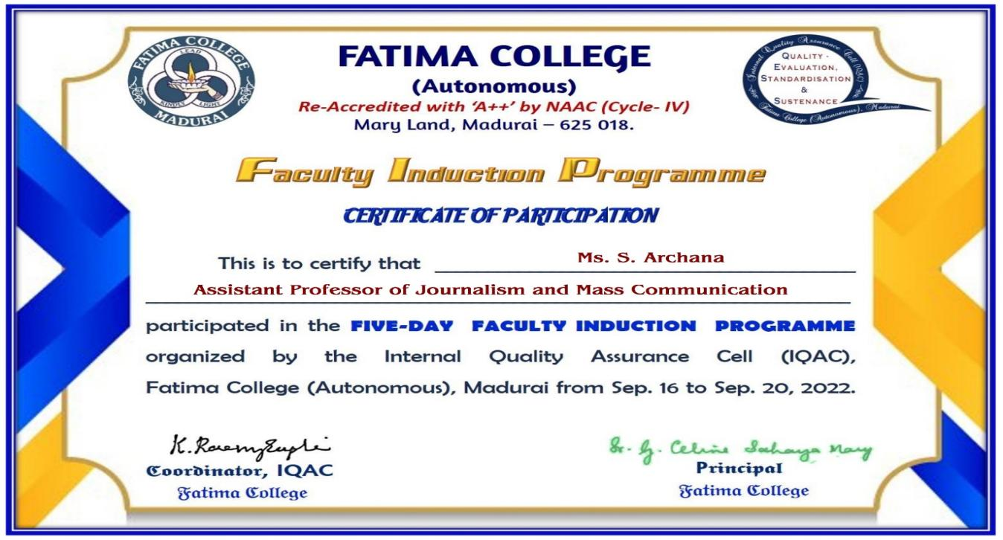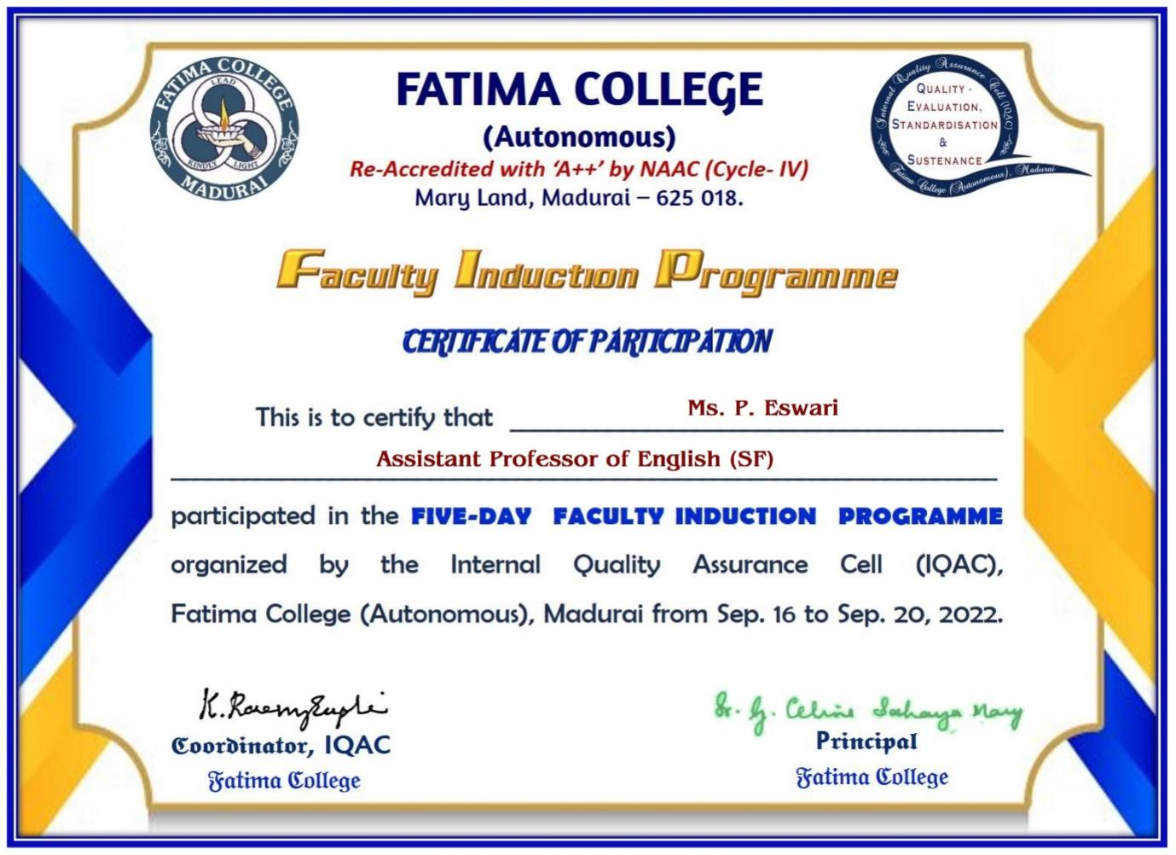

Google Form:

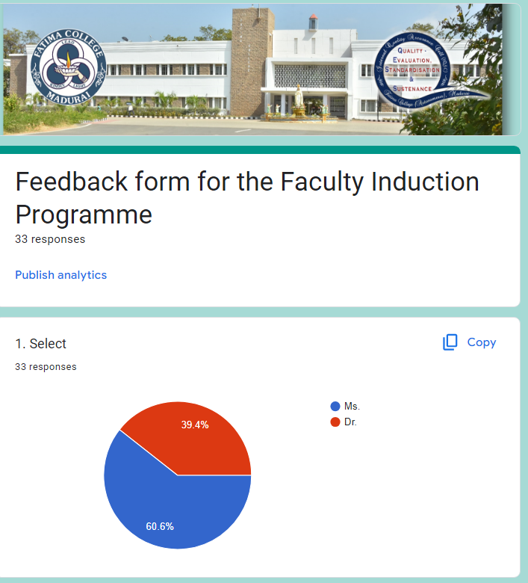

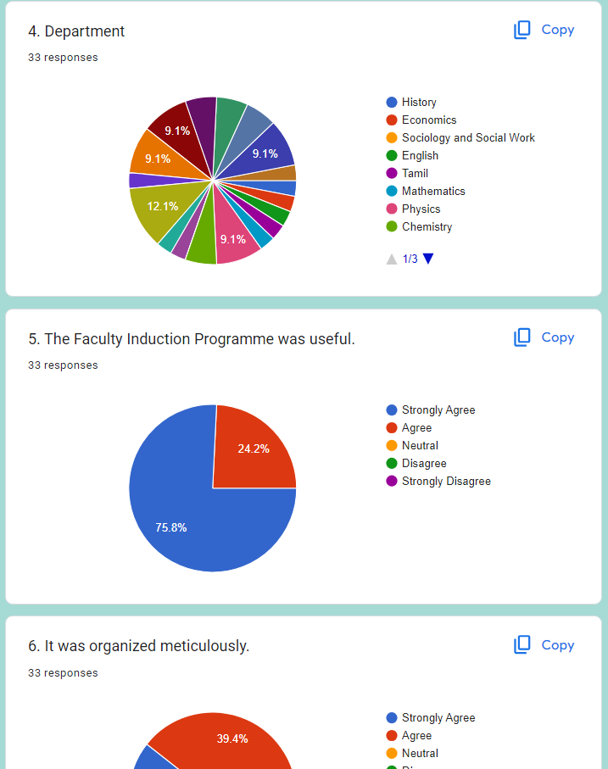
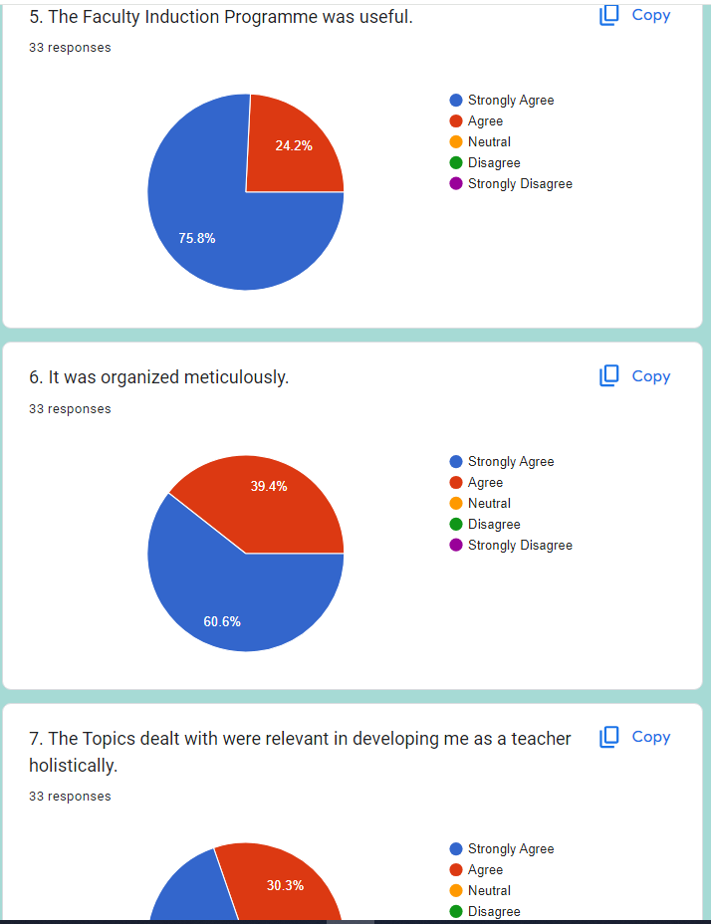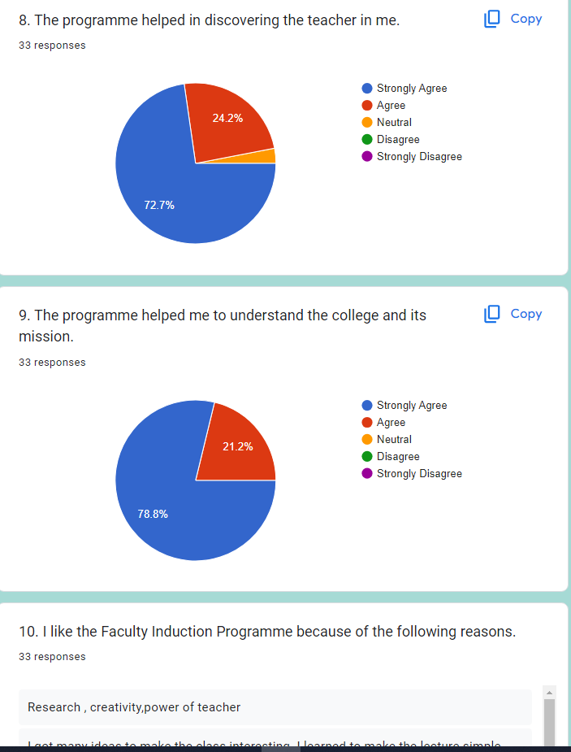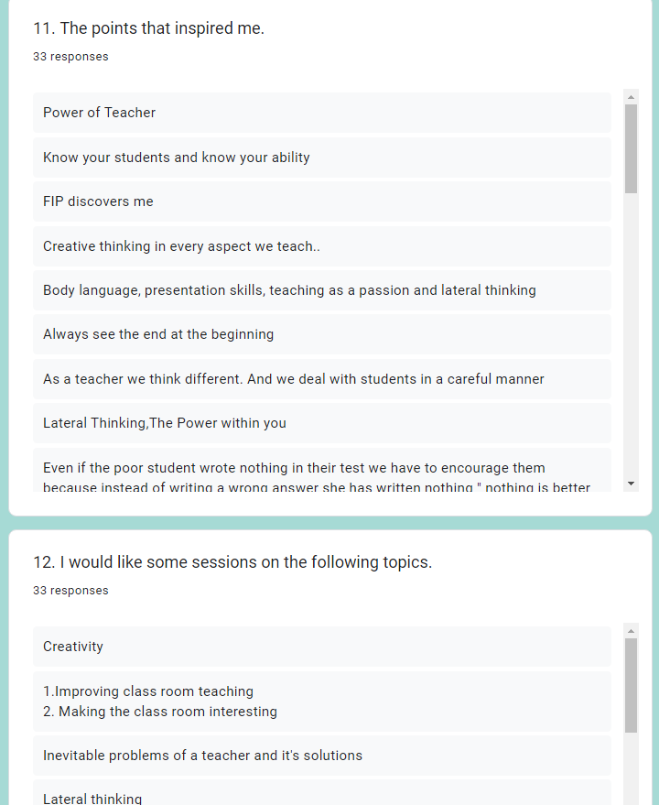

One - Day Faculty Enrichment Programme on
Enhancing Personal and Professional Competencies
October 29, 2022
Faculty Enrichment Programme organised by IQAC
Report
A one – day Faculty Enrichment Programme was successfully conducted by the IQAC of Fatima College on October 29, 2022. The FEP programme received an overwhelming response with around 190 teaching staff from Shift I and Shift II. The entire programme was spearheaded by Dr. K. Rosemary Euphrasia, Coordinator of IQAC. Dr. L. Meena, Assistant Professor, MBA welcomed the audience and introduced the chief guest Dr. Alex, Associate Professor, Department of Commerce, St. Joseph’s College (Autonomous) and briefed some of his academic achievements, highlighting his expertise in training the teachers and entrepreneurs.
The floor was then open to the Guest Speaker to address the audience who began quoting Swami Vivekananda, “You are what you are in darkness.” Dr. K. Alex informed the teachers to know the importance of the place of work. He also went on to distinguish expression and communication and explained that the former is words spoken with feelings whereas the latter is words spoken without expression.
The resource person quoted various examples from history and the life of the Zen philosophers to drive his point home. He also emphasised saying, “If teachers are not updated, they are outdated.”
The entire session was split into three divisions namely Screen time, Transforming and Inspiring. Further he also stressed on the importance of reading quoting “The Society that reads will reach the pinnacle of civilization.” The resource person also narrated few anecdotes that made the session more lively, interactive and interesting. Throughout the programme the audience were very interactive and kept on participating and responding to the questions of the speaker. Dr. Alex also pointed out how a teacher has to “learn, unlearn and relearn”; how a teacher has to be always ready to learn and facilitate the needs of the students in the classroom. The relationship between a teacher and student should be meaningful and productive. He also insisted that finally the students will remember the teacher for his attitude and not essentially for his knowledge and skills.
Sir also stated the responsibility that each teacher must contain towards the institution. The life lessons they were taught by the speaker were enriching and really those were the precious take aways of the day. It was absolutely an enriching session which had rejuvenated the teachers and made them once again enlightened and refreshed.
Dr. R. Saktheswari proposed the vote of thanks and the session came to a close.
Invitation
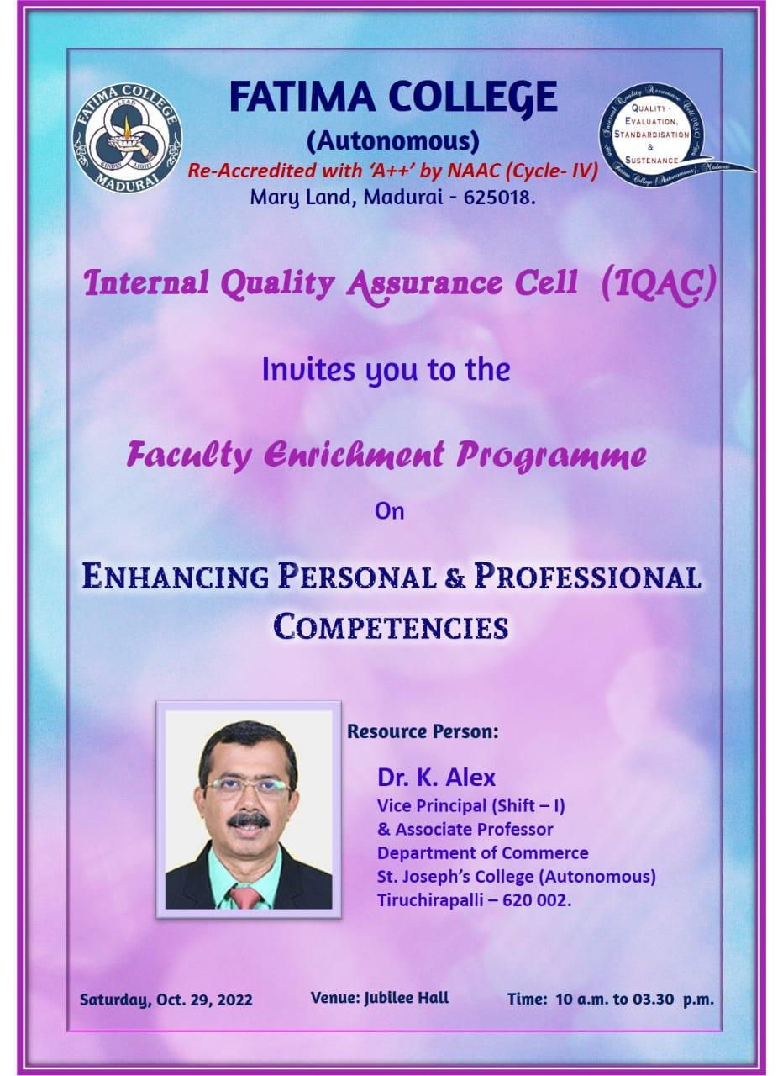

Photos
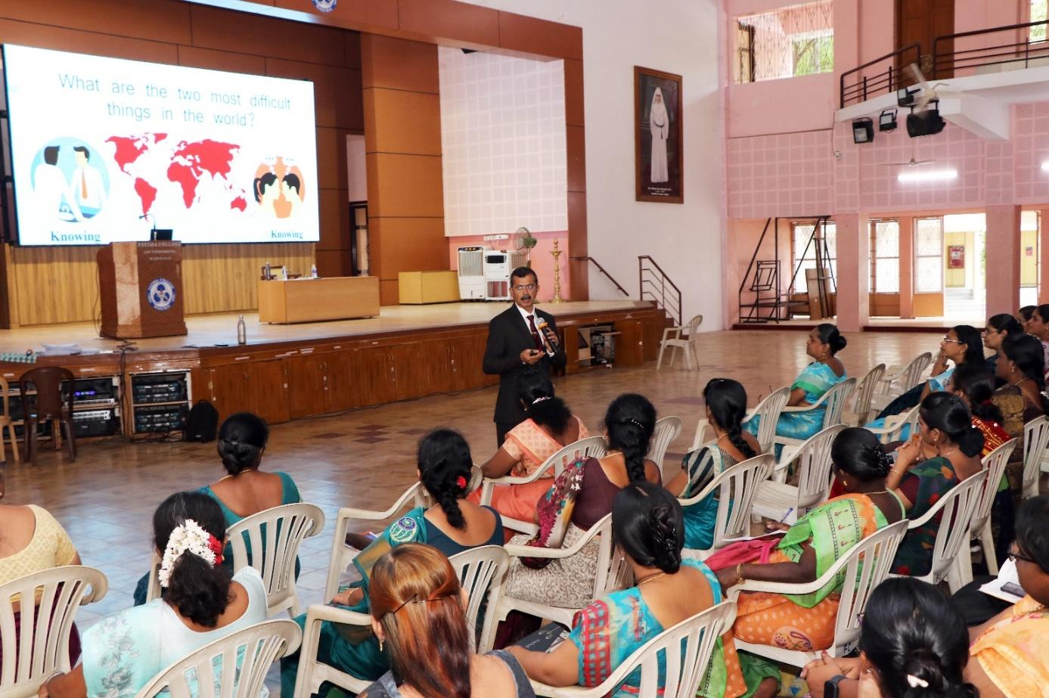
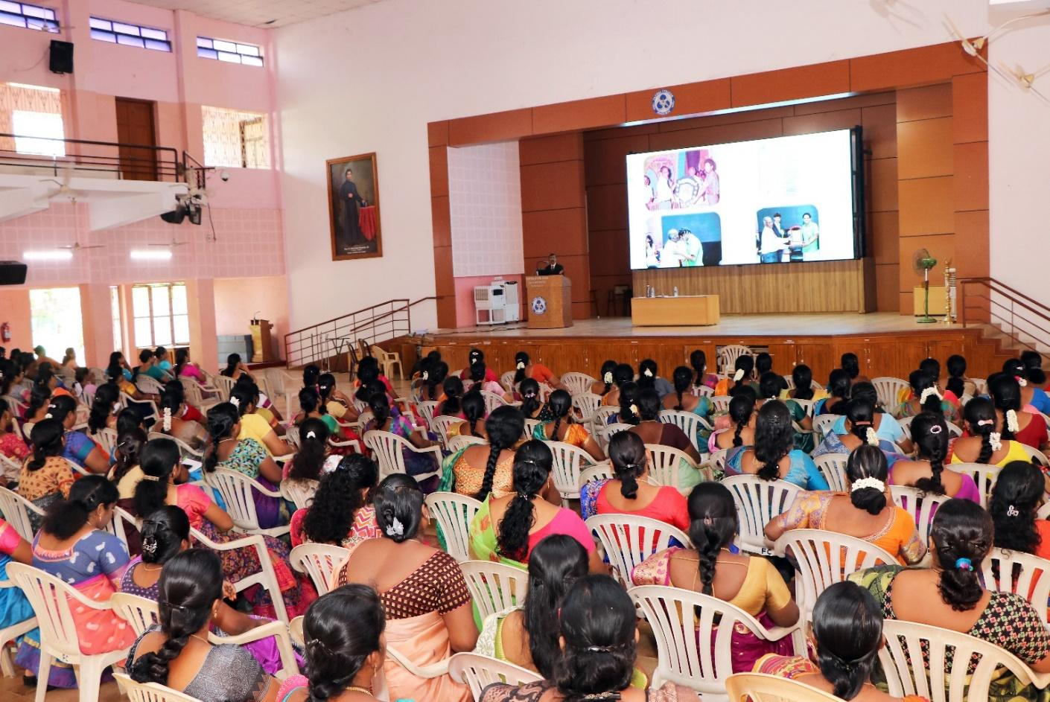

ATTENDANCE
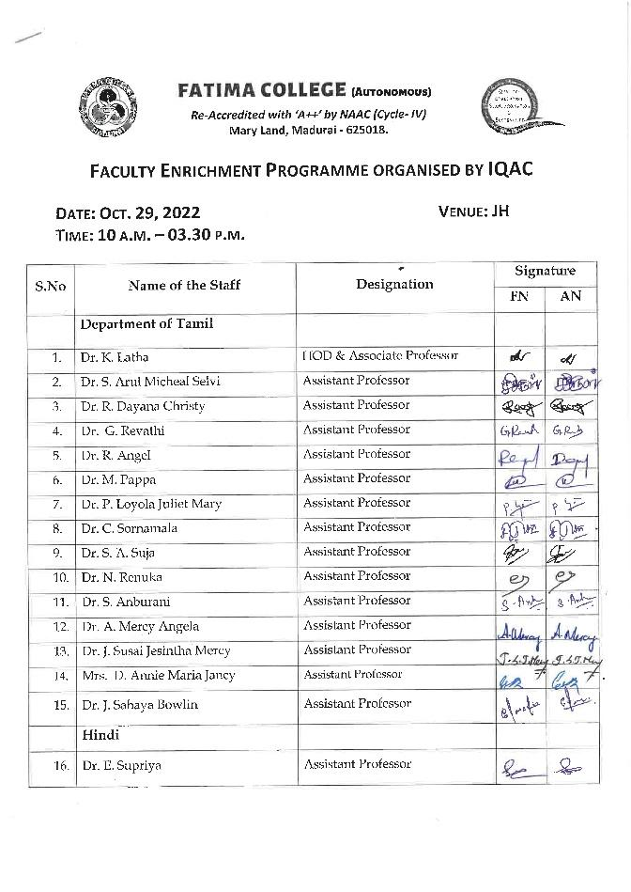 | 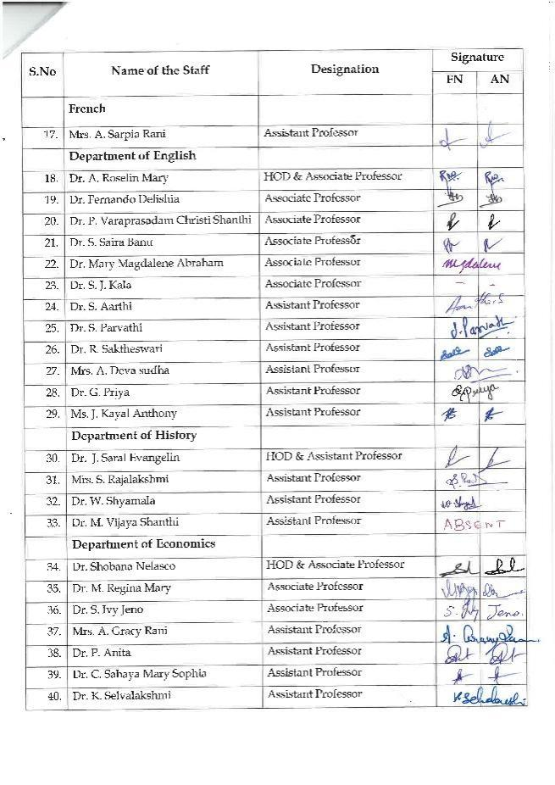
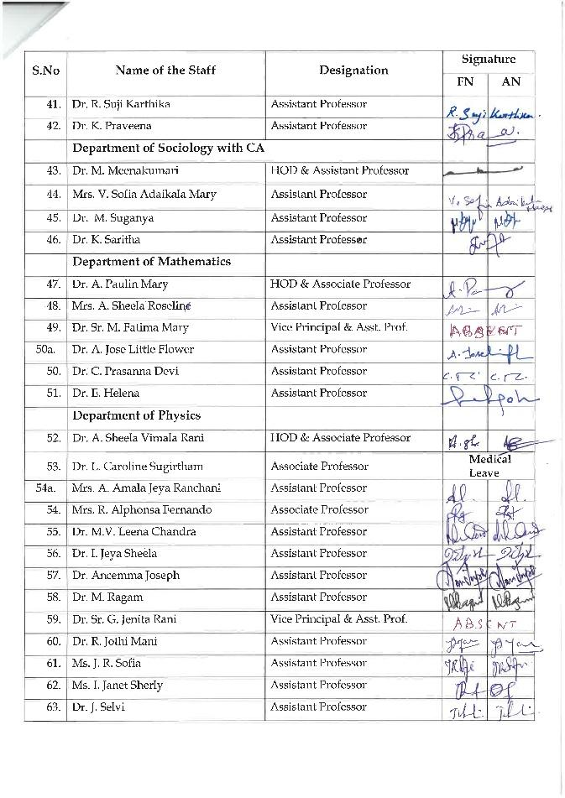 | 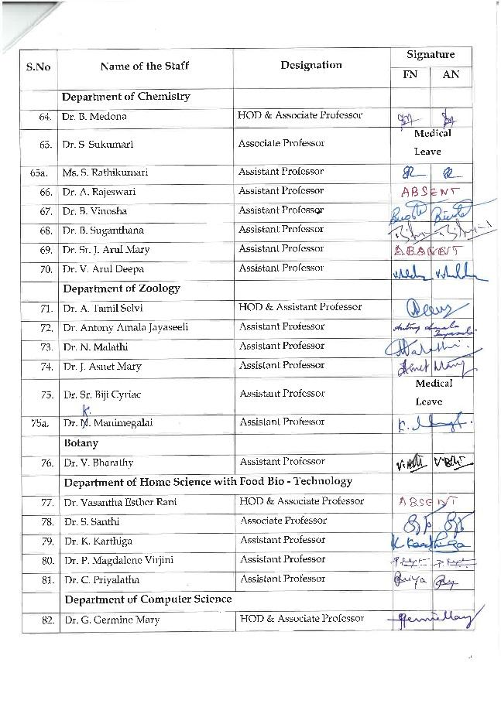
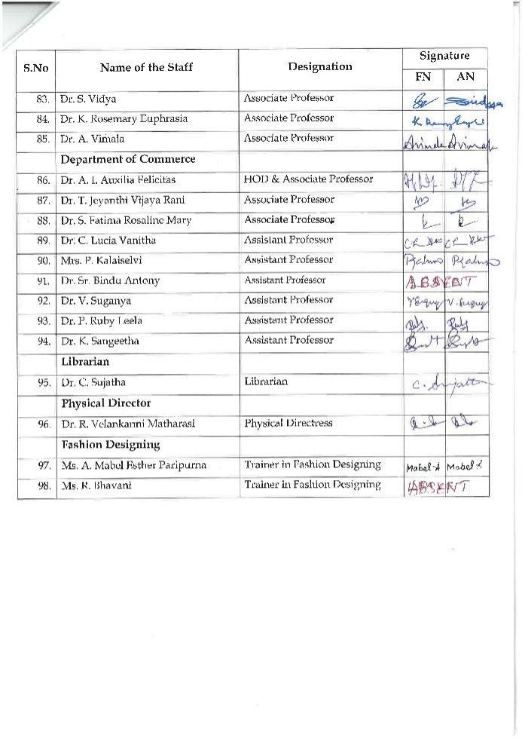 | 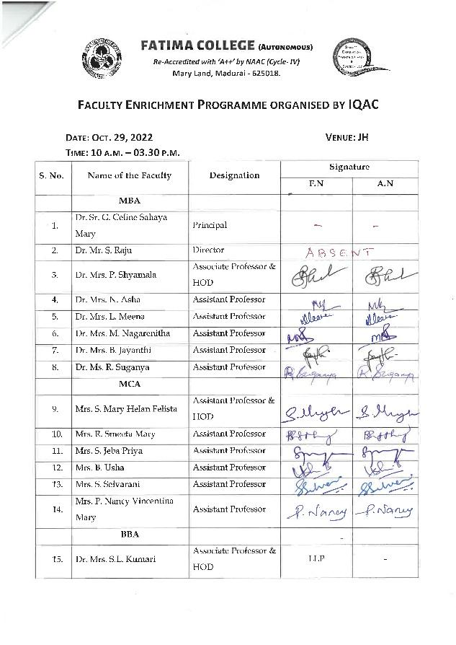
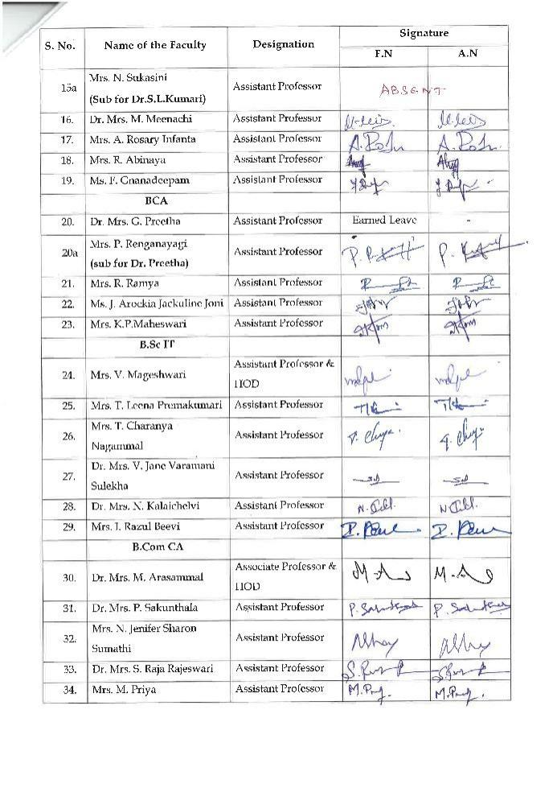 | 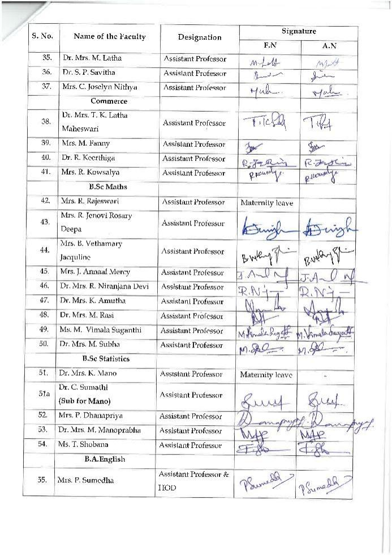
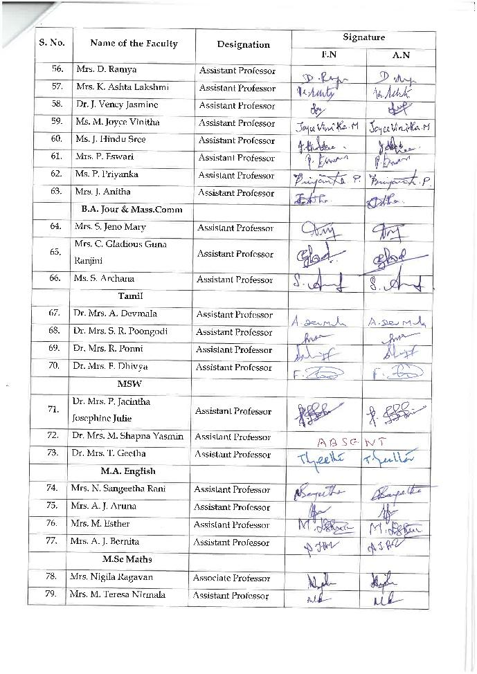 | 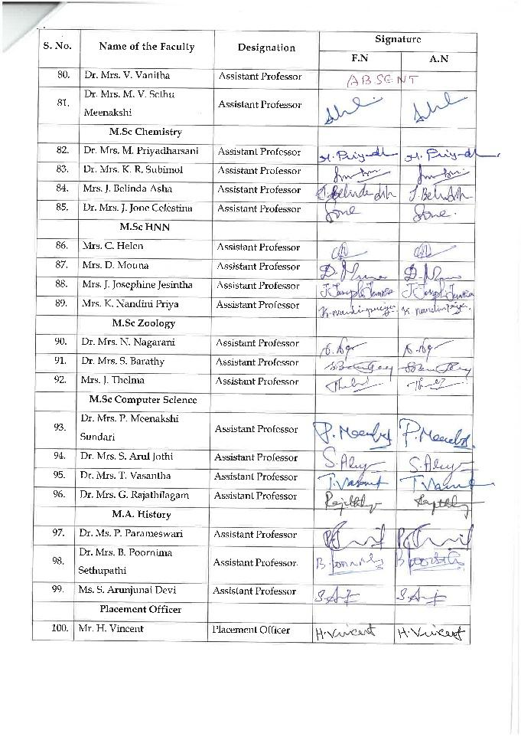
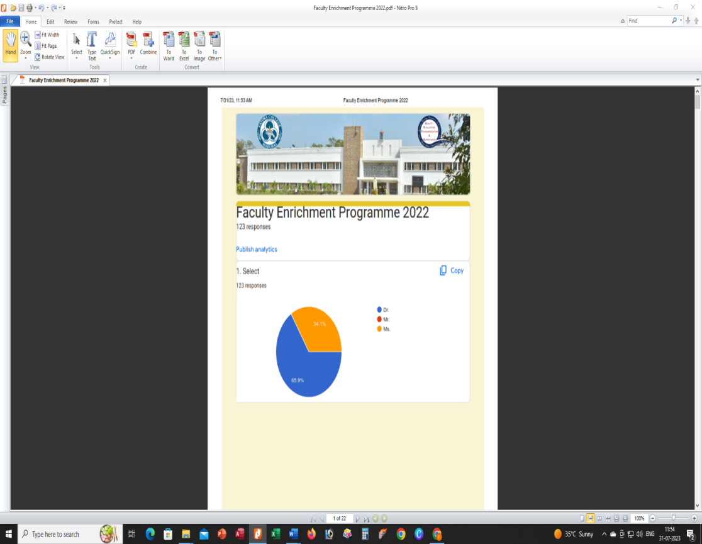
FEEDBACK FORMS
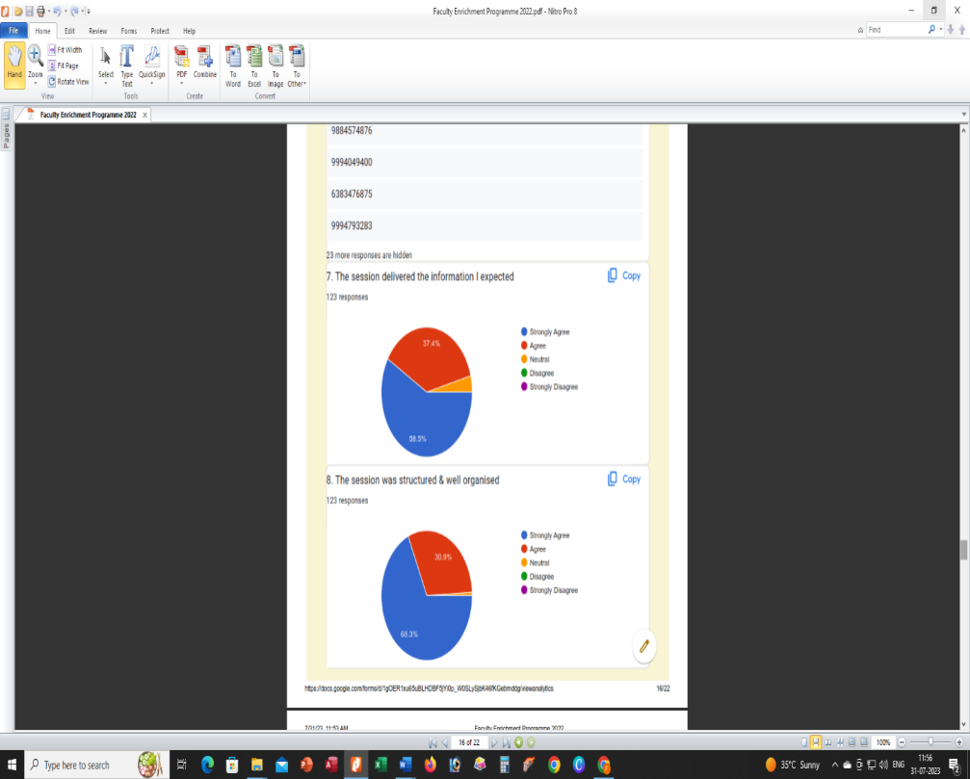

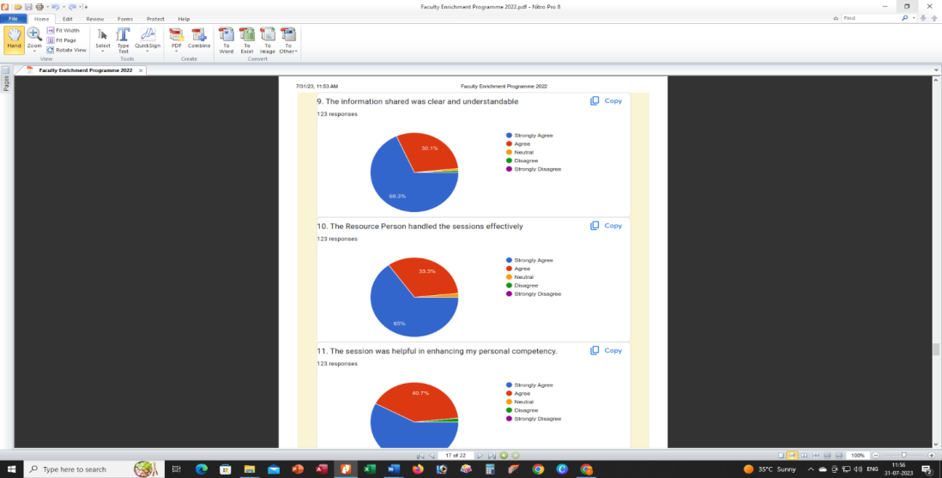
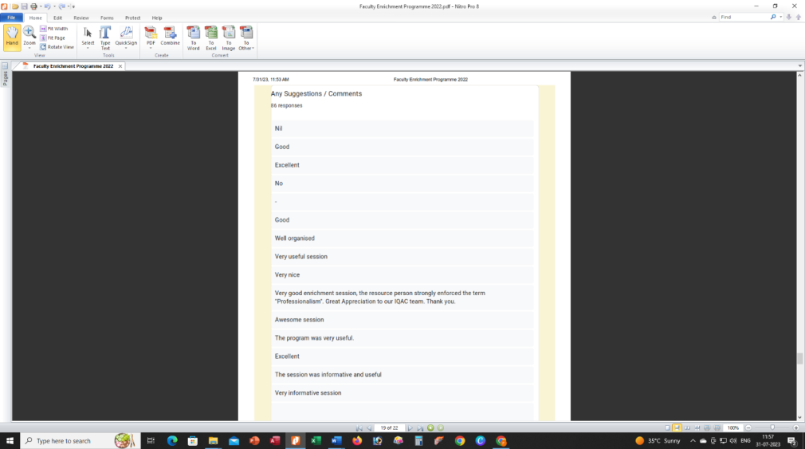

AWARENESS PROGRAMME
on
Health & Therapeutic Benefits of Millets
for the Non-Teaching Staff
Report:
The 2023 International Year of Millets is a chance to increase public knowledge of the many advantages of millets, ranging from economic growth and environmental sustainability to health and nutrition. The Year will improve the relationship between science and policy, foster collaborations, inspire stakeholders to take initiative in developing and producing millets, and promote millets' use by the general public.Everyone has a part to play, including home cooks, chefs, young people, and representatives of the public and business sectors. To fully realise millets' potential for improving human and planetary health and wellbeing, we must cooperate.
To commemorate the International Year of Millets (2023), IQAC of Fatima College and The Research Centre of Home Science jointly organised a two-day' workshop for their non-teaching and sub-staff at the Food Science Lab, The Research Centre of Home Science, Fatima College, Madurai. IQAC members welcomed the chief guest, and Dr. Rosemary, Associate Professor of Computer Science and Co-Ordinator of IQAC, inaugurated the programme. Mr. Mariappan discussed the value of millet and the reasons it's considered a nutritious diet. After giving a demonstration of how to cook using millets, he gave each group a task to prepare a meal using millets. The employees made a variety of foods, including small grains laddu, saamai thosai, varagu Pongal, and small grains thosai. He sampled the cuisine after the session and expressed gratitude to the groups.

Invitation
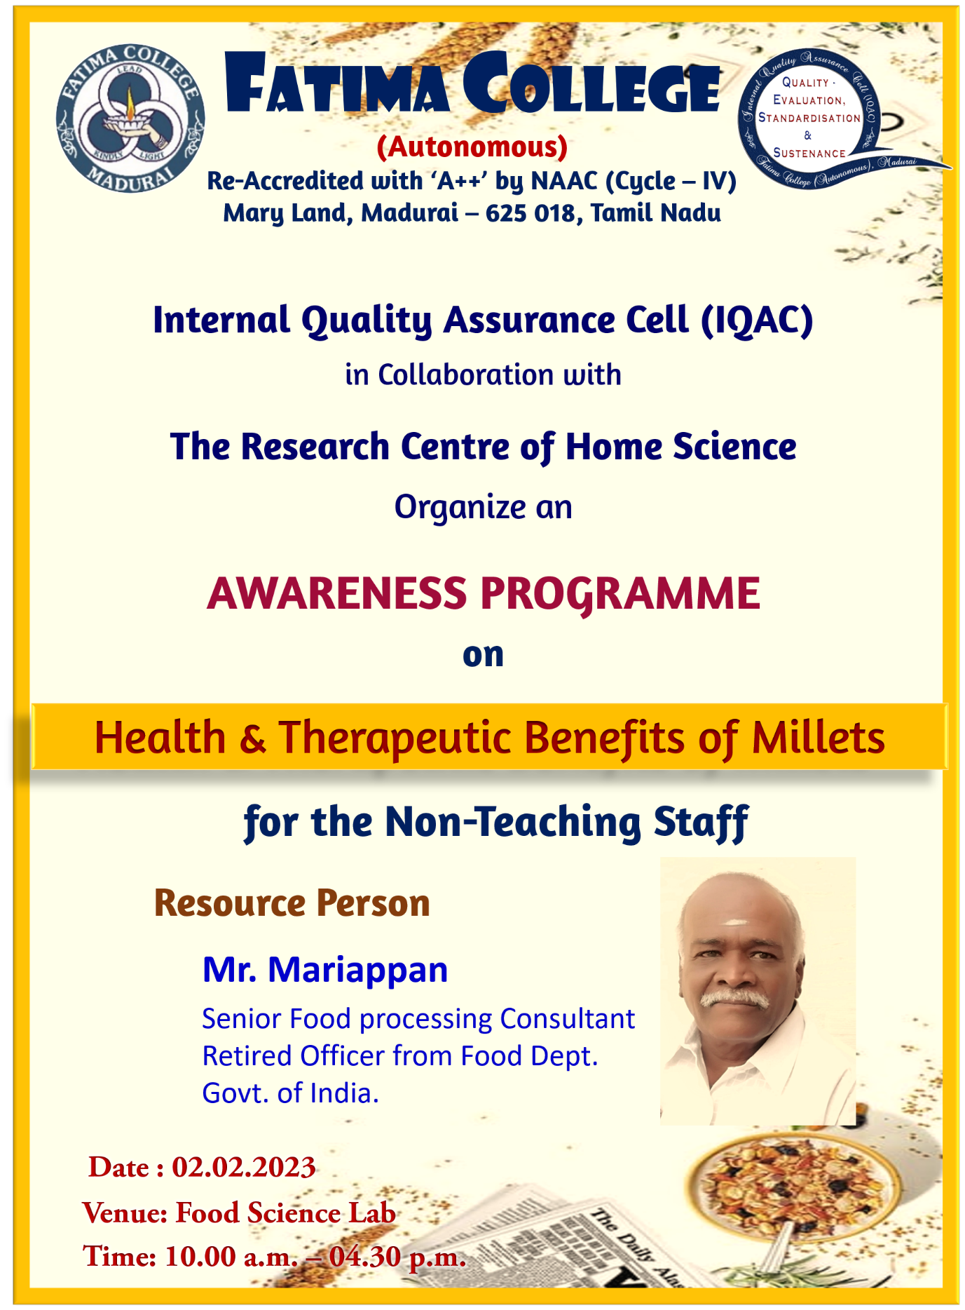

Photos
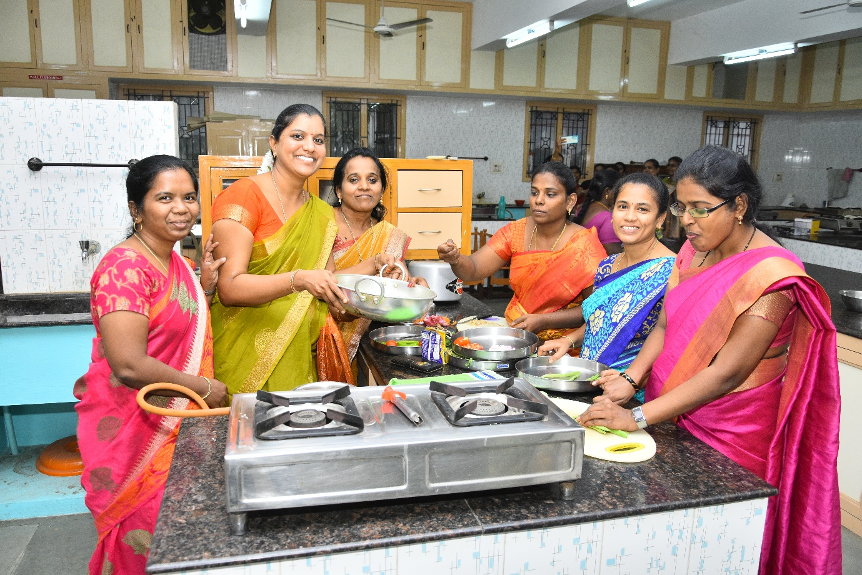

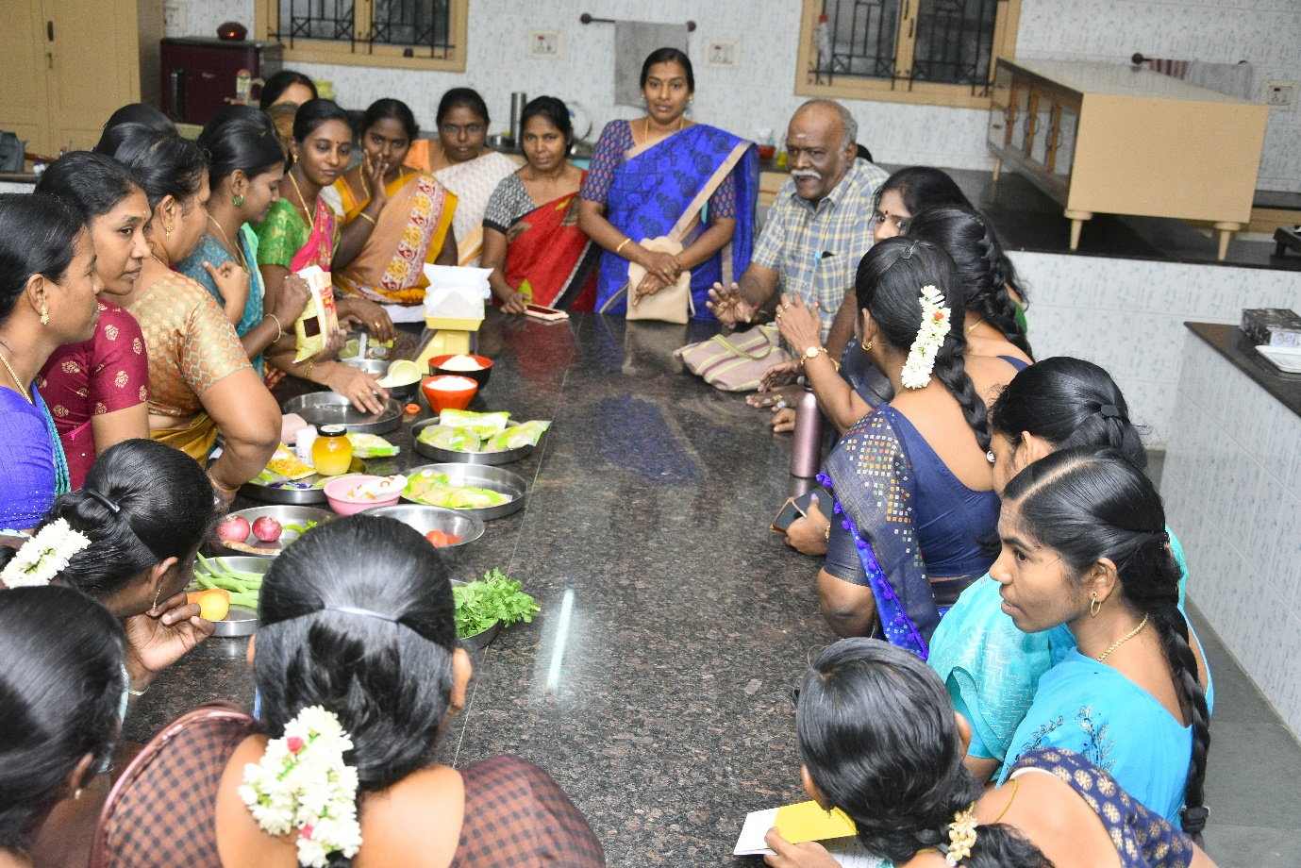

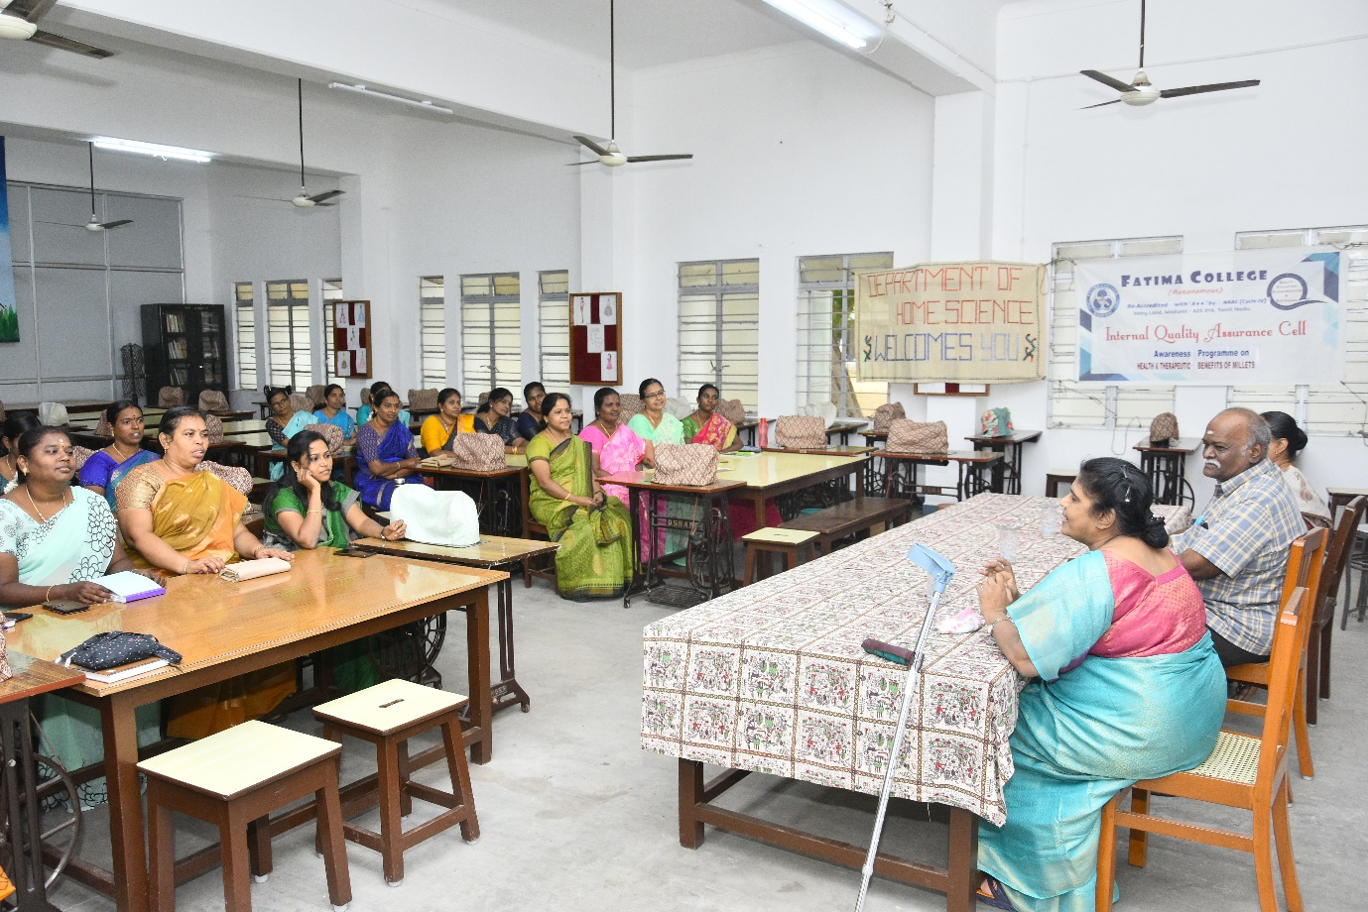

Carrying Capacity Building
on
Healthy Millet Recipes
Report:
The Fatima College sub-staff members were the target audience for the programme. They enthusiastically engaged in the programme and displayed their abilities in a competitive manner. The main guest acknowledged their curiosity and gave them advice on how to promote the cuisine locally.
Outcome: This event was being recreated by non-teaching and support staff members. They got the notion to start their own business.
Invitation
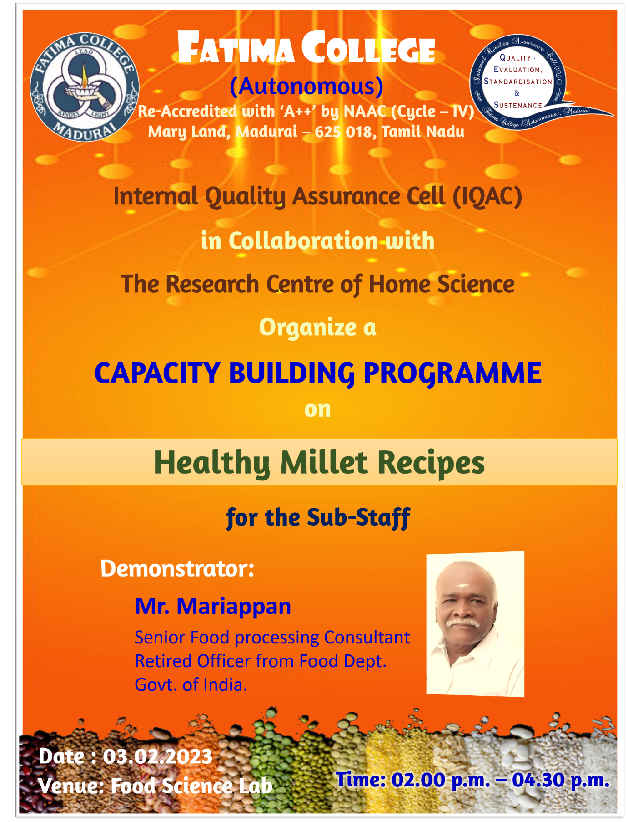

Photos
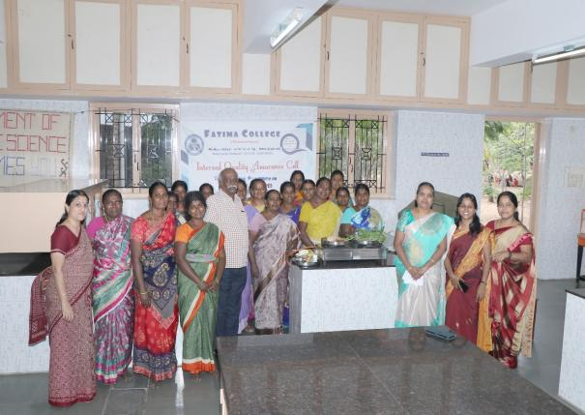
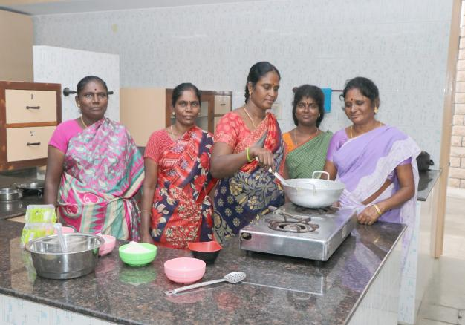

Attendance:
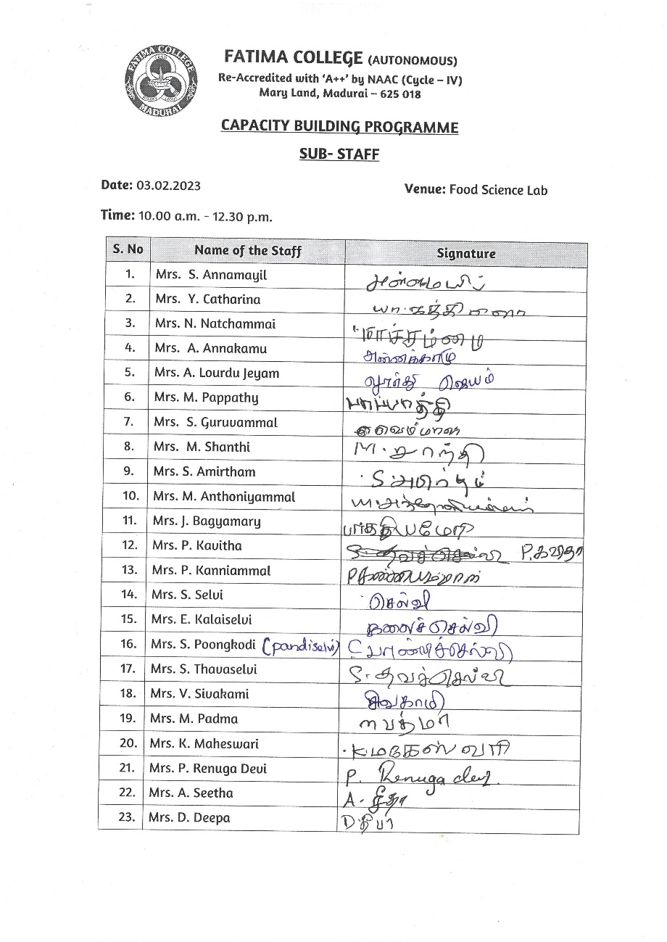

Feedback Form:
