**LMS (Learning Management System)**

**Fatima College has provided infrastructure for LMS usage in classrooms for all departments**

**Google Classroom as an LMS Screen shots of Google Class room**

**DEPARTMENT OF MBA**

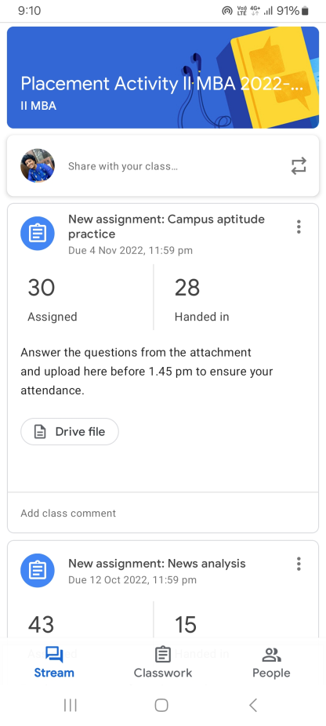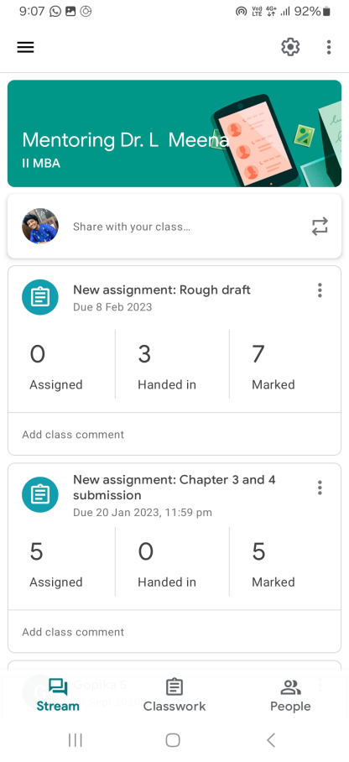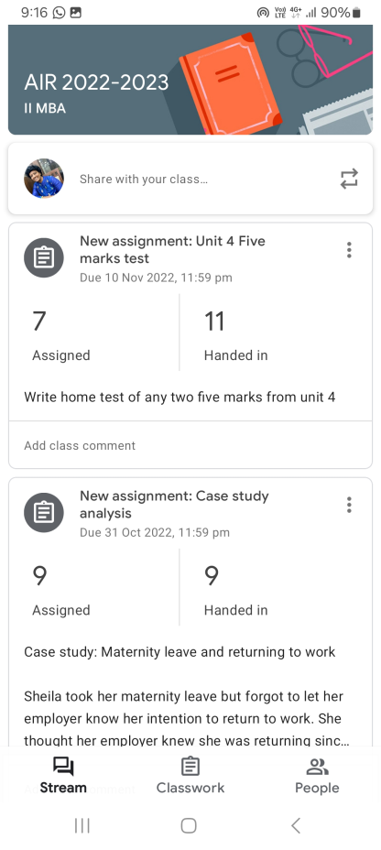

**Google Classroom of Dr. L. Meena**

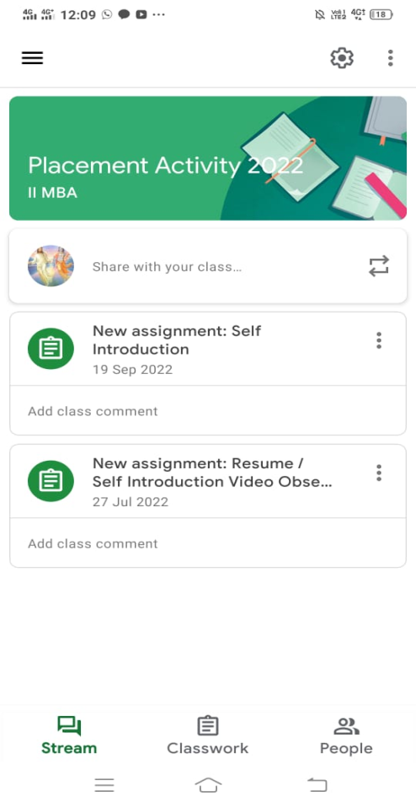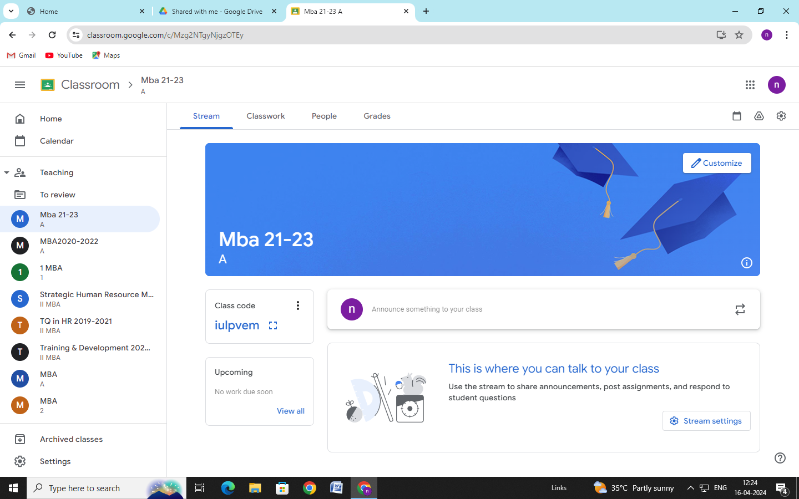

**Google Classroom of Dr. M. Nagarenitha**

**DEPARTMENT OF MCA**

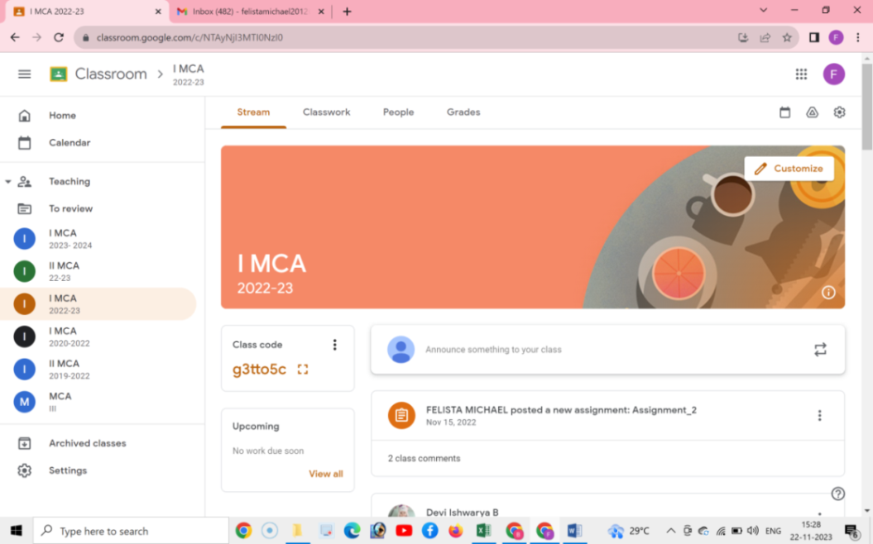

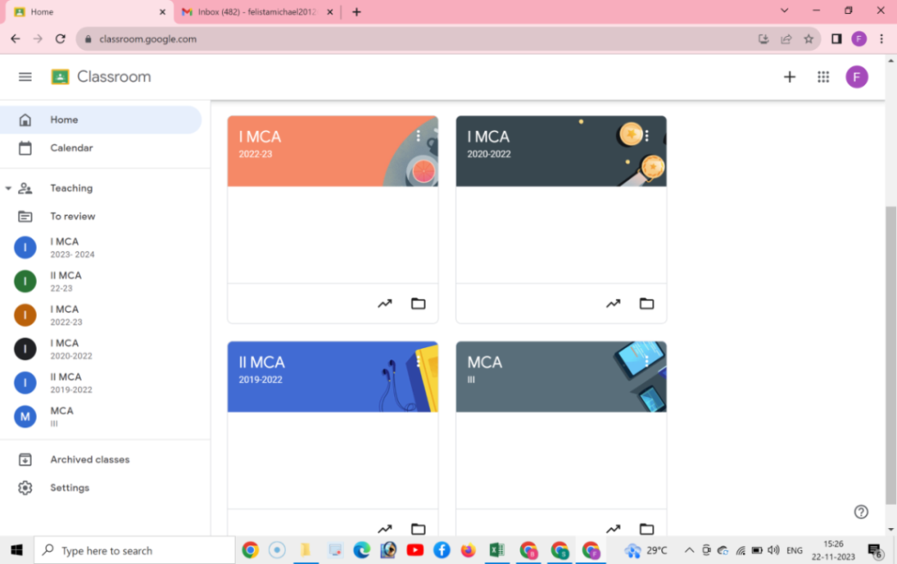

**Google Classroom of Mrs. S. Mary Helan Felista**

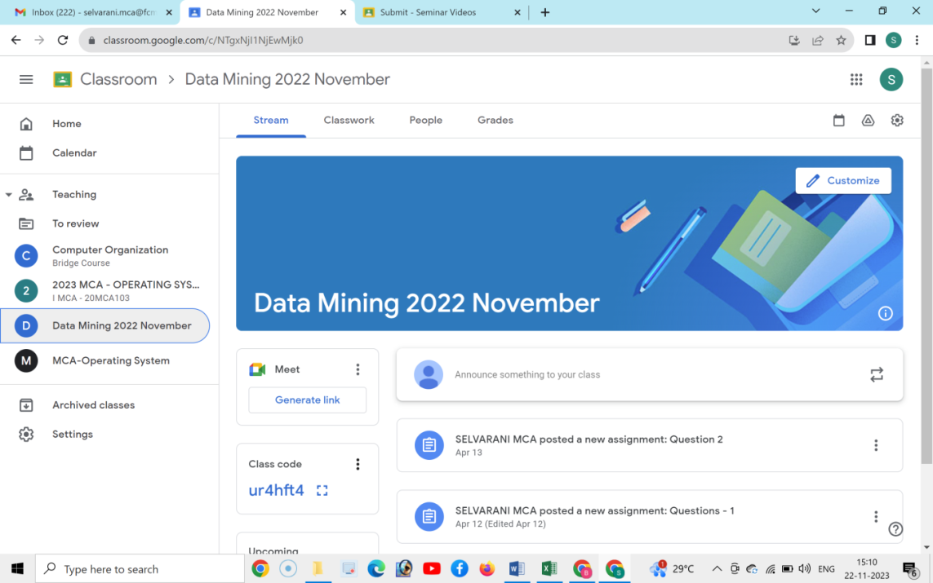

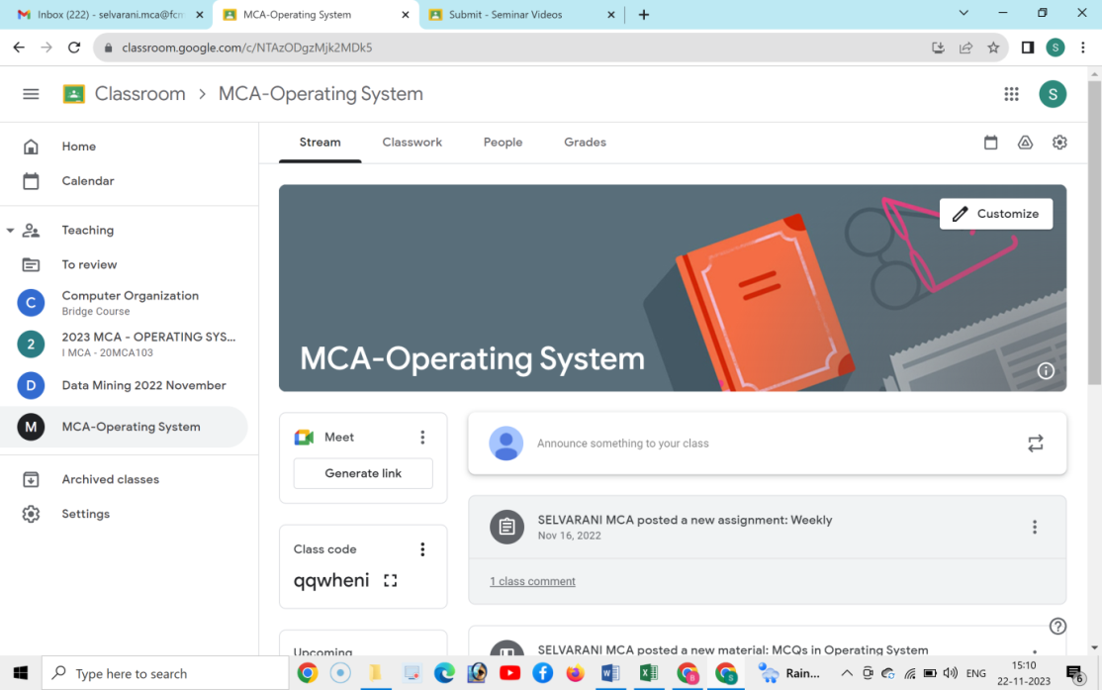

**Google Classroom of Mrs. S. Selvarani**

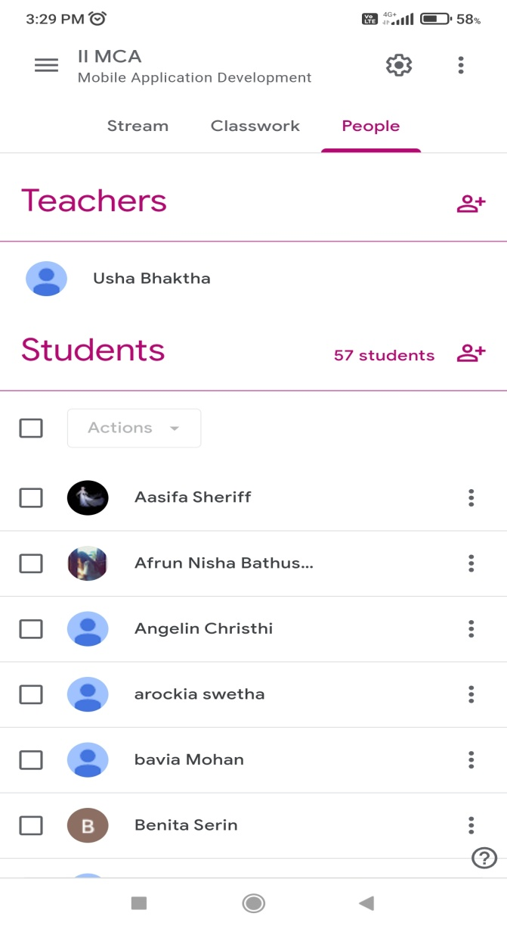

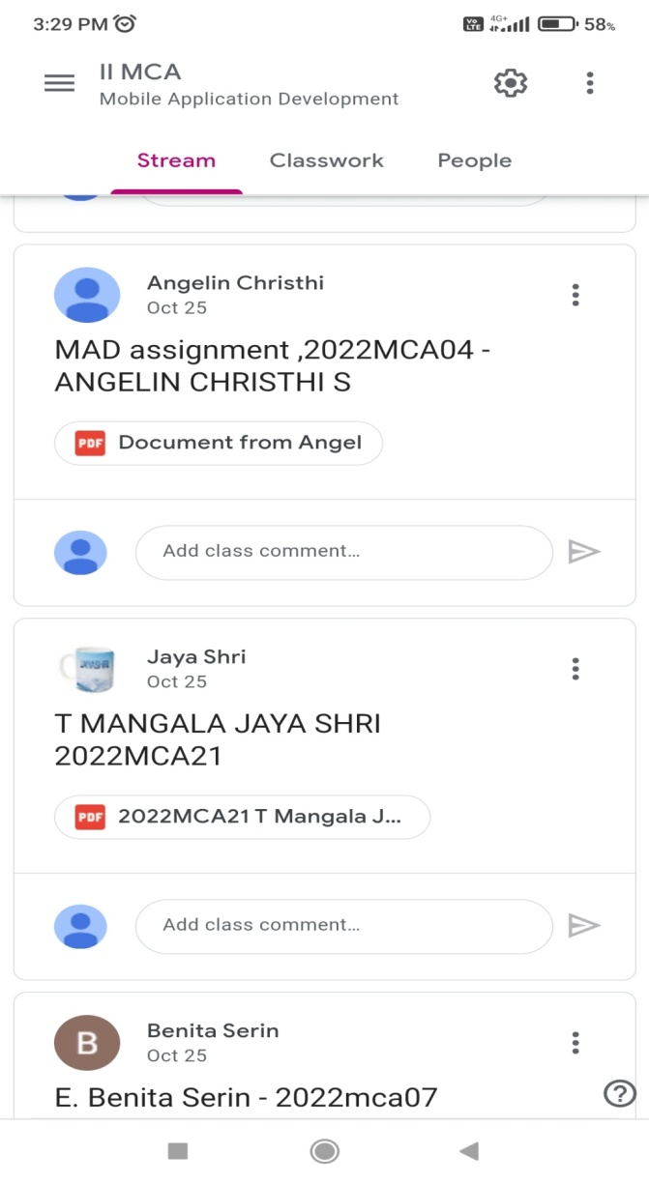

**Google Classroom of Mrs. B. Usha**

**DEPARTMENT OF COMMERCE (SF)**

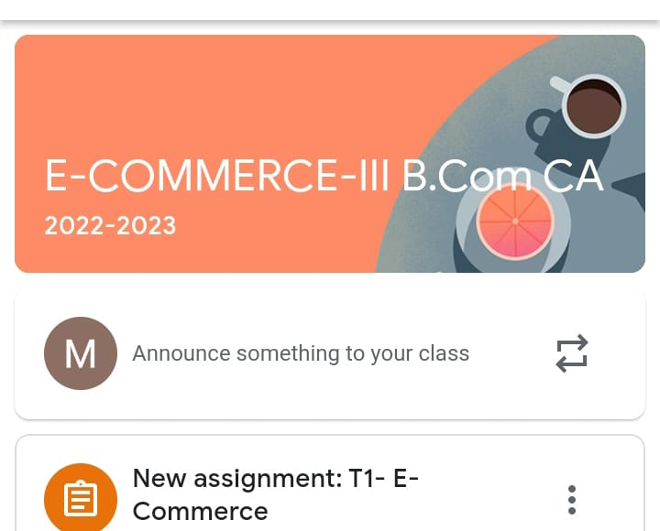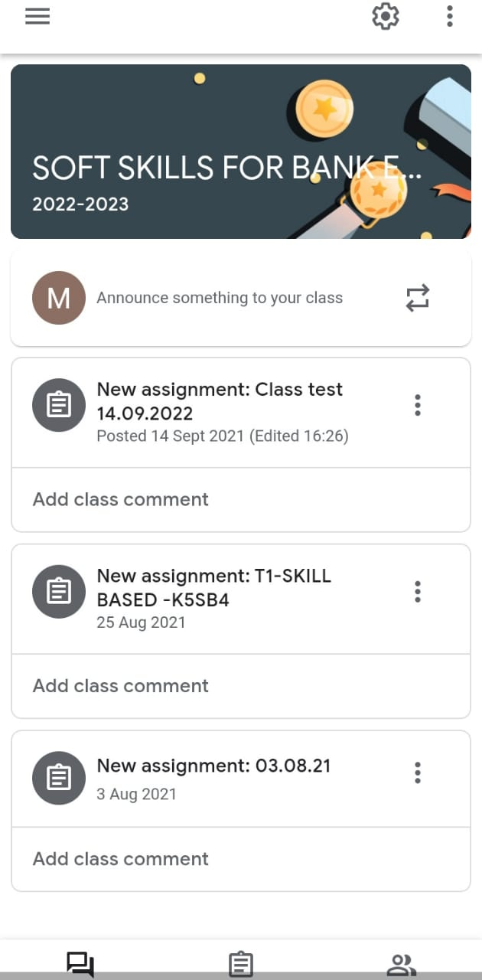

**Google Classroom of Dr. P. Sakunthala**

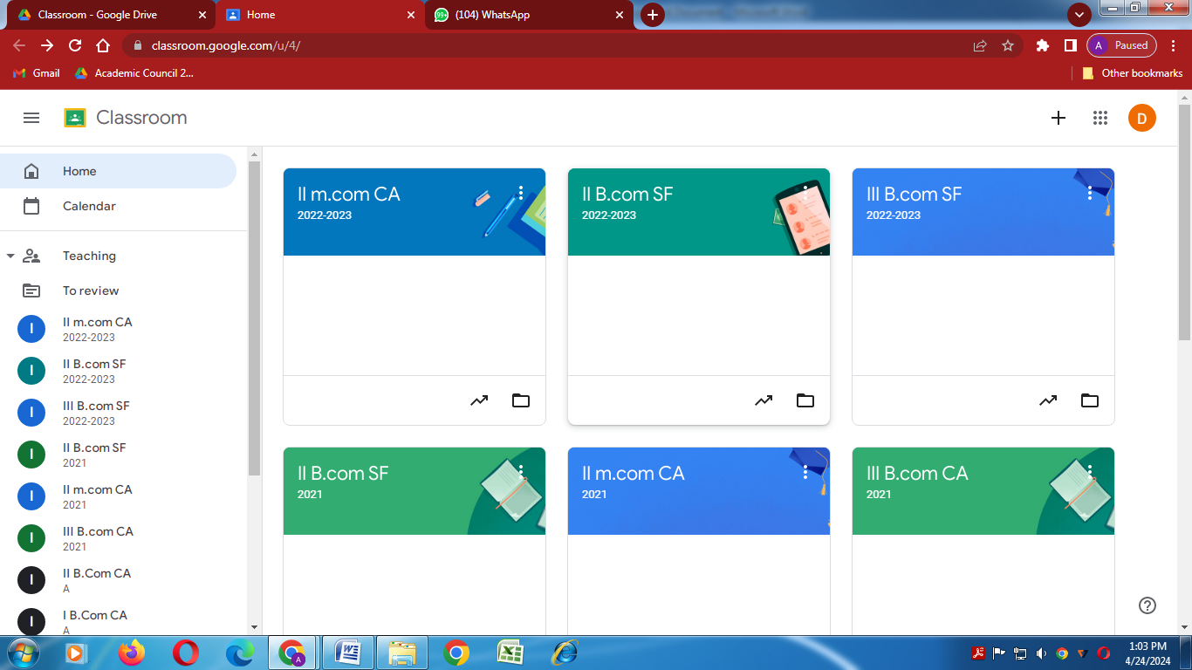

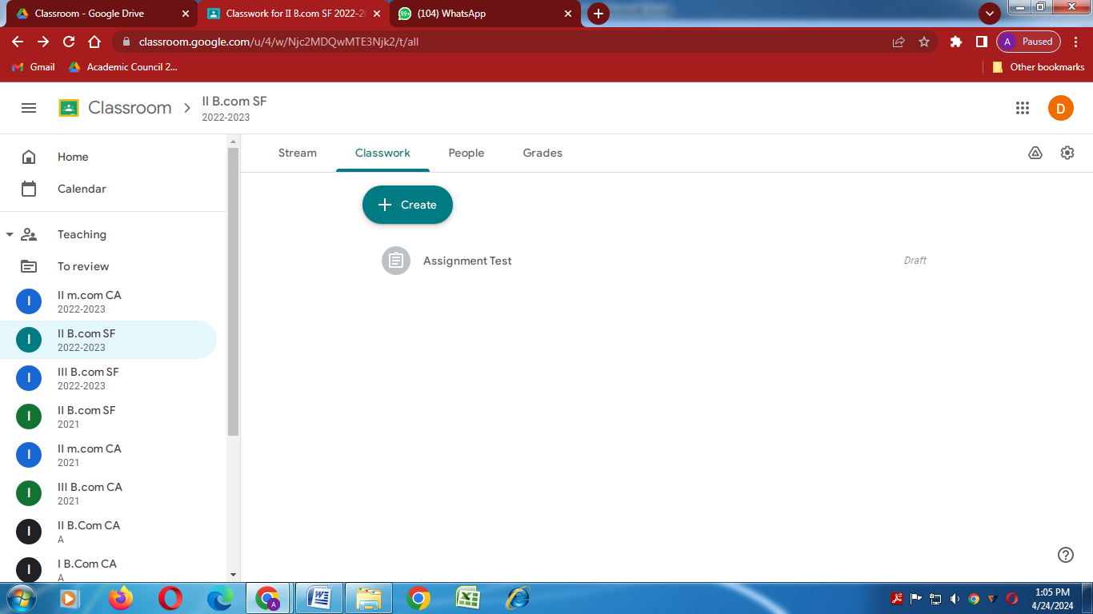

**Google Classroom of Dr. T. K. Latha Mageshwari**

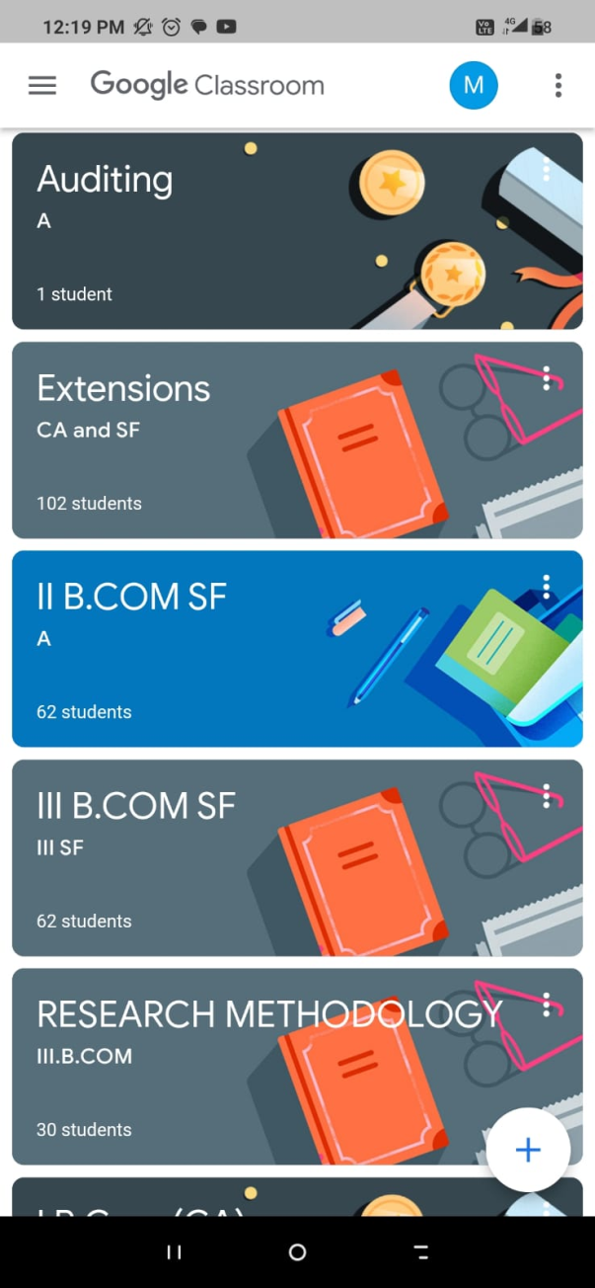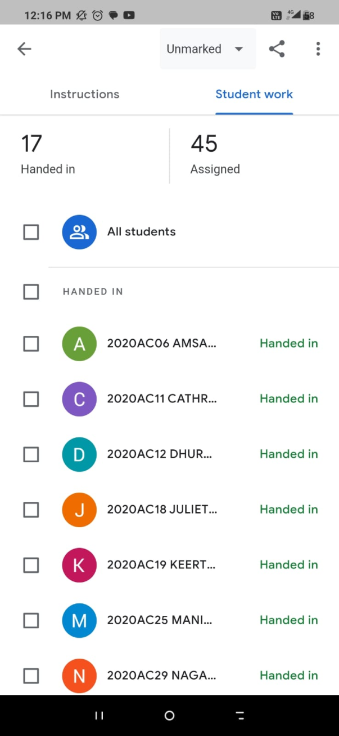

**Google Classroom of Ms. M. Priya**

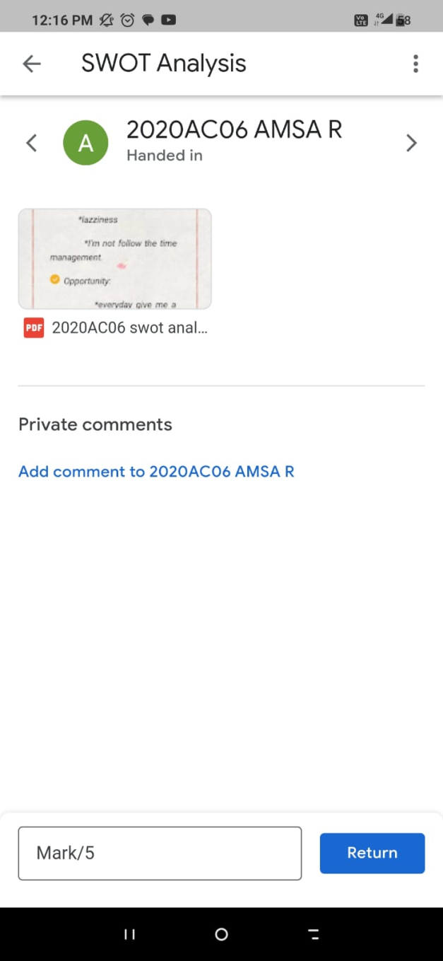

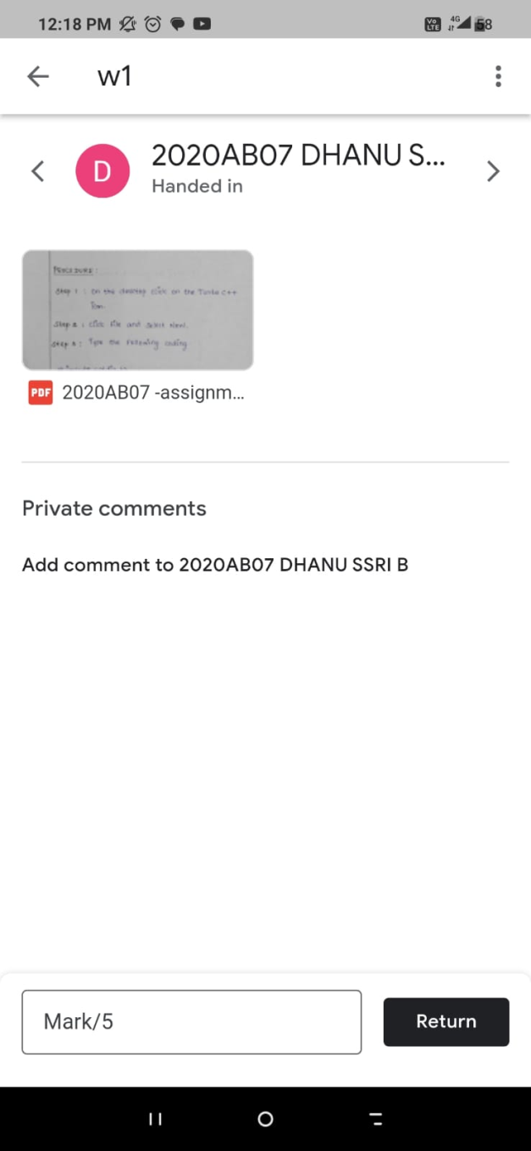

**Google Classroom of Ms. M. Fanny**

**DEPARTMENT OF COMPUTER SCIENCE**

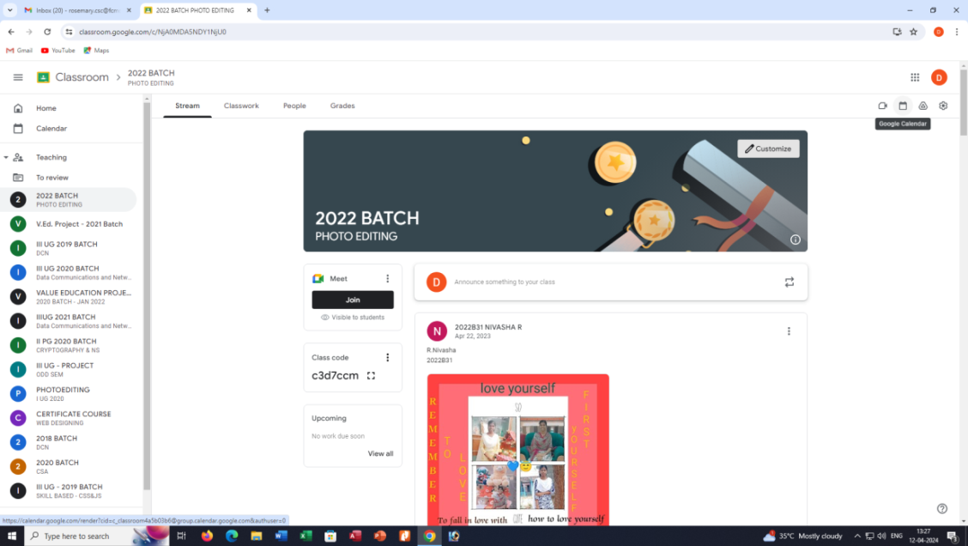

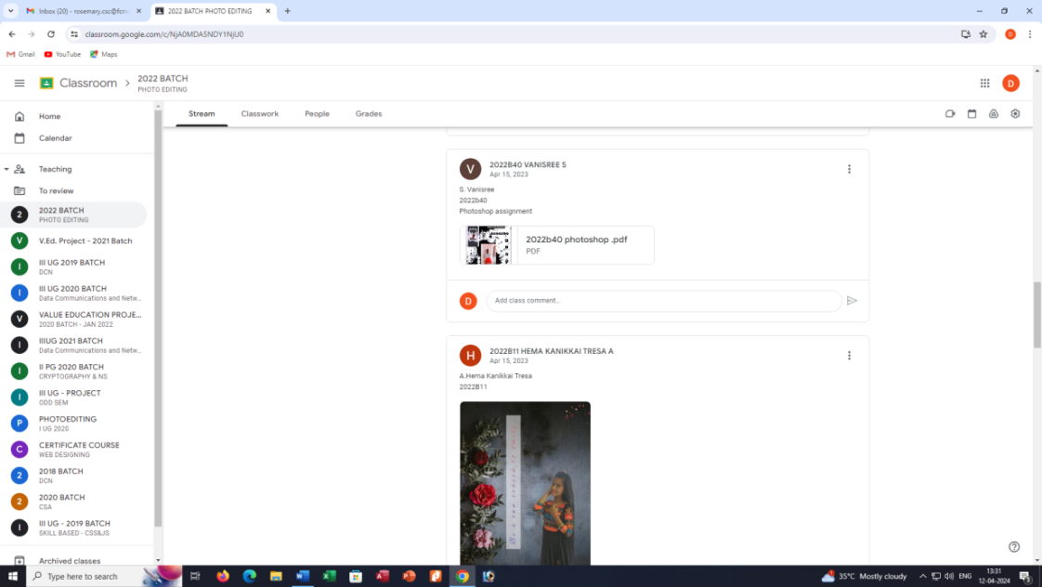**Google Classroom of Dr. K. Rosemary Euphrasia**