4.34 – Institution has the following facilities for E-Content development

- Media centre
- Audio Visual Centre
- Lecture Capturing System(LCS)
- Mixing Equipment s and software for editing

S.No. | Data Requirement as per SOP | Reference Link
1. | List of Equipments
2. | Geo Tagged Photos of the Facility
3. | Stock Register for Equipments availability
4. | Video | E-Content Center Video
4. | Video | E-Content Studio Video

E-CONTENT DEVELOPMENT FACILITY

EQUIPMENTS LIST

S.No | Equipment | Quantity
1 | DSLR Camera (Canon & Nikon) | 2
2 | Studio Light System with Light Stand- with Umbrella | 2
3 | Tripod | 1
4 | Green Matte | 1
5 | Script stand | 1
6 | Headphone | 2
7 | Mic with stand and Cable | 1
8 | Yamaha Studio Monitors | 2
9 | Headphone Amplifier | 1
10 | Desktop Computer – Lenovo  Software Installed  1.Adobe Photoshop  2. Cubase | 1
11 | Yamaha 16 Channel Mixer | 1
12 | Sennheiser HD206 Headphone | 1
13 | Rode Lavalier Collar Mic | 1
14 | Voice Filter | 1
15 | Sony Voice Recorder | 1
16 | Shure Condenser Mic | 1
17 | Headphone Splitter | 1
18 | MX Microphone | 1

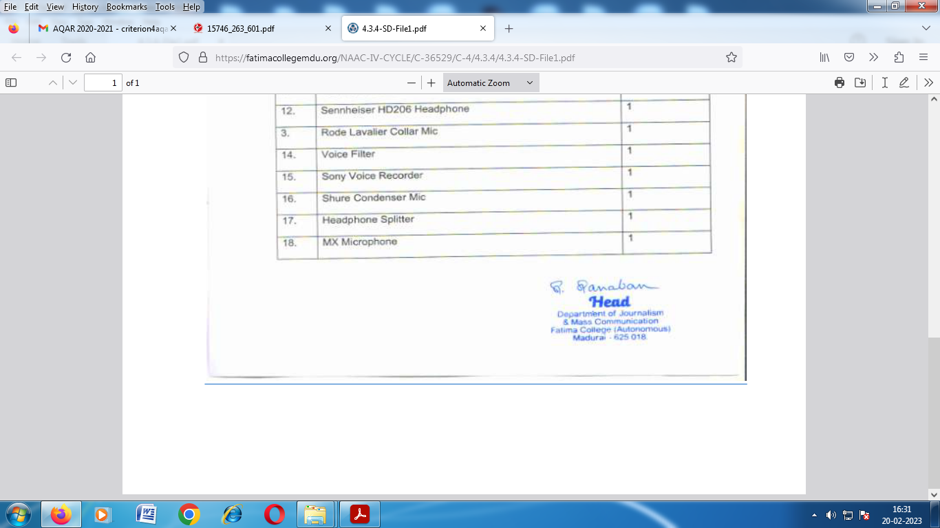

Geo Tagged Photos of the Facility
