**ERP DOCUMENTS**



**ROVAN IMS –Education ERP software**

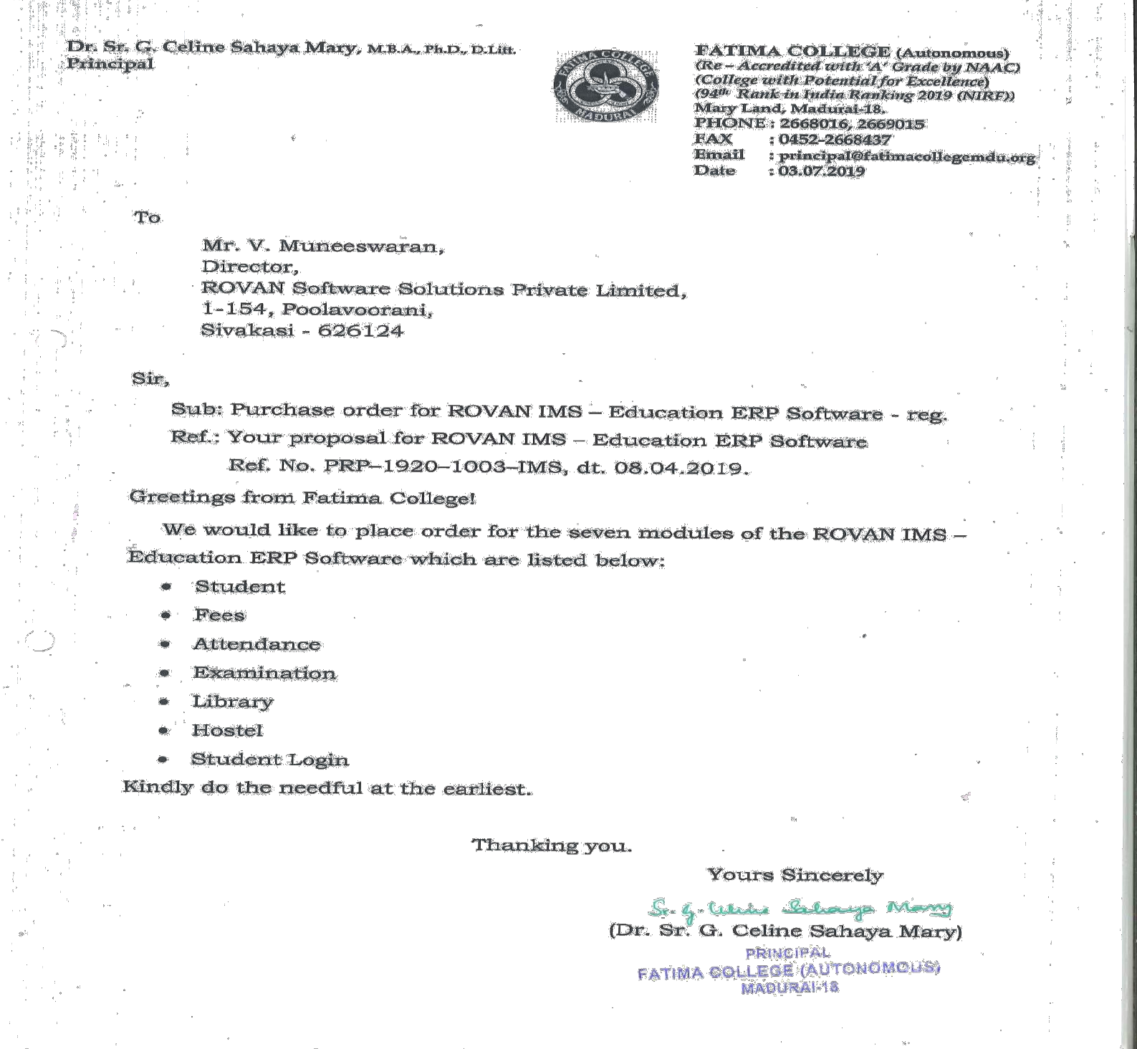

**ROVAN IMS –Education ERP software-Bill**

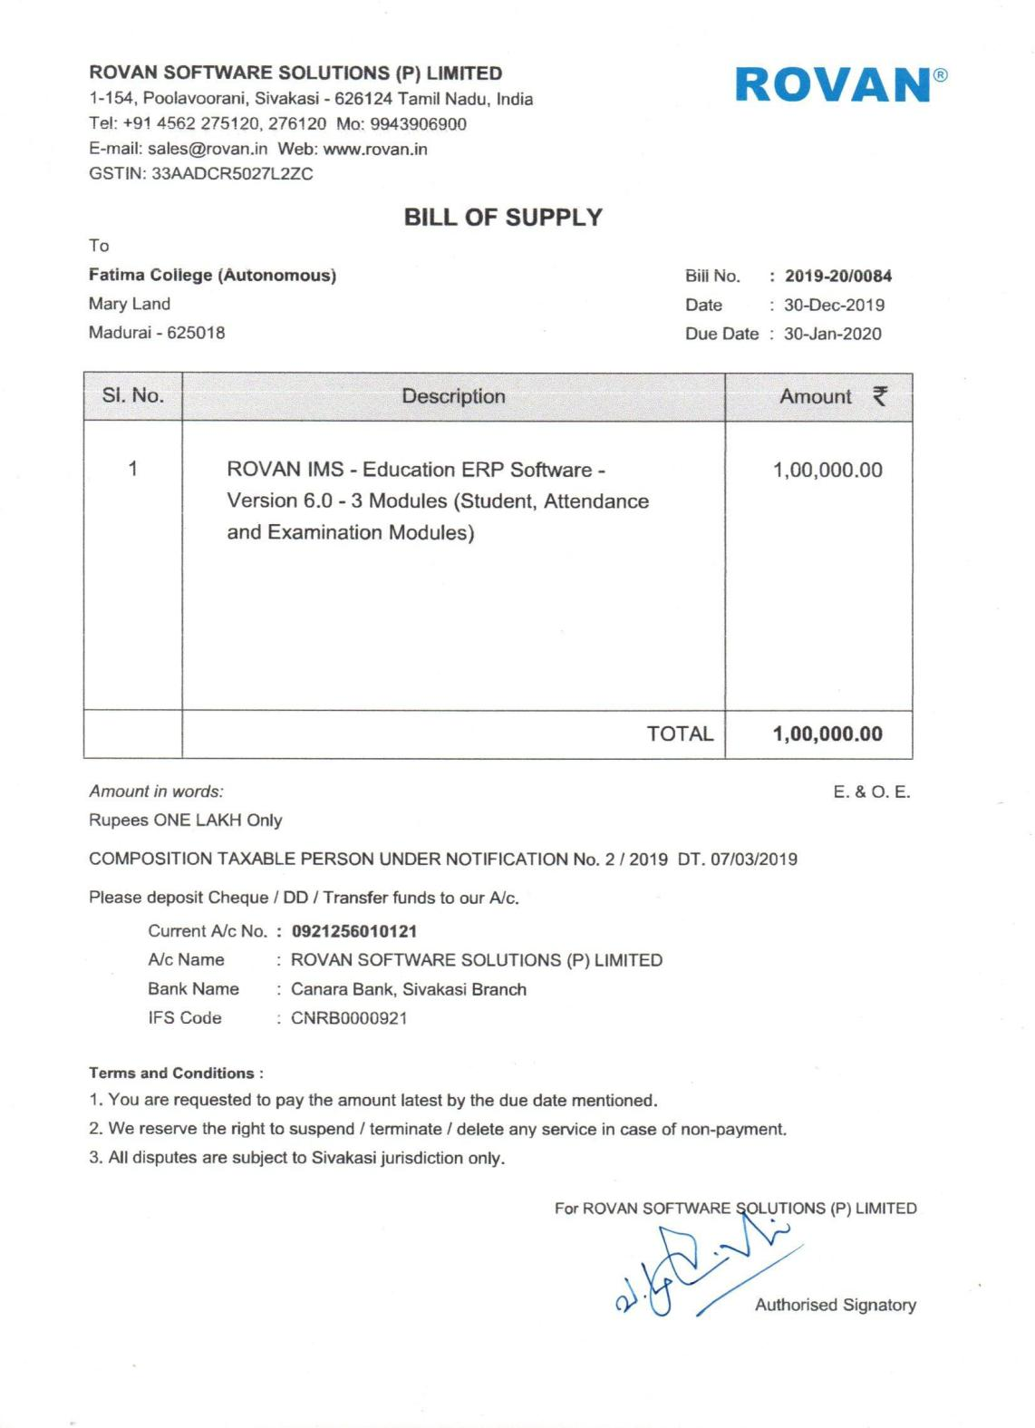

**Tally ERP 9**

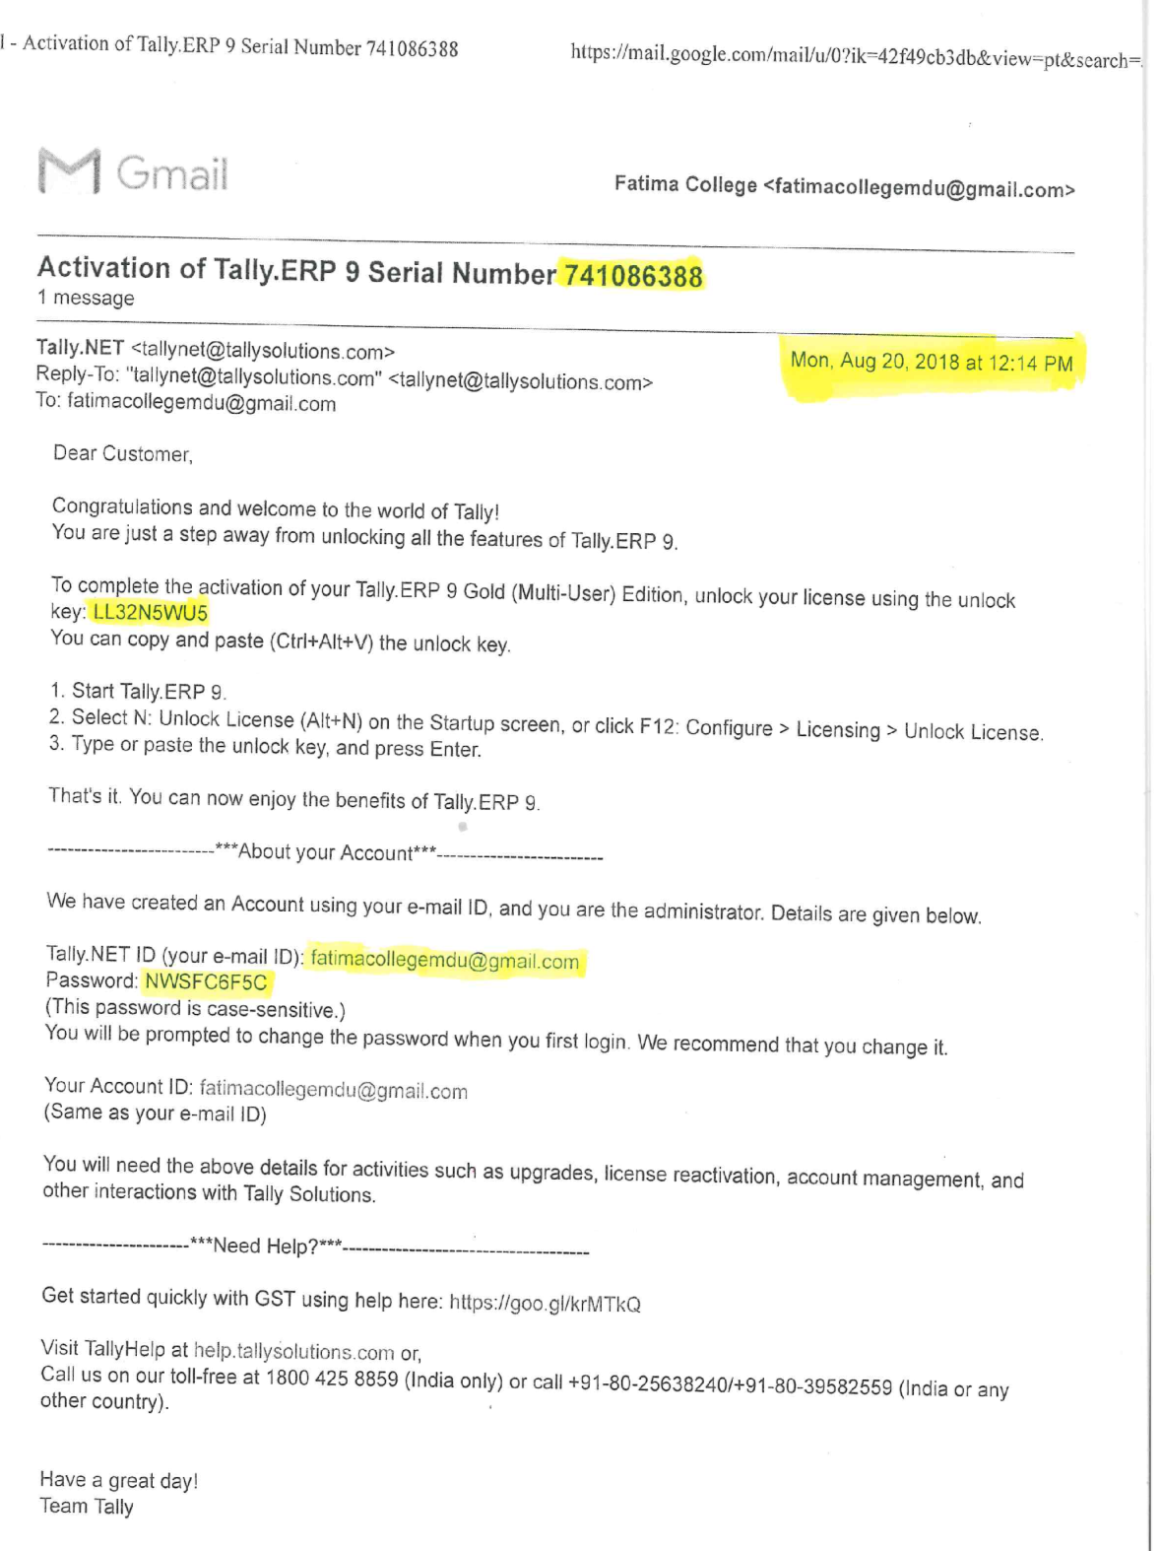

**Tally ERP 9**

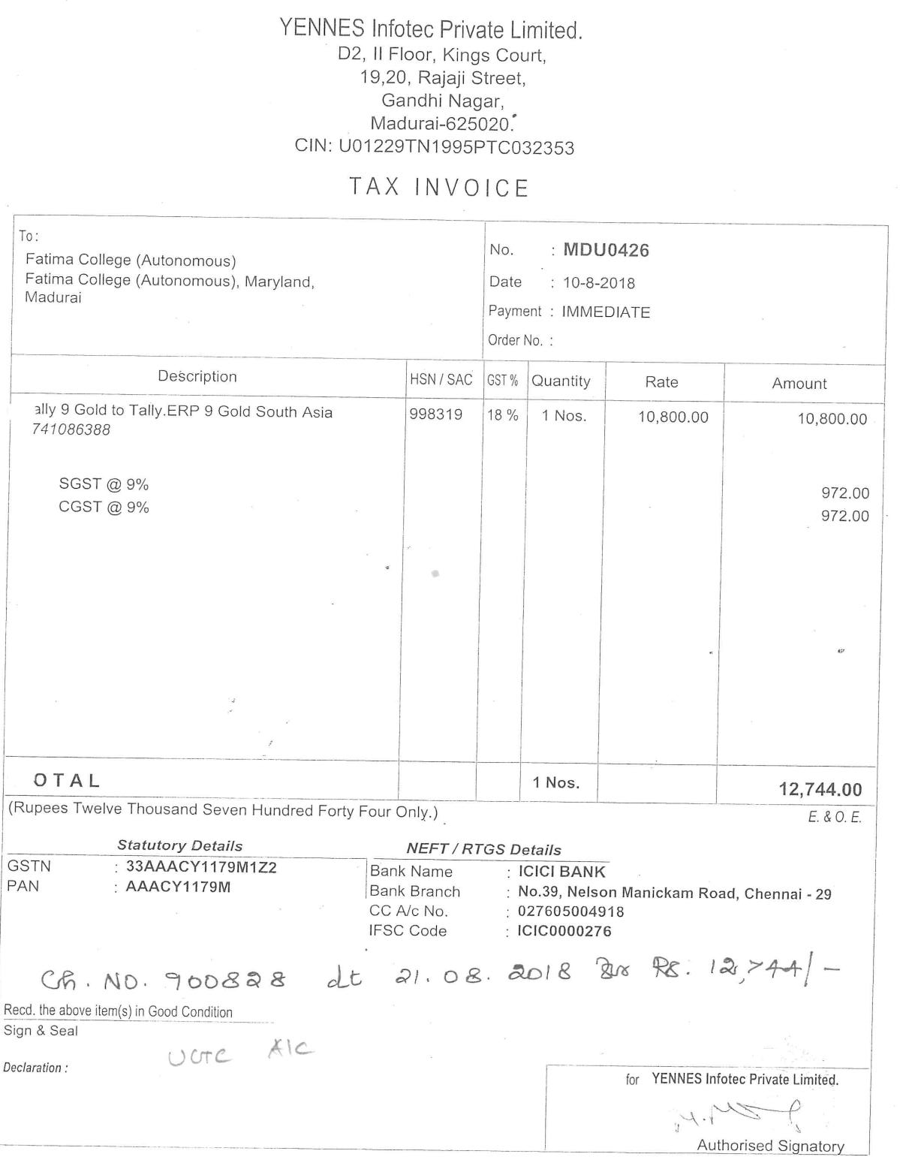

**Tally Software Services (TSS-Silver**)

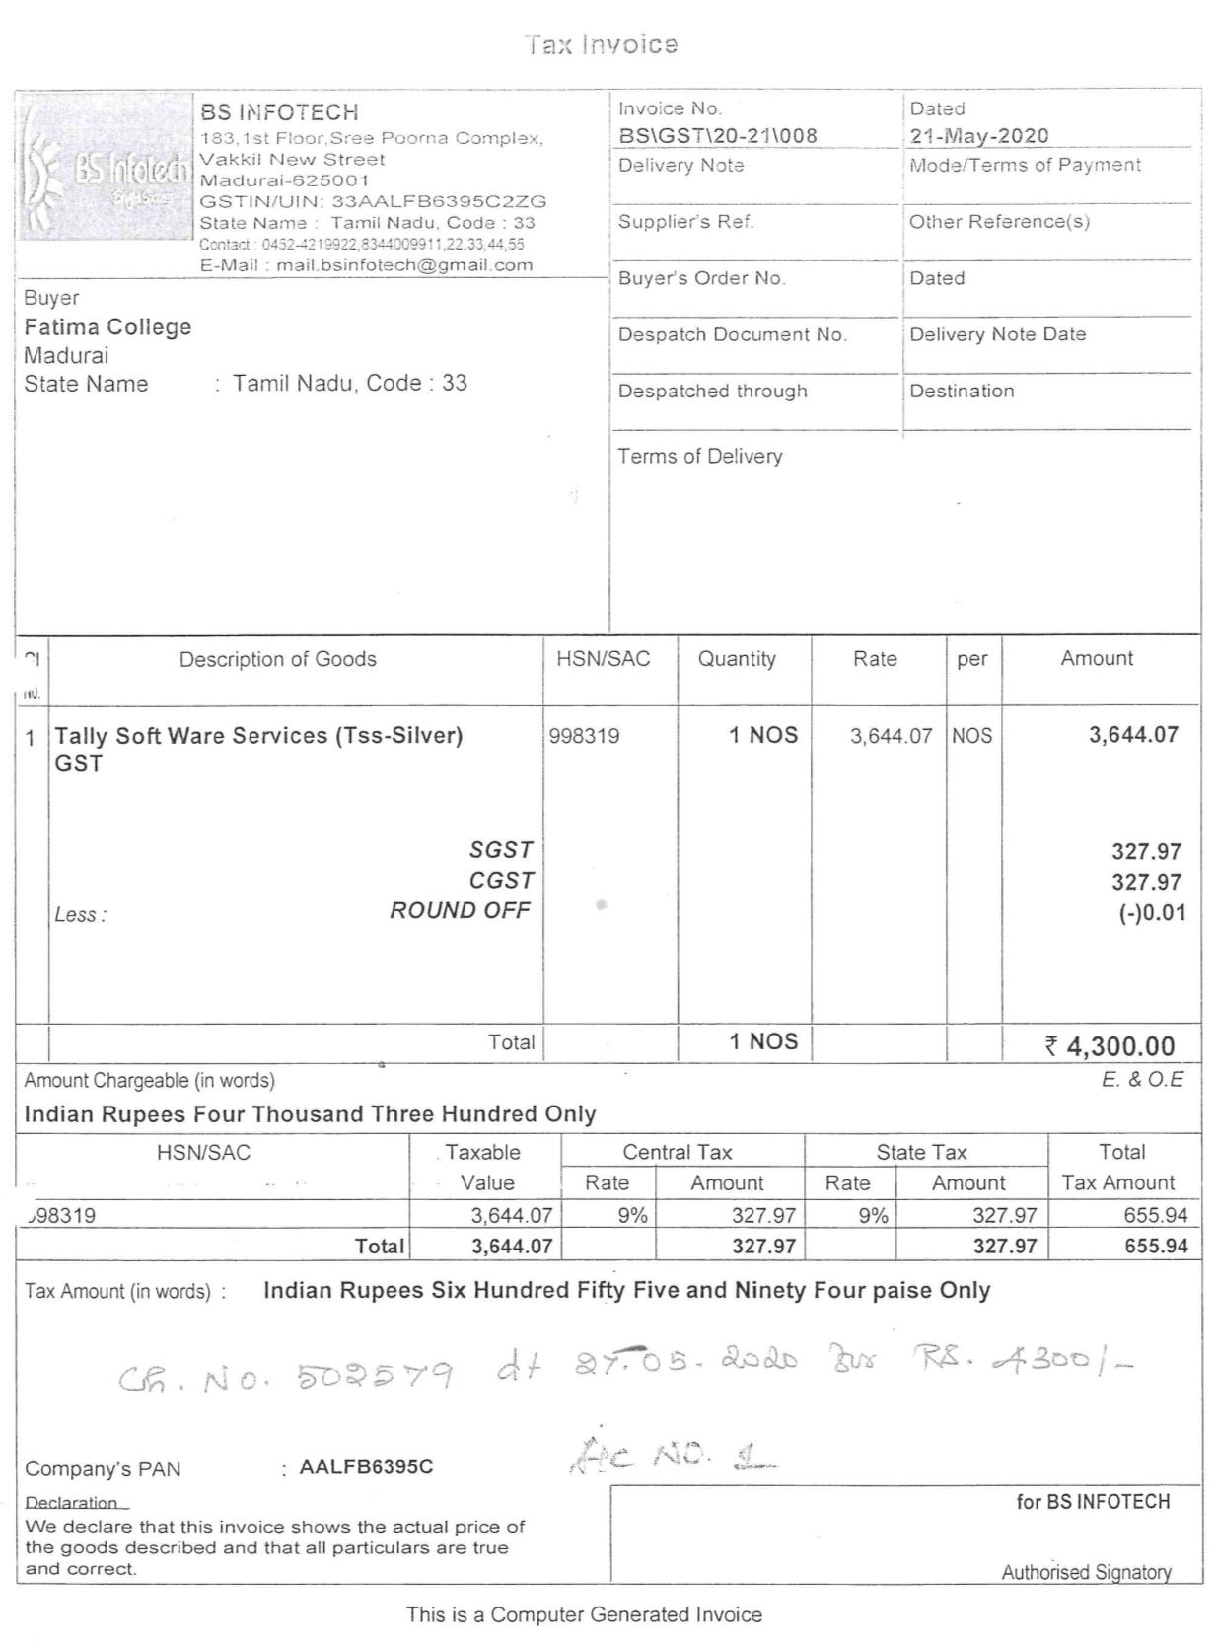

**Tally 9 Gold to Tally ERP 9 Upgrade**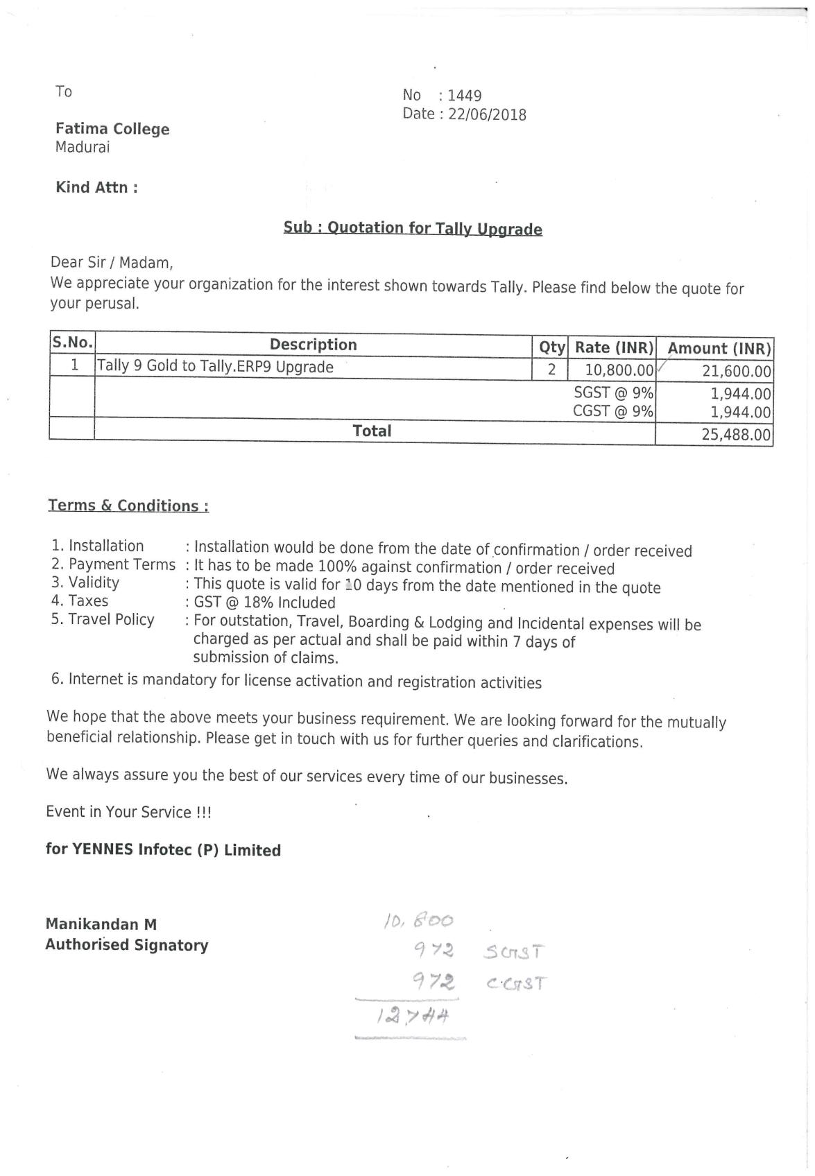

**Tally 9 Gold to Tally ERP 9 Upgrade**

