4.2.1 Library is automated using Integrated Library Management System (ILMS)

S. No. | Data Requirement | Reference Link
1. | Policy on Library and its usage | 
2. | Integrated Library Management System (ILMS) | 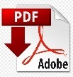
3. | Library – Infrastructure & learning resources

